

|  |  |
| --- | --- |
|  | **MINISTRY OF EDUCATION AND TRAINING** |

**Capstone Project Report**

**Report 3 – Software Requirement Specification**

– Ho Chi Minh, September 2024 –

I. Record of Changes 3

II. Software Requirement Specification 4

1. Product Overview 4

2. User Requirements 5

2.1. Actors 5

2.2. Use Cases 6

2.2.1. Diagram(s) 6

2.2.2. Descriptions 6

2.2.2.1. Administrator Use Case Description 6

2.2.2.2. Counselor Use Case Description 8

2.2.2.3. Manager Use Case Description 11

2.2.2.4. Support Staff Use Case Description 12

2.2.2.5. Student Use Case Description 13

3. Functional Requirements 15

3.1. System Functional Overview 15

3.1.1. Screens Flow 15

3.1.1.1. Administrator Screen Flow 15

3.1.1.2. Counselor Screenflow 16

3.1.1.3. Manager Screen Flow 17

3.1.1.4. Support Staff Screenflow 18

3.1.1.5. Student Screenflow 18

3.1.2. Screen Descriptions 19

3.1.2.1. Administrator Screen Description 19

3.1.2.2. Counselor Screen Description 21

3.1.2.3. Manager Screen Description 22

3.1.2.4. Support Staff Screen Description 24

3.1.2.5. Student Screen Description 24

3.1.3. Screen Authorization 25

3.1.3.1. Web Screen Authorization 25

3.1.3.2. Mobile Screen Authorization 28

3.1.4. Non-Screen Functions 28

3.1.5.1 Conceptual Model 28

3.1.5.2 Logical Model 29

3.2. Functional requirements 31

3.2.1. Accounts Feature 31

3.2.2. Authentications Feature 32

3.2.3. Booking Counseling Feature 33

3.2.4. Appointment Feature 35

3.2.5. Q&A Feature 36

3.2.6. Counseling Demand Feature 37

3.2.7. Dashboards Feature 39

3.2.8. Manage Student Feature 39

3.2.9. Manage Counselor Feature 40

4. Non-Functional Requirements 43

4.1. External Interfaces 43

4.1.1. User Interfaces 43

4.1.2. Communications Interfaces 43

4.2. Quality Attributes 43

4.2.1. Usability 43

4.2.2. Reliability 43

4.2.3. Performance 43

4.2.4. Security 43

5. Requirement Appendix 44

5.1. Business Rules 44

5.2. Application Messages List 44

5.2.1. Web application 44

5.2.2. Mobile application 47

# I. Record of Changes

|  |  |  |  |
| --- | --- | --- | --- |
| Date | A*  M, D | In charge | Change Description |
| 21/09/2024 | A | Trình Vĩnh Phát | Initialize document |
| 21/09/2024 | A | Đoàn Tiến Phát | Added content:   * Overall Description * User Requirements |
| 21/09/2024 | A | Phạm Trần Sơn Nguyên | Added content:   * Functional Requirements |
| 21/09/2024 | A | Vũ Ngọc Hải Đăng | Added Non-Functional Requirements |
| 21/09/2024 | M | Nguyễn An Khánh | Modified User Requirements |
| 21/09/2024 | M | Phạm Trần Sơn Nguyên | Modified Non-Functional Requirements |
| 21/09/2024 | M | Trình Vĩnh Phát | Modified Functional Requirements |
| 5/10/2024 | M | Phạm Trần Sơn Nguyên | Modified User Requirements |

*A - Added M - Modified D - Deleted

# II. Software Requirement Specification

## 1. Product Overview

The Student Counseling and Support System (SCSS) is a comprehensive platform designed to provide essential support services to students at FPT University HCM Campus. This system includes a wide range of services such as academic counseling, career guidance, and mental health resources. To improve user experience, the platform features an advanced search functionality, enabling students and staff to efficiently locate the resources and services they need. The system also incorporates a Manager role, which is crucial for overseeing operations, managing resource allocation, and monitoring counselor performance. Overall, SCSS is designed to be a robust and effective tool that not only offers vital counseling and support services but also includes advanced management features to ensure smooth and efficient administration at the FPTU HCM Campus.

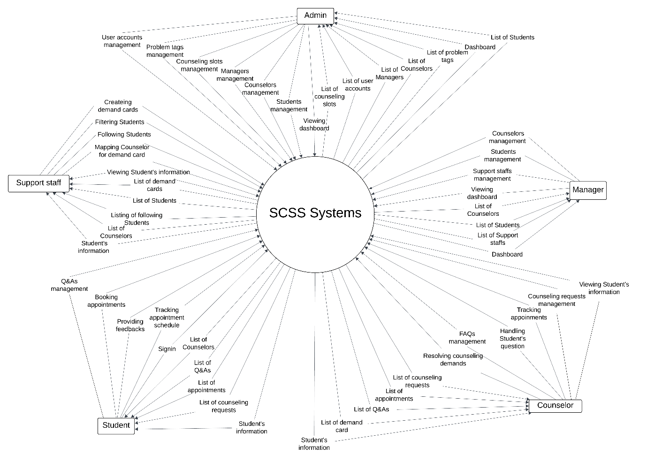

## 2. User Requirements

## 2.1. Actors

|  |  |  |
| --- | --- | --- |
| **#** | **Actor** | **Description** |
| 1 | Student | A person who logs in, books appointments, creates questions. |
| 2 | Counselor | A person who manages counseling slots, Q&A and takes appointments with students. |
| 3 | Manager | A person who manages counselors, support staff. Assign a counseling slot to the counselor. |
| 4 | Support Staff | A person who assigns counselors to the student base on demand form system. |
| 5 | Administrator | A person who manages the SCSS system. |

### 2.2. Use Cases

#### 2.2.1. Diagram(s)

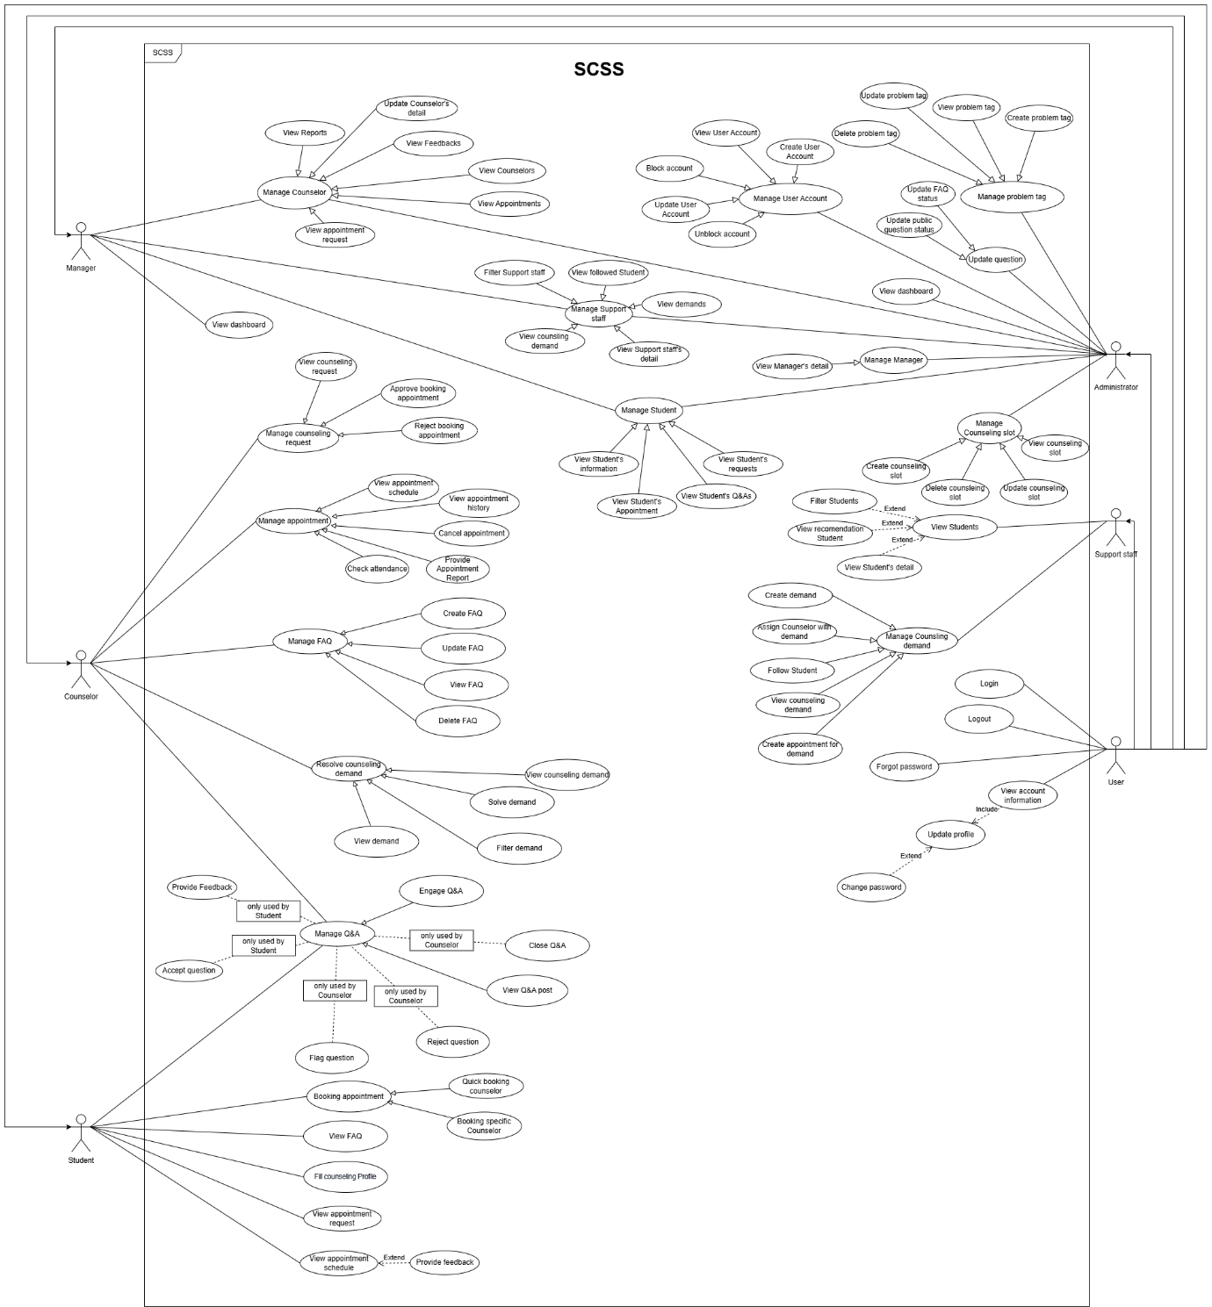

###### 2.2.2. Descriptions

##### 2.2.2.1. Administrator Use Case Description

|  |  |  |  |
| --- | --- | --- | --- |
| **ID** | **Use Case** | **Actors** | **Use Case Description** |
| 01 | Login | Administrator | This use case allows “Admin” to login by gmail. |
| 02 | Logout | Administrator | This use case allows “Admin” to logout from SCSS Web applications. |
| 03 | View dashboard | Administrator | This use case allows “Admin” to view dashboard. |
| 04 | View Profile | Administrator | This use case allows “Admin” to view user’s profile. |
| 05 | View user accounts | Administrator | This use case allows “Admin” to view user accounts. |
| 06 | Filter account | Administrator | This use case allows “Admin” to filter account. |
| 07 | View user detail | Administrator | This use case allows “Admin” to view user details. |
| 08 | Update profile | Administrator | This use case allows “Admin” to search update profile. |
| 09 | Create user account | Administrator | This use case allows “Admin” to create a new user account and assign roles. |
| 10 | Delete user account | Administrator | This use case allows “Admin” to delete user accounts. |
| 11 | Update user account | Administrator | This use case allows “Admin” to update user account roles and information. |
| 12 | Ban user | Administrator | This use case allows “Admin” to block user account. |
| 13 | Unban user | Administrator | This use case allows “Admin” to unblock user accounts. |
| 14 | Create problem tag | Administrator | This use case allows “Admin” to create problem tag. |
| 15 | View problem tag | Administrator | This use case allows “Admin” to view problem tag. |
| 16 | Update problem tag | Administrator | This use case allows “Admin” to update problem tag. |
| 17 | Delete problem tag | Administrator | This use case allows “Admin” to delete problem tag. |
| 18 | Create counseling slot | Administrator | This use case allows “Admin” to create counseling slot. |
| 19 | View Counseling slots | Administrator | This use case allows “Admin” to view counseling slot list. |
| 20 | View Counseling slot | Administrator | This use case allows “Admin” to view counseling slot details. |
| 21 | Search counseling slot | Administrator | This use case allows “Admin” to search counseling slot. |
| 22 | Update counseling slot | Administrator | This use case allows “Admin” to update counseling slot. |
| 23 | Delete counseling slot | Administrator | This use case allows “Admin” to delete counseling slots. |
| 24 | Update counselor | Administrator | This use case allows “Admin” to delete update counselor. |
| 25 | View counselor detail | Administrator | This use case allows “Admin” to view counselor detail. |
| 26 | Update student | Administrator | This use case allows “Admin” to view update student. |
| 27 | View student detail | Administrator | This use case allows “Admin” to search view student detail. |
| 28 | Update manager | Administrator | This use case allows “Admin” to update update manager. |
| 29 | View manager detail | Administrator | This use case allows “Admin” to delete view manager details. |
| 30 | Update support staff | Administrator | This use case allows “Admin” to view update support staff. |
| 31 | View support staff | Administrator | This use case allows “Admin” to view support staff. |

##### 2.2.2.2. Counselor Use Case Description

|  |  |  |  |
| --- | --- | --- | --- |
| **ID** | **Use Case** | **Actors** | **Use Case Description** |
| 01 | Login | Counselor | This use case allows “Counselor” to Login. |
| 02 | Logout | Counselor | This use case allows “Counselor” to Logout. |
| 03 | Update password | Counselor | This use case allows “Counselor” to update password. |
| 04 | View Profile | Counselor | This use case allows “Counselor” to View Profile. |
| 05 | Filter student | Counselor | This use case allows “Counselor” to Filter students. |
| 06 | View student detail | Counselor | This use case allows “Counselor” to View student detail. |
| 07 | View request history | Counselor | This use case allows “Counselor” to View request History. |
| 08 | View request detail | Counselor | This use case allows “Counselor” to View request detail. |
| 09 | Filter request history | Counselor | This use case allows “Counselor” to Filter request history. |
| 10 | Approve booking appointment | Counselor | This use case allows “Counselor” to Approve booking appointments. |
| 11 | Approve Online Request | Counselor | This use case allows “Counselor” to Approve Online Request. |
| 12 | Approve Offline Request | Counselor | This use case allows “Counselor” to Approve Offline Requests. |
| 13 | Reject booking appointment | Counselor | This use case allows “Counselor” to Reject booking appointments. |
| 14 | View appointment schedule | Counselor | This use case allows “Counselor” to View appointment schedules. |
| 15 | View Appointment History | Counselor | This use case allows “Counselor” to View Appointment History. |
| 16 | View Appointment detail | Counselor | This use case allows “Counselor” to View Appointment detail. |
| 17 | Filter appointment history | Counselor | This use case allows “Counselor” to Filter appointment history. |
| 18 | Update Attendance | Counselor | This use case allows “Counselor” to Update Attendance. |
| 19 | Provide Appointment Report | Counselor | This use case allows “Counselor” to Provide Appointment Report. |
| 20 | View report | Counselor | This use case allows “Counselor” to View report. |
| 21 | Check Attendance | Counselor | This use case allows “Counselor” to Check Attendance. |
| 22 | Create report | Counselor | This use case allows “Counselor” to Create report. |
| 23 | Engage Q&A | Counselor | This use case allows “Counselor” to Engage Q&A. |
| 24 | Chat Student | Counselor | This use case allows “Counselor” to Chat Student. |
| 25 | Answer Question | Counselor | This use case allows “Counselor” to Answer Question. |
| 26 | Close Q&A | Counselor | This use case allows “Counselor” to Close Q&A. |
| 27 | View Q&A post | Counselor | This use case allows “Counselor” to View Q&A post. |
| 28 | Reject question | Counselor | This use case allows “Counselor” to reject questions. |
| 29 | Flag question | Counselor | This use case allows “Counselor” to flag questions. |
| 30 | Filter Q&A | Counselor | This use case allows “Counselor” to Filter Q&A. |
| 31 | View Q&A detail | Counselor | This use case allows “Counselor” to View Q&A detail. |
| 32 | View counseling demand | Counselor | This use case allows “Counselor” to VIew counseling demand. |
| 33 | Filter demand | Counselor | This use case allows “Counselor” to Filter demand. |
| 34 | View demand | Counselor | This use case allows “Counselor” to View demand. |
| 35 | Create appointment for demand | Counselor | This use case allows “Counselor” to Create appointments for demand. |
| 36 | Create FAQ | Counselor | This use case allows “Counselor” to create FAQs. |
| 37 | Update FAQ | Counselor | This use case allows “Counselor” to update FAQs. |
| 38 | View FAQ | Counselor | This use case allows “Counselor” to view FAQs. |
| 39 | Delete FAQ | Counselor | This use case allows “Counselor” to delete FAQs. |

##### 2.2.2.3. Manager Use Case Description

|  |  |  |  |
| --- | --- | --- | --- |
| **ID** | **Use Case** | **Actors** | **Use Case Description** |
| 01 | Login | Manager | This use case allows “Manager” to login. |
| 02 | Logout | Manager | This use case allows “Manager” to Logout. |
| 03 | View Profile | Manager | This use case allows “Manager” to View Profile. |
| 04 | Update profile | Manager | This use case allows “Manager” to Update profile. |
| 05 | View Counselors | Manager | This use case allows “Manager” to View Counselors. |
| 06 | View Counselor Profile | Manager | This use case allows “Manager” to View Counselor Profile. |
| 07 | Search Counselor | Manager | This use case allows “Manager” to Search Counselor. |
| 08 | Change Status | Manager | This use case allows “Manager” to Change Status. |
| 09 | Assign Slot | Manager | This use case allows “Manager” to Assign Slot. |
| 10 | Update date range | Manager | This use case allows “Manager” to Update date range. |
| 11 | View Appointment request | Manager | This use case allows “Manager” to View Appointment requests. |
| 12 | View Appointments | Manager | This use case allows “Manager” to View Appointments. |
| 13 | View Feedbacks | Manager | This use case allows “Manager” to View Feedbacks. |
| 14 | View Reports | Manager | This use case allows “Manager” to View Reports. |
| 15 | View Students | Manager | This use case allows “Manager” to View Students. |
| 16 | View Student Profile | Manager | This use case allows “Manager” to View Student Profile. |
| 17 | Search student | Manager | This use case allows “Manager” to Search students. |

##### 2.2.2.4. Support Staff Use Case Description

|  |  |  |  |
| --- | --- | --- | --- |
| **ID** | **Use Case** | **Actors** | **Use Case Description** |
| 01 | Login | Support Staff | This use case allows “Support Staff” to login. |
| 02 | Logout | Support Staff | This use case allows “Support Staff” to Logout. |
| 03 | Reset password | Support Staff | This use case allows “Support Staff” to reset password. |
| 04 | Create demand | Support Staff | This use case allows “Support Staff” to create demand. |
| 05 | View counseling demand | Support Staff | This use case allows “Support Staff” to view counseling demand. |
| 06 | Filter counseling demand | Support Staff | This use case allows “Support Staff” to filter counseling demand. |
| 07 | View counseling detail | Support Staff | This use case allows “Support Staff” to view counseling details. |
| 08 | Assign counselor with demand | Support Staff | This use case allows “Support Staff” to assign counselor with demand. |
| 09 | Find counselor | Support Staff | This use case allows “Support Staff” to find counselor. |
| 10 | Fill student contact note | Support Staff | This use case allows “Support Staff” to fill student contact note. |
| 11 | Search student detail | Support Staff | This use case allows “Support Staff” to Fill student contact notes. |
| 12 | View Students | Support Staff | This use case allows “Support Staff” to View Students . |
| 13 | View student detail | Support Staff | This use case allows “Support Staff” to View student detail. |
| 14 | Filter student | Support Staff | This use case allows “Support Staff” to Filter students. |

##### 2.2.2.5. Student Use Case Description

|  |  |  |  |
| --- | --- | --- | --- |
| **ID** | **Use Case** | **Actors** | **Use Case Description** |
| 01 | Login | Student | This use case allows the “Student” to log in to the platform using their university credentials. |
| 02 | View profile | Student | This use case allows “Student” to view their profile. |
| 03 | Update password | Student | This use case allows “Student” to update their password. |
| 04 | Logout | Student | This use case allows “Student” to logout. |
| 05 | View dashboard | Student | This use case allows “Student” to view dashboard. |
| 06 | View appointment schedule | Student | This use case allows “Student” to view the appointment schedule . |
| 07 | View counseling booking request | Student | This use case allows “Student” to view counseling booking requests. |
| 08 | View appointment details | Student | This use case allows the “Student” to view appointment details. |
| 09 | Filter appointment request | Student | This use case allows the “Student” to view filter appointment requests. |
| 10 | View detail request | Student | This use case allows the “Student” to view detail requests. |
| 11 | Booking Appointment | Student | This use case allows the “Student” to book appointments. |
| 12 | Quick booking counselor | Student | This use case allows the “Student” to quickly book a counselor. |
| 13 | Booking Specific Counselor | Student | This use case allows the “Student” to book a Specific Counselor. |
| 14 | Booking academic counselor | Student | This use case allows the “Student” to book an academic counselor. |
| 15 | Booking non-academic counselor | Student | This use case allows the “Student” to book a non-academic counselor. |
| 16 | Provide counseling feedback | Student | This use case allows the “Student” to provide feedback. |
| 17 | View Q&A post | Student | This use case allows the “Student” to view Q&A posts. |
| 18 | Create Question | Student | This use case allows the “Student” to create question |
| 19 | Filter Question | Student | This use case allows the “Student” to filter question posts. |
| 20 | Engage Q&A | Student | This use case allows the “Student” to engage Q&A. |
| 21 | Chat counselor | Student | This use case allows the “Student” to chat with a counselor. |
| 22 | Update Question | Student | This use case allows the “Student” to update Q&A. |
| 23 | Delete Question | Student | This use case allows the “Student” to delete questions. |
| 24 | Edit Question | Student | This use case allows the “Student” to edit question |
| 25 | Close question | Student | This use case allows the “Student” to close question |
| 26 | View Appointment History | Student | This use case allows the “Student” to view Appointment History list |
| 27 | Filter appointment history | Student | This use case allows the “Student” to filter appointment history |
| 28 | View Appointment detail | Student | This use case allows the “Student” to view appointment details. |
| 29 | Fill counseling profile | Student | This use case allows the “Student” to fill counseling profile |

## 3. Functional Requirements

### 3.1. System Functional Overview

#### 3.1.1. Screens Flow

##### 3.1.1.1. Administrator Screen Flow

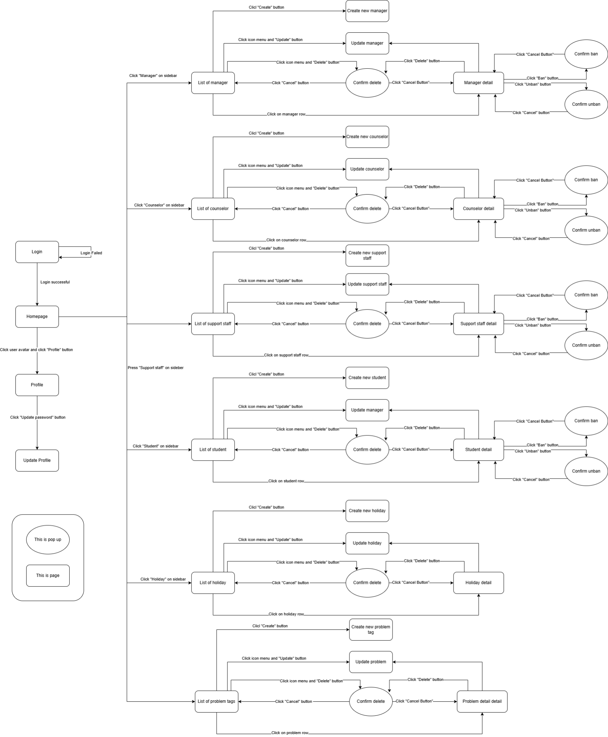

##### 3.1.1.2. Counselor Screenflow

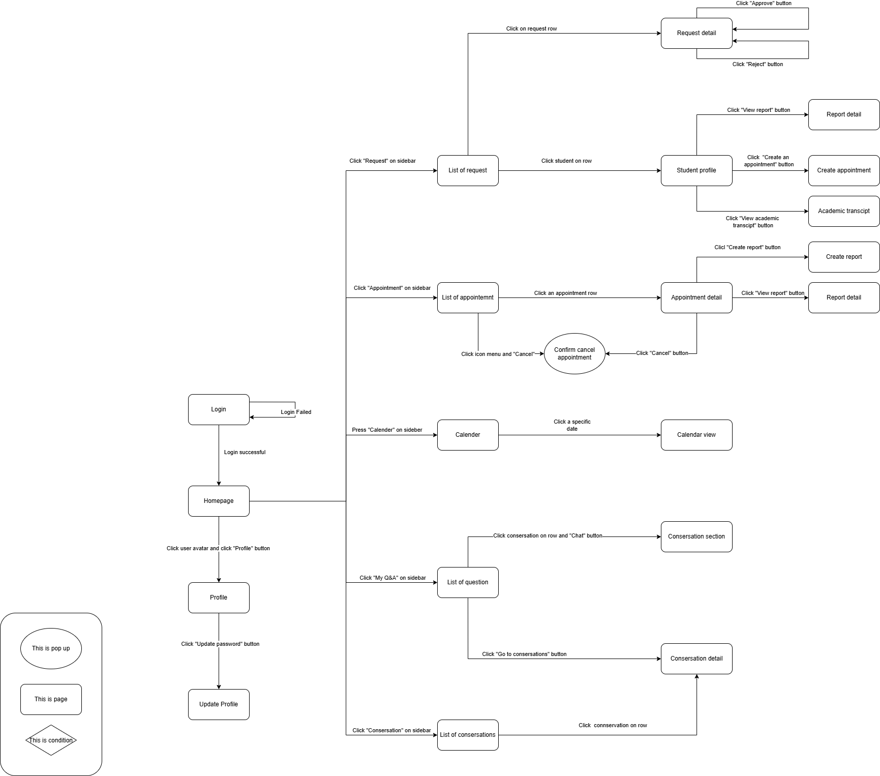

##### 3.1.1.3. Manager Screen Flow

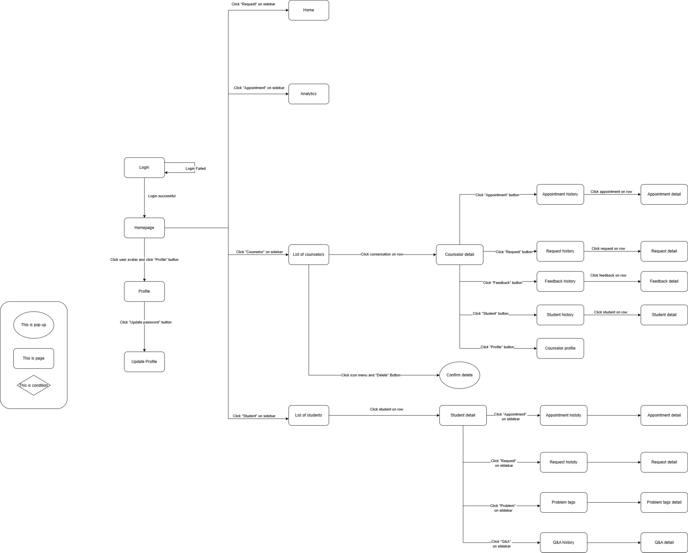

##### 3.1.1.4. Support Staff Screenflow

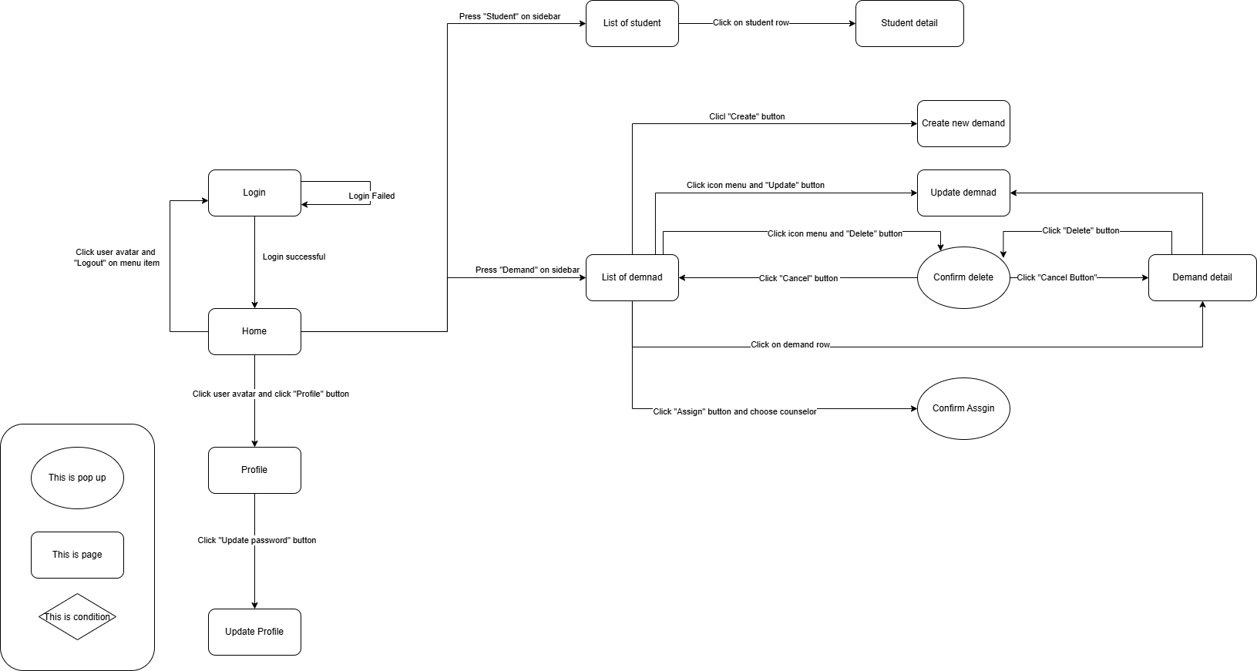

##### 3.1.1.5. Student Screenflow

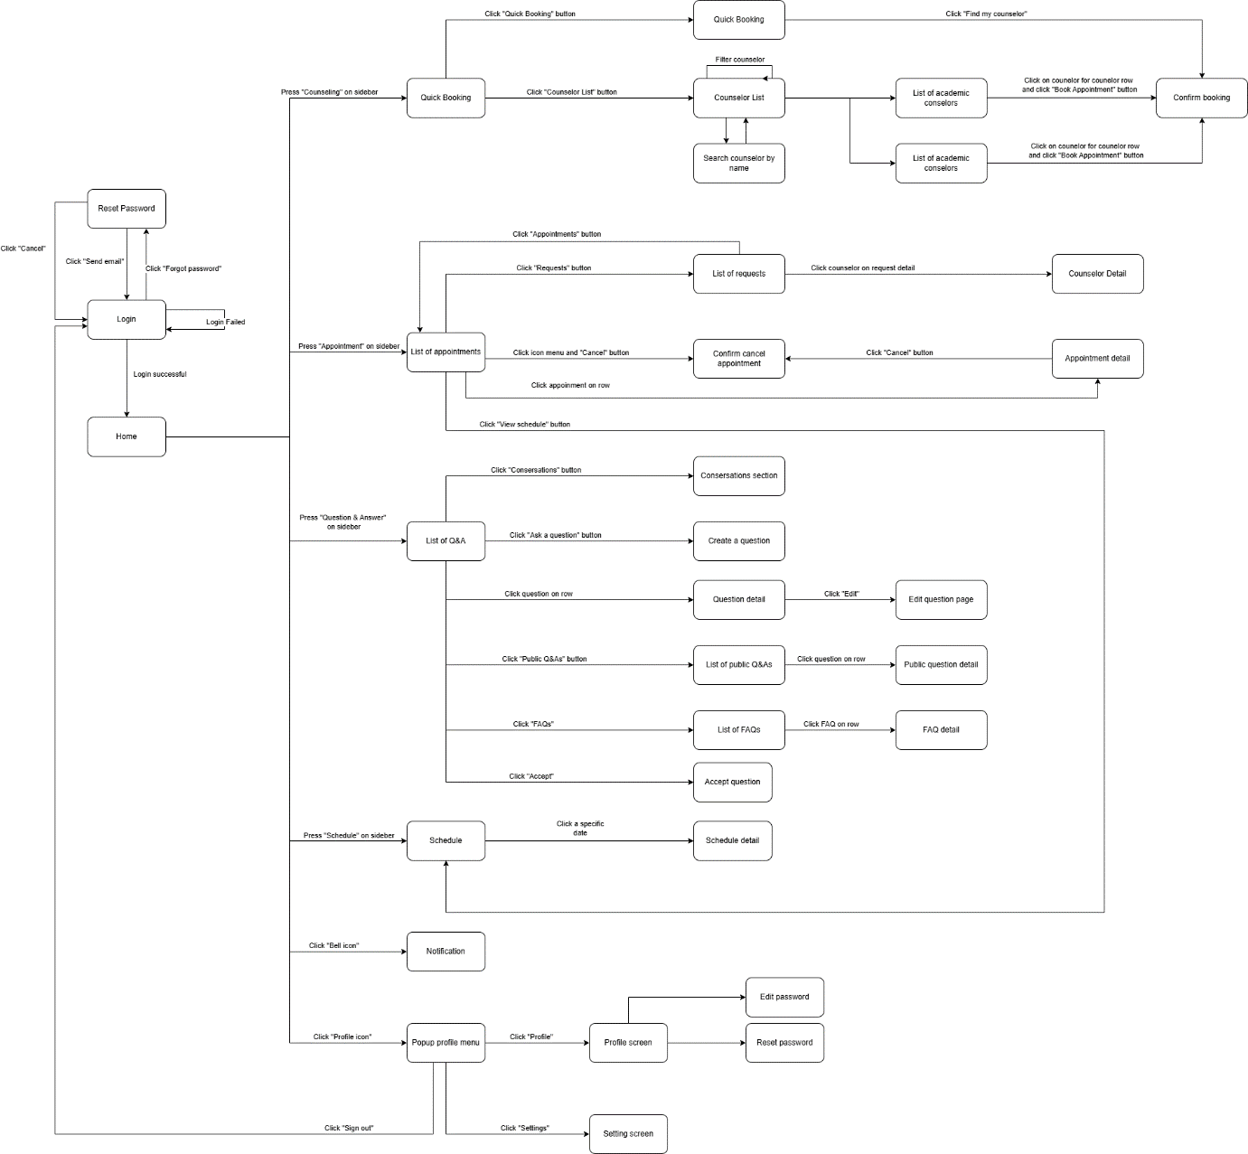

#### 3.1.2. Screen Descriptions

##### 3.1.2.1. Administrator Screen Description

|  |  |  |  |
| --- | --- | --- | --- |
| # | Feature | Screen | Description |
| 1 | Login | Login | Admin can login into the system by gâmil |
| 2 | View homepage | Homepage | Admin can view a few information: accounts, notifications, … |
| 3 | View list of manager | List of manager | Admin can view list of managers in the system. Include all information of manager |
| 4 | View list of counselor | List of counselor | Admin can view list of counselor sin the system. Include all information of manager |
| 5 | View list of counselor | List of support staff | Admin can view list of support staff in the system. Include all information of manager |
| 6 | View list of student | List of student | Admin can view list of student in the system. Include all information of manager |
| 7 | Create new manager | Create new manager | Admin can create a new manager for the system with input manager information. |
| 3 | Update manager | Update manager | Admin can update manager information with input manager information |
| 4 | View manager detail | Manager detail | Admin can view all information of manager. |
| 5 | Delete manager | List of manager, Manager detail | Admin can delete manager’s account. |
| 6 | Ban manager | Manager detail | Admin can ban manager. |
| 7 | Unban manager | Manager detail | Admin can unban manager |
| 8 | Create new counselor | Create new counselor | Admin can create a new counselor for the system with input manager information. |
| 9 | Update counselor | Update counselor | Admin can update counselor information with input counselor information |
| 10 | View counselor detail | Counselor detail | Admin can view all information of counselor. |
| 11 | Ban manager | Manager detail | Admin can ban counselor. |
| 12 | Unban manager | Manager detail | Admin can unban counselor |
| 12 | Create new support staff | Create new support staff | Admin can create a new support staff for the system with input manager information. |
| 13 | Update support staff | Update support staff | Admin can update support staff information with input manager information. |
| 14 | View support staff detail | Support staff detail | Admin can view all information of support staff. |
| 15 | Ban manager | Manager detail | Admin can ban support staff.. |
| 16 | Unban manager | Manager detail | Admin can unban support staff. |
| 17 | Create new student | Create new student | Admin can create a new student for the system with input manager information. |
| 18 | Update student | Update student | Admin can update student information with input manager information. |
| 19 | View student detail | Student detail | Admin can view all information of student. |
| 20 | Ban manager | Manager detail | Admin can ban student. |
| 21 | Unban manager | Manager detail | Admin can unban student. |
| 20 | View Account  Info | Account  Info | View Account  Info |
| 21 | View Specialization | View Specialization | Admin View Specialization |
| 22 | View Work Experience | View Work Experience | Admin View Work Experience |
| 23 | View Qualifications | View Qualifications | View Qualifications |
| 24 | View Certifications | View Certifications | View Certifications |
| 25 | View list of problem tags | List of problem tags | Admin can view list of problem tags |
| 26 | Create new problem tag | Create new problem tag | Admin can create a new problem tag for the system with input holiday information. |
| 27 | Update problem tag | Update problem tag | Admin can update holiday information with input manager information. |
| 29 | Problem tag detail | Problem tag detail | Admin can view all information of support staff. |

##### 3.1.2.2. Counselor Screen Description

|  |  |  |  |
| --- | --- | --- | --- |
| **#** | **Feature** | **Screen** | **Description** |
| 1 | Loign | Login | Counselor can login into the system by gmail. |
| 2 | View homepage | Homepage | Counselor can view a few information: upcoming appointments, … |
| 3 | View profile | Profile | Counselor can view profile. |
| 4 | Update profile | Update profile | Counselor can update their profile. |
| 5 | View list of requests | List of request | Counselor can view list of requests. |
| 6 | View request detail | Request detail | Counselor can view request detail. Include all details of request. |
| 7 | Approve request | Request detail | Counselor can approve request |
| 8 | Reject request | Request detail | Counselor can reject request |
| 9 | View student profile | Student profile | Counselor can view student profile. Include all information of student. |
| 10 | View report detail | Report detail | Counselor can view report detail. Include all information of report. |
| 1 | Create an appointment | Create appointment | Counselor can create an appointment for student with select date, slot, time, meeting type (online/offline). |
| 12 | View academic transcript | Academic transcript | Counselor can view academic transcript of student, each row of table list has no, term, semester, subject code, prerequisite, replaced subject,subject name, credit, grade, status. |
| 13 | View list of appointment | List of appointment | Counselor can view list of appointment, each row has date, time, meeting type, student profile.attendance status |
| 14 | Cancel appointment | List of appointment, Appointment detail | Counselor can cancel appointment |
| 15 | View appointment detail | Appointment detail | Counselor can view appointment detail. Include all information of appointment |
| 16 | Create report | Create report | Counselor can create report with input consultation goal, consultation content, consultation conclusion, intervention. |
| 17 | View report | Report detail | Counselor can view all information of report. |
| 18 | View calendar | Calendar | Counselor can view calendar by day, week, month |
| 19 | View calendar detail | Calendar view | Counselor can view all appointment in that day. |
| 20 | View list of question, Answer the question | List of question | Counselor can view list of question, each row has student name, question and counselor can answer the question. |
| 21 | Chat with student | Conversation detail, conversation section | Counselor can chat with the student to clarify the answer for them. |

##### 3.1.2.3. Manager Screen Description

|  |  |  |  |
| --- | --- | --- | --- |
| **#** | **Feature** | **Screen** | **Description** |
| 1 | Loign | Login | Manager can login into the system by gmail. |
| 2 | View homepage | Homepage, Home | Manager can view a few information: upcoming appointments, … |
| 3 | View analytics | Analytics | Manager can view analytics of the system. |
| 4 | Update profile | Update profile | Manager can update their profile. |
| 5 | View list of counselor | List of counselor | Manager can view list of counselors. |
| 6 | View counselor detail | Counselor detail | Manager can view request details. Include all details of counselor. |
| 7 | View appointment history | Appointment history | Manager can view appointment history. |
| 8 | View appointment detail | Appointment detail | Manager can view appointment detail |
| 9 | View request history | Request history | Manager can view request history. |
| 10 | View request detail | Request detail | Manager can view request detail |
| 11 | View feedback history | Feedback history | Manager can view feedback history. |
| 12 | View feedback detail | Feedback detail | Manager can view feedback detail |
| 13 | View student counseling history | Appointment history | Manager can view student counseling history. |
| 14 | View student counseling detail | Appointment detail | Manager can view student counseling detail |
| 15 | View counselor detail | Counselor profile | Manager can view counselor’s profile. |
| 16 | View list of student | List of student | Manager can view list of students. Include all details of student. |
| 17 | View problem tag history | Problem tag | Manager can view all the student's problem tags. |
| 18 | View problem tag detail detail | Problem tag detail | Manager can view student’s problem tag detail |
| 19 | View student appointment history | Appointment history | Manager can view student appointment history. |
| 20 | View student appointment detail | Appointment detail | Manager can view student appointment history. detail |
| 21 | View student request history | Request history | Manager can view student request history. |
| 22 | View student appointment detail | Request Detail | Manager can view student request history detail |
| 23 | View student Q&A | Q&A history | Manager can view student Q&A history |
| 24 | View student Q&A detail | Q&A detail | Manager can view student Q&A detail |

##### 3.1.2.4. Support Staff Screen Description

|  |  |  |  |
| --- | --- | --- | --- |
| **#** | **Feature** | **Screen** | **Description** |
| 1 | View list of student | List of student | Support staff can view list of student. |
| 2 | View student’ detail | Student detail | Support staff can view the student with full information. |
| 3 | View list of demand | List of demand | Support staff can view list of demand |
| 4 | Create new demand | Create new demand | Support staff can create a new demand to a specific student. |
| 5 | Update demand | Update demand | Support staff can update demand. |
| 6 | View demand detail | Demand detail | Support staff can view demand detail with full information of that detail. |
| 7 | Delete demand | List of demand | Support staff can delete demand |
| 8 | Assign counselor with demand | List of demand | Support staff can assign a specific counselor with demand. |

##### 3.1.2.5. Student Screen Description

|  |  |  |  |
| --- | --- | --- | --- |
| **#** | **Feature** | **Screen** | **Description** |
| 1 | Login | Login | Student can login into the system by gmail or FeID. |
| 2 | View homepage | Home | Student can view a few information: upcoming appointments, … |
| 3 | Counselling | Counselling | Students can book an appointment using Quick Booking or by selecting a counselor from the Counselor List. |
| 4 | View Profile | Profile | Student can view profile. |
| 5 | Quick Booking | Quick Booking | Students can book an appointment using Quick Booking by selecting the counseling type, date, time, counselor's specialization (optional), and counselor's gender (optional). |
| 6 | View counselor list | Counselor List | Students can book an appointment by selecting a specific counselor, counseling type, date, time. |
| 7 | Manage appointment | Appointment Management | Student can view list of appointment, list of request and other activity |
| 8 | View list of request | List of request | Student can view a list of requests, each row of table list has date, time, meeting type, status, counselor profile |
| 9 | View list of management | List of appointment | Student can view a list of appointment, each row of table list has date, time, meeting type,meet URL, status, counselor profile. |
| 10 | View appointment detail | Appointment detail | Student can view appointment detail and provide feedback |
| 11 | Cancer Appointment | Appointment detail, List of appointment | Student can cancel appointment and enter reason. |
| 12 | View other activity | Other Activity | Student can view other activity |
| 13 | View counselor profile | Counselor profile | Student can view counselor profile such as name, major, phone, bio, |
| 14 | View list of Q&A | List of Q&A | Student can view list of Q&Ai in the system, each row of table list has id, type, status, topic, question title, and answer. |
| 15 | Conversation | Conversations | Student can view list of conversations and chat section |
| 16 | Ask a question | Ask a question | Student can submit a question by select question, counseling topic and input content |
| 17 | View calendar | Calendar | Student can view calendar by day, week, month |
| 18 | View calendar detail | Calendar view | Student can view all appointment in a specific day |

#### 3.1.3. Screen Authorization

##### 3.1.3.1. Web Screen Authorization

|  |  |  |  |  |  |
| --- | --- | --- | --- | --- | --- |
| **Screen** | **Admin** | **Counselor** | **Manager** | **Support Staff** | **Student** |
| Login | X | X | X | X | X |
| Homepage | X | X | X | X | X |
| List of manager | X |  |  |  |  |
| List of counselor | X |  | X |  | X |
| List of support staff | X |  |  |  |  |
| List of student | X | X | X | X |  |
| Create new manager | X |  |  |  |  |
| Update manager | X |  |  |  |  |
| Manager detail | X |  |  |  |  |
| Create new counselor | X |  |  |  |  |
| Update counselor | X |  |  |  |  |
| Counselor detail | X |  |  |  |  |
| Create new support staff | X |  |  |  |  |
| Update support staff | X |  |  |  |  |
| Support staff detail | X |  |  |  |  |
| Create new student | X |  |  |  |  |
| Update student | X |  |  |  |  |
| Student detail | X | X | X | X | X |
| List of holiday | X |  |  |  |  |
| Create new holiday | X |  |  |  |  |
| Update holiday | X |  |  |  |  |
| Holiday detail | X |  |  |  |  |
| List of problem tags | X |  |  |  |  |
| Create new problem tag | X |  |  |  |  |
| Update problem tag | X |  |  |  |  |
| Problem tag detail | X |  |  |  |  |
| Counselor detail | X | X | X | X | X |
| Appointment history | X | X | X |  | X |
| Appointment detail | X | X | X |  | X |
| Request history | X | X | X |  | X |
| Request detail | X | X | X |  | X |
| Feedback history | X | X | X |  | X |
| Feedback detail | X | X | X |  | X |
| Student detail |  |  | X |  |  |
| Analytics |  |  | X |  |  |
| Create appointment |  | X |  |  |  |
| Student’s academic transcript | X | X | X | X | X |
| Create report |  | X |  |  |  |
| Report detail |  | X |  |  |  |
| Schedule |  | X |  |  | X |
| Schedule detail |  | X |  |  | X |
| List of question |  | X |  |  |  |
| Conversation detail |  | X |  |  | X |
| Conversation section |  | X |  |  |  |
| List of demand |  |  |  | X |  |
| Create new demand |  |  |  | X |  |
| Update demand |  |  |  | X |  |
| Demand detail |  |  |  | X |  |
| Counselling |  |  |  |  | X |
| Profile |  |  |  |  | X |
| Counselor List |  |  |  |  | X |
| Appointment Management |  |  |  |  | X |
| Other Activity |  |  |  |  | X |
| Counselor profile |  |  |  |  | X |
| List of Q&A |  |  |  |  | X |
| Ask a question |  |  |  |  | X |
| Schedule |  |  | X |  | X |
| Schedule view |  |  | X |  | X |

##### 3.1.3.2. Mobile Screen Authorization

|  |  |  |
| --- | --- | --- |
| **Screen** | **Student** | **Counselor** |
| Login | X | X |
| Home | X | X |
| Profile | X | X |
| Schedule | X | X |
| Q&A | X | X |
| Personal | X | X |
| Quick booking | X |  |
| Academic booking | X |  |
| Non academic booking | X |  |
| Chat section | X | X |
| Notification | X | X |
| Appointment detail | X | X |
| Feedback detail | X | X |

#### 3.1.4. Non-Screen Functions

|  |  |  |  |
| --- | --- | --- | --- |
| **#** | **Feature** | **System Function** | **Description** |
| 01 | Send notification | Send notification | The system will send notifications in the following cases:   * Booking appointment * Question Notification |
| 02 | Send mail | Send mail | The system will send mail in the following cases:   * Forget password |

**3.1.5. Entity Relationship Diagram**

##### 3.1.5.1 Conceptual Model

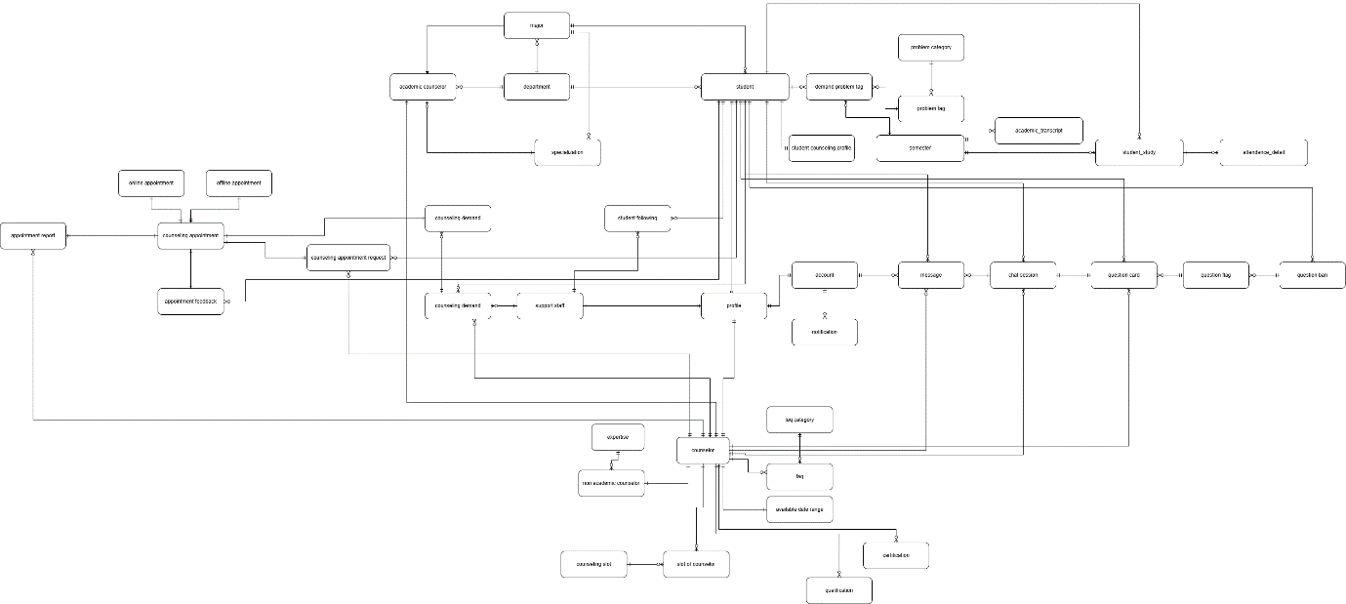

##### 3.1.5.2 Logical Model

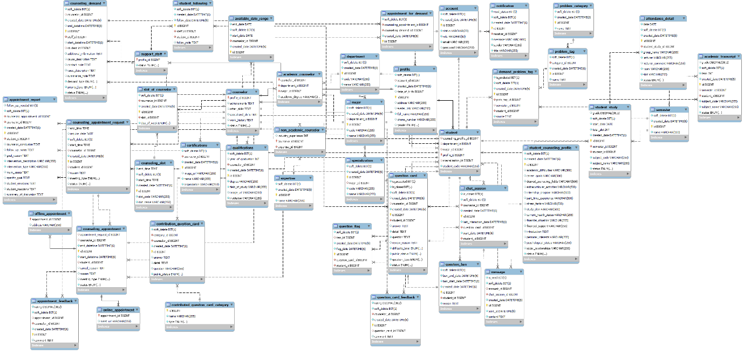

**Entities Description**

|  |  |  |
| --- | --- | --- |
| **#** | **Entity** | **Description** |
| 01 | account | Store account in system |
| 02 | academic counselor | Store academic counselor in system |
| 03 | academic_transcript | Store academic transcript in system |
| 04 | available date range | Store available date range |
| 05 | appointment feedback | Store appointment feedback |
| 06 | appointment for demand | Store appointment for demand in system |
| 07 | appointment report | Store appointment report in system |
| 08 | Attendance detail | Store attendance detail in system |
| 09 | counselor | Store certification |
| 10 | certification | Store certification |
| 11 | chat session | Store counseling demand |
| 12 | counseling demand | Store counseling demand |
| 13 | Contributed question card category | Store contributed question card category category in system |
| 14 | Contribution question card | Store contribution question card |
| 15 | counseling appointment | Store counseling appointment |
| 16 | counseling appointment request | Store counseling appointment request |
| 17 | counseling slot | Store counseling slot |
| 18 | demand problem tag | Store demand problem tag |
| 19 | department | Store department |
| 20 | expertise | Store expertise |
| 21 | faq | Store faq |
| 22 | faq category | Store faq category |
| 23 | message | Store message |
| 24 | major | Store major major |
| 25 | notification | Store notification used through out the system |
| 26 | non academic counselor | Store non academic counselor |
| 27 | online appointment | Store online appointment |
| 28 | offline appointment | Store offline appointment |
| 29 | profile | Store profile of user |
| 30 | problem category | Store problem category |
| 31 | problem tag | Store problem tag |
| 32 | qualification | Store qualification |
| 33 | question card | Store question card |
| 34 | question flag | Store question flag |
| 35 | question ban | Store question ban |
| 36 | slot of counselor | Store slot of counselor |
| 37 | student | Store student |
| 38 | specialization | Store specialization of counselor |
| 39 | support staff | Store support staff |
| 40 | student following | Store student following by support staff |
| 41 | student counseling profile | Store student counseling profile |

### 3.2. Functional requirements

#### 3.2.1. Accounts Feature

|  |  |  |  |  |  |
| --- | --- | --- | --- | --- | --- |
| **No** | **Actor** | **Function Name** | **Purpose** | **Data requirements** | **Data validation** |
| 1 | Admin, manager, counselor, support staff, student | View account detail | View information of a specific account | Account id |  |
| 2 | Admin, manager, counselor, support staff, student | View account profile | View account profile | Account id |  |
| 3 | Admin | Ban account | Ban account | Account id |  |
| 4 | Admin | Unban account | Unban account | Account id |  |
| 5 | Admin | Create account | Create account | Email  Password  fullName  phoneNumber  dateOfBirth  avatar  Gender  role | Email:  Type: text field (string)   * Not empty * Max Length = 100 * Email address format   Password:  Type: text field (string)   * Not empty   Fullname:   * Type: text field (string) * Not empty   phoneNumber:   * Type: text field (string) * Not empty   dateOfBirth:   * Type: Datetime picker * Not empty   Avatar:   * Type: file (image) * Not empty * Max size < 5MB * Extension file: .png, .jpg, .webp, .jpeg   Gender:   * Type: Dropdown * Not empty   Role:   * Type: Dropdown * Not Empty |
| 6 | Admin | Delete account | Delete account | Account id |  |

#### 3.2.2. Authentications Feature

|  |  |  |  |  |  |
| --- | --- | --- | --- | --- | --- |
| **No** | **Actor** | **Function Name** | **Purpose** | **Data requirements** | **Data validation** |
| 1 | Admin, manager, counselor, support staff, student | Login | Login to website and mobile app | Email  Password | Email:   * Type: text field (string) * Email address format * Not empty   Password:   * Type: text fields (string) |
| 2 | Admin, manager, counselor, support staff, student | Regeneration token | Re-generate pair token from the old pair token provided by the SCSS system before. | Access token Refresh token | AccessToken:   * Type: text field (string) * Not empty   RefreshToken:   * Type: text field (string) * Not empty |
| 3 | Admin, manager, counselor, support staff, student | Logout | Logout to website and mobile app |  |  |

#### 3.2.3. Booking Counseling Feature

|  |  |  |  |  |  |
| --- | --- | --- | --- | --- | --- |
| **No** | **Actor** | **Function Name** | **Purpose** | **Data requirements** | **Data validation** |
| 1 | Student | Quick booking counselor | Quick booking counselor | Counseling Type  Date  SlotCode  Counselor's specialization  Gender  Meeting type  Resson | Counseling type:   * Dropdown * Not empty   Date:   * Type:Datetime picker * Not empty   SlotCode:   * Type:Datetime picker * Not empty   Counselor’s specialization:   * Type: Dropdown   Gender:   * Type: Dropdown   Meeting type:   * Type: Dropdown * Not empty   Resson:   * Type; Text field (String) * Not empty |
| 2 | Counselor,  Student | View appointment schedule | View appointment schedule | Appointment id |  |
| 3 | Counselor,  Student | View appointment request | View appointment request | Request id  Start date  End date | Start date:   * Type: text field (string) * Format type dd/MM/yyyy * Must less than or equal End Date   End date:   * Type: text field (string) * Format type dd/MM/yyyy |
| 4 | Admin, manager | View Counselor’s appointment request | View Counselor’s appointment request | Counselor id  Request id |  |
| 5 | Student | Booking specific counselor | Booking specific counselor | Date  Slot  Meeting type  Resson | Date:  + Type:Datetime picker  + Not empty  Meeting type:   * Type: Dropdown * Not empty   Resson:   * Type; Text field (String) * Not empty |
| 6 | Counselor | View counseling request | View a list of request from the system | Student Id  Start date  End date  Meeting type  SortBy | Start date:   * Type: text field (string) * Format type dd/MM/yyyy * Must less than or equal End Date   End date:   * Type: text field (string) * Format type dd/MM/yyyy   Meeting type:   * Required: “Online” or “Offline”   Sort:   * Match with format “id_ASC” or “id_DESC” |
| 7 | Counselor | Approve online request | Approve online request | Request id  Meet url | Meet URL:   * Type: URL format * Not empty |
| 8 | Counselor | Approve offline request | Approve offline request | Request id  Address | Address:   * Type: text field(String) * Not empty |
| 9 | Counselor | Reject booking appointment | Reject booking appointment | Request id |  |

#### 3.2.4. Appointment Feature

|  |  |  |  |  |  |
| --- | --- | --- | --- | --- | --- |
| **No** | **Actor** | **Function Name** | **Purpose** | **Data requirements** | **Data validation** |
| 1 | Counselor, student | View list of appointment | Get a list of counselor’s appointment from the system | Appointment id  Start date  Endate  Status | Start date:   * Type: text field (string) * Format type dd/MM/yyyy * Must less than or equal End Date   End date:   * Type: text field (string) * Format type dd/MM/yyyy   Status:   * Must equal “Cancel” or “Attend” or “Absent” or “Expired” |
| 3 | Counselor, student | Cancel appointment | Cancel appointment | Appointment id  Resson | Resson:   * Type: text field (string) * Not empty |
| 4 | Counselor | Check attendance | Check attendance for student by counselor | Appointment id |  |
| 5 | Counselor | Create appointment for specific student | Create an appointment to counseling with student | Student id  Date  SlotCode  Meeting type  Resson | Date:   * Type:Datetime picker * Not empty   SlotCode:   * Type:Datetime picker * Not empty   Meeting type:   * Required: “Online” and “URL” or “Offline” and “Address”   Resson:   * Type; Text field (String) * Not empty |
| 6 | Student | Provide feedback | Provide feedback | Appointment id  Ratting  Commnet | Ratting:   * Type: * Not empty   Comment:   * Type: text field (string) * Not empty |

#### 3.2.5. Q&A Feature

|  |  |  |  |  |  |
| --- | --- | --- | --- | --- | --- |
| **No** | **Actor** | **Function Name** | **Purpose** | **Data requirements** | **Data validation** |
| 1 | Student | Create a question | Create a question | Question type  Topic  Content | Question type:   * Type: Dropdown * Not empty   Topic:   * Type: Dropdown * Not empty   Content:   * Text field: (string) * Not empty |
| 2 | Counselor, Admin,  Student | View Q&A posts | View Q&A posts | Question card id |  |
| 3 | Counselor | Close Q&A | Close Q&A | Question card id |  |
| 4 | Counselor | Answer question | Answer question | Question card id  Content | Content:   * Text field: (string) * Not empty |
| 5 | Counselor | Approve question | Approve question | Question card id |  |
| 6 | Counselor | Reject question | Reject question | Question card id |  |
| 7 | Counselor | Flag question | Flag question | Question card id |  |
| 8 | Student | Delete question | Delete question before answer by counselor | Question card id |  |
| 9 | Student | Update question | Update question before answer by counselor | Question card id  Content | Content:   * Type: text field (string) |
| 10 | Counselor | Update answer | Update answer | Question card id |  |
| 11 | Student, counselor | Engage chat session | Engage into chat session for specific question card | Chat session id |  |
| 12 | Student | Provide feedback for question | Student can provide feedback after close question | Question card id  Rating  Comment | Rating:   * Type: number * Must from 1 to 5   Comment:   * Type: text field (string) |
| 13 | Stundet | Accept question | Student accept a question to counselor | Question card id |  |

#### 3.2.6. Counseling Demand Feature

|  |  |  |  |  |  |
| --- | --- | --- | --- | --- | --- |
| **No** | **Actor** | **Function Name** | **Purpose** | **Data requirements** | **Data validation** |
| 1 | Admin, Counselor | View demand list | View demand list | Demand id  Start date  End date | Start date:   * Type: text field (string) * Format type dd/MM/yyyy * Must less than or equal End Date   End date:   * Type: text field (string) * Format type dd/MM/yyyy |
| 2 | Counselor | Create appointment for demand | Create appointment for demand | Demand id  Student id  Date  SlotCode  Meeting type  Resson | Date:   * Type:Datetime picker * Not empty   SlotCode:   * Type:Datetime picker * Not empty   Meeting type:   * Required: “Online” and “URL” or “Offline” and “Address”   Resson:   * Type; Text field (String) * Not empty |
| 3 | Counselor | Solve demand card | Solve demand card | Demand id  Summarize Note | Summarize Note:   * Type: text field(string) * Not empty |
| 4 | Support staff | Create demand card | Create demand card | Demand id |  |
| 5 | Support staff | Assign demand card to counselor | Assign demand to card to counselor by counselor to solve problem of student | Counselor id |  |
| 6 | Support staff | Follow student | Support staff follows student who have problems in recommendation | Student id |  |
| 7 | Support Staff | Unfollow student | Support staff unfollows student has been resolve problem | Student id |  |

#### 3.2.7. Dashboards Feature

|  |  |  |  |  |  |
| --- | --- | --- | --- | --- | --- |
| **No** | **Actor** | **Function Name** | **Purpose** | **Data requirements** | **Data validation** |
| 1 | Admin | View admin dashboard | View admin dashboard |  |  |
| 2 | Manager | View manager dashboard | View manager dashboard |  |  |
| 3 | Counselor | View counselor dashboard | View counselor dashboard |  |  |

#### 3.2.8. Manage Student Feature

|  |  |  |  |  |  |
| --- | --- | --- | --- | --- | --- |
| **No** | **Actor** | **Function Name** | **Purpose** | **Data requirements** | **Data validation** |
| 1 | Manager, counselor, admin, support staff | View student list | View student list | Student id  specializationId  sortBy  Keyword  sortDirection  page | sortBy:   * Type: text field (string) * Format type dd/MM/yyyy   Keyword:   * Type: text field (string)   sortDirection:   * Match with format “ID_ASC” or “ID_DESC” |
| 2 | Manager, counselor, admin, support staff | View student profile | View student profile | Student id |  |
| 3 | Manager, counselor, admin, support staff | View student’s academic transcript | View student’s academic transcript | Student id |  |
| 4 | Manager, counselor, admin, support staff | View student attendance report | View student attendance report | Appointment Id |  |
| 5 | Admin, manager, counselor, student | View list of student’s appointment | Get a list of appointment from the system | Appointment id  Start date  End date  Status | Start date:   * Type: text field (string) * Format type dd/MM/yyyy * Must less than or equal End Date   End date:   * Type: text field (string) * Format type dd/MM/yyyy   Status:   * Must equal “Cancel” or “Waiting” or “Attend” or “Absent” or “Expired” |

#### 3.2.9. Manage Counselor Feature

|  |  |  |  |  |  |
| --- | --- | --- | --- | --- | --- |
| **No** | **Actor** | **Function Name** | **Purpose** | **Data requirements** | **Data validation** |
| 1 | Admin, manger, counselor | View list of counselor’s appointment | Get a list of counselor’s appointment from the system | Appointment id  Start date  Endate  Status | Start date:   * Type: text field (string) * Format type dd/MM/yyyy * Must less than or equal End Date   End date:   * Type: text field (string) * Format type dd/MM/yyyy   Status:   * Must equal “Cancel” or “Attend” or “Absent” or “Expired” |
| 2 | Admin, manger | View list of academic counselor | View list of academic counselors in the system | Search  ratingFrom  ratingTo  availableFrom  availableTo  specializationId  SortDirection  sortBy  page | Search:   * Type: text field (string)   ratingFrom:   * Type: number * Must less than or equal rating   ratingTo:   * Type: number * Max number = 5   availableFrom:   * Type: text field (string) * Format type dd/MM/yyyy * Must less than or equal availableTo   availableTo:   * Type: text field (string) * Format type dd/MM/yyyy   SortDirection:   * Match with format “ID_ASC” or “ID_DESC”   SortBy:   * Type: text fields (string) * Fo |
| 3 | Admin, manger | View list of non-academic counselor | View list of non-academic counselors in the system | Search  ratingFrom  ratingTo  availableFrom  availableTo  expertiseId  SortDirection  sortBy  page | Search:   * Type: text field (string)   ratingFrom:   * Type: number * Must less than or equal rating   ratingTo:   * Type: number * Max number = 5   availableFrom:   * Type: text field (string) * Format type dd/MM/yyyy * Must less than or equal availableTo   availableTo:   * Type: text field (string) * Format type dd/MM/yyyy   SortDirection:   * Match with format “ID_ASC” or “ID_DESC”   SortBy:   * Type: text fields (string) * Format type dd/MM/yyyy |
| 4 | Admin, manger | View counselor detail | View a specific counselor’s detail | Counselor id |  |
| 5 | Admin, manger | Change counselor status | Change counselor status | Counselor id  Status | Status:   * Required Status is required some statuses such as: AVAILABLE, UNAVAILABLE. |
| 6 | Admin, manger | Assign slot to counselor | Assign counseling slot to counselor | Counselor id  Slot id |  |
| 7 | Admin, manager | Unsign slot to counselor | Unsign counseling slot to counselor | Counselor id  Slot id |  |

## 4. Non-Functional Requirements

### 4.1. External Interfaces

#### 4.1.1. User Interfaces

* **Language**: Supports English.
* **Icons**: Easy to identify.
* **Colors**: Sufficient contrast.
* **Font**: Easy to read.

#### 4.1.2. Communications Interfaces

* **HTTP Methods**: Uses HTTP request methods for data transfer.
* **Protocol**: HTTP for Web Application and server communication.

### 4.2. Quality Attributes

#### 4.2.1. Usability

* **Language**: UI text in English.
* **Ease of Use**: Simple to use after training.
* **Training**: One-hour training is sufficient.
* **Standards**: Follows usability and accessibility standards.

#### 4.2.2. Reliability

* **Training**: All users need training.
* **Failure Rate**: Less than 5%, availability above 80%.

#### 4.2.3. Performance

* All responses’ time is less than 15 seconds.

#### 4.2.4. Security

* **Input Validation**: Validate all inputs.
* **Authorization**: Role-based access control.
* **Password Encryption**: MD5 hashing on server-side

## 5. Requirement Appendix

### 5.1. Business Rules

|  |  |
| --- | --- |
| ID | Rule Definition |
| BR-01 | Username must be in Email format. |
| BR-02 | Passwords must be hashed by the MD5 algorithm on the server-side. |
| BR-03 | Password length of account must be at least 6 characters. |
| BR-04 | Email must be unique. |
| BR-05 | Access token will expire within 1 hour after the successful login. |
| BR-06 | Refresh token will expire 365 days after the successful login. |
| BR-07 | Image file is required extension type “.png”, “.jpg”, “.jpeg”, “.webp”. |
| BR-08 | Date of birth must be in YYYY-MM-DD format. |
| BR-09 | Counselor must have their own major or expertise. |
| BR-10 | With Student, only 3 counseling requests which are on “WAITING” status are allowed to be at the same time. |
| BR-11 | With Student, only 3 appointments which are on “WAITING” status are allowed to be at the same time. |
| BR-12 | Student must provide all required infomation for every each of counseling requests. |
| BR-13 | Student can only provide feedback after appointment is “ATTENDED” |
| BR-14 | Counselor can only provide report after appointment is “ATTENDED” |
| BR-15 | When Counselor or Student cancels an appointment, they must enter a reason for the cancellation. |
| BR-16 | After Counselor approves request, Counselor must provide meet URL for online appointment or provide location for offline appointment. |
| BR-17 | After question cards being flagged 3 times, Student will be forbidden on creating another question card for 7 days. |
| BR-18 | Student can only edit or delete question when the question is not anwered. |
| BR-19 | Only 3 question cards are opened at the same time. |
| BR-20 | Student can only initiate chat session after question card is being answered by Counselor. |
| BR-21 | Counselor can only close question after provide answer. |
| BR-22 | Meeting URL must follow a specific URL format. |
| BR-23 | Student can only provide feedback after question card is being close by Counselor. |
| BR-24 | After question is being close, it will be public for everyone. |
| BR-25 | Student can only is being followed by 1 Support staff at the same time. |
| BR-26 | Only “AVAILABLE” Counselor is visible to Student. |

### 5.2. Application Messages List

#### 5.2.1. Web application

|  |  |  |  |  |
| --- | --- | --- | --- | --- |
| **#** | **Message code** | **Message Type** | **Context** | **Content** |
| 1 | MSG-01 | Toast message | Login with wrong username or wrong password. | Email or Password is invalid. |
| 2 | MSG-02 | Toast message | Login with ban account. | Account has been banned. |
| 3 | MSG-03 | Toast message | Login with correct username and correct password. | Login Successfully. |
| 4 | MSG-04 | Toast message | Account activation successful. | Your account has been activated successfully. |
| 5 | MSG-05 | Toast message | Account activation failed. | Activation link is invalid or expired. |
| 6 | MSG-06 | Toast message | Account already activated. | Your account has already been activated. |
| 7 | MSG-07 | Toast message | Account update successful. | Your account information has been updated successfully. |
| 8 | MSG-08 | Toast message | Account update failed. | Failed to update account information. Please try again. |
| 9 | MSG-09 | Toast message | Unauthorized action. | You do not have permission to perform this action. |
| 10 | MSG-10 | Toast message | Session expired. | Your session has expired. Please log in again. |
| 11 | MSG-11 | Toast message | Logout successful. | You have been logged out successfully. |
| 12 | MSG-12 | Toast message | Unauthorized access. | Please log in to access this page. |
| 13 | MSG-13 | Toast message | Counselor not available. | The selected counselor is not available at this time. |
| 14 | MSG-14 | Toast message | Appointment booked successfully. | Your appointment has been booked successfully. |
| 15 | MSG-15 | Toast message | Appointment booking failed. | Failed to book appointment. Please try again. |
| 16 | MSG-16 | Toast message | Appointment canceled. | Your appointment has been canceled. |
| 17 | MSG-17 | Toast message | Appointment cancellation failed. | Failed to cancel the appointment. Please try again. |
| 18 | MSG-18 | Toast message | Invalid input. | Please check the provided information and try again |
| 19 | MSG-19 | Toast message | Profile updated successfully. | Your profile has been updated successfully. |
| 20 | MSG-20 | Toast message | Failed to update profile. | Unable to update profile. Please try again later. |
| 21 | MSG-21 | Toast message | Invalid email format. | Please enter a valid email address. |
| 22 | MSG-22 | Toast message | Counselor assigned successfully. | A counselor has been assigned to your request. |
| 23 | MSG-23 | Toast message | Failed to assign counselor. | Unable to assign a counselor. Please try again later. |
| 24 | MSG-24 | Toast message | Question posted successfully. | Your question has been posted successfully. |
| 25 | MSG-25 | Toast message | Failed to post question. | Unable to post the question. Please check your input. |
| 26 | MSG-26 | Toast message | Question updated successfully. | Your question has been updated successfully. |
| 27 | MSG-27 | Toast message | Failed to update question. | Unable to update the question. Please try again later. |
| 28 | MSG-28 | Toast message | Question deleted successfully. | The question has been deleted. |
| 29 | MSG-29 | Toast message | Failed to delete question. | Unable to delete the question. Please try again later. |
| 30 | MSG-30 | Toast message | Feedback submitted successfully. | Your feedback has been submitted. |
| 31 | MSG-31 | Toast message | Failed to submit feedback. | Unable to submit feedback. Please try again later. |
| 32 | MSG-32 | Toast message | Counselor not found. | The selected counselor could not be found. Please choose another. |
| 33 | MSG-33 | Toast message | Demand successfully assigned. | The demand has been assigned successfully. |
| 34 | MSG-34 | Toast message | Failed to assign demand. | Unable to assign the demand. Please try again later. |
| 35 | MSG-35 | Toast message | Report generated successfully. | The report has been generated. |
| 36 | MSG-36 | Toast message | Failed to generate report. | Unable to generate the report. Please try again later. |

#### 5.2.2. Mobile application

|  |  |  |  |  |
| --- | --- | --- | --- | --- |
| **#** | **Message code** | **Message Type** | **Context** | **Content** |
| 1 | MSG-01 | Toast message | Login with wrong username or wrong password. | Email or password incorrect |
| 2 | MSG-02 | Toast message | Login with ban account. | Account has been banned. |
| 3 | MSG-03 | Toast message | Login with correct username and correct password. | Login Successfully. |
| 4 | MSG-04 | Toast message | Logout successful. | Logout successfully |
| 5 | MSG-05 | Toast message | Appointment booked successfully. | Request has been sent successfully! Please wait while the counselor processes your request. |
| 6 | MSG-06 | Toast message | Appointment booking failed. | Failed to request |
| 7 | MSG-07 | Toast message | Appointment canceled. | Appointment canceled |
| 8 | MSG-08 | Toast message | Appointment cancellation failed. | Failed to cancel appointment. |
| 9 | MSG-09 | Toast message | Profile updated successfully. | Profile updated successfully |
| 10 | MSG-10 | Toast message | Failed to update profile. | Can’t update counseling profile. |
| 11 | MSG-11 | Toast message | Question posted successfully. | New question has been created |
| 12 | MSG-12 | Toast message | Failed to post question. | Can’t create question |
| 13 | MSG-13 | Toast message | Question updated successfully. | Your question has been updated. |
| 14 | MSG-14 | Toast message | Failed to update question. | Can’t edit question. |
| 15 | MSG-15 | Toast message | Question deleted successfully. | Your question has been deleted. |
| 16 | MSG-16 | Toast message | Failed to delete question. | Can’t delete question |
| 17 | MSG-17 | Toast message | Feedback submitted successfully. | Your feedback has been submitted. |
| 18 | MSG-18 | Toast message | Failed to submit feedback. | Can’t feedback this appointment. |
| 19 | MSG-19 | Toast message | Counselor not found. | Can't find counselor suitable with your request. Please choose another slot, date, or write a clearer purpose |
| 20 | MSG-20 | Toast message | Report generated successfully. | Appointment report created |
| 21 | MSG-21 | Toast message | Failed to generate report. | Can’t create appointment report |