Group 8 Invoice System

System Design Document
Version 0.1
MM/DD/YYYY

Table of Contents
1. Introduction 1
1.1 Purpose of the SDD 1
2. General Overview and Design Guidelines/Approach 2
2.1 General Overview 2
2.2 Assumptions/Constraints/Risks 2
2.2.1 Assumptions 2
2.2.2 Constraints 2
2.2.3 Risks 3
2.3 Alignment with Federal Enterprise Architecture 3
3. Design Considerations 4
3.1 Goals and Guidelines 4
3.2 Development Methods & Contingencies 4
3.3 Architectural Strategies 4
3.4 Performance Engineering 5
4. System Architecture and Architecture Design 6
4.1 Logical View 6
4.2 Hardware Architecture 6
4.2.1 Security Hardware Architecture 6
4.2.2 Performance Hardware Architecture 7
4.3 Software Architecture 7
4.3.1 Security Software Architecture 8
4.3.2 Performance Software Architecture 8
4.4 Information Architecture 8
4.4.1 Records Management 8
4.5 Internal Communications Architecture 8
4.6 Security Architecture 9
4.7 Performance 9
4.8 System Architecture Diagram 9
5. System Design 10
5.1 Business Requirements 10
5.2 Database Design 10
5.2.1 Data Objects and Resultant Data Structures 10
5.2.2 File and Database Structures 10
5.3 Data Conversion 11
5.4 User Machine-Readable Interface 11
5.4.1 Inputs 11
5.4.2 Outputs 12
5.5 User Interface Design 12
5.5.1 Section 508 Compliance 12
6. Operational Scenarios 13
7. Detailed Design 14
7.1 Hardware Detailed Design 14
7.2 Software Detailed Design 14
7.3 Security Detailed Design 15
7.4 Performance Detailed Design 16
7.5 Internal Communications Detailed Design 16
8. System Integrity Controls 17
9. External Interfaces 18
9.1 Interface Architecture 18
9.2 Interface Detailed Design 18
Appendix A: Record of Changes 19
Appendix B: Acronyms 20
Appendix C: Glossary 21
Appendix D: Referenced Documents 22
Appendix E: Approvals 23
Appendix F: Additional Appendices 24
Appendix G: Notes to the Author/Template Instructions 25

List of Figures
No table of figures entries found.

List of Tables
Table 1 - Record of Changes 19
Table 2 - Acronyms 20
Table 3 - Glossary 21
Table 4 - Referenced Documents 22
Table 5 - Approvals 23

Introduction
The SDD documents the high-level system design and the low-level detailed design specifications. The SDD describes design goals and considerations, provides a high-level overview of the system architecture, and describes the data design associated with the system, as well as the human-machine interface and operational scenarios. The high-level system design is further decomposed into low-level detailed design specifications for each system component, including hardware, internal communications, software, system integrity controls, and external interfaces.

Purpose of the SDD
The SDD documents and tracks the necessary information required to effectively define architecture and system design in order to ensure the project team all have the same expectations on the architecture of the system to be developed.

General Overview and Design Guidelines/Approach
This section describes the principles and strategies to be used as guidelines when designing and implementing the system.

General Overview
Our project will address the time and errors involved in manually processing workplace invoices. Employees often have to read invoices and enter vendor names, invoice numbers, dates, line items, and totals into company systems in order to process database updates and generate reports. We propose a system that automates much of this process while keeping a person involved in verifying the results.

The architecture will be a 3-tier architecture as follows:
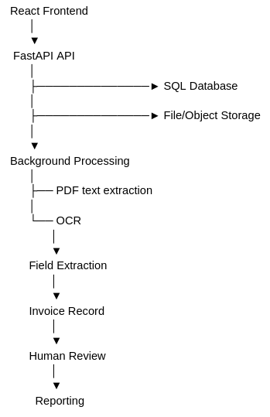

Assumptions/Constraints/Risks

Assumptions
- Users upload invoice PDFs through the React UI.
- PDFs may be text-based or scanned/image-based.
- OCR extracts key fields such as vendor, invoice number, date, subtotal, tax, total, and currency.
- Extracted data is reviewed/corrected by a user before being committed.
- FastAPI provides the API and orchestrates processing.
- SQL stores invoices and extracted fields.
- Reporting initially means a searchable/filterable invoice report with CSV export.
- Authentication, complex workflow/approval, and advanced analytics are out of scope for the first 8 weeks.

Constraints
- The software must be publicly available for testing purposes
- The hosting must be free

Risks
The three main technical risks we see are OCR errors, sensitive invoice data being exposed, and integration failures between our components. We plan to mitigate these through human verification/confidence thresholds, authentication and encryption, and API validation, error handling, logging, and integration testing.

Design Considerations
Instructions: Describe issues which need to be addressed or resolved before attempting to devise a complete design solution.

Goals and Guidelines
Instructions: Describe any goals, guidelines, principles, or priorities which dominate or embody the design of the system and its software. Examples of such goals might be: an emphasis on speed versus memory use; or working, looking, or “feeling” like an existing product. Guidelines include coding guidelines and conventions. For each such goal or guideline, describe the reason for its desirability unless it is implicitly obvious. Describe any design policies and/or tactics that do not have sweeping architectural implications (meaning they would not significantly affect the overall organization of the system and its high-level structures), but which nonetheless affect the details of the interface and/or implementation of various aspects of the system (e.g., choice of which specific product to use).

Development Methods & Contingencies
For the tech stack, we plan to use React for the frontend, Python/FastAPI for the backend, PostgreSQL for storing invoice data, and an existing Optical Character Recognition (OCR) solution, Python Tesseract or a library based off of it such as PyOCR, for document processing. Bednarz and Miłosz (2025) benchmarked Python web frameworks and found FastAPI performed strongly across API tests. Chen et al. (2025) evaluated OCR technologies on 122 invoices and demonstrated high extraction proficiency in Tesseract.

Architectural Strategies
Instructions: Describe any design decisions and/or strategies that affect the overall organization of the system and its higher-level structures. These strategies should provide insight into the key abstractions and mechanisms used in the system architecture. Describe the reasoning employed for each decision and/or strategy (possibly referring to previously stated design goals and principles) and how any design goals or priorities were balanced or traded-off.
When describing a design decision, discuss any other significant alternatives that were considered, and the reasons for rejecting them (as well as the reasons for accepting the alternative finally chosen). Sometimes it may be most effective to employ the “pattern format” for describing a strategy.
Examples of design decisions might concern (but are not limited to) things like the following:
- Use of a particular type of product (programming language, database, library, commercial off-the-shelf (COTS) product, etc.)
- Reuse of existing software components to implement various parts/features of the system
- Future plans for extending or enhancing the software
- User interface paradigms (or system input and output models)
- Hardware and/or software interface paradigms
- Error detection and recovery
- Memory management policies
- External databases and/or data storage management and persistence
- Distributed data or control over a network
- Generalized approaches to control
- Concurrency and synchronization
- Communication mechanisms
- Management of other resources

SL: explain why we do all parts of the upload handling from app instead of backend

Andres: Explain why we aren’t using Tesseract

Seth: Talk about database decisioning

System Architecture and Architecture Design
Instructions: Describe the system architecture, how the application interacts with other applications. Not necessarily how the application itself works but, how the appropriate data is correctly passed between applications. Provide an overview of how the functionality and responsibilities of the system were partitioned and then assigned to subsystems or components. Don’t go into too much detail about the individual components themselves in this section. A subsequent section of the SDD will provide the detailed component descriptions. The main purpose here is to gain a general understanding of how and why the system was decomposed, and how the individual parts work together to provide the desired functionality.
At the top-most level, describe the major responsibilities that the software must undertake and the various roles that the system (or portion of the system) must play. Describe how the system was broken down into its components/subsystems (identifying each top-level component/subsystem and the roles/responsibilities assigned to it). Describe how the higher-level components collaborate with each other in order to achieve the required results. Provide some sort of rationale for choosing this particular decomposition of the system (perhaps discussing other proposed decompositions and why they were rejected).
Make use of design patterns whenever possible, either in describing parts of the architecture (in pattern format), or for referring to elements of the architecture that employ them. Provide rationale for choosing a particular algorithm or programming idiom (or design pattern) to implement portions of the system’s functionality.
This section outlines the system and hardware architecture design of the system.

Component Diagram

SL: update
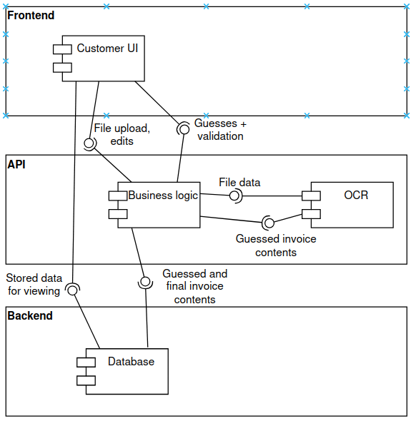

Hardware Architecture
Instructions: Describe the overall system hardware and organization, indicating whether the processing system is distributed or centralized. Identify the type, number, and location of all hardware components including the presentation, application, and data servers and any peripheral devices (e.g., load balancers, SSL accelerator, switches, firewalls, with a brief description of each item and diagrams showing the connectivity between the components along with required firewalls, ports, and network bands utilized (e.g., management band). Include resource estimates for processor capacity, memory, on-line storage, and auxiliary storage.
The system is a web-based application. Servers used include the backend database at port 8001 and the frontend at port 5173.

Seth: confirm please

Software Architecture
Instructions: Describe all software that is needed to support the system, the hardware component for which each software component is targeted, and specify the physical location of all software systems. List such things as logical components (e.g., JSP in presentation layer, JNDI in application layer, EJB and JDBC in data layer), database platforms, computer languages, compilers, utilities, operating systems, communications software, programming computer-aided software engineering tools, commercial off-the-shelf (COTS) software, open source frameworks, etc., with a brief description of the function of each item and any identifying information such as manufacturer, version number, number and types of licenses needed, etc., as appropriate. Identify all Computer Software Configuration Items (CSCIs), Computer Software Components (CSCs) and Application Programming Interfaces (APIs) to include name, type, purpose and function for each; the interfaces, messaging, and protocols for those elements; and rationale for the software architectural design. Include software modules that are functions, subroutines, or classes. Use functional hierarchy diagrams, structured organization diagrams (e.g., structure charts), or object-oriented diagrams that show the various segmentation levels down to the lowest level. All features on the diagrams should have reference numbers and names.
Include a narrative that expands on and enhances the understanding of the functional breakdown. If necessary, describe how a component was further divided into subcomponents, and the relationships and interactions between the subcomponents. Proceed into as many levels/subsections of discussion as needed in order to provide a high-level understanding of the entire system or subsystem, leaving the details for inclusion in a later section of the SDD. Include data flow diagrams that conform to appropriate standards (e.g., Yourdon-Demarco conventions) and provide the physical process and data flow related to the logical process and data flow decomposed to the primitive process level (describing how each input is processed/transformed into the resulting output). If there are parts of the system that already existed before this development effort began, then only describe the relationships and interactions between the old parts and the new parts. Pre-existing parts that are modified or enhanced need to be described only to the extent that is necessary to provide a sufficient understanding of the nature of the changes that are being made.

Andres: make this about our project:
Clarify the AI architecture.
Resolve the contradiction between describing the AI as a separate service and describing it as a module within the application layer.
Expand the AI learning lifecycle.
Explain how interaction data becomes prompt, knowledge-base, or model improvements and who validates those changes.
Strengthen cohesion/coupling analysis.

The AI chatbot will be implemented as a separate AI Service to reduce dependencies and maintain separation of concerns. The Chat Service will communicate with the AI service through an API. When a customer sends a message, it passes through the API Gateway to the Chat Service, which sends the message and customer context to the AI Service. The AI Service generates a response along with a confidence score. The Chat Service then evaluates the confidence score to determine if the response should be returned to the customer or escalated to the Ticket Service for human assistance. A low confidence response or an unsupported request is automatically routed to a human agent. The AI service accesses an approved Knowledge Service for information and does not directly modify the customer database. Customer conversations are stored to support performance analysis and for continuous improvement of the chatbot. This design allows the AI service to be maintained, tested, updated, and scaled independently without affecting the rest of the customer service platform.

3.1.1. Frontend/Presentation Layer
This layer resides at the “edge” of the software system. Its job is to capture external event requests from the chat service. It also is charged with presenting the event responses to the user interface.

3.1.2. Business Logic Layer
This layer contains the code. The business rules are contained in the “business” logic layer, hence the name.

3.1.3. Database Layer
This layer provides access to the stored data. It manages concurrent requests to read and write to customer databases.

System Architecture Component Diagram (Sally Little)
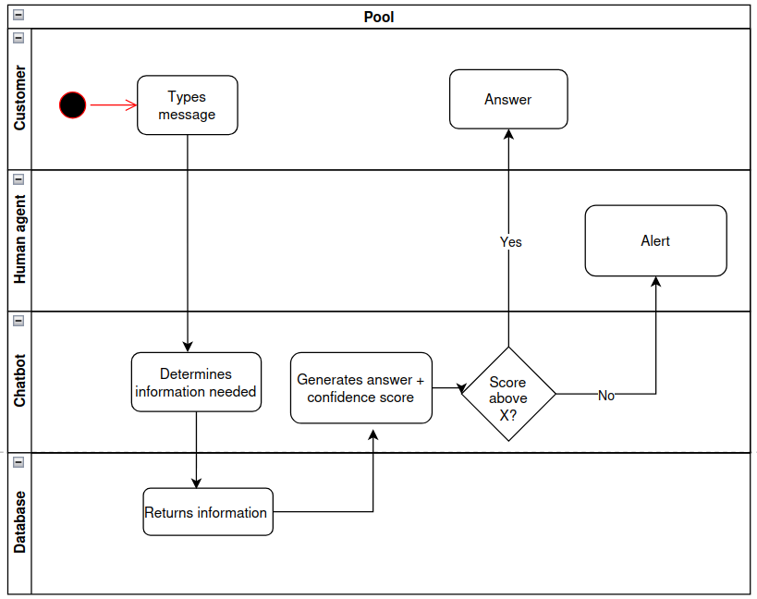

SL: replace

3.3 Design Rationale (Andres Ortiz Sanchez)

The proposed system design for the customer service platform is based on an n-tier architecture that balances scalability, maintainability, and clarity across the system components. This design rationale explains how the design applies to modular principles, manages cohesion and coupling, all while integrating the AI chatbot features.

Separation of concerns

The architecture enforces separation of concerns by dividing the system into distinct layers: the presentation layer (customer UI, human agent), application layer (Chatbot logic), and data layer(database). The presentation layer handles user interaction by capturing input and displaying the chatbot's responses. The application layer contains the system logic, including chat services and escalation processing. The data layer manages persistence, including customer records, chatbot training data, and interaction logs.

Cohesion and Coupling

Each tier is designed for high cohesion. The chatbot service focuses primarily on natural language processing and response generation, while the escalation handles unresolved queries to human agents. This specialization improves clarity and maintainability. At the same time, the system minimizes coupling between tiers by enforcing communication through the APIs.The presentation layer doesn't directly use the database; it interacts with the application layer that then accesses the data. Coupling this loosely allows the developers to modify the database schemas or replace the chatbot without breaking the whole system.

AI Integration

Andres: make this about our project
The AI Chatbot is implemented as a module in the application layer, ensuring it doesn't interfere with other services. It communicates with the knowledge base and customer database through APIs, and logs interactions in the data layer for continuous learning. The escalation is built into the ghr chatbot service, allowing an easy handoff to a human agent when its confidence score is below the 0.8 threshold. This modular integration ensures that the AI can evolve independently while remaining in the application layer.

Information Architecture
Instructions: Describe the information that will be stored in the system (e.g. beneficiary information, claim data, etc.) Identify if any of the information is personally identifiable information (PII), individually identifiable information (IIF), or personal health information (PHI).

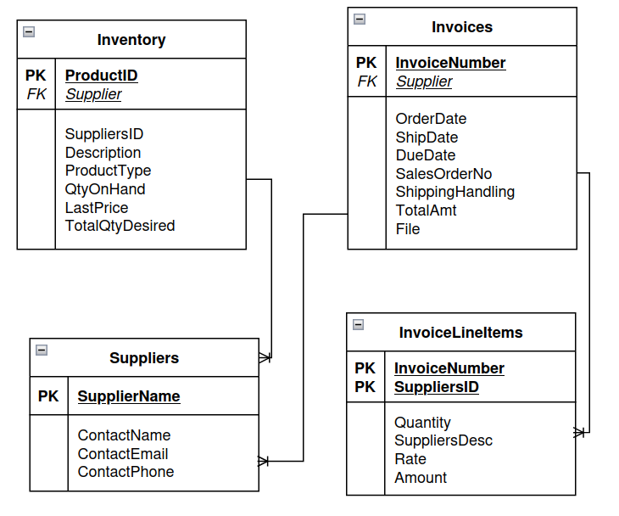

SL: replace

Logical Diagram
Instructions: Using the hardware, software, communications, and information designs described above, depict the overall, integrated structure of the system in terms of presentation, application, and data regions.
Diagram(s) should show the architecture of the “to-be-production-system,” i.e., the architectural design must map to the targeted production environment.
Diagram(s) must reflect the accuracy and clarity of the system architecture.
Diagram(s) must reflect the complete system’s context, i.e., more detailed software components, internal/external interfaces, and their underlying infrastructure, etc., not just pertain to the design under review.
Front layer:
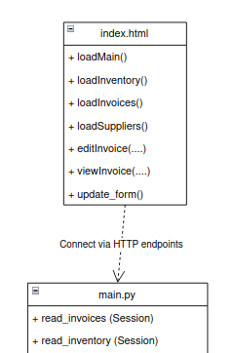

API layer:
FastAPI architecture:

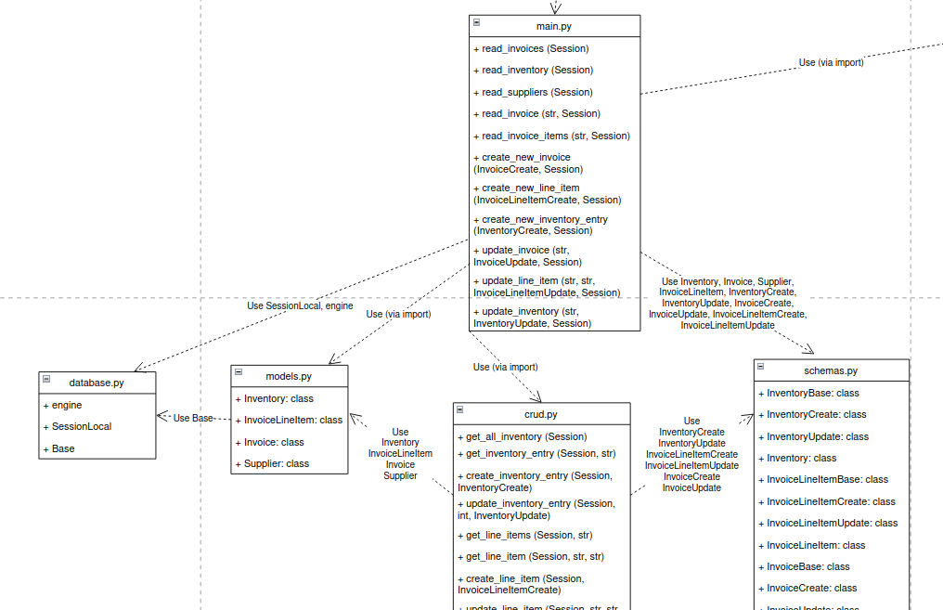

Business Logic:
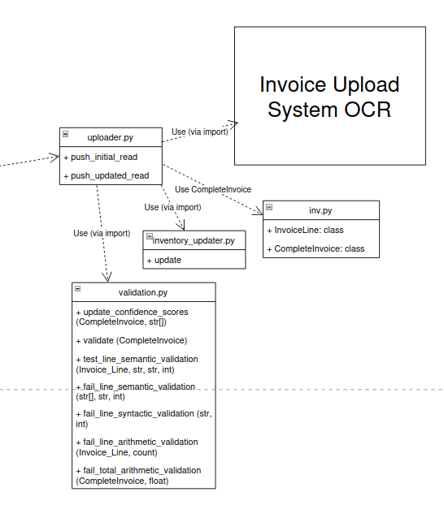

SL: replace

System Design

Business Requirements

Priority | Backlog item | Acceptance criteria
P0 | Define invoice data model | Required fields, types, validation rules, and invoice lifecycle documented
P0 | Set up SQL database and migrations | Local/dev DB works; schema created through migrations
P0 | Create FastAPI project structure | Health endpoint, configuration, logging, error handling
P0 | Create React application shell | Routing, layout, API client, basic styling
P0 | Define OCR extraction contract | OCR output mapped to normalized invoice fields
P0 | Build PDF upload API | Valid PDF can be uploaded; invalid file extensions rejected; upload receives unique ID
P0 | Build invoice upload UI | User can select/upload PDF
P0 | Implement PDF text extraction | Text-based PDFs produce usable text
P0 | Integrate OCR engine | Scanned invoice can be converted into machine-readable text
P1 | Store original PDF and processing metadata | File reference, timestamps, status, and errors are persisted
P0 | Implement invoice field extraction | Vendor, invoice #, dates, amounts, tax, total, currency extracted where present
P1 | Add confidence scores | Extracted fields have confidence/quality indicators
P0 | Create invoice detail API | UI can retrieve extracted invoice
P0 | Build invoice review screen | User sees PDF/extracted fields and can edit fields
P0 | Save corrected invoice data | User edits persist to SQL with validation
P0 | Add invoice validation | Required fields and amount/date rules are enforced
P1 | Handle OCR failures | Failed invoices receive meaningful status/error and can be retried
P0 | Build invoice list | Invoice list with vendor, invoice #, date, total
P2 | Build supplier list | Supplier list with contact information
P1 | Build inventory list | Paginated inventory list that hides items neither had nor wanted
P1 | Add search/filtering | Search vendor/invoice # and filter by date/status. Filter inventory by product type, quantity needed, quantity on hand.
P1 | Implement duplicate detection | System identifies likely duplicate invoice numbers/vendors
P0 | Build report endpoint | API returns invoice data suitable for reporting
P0 | Build report UI | Users can view totals and invoice records
P1 | Add CSV export | Filtered report can be downloaded as CSV
P1 | Add basic report totals | Total invoices, subtotal, tax, and invoice amount displayed
P1 | Add field-level review indicators | Low-confidence fields are clearly highlighted
P1 | Add retry/reprocess controls | Authorized user can retry failed OCR processing

Database Design
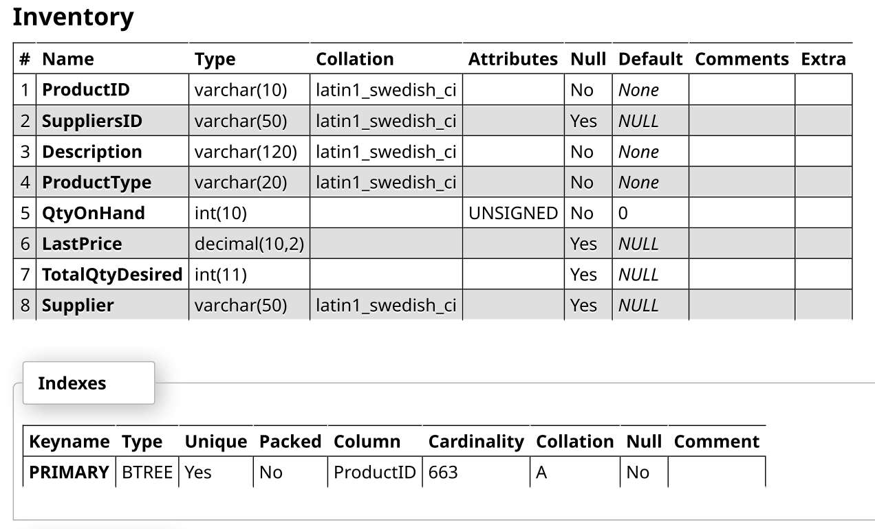
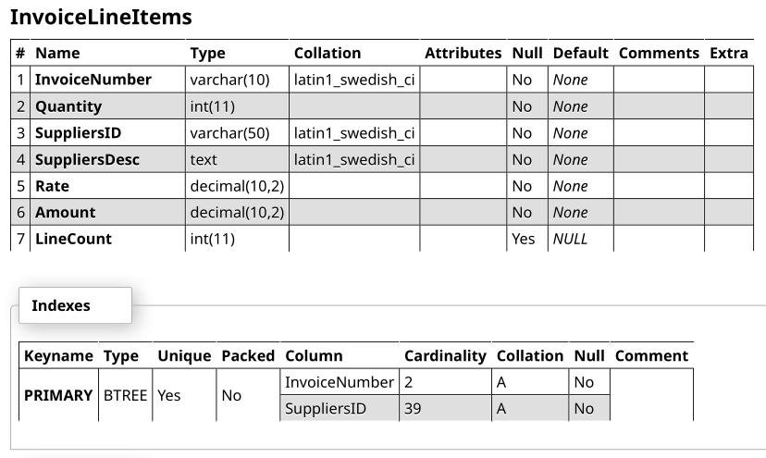

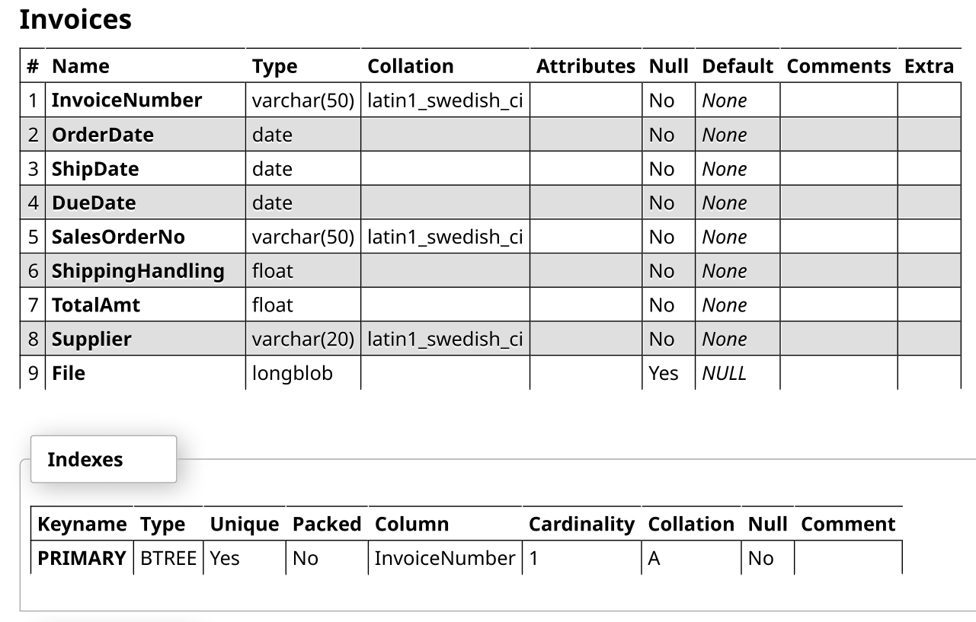

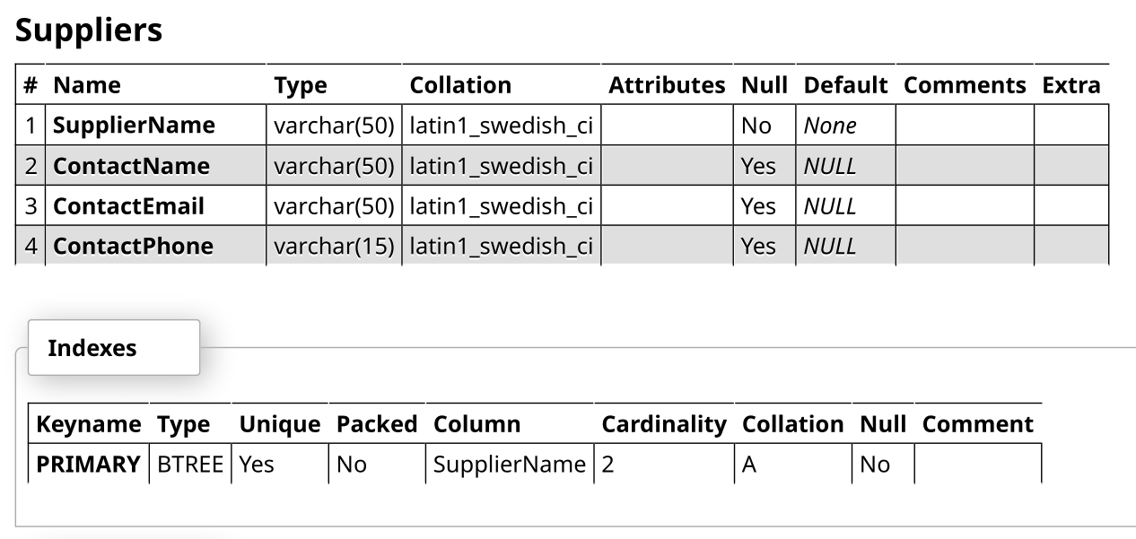
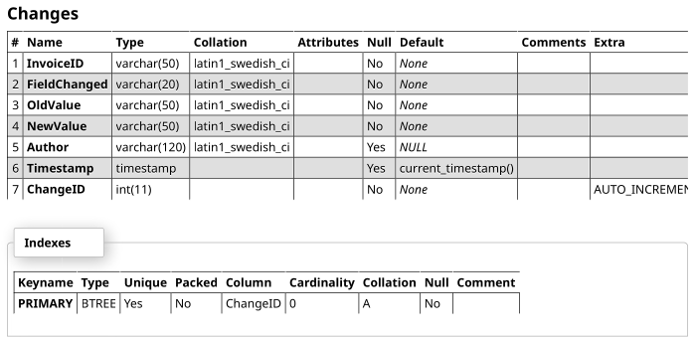

Data Objects
Explain where invoices are stored

User Interface
Instructions: Provide a description of each user class or role associated with the system. A user class is distinguished by the ways in which users interact with the proposed system or situation. Factors that distinguish a user class include common responsibilities, skill levels, work activities, and modes of interaction with the system. In this context, a user is anyone who interacts with the proposed system, including operational users, data entry personnel, system operators, operational support personnel, system maintainers, and trainers. For each user class, provide estimates of the total number of users anticipated, a maximum number of concurrent users, and the number of external users.

Inputs
Instructions: Provide a description of the input media used by the user/operator for providing information to the system. Show a mapping to the high-level data flows (e.g., data entry screens, optical character readers, bar scanners, etc.). If appropriate, the input record types, file structures, and database structures provided in the section for Data Design, may be referenced. Include data element definitions, or refer to the data dictionary. Provide the layout of all input data screens or graphical user interfaces (GUIs) (e.g., windows). Define all data elements associated with each screen or GUI, or reference the data dictionary. Provide edit criteria for the data elements, including specific values, range of values, mandatory/optional, alphanumeric values, and length. Also address data entry controls to prevent edit bypassing. Discuss the miscellaneous messages associated with user/operator inputs, including (but not limited to) the following:
- Copies of form(s) if the input data are keyed or scanned for data entry from printed forms
- Description of any access restrictions or security considerations
- Each transaction name, code, and definition, if the system is a transaction-based processing system
- Incorporation of the Privacy Act statement into the screen flow, if the system is covered by the Privacy Act
- Description of accessibility provisions to comply with Section 508 of the Rehabilitation Act

Outputs
Instructions: Describe the system output design relative to the user/operator. Show a mapping to the high-level data flows. System outputs include reports, data display screens and GUIs, query results, etc. The output files described in the section for Data Design may be referenced. The following should be provided, if appropriate:
- Identification of codes and names for reports and data display screens
- Description of report and screen contents (provide a graphical representation of each layout and define all data elements associated with the layout or reference the data dictionary)
- Description of the purpose of the output, including identification of the primary users
- Report distribution requirements, if any (include frequency for periodic reports)
- Description of any access restrictions or security considerations

Operational Scenarios
Instructions: Describe the general functionality of the system from the users’ perspectives and provide an execution or operational flow of the system via operational scenarios that provide step-by-step descriptions of how the proposed system should operate and interact with its users and its external interfaces under a given set of circumstances. The scenarios tie together all parts of the system, the users, and other entities by describing how they interact, and may also be used to describe what the system should not do.
Operational scenarios should be described for all operational modes, transactions, and all classes of users identified for the proposed system. For each transaction, provide an estimate of the size (use maximum, if variable) and frequency (e.g., average number per session). Identify if there any transactional peak periods and include an estimate of frequency during those periods. Each scenario should include events, actions, stimuli, information, and interactions as appropriate to provide a comprehensive understanding of the operational aspects of the proposed system.
The scenarios can be presented in several different ways: 1) for each major processing function of the proposed system, or 2) thread-based, where each scenario follows one type of transaction type through the proposed system, or 3) following the information flow through the system for each user capability, following the control flows, or focusing on the objects and events in the system. The number of scenarios and level of detail specified will be proportional to the perceived risk and the criticality of the project.
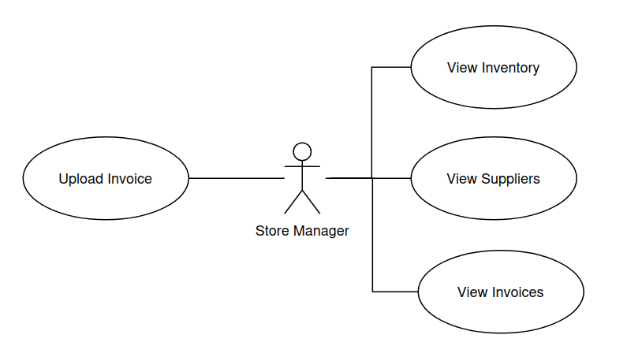

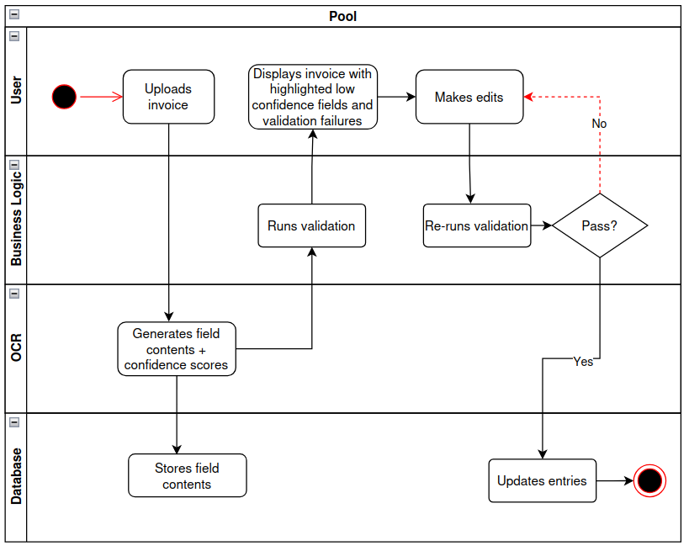

Detailed Design
Instructions: Provide the information needed for a system development team to actually build and integrate the hardware components, code and integrate the software components, and interconnect the hardware and software segments into a functional product. Additionally, address the detailed procedures for combining separate COTS packages into a single system.

Hardware Detailed Design
Instructions: Provide enough detailed information about each of the individual hardware components to correctly build and/or procure all the hardware for the system (or integrate COTS items). If there are many components or if the component documentation is extensive, place it in an appendix. Add additional diagrams and information, if necessary, to describe each component and its functions adequately. Industry-standard component specification practices should be followed. For COTS components, identify specific vendor and appropriate item names and model numbers. Include the following information in the detailed component designs, as applicable:
- Power input requirements for each component
- Signal impedances and logic states
- Connector specifications (serial/parallel, 11-pin, male/female, etc.)
- Memory and/or storage space specifications
- Processor requirements (speed and functionality)
- Graphical representation depicting the number of hardware items (e.g., servers, I/O devices, monitors, printers, etc.), and the relative positioning of the components to each other
- Cable type(s) and length(s)
- User interfaces (buttons, toggle switches, etc.)
- Hard drive/floppy drive/CD-ROM specifications
- Monitor resolution

Software Detailed Design
Provide a detailed description for each system software service that addresses the following software service attributes. Much of the information that appears in this section should be contained in the headers/prologues and comment sections of the source code for each component, subsystem, module, and subroutine. If so, this section may largely consist of references to or excerpts of annotated diagrams and source code. Any referenced diagrams or source code excerpts should be provided at any design reviews.
- Service Identifier - The unique identifier and/or name of the software service
- Classification - The kind of service (e.g., application, data service, etc.)
- Definition - The specific purpose and semantic meaning of the service
- Requirements - The specific functional or nonfunctional requirements that the service satisfies
- Internal Data Structures - The internal data structures for the service
- Constraints - Any relevant, assumptions, limitations, or constraints for the service (this should include constraints on timing, storage, or service state, and might include rules for interacting with the service (encompassing pre-conditions, post-conditions, invariants, other constraints on input or output values and local or global values, data formats and data access, synchronization, exceptions, etc.))
- Composition - A description of the use and meaning of the subservices that are a part of the service
- Users/Interactions - A description of the service’s collaborations with other services (what other services use this this entity? what other services does this entity use (including any side-effects this service might have on other parts of the system)? this includes the method of interaction, as well as the interaction itself. Object-oriented designs should include a description of any known or anticipated sub-classes, super-classes, and meta-classes)
- Processing - A description of precisely how the service goes about performing the duties necessary to fulfill its responsibilities (this should encompass a description of any algorithms used; changes or state; relevant time or space complexity; concurrency; methods of creation, initialization, and cleanup; and handling of exceptional conditions)
- Interfaces/Exports - The set of services (resources, data types, constants, subroutines, and exceptions) that the service provides (the precise definition or declaration of each such element should be present, along with comments or annotations describing the meanings of values, parameters, etc.; for each service element described, include or provide a reference in its discussion to a description of its important software service attributes (Component Identifier, Classification, Language, SLOC Estimate, Definition, Responsibilities, Requirements, Internal Data Structures, Constraints, Composition, Uses/Interactions, Resources, Processing, and Interfaces/Exports))
- Reporting Design and Integration - If built in, provide details on data traffic and volumes

Security Detailed Design
Instructions: Provide a graphical representation with detailed information for each of the individual security hardware components. Specify the design for the below items as required.
- Authentication
- Authorization
- Logging and Auditing
- Encryption
- Network ports usage
- Intrusion Detection and Prevention (especially if hosted in a non-CMS data center
The design should be based on the designated system security level and provide adequate protection against threats and vulnerabilities.

Performance Detailed Design
Instructions: Provide a graphical representation with detailed information for each of the individual performance and reliability hardware components to include the below items:
- Capacity and volume requirements/estimates
- Performance expectations
- Availability requirements
- Performance design to meet capacity requirements
- Reliability design to meet availability requirements
- Backup, recovery, and archive design
Identify single points of failure and, if relevant, describe high availability design (e.g., clustering).

Internal Communications Detailed Design
Instructions: If the system includes more than one component, there may be a requirement for internal communications to exchange information, provide commands, or support input/output functions. Provide enough detailed information about the communication design to correctly build and/or procure the communications components for the system. Include the following information in the detailed component designs, as appropriate:
- Number of servers and clients to be included on each area network
- Specifications for bus timing requirements and bus control
- Format(s) for data being exchanged between components
- Graphical representation of the connectivity between components, showing the direction of data flow (if applicable), and approximate distances between components (information should provide enough detail to support the procurement of hardware to complete the installation at a given location)
- LAN topology

System Integrity Controls
Instructions: Provide design specifications for the following minimum levels of control and any additional controls as appropriate or necessary:
- Internal security to restrict access of critical data items to only those access types required by users/operators
- Audit procedures to meet control, reporting, and retention period requirements for operational and management reports
- Application audit trails to dynamically audit retrieval access to designated critical data
- Standard tables to be used or requested for validating data fields
- Verification processes for additions, deletions, or updates of critical data
- Ability to identify all audit information by user identification, network terminal identification, date, time, and data accessed or changed.

External Interfaces
Instructions: Describe any interfaces that exist with external systems that are not within the scope of the system being designed, regardless whether the other systems are managed by CMS or another entity. Describe the electronic interface(s) between the system being designed and each of the other systems and/or subsystem(s), emphasizing the point of view of the system being designed. If there are more than one or two external systems, or if the interfaces are not simplistic, one or more separate Interface Control Documents (ICDs) should be prepared and referenced here. If applicable, identify how many ICDs exist and what they are. A template for an ICD is available from the CMS Integrated IT Investment & System Life Cycle Framework Web site located at https://www.cms.gov/Research-Statistics-Data-and-Systems/CMS-Information-Technology/XLC/Downloads/InterfaceControlDocument.docx.

Interface Architecture
Instructions: Describe the interface(s) between the system being developed and other systems (e.g., batch transfers, queries, etc.), indicating the location of the interfacing system. Include the interface architecture(s) being implemented (e.g., wide area networks, gateways, etc.) and the interfacing mechanisms (e.g., MQ, Gentran, etc.) If remote connectivity is required, identify the method of access. Provide a diagram depicting the communications path(s) between this system and each of the other systems, which should map to the context diagram(s) provided in the Section for System Overview. The graphical representation should depict the connectivity between systems, showing the direction of data flow. Use subsections or a separate ICD(s) to address each interface independently.
The customer service platform will use REST APIs to separate the user interface, application logic, AI chatbot, customer database, human-agent escalation, and feedback components. The frontend will communicate only with the API layer and will not directly access the database or AI service. This keeps each component independent and easier to maintain.
The primary communication flow is:
Customer → Web Interface → API Layer → AI Chatbot
The API layer may also communicate with the Customer Database, Human Agent/Escalation System, and Feedback System depending on the request. If the chatbot cannot confidently answer a question, the conversation will be escalated to a human agent.

Interface Detailed Design
The complete API contracts can be found at http://127.0.0.1:8001/docs once the backend is running locally. For baselining and reference purposes, a printout copy is included with this document.
For ease of understanding this document, a summary is provided below.

Method / Endpoint | Purpose | Main Input | Main Output
GET /invoices/all | Read invoices | none | List of Invoice objects
POST /invoices/all | Create new invoice | InvoiceCreate object | InvoiceCreate object
GET /inventory | Read inventory | none | List of Inventory objects
POST /inventory | Create new inventory entry | InventoryCreate object | InventoryCreate object
GET /suppliers | Read suppliers | none | List of Supplier objects
GET /changes | Read all changes | None | List of Change objects
GET /invoices/{InvoiceNumber} | Read invoice | String InvoiceNumber | Invoice object
PUT /invoices/{InvoiceNumber} | Update invoice | String InvoiceNumber, InvoiceUpdate object | InvoiceUpdate object
GET /invoices/{InvoiceNumber}/lineitems | Read invoice items | String InvoiceNumber | List of InvoiceLineItem objects
POST /invoices/{InvoiceNumber}/lineitems | Create new line item | String InvoiceNumber, InvoiceLineItemCreate object | InvoiceLineItemCreate object
GET /inventory/{ProductID} | Read inventory entry | String ProductID | Inventory object
PUT /inventory/{ProductID} | Update inventory entry | String ProductID, InventoryUpdate object | InventoryUpdate object
GET /invoices/{InvoiceNumber}/changes | Read changes for a given invoice | String InvoiceNumber | List of Change objects
POST /invoices/{InvoiceNumber}/changes | Create change | ChangeCreate object | ChangeCreate object
GET /invoices/{InvoiceNumber}/changes/{ChangeID} | Read change | Integer ChangeID | Change object
PUT /invoices/{InvoiceNumber}/lineitems/{SuppliersID} | Update line item | String InvoiceNumber, String SuppliersID | InvoiceLineItem object
POST /confirm_values | Collect user-edited invoice and pass to validation module | InvoiceCreate object, list of InvoiceLineItemUpdate objects | InvoiceCreate object, list of InvoiceLineItemUpdate objects
POST /update_all_inventory | Update all inventory objects mentioned by invoice | InvoiceCreate object, list of InvoiceLineItemUpdate objects | InvoiceCreate object, list of InvoiceLineItemUpdate objects
POST /upload | Collects file from user | UploadFile object | Invoice object, list of InvoiceLineItem objects, list of confidence intervals

Appendix A: Record of Changes

Table 1 - Record of Changes
Version Number | Date | Author/Owner | Description of Change
0.1 | 9/3/26 | SL | First pass
0.2 | 9/4/26 | SL | Added diagrams
<X.X> | <MM/DD/YYYY> | CMS | <Description of Change>

Appendix F: Additional Appendices
Instructions: Utilize additional appendices to facilitate ease of use and maintenance of the document. Suggested appendices include (but are not limited to):
- Software Architecture Diagrams - provide the functional hierarchy diagrams, structured organization diagrams, or object-oriented diagrams that show the various segmentation levels of the software architecture down to the lowest level.
- Data Dictionary - provide definitions of all processes, data flows, data elements, and data stores.
- Requirements Traceability Matrix - demonstrate backward traceability of the system and software architectural designs to the functional and nonfunctional requirements documented in the Requirements Document.

Appendix G: Notes to the Author/Template Instructions
This document is a template for creating an SDD for a given investment or project. The final document should be delivered in an electronically searchable format. The SDD should stand on its own with all elements explained and acronyms spelled out for reader/reviewers, including reviewers outside CMS who may not be familiar with CMS projects and investments.
This template includes instructions, boilerplate text, and fields. The developer should note that:
- Each section provides instructions or describes the intent, assumptions, and context for content included in that section. Instructional text appears in blue italicized font throughout this template.
- Instructional text in each section should be replaced with information specific to the particular investment.
- Some text and tables are provided as boilerplate examples of wording and formats that may be used or modified as appropriate.
When using this template, follow these steps:
- Table captions and descriptions are to be placed left-aligned, above the table.
- Modify any boilerplate text, as appropriate, to your specific investment.
- Do not delete any headings. If the heading is not applicable to the investment, enter “Not Applicable” under the heading.
- All documents must be compliant with Section 508 requirements.
- Figure captions and descriptions are to be placed left-aligned, below the figure. All figures must have an associated tag providing appropriate alternative text for Section 508 compliance.
- Delete this “Notes to the Author/Template Instructions” page and all instructions to the author before finalizing the initial draft of the document.

