FlashFund

Crowdfunding for the University Community

Mahesh Gaire

Ahmed Alsaleh

Skylar Beaty

Ian Kusner

Jimmy Mertival

Project:

Our project is to create a crowdfunding application specifically for students and other university community members who are in need of financial assistance.

Purpose:

* Student organizations require funding.
* Some students require financial help affording school supplies like laptops, software, etc.
* Traditional methods of funding like grants, scholarships, and loans may be too timely or logistically burdensome

Customers and Users:

* Kent State University
  + Administrator for our application
  + Approves/denys requests for funding
  + Requires easy to use UI
  + Given a filtered list of applications to approve/deny
* Students and Student Organizations
  + Makes applications for funding
  + Customises their funding pages
  + Requires a student email address to be able to access funding
* Donators
  + Anyone is able to donate
  + Uses an digital wallet service to donate

Other Considerations:

* Our website should be built so that a it can be easily navigated by screen reading software
* The list of applications should be filtered before given to the admin. A full list of applications will quickly make the site unusable.
* Our website must be able to handle at the very least 1000 users, with ~250 of them being concurrent.

Technical:

* Web application
* Built using HTML and PHP, with an SQL database
* Front end design implemented using the React library, version 17.0.1
* Database and backend routes implemented using Laravel, version 8.16.1
* Integration of one digital wallet service. Paypal and GooglePay are currently being considered.
* Features two types of account, student and donor, allotted automatically.
* Further updates with extra features will be rolled out once the first working build is completed.
* Will be worked on using the Agile development process.

Assumptions and Risks:

* Assumption: Universities will be able to adopt this application
  + We plan to make the app very lightweight and require no maintenance on the university’s end.
  + University here only serves as the administrator if they want to. They do not need to filter through the list of applications, or do maintenance on the servers.
  + The website must be easy to navigate and use and should not require any training to do so.
* Risk: Legal issues might be involved with a crowdfunding application working closely with a public university.
* Risk: Crowdfunding funds not used for the poster’s intended purpose.
* Risk: Network security

Stakeholder Interviews

Steven M.

Former Event Organizer, Paper Aviation

*How hard was it to get Paper Aviation funded?*

“Not hard, really. We mostly just needed a room for us to use. I thought it would be nice to eventually get t-shirts made or something but the university never came through with the funding. We actually lost the room eventually too.”

*What features would you like to see in a crowdfunding application for university clubs?*

“I want it to be able to customize my page. I want to use it to get funding and attract more club members at the same time”

*Have you personally used crowdfunding apps before?*

“I used Kickstarter before.”

*How can we make it easy for people to donate using our app? What are some roadblocks that will personally prevent you from donating?*

“I can’t think of any. Maybe a problem with payment? I know I use Paypal a lot because it’s easy to log in and use, and some sites don’t take it.”

*Tell me, if you can, a horror story you’ve heard about a crowdfunding service. Can you think of a time where a crowdfunding endeavor went horribly wrong?*

“Yeah, I remember that thing with Star Citizen where people wanted to get their money back because the game was delayed over and over. The guy making it wouldn’t do it and people were trying to sue him.”

Emily B.

Kent Boxing Club

*How hard was it to get the boxing club funded?*

“It was difficult. We have to resort to club dues to take care of the small stuff, but the big problem was getting a space for us to practice. We always tried to get the combative studio in the rec, but they told us “large groups” were not allowed to sign up for studio time unless we pay for it. I tried to get the university to pay for it, since it’s the university’s rec center, you know, but they never did anything.”

*What features would you like to see in a crowdfunding application for university clubs?*

“I’m not sure. I guess I want it so its easy to use and donate with and it will be seen by a lot of people. That way the clubs might get funded. Yeah, I want an app with a lot of traffic.”

*Have you personally used crowdfunding apps before?*

“Not really. I’ve used like those donation things before on Facebook where you just set it up and post it, but I’ve never used the big crowdfunding apps.”

*How can we make it easy for people to donate using our app? What are some roadblocks that will personally prevent you from donating?*

“Well, I want people to know about the app, so I guess my biggest concern is people actually using it. It’ll be easier to use if the word is out. I probably won’t bother setting up a funding page for the club if no one’s on there.”

*Tell me, if you can, a horror story you’ve heard about a crowdfunding service. Can you think of a time where a crowdfunding endeavor went horribly wrong?*

“I can’t think of a specific time. My roommate once shown me this video where people Kickstarter spent a bunch of money on this board game and the company making it just never made the board game. It was like, a lot of people were angry and Kickstarter couldn’t just get the money back to them.”

We also have one unrecorded interview with Katharine G. from Kent University Center for Student Improvement.

Takeaways from the interviews,

* Minimal affiliation with the university
  + This is for legal reasons. We must take care of the money side of things ourselves
  + The system administrator roles can still be built with the university in mind. This is just so university staff may administrate should they wish to.
* Ease of use
  + Application must be easy to use for all users involved
  + Donors are less likely to donate should the application not accept their desired form of payment
  + Students are more likely to request funding if the interface is intuitive and easy to navigate.

System Overview

FlashFund users are divided into three account types,

Doner accounts can be created with any valid email address.

Student accounts are made with a valid student email address.

Admin accounts are added directly into the system database.

*The student account creation process right now only takes into account of a .edu extension within the email address. This means that former university students with a .edu account can still make a Student account and make fundraising requests. This is something we will look into remedying, as it causes clog, but since it is not particularly a security issue, it is low on the priority list.*

Figure

In the system overview, figure 1, Student users are the ones that create campaigns. Admins approve or deny those campaigns. Donors use the digital payment services to donate to the campaigns.

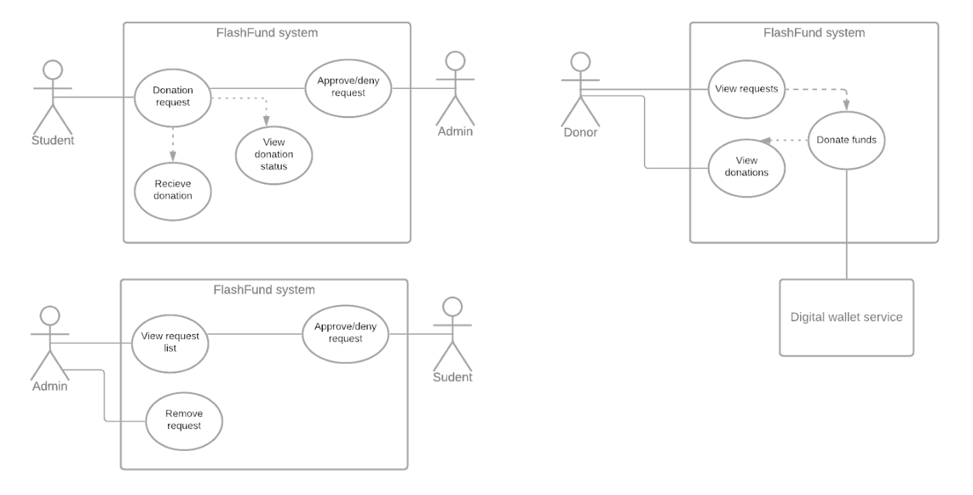

Figure .1

Figure 2.1

Administrator interactions consists of being able to view a filtered list of requests and approve or deny requests from that list. Administrators are also able to remove fundraisers that are ongoing or finished from the FlashFund database. Administrators do not have the ability to donate or make requests for funding.



Figure 2.2

Figure 2.2

Donor interaction consists of being able to view the approved ongoing requests, donating to those requests, and viewing past donations made. Donations are made with a digital wallet service. Paypal and GooglePay are currently being considered as well as other “suite” payment options such as Stripe.

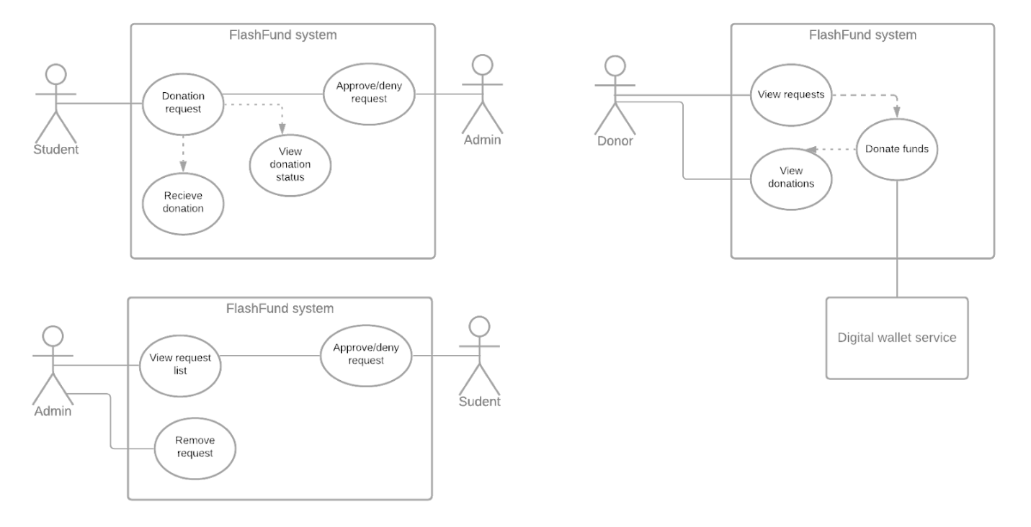

Figure 2.3

Figure 2.3

Student interaction consists of being able to make requests for funding and seeing the status of ongoing funding requests. If the request is denied, approved, in the donation phase, or finished, the user with the student account will be able to view the status. Once the fundraiser is finished, the user is able to receive the raised funds. Student accounts also have all the privileges of Donor accounts. They are able to donate to fundraisers just like donors.

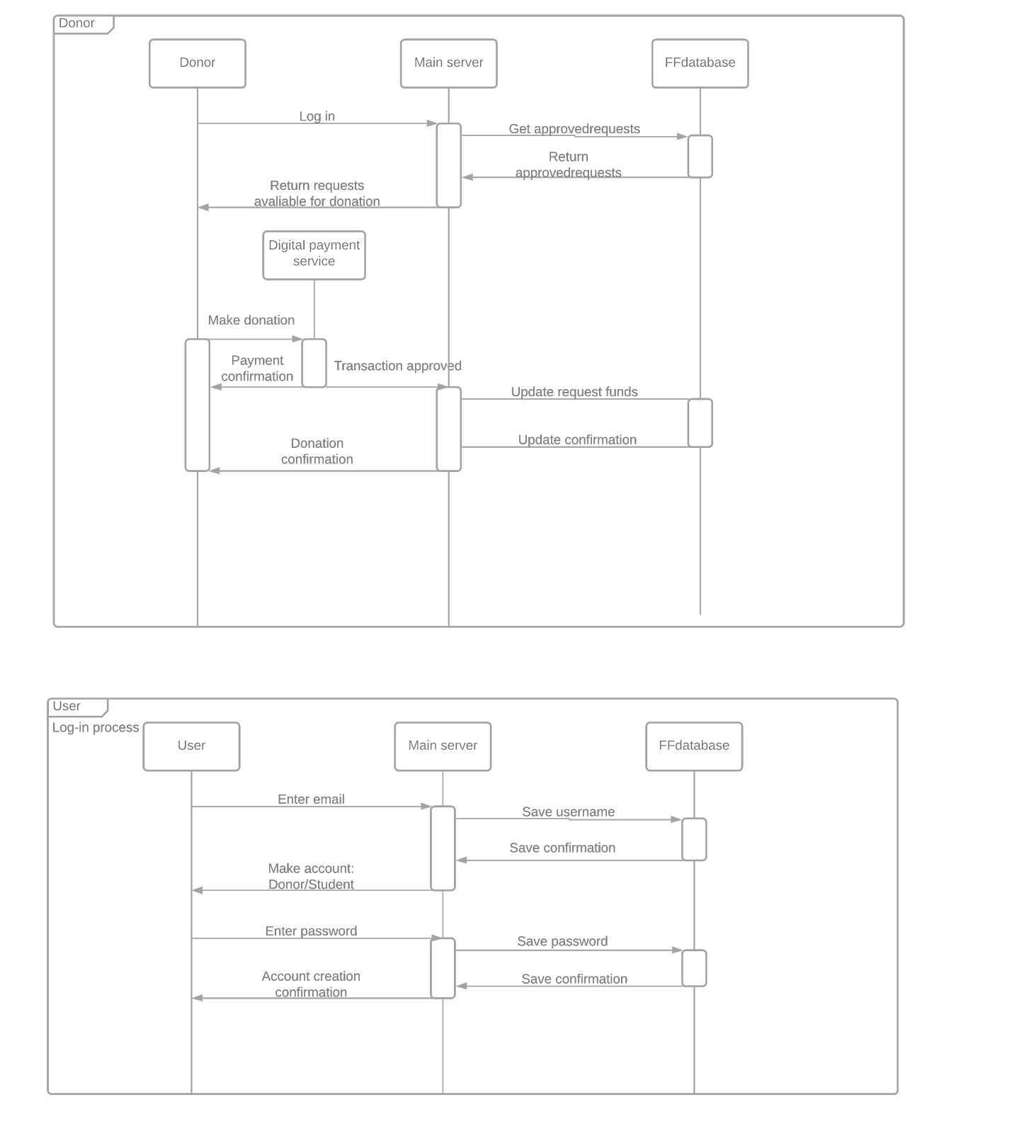

Figure .1

Login sequence, figure 3.1

AnyUser will be asked to make an account for the FlashFund system by first entering an email address. The server will allot the User a Donor or Student account dependent on the submitted email address. It will then ask for a set password. The User will get confirmation of enrollment from the database via the server.

*An email verification system will be coming in a later version, which will change this sequence.*

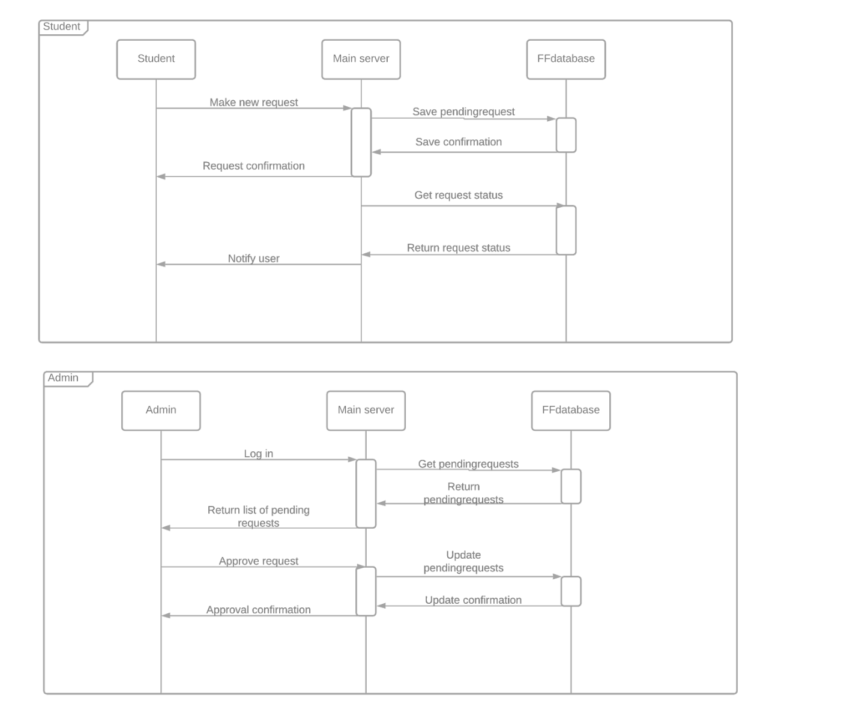

Figure 3.2

Admin user sequence, figure 3.2

AnAdmin will log in to the server and receive a list of pending requests from the server, fetched from the database. They can process and update pending requests for fundraising to/from students via the server.



Figure 3.3

Donor donations sequence, figure 3.3

ADonor will log in to the server and receive a list of funding requests available for donation. They may donate to some of the fundraising requests by PayPal (or another digital wallet service). The Doner will receive confirmation of the transaction from both PayPal, and the database where the fundraising will be updated via server.



Figure 3.4

Student newrequest sequence, figure 3.4

AStudent will make a new request for fundraising and get confirmation of the submission from the server. The server will also automatically request the status of funding submissions from the database and notify the student.

I. Overview of the key features and capabilities supported

* Login for posters (students)
* Login for donators (anyone)
* Login for admin to moderate posters of their university
* People with valid university emails can start a donation campaign (pending admin approval)
* Anyone with an account made can contribute money to a campaign
* Admin can approve or deny anyones request to start a campaign

II. System Context

|  |  |  |
| --- | --- | --- |
| System | Interface | Support |
| 3rd party payment service | Digital wallet api | Apple Pay, version 10.14.6  Stripe API, version 2020-08-27 |
| Donor User | Donor interface | Make payments to campaign |
| Admin User | Admin interface | Accept / deny campaigns |
| Student User | Campaign poster interface | Post campaign / make payments to campaign |

III. Hardware Components

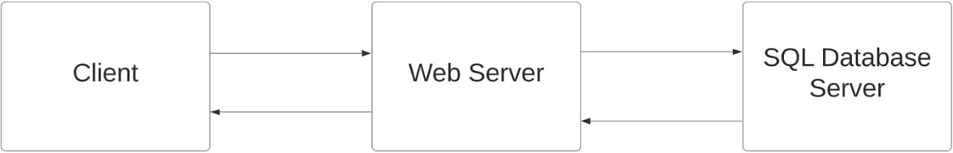

IV. Software Components

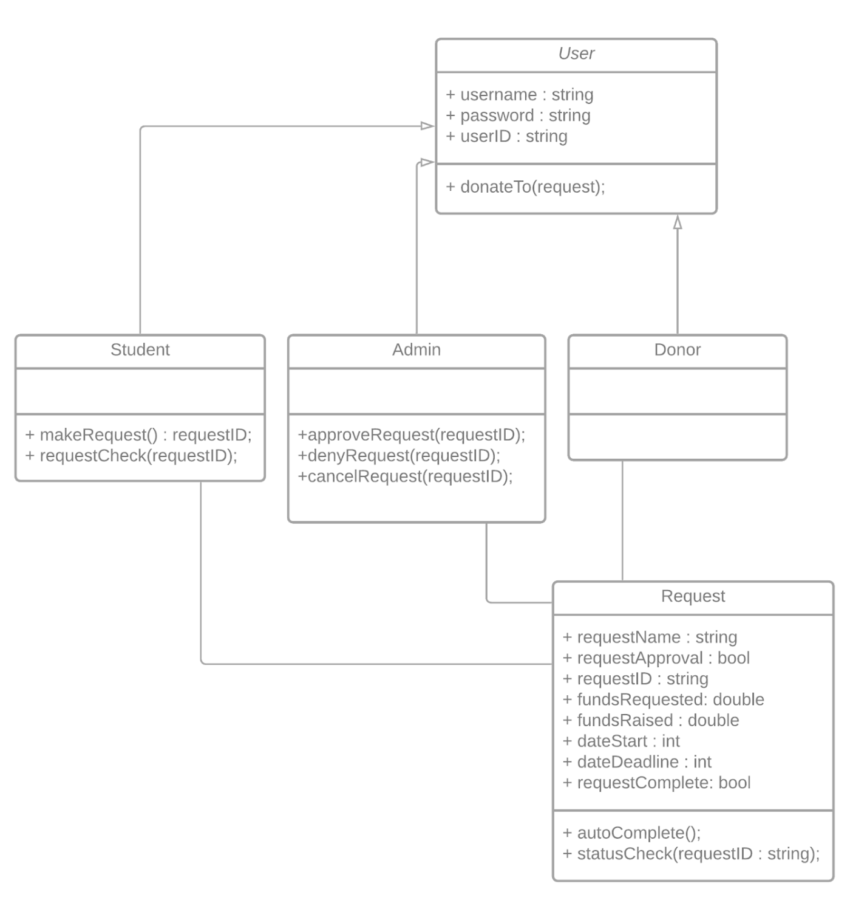

V. Users

System admin

* server maintenance / backups
* Hold money of campaigns

Application Admin

* Moderate campaigns from users of their domain

End user

* Donate or create campaigns

VI. Capability and Performance

|  |  |  |  |
| --- | --- | --- | --- |
| Attribute | Value | Software Configurable | Hardware Configurable |
| Simultaneous users | 250 | Yes | Yes (expand servers) |
| Transactions per hour | 100 | No | Yes |
| Total campaign postings | 1,000 | No | Yes (expand database storage) |

