**Athan Kim, Jerrell Lewis, Kian Azadi, Tyler Weiss, Varsha Vattappally**

**CIS4398 – GroupMeet Requirements Document**

**Keywords**Section 704, iOS App, Android App, AIO Collaboration Tool, Group Projects, Friend Group Scheduling, Contact Information Share, Code-Based, Scheduling Algorithm  
 **Project Abstract**  
This document proposes a multi-platform mobile application called “GroupMeet” that creates an environment for students and social groups to easily organize each other’s schedules for availability and share contact information. In academic group projects, students can now easily begin communications with each other and align each other’s schedules to immediately become successful in their academic endeavors. In social groups, friends can now easily coordinate each other’s busy lives and adjust accordingly to spontaneous events. With this application, no particular individual must take charge; the responsibility lies on the application itself.   
  
**High Level Requirement**  
This application runs on a simplistic overall design, prioritizing an easy and fluent user experience above all else. Users who download our application on the app store must create a profile/account and must add at least one social media account to it, whether it be phone number, Discord, Twitter, Instagram, Snapchat, etc. After setting up their contact information, the last thing users will have an option of doing is setting up or syncing a static calendar to show their availability. Syncing a static calendar from a product like Google Calendars will not share the specific details about each event in the calendar, just the dates/times. After these steps, the user is all set up and ready to use the application when needed for group projects or friend groups.

When the application is needed, the user will have to create an instance that generates a code – this code will be inputted by other participants of the event to join in. Upon joining/creating the group, individual users will choose at least one of their social media profiles to share with privacy in mind. After everyone joins the instance, a universal calendar will automatically be generated that shows dates/times available for all participants. If a user has not already set up a static calendar, that specific user by preference will either be asked to update their calendar, or in the presence of strict scheduling be asked by the application if specific times work based on the generated calendar. Throughout the instance’s lifecycle, users can update any spontaneous events that occur causing them to be unavailable. When this occurs, all other users will be prompted and the application will make suggestions for the next best option, or any compromises if there truly is no other time that works.  
  
**Conceptual Design**  
It has been decided that GroupMeet’s programming environment will be in Flutter so that the application can be developed for both iOS and Android devices. This is to ensure that the only requirement to use our application is owning a smartphone so that we can reach most users. As for hosting of the application, we are trying to get physical hardware, but it is no big deal if we cannot oblige. AWS or another choice among the vast arrange of hosting services will be chosen.   
  
**Background**  
Throughout my academic career, I felt that one of the most repetitively troublesome procedures that I experienced was getting assigned a group project and simply getting the flow of communication going, and especially trying to sync everyone’s schedules together to ensure efficient work is done. And as my friends and I are graduating, starting their careers, or continuing their education, I feel that one of the most agonizing things is trying to align each other’s schedules to simply get together once in a while. In both of these scenarios, there is always tiresome work that needs to be done overall, and usually it is shouldered on one person to take control and organize for everyone else. Just the concept of a group project being stalled from the get-go because of this, or a friend group causing unnecessary work sounds like a nuisance that can be avoided.

Similar products to GroupMeet include official calendars with calendar sync integration like Google Calendars, or Calendar (<https://www.calendar.com/>) which has dynamic scheduling integration, but has a lot of its features locked behind a paywall. The problem at hand with these products though, is simply that they are not convenient enough for short-term use. Combine this with privacy issues, because a majority of users do not want to share their entire detailed calendar with other people – they would just want to share their times and nothing else attached. The only instances I have ever heard of people sharing each other’s calendars is close family members, and in a professional environment where they only share their work calendar and not their personal calendar. GroupMeet aspires to make calendar sync integration an easy and seamless process with privacy in mind.   
  
**Required Resources**  
Experience with Mobile App Development would be optimal for all group members. If every member has experience with Flutter specifically, that would be the best. This application prioritizes user experience, so a background in that would be great as well. If no local hardware is available immediately from any participant, AWS will most likely be the designated hosting service but hosting services are not hard to find.

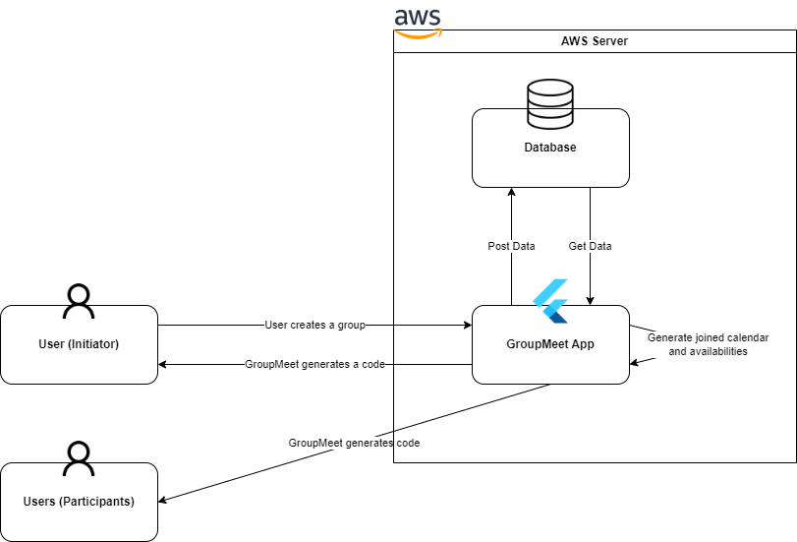**System Block Diagram**

**General Requirements**

1. A smartphone (iOS or Android)

2. A stable internet connection or cellular data

3. At least one social media account (Discord, Instagram, Snapchat, Facebook, SMS, etc.)

**Features and Requirements**

1. Users will be able to create and share a group link to a shared calendar

2. GroupMeet will provide a way for users contact each other through a in-app messaging platform

3. Users can transfer events from their personal calendar to GroupMeet

4. Users can see which times are busy for their group members in a synced GroupMeet calendar

5. Members of the group can vote on free blocks of time they would prefer to meet at

6. Users will receive a notification of preferred times according to votes

7. GroupMeet will display a list of available times for everyone to meet

8. Proposer of the meeting will be able to title the meeting, set a location, and give a description

9. Planned meetings can be cancelled

10. Users will be notified of cancelled meetings

11. GroupMeet will send a notification to confirm that users will be able to attend 1 day before the meeting

12. Users will be notified 15 minutes before a meeting

13. Users will be able to review the meeting after

**Nonfunctional Requirements**

1. Users can customize the layout of the application to suit their style preferences

**Use-case descriptions**

Use case 1: Assigned Group Project

1. Students gather together after being assigned a group project.

2. One student logs into the GroupMeet app and creates a new group.

3. A code/QR code/link is generated, and the one student shares their screen with the rest of the group.

4. Every other student in the group has free choice of writing down the code and inputting later, scanning the QR code immediately, clicking on the link and instantly redirecting to joining on the app, etc.

5. Once all group members have joined the GroupMeet group, a calendar is generated with everyone’s schedules in mind.

6. A group member sees that Friday the 27th from 7PM – 9PM is a time where everyone is available, so they click on that day and propose it.

7. Upon proposing it, a notification is sent to all other group members, asking them to approve of this date and time.

8. All group members approve of this date and time.

9. Another group member later realizes that they actually cannot make that time, so they override that decision.

10. Upon overriding this decision, a notification is sent to all group members with a suggestion that GroupMeet makes as to what other time(s) would work.

11. Example: “Something came up for Adam and he can no longer make it on FRIDAY 27TH from 7PM – 9PM. How does SATURDAY 28TH from 2PM – 4PM sound?” in which Saturday 28th from 2PM – 4PM is the next time where everyone is available.

Use case 2: Busy Friends

1. A friend group has been trying to get together for dinner for a long time, but nobody is dedicated enough to coordinate everyone’s schedules.

2. One friend texts a link to the friend group chat to install GroupMeet.

3. Each friend installs GroupMeet, creates an account and syncs their Google calendars.

4. GroupMeet then puts them into the group originally stored in the link generated by the first friend.

5. Before GroupMeet can generate a static calendar, there is one friend who needs to be accounted for. This friend registered without syncing a Google calendar, and also has no plans to fill one in.

6. This friend gets to see a pre-released static calendar in which they see when everyone else is available. They then simply look at all of the available times and quickly fill in all of their available times manually.

7. Once this friend is finished filling times manually, the static calendar is generated and released to the entire group.

Use case 3: User seeks to set/change longevity of project for Group 2

1. User enters the GroupMeet app

2. The Home Screen is displayed

3. User selects the Group Tab

4. A list of groups are displayed

5. User selects Group 2 chat

6. The group 2 chat is displayed along with members

7. User clicks on Gear Icon in top right of screen

8. A list of functions and tabs are now shown

9. User chooses Longevity

10. User is prompted with add new, change existing or delete current timeline options

11. User selects change existing

12. User is prompted with a calendar to select new date for start & end of timeline and time.

13.User selects appropriate new date and time.

14. User presses the Save New button to the bottom left of screen

15. A message is shown confirming the change of timeline

16. User receives a message from the Group 2 Chat with new timeline adjustments

Use case 4: User would like to check if a meeting for a specific day is still scheduled one hour prior

1. User receives a message from the GroupMeet app reminding them that there is a Meeting to be held at 4 pm in which he offered to attend.

2. User taps on the message

3. User is instantly taken to the applications home page

4. User is shown a pop-up message with details about the meeting, the time, place, and who is participating.

5. User then look towards the status icon to the bottom of the pop-up menu, which shows active.

6. User taps on the active status.

7. A description pops up telling the user that no one has made a cancelations and all participants are still on.

8. The user then hits the “X” button to the top right of the pop-up menu.

9. The pop-up menu disappears.

10. User is now on the home page of the GroupMeet app

Use case 5: User would like to sign up for the GroupMeet app for the first time

1. User opens the app

2. User taps on the "Sign Up" button

3. User is presented with a form where they are asked to provide their email address, password, and social media account.

4. User carefully fills out the form and clicks the next button

5. User is asked to sign in to the social media account making sure that the user identity is correct

6. User receives a confirmation email, and the user taps on the link to confirm the user’s email

User Story 1: The Group Project

Johnson, a student at Temple University studying Math, will like to meet with select students from his class to form a group to study with for the upcoming finals. He normally has a hard time keeping up with his own schedule, much less remembering others. For the next class, he got 5 minutes of everyone’s time and recommended they use the GroupMeet App. On this application, he explained that everyone will be able to sign in and create/join a group using a code. In this group, everyone will have access to a Calendar in which they can place their availability. The Calendar will then sync everyone’s submission and portray the availability of when everyone would be free to meet.

User Story 2: Friends

Christy, age 32, has been longing for a vacation with her friends. As they are all in different states, it’s hard to keep up with each other, much less get on the phone for a conversation. In the group chat they have on Telegram, she sent the GroupMeet app link so all the girls can download it. She texted that this app will allow them to sync their personal static calendars into a group calendar for ease of visibility. This syncing will not reveal specific details of their normal schedule but mark dates and times where they’re available. She also told them that if something comes up on the fly that will cause an unavailability, they can instantly place it in the GroupMeet app calendar which will reflect on everyone else’s end.