**R’s-Earn: Reverse Paper Waste Vending Machine with Monitoring System**

A Research/Capstone Proposal

Presented to the Faculty of the

College of Computer Studies, University of Cebu

In Partial Fulfillment of the Requirements

for the degree Bachelor of Science and Information Technology

By:

Mary Andrie Van F. Manolong

Charls’ Dave Erana

Maican Labajo

Kim Mendoza

Mr. Edsel C. Paray

Adviser

October 2018

**ACKNOWLEDGMENT**

To Mr. Edsel C. Paray, Thank you for being a great adviser. Thank you for guiding us and giving us ideas for betterment of this study.By doing this research we discovered our potentials and learn so many things.

To our Capstone Subject Adviser, Mrs. Moma Ortega, we extend our sincerest gratitude for the assistance in completion of this study.

To our family and friends thank you for supporting and encouraging us in doing this project.

Lastly, to Almighty God, for giving us strength, wisdom, and enlightenment in conducting this study.

**The Researchers**

Mary Andrie Van F. Manolong

Charls’ Dave Erana

Maican Labajo

Kim Mendoza

**DEDICATION**

To our Family

To Almighty God

To University of Cebu-Banilad

To Faculty Instructors and Students

**TABLE OF CONTENTS**

**Page**

ACKNOWLEDGMENT ............................................................................................ ii

DEDICATION ............................................................................................................ iii

TABLE OF CONTENTS............................................................................................. iv

LIST OF TABLES ...................................................................................................... vi

LIST OF FIGURES ..................................................................................................... vii

CHAPTER I: INTRODUCTION

Rationale of the Study...................................................................................... 1

Objectives of the Study.................................................................................... 2

Scope and Limitation of the Study................................................................. 3

Significance of the Study................................................................................. 3

Flow of the Study............................................................................................. 4

Definition of Terms .......................................................................................... 5

CHAPTER II: REVIEW OF RELATED LITERATURE AND STUDIES

Related Literatures ......................................................................................... 6

Related Studies ............................................................................................... 7

Comparative Matrix ........................................................................... 8

CHAPTER III: RESEARCH METHODOLOGY

Software Engineering Methodology ............................................................. 11

Planning/Conception-Initiation Phase

Business Model Canvas ................................................................... 14

Program Workflow ........................................................................... 16

Validation Board .............................................................................. 18

Gantt Chart ....................................................................................... 18

Functional Decomposition Diagram ................................................ 20

Analysis-Design Phase

Use Case Diagram ......................................................................... 21

Storyboard ...................................................................................... 22

User Interface Diagram .................................................................. 23

Database Design ............................................................................. 31

Entity-Relationship Diagram ............................................. 35

Data Dictionary................................................................... 36

Architectural Design ....................................................................... 40

Network Design

Network Model ............................................................................... 41

Network Topology .......................................................................... 42

Development/Construction/Build Phase

Technology Stack Diagram.............................................................. 43

Software Specification ....................................................... 44

Hardware Specification ...................................................... 44

Program Specification ..................................................................... 48

Software List of Modules .................................................... 48

Hardware List of Modules .................................................. 50

REFERENCES .......................................................................................................... 51

CURRICULUM VITAE ............................................................................................ 52

APPENDICES

A – Censor’s Certificate ............................................................................... 56

**LIST OF TABLES**

Table No. Table Name Page

1 Comparative Matrix 8

2 Business Model Canvas 14

3 Validation Board 18

4 Gantt Chart 19

5 USER_PROFILE 31

6 ADMIN_PROFILE 32

7 USER_POINTS 32

8 GENERATED_CODE_HEADER 33

9 GENERATED_CODE_DETAIL 33

10 POINTS_HISTORY_HEADER 34

11 POINTS_HISTORY_DETAIL 34

12 User Profile Data 36

13 Admin Profile Data 36

14 User Points Data 37

15 Generated Code Header Data 37

16 Generated Code Detail Data 38

17 Points History Header Data 38

18 Point History Detail Data 39

19 Software List of Modules 48

20 Hardware List of Modules 50

**LIST OF FIGURES**

Figure No. Figure Name Page

1. Flow of the study 4
2. Agile Development Methodology 11
3. User Activity Program Workflow 16
4. Notification Activity System Workflow 17
5. Functional Decomposition Diagram 20
6. Use Case Diagram 21
7. R’s Earn Story Board 22
8. Begin Screen 23
9. Login As 24
10. Admin Login 24
11. Registration Screen 25
12. Admin Profile 25
13. User Details 26
14. View Machine Status 26
15. User Login 26
16. User Menu Screen 26
17. Add Code 27
18. Search Added Points History 27
19. Ways of Segregating Paper 28
20. View Items 28
21. User Profile 29
22. Entity Relationship Diagram 34
23. Architectural Design of the R’s Earn Proposed Project 40
24. Network Model 41
25. Network Topology 42
26. Technology Stack Diagram 43
27. Arduino Uno Rev3 Wifi 44
28. Iscale SE Digital Scale 45
29. Bluetooth Module HC-06 45
30. LCD Display 46
31. Control Leds with Arduino 46
32. Nano Thermal Printer 47
33. Electronic Buzzer 47

**CHAPTER I**

**INTRODUCTION**

Paper is a common commodity. Almost everyone uses it everyday, everywhere, for many reasons, from printing press, newspapers, offices and schools. The incremental demand for paper leads to an increasing consumption and waste that cause pose risks to environmental and human health. From the production of paper that consume a lot of natural resources to the improper disposal of paper waste. Most individuals lack of awareness about the harmful effects of paper waste resulted to generate paper waste unnecessarily and unconsciously aware that paper should not be taken for granted, that the practice of proper disposal of paper waste and putting the paper waste in a proper garbage bin should be taken seriously. Paper pollution is another problem, unfortunately, an issue that stares us in our faces yet gets unnoticed so easily. In regard to this matter. The project team proposes a reverse vending machine with a reward feature and monitoring system called R’s-Earn. With the continuous improvement of technology, this will serve as an instrument to create a machine that deals with the collection of paper waste in motivating and encouraging individuals to recycle as they will be rewarded and eventually increase their awareness on the importance of waste recycling.

**Rationale of the Study**

People need paper products and this is a very important material that is used every day. Even with the advent technology existed, paper still plays an important role in every individual daily tasks like reminders, to do list, and other documentation needs to be done.Each day people use 45% of paper products and most of the paper waste end up in our landfills and worst everywhere.

Paper is used by everyone that this material is already part of their everyday task. Students use paper for their documentary activities, exams, DIY. After using these paper materials, most of the students will just leave them in the classrooms, canteen or everywhere. Students are unconsciously aware of what paper waste can do to their health and surroundings. Office employees these organizations have a higher consumption of papers, and only 30% of used papers are recycled properly. Because of some regulations that the company have about the collection of papers some employee will just leave their bulk of paper waste everywhere and some of them is used to wipe wet floors, table, and throw it everywhere.

The Philippines consumes 19kg per capita, total annual demand is growing at 2.5% per year. Within 5 years the estimated additional of 0.3 million tons per year at the current levels. The Philippines produce 19% of municipal waste. Paper waste is the second most produced solid waste in the Philippines. The Philippines strive for having a greener environment that's why they promoted different programs about recycling methods and other projects to lessen the waste most specifically in paper waste but still, some individuals failed to perform these methods because it consumes a lot of effort that dreads them to apply it to their paper waste.

Paper is recyclable but not everyone recycles, Some individuals are will think that "Paper will just decompose easily If the paper is buried or already decompose it will be gone completely" that they neglect their duties to throw their paper trash properly without realizing that it causes pose risks to human and environmental health. Though paper decomposes faster, if they are not properly disposed and decompose everywhere the chemicals involved to improve and enhance the quality of paper product and toxic inks, dyes during printings pollutes water, land, and air.

Without a proper disposal of this material the caustic chemicals that pose a direct threat to the humans and the environment. Paper waste creates chemical sludge especially if they are mixed to a wet substance, it develops a carcinogenic substance that seeps and mixes into the land, water, and air. Paper waste also emits methane gas which is 25 more toxic than co2.

The researchers use these problems as our basis to create projects that deal with paper waste, to collect a recyclable paper. Taking advantage of the existing technologies to overcome the issue of paper waste. We use the concept of the Reverse Vending Machine(RVM) to encourage the individuals not to throw their paper waste everywhere instead save them and feed it to our machine to earn redeemable points. The Project team aims to spread awareness to individuals about the harmful effects of papers, that they should discipline themselves to throw their paper waste properly.

**Objectives of the Study**

The study aims to develop R’s-Earns: Reverse Paper Waste Vending Machine with Monitoring System.

To achieve this aim, the specific objectives are;

1. to gather data procedures on the most proficient method to reuse paper waste;

2. to determine the hardware and software requirements;

3. to define a mechanism that gathers paper waste and reaps rewards;

4. to determine forms of reward;

5. to determine notification scheme for the status of the machine.

**Scope and Limitation**

R’s-Earn is a Reverse Vending Machine that accepts paper waste. The user will insert the paper waste to the machine inlet. The inlet measures 5 inches by height and 12 inches by width. After the user inserted the paper waste, the machine will weigh the paper waste and if the user already finishes the load, the submit button needs to be press, after pressing the submit button the machine will print a receipt consisting the code, weight of the waste. The weight has corresponding points.The earned points can be redeemed based on the machine forms of reward. The forms of reward can be monetary, discount, list of items, raffles, and coupons.

The machine will have a weighing scale for weighing the paper waste and the weight serve as the basis for generating points. Every kilo has a corresponding points. The machine requires a minimum of ½ kg and a maximum of 5 kg of paper waste per load. The machine will have a sound alert sensor to notify the user that he/she already exceeds the maximum kg per load. Submit button is pressed if the user is already done her/his transaction per load. Thermal receipt printer is for receipt print out. LCD is for viewing the kilo for the paper waste that has been thrown to the machine. The capacity of machine bin for whole paper waste will be 25 kg. The machine bin measures 30 inches by height and12 inches by width. The machine measures 50 inches by height and both sides measures 25 inches. The machine requires at least 220 volts for the input and output depends on the machine specifications.

An application is also used to monitor the user's information, store the gained points, the garbage containers status, and notify the owners if the container is already full. The application will be running on Android devices. The application can be used by devices running from Android 5.0 (Lollipop) up to the latest version. The app must have an internet connection.

**Significance of the Study**

The results of the study will be of great benefit to the following:

**Schools.** The schools will benefit from this study because all the papers are stored in one

place and can be used for other recycling methods.

**Offices.** They will benefit from this study because those people who work in offices can

work comfortably in their workplace. The paper waste will be accumulated and it can lessen their bulk of paper waste in their offices.

**Paper manufacturers.** Manufacturers can lessen their energy cost from the paper waste

collected for recycling.

**General individuals.** The general individuals will benefit from the study as they will earn points by feeding the machine of their used papers. It will lessen their waste and at the same time earn a usable reward. They don't need to pill up their paper waste and worry about how to dispose it.

**Researchers.** Researchers will benefit from the proposed study from gathering information they would be able to gain new knowledge, ideas, and experience during the implementation. The researchers will have a better understanding and decision making used for the project.

**Future Researchers.** Future researchers will benefit from the study for they will have ideas on where to improve or innovate.

**Flow of the Study**

Flow of the study shows the inputs and the selection of the processes to be included for the conduct of the study.

**Input**

**Output**

**Process**

**R’s Earn**: Reverse Paper Waste Vending Machine with Monitoring System

-Develop a hardware with monitoring system

An Agile method that consist of the following phases:

* Requirement Phase
* Design Phase
* Development Phase
* Market Release
* Track and Monitor

-to gather data procedures on the most proficient method to reuse paper waste.

- to determine the hardware and software requirements.

- to define a mechanism that gathers paper waste and reaps rewards.

- to determine forms of rewards

- to determine notification scheme for the status of the machine

Figure 1: **Flow of the Study**

Figure 1 shows the flow of the study. The flow is divided into three parts. Firstly, an input is the requirement needed for the application. Secondly, process is the development of the application. Finally, an output is produced out of the input and process.

The inputs are gathering of information about the paper consumption, demand and harmful effects of paper waste,determining the hardware and software requirements needed in building the system and defining a mechainsm for collection of paper .

The process of the study will be implemented by the use of a Software Development

Lifecycle Methodology which is the Agile Model. It is composed of 5 phases comprises Requirement Phase,Design Phase,Development Phase, and Market ReleaseTrack and Monitor

The output of the study is a machine that gather recyclable paper waste entiltled as "R’s-Earn: Reverse Paper Waste Vending Machine with Monitoring System".

**Definition of Terms**

The following terms are used in the study with their corresponding definitions for the readers to understand better.

**Hardware Requirements** - These are tangible objects or materials required or needed in building the intrusion detection system. Hardware requirements may refer to the hardware components needed in the study like the Motion Sensor Device.

**Mechanism -** a piece of machinery, process, technique, or system for achieving a result.

**Paper Waste**- paper discarded as used, superfluous, or not fit for use.

**Reverse Vending Machine -** A reverse vending machine is a machine where people can return empty beverage containers like bottles and cans or any solid waste for recycling. The machine often gives back a deposit or refund amount to the end user.

**Reap -** to get (something, such as a reward) as a result of something that you have done.

**Software Requirements** - These are the non-tangible objects required or needed in programming the intrusion detection system. Software requirements may refer to the programming language and platform that will be used in building the system.

**CHAPTER II**

**REVIEW OF RELATED LITERATURE AND RELATED STUDIES**

This chapter discusses the related literature and related studies of the study about paper waste. These discussions served as a guide in achieving the objectives of the study and helped in determining and familiarizing information that are relevant and similar to the nature of proponents’ developed study.

**Related Literature**

The environmental impact of paper is significant, which has led to changes in [industry](https://en.wikipedia.org/wiki/Paper_industry) and behaviour at both business and personal levels. With the use of modern technology such as the [printing press](https://en.wikipedia.org/wiki/Printing_press) and the highly mechanized [harvesting of wood](https://en.wikipedia.org/wiki/Forest_harvester), [disposable](https://en.wikipedia.org/wiki/Disposable) paper became a relatively cheap commodity, which led to a high level of consumption and [waste](https://en.wikipedia.org/wiki/Waste). The rise in global environmental issues such as air and water pollution, climate change, overflowing landfills and [clearcutting](https://en.wikipedia.org/wiki/Clearcutting) have all lead to increased government regulations(Wikipedia,2018).

According to statistics from Green Student U, 35 of every 100 pounds of waste that goes to landfills is paper. This makes paper is No. 1 waste product. As landfill volume increases, more and more land is needed for waste containment. Wastes often need to be burned, causing air pollution. Paper contains many toxins that leak into the soil from open and covered landfills and into soil, where it causes ecological damage(Taylor,2017).When paper rots, it emits methane gas which is 25 times more toxic than CO2(TheWorldCounts, 2014).

The average office worker in the US uses approximately 10,000 sheets of paper per year! The saddest part is that approximately 45 percent of the paper will end up in the trash bin. This is one of the most shocking paper waste facts out there. Almost 50 percent of the waste that companies produce consists of paper. In other words, companies in the US alone will need about 12.1 trillion sheets of paper every single year. Just to put things in perspective, one trillion equals a thousand billions([Adshead](https://blog.mesltd.ca/author/robert-adshead),2017).50% of office waste going to landfills is paper. Even with recycling programs in place, a very high volume of paper isn’t properly recycled, particularly from office buildings([D'Arcy](https://blog.mesltd.ca/author/kevin-darcy),2014).

Apart from causing deforestation, paper affects the environment in yet another adverse way – pollution. Paper pollution is becoming a more and more serious issue. By 2020, paper mills will be producing 500 million tons of paper on an annual basis. This process is the third biggest air polluter in the industrial world. In addition, paper production involves the use of chlorine-based bleaches. These toxic materials can contaminate both the water and the soil([Adshead](https://blog.mesltd.ca/author/robert-adshead),2017).

In fact, the annual per capita consumption of paper in the Philippines is 13 kg, which is still much below the per capita paper consumption of developed countries (DBP, 2005).For waste paper alone, only 60% of the 100 tons produced in a year is being recycled and the rest goes to the landfill. Waste paper is the second most produced solid waste in the Philippines, contributing nineteen percent of the total municipal solid waste production. Waste paper contributes to nineteen percent (19%) of the total municipal solid waste in the Philippines. It is the second most produced solid waste, next to kitchen waste. Despite the generation of high amount of waste paper, the Philippine paper industry is still largely a net importer of waste paper products as its primary raw material (ADB, 2004).

In conclusion,paper waste is increasing each year this means that the higher risk in environmental and human.further, if paper waste will end up everywhere or this materials is not disposed properly it produces chemical sludge, carcenogenic substance, and pollutes our air, water, and land.

**Related Studies**

This section shows a lot of different studies and projects done with different approaches

and technologies to collect and recycle waste.

 A project done by Epson called Epson’s PaperLab is designed to accept used office print out documents,once you put waste paper into the machine, PaperLab turns the sheets back into fibers, which Epson says destroys confidential documents—making this a paper shredder and paper maker in one.The company recently announced PaperLab, the world’s first in-office paper recycling system, You stick used paper in this machine and a few minutes later, fresh sheets of A4 or A3 paper spit out. But there are a lot of unknowns about this machine right now. It still unknown how much waste paper it takes for PaperLab to make 14 fresh sheets, for example, or how much energy this machine consumes.

Reverse Vending Machine is another way in collecting waste. Different countries is trying to implement this method to reduce waste and encourage individuals to change their bevaviour about the waste they produce. RVM is installed to different location or store and give the customer a reward it either a redeemable cash, items , or discount points. Recycle and Reward - Reverse Vending at IKEA and Iceland’s in-store RVM, A Project done by ZERO WASTE SCOTLAND that accepts plastic bottles and customer will receive 10 pence for every plastic bottle recycled through the revend Reverse Vending Machine ( the bottles must be purchased at Iceland Stores).

Beston Machinery creates different types of recycling machine concerning about the paper waste. Beston Machinery developed huge machines that could recycle paper waste and produce new usable products.

A manually operated paper-recycling machine was designed and fabricated. This was done to enable waste paper conversion into useful product. Recycling, which is the extraction and recovery of valuable materials from scrap or other discarded materials, is employed to supplement the production of paper. The designing and fabricating of a used paper recycling plant is therefore a welcome development as it will ensure that the source of raw material for paper production is multiplied and also waste paper that could have constituted into wastes are recycled for various productive purposes. Designing a manually operated paper recycling plant ensures that a cheap and non-complex method of production of paper product is guaranteed. This is the objective of this paper.

Related studies give the researchers important details about what we need to prepare for and work on in our system. Existing machinery and system that deals with paper waste collection is vital in developing the proposed system for the researchers would know where and what to innovate on or improve on, for the benefit of the society and know if such study is still relevant or necessary. Also the researchers would develop ways on how to effectively implement the system once completed.

**Comparative Matrix**

This section shows the different studies that are related to the proposed study. This shows the differences and limitations between the existing studies and the proposed study. This will be used by the proponents as basis to create and innovate the features of the proposed study.

**Table 1**

COMPARATIVE MATRIX

|  |  |  |  |
| --- | --- | --- | --- |
| **Related Studies** | **Features** | **Limitations** | **Platform Details** |
| **Name:** Epson’s PaperLab  **URL:** <https://www.pcworld.com/article/3011588/business/worlds-first-in-office-paper-recycling-machine-turns-used-paper-into-clean-white-sheets.html>  **Year:** 2015  **Proponents:** Epson | -recycles used office papers  -create new paper sheets using wastepaper  -accepts offices papers | -No monitoring Application  -Unknown, how waste paper it takes to create new ones; | -None |
| **Name:** Iceland’s in-store of RVM  **URL:** <https://reversevending.wordpress.com/2018/06/15/first-in-scotland-deposit-return-scheme/>  **Year:** 2018  **Proponets:**  ZERO WASTE SCOTLAND | - accepts plastic bottles and customer recieve receipt with redeemable cash code | -customers cannot store their gained code to an application  -Accepts only bottles that purchased at Iceland Stores | -None |
| **Name:** IKEA cash for cans and bottles  **URL:**  <http://www.recycle-and-reward.co.uk/>  **Year:** 2013  **Proponents:**  Iain Gulland | - accepts plastic bottles and customer recieve receipt with redeemable cash code | -customers cannot store their gained code to an application  -Accepts only bottles that purchased at Iceland Stores | **Name:** IKEA cash for cans and bottles  **URL:**  <http://www.recycle-and-reward.co.uk/> |
| **Name:** Waste Paper Recycling Machine  **URL:** <https://bestonpapermachine.com/waste-paper-recycling-machine/>  **Year:** 2017  **Proponents:**  Beston Machinery | -Accepts different types of paper waste  -Create a new reusable materials from the paper waste collected | -Expensive machinery  -not Accesable for all | **Name:** Waste Paper Recycling Machine  **URL:** <https://bestonpapermachine.com/waste-paper-recycling-machine/>  **Year:** 2017 |
| **Name:** Design of a Manually Operated Paper-Recycling Machine  **URL:**  <http://lejpt.academicdirect.org/A07/49_54.htm>  **Year:**  **Proponents:**  M. A. OLUTOYE | -Recycles Paper waste into usable product | -Time consuming  -Hassle  -no reward features |  |

**CHAPTER III**

**RESEARCH METHODOLOGY**

This section presents the methodology that will be utilized for the study and other technical specifications that will help to strengthen the proposal. It also covers diagrams, designs, features, techniques and the materials to implement R’s-Earn: Reverse Paper Waste Vending Machine with Monitoring System that will meet the requirement of objectives of the study.

**Software Engineering Methodology**

This section will cover R’s-Earn diverse structures that were utilized as part of arranging and controlling the process towards building its framework. The methodology that was used for the study is Agile Development methodology since it characterizes an adaptable, all-encompassing item improvement system where the development team acts as a unit to achieve a typical goal, successive way to deal with item improvement, and empowers groups to self-sort out by empowering physical co-area coordinated effort of all team members, and additionally day by day up close and personal correspondence among all team members and orders included.

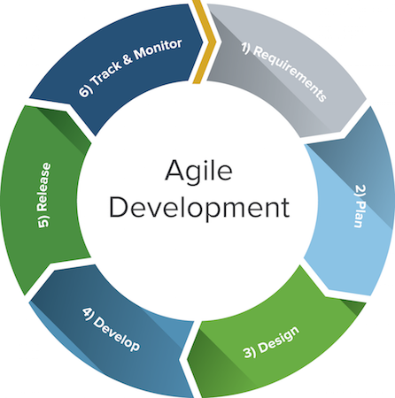

Figure 2: **Agile Development Methodology**

Figure 2 (Cryptex Technologies Pvt Ltd, 2016), demonstrates the framework lifecycle in an agile development methodology. Agile approaches are typically used in software development to help businesses respond to unpredictability. This methodology provides opportunities to assess the direction throughout the development lifecycle. This is accomplished through standard flows of work, known as sprints or cycles, toward the finish of which groups must present a potentially transmittable product increment. This methodology focuses the team on the repetition of abbreviated work cycles as well as the functional product yield; agile methodology is described as iterative and incremental.

The developers did the following phases of the Agile Methodology:

**Requirement Analysis.** Define the requirements for the iteration based on the product backlog, sprint backlog, customer and stakeholder feedback.

For this section the features of the system are gathered by doing research, interviews with experts in the industry specifically in the related fields. The UI designer and the programmer will identify the software requirements needed for the system to fulfill the features. The technical writer will take note of the changes made. The technical writer will then validate this with all the team members. The database designer will then verify with the materials if the features are compatible. The project manager will report to the team’s adviser about the adjustments made by the team.

For the next iterations, the team members assigned to work on the blockers will analyze the problem and come up with a possible solution. They will consult with the other members for possible solutions. The team members will make a report on their progress at the end of each day.

**Plan Phase.** Planning phase involves creating a set of plans that helped in guiding the team through the execution and closure phases of the project. The plans created during this phase helped the developers to manage time, cost, quality, change, risk, and issues to ensure that the developers delivered the project on time and within budget.

**Design Phase.** In the designing phase, the requirements that the developers had analyzed and identified were used to make design choices using various diagrams. The UI designer will design the screen layouts for the user interface. The programmer and database designer will define the interfacing mechanism for the system components. The project manager will check on the progress of the tasks of the members. In this phase, the researchers will identify the different hardware used for the project.

**Development Phase.**In this phase, all aspects of the product will be tested for functionality and performance. The product will be verified if it contains all the requirements laid out in the requirements analysis and if it accurately processes the data.

The developers tested the program, process it, then recognized the issues and revised or changed the issues that fall outside of set up measures or necessities. Hardware components are tested also independently and physically to guarantee that it has the capacity to build the necessary information integrated in the mobile application for the notice of the end clients. Each part of the activity experienced a progression of individual testing through various testing techniques to guarantee its effectivity and productivity before deployment.

**Release.** Before releasing it out to the market, developers did several activities on testing the device and the application so that it passes through the required process. This involves requirements for the system to operate with tolerable performance and precise processes within each activity of the deployment process. After that, developers installed the application into the client environment with the help of guidelines provided in the deployment document.

**Track and Monitor.** In this phase, after the system has been sent out to the customers/clients. The developers keep track, monitor and provide IT support services to include improvement and upgrade of the device and application if necessary.

**Planning/Conception-Initiation Phase**

In this section, high-level decisions are made regarding why a project is needed, whether or not it can be done, and what is needed.This helped the researchers to keep track of their assigned tasks in fulfilling the specified time, the progress of each requirement and task, and the budget with project work plans.

**Business Model Canvas**

The Business Model Canvas is a visual representation of current or new business models,

generally used by strategic managers.

**Table 2**

BUSINESS MODEL CANVAS

|  |  |  |  |  |  |
| --- | --- | --- | --- | --- | --- |
| **Key Partners** | **Key Activities** | **Value Proposition** | | **Relationships** | **Customer Segment** |
| -Offices  -Schools  -Paper Manufacturers  - Partner Stores | -Design and develop a machine that collects paper waste | -Users could Earn Redeemable Points from the machine  -Users could store their gained points to the application  -A Notification alert will be send for the containers status | | -User Account  -User Feedbacks  -Email | -General Individuals  -Office Employees  -Students |
| **Key Resources** | **Channels** |
| -Hardware Suppliers  -Electronics Engineers  -Software Engineers and Testers/Analyst  -UI Designers  -Database Designers | -Social Media Marketing |
| **Cost Structures** | | | **Revenue Streams** | | |
| -Design and Construction  -Support and Maintenance | | | -Direct Selling  -Partnership | | |

Table 2 illustrates the system’s Business Model Canvass. The Business Model Canvass is essential in building a successful business market. This will give the researchers concrete ideas about the system’s target market and the cost in developing it. Value propositions will illustrate the necessity of the system and show its value to the community. Channels are a way for the team to market the system at the same time to communicate with buyers and investors. Customer relations will make sure we maintain our business relationship will the entities involved and Revenue streams show how we can gain income from the products and services offered.

**Program Workflow**

A program workflow is to define, control, automate and improve business processes. Progressions of steps (tasks, events, interactions) that comprise a work process, involve two or more persons, and create or add value to the organization's activities.

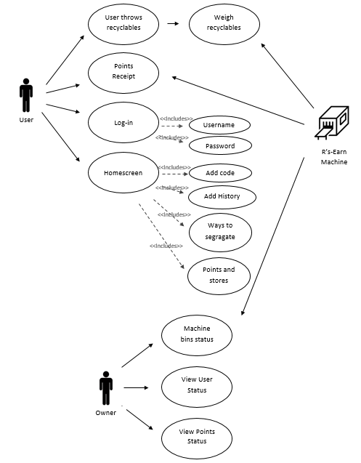

Figure 3: **User Activity Program Workflow**

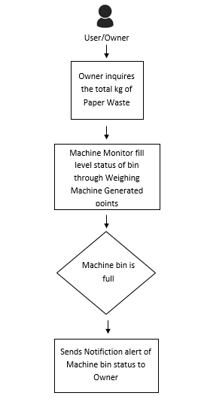

Figure 4: **Notification Activity System Workflow**

Figure 3 and 4 is Program Workflow of R’s-Earn. It shows the flow of the functionalities of the system in . It also shows the limitations of the different roles. It show the User Activity System Wokflow it starts with user’s authorixation, If it is valid it proceeds to the different modules shown in the diagram. In Notification Activity System Workflow shows the owner side. In this process the owner will get the machine bins status, user status, user points status.

**Table 3**

Validation Board

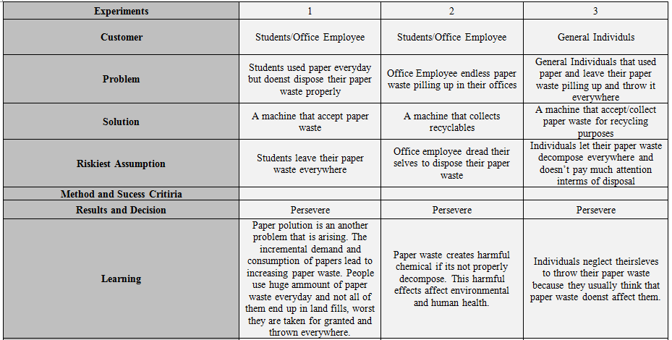

Table 3 shows the different problems that our customers encountered. It also shows the solution that the researcher will use to solve the problem. Table 3 also contains the riskiest assumption, the methods and success Criteria, also the reuslts and decision and also the learning.

**Gantt Chart**

This section presents a Gantt chart that demonstrates the measure of work done or activities that were completed in specific timeframes in relation to the amount planned for the specified periods. The completion of each activity is represented in three different colors: red means the activity is still incomplete, yellow means the activity is still on the process, and green means the activity is already complete. This chart serves as a basis for the proponents to assess how long a project should take, determine the resources needed, and plan the order in which the researchers’ complete tasks.

**Table 4**

Gantt Chart

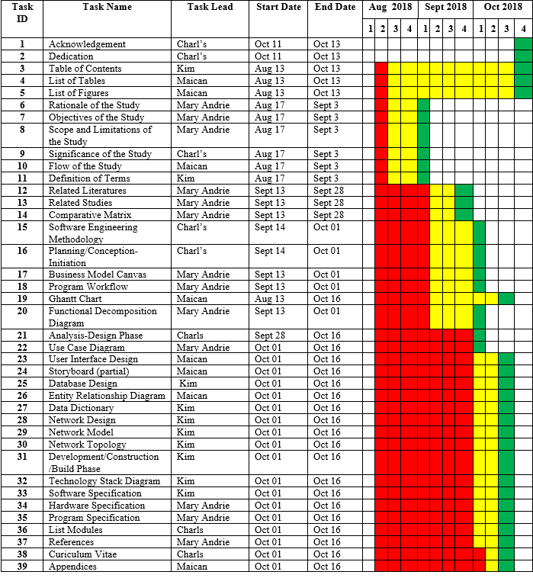

**Legends:**

* **Incomplete**
* **Going**
* **Complete**

Table 4 : **Gantt Chart- Documentation Phase**

Table 4 shows the list of task and activities completed during the days within the time frame with the corresponding start and end date. And the activities shows on the table are in the requirements analysis, planning, to design, to develop, and to track the study.

**Functional Decomposition Diagram**

This section shows the functional relationship of the different components of the project decomposed into important modules in order to clearly illustrate and simplify different activities. The tasks in turn are broken down into simpler details.

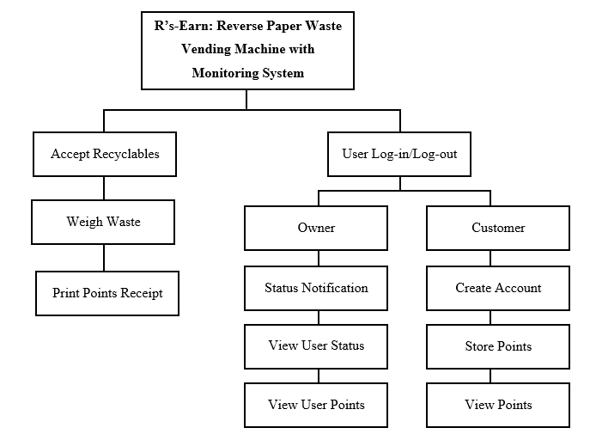

Figure 5: **Functional Decomposition Diagram**

Figure 5 shows beginning processes of the system. It visualizes what the proposed system is able to perform. The machine is applicable for any user and collector. On the machine the user needs to insert paper waste, after inserted, the machine will weigh the paper waste and the user need to press the submit button to get the receipt print out for redeeming points that is use for accesing the form of reward.On the software an application is used to monitor the machine bin status, user and points.

The notification system is on the owner’s side. The machine is connected to the application.The application is used for monitoring and notification for machine bin status. The user also uses the application for storing points and viewing the other feature most specifically the reward and points.

**Analysis / Design Phase**

The analysis phase covers the definition of requirements that are needed for the system to be accomplished. This phase defines the problem that the customer is trying to solve.

**Use Case Diagram**

Use case diagram exhibits the graphic representation of the R’s-Earn process and

possible sequences of interactions between systems and users in a particular environment and

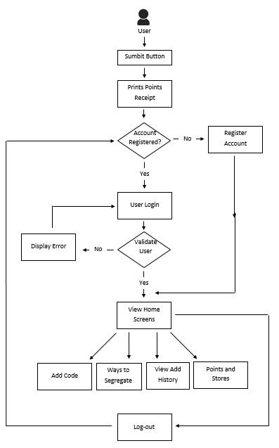related to a particular goal.

Figure 6 : **Use Case Diagram**

Figure 6 shows the graphical representation of how the system works. The use case diagram presents the flow of the business process of the proposed system with the modules and the external entities involved. The diagram consists of an actor who will complete the flow of the mobile notification system that corresponds to the next action that will happen. The user is involved in creating and storing data for the machine main features.

**Storyboard**

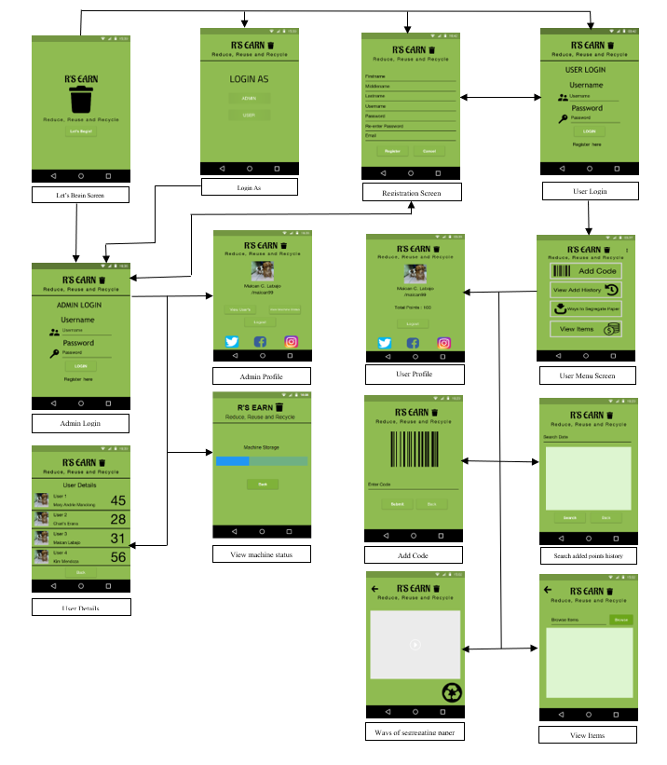Figure 7 : **R’s Earn Story Board**

R’s Earn presents the organized visual story wherein the person first Login as what he/she wants, the admin or the user. After picking the decide option the person will see the logging in screen based on the option he/she picks. If the person clicks the admin then it will focus on the admin side and if the person clicks the user side then it will focus on the user side. In the admin side, the admin can login the account that is generated and then after that the admin will see the admin profile in which the admin can see the buttons that are use to monitor the user and the machine. And in the other hand, the user part can log in the user account after the registration. If the user and the admin had already an account then they can login right away if not then they will register. The user also can see its profile and the total points that are added to its account. There is the menu in which the user can add the code that is generated by the machine, can view the added points history, can watch videos on youtube on how to segregate papers and also, they can view items base on the inputted points they write.

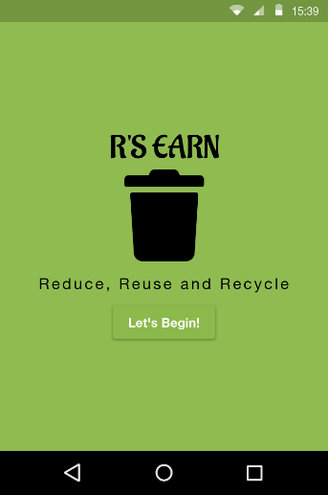**User Interface Diagram**

Figure 8 : **Begin Screen**

Figure 8 shows the Begin Screen. It displays the button “Let’s Begin” which is use to be the first page of the application. Once the button is press it will goto the next page which is the Login As screen.

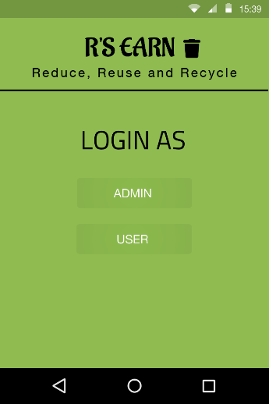Figure 9: **Login As**

The Login As screen shows the options whether the person will log in as Admin or the user. If the person has the machine then he/she will login as Admin and if the person doesn’t have the machine then he/she will login as user.

**Login as Admin**

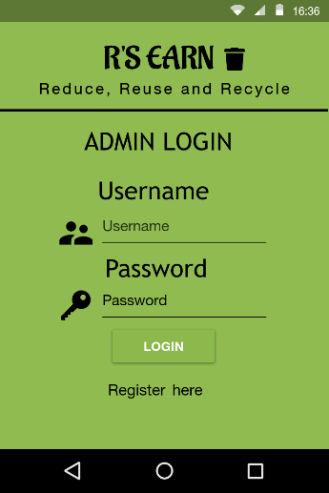

Figure 10 : **Admin Login**

The admin login screen shows the username and the password. And also, the person can register if he/she doesn’t have an account.

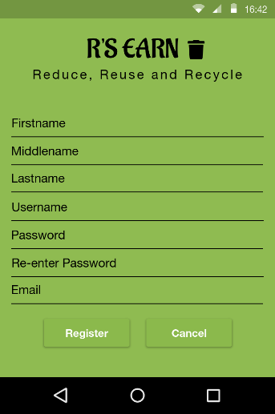

Figure 11 : **Registration Screen**

Figure 11 registration screen shows the registration form where the person can add its basic information like firstname, middlename, lastname, and etc. And also, the person can add its username and the password.

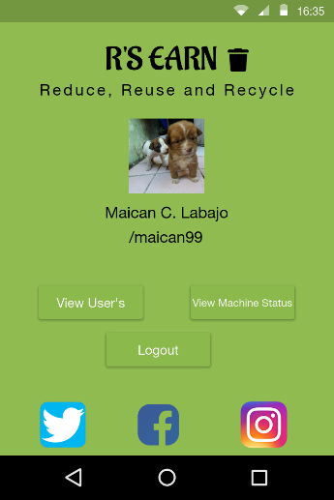

Figure 12 : **Admin Profile**

This is where the admin can view the user’s and view the machine status and also the admin can add his social media accounts.

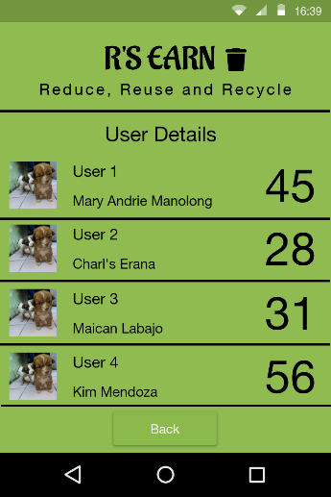

Figure 13 : **User Details**

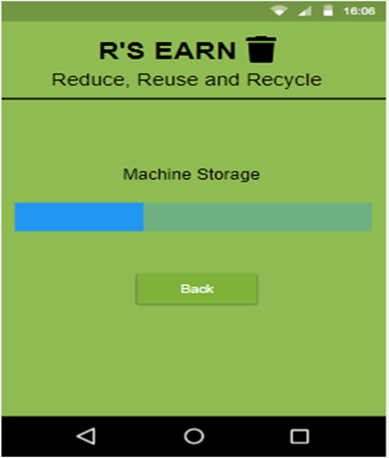Figure 13 user details shows all the users of the machine and their corresponding points and names.

Figure 14: **View machine status**

This is where the admin can watch the status of the machine’s storage if it is full or not. Both of the machine was monitored.

**Login as User**

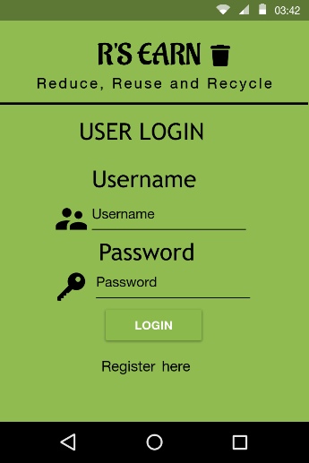

Figure 15 : **User Login**

User login is where the user will login his/her account in order to be logged in as the user and also the user can register.

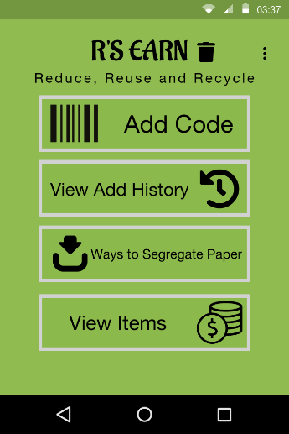

Figure 16 : **User Menu Screen**

This user menu screen shows the user’s menu where it can add the code, view the added code history, can watch videos on how to segregate papers and view items available of their points. And also, the user can view its profile.

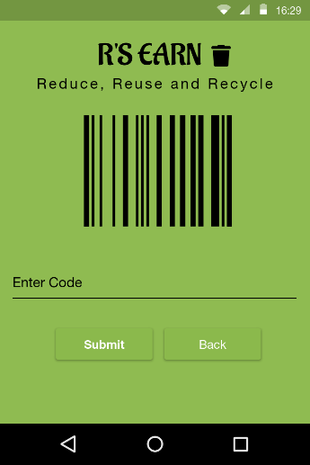

Figure 17 : **Add Code**

This figure shows that the user can add its code generated by the machine.

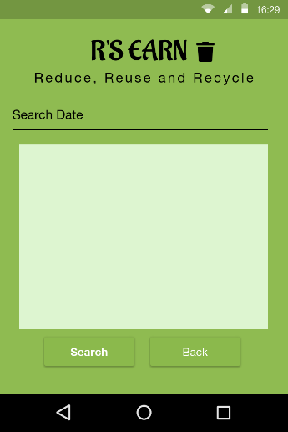

Figure 18 : **Search added points history**

Figure 18 search add history shows that the user can search the date he/she wants and the table will display all the list of added points and the specific points based on the searched date.

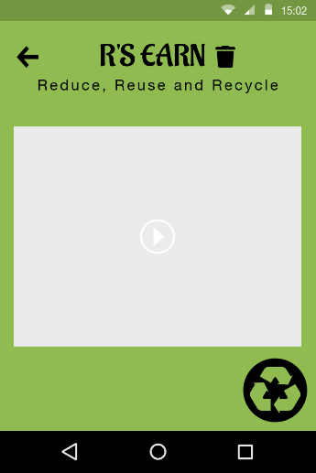

Figure 19 : **Ways of segregating paper**

This figure shows that the user can watch youtube videos on ways of segregating papers. User can pick videos on youtube.

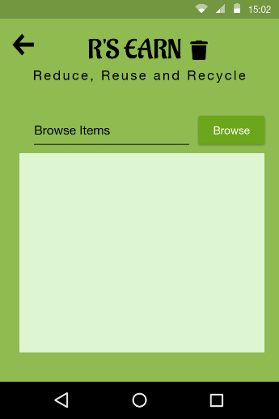

Figure 20 : **View Items**

This figure shows that the user can add specific points and browse items based on the users add points. The items will be displayed on a table.

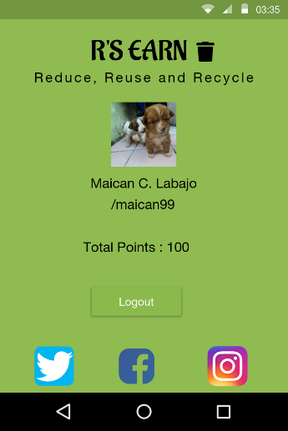

Figure 21: **User Profile**

Figure 21 user profile is where the user can see the total points he/she gained after adding it. And like the admin profile the user also can add its social media account, can view its basic information’s.

**Database Design**

This section exhibits the relationship of every table through its key information. Each database design table has corresponding keys which will be used to retrieve the contents of the tables. In relational databases‟ environment, primary key is a unique identifier, and cannot contain a null value. Foreign key, or the secondary key, is often a primary key of another table which links a table to another table.

**Table 5**

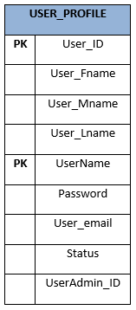

Table 5 shows the user’s profile information which is composed of User_ID, User_Fname, User_Mname, User_Lname, UserName, Password, User_email, Status, UserAdmin_ID. User_ID is a unique number ID for identification purpose of the user, the UserName is also primary key for the purpose of not duplicating entries when logging in to the application. The UserAdmin_ID is the admin’s ID. This table holds the recorded information of the user.

**Table 6**

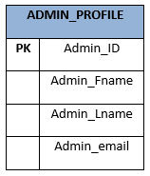

Table 6 shows the admin profile information which is composed of Admin_ID, Admin_Fname, Admin_Lname, Admin_email. The Admin_ID is the primary key of the table, a unique number ID for identification purpose of the admin.

**Table 7**

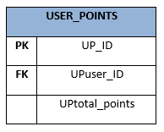

Table 7 shows the user’s points reference which is composed of UP_ID, UPuser_ID, UPtotal_points. UPuser_ID is the user’s ID which can be found in the User_Profile table. The UPuser_ID will be the reference to which user is the Total_Points belongs to. The UP_ID is the primary key of this table

**Table 8**

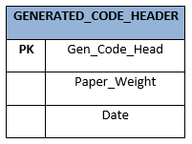

Table 8 shows where the generated code will be stored which is composed of Gen_Code_Head,Paper_Weight, Date. The Gen_Code_Head is the the code that is uniquely generated for the user after using the machine which they can put to the application to add points to their accounts and this is also the primary key of the table.

**Table 9**

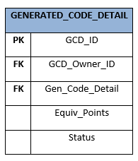

Table 9 shows the equivalent points given to the generated code which is composed of GCD_ID, GCD_Owner_ID, Gen_Code_Detail, Equiv_Points, Status. GCD_Owner_ID is the ID of the user which is the one who successfully claimed and redeemed the code to the application, while the Gen_Code_Detail will be the reference of which user and code the points belongs to. The status will tell if it is already redeemed or not. The GCD_ID is the primary key of this table.

**Table 10**

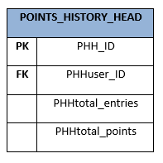

Table 10 shows the points history of the user which is composed of PHH_ID, PHHuser_ID, PHHtotal_entries, PHHtotal_points. The PHHuser_ID is the user’s ID, PHHtotal_entries is the number of the user’s points history. The PHH_ID is the unique number for identification. The PHH_ID is the primary key of this table

**Table 11**

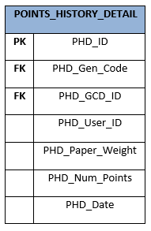

Table 11 shows the information of each code that the user successfully redeemed which contains PHD_ID, PHD_Gen_Code, PHD_GCD_ID, PHD_User_ID, PHD_Paper_Weight, PHD_Num_Points, PHD_Date. The PHD_Gen_Code and the PHD_GCD_ID will be the foreign key to connect to the GENERATED_CODE_HEADER and GENERATED_CODE_DETAIL to get the necessary data.

**Entity-Relationship Diagram**

This section shows the relationship of entities involved in Reverse Paper Waste Vending Machine with Monitoring System. Each relationship is represented by arrows.

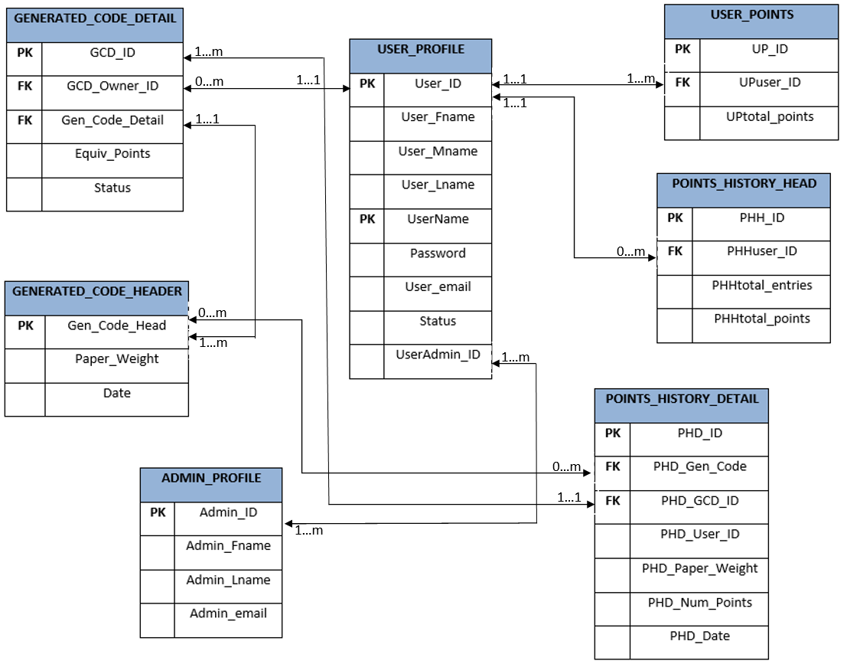

Figure 22: **Entity Relationship Diagram**

Figure 22 shows the relationship of the tables in the database. The admin can see who the user are. The users can add points using the code they get after using the machine. The code can be redeemed for points using the application. The user can also see the point history, this will track all the codes you redeemed and how many points did you received on that code. The users can also see their profile showing their name, total points and picture.

**Data Dictionary**

This section describes the data types, properties, and size of the fields in the tables shown in the previous section.

**Table 12**

User Profile Data

|  |  |  |  |  |  |
| --- | --- | --- | --- | --- | --- |
| **Table Name** | **Column Name** | **Data Type** | **Size** | **Null** | **Description** |
| USER_PROFILE | User_ID | INT | - | No | Primary key of this table |
| User_Fname | VARCHAR | 40 | No | User’s first name |
| User_Mname | VARCHAR | 40 | Yes | User’s middle name |
| User_Lname | VARCHAR | 40 | No | User’s last name |
| UserName | VARCHAR | 40 | No | User’s chosen username |
| Password | VARCHAR | 30 | No | User’s password |
| User_email | VARCHAR | 40 | Yes | User’s e-mail |
| Status | CHAR | 15 | No | User’s status  AC- Active IN- Inactive |
| UserAdmin_ID | INT | - | No | User’s admin holder |

Table 12 presents the fields of user profile. This stores all the information about the user. These informations will be later used in the other tables. User_ID and UserName are the primary keys of this table.

**Table 13**

Admin Profile Data

|  |  |  |  |  |  |
| --- | --- | --- | --- | --- | --- |
| **Table Name** | **Column Name** | **Data Type** | **Size** | **Null** | **Description** |
| ADMIN_PROFILE | Admin_ID | INT | - | No | Primary key of this table |
| Admin_Fname | VARCHAR | 40 | No | Admin’s first name |
| Admin_Lname | VARCHAR | 40 | No | Admin’s lastname |
| Admin_email | VARCHAR | 40 | Yes | Admin’s e-mail |

Table 13 presents the fields of admin profile. This stores the information about the admin. Like admin’s first name,admin’s middle name, and admin’s last name. This will be the basis if the admin is registered.

**Table 14**

User Points Data

|  |  |  |  |  |  |
| --- | --- | --- | --- | --- | --- |
| **Table Name** | **Column Name** | **Data Type** | **Size** | **Null** | **Description** |
| USER_POINTS | UP_ID | INT | - | No | Primary key of this table |
| UPuser_ID | INT | - | No | User’s ID from the USER_PROFILE table |
| UPtotal_points | INT | 100 | Yes | User’s total points |

Table 14 presents the fields of user’s points. This table stores the points of the corresponding user. This will store how many points the user has. This will be used in the profile page of the application.

**Table 15**

Generated Code Header Data

|  |  |  |  |  |  |
| --- | --- | --- | --- | --- | --- |
| **Table Name** | **Column Name** | **Data Type** | **Size** | **Null** | **Description** |
| GENERATED_CODE_HEADER | Gen_Code_Head | INT | - | No | Primary key of this table |
| Paper_Weight | DECIMAL | 100 | No | Paper’s Weight |
| Date | DATE | FIXED | No | Date the Code generated |

Table 15 presents the fields of generated code header. This contains the code generated by the system which will be used by the user to add points to a account. This also has the paper’s weight and the date the code generated. This table will be also the basis of the generated code detail.

**Table 16**

Generated Code Detail Data

|  |  |  |  |  |  |
| --- | --- | --- | --- | --- | --- |
| **Table Name** | **Column Name** | **Data Type** | **Size** | **Null** | **Description** |
| GENERATED_CODE_DETAIL | GCD_ID | INT | - | No | Primary key of this table |
| GCD_Owner_ID | INT | - | No | ID of the user who redeemed the code |
| Gen_Code_Detail | INT | - | No | Reference to the GENERATED_CODE_HEADE table |
| Equiv_Points | INT | 100 | No | Equivalent points to the code |
| Status | CHAR | 15 | No | Generated code status |

Table 16 presents the fields of generated code detail. This holds the details of the code generated by the system which will be the basis of the other tables. This will also store the equivalent points that the corresponding code has.

**Table 17**

Points History Header Data

|  |  |  |  |  |  |
| --- | --- | --- | --- | --- | --- |
| **Table Name** | **Column Name** | **Data Type** | **Size** | **Null** | **Description** |
| POINTS_HISTORY_HEAD | PHH_ID | INT | - | No | Primary key of this table |
| PHHuser_ID | INT | - | No | User’s ID which will be the basis to which the codes belong to |
| PHHtotal_entries | INT | 100 | No | Total of entries in the user’s points history |
| PHHtotal_points | INT | 100 | Yes | Points history total value |

Table 17 presents the fields of point’s history header. This holds the number of entries and total points of the user’s point history. This table will be also the basis of the point’s history detail. This will also the basis on how much are the code and the total of the codes the user acquired.

**Table 18**

Points History Detail Data

|  |  |  |  |  |  |
| --- | --- | --- | --- | --- | --- |
| **Table Name** | **Column Name** | **Data Type** | **Size** | **Null** | **Description** |
| POINTS_HISTORY_DETAIL | PHD_ID | INT | - | No | Primary key of this table |
| PHD_Gen_Code | INT | - | No | Reference to get the necessary data in GENERATED_CODEHEAD |
| PHD_GCD_ID | INT | - | No | Reference to get the necessary data in GENERATED_CODE_DETAIL |
| PHD_User_ID | INT | - | No | User’s ID |
| PHD_Paper_Weight | DECIMAL | 100 | No | Total Weight of the corresponding code |
| PHD_Num_Points | INT | 100 | No | Equivalent points given to the code |
| PHD_Date | DATE | FIXED | No | Date of when the code generated |

Table 18 presents the fields of point’s history detail. This contains the detailed information about the code which the user successfully redeemed. The user can track the codes he inputted whenever needed and also for security purpose.

**Architectural Design**

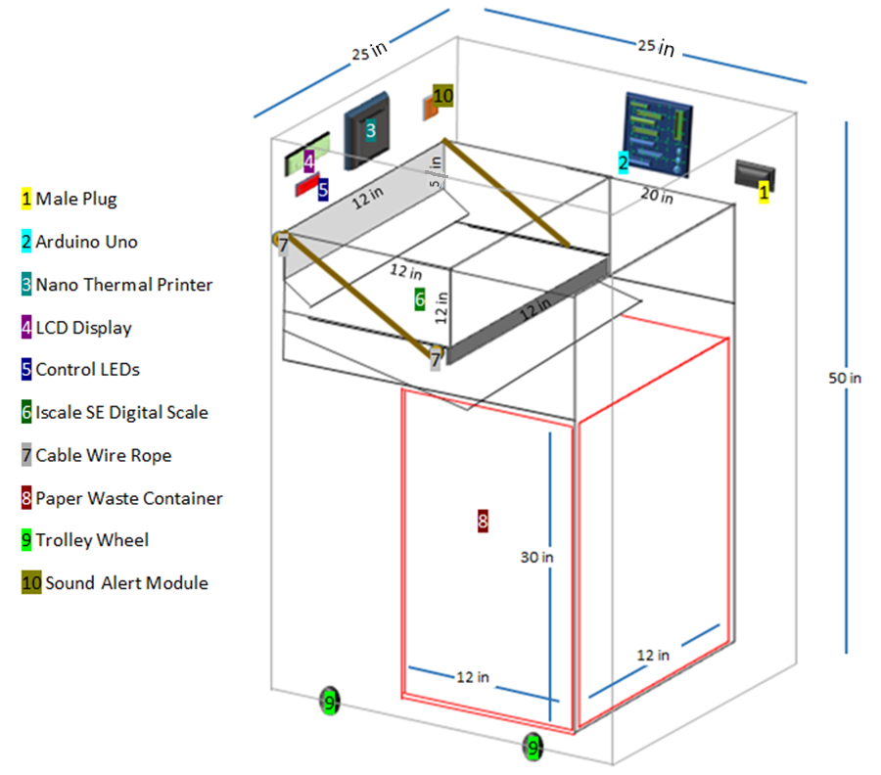

Figure 23 : **Architectural Design of the R’s-Earn Proposed Project**

Figure 23 shows the hardware architectural design of R’s-Earn. The figure shows the integration of the hardware devices. Control Leads ,Nano Thermal Printer,Sound Sensor Module,Iscale SE Digital Scale, Arduino Uno are combined and placed inside a container. Arduino Uno is integrated with the other hardware which made the connection between the device and application possible. The Control Leads with an Arduino Uno are connect with other parts , through connecting wires. It is placed outside the container for the submit button, this process is recquired to put the recyclables to bin. The Iscale SE Digital Scale is used to get the weight of recyclables to generate points, Nano thermal printer for the points print out, sound sensor module is for user alert if the recyclables already reaches the maximum kg per load.

**Network Model**

The network model shows how the components of the system communicates through the internet. The diagram shows the user can check and monitor their account for possible breach or errors through application.

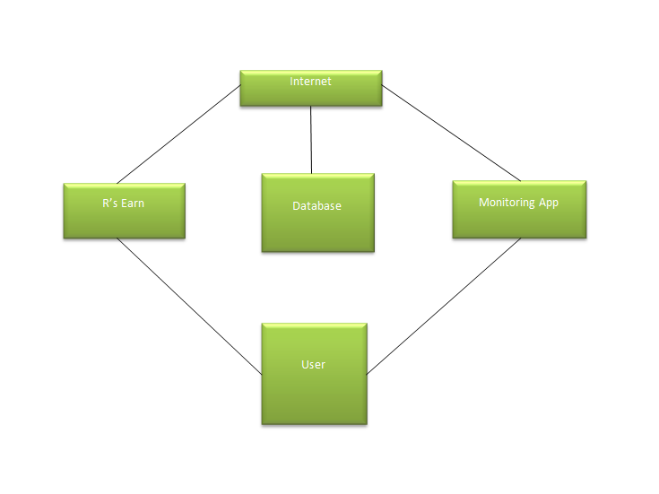

Figure 24 : **Network Model**

Figure 24 shows the network model of the system. Internet is used for the both hardware and software to interact with the database. The monitoring application connects the internet to interact with the database while the machine connects also to the internet to get the necessary data.

**Network Topology**

The network topology shows how both the hardware and the software part of the system works together with the use of internet connection to access the database for the user’s access.

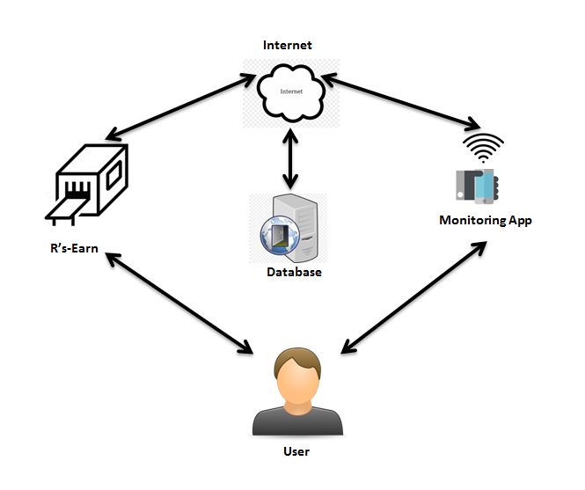

Figure 25: **Network Topology**

Figure 25 shows the network topology of the system. As shown the user can use the monitoring application with different functionalities. Including adding points to their account, which they get after using our machine and in turn communicate to the network through internet connection which in turn is connected to a database for the user’s access.

**Development/Construction/Build Phase**

The Development Phase marks the end of the initial section of the process and signifies the start of production. The purpose of this phase is to convert the system design prototyped in the Design Phase into a working system that addresses all documented system requirements. To complete this phase successfully, two elements are required: 1) a complete set of design specifications and 2) proper processes, standards, and tools.

**Technology Stack Diagram**

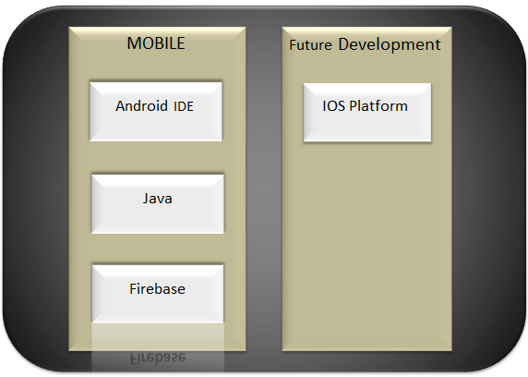

Figure 26 : **Technology Stack Diagram**

**Technology Stack for Mobile**

**Android Integrated Development Environment (IDE)** is a software application that allow programmers to develop an Android application. This is where the programmers code their apps. In Google’s Android operating system, Android Studio is the official IDE which is designed exclusively for Android development.

**Java** is a programming language used to create applications. It requires a software platform to execute programs. In this study, the software platform that will be utilized is the Android SDK which is used in developing Android applications.

**Firebase** is a web and mobile development platform that enable developers to create great applications quickly and easily. It offers the following various services which were expanded by Google: Analytics, Cloud Messaging, Authentication, Real-time Database, Storage, Hosting, Remote Config, Test Lab, Crash Reporting, Notifications, App Indexing, Dynamic Links, Invites.

**Technology Stack for Future Development**

**IOS Platform** is a mobile operating system that is exclusively for Apple’s product such as iPhone and iPad. In iOS mobile application development, developers’ uses iOS SDK is used. iOS SDK is free on all Mac users. Mac computers are also needed to develop iOS applications.

**Software Specification**

This section explains the functional requirements that were used on the study. This includes programming language, mobile development platform and the database management.

Android IDE was used on the mobile application development of the study. The application will run on most Android mobile devices specifically those with Android 5.0 Lollipop up to the latest version .The programming language that was used is Java. Firebase was used for the application’s authentication and database.

**Hardware Specification**

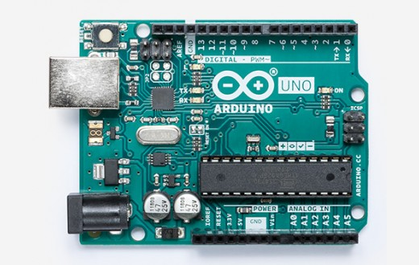Herein listed, with their description and specifications, are the hardware components to be used by the system.

Figure 27 : **Arduino Uno Rev3 WiFi**

This serves as the processing unit of the system. The board is based on the ATmega328P (datasheet) with an ESP8266 Wi-Fi Module integrated (datasheet). It has 14 digital input/output pins (of which 6 can be used as PWM outputs), 6 analog inputs, a 16 MHz ceramic resonator, a USB connection, a power jack, an ICSP header, and a reset button. The ESP8266 module is a self-contained SoC with a TCP/IP protocol stack.

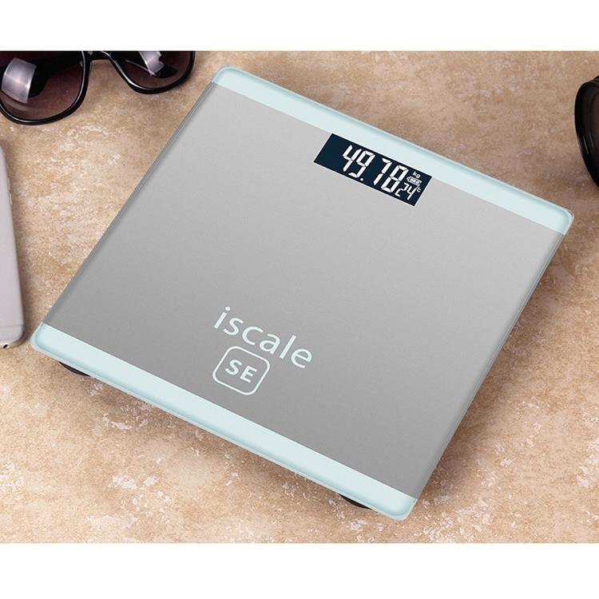

Figure 28 : **Iscale SE Digital Scale**

Iscale Weighing Machine body weight measuring electronic digital scale 180kg with LCD display, Built-in smart gravity sensor system, and High precision sensors provides more accurate measurements.

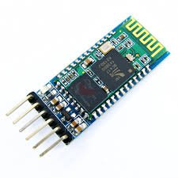

Figure 29 : **Bluetooth Module HC-06**

A Bluetooth module, HC-06. This provides a wireless communication between Arduino and Bluetooth capable smartphone. This is used to send and retrieve data from Arduino and vice versa. These data are sent to the Android application through Bluetooth within the range of 10 meters and vice versa.

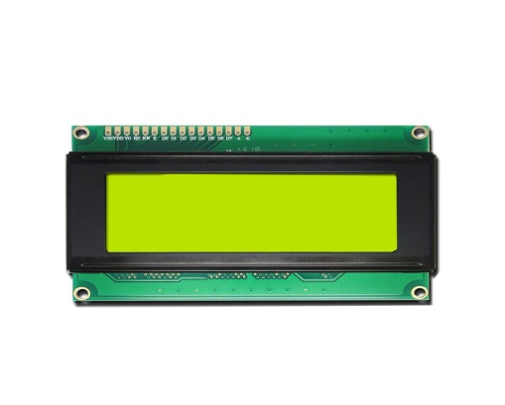

Figure 30 : **LCD display**

This is to be mounted on the devices for monitoring purposes outside the application. It features a basic 16x2 character display for simple readings.

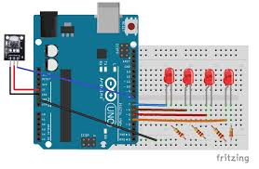

Figure 31 : **Control LEDs with an Arduino**

This will communicates with modules and sensors by switching on and off electrical current. It’s very similar to the one’s and zero’s in binary code. When current is switched on, it’s known as a “HIGH signal”. That’s comparable to the “one” in binary code. When the current is switched off, that’s a “LOW signal”, which is similar to the zero in binary code. The length of time the current stays on or off can be changed from a microsecond up to many minutes.

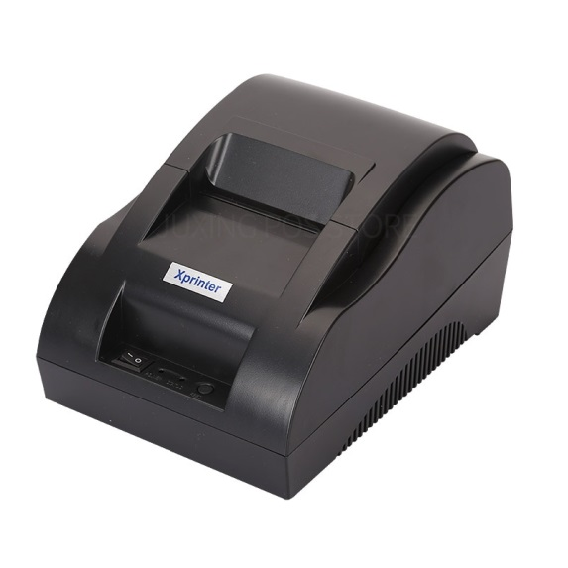

Figure 32 : **Thermal Receipt Printer**

This printer is ideal for interfacing with a microcontroller, you simply need a 3.3V-5V TTL serial output from your microcontroller to print text, barcodes, bitmap graphics, even a QR code.

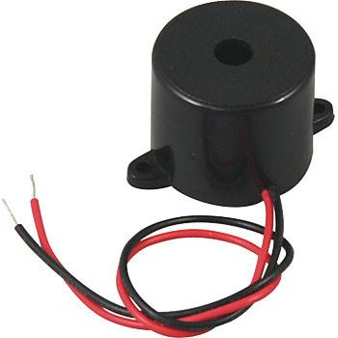

Figure 33: **Electronic Buzzer**

Figure 33 shows a electronic buzzer. This is used to alert user if the maximum kg exceeded. A buzzer or beeper is an audio signalling device, which may be mechanical, electromechanical, or piezoelectric (piezo for short). Typical uses of buzzers and beepers include alarm devices, timers, and confirmation of user input such as a mouse click or keystroke.

**Program Specifications**

Program specifications contain the list of algorithms needed for the system.

**Table 19**

SOFTWARE LIST OF MODULES

|  |  |  |
| --- | --- | --- |
| Programmer(s) | Modules | User |
| Charl’s Dave Erana | **Database Management** |  |
| Insert |  |
| Update |  |
| Delete |  |
| Retrieve |  |
| No. of points(1 point per module per user) | | 1 |
| Maican Labajo | **User Account** |  |
| Retrieve |  |
| Update |  |
| Activate |  |
| No. of points(1 point per module per user) | | 1 |

**Table 19.1**

SOFTWARE LIST OF MODULES cont’d

|  |  |  |
| --- | --- | --- |
| Charl’s Dave Erana | **User Registration** |  |
| Create |  |
| Retrieve |  |
| No. of points(1 point per module per user) | | 1 |
| Maican Labajo | **Admin Account** |  |
| Update |  |
| Activate |  |
| Retrieve |  |
| No. of points(1 point per module per user) | | 1 |
| Maican Labajo | **Code of receipt** |  |
| Add |  |
| Retrieve |  |
| No. of points(1 point per module per user) | | 1 |

**Table 19.2**

SOFTWARE LIST OF MODULES cont’d

|  |  |  |
| --- | --- | --- |
| Kim Mendoza | **Network Topology** |  |
| Installation |  |
| Maintenance |  |
| No. of points(1 point per module per user) | | 1 |
| Total Number of Modules | | 6 |

Table 19 shows the list of modules, the assigned modules and tasks to corresponding programmers, according to their knowledge, and capabilities.

**Table 20**

HARDWARE LIST OF MODULES

|  |  |  |
| --- | --- | --- |
| **Programmer(s)** | **Modules** | **User** |
| Mary Andrie Van Manolong  Charl’s Dave Erana  Maican Labajo  Kim Mendoza | **R’s Earn** |  |
| 1.Connect Control LEDs with Arduino to Sensors |  |
| 2. Connect Control LEDs to thermal printer and cable laying for weighing machine |  |
| 3. Connect thermal printer to Arduino Uno |  |
| 4. Connect Arduino Uno sensor and weighing machine |  |
| 5. Connect Arduino Uno and Contact image sensor |  |
| 6. Connect Roller kit |  |
| 7. Connect SD card module to Arduino |  |
| 7. Program Arduino sketch |  |
| 9. Upload Algorithm to Arduino |  |
| No. of Points (1 point per module per user) | | 1 |
| Total Number of Modules | | 1 |

Table 20 shows the hardware list of modules. It represents the processes or the task inorder to complete the hardware requirements and the respective persons who are assigned to do the tasks. The hardware list of modules will guide the team members of what are the step – by – step processes of the hardware system. The team members assigned to a specific module will make a progress report about the modules.

**REFERENCES**

Adshead,R. (2014, March 8) *6 Scary Paper Waste Facts* Retrieved from:<https://blog.mesltd.ca/6-scary-paper-waste-facts>

Dai,Z.(2012, December 3) *The Negative Impacts Of Paper On The Environment* Retrieved from: <https://prezi.com/trkgff33bsue/the-negative-impacts-of-paper-on-the-environment>

D'Arcy,K. (2014, November 21 )*The 8 Most Eye-Opening Facts about Paper Waste* Retrieved from: <https://blog.mesltd.ca/the-8-most-eye-opening-facts-about-paper-waste>

Farah,V.(2017, May 17) *6 Scary Facts about Paper Use and Waste in the Average Office* Retrieved from: <https://scannmore.com/paperless-office-statistics>

Lights,Z.(2012, October 30) *The Ultimate Guide to Cutting Your Paper Waste* Retrieved from: <https://www.onegreenplanet.org/lifestyle/the-ultimate-guide-to-cutting-your-paper-waste>

Taylor,S.(2017, September 26) *Negative Effects of Paper Wastes* Retrieved from: <https://bizfluent.com/info-8299267-negative-effects-paper-wastes.html>

TheWorldCounts (2014, May 14).*Paper Waste Facts* Retrieved from: <http://www.theworldcounts.com/stories/Paper-Waste-Facts>

Wikipedia (2018, September 4 ) *Environmental impact of paper* Retrieved from: <https://en.wikipedia.org/wiki/Environmental_impact_of_paper>

**CURRICULUM VITAE**



**PERSONAL DATA**

**NAME** **:** Mary Andrie Van F. Manolong

**DATE OF BIRTH :** November 30, 1998

**ADDRESS :** Apas, Cebu City, Cebu, Philippines

**GENDER :** Female

**CIVIL STATUS :** Single

**RELIGION :** Roman Catholic

**CONTACT NUMBER :**

**EDUCATIONAL BACKGROUND**

**COLLEGE :** Bachelor of Science in Information Technology

University of Cebu – Banilad Campus

Banilad, 6000 Cebu City, Philippines

School Year 2015 – Present

**HIGH SCHOOL :** Apas National High School

Omega St, Apas, 6000 Cebu City, Philippines

School Year 2011 – 2015

**ELEMENTARY :** Lahug Elementary School

Gorordo Ave, Cebu City

School Year 2005-2011

**CURRICULUM VITAE**



**PERSONAL DATA**

**NAME** **:** Charl’s Dave M. Erana

**DATE OF BIRTH :** October 9, 1997

**ADDRESS :** Upper Bacayan, Cebu City,

Cebu, Philippines

**GENDER :** Male

**CIVIL STATUS :** Single

**RELIGION :** Roman Catholic

**CONTACT NUMBER :** 09553713233

**EDUCATIONAL BACKGROUND**

**COLLEGE :** Bachelor of Science in Information Technology

University of Cebu – Banilad Campus

Banilad, 6000 Cebu City, Philippines

School Year 2015 – Present

**HIGH SCHOOL :** Pit-os National High School

Pit-os, 6000 Cebu City, Philippines

School Year 2010 – 2014

**ELEMENTARY :** Bacayan Elementary School

Upper Bacayan, Cebu City, Philippines

School Year 2004-2010

**CURRICULUM VITAE**

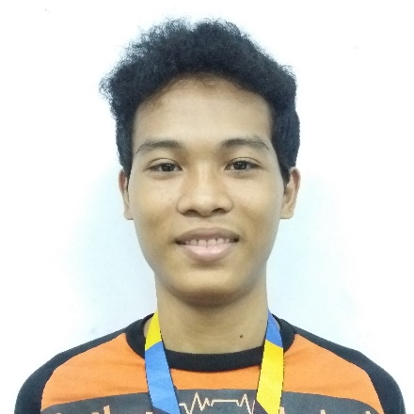**PERSONAL DATA**

**NAME** **:** Kim P. Mendoza

**DATE OF BIRTH :** September 18,1998

**ADDRESS :** M.L. Quezon Avenue Cabancalan

Mandaue City, Cebu

**GENDER :** Male

**CIVIL STATUS :** Single

**RELIGION :** Roman Catholic

**CONTACT NUMBER :** 09663572463/09223582814

**EDUCATIONAL BACKGROUND**

**COLLEGE :** Bachelor of Science in Information Technology

University of Cebu – Banilad Campus

Banilad, 6000 Cebu City, Philippines

School Year 2015 – Present

**HIGH SCHOOL :** Cabancalan National High School

M.L. Quezon Avenue Cabancalan,6014 Mandaue City, Philippines

School Year 2011 – 2015

**ELEMENTARY :** Cabancalan 2 Elementary School

M.L. Quezon Avenue Cabancalan,6014 Mandaue City, Philippines

School Year 2005-2011

**CURRICULUM VITAE**

**PERSONAL DATA**

**NAME** **:** Maican Labajo

**DATE OF BIRTH :** February 04, 1999

**ADDRESS :** 474 Lower Calvary Hills Brgy. Apas

Cebu City

**GENDER :** Male

**CIVIL STATUS :** Single

**RELIGION :** Roman Catholic

**CONTACT NUMBER :** 09176488571

**EDUCATIONAL BACKGROUND**

**COLLEGE :** Bachelor of Science in Information Technology

University of Cebu – Banilad Campus

Banilad, 6000 Cebu City, Philippines

School Year 2015 – Present

**HIGH SCHOOL :** Apas National High School

Omega St, Apas, 6000 Cebu City, Philippines

School Year 2011 – 2015

**ELEMENTARY :** Camp Lapu-Lapu Elementary School

Omega St, Apas, 6000 Cebu City, Philippines

School Year 2005 – 2011

**APPENDIX A**

**Censor’s Certificate**

University of Cebu

College of Computer Studies

Cebu City

Date: October 18, 2018

**CENSOR’S CERTIFICATE**

This is to certify that the undersigned has reviewed and went through all the pages of the proposed project study/ research manuscript titled “R’s-Earn: Reverse Paper Waste Vending Machine with Monitoring System” as against the set of structural rules that govern the composition of sentences, phrases, and words in the English language as well as the technical terms, syntax (format, etc.) and semantics appropriate for the Information Technology and Computing fields.

Signed: Conformed:

**MS. MIRIAM FLORES MARY ANDRIE VAN MANOLONG**

Grammarian Project Manager

Noted:

**MR. EDSEL C. PARAY**

Adviser