Hardware Part of the project:

Smart sensing for energy monitoring system for industrial refrigeration facilities comes with various sensors as part of the capstone project. We have included several sensors which are described below.

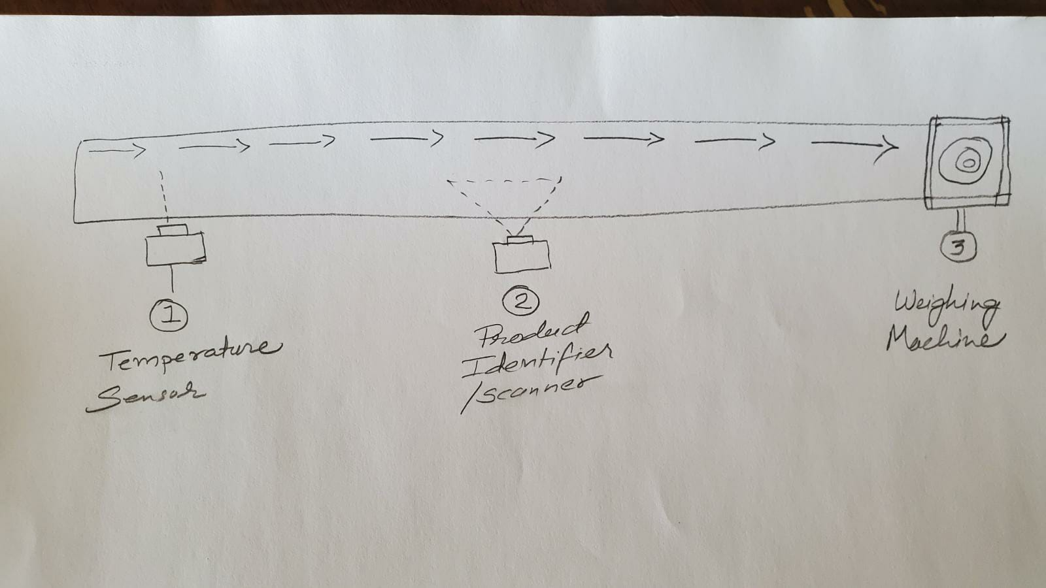

1. Temperature Sensor Unit :
We can do this unit with two different ways. On is with the thermal camera and the other with the long distance temperature sensor.
Thermal camera is also called Thermographic camera or Infrared camera which create images using infrared radiation. In this project we will be using this sensor to measure the temperature of the items which enters in the refrigeration area from the truck. This way we can save the time and the manpower at the same time.
In our capstone project we are going to use Grove – Thermal imaging camera/ IR Thermal sensor Array 32x24 (MLX90640). The camera can preset dynamic thermal images and detect temperature from -40*C to 300*C. It has 32x24 Array of thermal sensors. It has accuracy of ±1.5*C. It can measure the temperature from feet away.
The module can be interfaced with MCU with I2C protocol. However, the official website says that we can not interface this sensor with Arduino Uno because of not enough RAM.(seeed, n.d.)
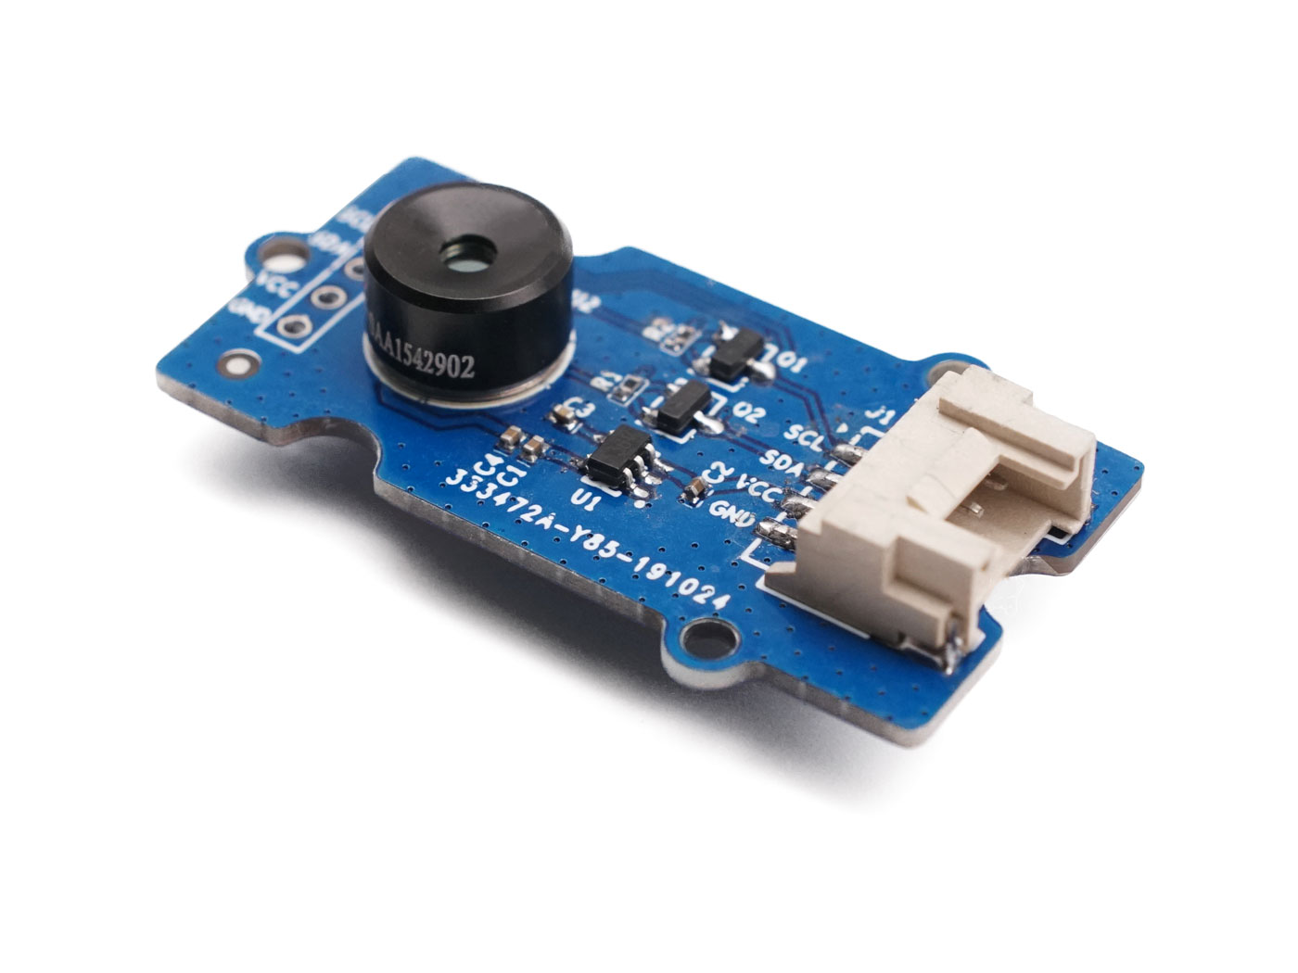

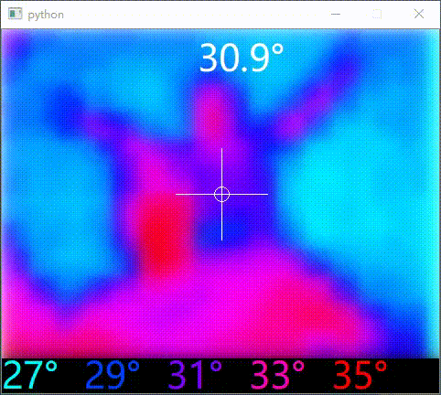

Good resolution cameras with large arrays can not be interfaced with Arduino Uno because of it’s lower calculating capabilities. In order to get the data from good quality temperature camera, we will have to use wifi module.(Spasov et al., 2019, #).
https://github.com/Seeed-Studio/Seeed_Arduino_MLX9064x#seeed-arduino-mlx90640--

2. Long range temperature sensor unit:
The other alternative as per the application is to use long range temperature sensor. The advantage to use this sensor over thermal camera are: This sensor is cheaper and the interfacing is less complicated.

2. Package identifier:

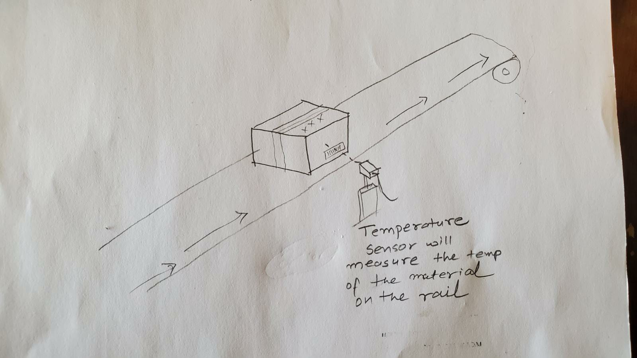
For package identifying purpose, we will be using Bar code scanner. Any USB barcode scanner is suitable to interface with Arduino with the help of USB host shield. We just have to attach USB host shield on the top of the Arduino. Then we connect USB port of barcode scanner to the USB host shield. Since we are using USB host shield, we have to install the USB host library to the Arduino.

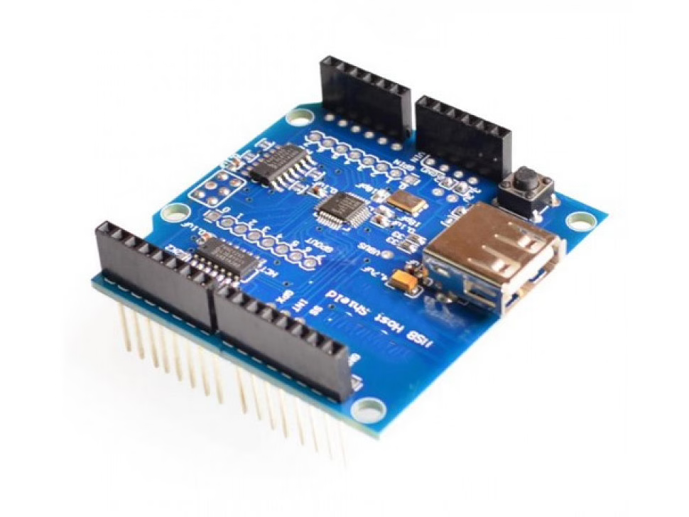
Fig: USB host shield

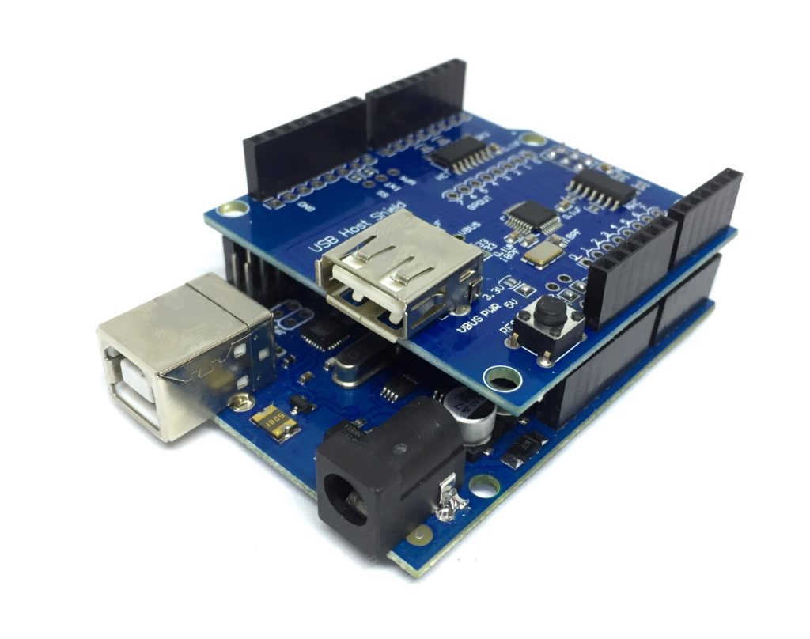
Fig: USB host shield connected to the Arduino

https://learn.circuit.rocks/barcode-scanner-integrated-to-arduino

3. Weighing unit :

The third unit is weighing unit. In this unit, in order to measure the weight of the product we use load cell. Load cell can be interfaced with the Arduino board with the help of different peripherals like ADC and amplifier.
For this purpose we use load cell and HX711 weight sensor module.
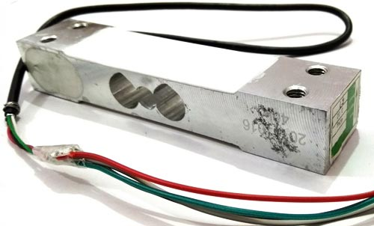

Fig: load cell

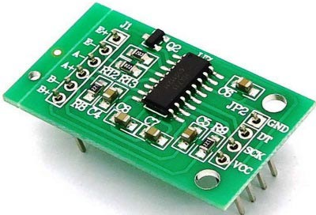

Fig: HX711 weight sensor module

Now the output of the load cell is in a few millivolts and then need to be further amplified by external source. To solve that problem, we use HX711 module. It amplifies low current output generated by the load cell. This module has inbuilt precise ADC as well as amplifier resistors.
This is how we can get weight readings from this unit and we can sent it further to the IoT cloud.
https://circuitdigest.com/microcontroller-projects/arduino-weight-measurement-using-load-cell

Referance:

seeed. (n.d.). Grove - Thermal Imaging Camera / IR Array MLX90640 110 degree. seeed. https://www.seeedstudio.com/Grove-Thermal-Imaging-Camera-IR-Array-MLX90640-110-degree-p-4334.html
Spasov, G. V., Tsvetkov, V., & Petyrova, G. (2019, September). Using IR array MLX90640 to build an IoT solution for ALL and security smart systems. https://www.researchgate.net/publication/336786254_Using_IR_array_MLX90640_to_build_an_IoT_solution_for_ALL_and_security_smart_systems

