**Functional Requirements Document**

**ZAM**

|  |  |  |  |
| --- | --- | --- | --- |
| **Version** | **Description of Change** | **Author** | **Date** |
|  |  |  |  |
|  |  |  |  |

**CONTENTS**

1 INTRODUCTION 4

1.1 Purpose 4

1.2 Scope 4

1.3 Background 4

1.4 References 4

1.5 Assumptions and Constraints 4

1.6 Document Overview 5

2 METHODOLOGY 6

3 FUNCTIONAL REQUIREMENTS 7

4.1 Context 7

4.2 User Requirements 7

APPENDIX A - GLOSSARY 11

1. **INTRODUCTION**

Cloud-based laboratory safety inspection and training software system.

## **Purpose**

The purpose of the FRD is outline requirements and specifications that will be followed in the design of the software system. The overall purpose in mind is to integrate the software system application into training and inspections for labs.

## **Scope**

Scope of the system varies based on the stakeholders that will be using the system. Certain roles are assigned to each potential client that will be used the application. For Safety coordinates, the scope will involve: report generation, report reviewing, report tracking, ticket issuing,etc. For Lab supervisors, submitting assigned reports, ticket handling.

## **Background**

The document is used to describe the business requirements set out by the primary stakeholder: Lauren. Other stakeholders that are being considered are students, lab supervisors, and safety coordinators.

## **References**

## **Assumptions and Constraints**

**Business Constraints:**

* Time. Development will be done incrementally in MVPs. Depending on how things progress, future MVPs might or might not be considered.
* Cost. Cloud based hosting solutions need to be considered that will provide facilities for hosting the application and data.

**Technical Constraints:**

* Learnability. How efficiently we will be able to understand the syntax and semantics for the technologies that we will be using in the software system.

**Business Constraints:**

* Data retention. Safety rules and regulations that might need to be considered when archiving data.

**Assumptions**

* Availability of a cloud provider for hosting services.

### **Constraints**

**Technical Constraints:**

|  |  |
| --- | --- |
| **Layer** | **Technology** |
| Client | JavaScript Framework |
| Server | Laravel/PHP |
| Database | MySQL |

## **Document Overview**

The document provides insight into a software system designed to enhance the laboratory experience for students, lab supervisors, and safety coordinators. The software system will be designed with the intention to bring awareness to lab safety rules and regulations in a convenient way.

In this regard, the system can be considered multi-purpose that can offer services to multiple stakeholders types.

For safety inspectors the system can be used for incident report building and performing inspections.

For students,the system can be used to educate them on standard lab protocols and regulations.

For supervisors, the system can provide real time access to issue tracking and check-list/reminders.

1. **METHODOLOGY**

A standard report reading style approach can be adopted when reading the FRD contents. Technical details are not extensively delved into, but are somewhat explored at a higher level to give transparency into the architecture of the software system without overwhelming the reader.

1. **FUNCTIONAL REQUIREMENTS**

## **Context**

The architecture diagram below details the architecture used for the software system.

**Exhibit 2 - Generic** Architecture **Diagram**

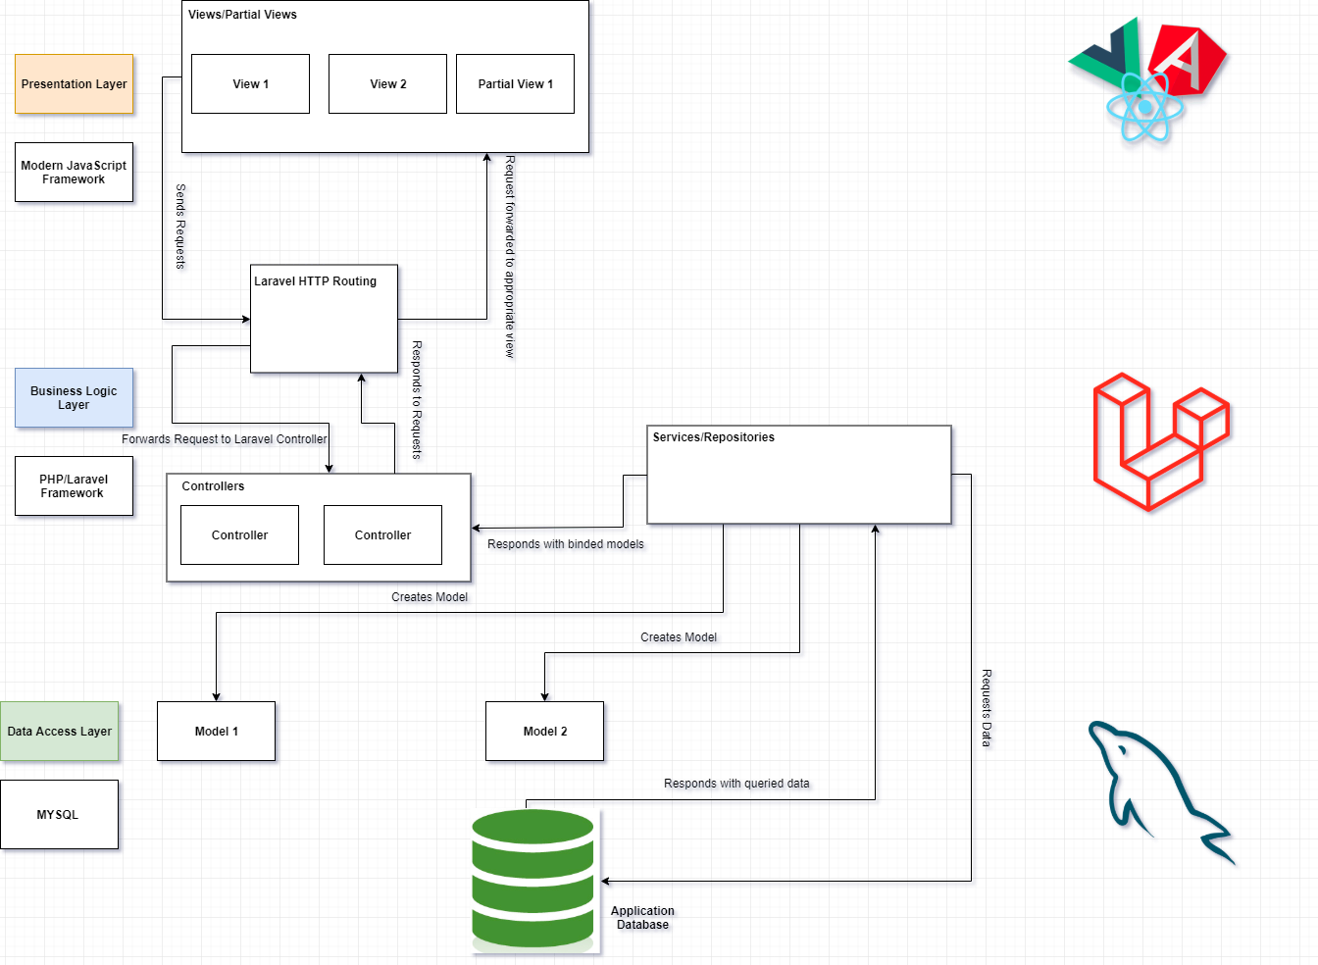

## **User Requirements**

|  |  |  |  |
| --- | --- | --- | --- |
| 1 | Student | Select University | Low |
| 2 | Student | Browse or search for a lab | Low |
| 3 | Student | Should be able to see safety info | Medium |
| 4 | Student | Should be able to see how to use equipments | Medium |
| 5 | Student | Able to see any notices | Low |
| 6 | Student | Able to contact lab instructor | Low |
| 7 | Student | Able to create a "Issue" ticket | Medium |
| 8 | Lab Supervisors | Able to setup a virtual Lab | Low |
| 9 | Lab Supervisors | Should be able to put safety/maintenance notices up | Low |
| 10 | Lab Supervisors | Edit and maintain equipment inventory in the lab | Low |
| 11 | Lab Supervisors | Should be able to post and update safety rules | Medium |
| 12 | Safety Coordinator | Able to create and update templates for inspection report | High |
| 13 | Safety Coordinator | Able to create instance of a report | High |
| 14 | Safety Coordinator | Able to assign a registered Safety Committee member/Lab Lab Supervisors to it | High |
| 15 | Safety Coordinator | Able review and approve submitted reports | High |
| 16 | Safety Coordinator | Able to track reports | High |
| 17 | Safety Coordinator | Able to create and assign "Issue" tickets for labs | High |
| 18 | Safety Coordinator | Able to create and delete accounts for Safety Committee members and Lab Supervisors | High |
| 19 | Safety Coordinator | Able to send notification email to inspectors | Low |
| 20 | Safety Coordinator | Able to ask and reply to questions on a report submission | Low |
| 21 | Safety Coordinator | Able to receive reminders for upcomming inspections | Low |
| 22 | Safety Coordinator | Able to identify re-occuring items on inspection reports | High |
|  | Safety Coordinator | Able to get notified about over due tasks | High |
| 23 | Lab Supervisors / Safety Committee members | Able to submit an **assigned** report | High |
| 24 | Lab Supervisors / Safety Committee members | Able to track reports | Medium |
| 25 | Lab Supervisors / Safety Committee members | Able to create and fill "Issue" tickets | High |
| 26 | Lab Supervisors / Safety Committee members | Able to see notification/emails | Medium |
| 27 | Lab Supervisors / Safety Committee members | Able to ask and reply to questions on a report submission | Medium |
| 28 | Lab Supervisors / Safety Committee members | Should be abel to login with an authorized account | High |

**APPENDIX A - GLOSSARY**

[Define terms, acronyms, and abbreviations used in the FRD.]