**FACULTY OF ENGINEERING**

**AFTER ACTION REVIEW**

**Labfiz**

Alwin Baby

Muhammad Ahmed

Zain Abedin

Table of Content

**1.** **Introduction** 3

**2.** **Initial Plan** 3

2.1 Scope 3

2.2 Expected Methodology 3

2.3 ITech Stack Decisions 3

2.4 Expected Timeline 4

**3.** **Actual Outcome** 4

3.1 Final Scope 4

3.2 Actual Methodology 4

3.3 Final Tech Stack Used 4

3.4 Major changes 5

**4.** **Final Product** 5

**5.** **What can be improved** 6

**6.** **Conclusion** 6

**7.** **Recommendation** 6

# **Introduction**

Lab safety is a major concern in an academic institution lab. There are many steps and procedures lab safety organizations follow to keep the labs safe for students. LabFiz is a web-based application which can be used by lab instructors to automate lab safety inspections. The app is specifically designed for the University of Regina Engineering labs. Lab inspectors will be able to login and will be able to record the inspection reports online. LabFiz has an in-app email notification system which will remind inspectors about any upcoming events.

# **Initial Plan**

## Scope

The initial plan was to create a web application platform for lab safety, training and inspection. The application will serve as one platform for managing equipment, safety hazard information, training manuals/videos and inspection management process. The intended audience were inspectors, instructors and students. Initial plan was to create an application which can be used by almost everyone at the university.

## Expected Methodology

The team's plan was to use Agile methodology for project management. Initially the plan was to use complete agile methodology which would help in the development of the webpage. Agile methodology began with the product description from the client.

## ITech Stack Decisions

There were lots of different models and plans which were discussed at the early stages of the development. Technologies that were envisioned to help design the project are as follows.

* Project Management: Asana
* Front End - HTML/CSS/Reactive JS Library
* Back End – Node.js, PHP
* DB - MariaDB, MongoDB, Cloud Service

## Expected Timeline

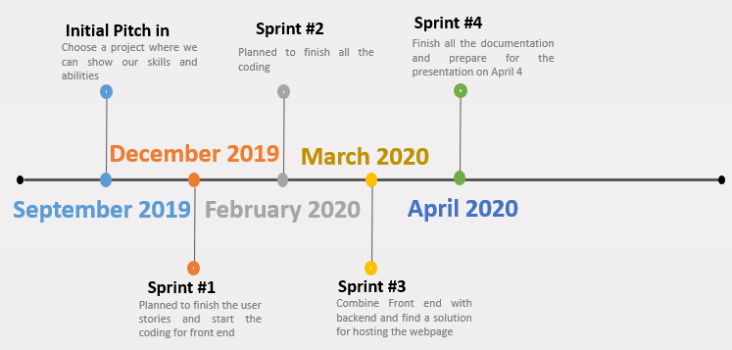

# **Actual Outcome**

## Final Scope

By the end of December 2020 most of the initially planned features were changed. More focus was given to the safety inspection and new features were added according to the recommendation by the client. The final product can only be used by inspectors and Lab safety coordinators.

## Actual Methodology

Since the time was limited and the workload was huge, the team decided to focus on the higher priority requirements for the project. The student and the instructor part of the initial plan was dropped. More focus was given to the inspection part of the project. Likewise, the initial agile methodology was dropped and the waterfall methodology was used. Most of the pre-planned ideas didn’t go as smoothly as planned due to barriers along the way.

## Final Tech Stack Used

* + Project Management: Asana
  + Front End – Vue.js, UI inspired by Material design
  + Back End – Laravel PHP
  + DB – MySQL

## Major changes

* Students and instructors’ part of the project due to advice from our prof. He suggested to focus more on the lab safety part. Also, the Moodle provides features for students and instructors already.
* Agile methodology was dropped and waterfall method was chosen due to certain constraints. Using waterfall methodology was much useful because of the constantly changing concepts and requirements. The client was able to make changes during the development of the webpage. Lauren, the lab safety coordinator wanted a method to recover any deleted inspection reports. The team was able to modify the design according to what the client wanted.
* Email reminders were added to help improve the lab safety. Regular notifications about upcoming inspections will make sure the inspectors don’t miss anu inspections
* Added recently deleted items section. If the admin deletes an inspection report and wants to get it back later, they will be able to do so from the deleted folder.

# **Final Product**

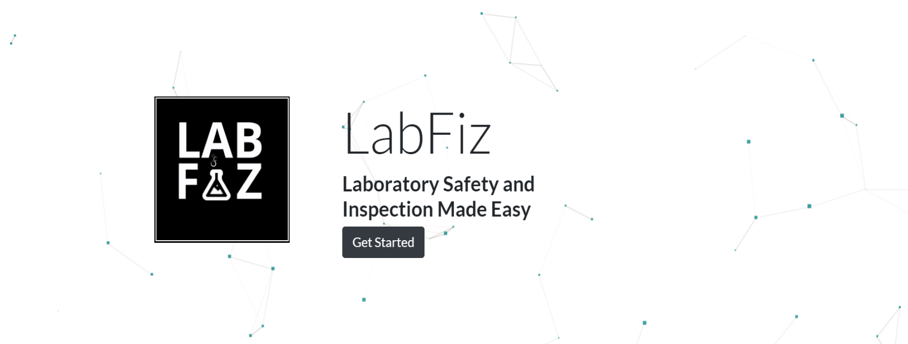By the end of March 2020, the webpage was live and was being hosted with the help of AWS. Lots of things have changed due to client’s recommendations. The client was very pleased to see the final product. Major change between the initial planning and the final product was that the final product could only be used by lab safety coordinators and inspectors. Final product had more features which could help improve lab safety.

# **What can be improved**

There are lots of things which can be improved. Thinking about the design patterns and planning before coding could have been improved for more successful product output. Getting more suggestions from the client could have helped the team finish the webpage earlier.

Timing – Planning and coding could have saved a lot of time while developing the webpage. One of the major problems was that there was no enough time to finish all the initial plans. The initial plans could have been achieved if the team utilized their time more proficiently.

Barriers – There were lots of barriers along the way. Other classes and exams made it much harder to focus on the project.

Planning – Planning was a major drawback in the developing. Most of the initial planned workload was dropped and new features were added. If the plans were perfect since the starting, a lot of time and resources could have been saved.

Team Organization – Team lacked interaction throughout the project. Better communication and meetings could have improved the outcome.

# **Conclusion**

Although there were lots of barriers on the way, the team did their best to finish the project and was able to produce an incredible webpage for safety Inspection. The webpage will be used by the University of Regina Engineering Faculty. The webpage can easily be modified and can be used by other faculties and departments at the university.

# **Recommendation**

* Use time wisely, Plan ahead
* Don’t wait till the last moment. There will be lots of barriers on the way which might slow down the process