

Capstone

Automated Sports Commentator (Tennis)

Report R1: Problem Identification, Research, and Requirements Specification

October 18, 2022

Nick Lang | 100592096
Tyler Wunderlich | 100707158
Graem Sheppard | 100700978

Project Summary
Throughout all of human history, the need to compete with another has been ingrained into our psyche. Sports are a huge part of our culture in modern society, and organizations invest tremendous amounts of time and energy into them. This is both research and analysis into optimal performance for the athletes as well as providing an optimal experience for all those who wish to enjoy spectating. With advances to the field of AI, we as engineers see an opportunity to develop tools to improve accessibility as well as the general experience of spectating.
For this project, we are using tennis, although this system could be expanded later to function with most any sport. The system is a machine-learning AI that is being developed to determine what is happening in a game of tennis from a video feed and output it in a human-accessible way. Although the output could be sent through any desired medium, we are using Twitter, due to its popularity and presence in modern culture.
This tool could be used for many purposes. A simple one is that someone without access to a live stream would be able to follow a tennis match with nothing more than a phone that sends them Twitter notifications. It would be useful for the broadcasters of a game too. An end user could synchronize timings between cameras and automatically generate live replays of important events in the game they're covering.
It is our expectation that we will be able to use modern technologies to improve the experience of spectating sports for everyone.

Problem identification
The basic essence of the project is to use machine learning to create an AI that will provide human-readable commentary on important events in a game of tennis. The AI must be able to follow a live stream and send tweets in real-time that a human could realistically use to follow the game and hear about the highlights.
The first stage of the system is that the AI must be able to follow a live stream. It will receive video input and perform its image processing on that video in real-time. It must be sufficiently performant to not lag behind the video.
The second stage is that the AI must generate output events from that input stream. The AI will generate two kinds of events. One is for use for internal processing, while the second is the explicit fulfillment of the project requirements.
The events the AI will publicly output are:
- Point. A player scores a point and increases their score.
  - Set point. A player is one point away from winning a set.
  - Break point. The player on set point does not have the serve.
- Fault. A player loses their serve.
- Let. A point must be replayed due either to service before the receiver is ready, or the ball striking the net but being otherwise valid.
- Set. A player scores a set and increases their score.
  - Match point. A player is one point away from winning a match.
- Match. A player scores a match and increases their score.
  - Game point. A player is one point away from winning the game.
- Game. The game ends and one player is the winner, while the other is the loser.
The AI will internally use smaller events that it will use to determine if and when a larger event is occurring. These events are:
- A player hits the ball.
  - The hit is a serve.
- The ball bounces.
  - The ball is in or out.
The third stage of the system is the output. The AI will tweet with the external events as they happen. This stage will involve natural language processing on a data object that the AI creates, and then publishing it via the Twitter API.

Background

The first thing we researched was different ways to create a dataset for our AI. We knew that this project would require some kind of image recognition. For that, we would need a way to annotate different images of a tennis game. In order to get these images, we used a tool called youtube dl to download tennis videos from Youtube. Then we used a custom script to download various frames of that video as images. Once we had those images, we could use a tool to annotate the images.
We initially experimented with a tool call LabelIMG, which let us manually create bounding boxes around the objects we wanted to detect, and label them. Eventually we switched to Roboflow, which did the same thing as LabelIMG but had a lot of extra features we needed. Roboflow allowed us to work on the same dataset, which meant we could split the work of annotating images between us. Roboflow also has a built-in way to augment images in our dataset. It would take various images and apply blur, visual noise, color saturation and other augmentations. This rapidly expanded and diversified our dataset without any additional work on our part. The final and most important feature is that Roboflow can generate the labels for our dataset in a way that YOLOv5 can read.
YOLOv5 (You Only Look Once) is the current object detection model we are using. There are plenty of models that exist for object detection, but our research found that YOLO is the most modern and fastest model. YOLO uses an algorithm that allows it to do its object detection in only one scan of an image, whereas other models would require multiple scans. They also had a demo project on Google Colab that we could use to train our models on. This way, we could use Google’s machines instead of our own to train and run our object detection AI. This ends up being much faster than running it on our own computers.

Design Process
The basic design of the system looks like this:
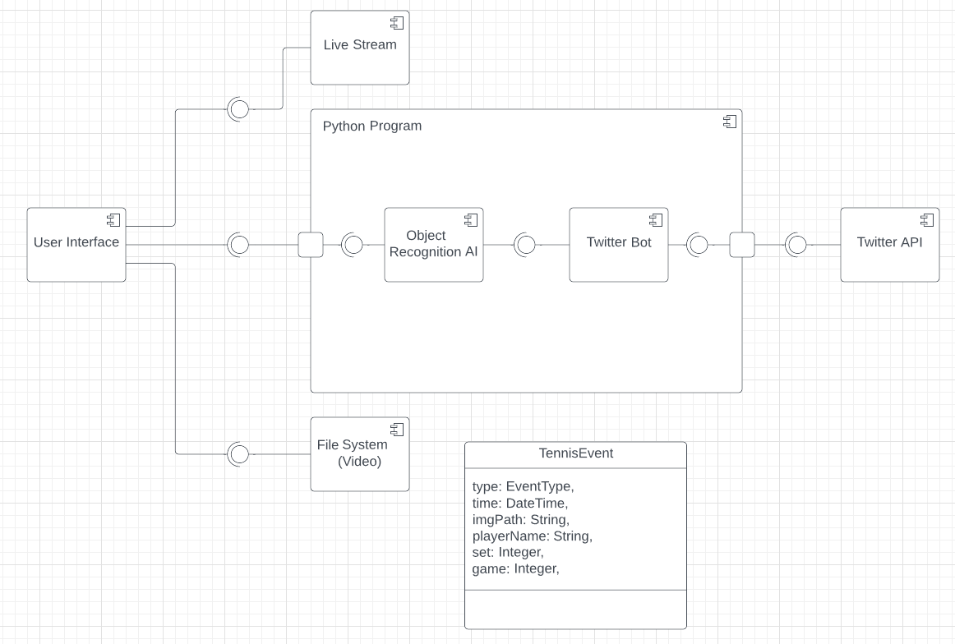
The system takes as input a live stream or a video from the file system through the user interface. From there it passes to a program that contains the AI and the natural language processor. The AI generates a TennisEvent object for each event, which the natural language processor converts into user-readable text. This program then sends the resulting output to the Twitter API.
The part we decided to focus on first was the annotating and machine-learning process. No system test can be conducted without the AI, so we considered that a good place to start. That being said, we have created the design such that there aren't significant blocking factors. The Twitter integration and user interface / video input components can both be developed fully independently with purely unit tests, meaning that if necessary, all three components can be developed in parallel.
The only real blocking flow between components in the process of developing the system was the data transfer from the AI to the Twitter bot. The natural language processor needs to have a specified input that it can convert into readable text. By creating the TennisEvent object in advance, as both a target for the natural language processor to process and an output for the AI, the systems are made entirely discrete and can be worked on and steadily improved as necessary.
The critical path will be the development of the AI itself. We expect making the AI able to detect events consistently enough to keep track of the score of an entire game accurately to be by far the lengthiest part of the process. The AI must first be able to detect events such as hitting the ball or the ball hitting the ground. It must then be made able to determine whether a point has been scored or not. It will then need to be made able to determine who has scored that point, despite any potential camera movement.
Quality assurance will be provided through a combination of manual system testing and automated unit testing. A system, when designed and worked on, will have unit tests that enforce its functionality and reliability. Regular manual tests on the system will be performed to ensure it is working as a cohesive whole.
The system is tracked through git on Github, which will also help with quality assurance. Github's continuous integration will be applied to the unit tests written for the project, so the test suite will be automatically run when changes are made. This will alert a developer who made a breaking change so they can fix the issue.
Our team doesn't have rigid roles. We are all software engineering students who are actively working on the various components. There are some areas that have received most of their work by certain individuals, however. Tyler has been the primary engineer on the machine learning components, doing much of the research and initial creation of the object detection AI. Graem has done most of the systems systems design, crafting the overall structure of our project and designing interfaces and data transfer. Nick has done most of the project management, writing documentation and organizing the team.

Scenarios
The first use case is an individual who would like to follow the tennis match but is unable to watch a live stream, perhaps because they are at work, or otherwise occupied. This user would be able to follow a Twitter account run by the AI. When a point is scored, the user will receive a notification from the Twitter account informing them, so they can have a live feed for whatever game they wish to follow.
The second use case is a broadcasting company that would like to get the most accurate and quickest live replays of a significant event. When the AI signals an event, the company can trigger their system to automatically cut the last 20 seconds or however long is desired of video footage from the various cameras around the court. The person managing the cameras can then immediately choose from the desired footage, instead of having to manually retrieve video for live replays while the match goes on.

Stakeholder Requirements
- The project must be able to process video in real-time. The AI cannot lag behind the video in processing time, or this will result in delayed or false commentary on the status of the game in question. Because processing time can vary from device to device, the system must either keep up with the video on a processor for a laptop that costs less than $1000, or the system must run on a cloud server with a computation cost of less than $5 per game.
- The AI must provide output in a manner that is human-readable and natural seeming. The output must contain no grammar errors or other mistakes.

Acceptance tests
- View the live feed from the Twitter account. Find a tennis match online, for example, on YouTube. Feed the video to the AI. When an important event such as a point being scored occurs, verify that the AI posts a tweet with the correct information.
- Give the AI a fixed video. Observe that, upon output, the winner and score are correct.
- View tweets from Twitter. There should be no grammatical errors.

Plan
By December 1st, we will have created a proof-of-concept for the AI that is capable of detecting events in a game of tennis from a video input. We will then focus on building an interface for the system that will allow the AI to detect scored points from a live video feed, which is expected to be done by January 15th. We will then build the Twitter integration, creating a bot that can convert our data output to natural language and post it publicly as tweets. We expect this to be done by January 31st. We will spend the remainder of the time improving the AI and its ability to detect events, as well as the events that it can detect.
The lengthiest part of the process will be improving the AI and its ability to monitor the status of the tennis match. The AI must be able to consistently determine whether or not a point has been scored, as well as who has scored that point. To achieve that end, we will be following the steps in the order presented in the design section above. After having developed the AI to be able to tell when an event has occurred, it will then be made able to determine whether a point has been scored or not. Once we have achieved this, we will then make the AI able to determine who has scored that point, despite any potential camera movement.

Contribution matrix
// All reports should include a contribution matrix detailing how each member has contributed to the content of the report both in writing and material. The faculty advisor can use this information to decide on individual grading.

