NATURAL RESOURCES CANADA

Modular Automated ETL Pipeline
User Manual
Author
Team Data Dragons (Braonain Masterton, Connor Coyle, Aidan Dodds, Chester Francisco)

Course & Program Information
Technical Communication (ENGL -273)
Information & Computer Systems Program

Recipient
Katie Tanigawa

Submission Date
July 19, 2024
Table of Contents
Introduction 1
Reading Guide 1
Icons 1
Tools 2
Visual Studio Code Extensions as shown in Figures 1, 2, and 3: 2
Copernicus API Site: https://documentation.dataspace.copernicus.eu/APIs.html 2
Rocky Linux 2
Installation 2
How to start VM 6
Copernicus Browser 7
Login 8
Copernicus Browser - Tiles 8
QGIS 10
Download 10
Inside QGIS 11
Tiles 12
Prepare Tiles 12
Stitching 13
Mosaic 15
GeoNetwork 16
Installation 16
Cloning from GeoNetwork’s Repository 16
Downloading Docker 17
Final Steps 17
Importing Metadata to GeoNetwork 19
Pentaho 20
Installation 20
Usage 25
MongoDatabase 26
Login Steps 26
Clusters 27
Copying and Setup 27
R Language & RStudio 30
R - Language 30
Installation 30
RStudio 30
Installation 30
Usage 31
Conclusion 33

Introduction
The Modular Automated ETL Pipeline is responsible for streamlining and automating processes that are being done manually in order to save time. Our application potentially allows hundreds of scientists at NRC to increase their workflows by removing manual bottlenecks in their processes. This user manual is a step-by-step guide that allows you, the scientist, to navigate and use all of the tools needed to automate your process. This manual includes tools, software installation guides and concept guides in order to help the user know how they all work and connect to each other. This guide will talk about setting up a VM to host the project, as well as getting QGIS a geographical Information software, Pentaho a Data Integration software installed and how to run them. This guide will also speak on how to use certain required APIS such as GeoNetoworksAPI.

Reading Guide

Icons
These icons are used to bring attention to additional information:
This icon indicates additional information which will be helpful as you read the steps.
This icon indicates a tip to help you through the steps. It can also be terminal commands.
This icon indicates a warning and alerts you to potential consequences that may occur from the steps.

Tools
Visual Studio Code Extensions as shown in Figures 1, 2, and 3:
Figure 1 - Docker extension.
- 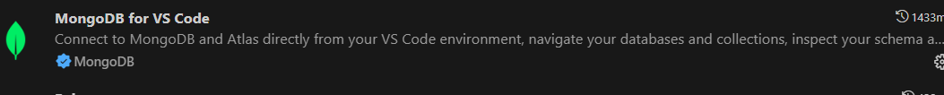
Figure 2 - MongoDB extension.
Figure 3 - Python extension.
Copernicus API Site: https://documentation.dataspace.copernicus.eu/APIs.html

Rocky Linux
This is the Linux Distro we will be using, specifically the 9th version as it is the most up-to-date and stable. This does lead to some difficulties in installing older applications as they may not be compatible.

Installation
Below is an installation guide for Rocky Linux 9, it will go over what to download and what steps are necessary when it comes to installation options. Many of these options can be changed depending on the required scenario.

- Navigate to the Rocky Linux Downloads page - https://rockylinux.org/download
- Download the DVD ISO for v9.4 (the first image download to show up) as shown in Figure 4.
  - 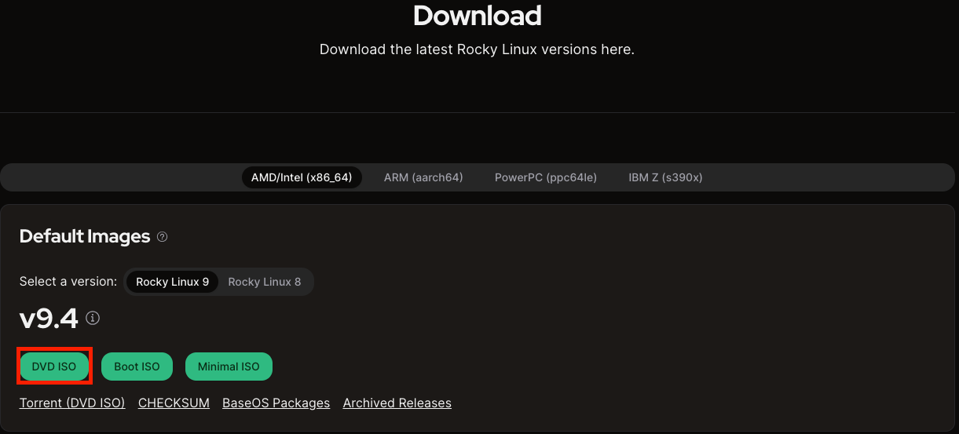
Figure 4 - Download page for Rocky Linux.
- Open Hyper-V Manager (or other VM software)
- Click New
- Click Virtual Machine as shown in Figure 5.
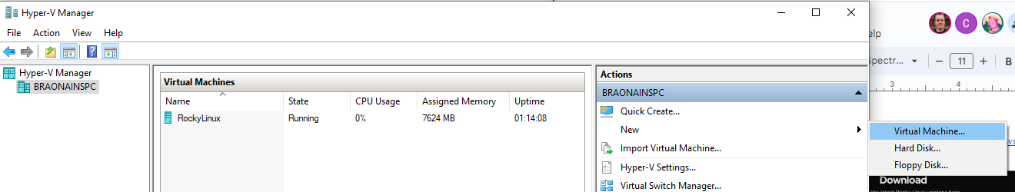
Figure 5 - Hyper-V Manager.
This should bring up a popup with installation info which will be walked through.
- Type in a Name for the VM like in Figure 6.
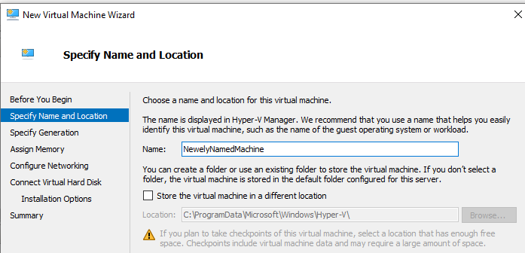
Figure 6 - Specify Name and Location section of Virtual Machine Wizard.
- Click Next.
- Click the Generation 1 radio button in the Specify Generation section as displayed in Figure 7 below.
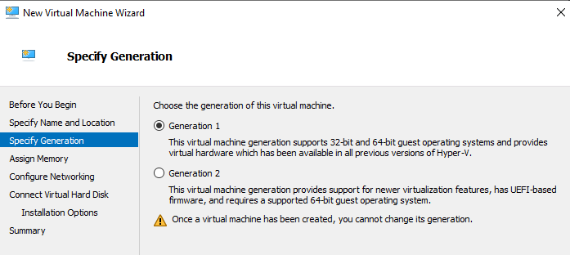
Figure 7 - Specify Generation page of the Virtual Machine Wizard.
- Click Next
- Set startup memory to 4090 MB or higher in the Assign memory section
This number depends on how much memory your main server computer has
- Click Next
- Select the ‘External’ option in the Configure Networking section similar to Figure 8.
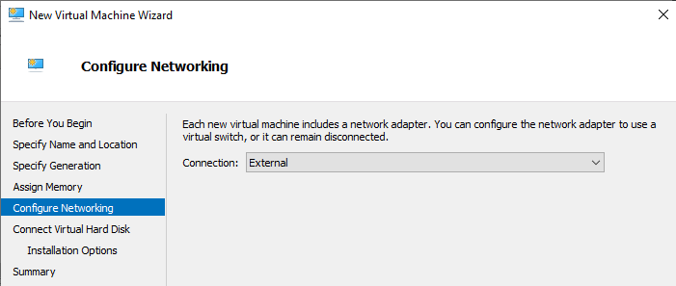
Figure 8 - Configure Networking section of the Virtual Machine Wizard.
- Click Next
- Click the ‘Create a virtual hard disk’ radio button in the Connect Virtual Hard Disk section as shown in Figure 9 below.
You may change the size of the Hard disk to whatever you have room for.
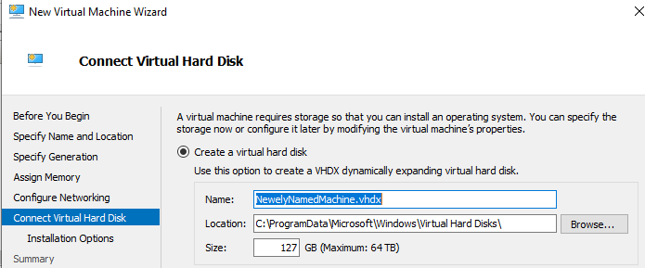
Figure 9 - Connect the Virtual Hard Disk section of the Virtual Machine Wizard.
- Click on ‘Installation Options’ and click the ‘Install an operating system from a bootable CD/DVD-ROM’ radio button
- Click the ‘Image file (.iso) radio button under the ‘Media’ heading and browse for the location where you saved the DVD Iso like in the example shown on Figure 10.
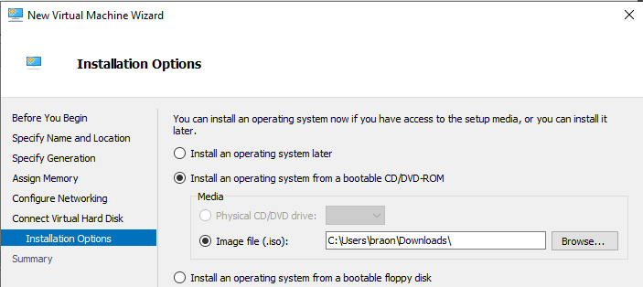
Figure 10 - Installation Options section of the Virtual Machine Wizard.
- Click Finish

How to start VM
Virtual Machine software can be difficult to run, so below is an example of how to connect to the newly created VM when using Hyper-V Manager.
- Right-click the Newly Created VM
- Click Start
- Right-click the VM again
- Click the Connect option outlined in Figure 11.
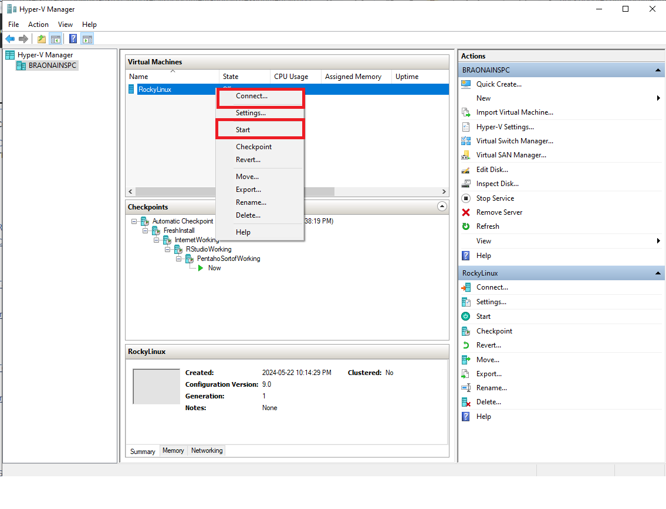
Figure 11 - Connecting to a virtual machine in Hyper-V Manager.
- Run through the Rocky Linux installation wizard
For our installation, no custom changes, only clicking next and adding relevant info if required. Such as time zone or username and password options.
- Login
- VM running

Copernicus Browser
Copernicus Browser is an online tool used to search for satellite and tile data, all information comes from the European Union Space Programme. This section will show the user how to use the browser's search functionality and how to use downloaded tile datasets afterwards.

Login
This section will help a user log into the Copernicus browser, as it is a required step to download any form of data.
- Go to this website:
https://browser.dataspace.copernicus.eu/?zoom=5&lat=50.16282&lng=20.78613&themeId=DEFAULT-THEME&visualizationUrl=U2FsdGVkX19%2FVO2kw8EpQNxr2DfBWLgxqknBCJszB7EAS4yHyoPMhEwHTR2z27IV3i1WPu2wKbez%2FW2hQt%2BcoJUF1c1Z0%2FKk7Nl9Ve45lEidP%2FHglwnwDjs9gGUPyi2%2B&datasetId=S2_L2A_CDAS&demSource3D=%22MAPZEN%22&cloudCoverage=30&dateMode=SINGLE
- Click the login (If you don’t have an account, you can create one when you click it) or use Anonymously.
If you use this site anonymously, you won’t be able to use the tiles we will discuss in the next step.

Copernicus Browser - Tiles
After setting up your account, you’re ready to download tiles. This section will show the user how to search for info, what to search for and how to download certain or all tileset data.
I recommend downloading at least three of any adjacent blue shapes (tiles) for this next step to make sense.
This User Document uses Sentinel-2 L2a data, initially, find an area of your interest
You will have to zoom in quite a bit to narrow down your area of interest, then click the search tab.
(Numbers correlate with photo on next page)
- Click on the Search tab
- Click on the Sentinel-2 checkmark
MSI should be automatically checked and bring down a dropdown menu
- Click on the L2A
- Set the cloud coverage slider down to roughly what your scientist(s) want
In our case, it was ~16%.
- Time range (confirm with scientist(s))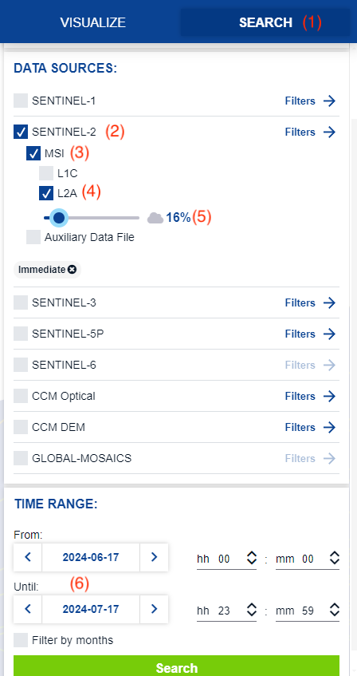
Figure 12 - Copernicus search section.
- Click on the Search Button like in Figure 12 above.

QGIS
QGIS is an Open Source Geographical Information System Software, that allows the user to compartmentalize and visualize datasets. This section will show users how to download, install and use QGIS.

Download
This section will explain to the user how to download QGIS for Rocky Linux 9
- Navigate to this website: https://www.qgis.org/download/
- Scroll down and click “Skip it and go to download” on the donation popup page
- Running this on Rocky Linux 9, you have to click on the Linux
Penguin at the bottom of the page
- Click on “Flatpak” as outlined in Figure 13.
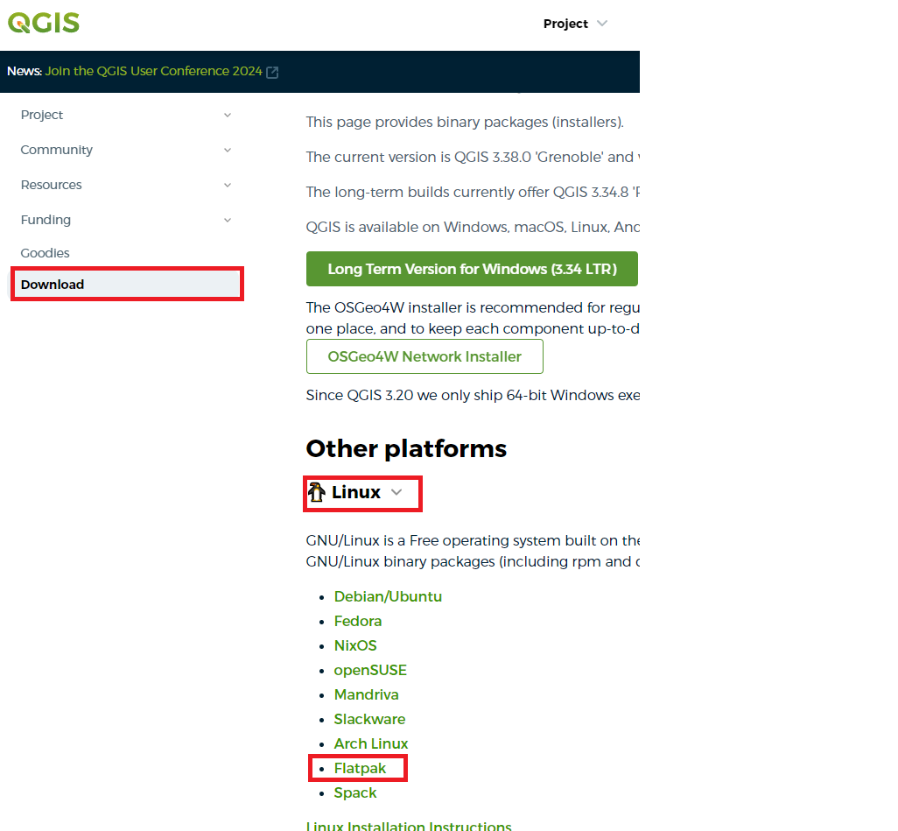
Figure 13 - QGIS download page.
For general Linux Flatpak install notes, see https://flatpak.org/setup/
QGIS on Flathub: https://flathub.org/apps/details/org.qgis.qgis
- Install:
flatpak install --from https://dl.flathub.org/repo/appstream/org.qgis.qgis.flatpakref
b. Run:
flatpak run org.qgis.qgis
c. Update your flatpak QGIS:
flatpak update

Inside QGIS
This section explains how to get saved tile data into QGIS:
- Open QGIS, and you will see a blank canvas. To see an overview of the map, click on the coordinates at the bottom shown in Figure 14.
Figure 14 - Bottom of QGIS page.
- Type in “world”.
Do not add the “”
You should now see the world map on your screen.
- Drag the downloaded zip files into QGIS.
This will ONLY work with zipped files. Do not unzip the downloaded files

Tiles
Tiles are sets of data retrieved from satellite imagery and sensor data.

Prepare Tiles
This section will show how we prepare tile info to become a mosaic.
Looking at the picture below, you should have four layers per folder like in Figure 15.
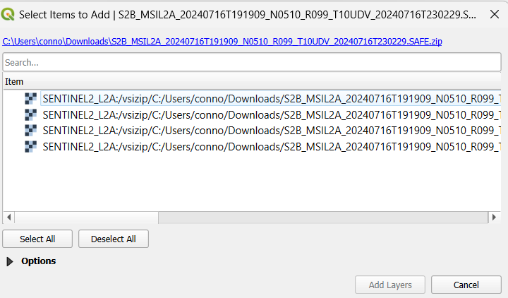
Figure 15 - Layers to be added to QGIS.
There might be more than 4 layers on this screen, if so, just include the XML files as described in Figure 16.
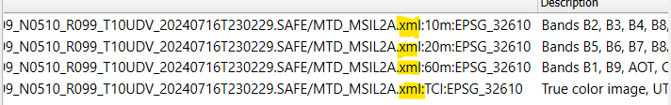
Figure 16 - Tile layers.
You should have 12 layers if you imported three folders

Stitching
Next, you will need to “stitch” these tiles together.
- Go to the Raster dropdown menu outlined in Figure 17.
Figure 17 - Raster dropdown menu.
- Click the “Miscellaneous” tab.
- Select “build virtual raster”.
- Click on the … next to the “input layers” button like in Figure 18.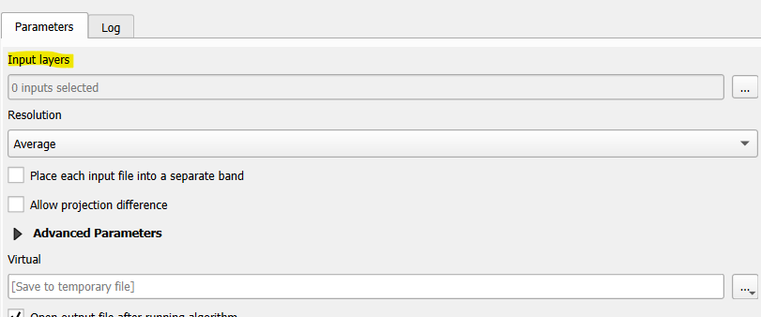
Figure 18 - Parameters options.
When you click the … you will be presented with 12 layers if you had three blue squares
- Select all layers then click Run.
You will see some red error-looking text, don’t worry about it, I’ve yet
to have a problem with them. When it is done running it will say complete and you will now see a “Virtual” named layer in your layers overview.

If you notice and uncheck all the other layers and keep the Virtual one checked, then it is a mosaic now.

Now you may have noticed a little…bug? Icon next to the virtual layer. This means that this is only a temporary layer. To make it permanent, you will need to Export it.

5. Click on the Virtual layer by depressing the right-hand mouse button on the Virtual layer, hover over Export, and click “Save as' ' to export your layers.
6. Name your file and choose a path with the … button. It will take a while, perhaps 2-3 minutes, the more tiles you have, the longer it will take.

Mosaic
A mosaic is a combination of tiles, all stitched together creating a larger dataset. The mosaic still contains all unique tile data but represents them as one. Some of these tiles might have four options when you drag them into QGIS, some might have more. It’s simply extra data for those specific tiles.
So we have a mosaic stitched together. To find the information on the separate layers of the mosaic you need to create a “group.”
Each of these layers has different states to them, such as infrared, satellite etc. Focus on your desired layer or state.
- Press the icon circled in red in Figure 19 below, to make a group.
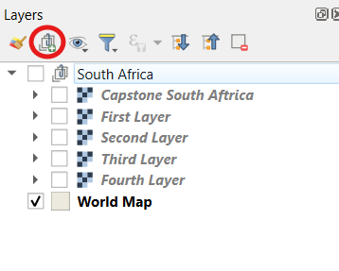
Figure 19 - Layers displayed on QGIS.
This will create a new group symbol at the bottom, and you just have to drag and drop everything into it
South Africa is the total 16 combined layers, and those other four represent the satellite layers of the different blue squares (tiles) you picked out earlier.
The world map is just there to orientate yourself around QGIS
To find all the data on all tiles and mosaics, right-click and press properties.
You have now created a basic Raster view mosaic.

GeoNetwork

Installation
These steps will guide you through how to install GeoNetwork so that you can use it to import metadata:

Cloning from GeoNetwork’s Repository
Install GeoNetwork and its components in order to bring the docker-geonetwork repository to your own computer:
- Go into a VS Code terminal.
- Type git clone http://github.com/geonetwork/docker-geonetwork.git.

After you run the command in step 2 you should have a result similar to Figure 20.
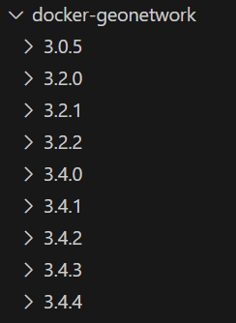
Figure 20 - docker-geonetwork repository with different versions of GeoNetwork.
Note that you will have more versions of GeoNetwork available than what is displayed in this picture.

Downloading Docker
Next, you will need Docker for VS Code and Docker Desktop:
- Install Docker for Visual Studio Code as shown in Figure 21.
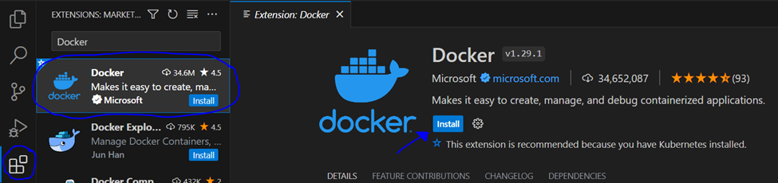
Figure 21 - Docker extension in Visual Studio Code.
- Type https://www.docker.com/products/docker-desktop/ in your browser search bar.
- Click the 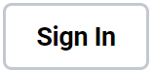 button and either enter your Docker credentials to log in or the Sign Up link near the bottom of the login page to create a Docker account.
- Download Docker Desktop using the  button.
Make sure you have logged into Docker before you do this. If you are not using Windows, click on the downward arrow next to where it says “Download for Windows” on the download button.

Final Steps
Now that you have everything needed for installing GeoNetwork, here are a few final steps you will need to complete:
- Type in the file path of the GeoNetwork version you wish to use
(cd docker-geonetwork/4.2.0 if you’re using version 4.2.0).
- Open Docker Desktop.
- Type docker-compose up in your VS Code terminal.
Once you’ve typed in the command in step 3, two things will happen:
- The following containers will be installed and run:
  - Elasticsearch.
  - GeoNetwork.
  - Kibana.
  - Nginx.
  - Postgres database.

- The GeoNetwork server will start up and be accessible through the following link: http://localhost:8080/geonetwork. If the link is not working, try pressing Ctrl+C and run docker-compose up on your terminal again.
Once all your containers are running, it should look similar to Figure 22 below.
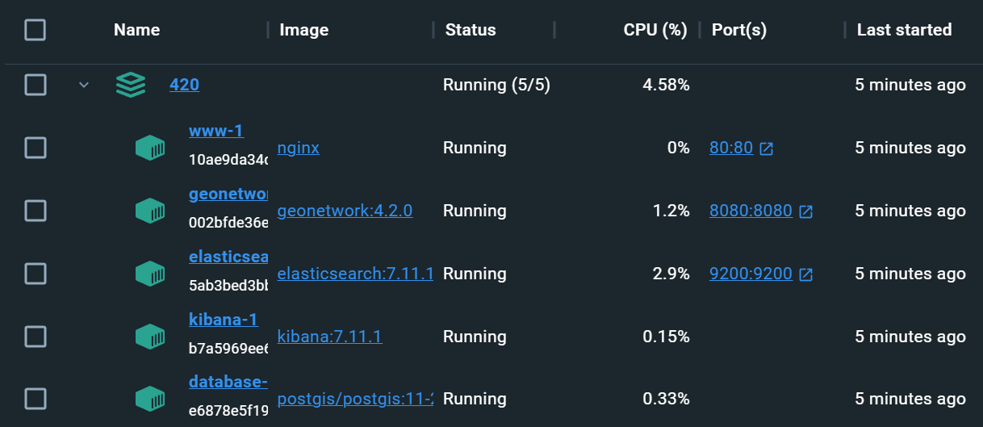
Figure 22 - Containers running on Docker Desktop.
Once you have completed these steps, you should now be able to run your GeoNetwork server through Docker Desktop!
These steps only cover version 4.2.0 of docker, and may not be as helpful for providing assistance for older versions of GeoNetwork.
Additionally, the steps for installing Docker Desktop only apply for Windows, Mac, and Linux operating systems and will not be as helpful if you’re using an operating system such as Rocky Linux.

Importing Metadata to GeoNetwork
You can now log in and add your metadata to GeoNetwork by following these steps:
- Log in to the server using admin as the username and password.
- Click on 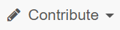, then .
Once you are on the import page, it will give you four options to import metadata:
  - Upload a file on your computer: Click on and pick the metadata file you wish to use.
  - Upload a file using a URL: Enter the url in the Metadata content field.
  - Copy xml code directly: Enter the xml code into the Metadata content field.
  - Upload multiple files from a folder: Enter the folder directory into the Folder path field.
- Leave the default settings as is for the remaining fields on the import form.
- Click the  button on the bottom of the form to import the metadata to GeoNetwork, or the 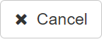 button to cancel the import.
- Click on the  option at the top of the page to verify that the metadata was imported successfully.
Once completed, you should have metadata imported to GeoNetwork.

MongoDatabase
MongoDB is a document-oriented NoSQL database program, the steps below will explain how to install and set up a MongoDB cluster for storing API data.

Login Steps
How to log into and create an Atlas account
- Create an Atlas account with either Atlas sign-up or Google credentials as explained in Figure 23 below.
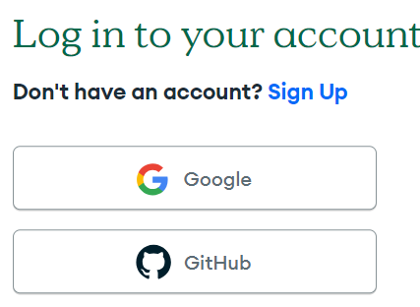
Figure 23 - MongoDB Atlas login screen.
Write down credentials, it is difficult to retrieve them once lost.
- Verify your email.
Once verified, you should be auto-directed to Atlas MongoDB. If not, you will have to go to the website and log in using your credentials.
Make sure you are using an extension for Python and MongoDB.
Ex. VSCode and VSCode Python extension with the MongoDB for VSC extension.
This tutorial will use the “MongoDB for VS Code” extension.

Clusters
A cluster is a collection of data similar to a table in SQL servers. It will be used to store unique scientists' data.
- Click the Create Cluster button shown in Figure 24.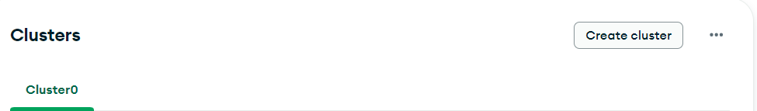
Figure 24 - Clusters section with Create Cluster button.

- Choose the type of cluster that best fits your needs, similar to Figure 25. 
Figure 25 - Types of clusters provided by MongoDB Atlas.

Copying and Setup
Now that you have a cluster, these steps will provide details on copying your password and connecting to the database on Visual Studio code.
- COPY THE PASSWORD THEY GIVE YOU AND STORE IT SOMEWHERE SAFE, cannot stress this enough
You HAVE to copy the password before creating a user like in Figure 26 below.

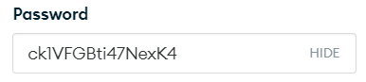
Figure 26 - Password field in MongoDB Atlas.
- Click 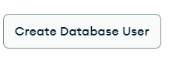button
3a. Click the connect button under the cluster you made, then click on Drivers as shown in Figure 27 below.
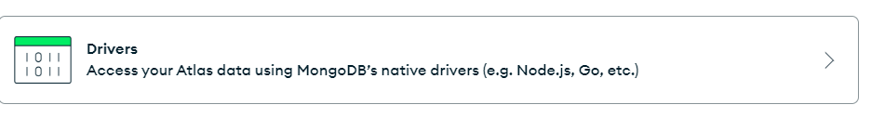
Figure 27 - Drivers drop-down on MongoDB Atlas.
4. Make the driver Python and the version should be the current stable version.
5. Install the driver with the command python -m pip install "pymongo[srv]" in VSCode.
6. Go into View > Command Palette > then look up MongoDB: Connect with Connection String
7. Add your connection string from earlier with the password and email setup from step 3.

You need to get rid of the <> in the <password> word for this connection to work
Your Connection String should have a similar format as below and is also shown below in Figure 28:
mongodb+srv://email:<password>@cluster0.3zqurog.mongodb.net/?retryWrites=true&w=majority&appName=Cluster0
Figure 28 - Format for MongoDB connection string.
You will get a MongoDB connection successful notification in the bottom right similar to Figure 29 below:
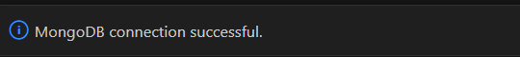
Figure 29 - MongoDB connection successful notification on Visual Studio Code.
Retry the Mongo Connection String, chances are you messed up your Specified password from step 3
9. Connected successfully with the connection string, the Mongo site should have a "View full code sample" under step #3 of the Connecting to "Cluster Name Here".
"Cluster Name Here" is what you named your cluster in step 7 for reference.
copy that into a new Python file, and then replace the <password> for your user from step 7 into here.
You need to also get rid of the <> in the <password> word for this connection to work
10. Make sure you are using the correct version of python and pip. Enter these commands in the terminal, "python --version" and "pip --version" and if they match like in Figure 30 below, you are good.
Figure 30 - Python commands in a terminal.
(Python 3.9.13 matches with Python 3.9, the 13 is irrelevant.)
11. Go to the directory where you saved your file. The name by default will be “playground-X.mongodb.py”
12. Execute the file by running python filename.py in the terminal
"python filename." is the name of the python file you created.

If the results of the executed file return “Pinged your deployment” then you are connected to your Mongo Cluster you created

If you don't get this result, try correcting your connection string to fit the email and the Specified Password you had before.

Make sure you are in the right directory in your terminal
13. Getting “Connected successfully to MongoDB!" message, you are now ready to start adding records to your collection.

Pentaho
Pentaho is a Data Integration Software. It allows the user to manipulate, transform, and extract data. It enables users to log information, use OLAP services, run reports and much more. Here we intended to have it run Python scripts to grab API data, transform that data and send it off to a MongoDB cluster.

Installation
Here we will explain how to install Pentaho Data-Integration Software.
- Go to the Pentaho Downloads page. https://pentaho.com/pentaho-community-edition/#communityProducts
- Fill in the signup box and click ‘Download Now’
- Arriving, a pop-up will emerge and bring the downloadable tools into view
- Download the two items:
  - Pentaho Data Integration (Base Install) like the one in Figure 31 below:
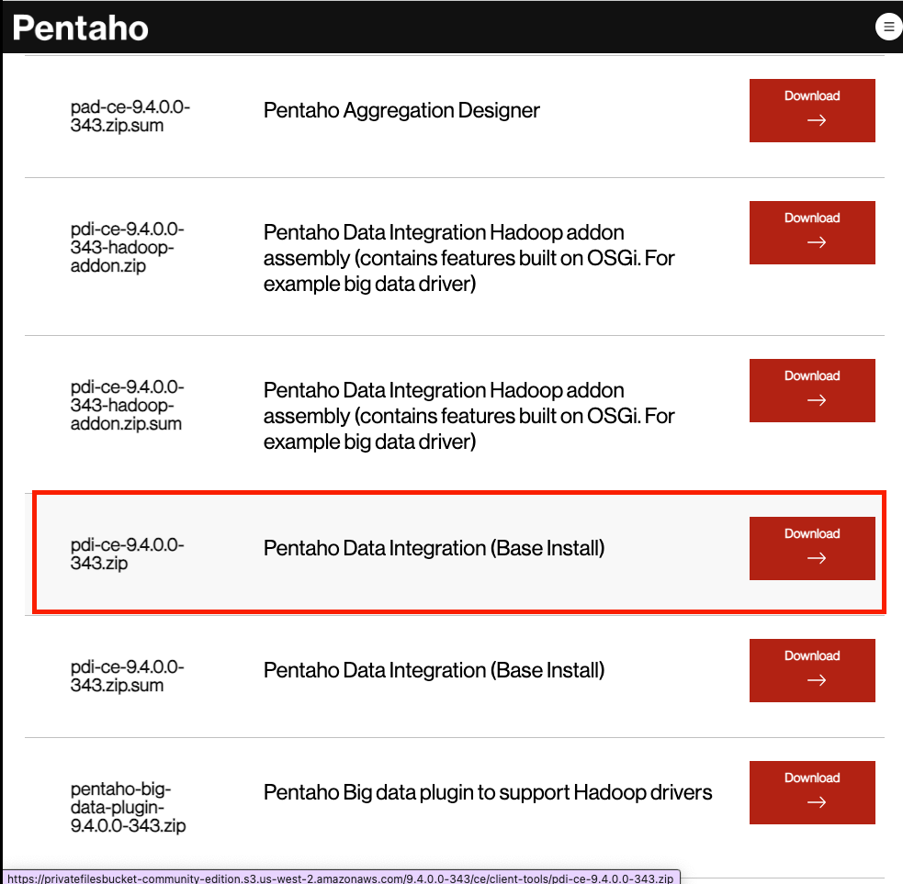
Figure 31 - Pentaho download page.
  - Pentaho Data Integration Hadoop addon assembly (contains features built on OSGI. For example big data driver) shown in Figure 32 below:
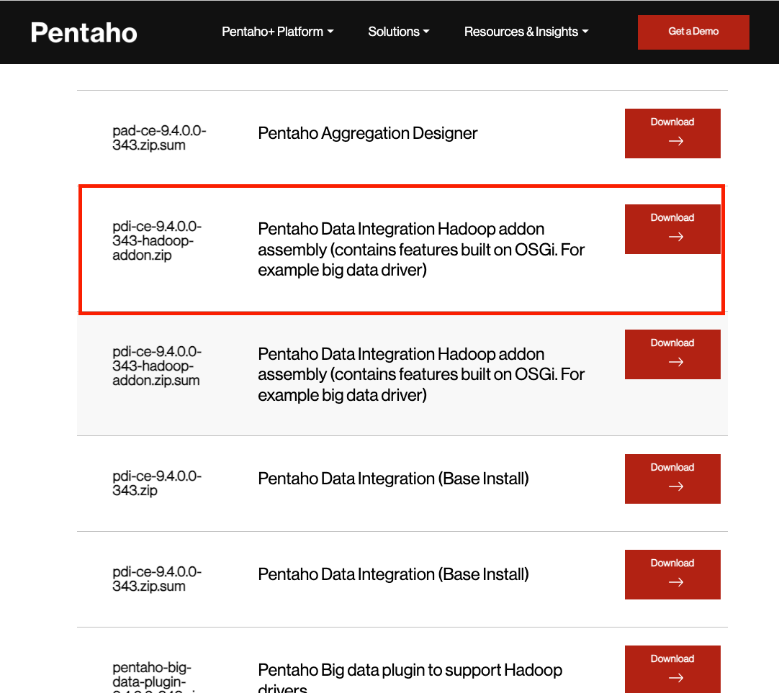
Figure 32 - Hadoop addon in Pentaho.
- Create a new Directory In /usr/local called ‘Pentaho’
mkdir -p /usr/local/Pentaho
The next few steps should all be done in the command line as it makes installation easier.
- Move the zipped Pentaho base installation file into the local newly created Pentaho directory
mv pdi-ce-9.4.9.9-343.zip /usr/local/Pentaho
- Move the zipped Pentaho Hadoop addon file into the Pentaho directory
mv pdi-ce-9.4.9.9-343-hadoop-addon.zip /usr/local/Pentaho
- Looking in the terminal, navigate to the /usr/local/Pentaho path
- Unzip the base installation
sudo dnf install unzip
sudo unzip pdi-ce-9.4.9.9-343.zip
- Unzip the addon
sudo unzip pdi-ce-9.4.9.9-343-hadoop-addon.zip

The addon once unzipped should automatically combine with the base file
- Change directories to /usr/local/Pentaho/data-integration
cd /usr/local/Pentaho/data-integration
Or if already in Pentaho directory cd data-integration
- Run the spoon.sh file to launch Pentaho application
./spoon.sh
- Depress the left-hand mouse button twice on the Title bar that pops up called ‘Spoon-Job 1’ like in Figure 33 below.
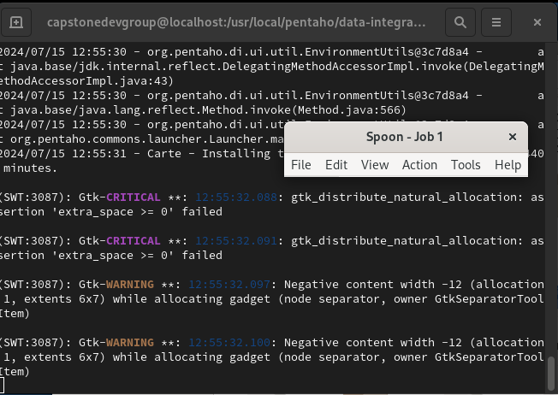
Figure 33 - Spoon - Job 1 popup with the terminal background.
- Opened, Pentaho is now available and should look like Figure 34 below:
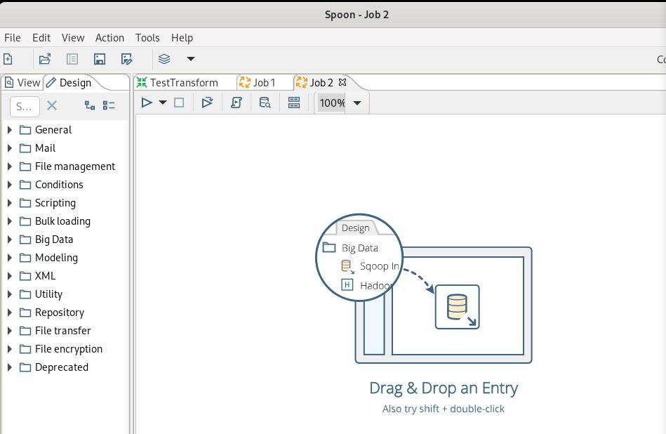
Figure 34 - Spoon - Job 2 page.
- Click ‘Tools’ in the Navbar and click ‘Marketplace’ as shown in Figure 35.
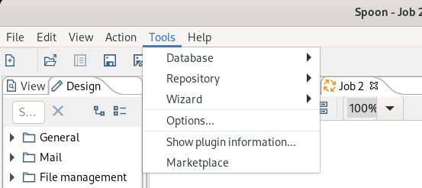
Figure 35 - Tools tab in Spoon - Job 2 page.
- Click install on the CPython Script Executor as outlined in Figure 36.
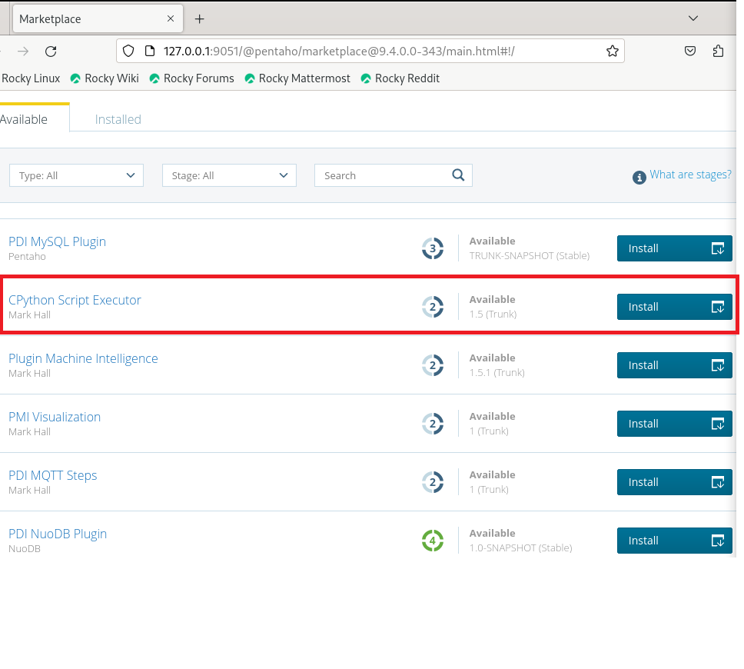
Figure 36 - CPython Script Executor.
- Go to this link and download the plugin if the marketplace does not work for whatever reason. https://marketplace.hitachivantara.com/pentaho/
- Drag or move the file into /usr/local/Pentaho/data-integration/plugins directory
mv <plugin file name> /usr/local/Pentaho/data-integration/plugins
- Unzip the file
Sudo unzip <filename.zip>

Usage
Pentaho has numerous usages. It deals with data in many ways but to simplify how it is used it can take and transform data, move it around, send it and more. It is a very complicated application that has endless applicability to a multitude of projects.
Jobs
See Figure 37 below.
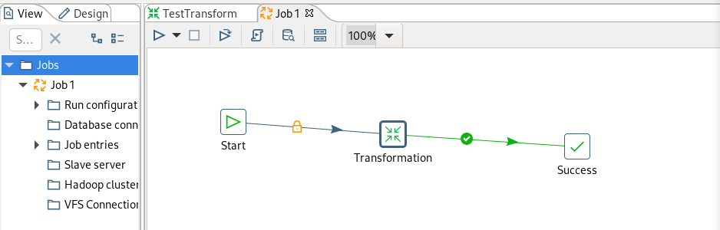
Figure 37 - Jobs in Pentaho.
Jobs are responsible for running a series of entries which can include Transform. A job always needs a “Start” entry and a “Success” entry and your processes go in between.
A typical workflow would be “Start”, then continue to a transformation or other entry, upon its success it would move to the next stage, which may be a new transformation. This series would continue until the entire job was completed. At any point, you can have checks so that if something goes wrong the program handles it and either logs the info or restarts from that stage.
Transform
See Figure 38 below.
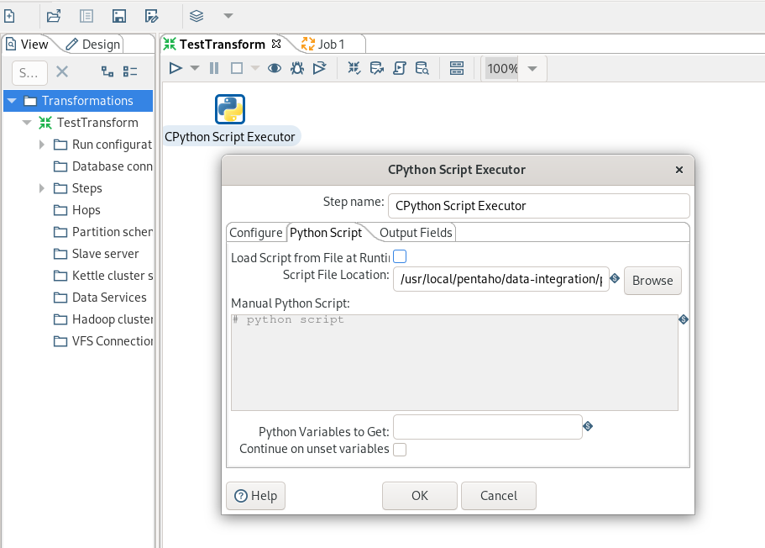
Figure 38 - TestTransform page in Pentaho.
Transforms can be many things, but in general, they do work on input data. This example above shows that you can like a transformation to a script, in this case, a Python script, and then have data be transformed against the script code. You can have data pushed to databases, and you can set logging and metadata, along with many other abilities.

R Language & RStudio
In order to transform certain API response data, we use R scripts to manipulate it and create Analysis Ready Data. The steps below explain how to install and use both R and Rstudio.

R - Language

Installation
This section will explain how to install the R language.
- Open up the terminal on Rocky Linux
- Enter the following commands to install R into the system

Sudo dnf -y install R
Accept all the default prompts by hitting ‘enter’ or typing ‘y’ and then press enter

RStudio
This is the IDE for R, allowing users to use and run R code against data.

Installation
This section will explain how to set up RStudio on a RHEL system.
- Open up the terminal on Rocky Linux
- Enter the following commands to install Rstudio (this is one command)
sudo dnf install https://download2.rstudio.org/server/rhel9/x86_64/rstudio-server-rhel-2023.03.0-386-x86_64.rpm
- Follow the default prompts and hit enter or press ‘y’ and then press enter

If all goes well, Figure 39 below shows what the program should look like.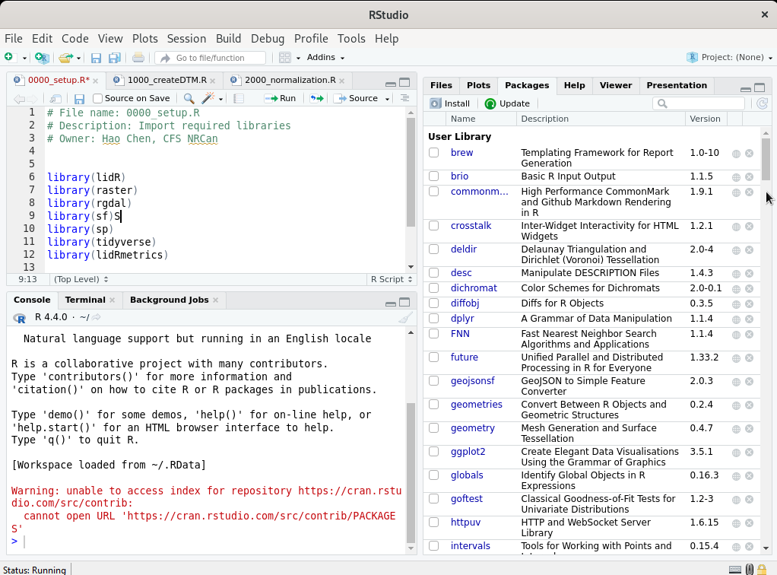
Figure 39 - RStudio page.

Usage
This section will give a very brief overview of how to use R studio,
- Install the necessary libraries needed for your scripts (following these instructions)
- Go to ‘Tools”
- Press “Install Packages” like in Figure 40 below.
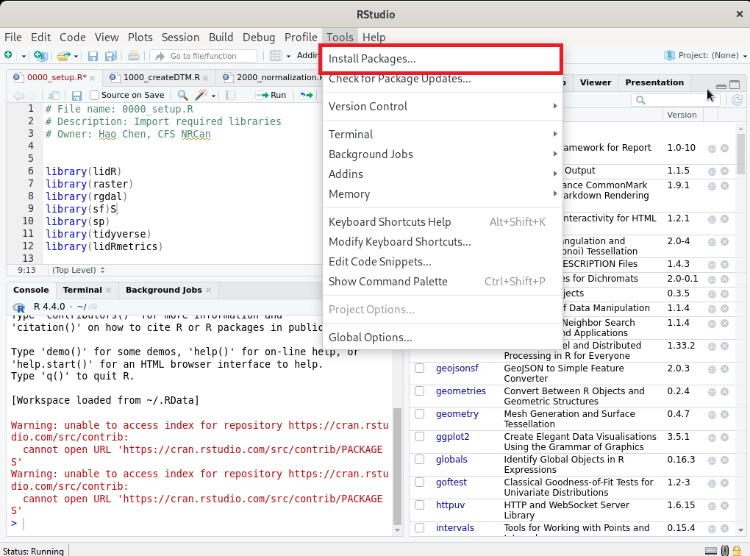
Figure 40 - Tools tab in RStudio.
- Type in the desired library in the search bar (ie. ‘sf’), similar to Figure 41.
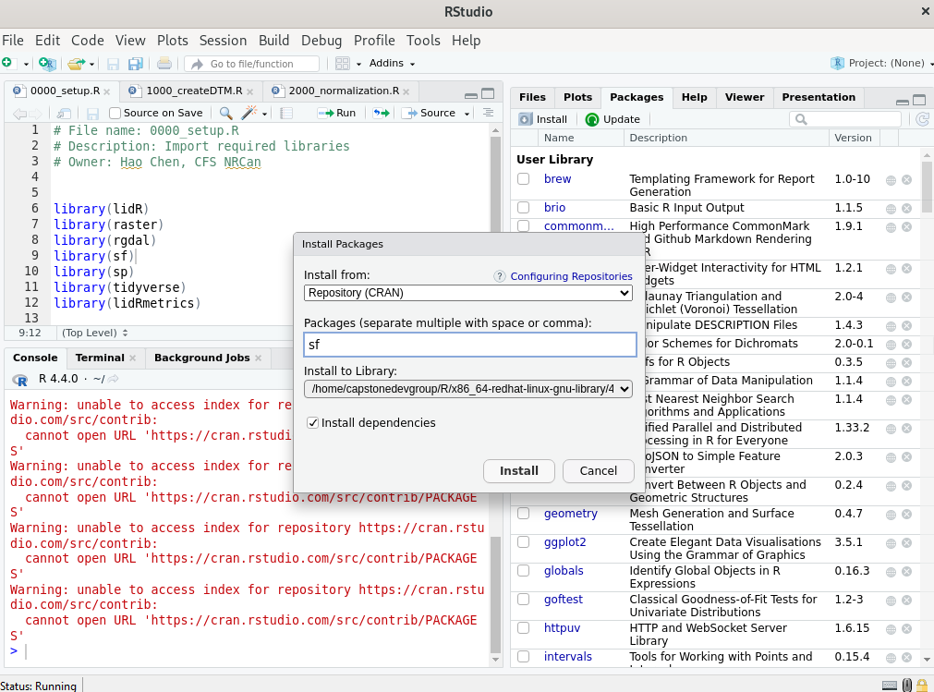
Figure 41 - Install Packages dialog box.
- Press install and wait for the process to finish (it will take a while)
2. Set the Working directory to the location of R scripts and required data as shown in Figure 42 below.
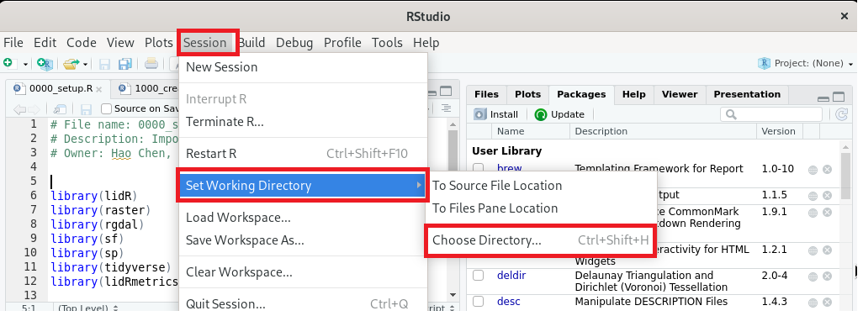
Figure 42 - Session tab in RStudio.
3. Press ‘Run’ to execute your scripts once all libraries are added like in Figure 43 below.
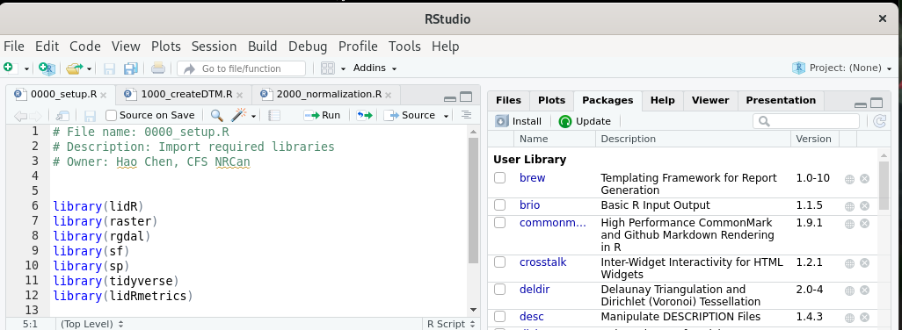
Figure 43 - List of libraries displayed in RStudio.

Conclusion
Upon completion of this user manual, you should now have a greater understanding of how to set up and use many new software applications. These include R, Rstudio, Pentaho, QGIS, Virtual Machines, Linux Servers, Geonetworks API and more. You have gained skills in IT, Administration, and Data Science, and gained a further understanding of how some of these systems and concepts work together. The modular ETL pipeline can only be effective if all of these systems work together. This is why understanding how each works on its own is so important.

Our sponsors have given us a platform to learn and foster new skills. We thank them for that opportunity as it is invaluable and allows us to grow more in the future.

If you would like any further information or to ask any questions about the projects you can contact us at capstone2024nrc@gmail.com.

