GETTING SET UP:

* Move the EVLENGTH and FREEFALL files to the microSD card you want to use (located in /Settings Files)
* Install the Sparkfun AVR pocket Programmer Drivers:
  + Follow: <https://learn.sparkfun.com/tutorials/pocket-avr-programmer-hookup-guide>
* Install the FTDI drivers:
  + Follow: https://learn.sparkfun.com/tutorials/how-to-install-ftdi-drivers

PROGRAMMING NEW DEVICES:

1. Install the Arduino IDE (located in /Arduino Installers)
2. In the Arduino IDE:
   1. Tools -> Board, and select Arduino Pro or Pro Mini
   2. Tools -> Processor, select ATmega328 (3.3V, 8MHz)
3. Open the Capstone_46_SetRTC program (located in Firmware/Capstone_46_SetRTC/)
4. Connect the Sparkfun FTDI Basic Breakout to your computer USB
5. Connect the Sparkfun Pocket AVR Programmer to your computer USB
6. Connect the Sparkfun FTDI Basic Breakout to the device JP1 (*see image)
7. Connect the Sparkfun Pocket AVR Programmer to the device 2x3 header below the RST button (*see image) (MAKE SURE IT IS SET TO “No Power”)
   1. (both the fdti and the AVR programmer should be connected)

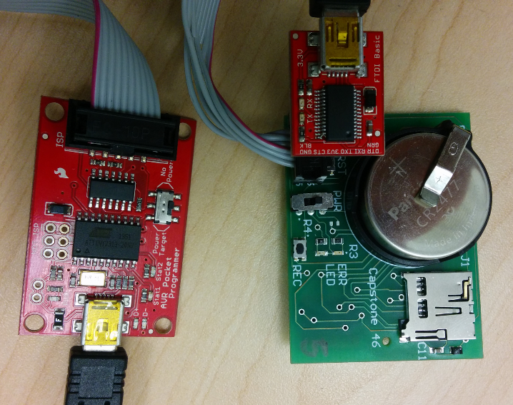

1. Tools -> Programmer, select USBtinyISP
2. Make sure the Power switch is UP!!! (towards the PWR label)
3. Tools -> Burn Bootloader
4. Wait until the Arduino IDE indicates that the bootloader was burned successfully
5. Remove the 2x3 AVR programmer connector and unplug the USB
6. Flip the power switch Down
7. File -> Upload
8. Wait until the Arduino IDE indicates the program (the RTC program in this case) was uploaded properly
9. Tools -> Serial Monitor
10. Follow the prompts to set the time on the RTC
11. Close the serial window
12. Insert the microSD card into the device
13. Now open the Capstone_46_Proto2_SLOWSD program (located in Firmware/Capstone_46_Proto2_SLOWSD)
14. File -> Upload
15. Remove the FTDI programmer, and flick the power switch up to turn device off!

USE

1. Make sure microSD has EVLENGTH and FREEFALL files
   1. EVLENGTH = 1 to 9999 (500-2000 recommended)
   2. FREEFALL = 1 to 60 (10-20 recommended)
2. Put microSD into device
3. Turn device on (down = on, up = off)
   1. Green LED should light
4. Press record (REC) to start
   1. Green LED should turn off
5. Close device and put on patient
6. Get device back from patient
7. Open device
   1. Be careful not to drop to trigger recording (bug when stopping during recording)
8. Press record again to stop
   1. Green LED should flash indicating completion
      1. *if not, data may still be ok! Just keep going
9. Turn device off (up = off) & remove microSD card, and insert into computer
10. Open Fall Data Analyser (/Excel Macro/)
11. Click on button and select data off of microSD card