Media Contribution Manual
A step-by-step guide for administrative contributors
Last updated: 5 July 2026
Website: https://capstonecrac-github-io.pages.dev/

READ THIS FIRST
This guide is for administrators who add project text, images, and videos to the website. You do not need to write or change any code.
There are only three things you will ever do:

- Edit a project's text in a Markdown (.md) file.
- Add approved images to the public/media folder, then point to them from the Markdown.
- Upload project videos to Cloudflare R2, then paste the video link into the Markdown.
Follow the steps in order. Whenever you see a coloured box, read it carefully — it is telling you something that matters.

0. Before you start — a few words explained
This guide keeps technical words to a minimum, but a handful come up often. Here is what they mean in plain language.
Word | What it means for you
Markdown (.md) | A simple text file that becomes one project page on the website. You edit it like a normal document — no coding.
Frontmatter | The settings at the very top of a Markdown file, written between two lines of three dashes (---). Details like the title, cover image, and video link live here.
Body | Everything below the second line of three dashes. This is the public story text that visitors read.
Repository (repo) | The online folder on GitHub that stores the whole website.
Commit and push | "Commit" saves your change. "Push" sends it up to GitHub. After you push, the website updates itself.

How to read the grey code boxes
Throughout this guide you will see grey boxes like the one below. They show exactly what to type into the Markdown file. Type or copy the text exactly — including the spaces at the start of indented lines. In Markdown, that spacing is not decoration; it changes the meaning.
EXAMPLE — A SINGLE SETTING
title: "Project Title"

KEY TO THE COLOURED BOXES
IMPORTANT (red) — do not skip. Getting this wrong can break the page.
RULE (grey) — a fixed rule to always follow.
TIP (green) — helpful advice that makes your life easier.
NOTE (blue) — extra information worth knowing.

1. What goes where
Everything you add falls into one of four buckets. This table shows where each thing lives and what the website does with it.
Item | Where it lives | What the website does with it
Project text | src/content/projects/<name>.md | Becomes one public project page.
Project images | public/media/projects/<name>/ | Shown on the page. Linked from the Markdown using a /media/... path.
Project videos | Cloudflare R2 (online storage) | The video link (URL) is pasted into the Markdown.
Publishing | GitHub main branch | After you commit and push, Cloudflare rebuilds the site automatically.

2. Editing a project's Markdown file
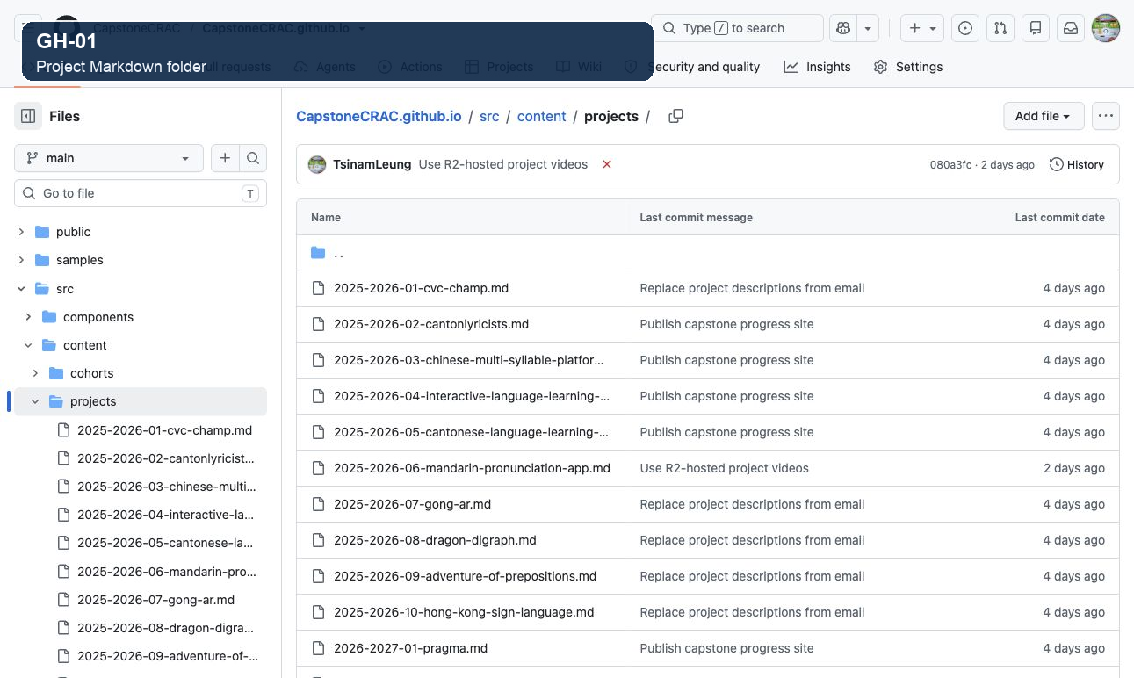
Figure GH-01 — Where the Markdown files live on GitHub
This is the GitHub website showing the project files. Click through the folders src, then content, then projects.
Inside projects you will see one .md file per project. Click the .md file for the project you want to change.
Only ever open files ending in .md. Leave every other (source-code) file alone.
Every project page is controlled by one Markdown file inside the folder src/content/projects. To change a project's text, you open that one file and edit it.
RULE — do not rename published files
The file name becomes part of the web address. If you rename a file that is already live, its link changes and any existing link to it will break. Change the text inside the file, but keep the file name the same.

The two parts of a Markdown file
Open any project .md file and you will see two parts. Knowing the difference makes everything else easier:
- The frontmatter — the settings block at the very top, between the two lines of three dashes (---). This holds the title, cover image, gallery, and video.
- The body — everything below the second ---. This is the public story text people read on the page. You can also place images directly here (see Section 3).

A complete starting template
You can copy the whole block below into a new project file and then change the values to match your project.
EXAMPLE — A FULL PROJECT .MD FILE
---
title: "Project Title"
author: "Author Name"
year: "2025-2026"
cohortId: "coh3"
order: 1
detailLevel: "full"
hasVideo: true
type: "App"
focus: "Language Learning"
summary: "Short public project description."
cover:
src: "/media/projects/project-name/cover.jpg"
alt: "Short description of the cover image"
video:
src: "https://pub-example.r2.dev/example-video.mp4"
type: "video/mp4"
duration: "2:14"
caption: "Demo walkthrough"
gallery:
- src: "/media/projects/project-name/01-home.jpg"
alt: "Home screen"
title: "Home Screen"
caption: "Entry point for the app."
---

Longer public project story goes here.

NOTE — the indented lines
Lines under cover:, video:, and gallery: begin with two spaces (and gallery items with a little more). Keep those spaces exactly as shown, or the settings will not be read correctly.

RULE — public text only
Only put public-facing text into a Markdown file. Never paste internal emails, private student notes, support-only comments, passwords, or unpublished approval discussions.

3. Adding images
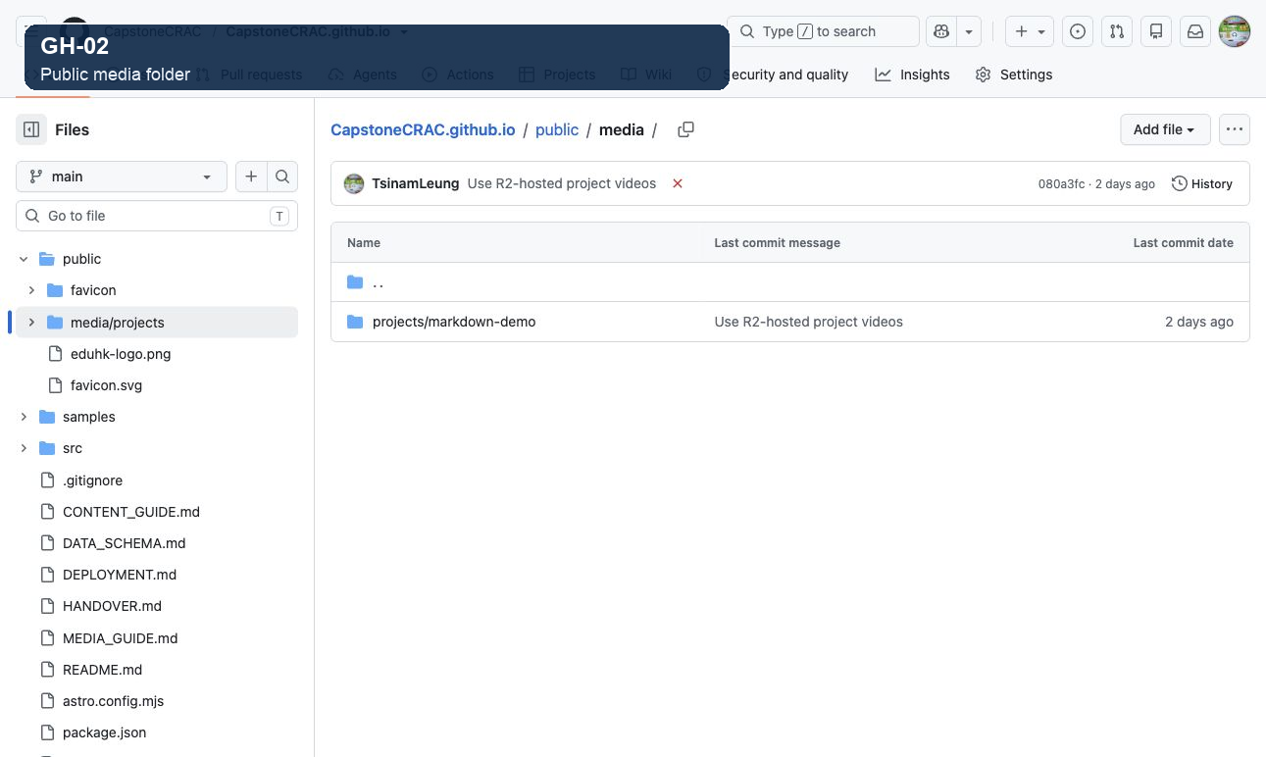
Figure GH-02 — Where approved images live on GitHub
Images are stored on GitHub under public, then media, then projects, then a folder named after the project.
Place your approved image in the correct project folder here first. An image cannot be shown on the page until the file exists in this location.
Give files clear names such as cover.jpg, 01-home-screen.jpg, or feedback-screen.png.
An image can appear on a project page in two ways. Both point to a file that you have already placed in the public/media folder, so always add the file first, then link to it.

First, the one path rule to remember
The public folder is the root of the website. That means the word public is never written in a Markdown path. You drop it and start the path with /media/.
Where the file really is (on GitHub) | What you type in the Markdown
public/media/projects/mandarin-app/cover.jpg | /media/projects/mandarin-app/cover.jpg

- Always start the Markdown path with a leading slash: /media/...
- Never write public/ inside the Markdown.
- Never paste a GitHub file web address as an image path.

Way 1 — Images set in the frontmatter (cover and gallery)
The cover is the large image at the top of the page. The gallery is the set of screenshots shown together. Both are set in the settings block at the top of the file.
EXAMPLE — COVER IMAGE
cover:
src: "/media/projects/mandarin-app/cover.jpg"
alt: "Mandarin pronunciation app home screen"

EXAMPLE — GALLERY IMAGE
gallery:
- src: "/media/projects/mandarin-app/01-practice.jpg"
alt: "Practice screen with pronunciation categories"
title: "Practice Activity"
caption: "Learners compare commonly confused Mandarin sounds."

The website places these images for you automatically — the cover at the top, and each gallery item in the project's picture set. You do not need to do anything else in the body text for them to appear.

Way 2 — Images placed inside the body text (inline)
You can also drop an image straight into the story, exactly where you want it to appear. This is called an inline image. Put it on its own line in the body:
EXAMPLE — AN INLINE IMAGE IN THE BODY
![Practice screen](/media/projects/mandarin-app/01-practice.jpg)

That single line has three parts. Here is what each one does:
Part | In the example | What it does
! | ! | Tells Markdown the next item is an image, not an ordinary link.
[ ] | [Practice screen] | The alt text — a short description of the image. It is shown if the image cannot load, and is read aloud to visually impaired visitors, so make it meaningful.
( ) | (/media/...01-practice.jpg) | The image path. It follows the same rule as above: start with /media/ and match a file already placed under public/media.

Putting an inline image in context
In real writing, an inline image sits between paragraphs. Leave one blank line above and one blank line below the image line so it displays on its own:
EXAMPLE — IMAGE BETWEEN TWO PARAGRAPHS
The home screen greets learners with today's practice goal.

![Home screen showing the daily goal](/media/projects/mandarin-app/01-home.jpg)

Tapping a category opens a set of pronunciation drills.

TIP — which one should I use?
Use the cover and gallery in the frontmatter for the main project screenshots. Use an inline image only when a picture needs to sit next to a specific paragraph in the story. Both use the same /media/... path.

4. Uploading videos to Cloudflare R2
IMPORTANT — videos never go into GitHub
Video files are too large for the GitHub repository. Every project video goes to Cloudflare R2 instead. Only the copied video link (URL) is placed in the Markdown.

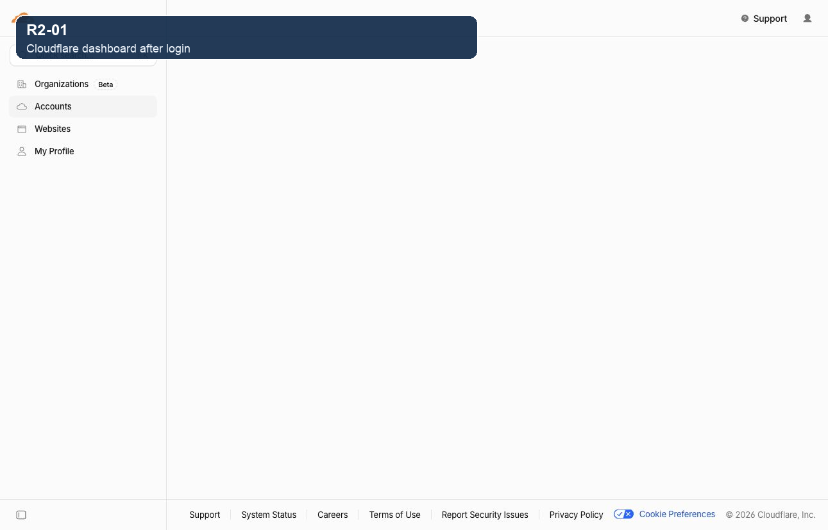
Figure R2-01 — The Cloudflare dashboard after you log in
Go to dash.cloudflare.com. If a login screen appears, sign in with the approved admin Cloudflare account only.
This is the dashboard home page. In the menu on the left, look for R2 Object Storage and click it.
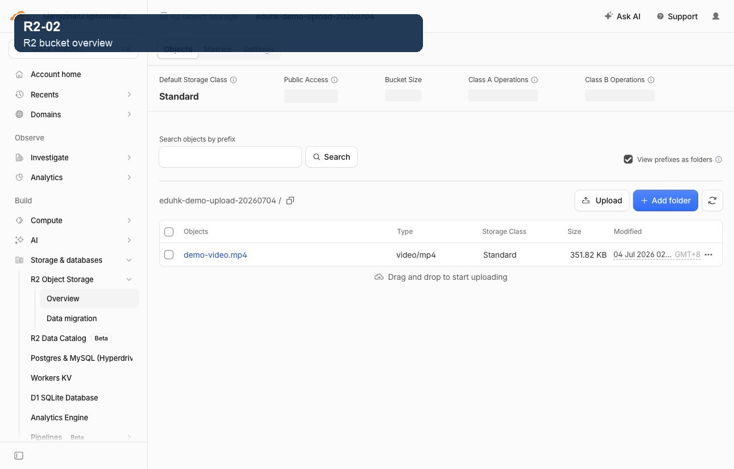
Figure R2-02 — Opening the project video bucket
A "bucket" is simply a storage folder in R2. This screen lists the buckets you can open.
Click the bucket used for project videos to open it.
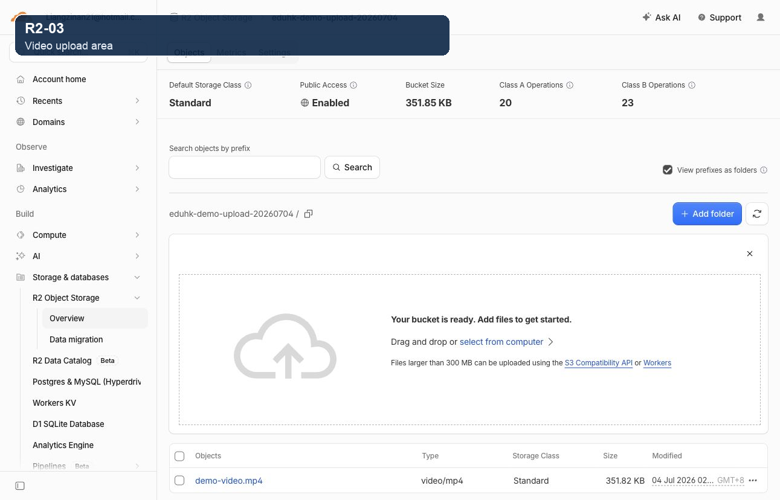
Figure R2-03 — Uploading the video file
Inside the bucket, drag your MP4 file into the upload area, or click it to choose the file from your computer.
- Give the file a simple name, for example mandarin-pronunciation-demo.mp4.
- Avoid spaces, Chinese punctuation, and very long names.
- Wait until the upload finishes completely before closing the page.
- Once it appears in the file list, click the uploaded file to open it.

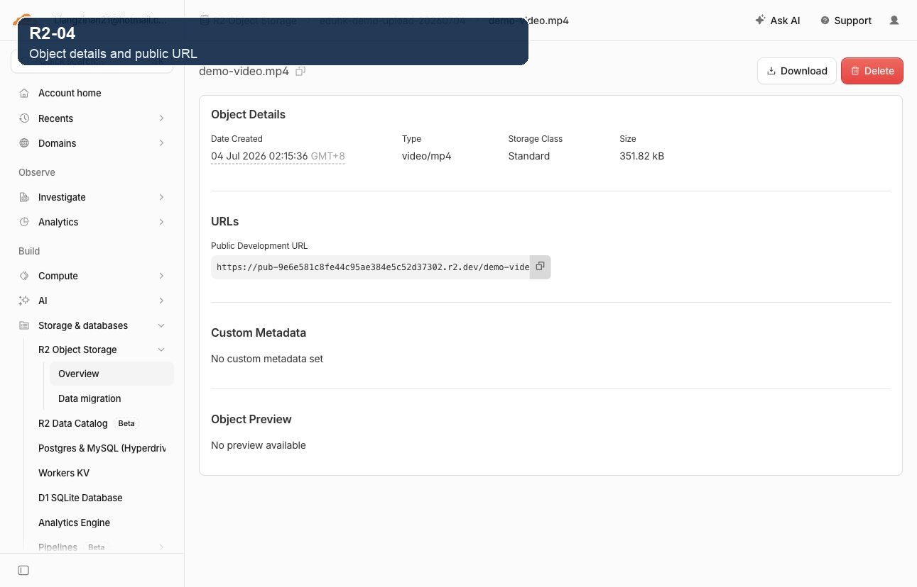
Figure R2-04 — Copying the public video link
On the file's page, find the Public Development URL — the link that begins with https:// and ends in .mp4.
Click to copy the full link. This exact link is what you paste into video.src in the Markdown (next step).

Point the page at your video
Paste the copied R2 link into the video block in the frontmatter, and make sure hasVideo is set to true:
EXAMPLE — THE VIDEO BLOCK IN THE FRONTMATTER
hasVideo: true
video:
src: "https://pub-9e6e581c8fe44c95ae384e5c52d37302.r2.dev/demo-video.mp4"
type: "video/mp4"
duration: "2:14"
caption: "Demo walkthrough"

NOTE — where video goes
On this website the video is set only in the frontmatter video block. Unlike an image, you do not place a video inside the body text — the site builds the video player for you from these settings.

NOTE — when does the website update?
If you replace a video but keep the same R2 link, the page usually does not need a rebuild. If you change anything in the Markdown, commit and push it — Cloudflare Pages will then rebuild the site automatically.

5. Deleting or replacing a video
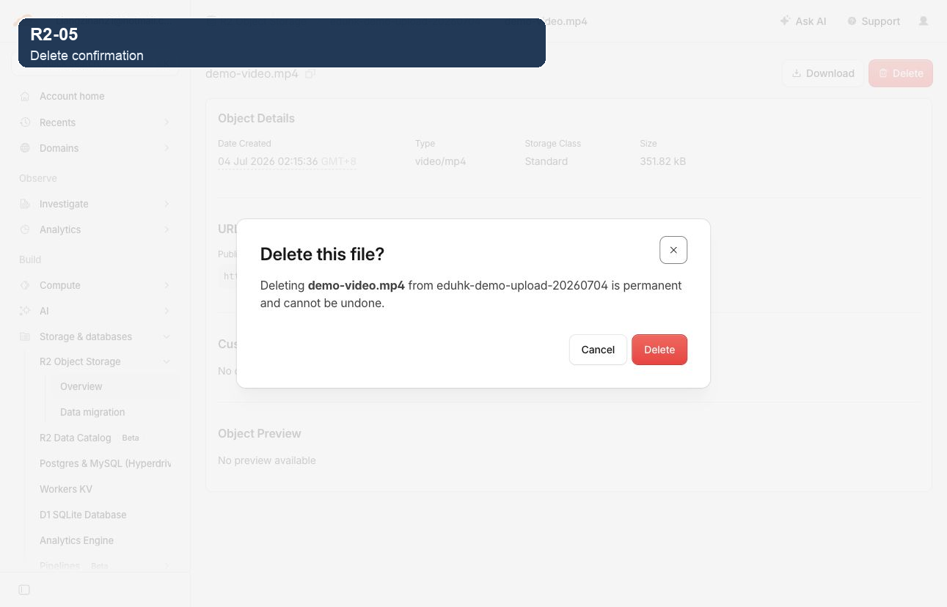
Figure R2-05 — The delete confirmation
The final Delete button permanently removes the file — this cannot be undone. If you are unsure, click Cancel.
Before deleting, read the file name carefully to be sure it is the right one.
If the website still points to a link you delete, that video will break on the page. To replace a video safely, do it in this order:
- Upload the new video file to R2 first.
- Copy the new file's link (the Public Development URL).
- Update video.src in the Markdown to the new link.
- Commit and push so Cloudflare Pages rebuilds. Only then delete the old file if it is no longer needed.

6. Final checklist before publishing
Run through this list before you commit and push. Tick each item once you have checked it.
- [ ] The Markdown file is in src/content/projects.
- [ ] Title, author, year, cohortId, summary, and detailLevel are correct.
- [ ] Image files are under public/media and referenced as /media/...
- [ ] Every image has useful alt text.
- [ ] The video file is uploaded to R2, not GitHub.
- [ ] video.src contains the full R2 link and hasVideo is true.
- [ ] If unsure, ask a maintainer to run pnpm build before publishing.
- [ ] Commit and push to GitHub main. Cloudflare Pages will rebuild automatically.

7. Common mistakes
Mistake | Do this instead
public/media/projects/app/cover.jpg | /media/projects/app/cover.jpg (drop the word public)
media/projects/app/cover.jpg | /media/projects/app/cover.jpg (start with a slash)
Uploading an MP4 into public/media | Upload the MP4 to Cloudflare R2 and paste the R2 link.
Deleting an R2 video but leaving its link in the Markdown | Update or remove the video block before publishing.
hasVideo: false while a video block is present | Set hasVideo: true when the video should show.

8. GitHub Desktop workflow for admins
You can use GitHub Desktop instead of typing Git commands. The important thing is the order: get the latest version first, then save your change, then send it up.
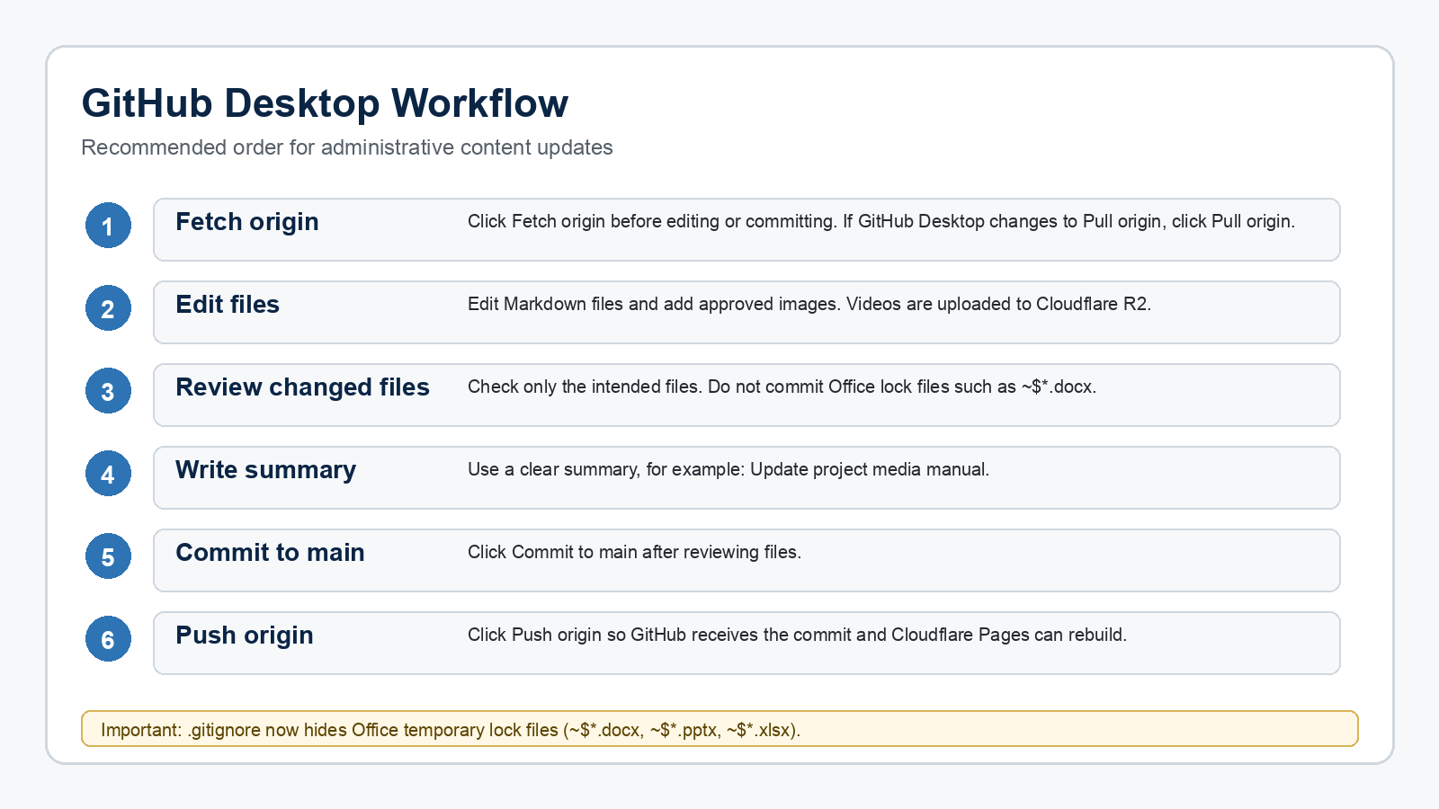
Figure GD-01 — The update, commit, and push order in GitHub Desktop
Follow the three steps in order: first Fetch origin (get the latest), then write a short summary and Commit to main (save), then Push origin (send your change up).
- Click Fetch origin to check for the latest version of the site.
- If a Pull origin button appears afterwards, click it before making or committing any of your own changes.
- Write a short summary of what you changed, then click Commit to main.
- Click Push origin to send your change to GitHub. Cloudflare Pages then rebuilds the site automatically.

RULE — always update before committing
Start every session by clicking Fetch origin. If GitHub Desktop then shows Pull origin, click it before you make or commit your own changes. This keeps your copy in step with everyone else's.

