CAPSTONECRAC ADMIN GUIDE
GitHub Desktop Setup
Open, update, and publish the website without typing Git commands or repository URLs
Before you start
Ask the website maintainer to invite the email address used for your GitHub account. Accept the GitHub invitation before continuing.
Download GitHub Desktop
Install GitHub Desktop, open it, and sign in using the same GitHub account that received the invitation.
No repository URL is required
Use the buttons and links in this guide. Do not copy the HTTPS address and do not use GitHub Desktop's URL tab.
Open the CapstoneCRAC website files

Step 1 — Open the repository
Click Open the CapstoneCRAC website files on page 1. Chrome opens GitHub. Confirm that the repository name at the top is CapstoneCRAC.github.io.
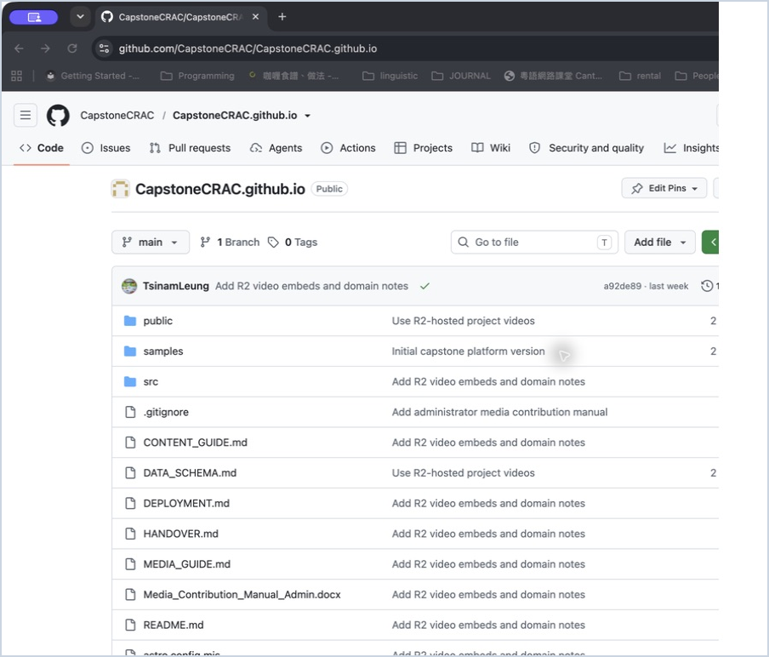
Figure 1 — The correct CapstoneCRAC.github.io repository page

Step 2 — Open it with GitHub Desktop
Click the green Code button. Stay on the Local tab and click Open with GitHub Desktop. Ignore the HTTPS address shown above it.
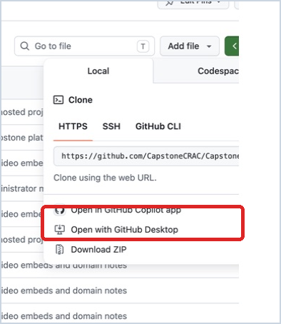
Figure 2 — Choose Open with GitHub Desktop
Chrome may ask for permission. Click Open GitHub Desktop. Leave Always allow unticked unless this is your permanent work computer.
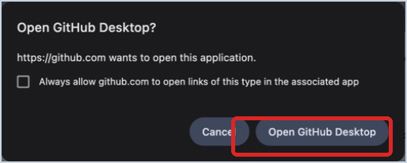
Figure 3 — Allow Chrome to open GitHub Desktop

Step 3 — Choose the repository and folder
If the repository list appears, stay on the GitHub.com tab, search for CapstoneCRAC, and select CapstoneCRAC/CapstoneCRAC.github.io. Click Choose to select a folder you can find later, then click Clone.
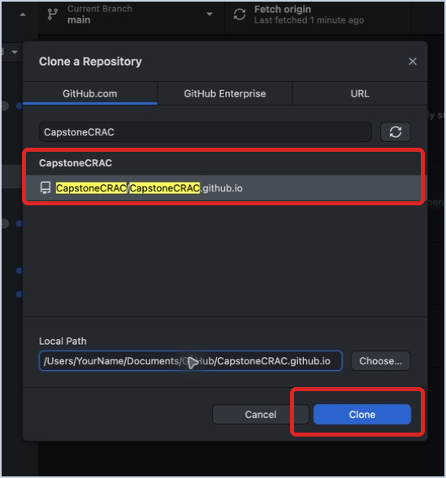
Figure 4 — Select the repository without entering a URL
Repository missing?
Stop and ask the website maintainer to add your GitHub account. Do not switch to the URL tab.

Step 4 — Pull updates before editing
Confirm Current Repository is CapstoneCRAC.github.io and Current Branch is main. Click Fetch origin. If the button changes to Pull origin, click it and wait until it finishes.
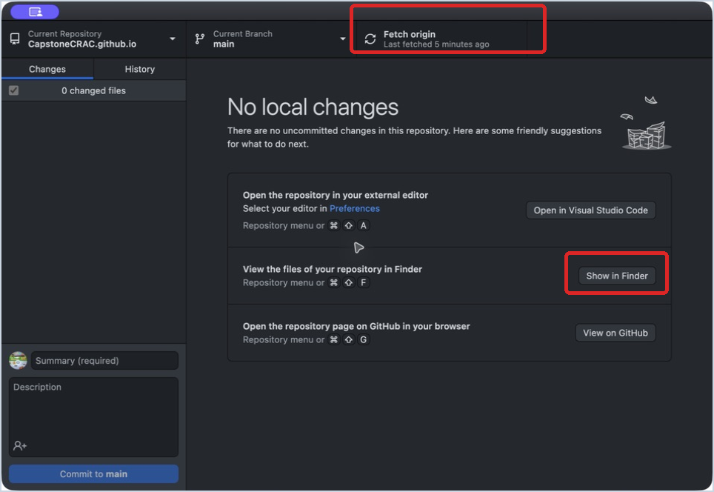
Figure 5 — Fetch or pull the latest version before every editing session
Step 5 — Find the downloaded files
Click Show in Finder. The selected folder contains the complete website and the administrator guides.
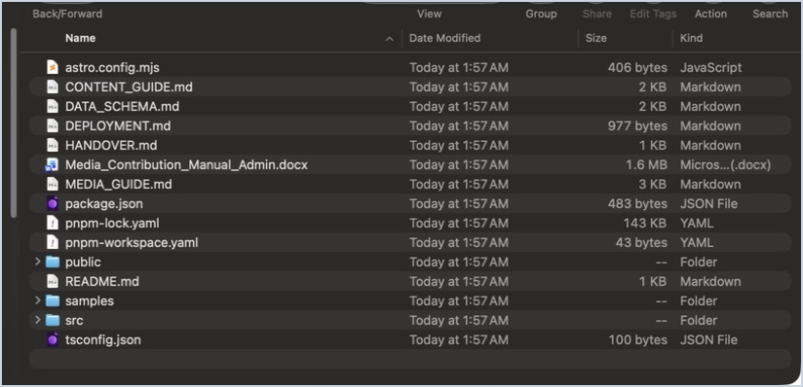
Figure 6 — The downloaded website folder in Finder
Step 6 — Open the project Markdown folder
In Finder, open src, then content, then projects. Each .md file controls one project page. The complete example is 2025-2026-06-mandarin-pronunciation-app.md.
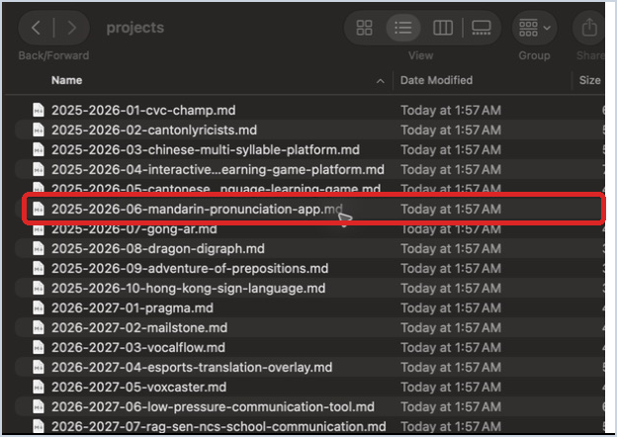
Figure 7 — Project files under src/content/projects
Before editing
Check that GitHub Desktop has finished pulling updates. Then open and edit only the required project file.

After editing — commit and push
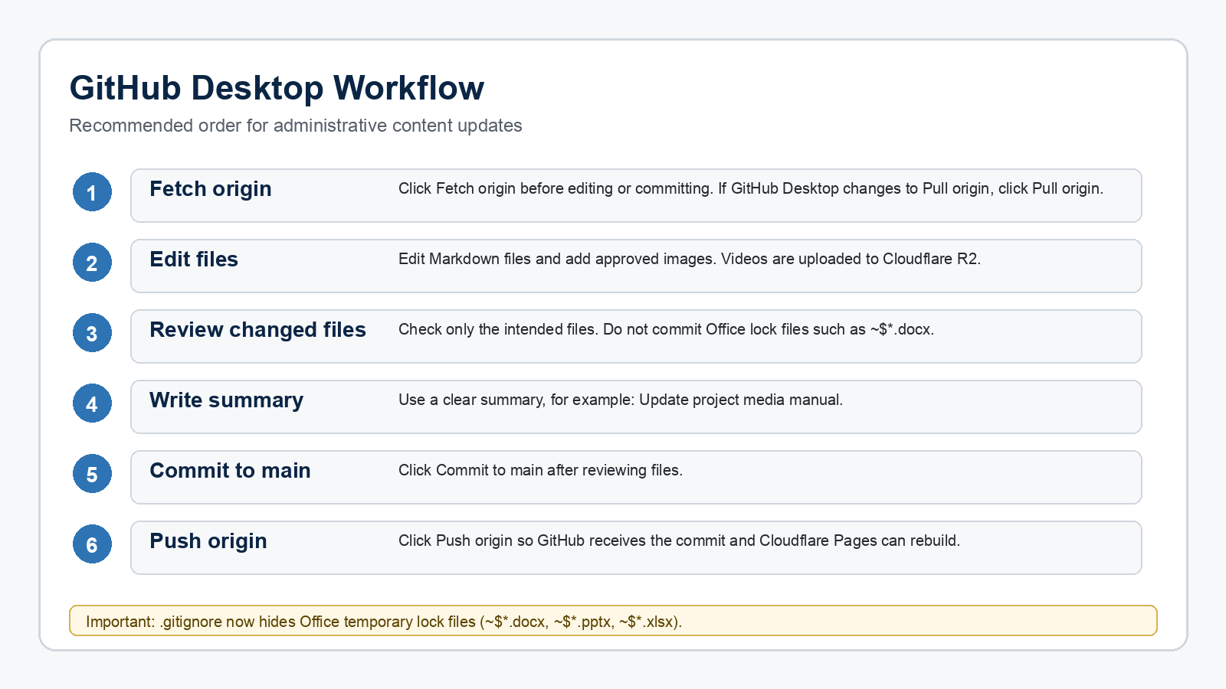
Figure 8 — The correct update, commit, and push order
1. Click Fetch origin again. If Pull origin appears, click it first.
2. Review the changed files and make sure only your intended files are selected.
3. Write a short summary, then click Commit to main.
4. Click Push origin. GitHub receives the change and Cloudflare Pages rebuilds the website automatically.
Finished
When GitHub Desktop shows no local changes and Fetch origin, your update has been sent successfully.

