Software Testing & Comparative Evaluation Report
StudySmart Companion | Week 7 Midterm Preparation
Team 5 • Test evidence: October 10 and October 21, 2026 • Report date: October 21, 2026
Prepared from screenshots and the Week 7 work checklist, team weekly report, and Prince Karki’s implementation support/testing notes. This is an evidence-based review, not a claim of full automated or end-to-end functional certification.

1. Executive summary
The visible StudySmart prototype presents subject-based task entry, a study-plan dashboard, standard and rapid quiz selection, a rapid-quiz result breakdown, and light/dark presentation. The current evidence expands on the previous week by documenting the quiz selection screen, a completed rapid-quiz result, dark mode, and a recently-added locally saved task list. Across both dates, the study-plan counts remain 7 total, 3 completed, 4 pending and 43% complete. Screenshot evidence alone does not prove that every control works, that changes persist after refresh, or that the complete journey was executed in one session.
Assessment | Current evidence-based finding
Visual/UI readiness | Main sections rendered; light and dark quiz result views captured
Quiz result | 2/10 = 20%; 2 correct, 8 incorrect; timeout reported
Dashboard consistency | 7 total = 3 completed + 4 pending; 3/7 ≈ 43%
Outstanding validation | Search operation, task-save validation, persistence, failure recovery, and full flow execution require recorded runs

2. Scope, sources and method
Comparison baseline: October 10 screenshots (five supplied images). Current observation: October 21 screenshots (five supplied images). Supplementary scope: Team 5 Week 7 Weekly Report (dated October 19), Week 7 Work Checklist (October 15–21), and Prince Karki’s Week 7 implementation/testing/documentation report. Method: visual comparison and arithmetic consistency checks. Status labels: OBSERVED = screenshot directly demonstrates a UI state; CONSISTENT = visible figures reconcile; NOT VERIFIED = behavior requires interactive execution; ISSUE = confirmed visual discrepancy or documented risk.

3. Week-over-week feature comparison
Feature | Oct 10 baseline | Oct 21 evidence | Assessment
Study Plan | 7 total; 3 done; 4 pending; 43%; 3 overdue | Same counts, progress and overdue total | CONSISTENT; no new task-count change shown
Upcoming task | Data Structures assignment, 3d overdue | Same assignment, 14d overdue | CONSISTENT with 11-day elapsed interval
Subjects & Tasks | Programming selected; entry form and 3 task entries | No subject selected; form locked; recently added list shows 7 locally saved | OBSERVED; different selection states
Quiz question screens | 10-question rapid question with timer; 15-question standard question | Quiz mode selection: 15 standard / 10 rapid, 30-sec limit | OBSERVED; complementary views
Quiz results | No completed score screen supplied | 2/10, 20%; answer-by-answer review, timeout | NEWLY DOCUMENTED
Theme | Light UI shown; dark toggle present | Light and dark quiz result views | NEWLY DOCUMENTED
Search | Search input visible | Search input visible | NOT VERIFIED: query/results absent
Add task | Task title, deadline and Save task visible | New task button; subject selection prerequisite | NOT VERIFIED: no new task-save execution shown

4. Detailed observations and visual evidence

4.1 Main dashboard / study plan
The current study plan shows a weekly workload callout, 43% progress ring, task totals, overdue badge, subject chips, status filters and task tracker. Arithmetic is internally consistent (3 completed ÷ 7 total = 42.86%, rounded to 43%). The overdue count remains 3, while the highlighted task’s overdue age advances from 3 to 14 days. This is plausible over 11 calendar days, but is not proof of automatic deadline recalculation.
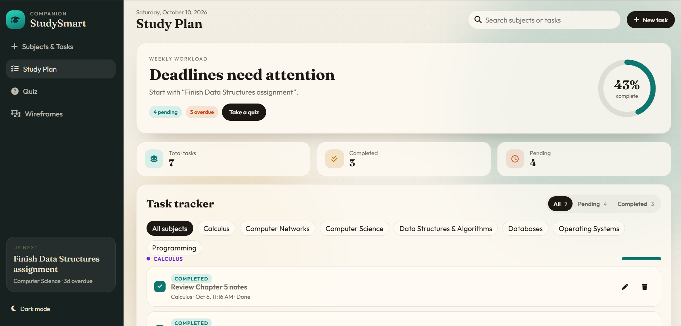
Figure 1. October 10 — Study Plan baseline
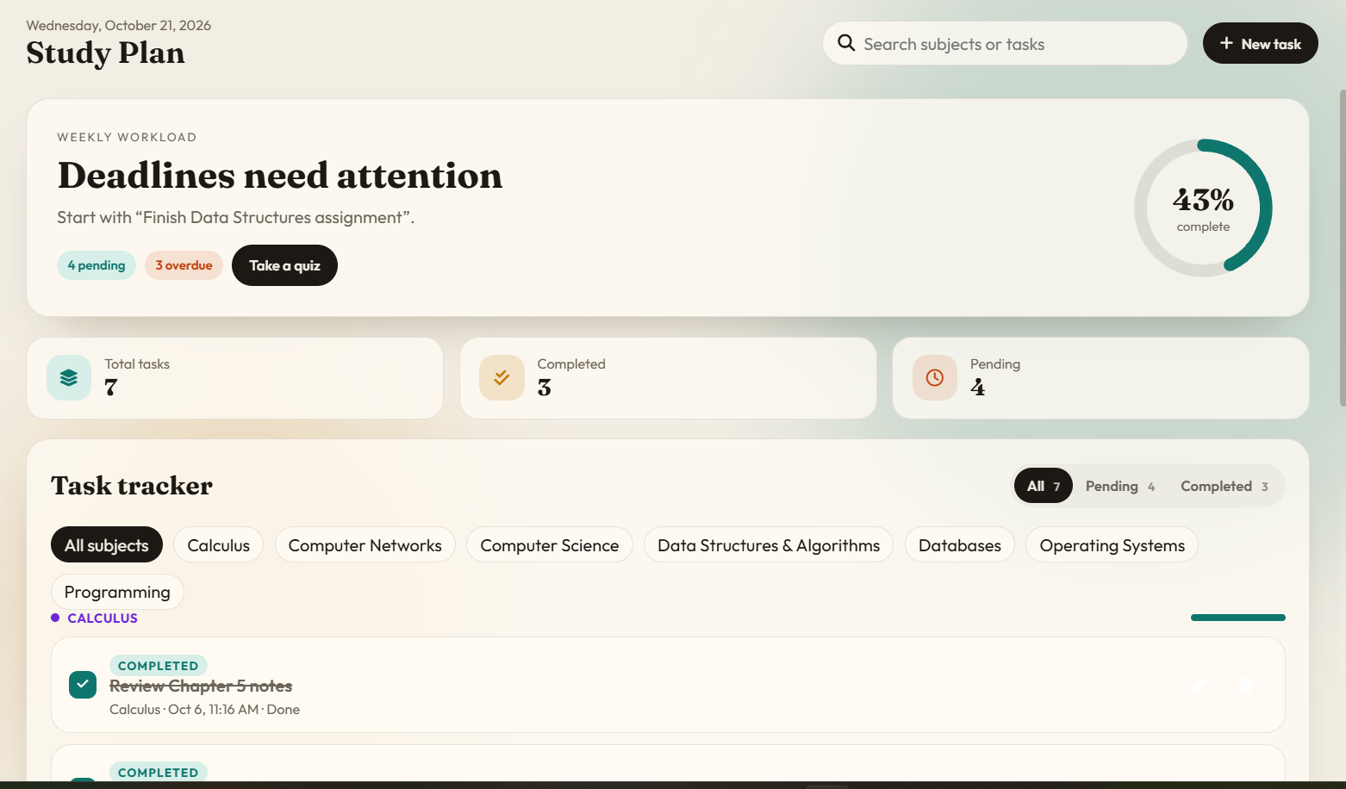
Figure 2. October 21 — Study Plan current state

4.2 Subjects, task creation and saved-task list
The October 10 view displays a selected Programming subject, task title input, deadline selector, Save task button and a list of three Programming tasks. The October 21 view starts without a subject selected and instructs the user to choose a subject to unlock the form; a “Recently added” area indicates 7 tasks saved locally. These are two valid-looking interface states, not evidence that a new task was created during the current test. Verify required fields, date handling, editing, deletion, and post-refresh persistence interactively.
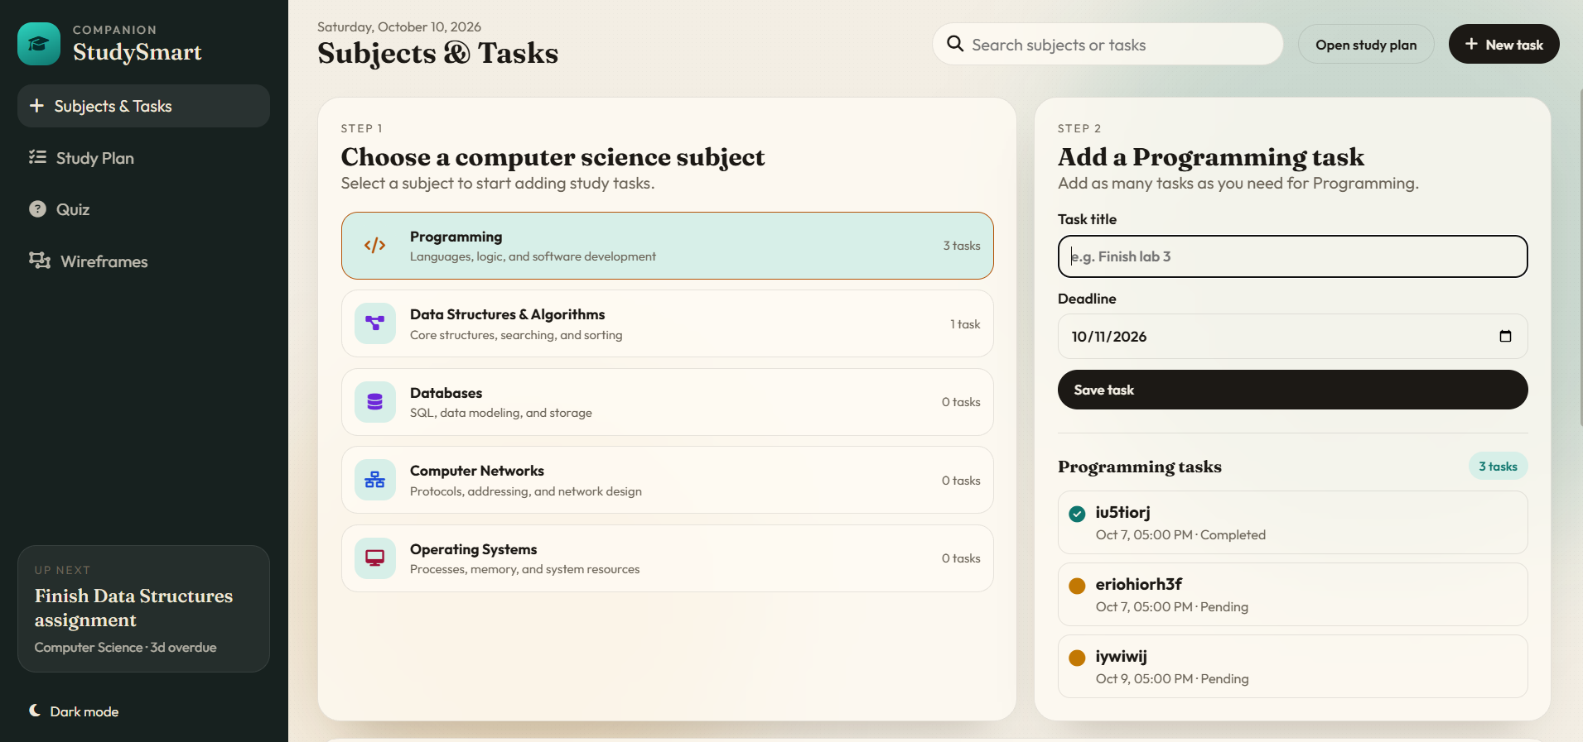
Figure 3. October 10 — Selected subject and task entry form
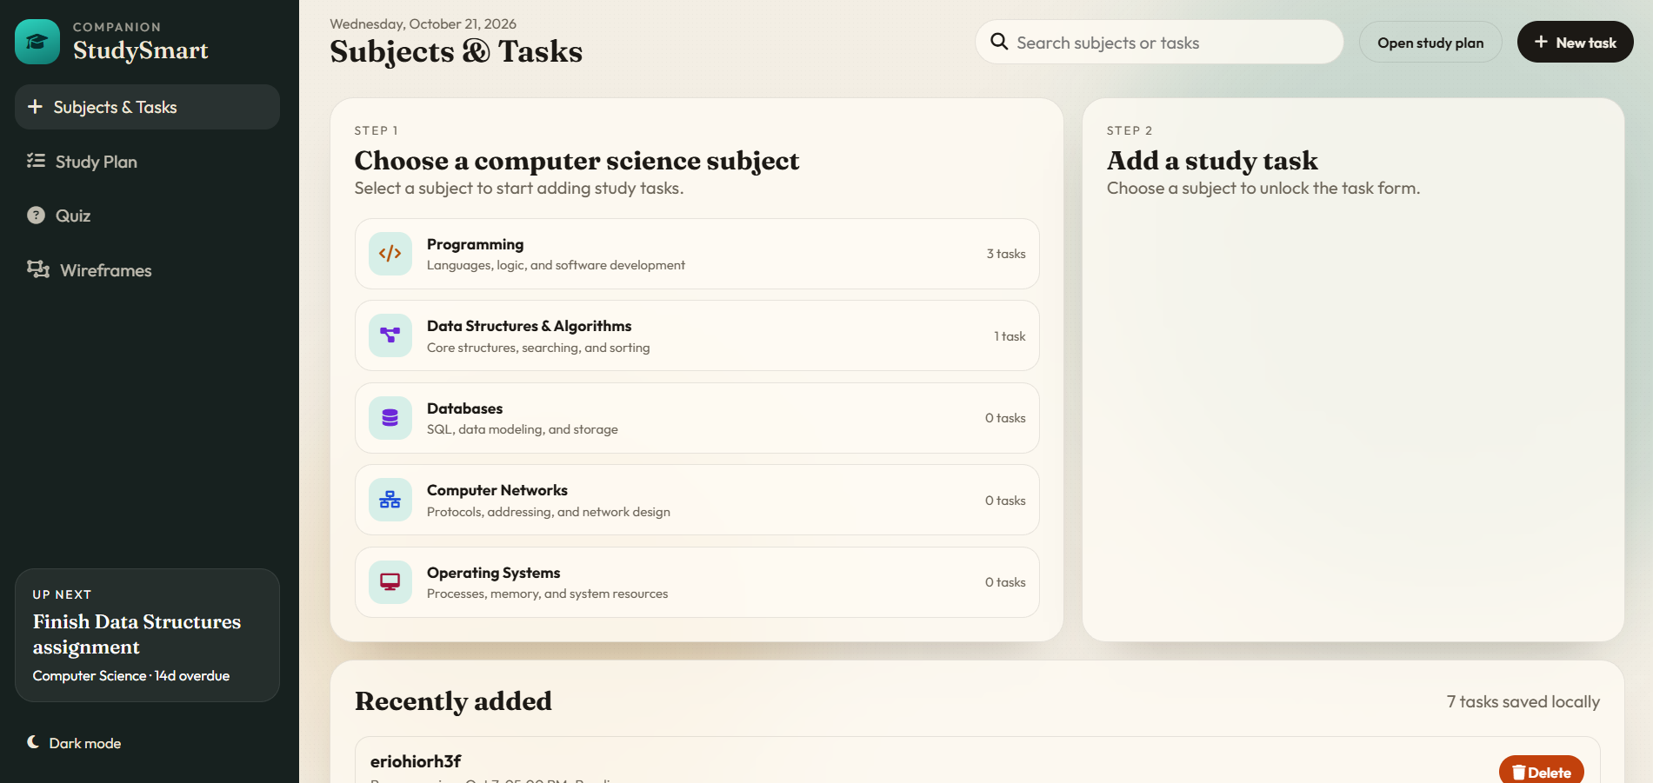
Figure 4. October 21 — Subject selection and recently added tasks

4.3 Quiz mode selection and question interface
Earlier screenshots show a Programming rapid quiz at question 1/10 with 24 seconds remaining, and a standard Programming quiz at question 1/15. The current screen explicitly offers a 15-question standard quiz and a 10-question rapid quiz with a 30-second limit. A full 30-second countdown and answer navigation were not independently timed in the supplied evidence.
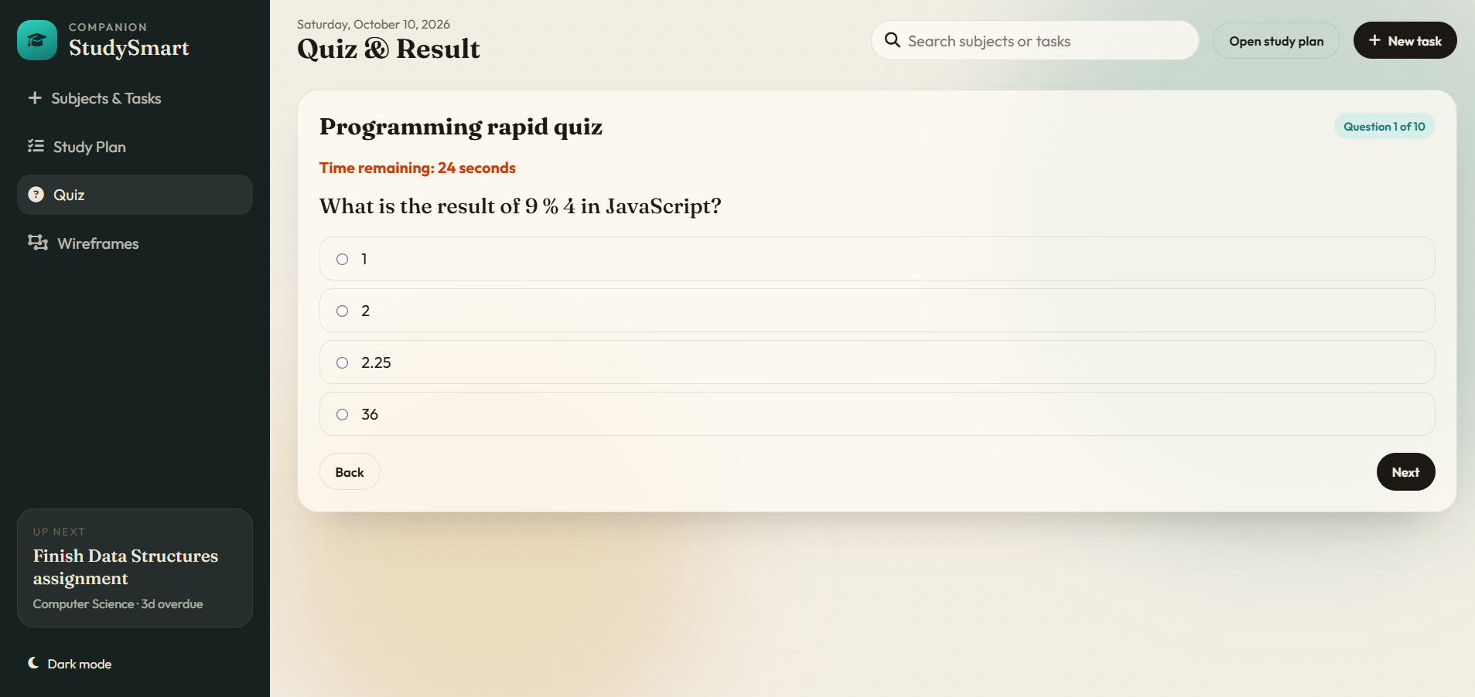
Figure 5. October 10 — Rapid quiz question and visible countdown
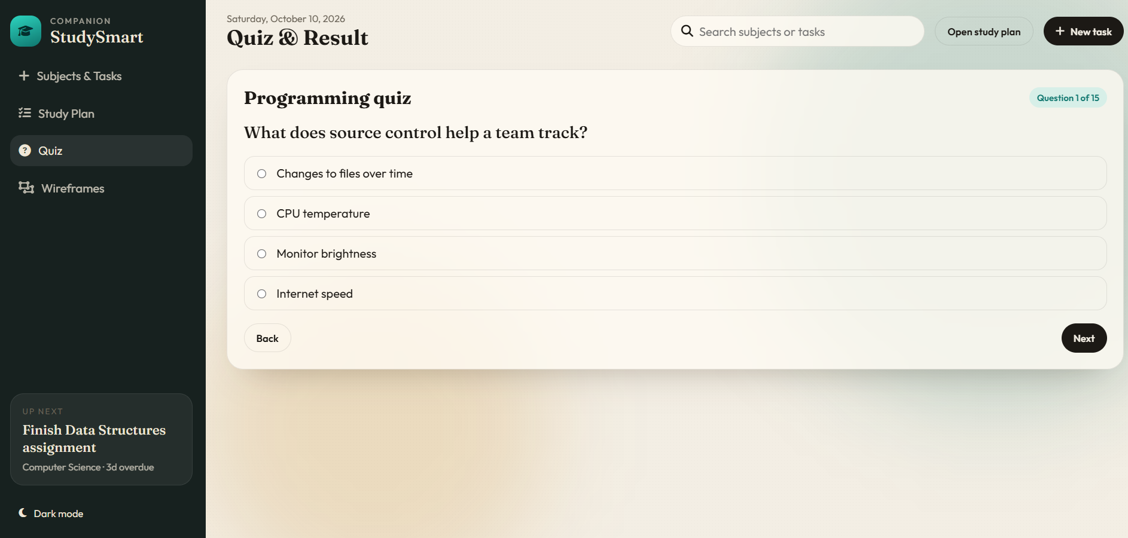
Figure 6. October 10 — Standard 15-question quiz
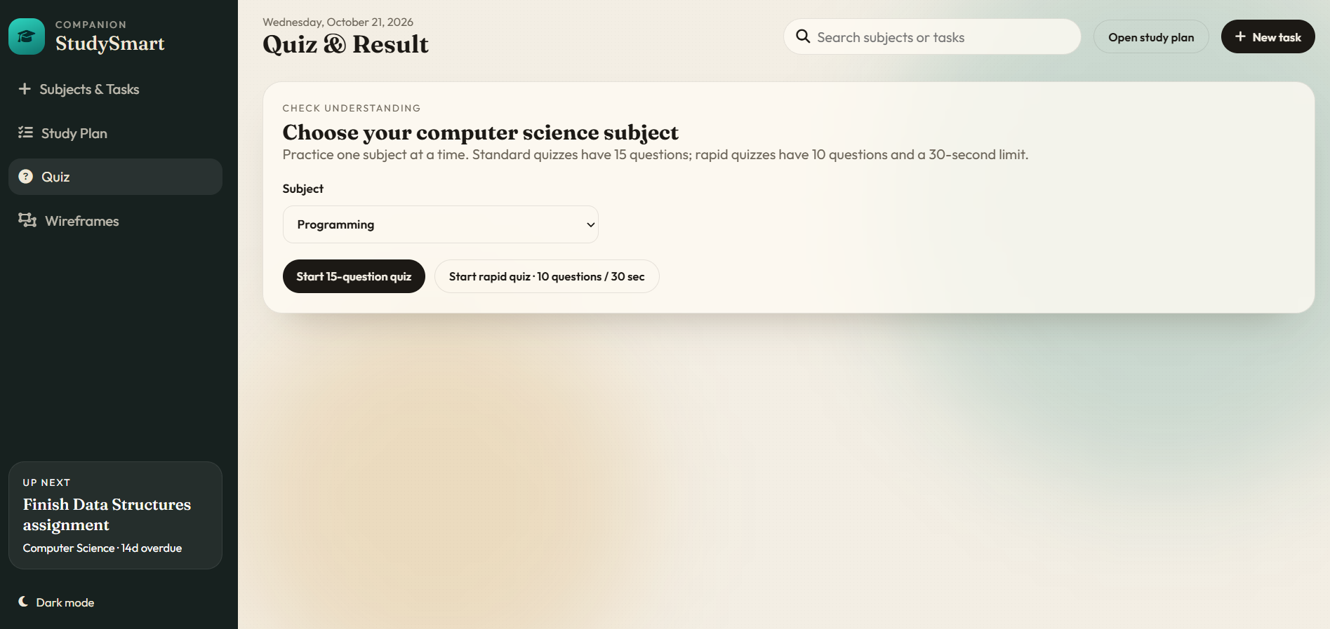
Figure 7. October 21 — Quiz subject and mode selection

4.4 Quiz completion and answer review
The October 21 result page reports “Time is up”, Programming rapid quiz, 2 correct and 8 incorrect, marks 2/10 and 20% correct. The four visible reviewed questions include incorrect HTML heading, syntax error and JavaScript remainder answers, and a correct debugging answer. For 9 % 4, the correct remainder is 1, matching the result page. The complete ten-item review is not visible in the cropped screenshot, so the reported score is arithmetically consistent but cannot be independently recounted from all ten answers.
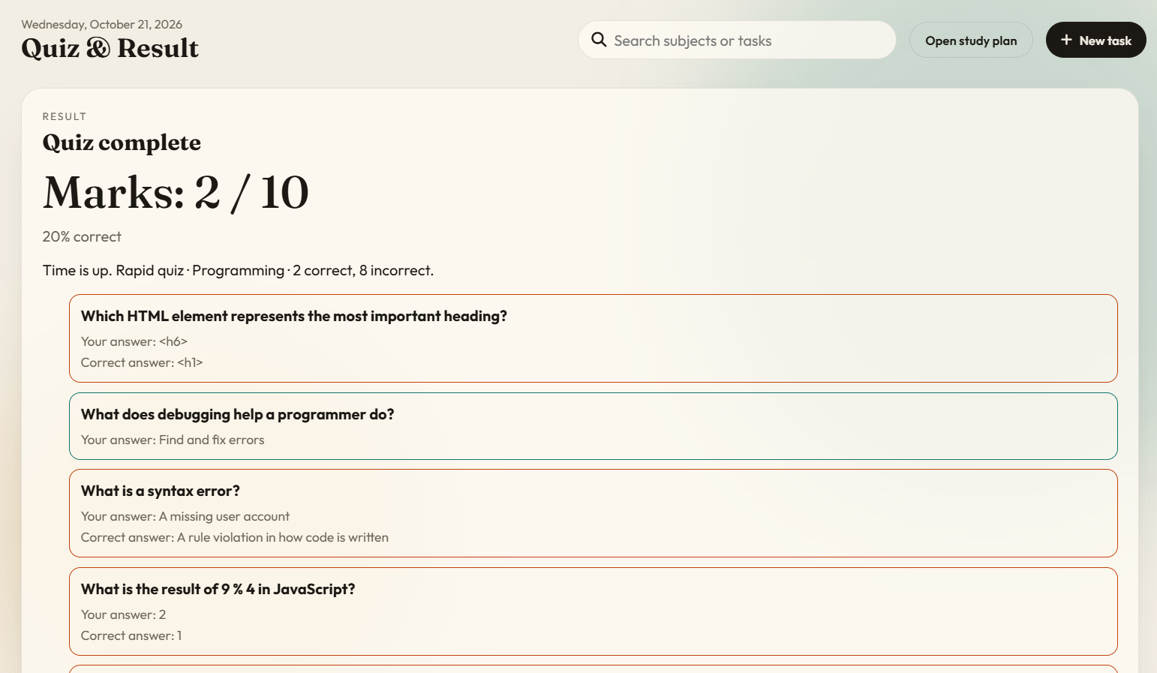
Figure 8. October 21 — Rapid quiz result and answer review (light mode)

4.5 Theme / dark and light mode
Light and dark screenshots show the same rapid-quiz result information and layout. The dark view uses a dark background, light text and colored result borders. This provides visual evidence of both themes; it does not establish theme persistence after refresh or verify every page and icon for contrast. In the current light-mode Study Plan screenshot, the task edit/delete icons appear very pale against the card background; check contrast and hover/focus states.
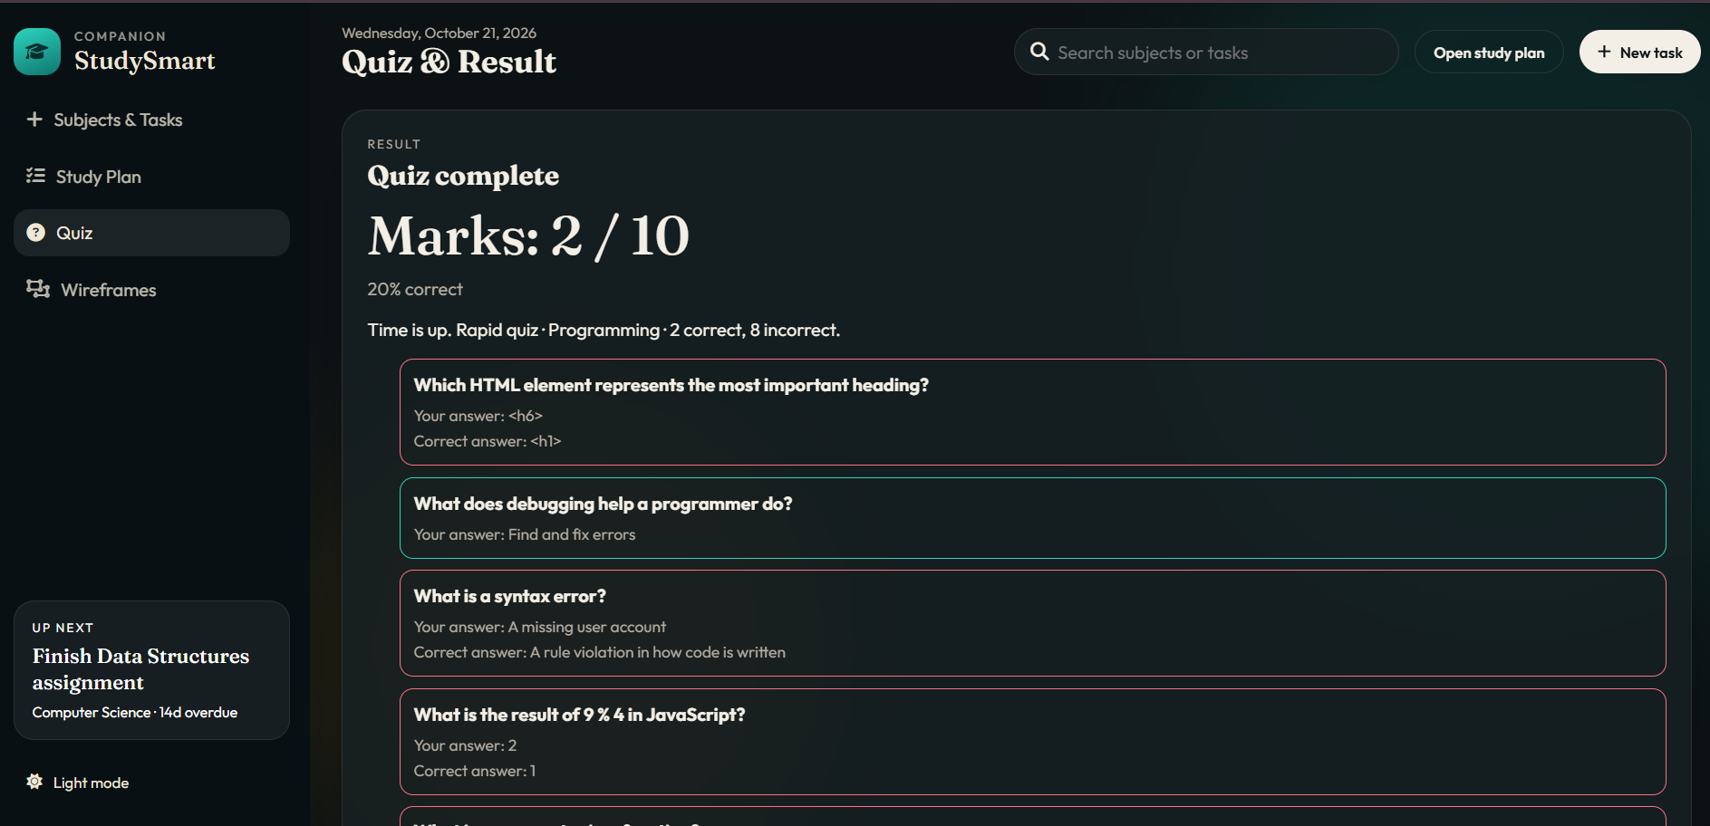
Figure 9. October 21 — Rapid quiz result in dark mode

4.6 Search and navigation
The top search field (“Search subjects or tasks”) and New task action are visible in both periods. Sidebar links to Subjects & Tasks, Study Plan, Quiz and Wireframes are shown in the full-page captures. No screenshot shows a submitted search query, matching results, an empty-results state or a confirmed navigation test; record these as unverified until an interactive run is captured.
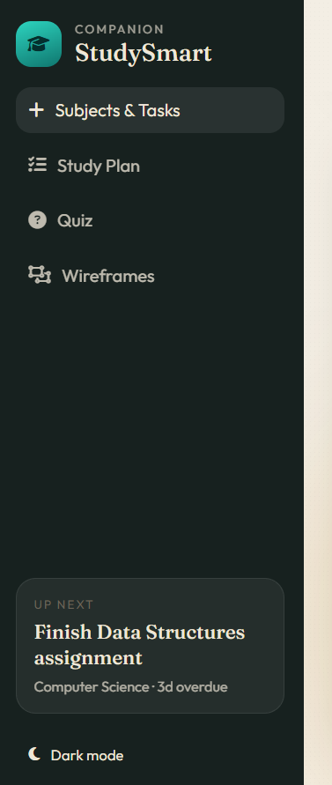
Figure 10. October 10 — Sidebar navigation and theme toggle

5. Test case register
ID / area | Expected result | Evidence / actual observation | Status
TC-01 Dashboard | Correct totals and progress | 7=3+4; 3/7 rounds to 43% | CONSISTENT
TC-02 Deadline | Overdue display updates appropriately | Same task: 3d → 14d over 11 days | OBSERVED; logic not verified
TC-03 Subject selection | Selected subject unlocks task form | Selected form (Oct 10); locked form (Oct 21) | OBSERVED states
TC-04 Add task | Valid title/deadline saves once | Form and local-list text visible; no save sequence | NOT VERIFIED
TC-05 Task completion | Status changes and counts update | Completed items and counts visible; no click sequence | NOT VERIFIED
TC-06 Quiz modes | 15 standard; 10 rapid / 30 sec | Mode labels and question screens visible | OBSERVED
TC-07 Quiz result | Score and corrections shown | 2/10, 20%, 2 correct/8 incorrect; review visible | OBSERVED; score consistent
TC-08 Timer | Rapid quiz ends at 30 sec | 24 sec remaining previously; “Time is up” now | PARTIAL evidence
TC-09 Theme | Light/dark readable and consistent | Both result-page themes captured | OBSERVED; contrast review needed
TC-10 Search | Search returns matching tasks/subjects | Search bar only; no query/output evidence | NOT VERIFIED
TC-11 Persistence | Task data/status survive refresh | “7 tasks saved locally” shown; no before/after refresh | NOT VERIFIED
TC-12 Invalid task | Required fields rejected cleanly | No invalid-input attempt supplied | NOT VERIFIED
TC-13 Missing data | Helpful empty/error/recovery state | No controlled failure supplied | NOT VERIFIED
TC-14 End-to-end | Subject → task → quiz → result in one run | Separate page states only | NOT VERIFIED end-to-end

6. Follow-up QA procedures

Persistence after refresh
Select a subject; create a uniquely named test task and deadline; mark complete; record any intended saved quiz data; refresh; inspect title, date, status, counts and quiz data separately. Capture before/after screenshots. Record tester, date/time, environment, expected/actual, status and screenshot or issue URL.

Invalid task data
With a subject selected, try blank title, whitespace-only title and invalid/missing deadline where allowed. Record validation text and confirm no invalid task is added. Record tester, date/time, environment, expected/actual, status and screenshot or issue URL.

Missing data / recovery
In a safe local test state, check empty task list and controlled unavailable-data behavior without deleting shared data. Confirm an understandable message and recovery route. Record tester, date/time, environment, expected/actual, status and screenshot or issue URL.

Search
Search an exact known task, partial task name, unknown term and subject name. Check matching results, clearing, and empty state. Record tester, date/time, environment, expected/actual, status and screenshot or issue URL.

Full demo path
From a documented URL/start state: choose subject → add task → open study plan → complete task → choose subject quiz → submit or time out → review result → refresh and verify expected persistence. Record tester, date/time, environment, expected/actual, status and screenshot or issue URL.

7. Risks, defects and recommended actions
Priority | Observation / risk | Recommended action
Medium | Previous team report identified theme/color inconsistency | Re-test both themes on every primary page; record contrast fixes and new screenshots
Medium | Light Study Plan action icons appear low contrast | Increase icon contrast and validate keyboard focus and hover visibility
High | Named tester and exact pass/fail run not included in supplied screenshots | Execute a clean end-to-end run and add a tested-by note with evidence
High | Refresh persistence and validation edge cases lack outcomes | Execute TC-11–13 and log actual results; file bugs only if reproduced
Medium | Search input and add-task button visible without behavioral proof | Record search queries and task save/edit/delete runs
Low | Current result capture shows only part of question review | Capture full-page review and final controls for completeness

8. Midterm demonstration readiness and traceability
Suggested 3–5 minute walkthrough: (1) open the application and identify target student/problem; (2) select a subject and create a task; (3) show study-plan totals and deadline tracking; (4) open quiz and choose standard or rapid mode; (5) demonstrate a result and answer review; (6) toggle dark mode; (7) state one limitation and next test. Mark any portion not successfully performed live as “unverified” rather than “working”.
Week 7 team references: Issues #22 (subject-based task/quiz selection), #23 (end-to-end student path), #25 (related feature), Week 6 tested-by notes, and the Week 7 evidence directory. The provided weekly report assigns theme follow-up to Sumit Adhikari, tester confirmation to Prabin Rai, and persistence/validation edge-case verification to J.N. Taj Oli. Prince Karki’s supplied report describes implementation support, testing and documentation; this report should be linked as an evidence artifact only after repository upload.
Repository: https://github.com/CapstoneDesign-Fall2026-UlsanCollege/Team-5-Capstone-Design
Week 7 evidence: https://github.com/CapstoneDesign-Fall2026-UlsanCollege/Team-5-Capstone-Design/tree/main/docs/week7/docs/week7/evidence

9. Conclusion
StudySmart has a coherent and visually demonstrable study-planning and quiz interface. The strongest current evidence is the consistent dashboard metrics, subject/task page states, two quiz modes, detailed rapid-quiz score, and light/dark result screens. The test package is suitable as a visual midterm evidence record, but not as proof of complete end-to-end reliability. The next milestone is a named, reproducible execution log with actual outcomes for task creation, search, persistence, validation and error recovery, followed by issue-linked retesting.
Evidence limitations: all findings reflect user-provided screenshots and documents; no live application interaction, repository commit inspection or automated test execution was performed in preparing this report.

