# Weekly Project Meeting Minutes

**RECOMMENDATION OF WEBSITES BASED ON REVIEWS**

Time group spent on project: **2.5 hours**

Group Number: **14**

Group members present (Name, ID):

* **Amandeep kaur (0734293)**
* **Ketana Pereddigari (0734184)**
* **Abhilash Rao Pallineni (0735412)**

Specific Activities from prior week:

List brief description of activities carried out **by group member**

* **Amandeep kaur:** Reading blogs and watching tutorials regarding Web scrapping in python. I have done some of the coding in python and get some regular code in html of scrapy online and did not hear back about the dataset from [julian.mcauley@gmail.com](mailto:julian.mcauley@gmail.com). So trying to get extract the dataset from websites.

* **Ketana Pereddigari:** Working on dataset, collecting data from different websites and aligning them to get appropriate dataset for the project.
* **Abhilash Rao Pallineni:** I have worked with Parse hub which is an application used for scrappy to retrieve data related to user reviews from e-commerce sites. Read the blogs and articles for workflow related our project for guidance.

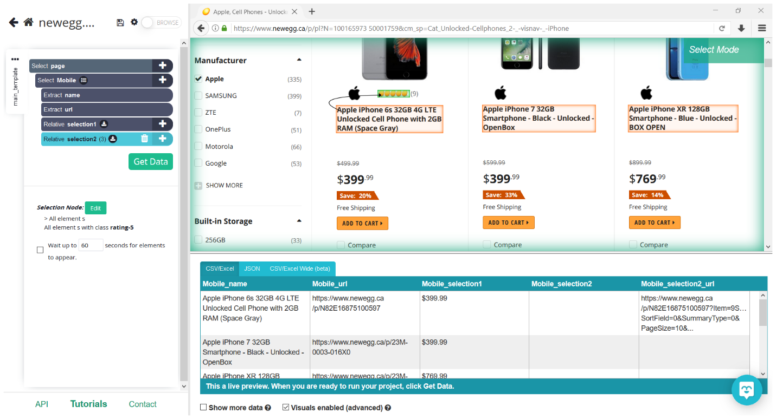

Specific Output from last week:

On Target:

* Indicate the current status of your project

**green: everything on track for completion by due date**

Challenges/Disagreements:

* **Getting all the data from the websites using parsehub about user reviews was a major challenge for us.**

Scrappy related tutorials help us to get knowledge step by step process of collecting required information with user reviews from websites. However, this is itself a project to install and run scrapy on our systems. This is being done on the side.

* **List any notable disagreements and subsequent discussion and resolution**

We are having discussion about proceeding in this project with or without scrapy as if it will be a cause of getting red flag or causing a delay and a pause in our project then we will have another step in moving ahead in this project.

Planned Activities for coming week:

* List brief description of activities **by group member**
* Data Analyzing
* Machine learning model for text classification.
* Learn the functionality of models.

**REFRENCES:**

<https://www.parsehub.com/what_is_web_scraping>

<https://monkeylearn.com/text-classification/>

<https://towardsdatascience.com/e-commerce-reviews-analysis-902210726d47>

<https://www.kaggle.com/nicapotato/womens-ecommerce-clothing-reviews>

<https://www.dummies.com/programming/big-data/data-science/using-machine-learning-analyze-reviews-e-commerce/>

<https://realpython.com/beautiful-soup-web-scraper-python/#extract-text-from-html-elements>