2. System Architectural Design

MVC Architecture

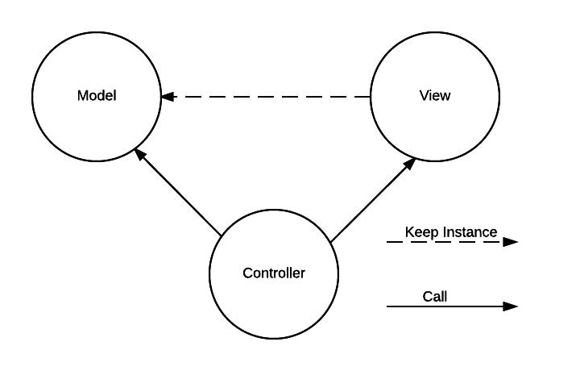

Why MVC Architecture?

* Our website is a big website and a kind of social website. MVC architecture separate a product (website, win form, phone app …) to three part that help us easier to build – develop – test – control project.
* MVC architecture can run with any environment or language, so in the future if we want to another instance for our website on Mobile Phone or Desktop Computer, We can do it easily.

2.1 Web Architecture

|  |  |
| --- | --- |
| Model – View – Controller Architecture | |
| User | Business object  Create Event  Process Event  Call  Call  Select View  Send  Result  View  Generated View  Call  Send |
| Controller |  |
| Model |  |
| View |  |

* Model is the part of the application that handles the logic for the application data. Model often receives data from database, process business, and then sends result to Controller.
* View is the part of the application that handles the display of the data. View often receives data from Controller and shows the data to user.
* Controller is the part of the application that handles user interaction. Controller often receives request from user, sends request to suitable Model, receives result from Model, and sends result to suitable View.