PHINMA UNIVERSITY OF ILOILO
College of Information Technology Education
CAPSTONE PROJECT PROPOSAL
Car Rental Management and Analytics System

SABLON, RONAMAE-BSIT3
GUNCE, BLAZE ARIANE-BSIT3
CUBOS, MARY GRACE-BSIT3
HAPUNDAR, ROY JAN-BSIT3
ROJO, RYAN-BSIT3
Data Informatics Track
Second Semester
2025-26

CHAPTER 1
INTRODUCTION
1.1 Background of the Study
As technology advances rapidly, the traditional methods of conducting businesses are giving way to automated systems to ensure efficiency and deliver accurate services. Consider the car rental industry, many of them still rely on manual processes like typing data by hand, taking reservations over the phone, and keeping track of inventory manually opens the door to human error, inaccurate data, and slower transactions. With more and more people opting to rent vehicles instead of owning them, seeking to avoid maintenance costs and parking hassles, rental operators are now struggling with the challenge of managing a growing number of clients effectively.
The main problem with the current system of many car rental companies is the lack of a centralized platform that connects operations and data analysis. Owners often struggle to monitor the status of each vehicle, booking management, and the track record of renters. In addition, the lack of analytics or data analysis hinders the business from knowing which vehicles are more profitable, when demand is highest, and how to increase their profits. Making decisions based solely on feelings, without considering real data, can lead to financial losses or poor customer service.
In the local market, small rental businesses face even bigger challenges as they grow. When an owner has a larger fleet, it becomes almost impossible to remember which vehicle needs a repair or which customer has a history of returning cars late. This is where data becomes important. A system that can turn raw numbers into simple charts and predictions gives the owner a "clear map" for their business. It shows them exactly where they are losing money and where they can improve.
In response to this challenge, the development of a car rental management and analytics system was necessary to modernize the entire business workflow. This system would not only serve as a tool for booking and inventory, but would also give in-depth analysis of transactions. By automating reports and displaying visual trends of sales and demand, it will be easier for business owners to make strategic decisions. Ultimately, this study aims to create a smart, secure and efficient system that will increase the quality of service in the car rental industry while ensuring business growth in the digital era.

This capstone project presents the design of a Car Rental Management and Analytics System, intended to furnish vehicle status updates, booking management and renter track records. The project incorporates software development methodologies, and database management techniques, serving as a practical application of the BSIT students’ acquired knowledge.

1.2 Statement of the Problem
Despite the growth of the car rental industry, many local owners still struggle with old-fashioned ways of working. This study aims to solve the following problems:
- Reliance on manual processes may lead to human errors.
- Lack of data analytics to help owners better understand the sales trend.
- Inefficient record-keeping and reporting.
- Lack of trust among clients due to the difficulty in identifying fraudulent or unreliable rental providers.
- Insufficient use of technology to facilitate booking, vehicle recommendations, and the overall customer experience.
- Complicated Price Calculations: Calculating different rates for 10-hour or 24-hour rentals by hand is confusing. Owners also struggle to compute extension fees and discounts accurately, which leads to mistakes in the final bill.
- Messy Scheduling and Availability: Without a calendar view, it is hard to see which cars are free on specific dates. This makes it easy to accidentally book the same car for two different people.
- Difficulty in Splitting Profits: When a car is owned by someone else but managed by the admin, it is hard to manually track how much goes to the operator and how much is the admin's commission.
- No Clear Business View: Without data analytics, owners don't really know their "sales trends." They can't easily see which cars are making them the most profit or which months are the busiest.
1.3 Objectives of the Study
1.3.1 General Objective
To develop a car rental management and analytics system that automates complex rental pricing, manages operator commissions, provides a clear calendar for scheduling and provide effective administrative supervision.
1.3.2 Specific Objectives
Specifically, the study aims to:
- To develop a digital inventory that monitors status of vehicles (available, not available, rented, under maintenance)
- Design a secure and user-friendly car rental interface for vehicle booking and management.
- To implement an analytics dashboard that displays the visual representation of sales and demands.
- Store and manage user and vehicle information using a secure database.
- Test and evaluate the accuracy, ease of efficiency, and overall performance of the system to ensure reliable and secure service.
- To create a system that automatically computes totals based on hours (10h or 24h), adds extension fees, and subtracts discounts.
- Implement a Calendar View: To design a visual calendar for both the admin and operators to see car availability and scheduled bookings at a glance.
- Build an Operator Management Feature: To create a way to track "tie-up" rates so the system automatically splits the profit between the admin and the car operator.
- Design an Analytics Dashboard: To build a page for the owner that shows charts of their sales and which vehicle types (like SUVs or Sedans) are most popular.
1.4 Scope and Delimitation
The scope of this project covers the development of a digital platform designed to manage daily car rental operations and analyze business data. The system allows the admin to manage a fleet of vehicles by recording details like plate numbers, fuel types, and car models (such as SUVs or Sedans). It features a smart booking system that automatically calculates rental costs based on 10-hour or 24-hour rates, including extension fees, discounts, and non-refundable cancellation charges. A key part of the system is the "tie-up" feature, which automatically calculates how much profit is shared between the admin and the car operator. To keep things organized, the system includes a calendar view for scheduling and an analytics dashboard that turns rental history into visual charts to show sales trends and popular car types. It also provides a way for customers to upload requirements like proof of billing and proof of payment directly to the platform.

The system has certain limits to focus on record-keeping and data analysis. It does not include real-time GPS hardware, meaning it cannot track the live movement or exact location of the cars on a map; all car status updates must be changed manually by the staff. The platform also does not have a direct connection to banks or e-wallet APIs (like GCash or PayMaya) for automatic payments. While users can upload a photo of their receipt, the administrator must manually verify the payment and click a button to approve the booking. Finally, the system is a standalone tool for the specific client and does not sync with third-party websites or external rental marketplaces.

1.5 Significance of the Study
The proposed system will benefit the following:
- Car Rental Owners - with the help of data visualization they will be able to easily understand the sales data.
- Users/Renters - by providing a safer and efficient booking system.
- Staff/Operators - to lessen their workloads and avoid human errors.
- Future Researchers - this study can be used as a guide or reference for other students

1.6 Definition of Terms
- Analytics - The process of studying data to find useful information and make better decisions.
- Automated Systems - Using systems to perform tasks automatically to lessen human workload.
- Manual Processes - A method of performing tasks manually or by hand.
- Inventory Monitoring - Tracking stock to know what's available or needed.
- User Experience - What the users feel when using the system.
- Booking - the process of reserving a car on a specific date and time.
- Analytics Dashboard - A visual screen in the system that uses charts and graphs to show sales trends, popular vehicle types, and peak seasons.
- Tie-up Rate - The percentage or fixed amount of money shared between the business admin and the person who actually owns the car (the operator).

CHAPTER 2
REVIEW OF RELATED LITERATURE AND STUDIES
2.1 Foreign Studies
Jyothi and Sheethal (2025) developed an advanced car rental management system that automates the vehicle rental process. The system includes features such as user registration, vehicle browsing, reservation management, payment handling, and fleet inventory management. The study concluded that implementing an automated system improves operational efficiency and customer satisfaction while providing accurate reporting tools for decision-making.
https://ijsci.com/index.php/home/article/view/1056
Azlan (2020) developed a web-based car rental service system to replace the traditional manual paper-based rental process. The study highlighted that manual systems are inefficient and can lead to data loss and difficulty retrieving records. The proposed web application uses PHP, HTML, CSS, and MySQL to manage reservations and customer information more effectively. https://ir.uitm.edu.my/id/eprint/38174/
Ogbiti and Aaron (2024) proposed a web-based car rental management system designed to streamline the rental process for both customers and administrators. The system was built using PHP, JavaScript, Bootstrap, and SQL Server to manage vehicle reservations and rental records. The study found that the system improves efficiency, reduces manual workload, and enhances the overall user experience. https://www.researchgate.net/publication/385028599_Development_of_a_web-based_car_rental_management_system

2.2 Local Studies
Study by De Jesus (2023). According to the study, the car rental industry in the Philippines plays an important role in providing flexible transportation services. The research focused on Drive Manila, analyzing customer behavior, marketing strategies, and industry trends. It concluded that improving online presence and digital interaction is essential for enhancing customer engagement and competitiveness in the car rental industry.
https://animorepository.dlsu.edu.ph/etdm_market/96/

2.3 Related Literature
Car rental management systems have evolved with the advancement of technology, shifting from traditional manual processes to automated and web-based platforms. These systems are designed to improve efficiency, reduce errors, and enhance customer satisfaction by providing faster and more reliable services.
According to Azlan (2020), manual car rental systems are inefficient and prone to data loss because they rely heavily on paper-based processes. The study proposed a web-based system using PHP and MySQL to manage customer records and reservations more effectively. This approach improves operational efficiency and minimizes errors in rental transactions. https://ir.uitm.edu.my/id/eprint/38174/
According to Ogbiti and Aaron (2024), web-based rental systems significantly enhance operational efficiency by integrating technologies such as PHP, JavaScript, and SQL databases. Their findings show that such systems reduce manual workload, improve system reliability, and enhance user experience. https://scienceworldjournal.org/article/view/24033
In addition, according to Shukri and Sahid (2024), common problems in car rental services include human error during booking and incomplete vehicle information. Their mobile-based system addressed these issues by providing modules for booking management, vehicle cataloging, and fuel monitoring, which improved both system efficiency and user satisfaction. https://publisher.uthm.edu.my/periodicals/index.php/aitcs/article/view/16316

2.4 Synthesis of the Reviewed Literature
From the review of the literature, it is clear that traditional car rental systems, which rely on manual and paper-based processes, often face inefficiencies and errors. Studies show that using automated, web-based systems can greatly improve the management of customer information, car records, and bookings. Automation not only reduces mistakes but also makes daily operations faster and more organized, which is essential for any modern rental business.

CHAPTER 3
METHODOLOGY
3.1 Research Design
This study utilizes a developmental research design, which focuses on the creation, improvement, and evaluation of a system or product. The purpose of using this design is to guide the researchers in developing a functional and practical solution to an existing problem in the car rental industry.
In this study, the researchers aim to design and develop a Car Rental Management and Analytics System that will help car rental businesses improve the way they manage their operations. Many small and medium-sized car rental services still rely on manual processes such as paper-based booking, manual tracking of vehicle availability, and basic computation of payments. These traditional methods often lead to inefficiencies, errors, and delays.
Through the developmental research design, the researchers are not only able to build the system but also test and refine it based on actual usage and feedback. This ensures that the final prototype is not only functional but also relevant and useful for its intended users.
3.2 System Development Methodology

To effectively develop the system, the researchers will adopt the Agile development methodology. Agile is a flexible and iterative approach that allows the team to develop the system in smaller parts, also known as increments or sprints. This method is particularly suitable for the project because it allows continuous improvement and quick adaptation to changes or issues encountered during development.
Instead of building the system all at once, the researchers will gradually develop and improve its features. This approach reduces the risk of major errors and ensures that each component of the system is properly tested before moving to the next stage.
The development process consists of the following phases:
- Requirements Analysis:
In this phase, the researchers gather and identify all the necessary features and functions of the system. This includes understanding how car rental businesses operate and determining what the system needs to support their daily activities. Key requirements include tracking the status of vehicles (such as Available, Not Available, Rented, or Under Maintenance), managing bookings, storing customer information, and automatically calculating fees such as the 5% reservation down payment.
- System Design:
After identifying the requirements, the researchers proceed to design the structure and layout of the system. This includes designing the user interface to ensure it is simple, user-friendly, and visually appealing. The chosen theme for the system is “Yellow, Black, and White,” which aims to create a clean and professional look. Additionally, the database structure is carefully planned, including how tables are related to each other to ensure efficient data storage and retrieval.
- Development:
In this stage, the actual coding of the system takes place. The researchers use PHP to handle the backend logic and MySQL to manage the database. During development, features such as user authentication, booking management, vehicle tracking, and payment computation are implemented step by step.
- Testing:
Once the system components are developed, they are tested to identify and fix errors. The researchers ensure that all computations are accurate, particularly for important values such as the PHP 200 carwash fee, late return penalties, and total rental cost. Testing also ensures that the system functions correctly under different scenarios.
- Deployment:
After successful testing, the system is finalized and prepared for presentation. The working prototype is demonstrated during the capstone defense to showcase how it can handle real-life car rental operations effectively.

3.3 System Architecture
The system follows a three-tier architecture, which separates the system into different layers to improve performance, organization, and scalability.
- Client Side (Presentation Layer):
This is the part of the system that users interact with directly. It includes the website interface accessed through mobile devices or computers. Users such as Admins, Operators, and Renters can log in, view information, and perform actions depending on their roles.
- Server Side (Application Layer):
This layer handles the main logic of the system. It processes user requests, performs computations, and manages the flow of data between the client side and the database. The server-side logic is developed using PHP.
- Database (Data Layer):
This layer is responsible for storing all system data. It includes information such as user accounts, car details, booking records, and payment history. The database is managed using MySQL to ensure organized and secure data storage.

3.4 Tools and Technologies Used
The researchers use a combination of modern tools and technologies to develop the system:
- Frontend Technologies:
HTML, CSS, JavaScript, and Bootstrap 5 are used to design and develop the user interface. These tools help create a responsive and visually appealing system.
- Backend Technology:
PHP is used to handle the system’s logic, including data processing and communication with the database.
- Database:
MySQL is used for storing and managing system data efficiently.
- Development Tools:
Visual Studio Code is used as the primary code editor, while GitHub is used for version control and collaboration among team members.

3.5 Data Gathering Techniques

To ensure that the system meets real-world requirements, the researchers used the following data gathering methods:
- Interviews:
The researchers conducted interviews with local car rental business owners in Iloilo. These interviews provided valuable insights into their current processes, challenges, and needs. Information gathered includes how they track vehicle availability, handle bookings, and manage payments.
- Document Analysis:
The researchers reviewed existing rental agreements and documents, such as those used by InstaCar. This helped ensure that the system aligns with actual business practices, including policies like the 5% reservation fee and travel limitations within Panay Island.
These methods helped the researchers design a system that is both practical and aligned with industry standards.

3.6 Testing Procedures
To ensure the quality and reliability of the system, different types of testing are conducted:
- Unit Testing:
Individual components of the system are tested separately to ensure they function correctly. Examples include testing the login feature, registration form, and “Add Car” functionality.
- System Testing:
The entire system is tested as a whole to ensure that all components work together properly. This includes testing the full booking process, from selecting a car to completing payment.
- User Acceptance Testing (UAT):
The system is tested by actual users, such as students or potential customers, to evaluate its usability and effectiveness. Feedback from users is used to further improve the system.
3.7 Evaluation Criteria
The developed system will be evaluated based on the following criteria:
- Functionality:
Determines whether all features of the system work correctly and as intended.
- Usability:
Evaluates how easy it is for users to navigate and use the system, especially those with limited technical knowledge.
- Accuracy:
Ensures that all calculations, including rental fees, carwash charges, and penalties, are correct and reliable.
- Security:
Assesses how well the system protects user data, including login credentials and payment information.
- Efficiency:
Measures how the system improves the speed and convenience of car rental operations compared to manual methods.

SUPPORTING DIAGRAMS (Included within Chapter 3)
Data Flow Diagram (DFD – Level 0)
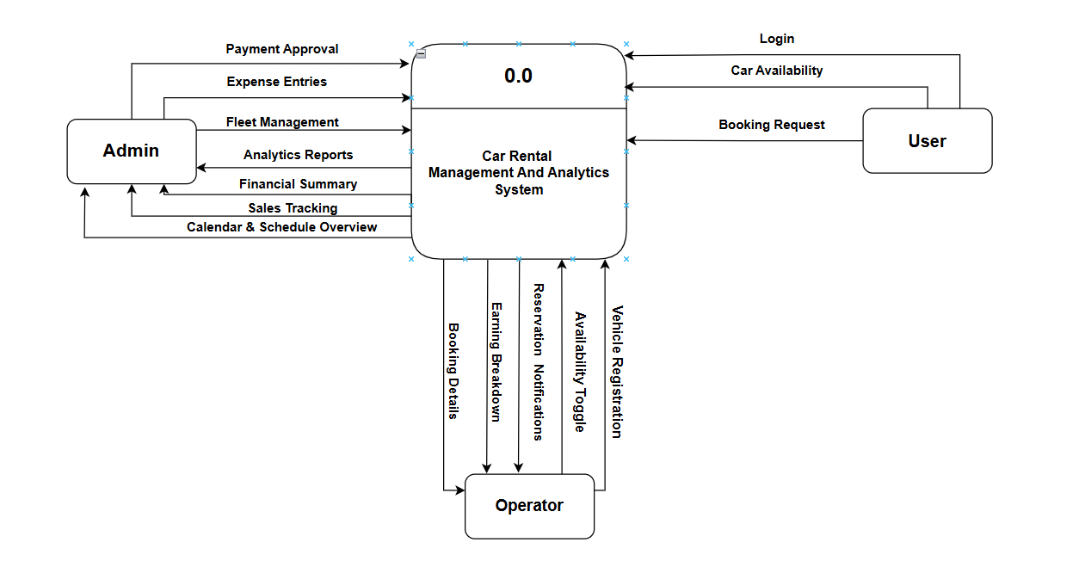
1.User
- Login
- Car Availability
- Booking Request

2.Admin
- Payment Approval
- Expenses Entries
- Fleet Management
- Analytics Reports
- Financial Summary
- Sales Tracking
- Calendar & Schedule Overview

3.Operator
- Vehicle Registration
- Availability Toggle
- Earning Breakdown
- Booking Details

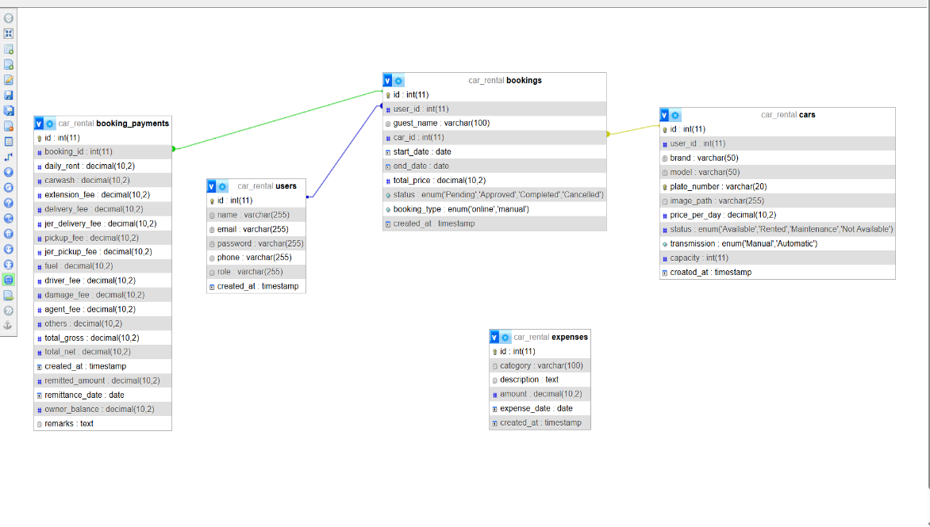
Entity Relationship Diagram (ERD)

Entities:
Users
- id (PK), name, gmail, password, phone_number, role (admin, owner, operator, renter), created_at.
Cars
- id (PK), user_id (FK), brand, model, plate_number, price_per_day, status (Available, Rented, Maintenance), image_path, transmission, capacity.
Bookings
- id (PK), user_id (FK), car_id (FK), guest_name, phone_number, gmail, start_date, end_date, pickup_time, return_time, total_price, status, booking_type, primary_id_path, secondary_id_path.
Expenses
- id (PK), category, description, amount, expense_date.

Relationships:

• User to Car (1:N): A User (with role 'owner') can own multiple Cars; each Car belongs to one specific Owner.
• User to Booking (1:N): A User (with role 'renter') can make multiple Bookings; a Booking is linked to one User account.
• Car to Booking (1:N): A Car can have many Bookings associated with it over time; a Booking is assigned to exactly one Car.
• Guest to Booking (1:N): A Guest (manual entry) can be associated with multiple Bookings via their name/email even without a registered User ID

Use Case Diagram
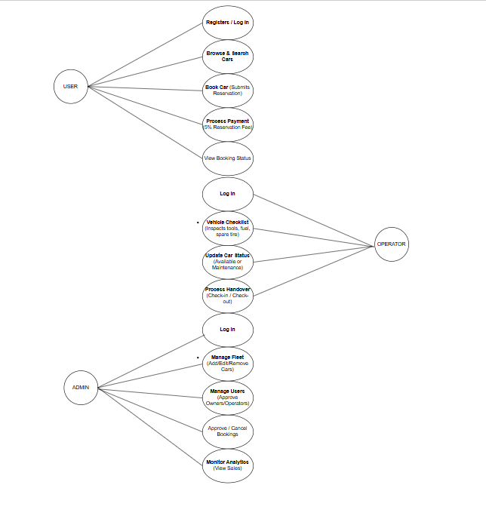
Actors:
Renter (User):
- Renter → Registers / Log In
- Renter → Browse & Search Cars
- Renter → Book Car (Submits Reservation)
- Renter → Process Payment (5% Reservation Fee)
- Renter → View Booking Status

Operator:
- Operator → Log In
- Operator → Vehicle Checklist (Inspects tools, fuel, spare tire)
- Operator → Update Car Status (Available or Maintenance)
- Operator → Process Handover (Check-in / Check-out)
Administrator:
- Admin → Log In
- Admin → Manage Fleet (Add/Edit/Remove Cars)
- Admin → Manage Users (Approve Owners/Operators)
- Admin → Approve / Cancel Bookings
- Admin → Monitor Analytics (View Sales)

End of Proposal
Note to the instructors handling this subject
CHED BSIT ALIGNMENT STATEMENT
This capstone project complies with CHED BSIT standards by demonstrating competencies in application development, database management, systems analysis and design, and emerging technologies such as machine learning. The project follows outcomes-based education principles and integrates ethical considerations, user safety, and data privacy.

