VIT VELLORE
COMPUTER NETWORKS
PROJECT REPORT
SMART-RUDP: A RELIABLE TRANSPORT PROTOCOL BUILT ON UDP WITH LEARNING-BASED CONGESTION CONTROL
Design, Implementation and Validation in C, with a Multi-Site OSPF Network Design and Wireshark Analysis
Submitted by
Harshavardhan Mallela (24BAI0274)
Rohit Arya (24BCE0819)
Shloak Sinha (24BDS0378)
Faculty: Anuradha G
Source code: github.com/Capsturrrr/rudp
8 October 2026

ABSTRACT
The Transmission Control Protocol (TCP) provides reliable, ordered and congestion-aware delivery over an unreliable network, but its mechanisms are usually studied only in theory. This project designs and implements RUDP (Reliable UDP), a custom transport-layer protocol written in C on top of UDP sockets, which reproduces the core mechanisms of TCP: a three-way handshake, sequence numbers with a 16-bit checksum, cumulative acknowledgments, retransmission on timeout and on three duplicate acknowledgments, a Go-Back-N sliding window, and additive-increase/multiplicative-decrease (AIMD) congestion control with slow start and congestion avoidance.
The project is extended in two directions. First, Smart-RUDP replaces the fixed AIMD rule with a tabular Q-learning congestion controller and compares it with AIMD on three emulated paths (5G-like, lossy wireless and satellite-like); the tabular agent matched but did not beat the rule-based controller on completion time, while a neural (deep Q-network) agent added later beat it on all three paths in the C transport (Section 8.5). Second, the protocol is placed in a multi-site network of four OSPF routers, two VLANs, a server LAN and a branch LAN built in Cisco Packet Tracer, and its traffic is analysed in Wireshark with a custom dissector.
The implementation is 673 lines of C in four source files. A test message of 2,442 bytes, sent as 62 packets, was delivered completely at every simulated loss level from 0% to 40%. Over the same range the transfer time rose from 108 ms to 20,236 ms and the final congestion window fell from 18.71 to 2.00 packets, which is the behaviour AIMD is designed to produce. Linux tc/netem loss injection and packet capture were used to check the protocol against real operating-system packet loss. The report also records the engineering problems met during the work, with screenshots, and how each was fixed.
Keywords: reliable transport, UDP, TCP, AIMD, congestion control, Q-learning, OSPF, Cisco Packet Tracer, Wireshark.

1. INTRODUCTION
Applications that send data across a network choose between two transport protocols. The User Datagram Protocol (UDP) [8] is simple and fast but gives no guarantee that a datagram arrives, arrives once, or arrives in order. TCP adds all of these guarantees, and also slows its sending rate when the network is congested, but it lives inside the operating-system kernel, which makes its behaviour difficult to observe or change.
The cost of ignoring congestion became clear in October 1986, when the Internet suffered its first congestion collapse and throughput between Lawrence Berkeley Laboratory and UC Berkeley fell from 32 Kbps to 40 bps [1]. TCP congestion control was developed in response. A sender that only retransmits lost data makes such a collapse worse, so reliability and congestion control must be designed together.
This project asks whether TCP's core ideas can be rebuilt from first principles on top of UDP, and whether the result can be shown to work under packet loss. The answer is RUDP, a small user-space protocol written in C and tested on Linux with both a built-in loss simulator and kernel-level network emulation.

1.1 Objectives
- Define a compact packet format with sequence numbers, flags and an integrity check.
- Establish connections with a three-way handshake and close them with a FIN exchange.
- Deliver data reliably and in order using acknowledgments, timeouts and fast retransmit.
- Control the sending rate with AIMD congestion control and make the congestion window visible in logs and graphs.
- Validate the protocol under loss from 0% to 40% and under real packet loss injected by tc/netem.
- Extend the protocol with a Q-learning congestion controller (Smart-RUDP) and compare it honestly with AIMD under emulated 5G, wireless and satellite conditions.
- Build a four-router OSPF network with VLANs, DHCP, an access list and a failover test in Cisco Packet Tracer, and analyse RUDP traffic with Wireshark.
- Record every mistake made during development and how it was corrected.

1.2 Application area
RUDP belongs to user-space reliable transport over UDP, the architecture used by QUIC to carry HTTPS traffic [5][6]. Building on UDP lets a transport evolve without waiting for operating-system or network-operator updates [5]. RUDP is a teaching and testing vehicle, not a production system: because it can be read from end to end, it makes congestion-control behaviour visible, and it provides a platform for studying how a transport reacts when the network misbehaves.

1.3 Purpose and use case
The purpose of the project is a reliable transport that can be read, changed and tested, for the common situation of campus users sending data to a server across a routed network. TCP cannot be modified without changing the operating system, and plain UDP leaves loss, duplication and reordering to the application. A transport built over UDP in user space closes that gap, which is why QUIC and similar protocols are built this way [5][6].
The concrete scenario is a student on the student VLAN uploading data to the server on the server LAN. The access list keeps the student VLAN out of the staff VLAN, and OSPF carries the traffic over the shortest path through R3. If the direct link fails, OSPF reroutes the traffic through R2, which is one hop longer and increases the round-trip time of a running flow. A fixed window rule does not know about this change, while Smart-RUDP observes it through its RTT-ratio state. The network design of Section 9 is therefore not a separate exercise: it supplies the conditions (routing, access policy and failover) under which the transport is meant to run. The protocol itself was tested on one machine with emulated paths (Sections 5 to 8), because Packet Tracer cannot run the C programs; the report states this wherever it matters. To make the protocol visible to a user, a small two-way messenger (RUDP Chat, src/chat.c) was written on the same packet format: each chat message is one RUDP data segment, delivered in order and acknowledged cumulatively, with simulated loss applied on the sending side. In a test with 30% loss in both directions, all 15 messages of one user and all 12 of the other arrived complete and in order, with the lost segments recovered by timeout and fast retransmit.

2. BACKGROUND AND RELATED WORK
Jacobson and Karels (1988) [1] introduced the packet-conservation principle and added several algorithms to 4BSD TCP, among them round-trip-time variance estimation, exponential retransmit backoff, slow start and congestion avoidance. Chiu and Jain (1989) [2] analysed increase and decrease rules and showed that additive increase with multiplicative decrease converges to an efficient and fair state; this is why RUDP grows its window linearly and cuts it by half. RFC 5681 [3] standardises slow start, congestion avoidance, fast retransmit and fast recovery.
CUBIC [4] replaces linear window growth with a cubic function of the time since the last congestion event, which scales better on fast, long-distance paths. It was not implemented in this project and remains future work. QUIC [5][6] shows that reliable, congestion-controlled transport can be built on UDP at Internet scale. RUDP shares its UDP foundation and its user-space design, but has no encryption or stream multiplexing. NetEm [7] is the Linux traffic-control module that adds delay, loss, duplication and corruption to packets leaving an interface; it was used here to inject real loss on the loopback interface.
The key researcher for this area is Van Jacobson, lead author of [1], whose work underlies every congestion-control mechanism used in RUDP. A fuller literature review accompanies this report.

3. SYSTEM DESIGN

3.1 Overview
RUDP has a client and a server. The client connects to the server on 127.0.0.1, UDP port 8888, performs a handshake, splits a message into 40-byte chunks, sends them under window and congestion control, and closes the connection with a FIN. The server reassembles the chunks in order and acknowledges them. All of this runs over plain UDP sockets.

3.2 Packet format
Every packet starts with a 13-byte header followed by an optional payload of up to 512 bytes. The fields are written into the byte buffer one at a time instead of sending the C structure directly, so compiler padding can never change the layout on the wire.
Table 1: RUDP header layout (13 bytes)
Field | Size | Offset | Purpose
seq_num | 4 bytes | 0 | Sequence number of this packet (counts packets, not bytes)
ack_num | 4 bytes | 4 | Next sequence number the sender of this packet expects
flags | 1 byte | 8 | SYN 0x01, ACK 0x02, FIN 0x04, DATA 0x08; flags may be combined
checksum | 2 bytes | 9 | 16-bit integrity check over header fields and payload
payload_len | 2 bytes | 11 | Number of payload bytes that follow

The checksum is a one's-complement sum: all header bytes (except the checksum itself) and payload bytes are added, carries above 16 bits are folded back in, and the result is inverted. A receiver that finds a mismatch drops the packet, and retransmission recovers it.

3.3 Connection management
The client picks a random initial sequence number and sends a SYN. The server replies with a SYN-ACK whose acknowledgment number is the client's number plus one, and the client confirms with an ACK. The client tries up to five times, waiting three seconds for each reply. The server follows a three-state machine: LISTEN, then SYN_RECEIVED after a SYN, then ESTABLISHED after the final ACK. A FIN is acknowledged and returns the server to LISTEN, ready for a new connection. After the fix described in Section 7.1, the server accepts a new SYN in any state.

3.4 Reliable delivery
The client numbers its data packets consecutively. The server accepts only the packet it expects next; it then advances its expected number and returns a cumulative ACK meaning that everything before that number has arrived. An out-of-order or duplicate packet is discarded and the server repeats its last ACK. This is the Go-Back-N strategy. It was the first design and was later replaced as the default by Selective Repeat (Section 8.9): the server now buffers out-of-order packets and reports them in every ACK, and the sender resends only what is missing. Go-Back-N remains available (--gbn, RUDP_GBN, server built with -DRUDP_GBN) for comparison.
The client recovers losses in two ways. If three duplicate ACKs arrive, it assumes the packet at the base of the window was lost and resends only that packet (fast retransmit). If no new ACK arrives within 500 ms, it times out and resends every packet from the base of the window to the last packet sent. A fixed window constant of 4 was used in Phase 4; once congestion control was added in Phase 5, the window became the congestion window and the constant was left unused.

3.5 Congestion control
The client keeps a congestion window (cwnd) and a slow-start threshold (ssthresh), and logs every change to a CSV file. The rules are shown in Table 2.
Table 2: AIMD congestion-control rules
Event | Action
Start | cwnd = 1, ssthresh = 16
New ACK, cwnd below ssthresh (slow start) | cwnd increases by 1 (about doubling every round trip)
New ACK, cwnd at or above ssthresh (congestion avoidance) | cwnd increases by 1/cwnd (about +1 per round trip)
Three duplicate ACKs (fast retransmit) | ssthresh = cwnd / 2, cwnd = ssthresh
Timeout | ssthresh = cwnd / 2, cwnd = 1 (back to slow start)
Limits | cwnd is never below 1 and never above 32

The treatment of fast retransmit is a simplified form of fast recovery: the window is halved and growth resumes in congestion avoidance, without the window inflation described in RFC 5681 [3]. The retransmission timer is a fixed 500 ms rather than an estimate derived from measured round-trip times [1].

3.6 Loss simulation
To test loss on demand, the client accepts a loss percentage as a command-line argument. Before each data packet is sent, including each retransmission, the client draws a random number and silently discards the packet if it falls below the chosen percentage. Handshake and FIN packets and the server's ACKs are never dropped. The random generator is seeded from the clock, so two runs at the same loss level differ.

4. IMPLEMENTATION

4.1 Environment and build
Development used Windows with WSL2 and Ubuntu, the GCC compiler, Make, Git, Valgrind, tc (iproute2), tshark and Wireshark, with Python and matplotlib for graphs. The code is compiled with the warning flags -Wall and -Wextra, debugging symbols and the C11 standard (Figure 1).
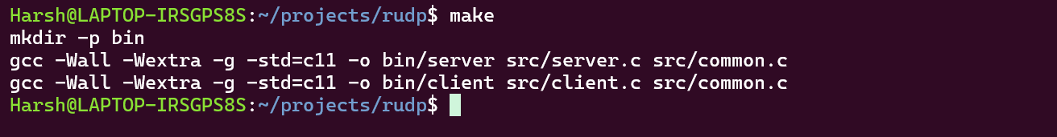
Figure 1: Successful build with make: gcc -Wall -Wextra -g -std=c11 produces bin/server and bin/client with no warnings

4.2 Source files
Table 3: Source files (line counts from the delivered source)
File | Lines | Role
src/common.h | 59 | Constants, flag bits, packet structure, function prototypes
src/common.c | 123 | Packing and unpacking, checksum, packet printing
src/client.c | 301 | Handshake, chunking, window and congestion control, retransmission, logging
src/server.c | 190 | State machine, in-order delivery, cumulative ACKs, reassembly
Total | 673

4.3 Development phases
Table 4: Implementation phases
Phase | Title | Outcome
0 | Environment | WSL2, Ubuntu, toolchain and Git repository set up; build verified
1 | Raw UDP echo | Baseline client and server exchanging datagrams
2 | Packet format | 13-byte header with manual pack/unpack; round-trip and corruption tests; Valgrind clean
3 | Handshake | Three-way handshake, state machine and FIN teardown
4 | Reliable delivery | Go-Back-N, cumulative ACKs, timeout, fast retransmit; byte-perfect reassembly at 40% simulated loss
5 | Congestion control | AIMD with slow start, congestion avoidance and cwnd logging
6 | Emulation and capture | Real loss with tc/netem on loopback, captured with tshark and Wireshark
7 | Benchmark and graphs | Seven-level loss sweep, CSV output, cwnd and benchmark plots, team handoff

4.4 Version control
The work is stored at github.com/Capsturrrr/rudp. The Phase 7 commit (d9bf3f3, "Phase 7 complete: benchmarking, visualization, resilient server, updated README for team handoff") changed 14 files with 458 insertions and 49 deletions and was pushed to the main branch (Figure 2). No credential is visible in the screenshot; the password prompt was answered at the terminal.
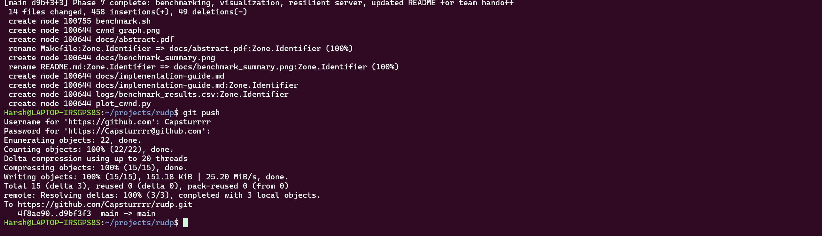
Figure 2: Phase 7 commit and push to github.com/Capsturrrr/rudp (4f8ae90..d9bf3f3, main -> main)

5. TEST METHODOLOGY
Three complementary methods were used.
- Built-in loss simulator. Drops outgoing client data packets at a chosen percentage (Section 3.6). Used for the benchmark sweep because it is repeatable from a single command.
- tc/netem on the loopback interface. The command tc qdisc add dev lo root netem loss 20% makes the kernel itself drop 20% of packets. This checks the protocol against loss that the program did not generate. The rule was always checked with tc qdisc show dev lo and removed afterwards (Section 7.2).
- Packet capture. tshark captured the loopback interface inside WSL and the file was opened in Wireshark on Windows, as independent evidence of what crossed the interface.
The benchmark script (benchmark.sh) starts the client once for each loss level of 0, 5, 10, 15, 20, 30 and 40 percent with a 30-second limit, measures wall-clock duration with date and awk, extracts the delivered-packet count and final congestion window from the client output, and writes one CSV row per level. The server must already be running. Each level was run once.

6. RESULTS

6.1 Benchmark sweep
Table 5 and Figures 3 and 4 show the final benchmark. Every level delivered all 62 packets, which together carry the 2,442-byte test message. Transfer time grew from 108 ms with no loss to 20,236 ms at 40% loss, about 187 times longer, while the final congestion window fell from 18.71 packets to 2.00. The terminal output that produced these numbers is shown in Figure 5.
Table 5: Benchmark results, one run per loss level
Simulated loss | Duration (ms) | Packets delivered | Final cwnd
0% | 108 | 62 / 62 | 18.71
5% | 608 | 62 / 62 | 7.30
10% | 3,112 | 62 / 62 | 3.83
15% | 7,118 | 62 / 62 | 2.00
20% | 7,617 | 62 / 62 | 2.90
30% | 13,625 | 62 / 62 | 2.00
40% | 20,236 | 62 / 62 | 2.00

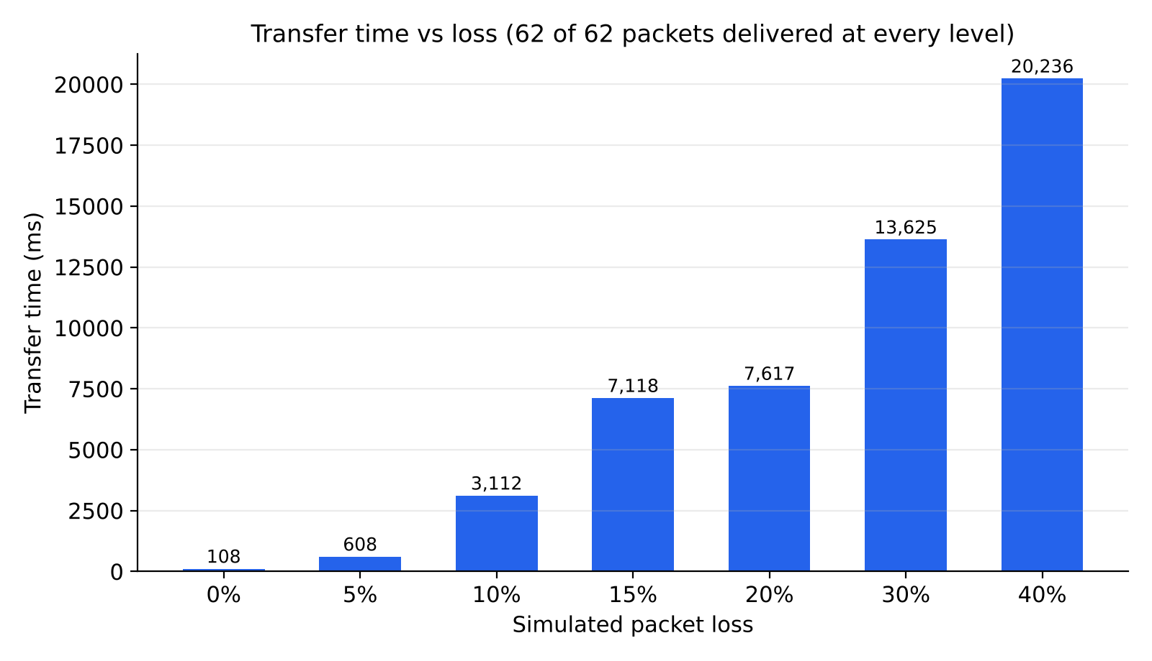
Figure 3: Transfer time against simulated loss, from the benchmark in Table 5; all 62 packets were delivered at every level
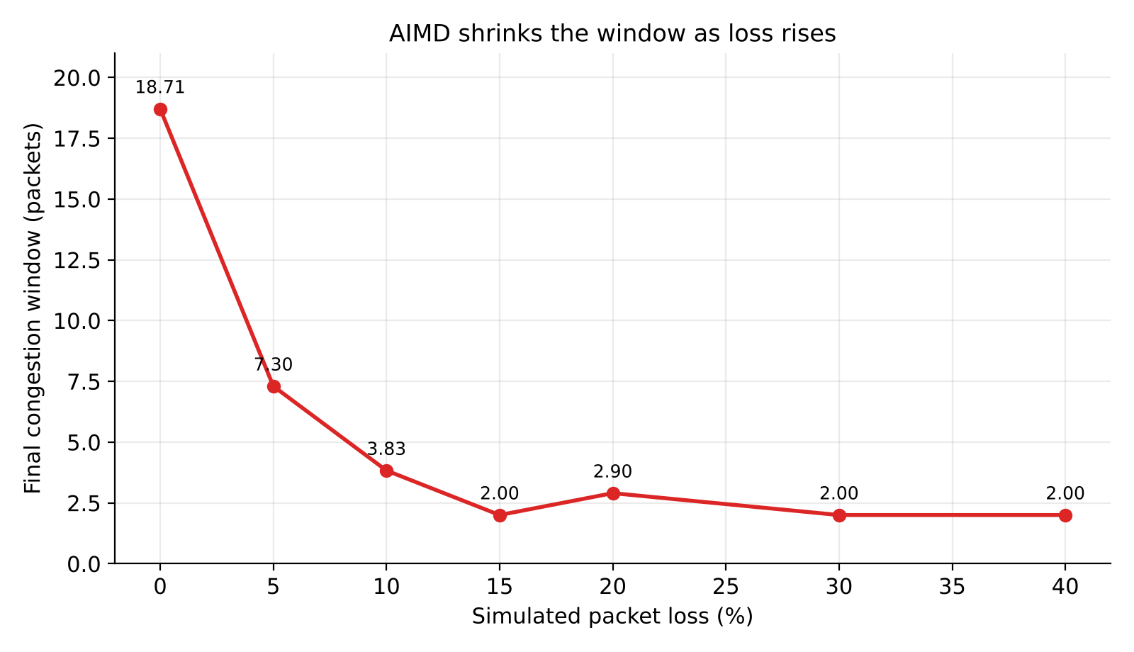
Figure 4: Final congestion window against simulated loss, from the benchmark in Table 5
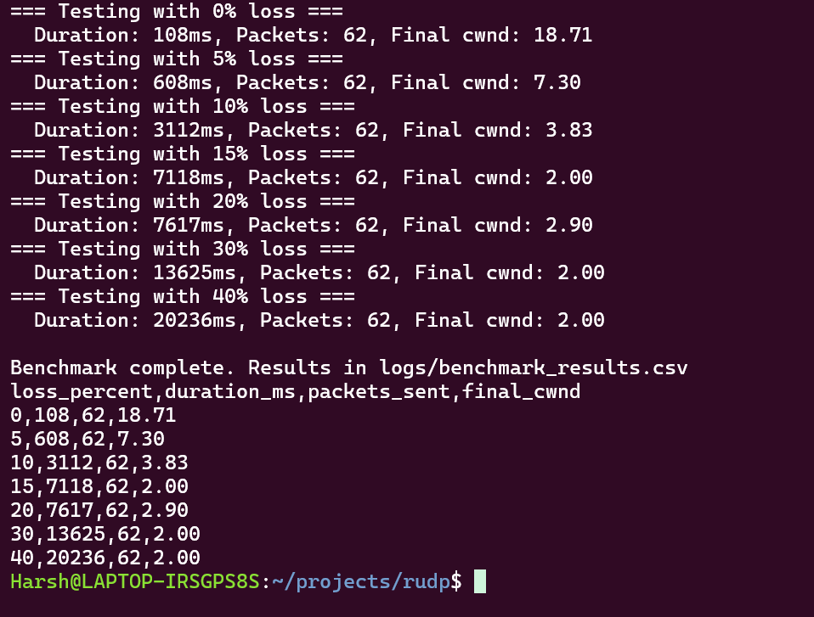
Figure 5: Terminal output of the final benchmark sweep, with the resulting CSV file
The 20% result (7,617 ms, final cwnd 2.90) is only slightly slower than the 15% result and ends with a larger window. Because each level was run once with a clock-seeded random generator, such small non-monotonic differences are expected run-to-run variation rather than a protocol effect. The trend across the whole range is clear: more loss means longer transfers and a smaller window.

6.2 Congestion window behaviour
Figure 6 shows the congestion window in a run with no loss. The window starts at 1 and grows by 1 per acknowledgment (slow start) until it reaches the threshold of 16, then grows by about 1/cwnd per acknowledgment (congestion avoidance), ending at 18.71 after 62 packets. The x-axis is the acknowledgment number because the whole transfer takes about a millisecond on the loopback interface.
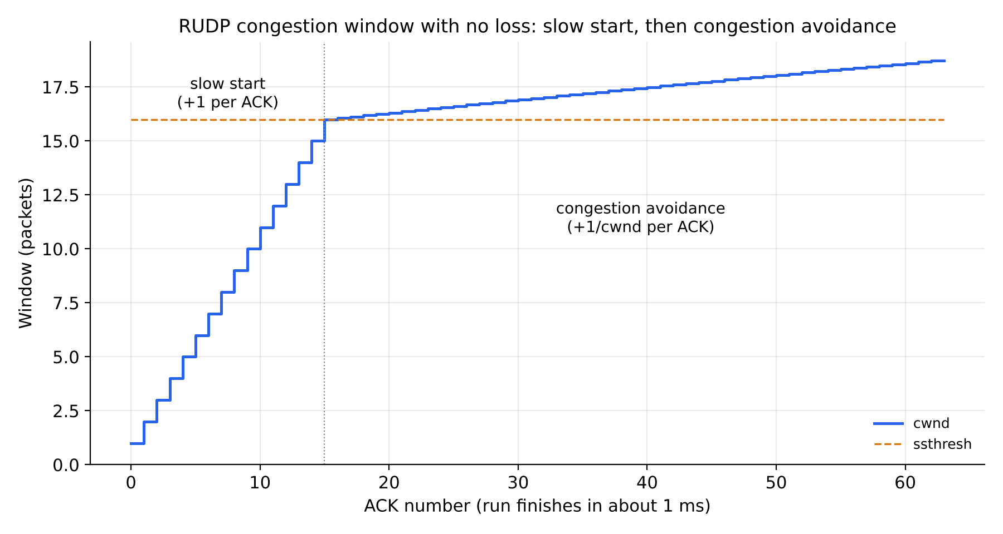
Figure 6: Congestion window in a run with no loss: slow start up to the threshold of 16, then congestion avoidance
Figure 7 shows separate runs at 0%, 10%, 20% and 40% simulated loss, plotted from the client's own cwnd log. Each timeout (red dot) resets the window to 1 and halves the threshold; each fast retransmit (green triangle) halves the window. Timeouts occur about 500 ms apart, matching the retransmission timer, and after each reset the window grows again in slow start. This sawtooth is the characteristic signature of AIMD. In these particular runs there were 5 timeouts and 2 fast retransmits at 10% loss, 8 and 6 at 20%, and 45 and 2 at 40%. The plots come from one extra run per level made on 8 October 2026 for these graphs, so their event counts differ from run to run and from the benchmark in Table 5.
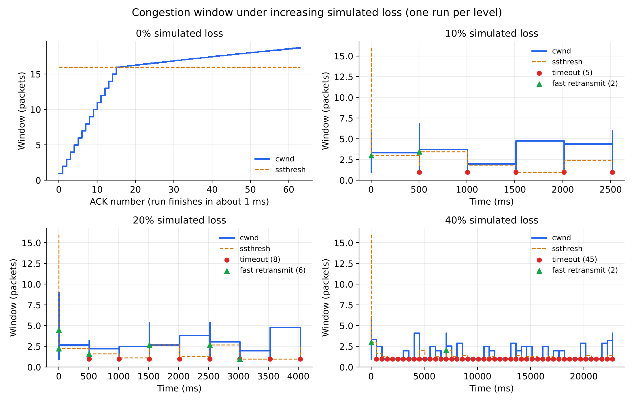
Figure 7: Congestion window and threshold at 0%, 10%, 20% and 40% simulated loss, with timeouts (red dots) and fast retransmits (green triangles); the 0% panel is plotted against acknowledgment number

6.3 Real loss and packet capture
With tc/netem dropping 20% of loopback packets, the transfer still completed. In the Wireshark/tshark capture, handshake and acknowledgment packets carried 13 bytes (header only) and data packets carried 53 bytes (13-byte header plus 40-byte payload), consistent with the 40-byte chunk size. Retransmission bursts appeared about 500 ms apart, matching the retransmission timeout, and the client logged 12 timeouts in that run. The capture screenshots are not reproduced in this report; the capture file and logs are kept with the project.

7. PROBLEMS ENCOUNTERED AND HOW THEY WERE FIXED
Every real obstacle is recorded here, with the evidence that was collected at the time.

7.1 Server stuck after an abandoned client
Symptom. The first complete benchmark sweep failed identically at every loss level. Each run took between 15.3 and 15.6 seconds and reported no packets and no window size (Figures 8 and 9). The CSV file contained 0 for both fields in every row.
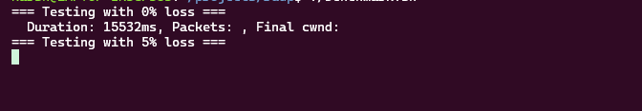
Figure 8: First symptom: a 15,532 ms run with empty packet-count and window fields
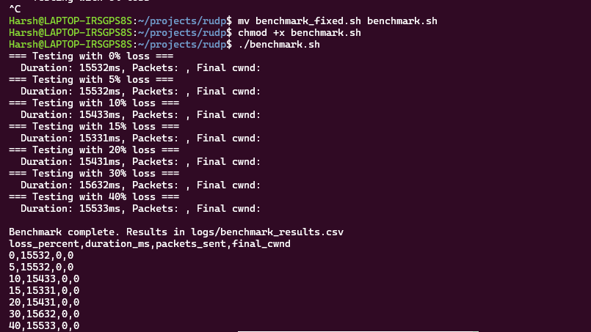
Figure 9: Whole sweep failing the same way: every level takes about 15.5 s and the CSV records 0 packets and 0 cwnd
Diagnosis. The command ss -ulnp | grep 8888 showed a server process still bound to UDP port 8888 (Figure 10), so the server was running but not completing handshakes. The duration matched the client's retry limit: five SYN attempts, each waiting up to three seconds, is 15 seconds, plus start-up overhead. The server only accepted a new SYN while in the LISTEN state. An earlier client had been stopped mid-transfer, which left the server in another state where it ignored every later SYN.
Figure 10: Diagnosis: a server process is still bound to UDP port 8888
Fix. The server now accepts a new SYN in any state, resets its sequence tracking and reassembly buffer, and replies with a SYN-ACK. This is the condition if (pkt.flags & FLAG_SYN) in src/server.c, replacing a test that also required the LISTEN state.

7.2 A leftover netem rule
Symptom. A test run behaved as though it were hung. Cause. A tc/netem rule from an earlier packet-capture session was still active on the loopback interface (Figure 11) and silently combined with the loss the benchmark was adding itself. Fix. The rule was removed with sudo tc qdisc del dev lo root netem, and tc qdisc show dev lo then reported only the default noqueue discipline (Figure 12). From then on the qdisc was checked before every test and deleted immediately after every netem test.
Figure 11: Leftover rule found: netem with loss 20% still active on lo
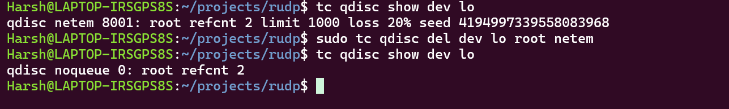
Figure 12: Rule deleted: only the default noqueue qdisc remains

7.3 Benchmark script produced wrong numbers
Symptom. One run reported a duration of 5,554,676,559 ms, about 64 days, although the packet count (62) and final window (3.55) were correct (Figure 13). Cause. The millisecond timestamp command date +%s%3N is not handled correctly by this shell. Separately, an earlier version of the script used grep -oP, which is not portable, and left the packet-count and window fields blank. Fix. The script now uses date +%s.%N with an awk calculation for milliseconds, and extracts values with plain grep and sed. The corrected script produced the results in Section 6.
Figure 13: Timing bug: an impossible duration of 5,554,676,559 ms next to correct packet and window values

7.4 Cluttered and misplaced project files
Symptom. The project folder in Windows Explorer showed leftover scripts and a stray server.c in the top-level directory (Figures 14 to 16), together with many files ending in :Zone.Identifier, which Windows adds to files that arrive from elsewhere. Fix. server.c was moved into src/, the extra scripts were deleted (Figure 17), and the Zone.Identifier files were removed. The first attempt used the pattern *.Zone.Identifier and matched nothing, because the file names contain a colon (Figure 18); the corrected pattern *:Zone.Identifier worked (Figure 19), leaving a clean directory of Makefile, README.md, benchmark.sh, bin, cwnd_graph.png, docs, logs, plot_cwnd.py, scripts, src and tests.
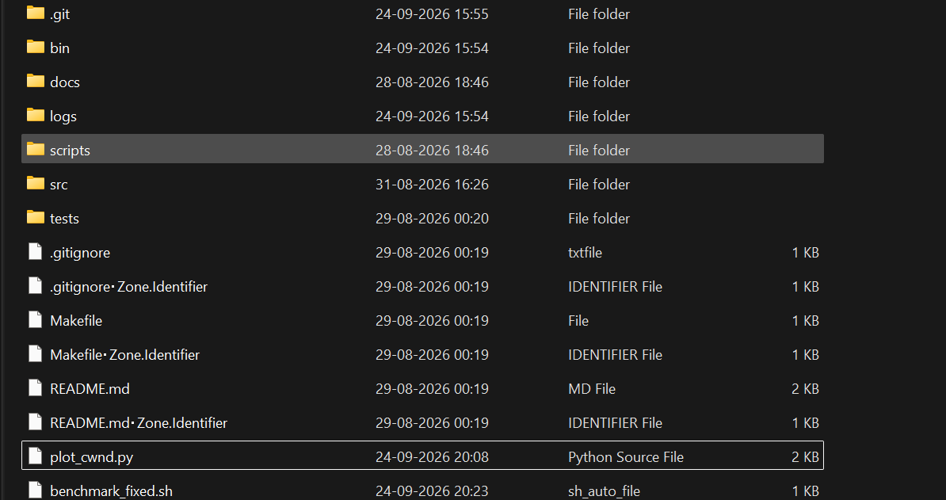
Figure 14: Project folder in Windows Explorer, including benchmark_fixed.sh
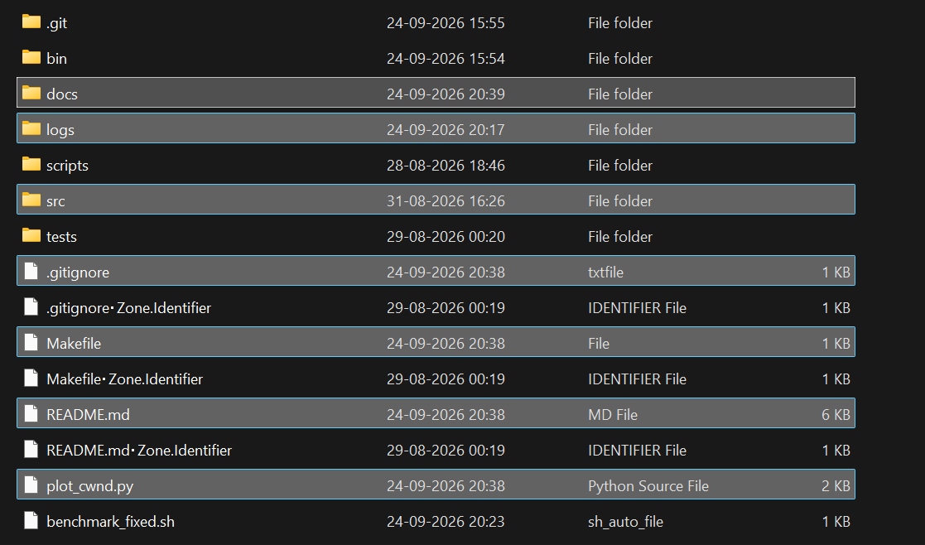
Figure 15: Folder listing after file updates; benchmark_fixed.sh still present
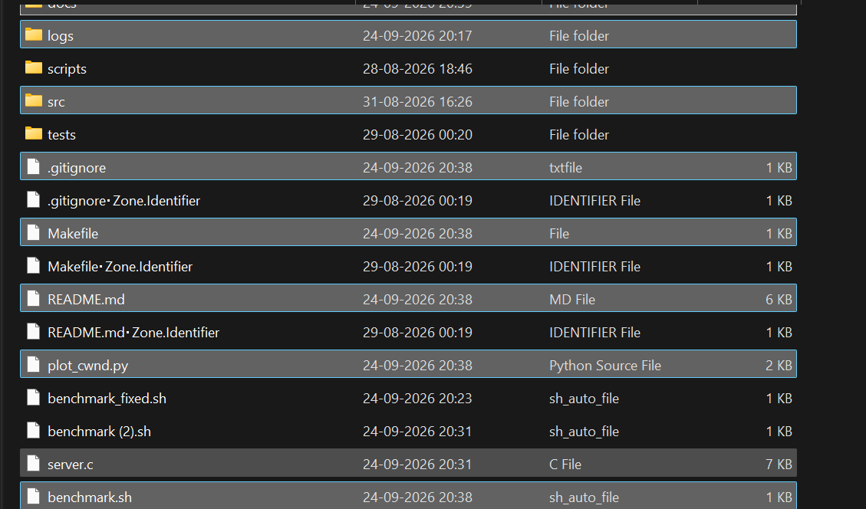
Figure 16: Stray copies in the top-level directory: benchmark (2).sh and server.c
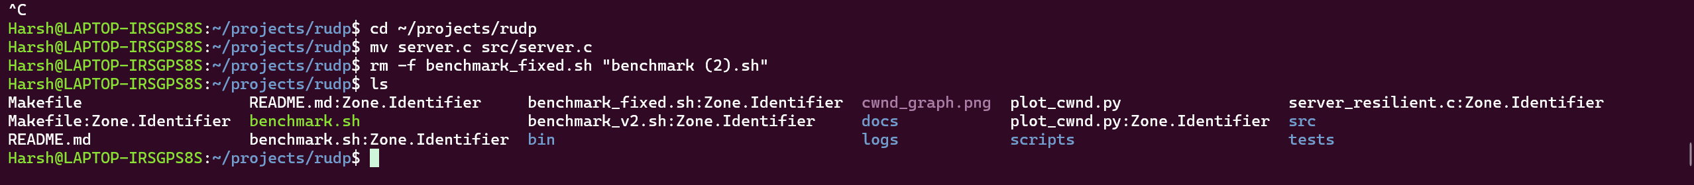
Figure 17: server.c moved into src/ and the extra benchmark scripts removed
Figure 18: First clean-up attempt: the wildcard *.Zone.Identifier matched nothing
Figure 19: Corrected pattern *:Zone.Identifier leaves a clean directory

7.5 Wireshark could not see WSL loopback traffic
Capturing on the vEthernet (WSL) interface from the Windows version of Wireshark showed no matching packets, because traffic between two processes inside WSL over 127.0.0.1 never reaches the Windows-visible adapter. The fix was to capture inside WSL with tshark on the lo interface, write a .pcapng file, and copy it to Windows to inspect in Wireshark. The first attempt to write the capture into the home directory failed with permission denied, so it was written to /tmp and copied with elevated rights.

7.6 Wrong assumption about the Windows user name
Copying a capture file to /mnt/c/Users/Harsh/Downloads failed with "No such file or directory" because the Windows account has a different name from the WSL account. Listing /mnt/c/Users showed the real name. The lesson is to confirm a path before using it.

7.7 A credential in a screenshot
A GitHub personal access token appeared in a screenshot shared during setup. A credential that appears in a screenshot or chat should be treated as compromised, so the token was revoked at once and a new one was created and typed only at the terminal prompt. No token appears in any figure in this report.

8. SMART-RUDP: LEARNING-BASED CONGESTION CONTROL
The AIMD policy used so far is a fixed rule. It halves the window on every loss signal, so it cannot tell a random wireless loss from congestion, and it grows by only one packet per round trip once past the threshold, which is slow on a long satellite path. Recent work applies reinforcement learning to this problem [9][10]. This section extends RUDP into Smart-RUDP by replacing the window-update rule with a Q-learning agent [11], and compares the two under emulated network conditions.

8.1 Design
The agent is a tabular Q-learner implemented in a single header (rl_cc.h, about 70 lines). Time is divided into monitor intervals of about one smoothed round-trip time (at least 10 ms). At the end of each interval the agent observes a state, receives a reward for the previous action, updates its table and chooses a new action. Table 6 lists the design.
Table 6: Smart-RUDP agent design
Element | Definition
State (80) | Mean-RTT ratio bucket (4) x retransmission-fraction bucket (4) x window-size bucket (5). The RTT ratio is the interval mean RTT divided by the minimum RTT plus twice the smallest observed RTT deviation, so natural jitter is not mistaken for queueing.
Action (5) | Multiply the window by 0.5, 0.85, 1.0, 1.15 or 1.5. Increases add at least one packet.
Reward | sqrt(throughput / reference) - 0.5 x max(0, RTT ratio - 1) - 4 x retransmission fraction, in the spirit of the utility functions of PCC [12]. The reference is the bottleneck rate.
Learning | Q(s,a) is updated with learning rate 0.15 and discount 0.9. Exploration probability decays from 0.35 to 0.03 over 40 training episodes. The table starts from a prior that favours growth when the path looks clean and shrinking when it looks congested.
Safety rule | After a retransmission timeout the window is halved (minimum 2) in Smart-RUDP, and reset to 1 in the AIMD baseline.

Both modes share the same reliability code (Go-Back-N when the experiments of Sections 8.1 to 8.8 were run; Selective Repeat is now the default, Section 8.9): an adaptive retransmission timeout from the smoothed RTT and its deviation (clamped between 60 and 3,000 ms, doubled after a timeout), and fast retransmit on three duplicate ACKs that resends the whole in-flight window. Only the window policy differs. The baseline therefore differs from the original RUDP client of Section 3 in using the adaptive timeout and in a 128-packet window cap; it keeps slow start to a threshold of 16 followed by additive increase.

8.2 Experimental setup
Real tc/netem needs root and was not available in the build environment, so the path is emulated inside the client: random loss, a bottleneck with a fixed service rate and a tail-drop queue, one-way delay with jitter, and a delayed return path for acknowledgments. Packets still travel through real UDP sockets to the real RUDP server. Three scenarios were used, each trained separately. The loss rates are modest because Go-Back-N degrades sharply at high loss (Section 8.4).
Table 7: Emulated scenarios
Scenario | One-way delay | Jitter | Random loss | Rate | Queue
5G-like | 10 ms | 3 ms | 0.2% | 1,500 pkt/s | 60 pkt
Lossy wireless | 25 ms | 10 ms | 2% | 800 pkt/s | 50 pkt
Satellite-like | 150 ms | 10 ms | 0.3% | 400 pkt/s | 100 pkt

For each scenario the agent was trained for 40 episodes (500 packets per episode, 800 for the satellite case), then its table was frozen and a 1,200-packet transfer was run six times against six runs of the AIMD baseline, using the same starting random seeds.

8.3 Results
Table 8: Mean of six 1,200-packet transfers per scenario (time shown with standard deviation)
Scenario | AIMD time (s) | Smart time (s) | AIMD retx | Smart retx | AIMD RTT (ms) | Smart RTT (ms)
5G-like | 1.44 +/- 0.21 | 2.35 +/- 0.04 | 62 | 34 | 25.1 | 23.8
Lossy wireless | 9.30 +/- 0.89 | 9.14 +/- 0.79 | 259 | 263 | 59.8 | 59.5
Satellite-like | 22.0 +/- 2.9 | 24.3 +/- 2.3 | 105 | 88 | 311.3 | 309.0

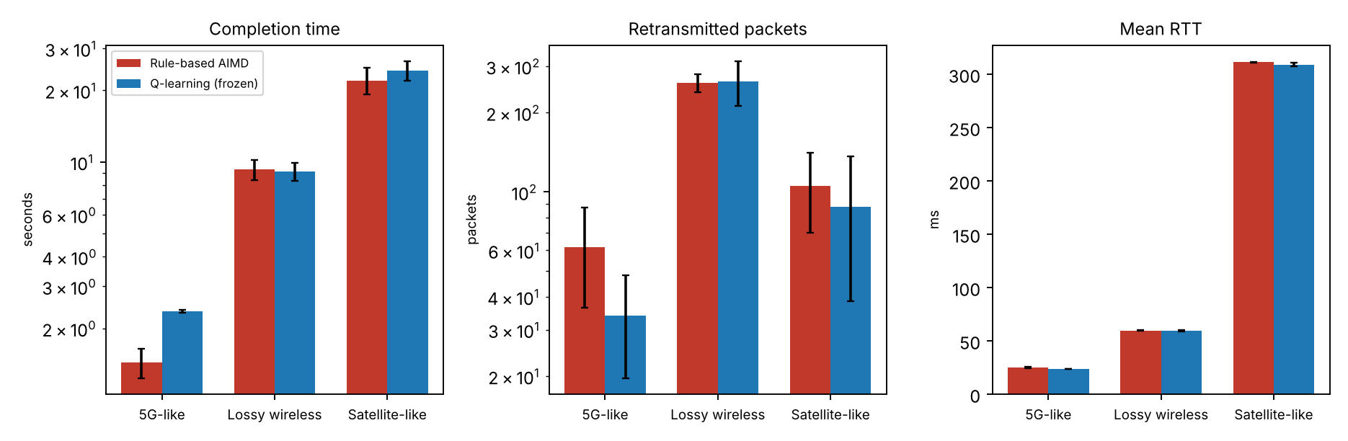
Figure 20: Completion time, retransmitted packets and mean RTT for the rule-based baseline and the frozen Q-learning agent (mean of six runs, error bars are one standard deviation)
Smart-RUDP did not beat the baseline on completion time. With six runs it was slower on the 5G-like and satellite-like paths (by about 63% and 10%) and equal within noise on the lossy path; a repeat with 20 runs per mode (Table 8b) gave tighter intervals and confirms the same pattern, with a larger satellite gap. It sent fewer retransmissions on the 5G-like and satellite-like paths and had a slightly lower mean RTT, but the retransmission differences are within one standard deviation across runs and should not be treated as significant. The result is reported as obtained: with a tabular agent, 40 training episodes per scenario and six evaluation runs, learning-based control matched but did not outperform a well-tuned rule on these paths. Section 8.5 reports a neural agent that does outperform it.
Table 8b: Mean of 20 runs per mode and scenario with 95% confidence intervals (frozen Q-tables, 1,200 packets, seeds 2001 to 2020; scripts eval_ci.sh and ci_summary.py)
Scenario | AIMD time (s) | Smart time (s) | Paired difference (s) | Significant?
5G-like | 1.36 +/- 0.09 | 2.29 +/- 0.06 | +0.92 +/- 0.12 | yes, slower
Lossy wireless | 9.27 +/- 0.54 | 8.90 +/- 0.46 | -0.37 +/- 0.45 | no (tie)
Satellite-like | 19.14 +/- 1.75 | 25.46 +/- 1.22 | +6.31 +/- 2.24 | yes, slower

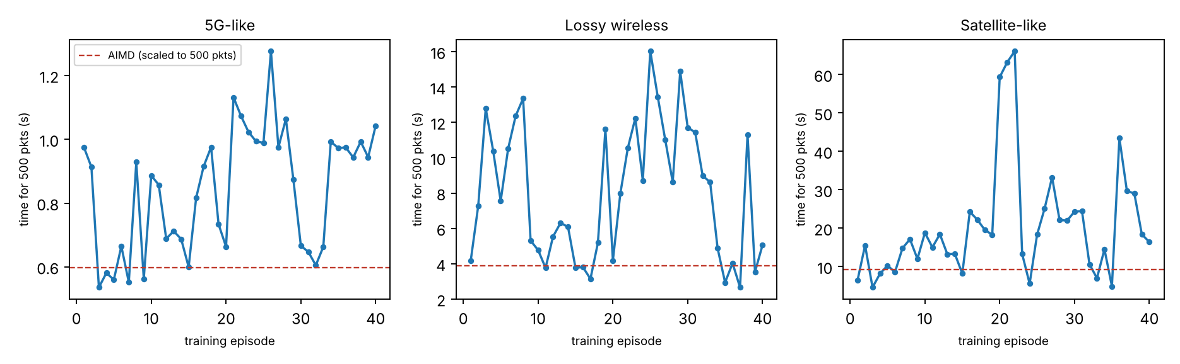
Figure 21: Training curves: time to deliver 500 packets in each training episode (dashed line: baseline, scaled to the same length)
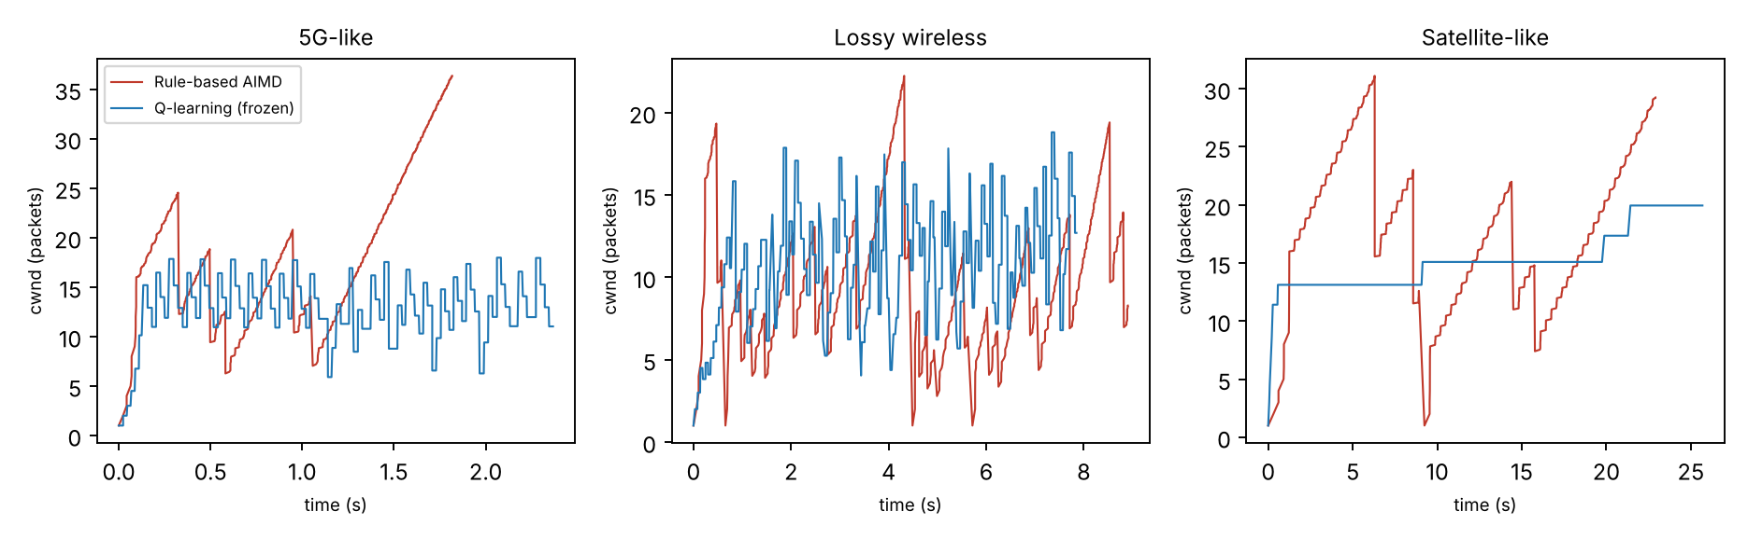
Figure 22: Congestion window over time in one evaluation run of each mode and scenario
The training curves in Figure 21 are noisy and do not show a steady improvement; in the 5G-like case later episodes are on average slower than early ones, which suggests that the agent is still exploring and that the training budget is too small for this table. Figure 22 shows that in the 5G-like and satellite-like runs the learned window stays within a narrow band (about 10 to 20 packets) while AIMD climbs to higher peaks and falls back, which is consistent with the learned policy being more conservative and finishing later. In the lossy run the learned window changes rapidly from one interval to the next.

8.4 Development notes and limits
- The first training round was far worse than the baseline (about four times slower on the satellite path). Three changes were made before the reported run: the prior was corrected to encourage growth under light loss, the window is halved rather than reset to one after a timeout, and the throughput term of the reward was square-rooted so that its signal is not drowned by the loss penalty at low utilisation. The reported numbers are from the final configuration and were not selected from several runs of it.
- Go-Back-N limits what any window policy can achieve: with loss of a few percent, most windows contain a loss and the receiver discards everything after it. Selective acknowledgments would help both modes, and Selective Repeat is now the default (Section 8.9).
- The emulated path in the C program keeps packets in order unless the option --reorder 1 is given; reordering was tested in the Python simulator (Section 11) and in one C scenario (Table 8d). A TCP model and plain UDP were compared in simulation; real kernel TCP over an impaired path was not run because the build environment has no tc/netem (a script, netem_baselines.sh, is provided for a Linux machine).
- A tc/netem script (netem_scenarios.sh) is supplied for repeating the scenarios with kernel emulation on Linux. It was not run for this report.

8.5 Neural agent, chat-style table agent and selective acknowledgments in the C transport
After Section 11 produced a neural agent and a retrained table in the Python simulator, both were added to the C transport so they could be tested on the same three emulated paths. The C client now has the modes rl2 (the retrained table, with the rule that the window may not shrink without a loss or delay signal, window cap 32 and a decision every 100 to 500 ms) and deep (the neural network of Section 11, a forward pass in src/deep_cc.h with weights exported by web/export_dqn.py). AIMD and the new modes all start from a window of 10 for a fair comparison. The agents were trained only in the Python simulator, on paths that are different from these three, so the C scenarios are unseen. Table 8c gives 15 runs per mode for the 5G-like and lossy paths and 8 runs for the satellite-like path, with 95% confidence intervals.
Table 8c: Completion time of 1,200 packets in the C transport (mean +/- 95% confidence interval; the last two columns are paired differences; all differences shown are significant)
Scenario | AIMD time (s) | rl2 time (s) | Deep time (s) | Deep - AIMD (s) | rl2 - AIMD (s)
5G-like | 1.38 +/- 0.16 | 2.64 +/- 0.50 | 1.18 +/- 0.03 | -0.20 +/- 0.15 | +1.25 +/- 0.56
Lossy wireless | 9.13 +/- 0.49 | 7.54 +/- 1.26 | 6.63 +/- 1.45 | -2.49 +/- 1.42 | -1.58 +/- 1.30
Satellite-like | 17.93 +/- 2.68 | 38.07 +/- 0.33 | 13.12 +/- 0.45 | -4.30 +/- 2.51 | +20.65 +/- 2.56

The neural agent finished faster than AIMD on all three paths, by 0.20 s (15%) on the 5G-like path, 2.49 s (27%) on the lossy path and 4.30 s (24%) on the satellite-like path. This is the first controller in this project that beats AIMD in the C experiments. The retrained table did not carry over: it was faster on the lossy path but 91% slower on the 5G-like path and more than twice as slow on the satellite-like path, where its window stayed small. The neural network, trained on the same paths with the same reward, generalised to these unseen paths and the table did not, which is the argument for a function approximator over a table. The caveats are the same as before: the agents were chosen on simulated validation paths, the paths here are emulated inside the client, AIMD keeps its original cap of 128 while the agents are capped at 32 (Section 8.7 repeats the comparison with equal caps and the conclusion holds), and the neural agent retransmitted more packets than AIMD on the lossy path (about 600 against 250), so it wins by sending more aggressively into a path whose loss is random.
Selective acknowledgments were also added to the C transport (a server built with -DRUDP_SACK buffers out-of-order packets and returns an 8-byte bitmap in every ACK; the client option --sack 1 then resends only the holes), together with a --reorder option that lets jitter reorder packets on the emulated path. Table 8d compares the Go-Back-N client on the plain server with the selective client on the selective server, 8 runs per cell. Selective acknowledgment cut retransmissions by about ten times in every scenario (for AIMD from 232 to 23 on the lossy path and from 245 to 22 with reordering). It did not change completion time significantly in these emulated scenarios, where the bottleneck rate limits throughput and extra retransmissions cost little; the large time gains seen in the simulator (Section 11) did not carry over. One interaction is worth knowing: a Go-Back-N client talking to the selective server was slower than on the plain server (13.2 s against 8.1 s on the lossy path), because the cumulative ACK jumps when a hole is filled, so the two sides should be used as a pair.
Table 8d: Mean completion time (s) of 1,200 packets with Go-Back-N and selective acknowledgment in the C transport (8 runs each, seeds 4001 to 4008; only the 5G-like and satellite-like differences are very small; none of the time differences is significant at 95%)
Scenario | AIMD GBN time | AIMD SACK time | Deep GBN time | Deep SACK time | Retx AIMD GBN / SACK
5G-like | 1.26 | 1.26 | 1.17 | 1.18 | 55 / 2
Lossy wireless | 8.07 | 8.50 | 8.72 | 4.56 | 232 / 23
Lossy, reordering | 10.22 | 9.24 | 6.99 | 5.09 | 245 / 22
Satellite-like | 18.88 | 18.11 | 13.28 | 13.32 | 87 / 4

8.6 Fairness, ablation study and chat gateway upgrades
Fairness. Two flows were run through one shared bottleneck in a multi-flow version of the simulator (300 packets per flow, 20 seeds). Table 8e reports flow A's share of the packets delivered when the first flow finished and the Jain fairness index (1.0 is a perfectly equal split; 0.5 is the worst case for two flows). The neural agent shares fairly with another neural agent (index 0.92 to 0.98) and with AIMD on the short paths (0.95 to 0.99). On the long 120 ms path it takes 74% of the bottleneck against an AIMD flow (index 0.82), which is about as unfair as a fixed window of 8 (72%, index 0.84). It is not a starvation case, since the AIMD flow still finishes, but the agent is not a polite sender on that path. A second finding is that two neural flows on a congestion-only path each finish more slowly (18.9 s) than two AIMD flows (12.2 s), so the single-flow gain does not simply scale to shared links. Fairness was not tested in the C transport.
Table 8e: Share of flow A (first-named controller) and Jain index for two flows on a shared bottleneck (simulator, 20 seeds)
Path | aimd/aimd | deep/deep | deep/aimd | smart/aimd | fixed/aimd | Metric
Congestion only | 52 / 0.998 | 56 / 0.984 | 44 / 0.987 | 38 / 0.948 | 29 / 0.845 | share % / Jain
Congestion + 2% loss | 50 / 0.990 | 55 / 0.921 | 60 / 0.952 | 54 / 0.965 | 62 / 0.944 | share % / Jain
Long path (120 ms) | 51 / 0.999 | 59 / 0.969 | 74 / 0.819 | 61 / 0.953 | 72 / 0.843 | share % / Jain

Ablation study. To find out which parts of the neural agent matter, it was retrained with one design choice removed (4,000 episodes, four seeds each, best seed chosen on the validation paths, scored on the 48 stress paths; Table 8f). The only component whose removal clearly hurts is the no-shrink mask: without it the best network averaged 6.54 s, close to AIMD (7.16 s), against 3.2 to 3.6 s with it. Removing the RTT-delay penalty, the last-action input or the throughput input did not hurt in the best seed (3.2 to 3.4 s); with the shorter 4,000-episode training the full agent was not better than those variants (3.59 s). The larger effect is the seed: the same recipe gave between 3.2 s and 7.4 s depending on the random seed, which is why the final agent was chosen on validation paths. The study therefore supports the no-shrink mask as the key ingredient and does not show a measurable value for the other three, and the seed sensitivity is a real weakness of the method.
Table 8f: Mean completion time on 48 unseen stress paths for each ablation (simulator; AIMD 7.16 s on the same paths)
Variant | Best seed (s) | All four seeds (s)
Full agent | 3.59 | 5.21, 7.10, 3.59, 7.31
No no-shrink mask | 6.54 | 6.60, 7.44, 7.24, 6.54
No RTT-delay penalty | 3.35 | 3.33, 3.24, 7.33, 3.35
No last-action input | 3.23 | 6.68, 7.45, 7.15, 3.23
No throughput input | 3.41 | 3.31, 3.41, 3.36, 3.24

Chat gateway upgrades. The web chat gateway gained a live dashboard (window, packets in flight, RTT and loss over the last 60 seconds, drawn from the gateway's own samples), an optional RFC 6298 adaptive retransmission timer with exponential backoff (--rto adaptive), and a fix for a retransmission storm. The storm was found while testing the dashboard: with delayed links, duplicate ACKs from an earlier fast retransmit kept arriving after the window had been resent, and each batch of three triggered another full resend, giving about 200,000 retransmissions in one 400-message run at 10% loss. The gateway and the terminal chat now allow a new fast retransmit only after the data outstanding at the last one has been acknowledged, as the C smart client already did. With the fix, a 200-message run sent 385 to 1,352 packets depending on the controller. On a 600 ms round-trip path with 5% loss, the adaptive timer finished 100 messages in 17.8 s with 54 retransmissions, against 29.0 s and 201 retransmissions for the fixed 300 ms timer, which is shorter than the round trip and times out spuriously (one run each, so illustrative only).

8.7 Validity check: equal window caps and a more realistic simulator
Two weaknesses in the comparison were found and tested. First, the window cap. AIMD in the C transport was capped at 128 packets and the agents at 32. Table 8g repeats the C experiment with AIMD capped at 32 as well (10 runs per cell, 95% intervals, paired by seed). The original neural agent still beats AIMD at the equal cap on all three paths: by 0.28 s (19%) on the 5G-like path, 2.61 s (29%) on the lossy path and 5.37 s (28%) on the satellite-like path, all significant. Against the old cap of 128 the 5G-like difference is not significant, and the other two are. The cap therefore does not explain the result.
Table 8g: Mean completion time (s) of 1,200 packets in the C transport with equal window caps (seeds 5001 to 5010; the retrained agent is the one described below)
Scenario | AIMD cap 128 | AIMD cap 32 | Neural (original) | Neural (retrained) | Runs
5G-like | 1.31 +/- 0.19 | 1.48 +/- 0.17 | 1.20 +/- 0.04 | 2.88 +/- 0.03 | 10
Lossy wireless | 8.89 +/- 0.58 | 9.12 +/- 1.18 | 6.51 +/- 0.93 | 9.53 +/- 0.49 | 10
Satellite-like | 18.66 +/- 2.73 | 18.85 +/- 1.92 | 13.48 +/- 0.40 | 30.02 +/- 6.42 | 10

Second, the simulator. The Python simulator that trained the agent and produced the stress results allowed a duplicate-ACK retransmission storm, the same flaw fixed in the chat gateway (Section 8.6): every duplicate ACK batch could trigger another full resend. At high loss this acts as aggressive redundancy and flatters aggressive controllers. With the realistic rule switched on (RUDP_RG=1: no new fast retransmit until the data outstanding at the last one is acknowledged, as in the C smart client), the stress result changes a great deal. Mean delivery time on the 48 stress paths was 7.27 s for the original neural agent, 7.10 s for the table agent, 7.16 s for the fixed window and 7.75 s for AIMD; the neural agent was faster than AIMD on 12 paths, slower on 15 and within 5% on 21. Training a new neural agent in the realistic simulator gave a stable result (all four seeds within 4.84 to 4.93 s on validation, against the earlier spread of 3.2 to 7.4 s) and a stress mean of 7.03 s, which is again about level with AIMD (faster on 13, slower on 13). That agent was much worse in the C transport (Table 8g), so it was not adopted. The honest conclusion is that the large simulated gains reported in Section 11 (3.20 s against 7.16 s) came partly from the storm effect and should not be quoted as general; the defensible evidence for the neural agent is the C measurement in Table 8g, which uses the realistic rule, an equal cap and paired runs, and it is limited to three emulated paths.
One more idea was tested and dropped: treating loss without RTT growth as random and refusing to shrink the window (a guard in web/cc.py, RANDOM_LOSS_RATIO). On 60 validation paths it changed the mean time from 3.83 s to between 3.87 s and 3.88 s, so it gave no gain and is off by default.

8.8 Hand-over to AIMD under heavy loss (hybrid agent)
The validity check exposed a serious weakness: at high random loss the neural agent is far worse than AIMD. A new C scenario with 10% loss (40 ms delay, 600 packets per second, queue 40, 300 packets) took the neural agent 85 s on average against 11 s for AIMD capped at 32, with about 1,300 packets sent for 300 delivered. The agent was trained mostly on mild loss and keeps its window large when the path is lossy. Two repairs were tried in the C transport. Cutting the window to a quarter on every retransmission timeout (--tcut 0.25) helped the 10% scenario (19 s) but made the 2% loss path much worse (24 s against 9 s), so it was dropped. A hand-over rule (--hybrid) works better: while the fraction of lost packets in the last decision interval is at least a threshold (5% or 10%), AIMD controls the window (reset to 1 on a timeout, halve on duplicate ACKs, additive growth), and after three clean intervals the agent takes over again.
Table 8h: Mean completion time (s) in the C transport, 95% intervals (seeds 7001 onward; the 10% loss scenario sends 300 packets, the others 1,200)
Scenario | AIMD cap 32 | Neural | Hybrid 5% | Hybrid 10% | Runs
5G-like | 1.48 +/- 0.21 | 1.17 +/- 0.03 | 1.19 +/- 0.04 | 1.23 +/- 0.07 | 10
Lossy wireless (2%) | 9.04 +/- 0.79 | 7.53 +/- 1.91 | 7.21 +/- 1.41 | 7.57 +/- 0.80 | 10
Satellite-like | 19.68 +/- 2.99 | 13.39 +/- 0.29 | 13.70 +/- 0.45 | 13.70 +/- 0.32 | 10
Hostile, 10% loss (300 packets) | 11.08 +/- 2.78 | 84.85 +/- 32.00 | 17.57 +/- 10.58 | 13.91 +/- 6.50 | 5

With the hand-over, the three benign paths keep the neural agent's advantage over AIMD (significant for all three with either threshold; for the lossy path the plain agent's difference of 1.5 s was not significant in this run, while the hybrid's was), and the hostile path drops from 85 s to 14 to 18 s, which is not significantly different from AIMD (paired difference +2.8 s with an interval of 8.3 s for the 10% threshold). The hybrid agent is therefore the recommended configuration (--hybrid 0.10). In the calibrated simulator (Section 8.7, in-order jitter, realistic recovery and adaptive timeout; 70 random paths of 300 packets) the plain agent averaged 73.3 s against 49.3 s for AIMD, and the hybrid 53.0 s (faster than AIMD on 25 paths, slower on 31): it removes most of the damage and gains only on paths with 1 to 8% loss (28.4 s against 31.0 s). The honest summary is that the learned controller helps on clean-to-moderate paths and needs a classical controller as a safety net everywhere else. The chat gateway has the same options (--hybrid, --tcut), and the test suite covers the hand-over.

8.9 Selective Repeat replaces Go-Back-N as the default
Go-Back-N was the weakest part of the design, so it has been replaced as the default in the C transport, the terminal chat and the web chat gateway. The receiver (server.c, chat.c, rudp_web.py) buffers out-of-order packets within a 64-packet window instead of discarding them and returns, in every ACK, the cumulative number plus an 8-byte bitmap of the packets it already holds. The sender (client.c, smart_client.c, the chat programs) keeps one timer per packet and resends only the packets that have expired and are not reported, and a fast retransmit resends only the holes below the highest reported packet. The window is capped at 60 so it fits the receiver's buffer. This is Selective Repeat with a cumulative ACK and a bitmap rather than one ACK per packet. Go-Back-N is still available for comparison (--gbn for smart_client, RUDP_GBN=1 for the original client and the terminal chat, --gbn for the gateway, and a server built with -DRUDP_GBN), and all tables in Sections 8.1 to 8.8 were measured with Go-Back-N and are labelled as such. The test suite now covers both modes (end to end at 20% loss for the original client in both modes, and all transport modes against both receivers).
Table 8i repeats the main C comparison with Selective Repeat on both sides (10 runs per cell, 95% intervals, paired by seed, AIMD capped at 32). The neural agent now beats AIMD by 9% on the 5G-like path (0.11 s), 46% on the lossy path (3.7 s) and 50% on the satellite-like path (12.8 s), all significant, a larger margin than with Go-Back-N. The hostile 10% loss path, where the plain neural agent took 85 s with Go-Back-N, now takes 8.1 s against 7.3 s for AIMD, which is not significantly different, with 329 packets sent for 300 delivered; the hand-over of Section 8.8 neither helps nor hurts (6.9 s). The large failure of Section 8.8 was therefore mainly a Go-Back-N effect, since a lost packet no longer causes the whole window to be resent. One result goes the other way: AIMD itself was slower on the satellite-like path with Selective Repeat (25.7 s) than with Go-Back-N (19.7 s in Table 8h); the cause was not investigated, and the neural agent is faster than AIMD under both.
Table 8i: Mean completion time (s) with Selective Repeat in the C transport (seeds 8001 onward)
Scenario | AIMD cap 32 | Neural | Hybrid 10% | Neural - AIMD | Runs
5G-like | 1.27 +/- 0.10 | 1.16 +/- 0.02 | 1.16 +/- 0.02 | -0.11 s | 10
Lossy wireless (2%) | 7.99 +/- 0.70 | 4.29 +/- 0.29 | 4.29 +/- 0.30 | -3.69 s | 10
Satellite-like | 25.70 +/- 2.82 | 12.91 +/- 0.26 | 13.00 +/- 0.27 | -12.78 s | 10
Hostile, 10% loss (300 packets) | 7.34 +/- 1.96 | 8.07 +/- 6.97 | 6.90 +/- 4.09 | +0.74 s (n.s.) | 5

The other implementations show the same direction. In the web gateway with 10% loss in each direction and 50 ms delay, 200 messages took 6.4 s with AIMD and Selective Repeat (23 retransmissions) against 11.9 s (141 retransmissions) with Go-Back-N, and 2.7 s against 8.6 s for the neural agent (37 against 877 retransmissions); every message arrived complete and in order. In the terminal chat at 30% loss in each direction, 30 messages were delivered with 53 packets sent (23 retransmissions) against 132 (102). These are single runs and illustrate the effect rather than measure it. A Go-Back-N sender talking to a Selective Repeat receiver still works but gets none of the benefit, and the reverse pairing delivers correctly but resends each missing packet only when its own timer expires.

9. NETWORK DESIGN AND CISCO PACKET TRACER
To place the transport protocol inside a realistic network, a four-router topology was built in Cisco Packet Tracer (Figures 23 and 24). A campus LAN with two VLANs reaches a server LAN across a routed core of three routers (R1, R2 and R3) connected in a triangle, and a branch LAN hangs off a fourth router (R4) behind R2. All routers run OSPF [13]. The RUDP client would run on a campus PC and the RUDP server on PC2, so every RUDP segment crosses the routed core as an ordinary UDP datagram to port 8888. In Packet Tracer the routers carry the device labels Router1, Router2, Router3 and Router0 for R1, R2, R3 and R4; the host names configured on them are R1 to R4.
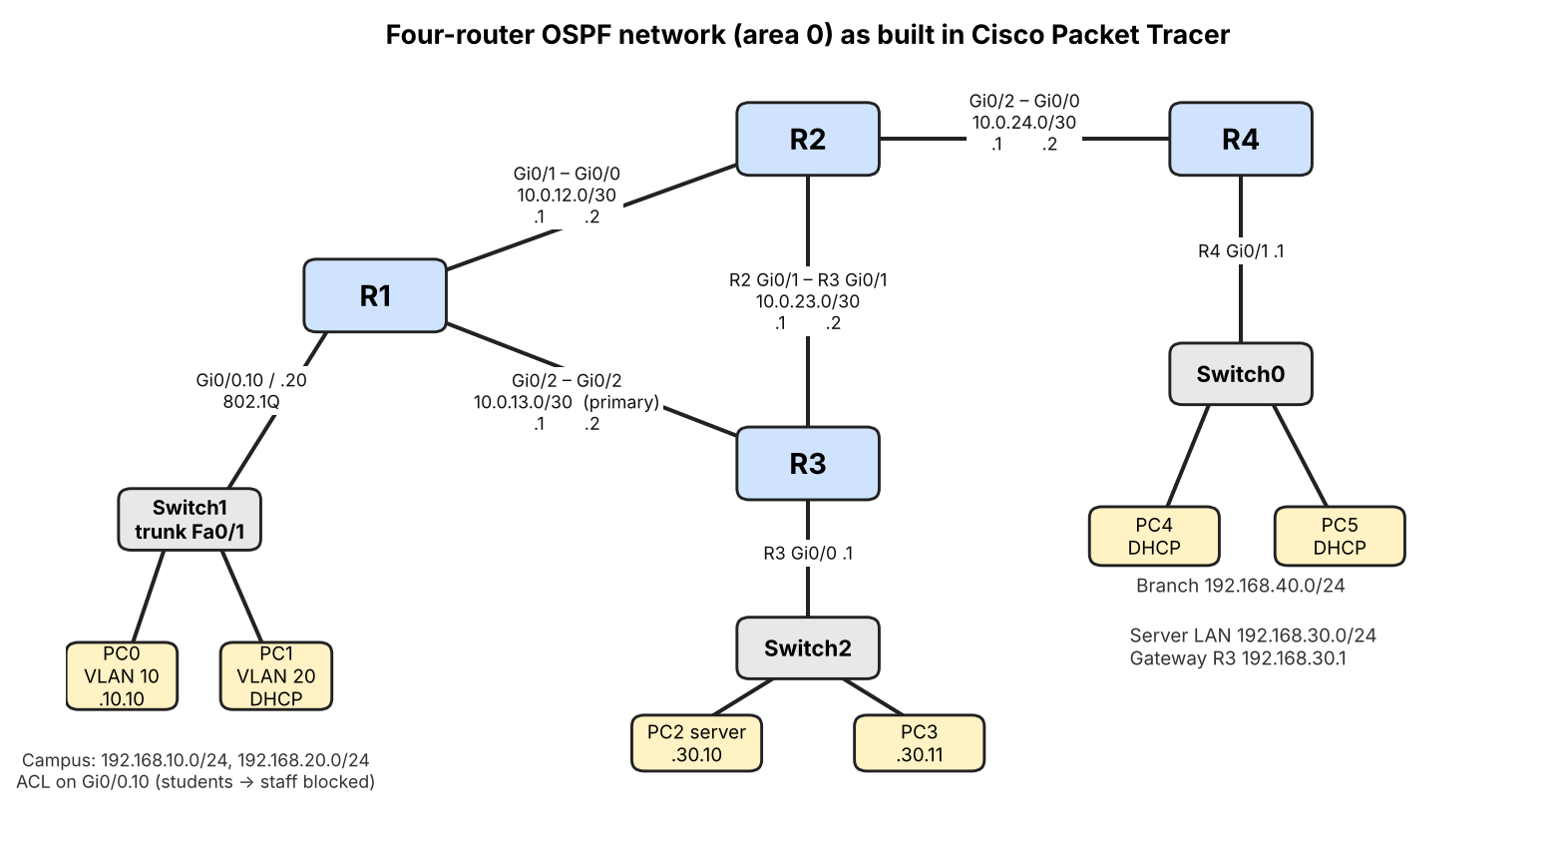
Figure 23: Four-router OSPF network as built: two campus VLANs behind R1, a server LAN behind R3, a branch LAN behind R4, with the interface used on each link
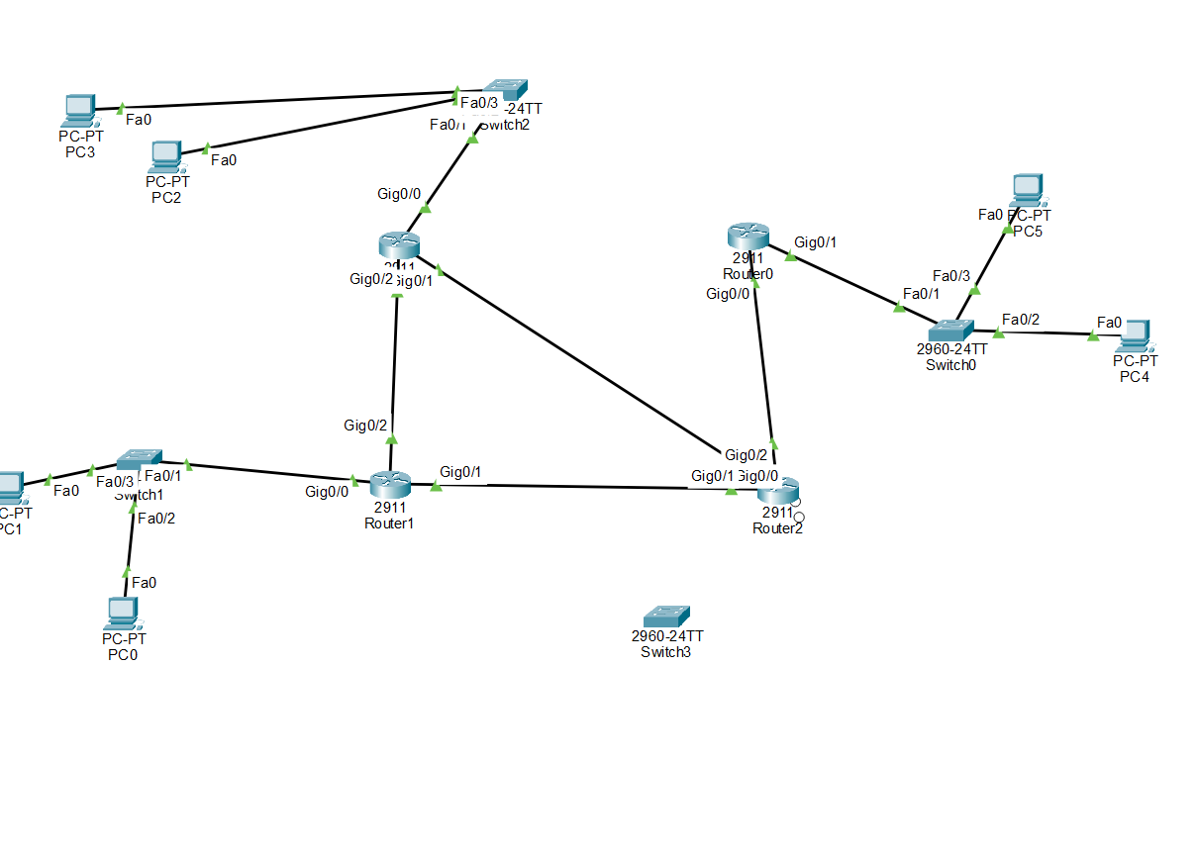
Figure 24: The same network in Cisco Packet Tracer with port labels shown

9.1 Addressing and configuration
Table 9: Addressing plan
Link | Subnet | Notes
R1 Gi0/1 - R2 Gi0/0 | 10.0.12.0/30 | R1 .1, R2 .2
R2 Gi0/1 - R3 Gi0/1 | 10.0.23.0/30 | R2 .1, R3 .2
R1 Gi0/2 - R3 Gi0/2 | 10.0.13.0/30 | R1 .1, R3 .2 (primary path)
R2 Gi0/2 - R4 Gi0/0 | 10.0.24.0/30 | R2 .1, R4 .2
VLAN 10 (students) | 192.168.10.0/24 | Gateway R1 .1; DHCP pool VLAN10; PC0 192.168.10.10
VLAN 20 (staff) | 192.168.20.0/24 | Gateway R1 .1; DHCP pool VLAN20; PC1 192.168.20.11
Server LAN | 192.168.30.0/24 | Gateway R3 .1; PC2 192.168.30.10, PC3 192.168.30.11
Branch LAN | 192.168.40.0/24 | Gateway R4 .1; DHCP pool BRANCH; PC4 192.168.40.11

Switch1 carries VLANs 10 and 20 to R1 over a trunk, and R1 routes between them with router-on-a-stick sub-interfaces (802.1Q encapsulation). R1 and R4 act as DHCP servers for the campus VLANs and the branch LAN. All four routers run OSPF process 1 in area 0 with router IDs 1.1.1.1 to 4.4.4.4. An extended access list named BLOCK-STUDENT-TO-STAFF on R1 sub-interface Gi0/0.10 denies traffic from the student VLAN to the staff VLAN and permits everything else. Because the replies of connections started from the staff VLAN toward students also have to pass back through that interface, the policy is effectively two-way between those VLANs, while both VLANs can still reach the server. During the build, the cabling of R2 was found by CDP (show cdp neighbors) to differ from the first plan, and the R2 addresses were changed to match the real cables.

9.2 Test plan and observed results
Table 10 lists the checks performed on the built network. The expected values come from the OSPF cost rules (a Gigabit Ethernet link has cost 1), and the right-hand column gives what was observed in Packet Tracer. R1 reaches the server LAN with metric 2 through R3 directly and the branch LAN with metric 3 through R2 (Figure 25). The first ping of every run was lost while ARP resolved, which is normal.
Table 10: Packet Tracer tests and observed results
No. | Check | Expected | Observed
1 | R2: show ip ospf neighbor | Three FULL neighbours | 1.1.1.1, 3.3.3.3 and 4.4.4.4 reached FULL
2 | R1: show ip route ospf | 192.168.30.0 metric 2, 192.168.40.0 metric 3 | As expected: via 10.0.13.2 and via 10.0.12.2
3 | PC0: tracert 192.168.30.10 | 192.168.10.1, 10.0.13.2, server | Exactly these three hops
4 | PC4 (DHCP): ping the server | Reachable through R4, R2, R3 | 4 of 4 replies, TTL 125
5 | PC0: ping a VLAN 20 host and the server after the access list | Staff host blocked, server reachable | Staff host: destination unreachable from 192.168.10.1; server still reachable (4 of 4, TTL 126)
6 | Shut R1 Gi0/2 during ping -t to the server | A few losses, then recovery via R2 | 70 of 71 replies; tracert via 10.0.12.2 and 10.0.23.2
7 | Restore R1 Gi0/2 | Neighbour returns | R1-R3 returned to FULL

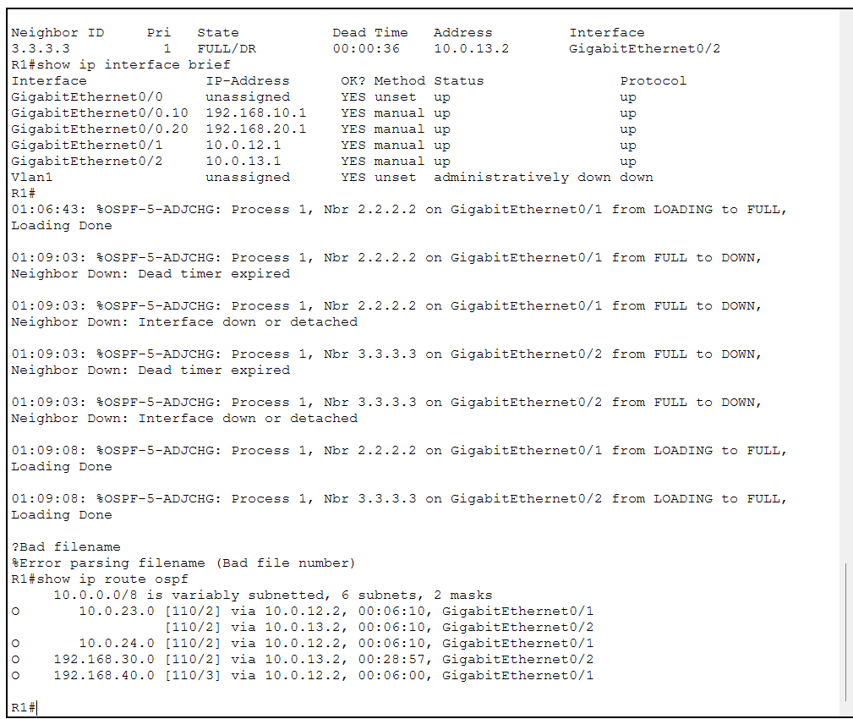
Figure 25: R1 console: OSPF routes (metric 2 to the server LAN, 3 to the branch LAN), then the Gi0/2 shutdown and restore used for the failover test
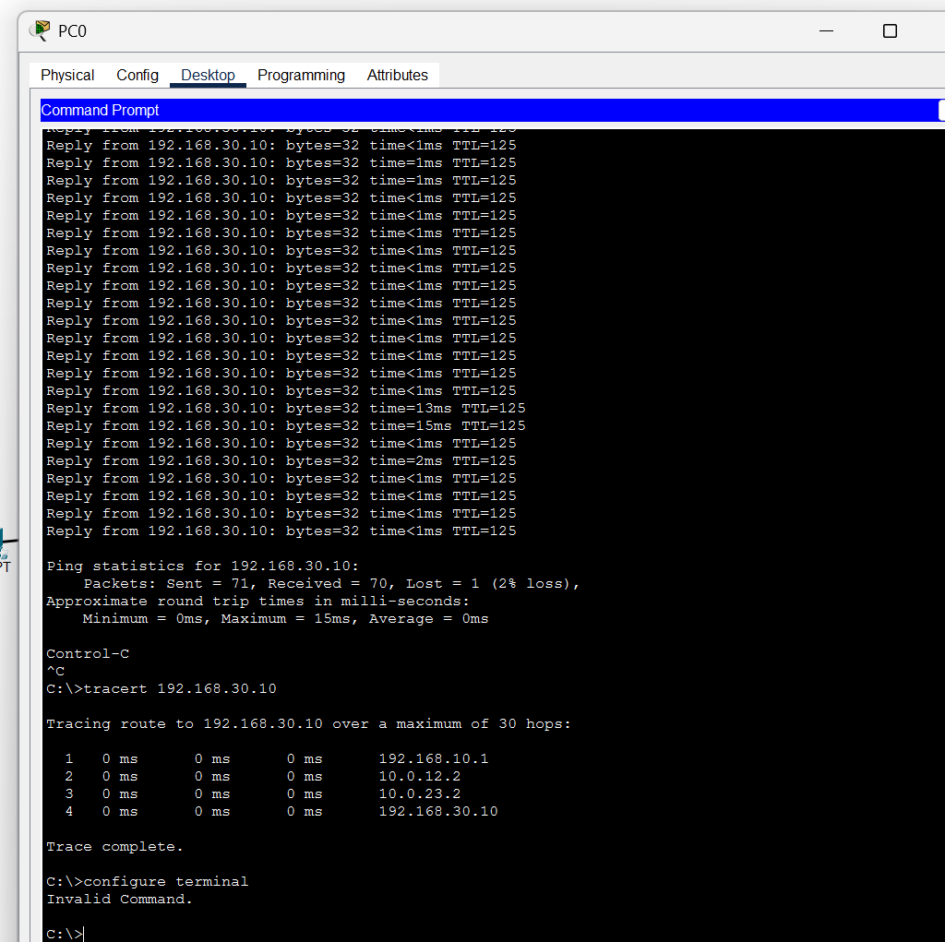
Figure 26: PC0 during the failover test: 70 of 71 replies, then tracert showing the longer path through R2 and R3
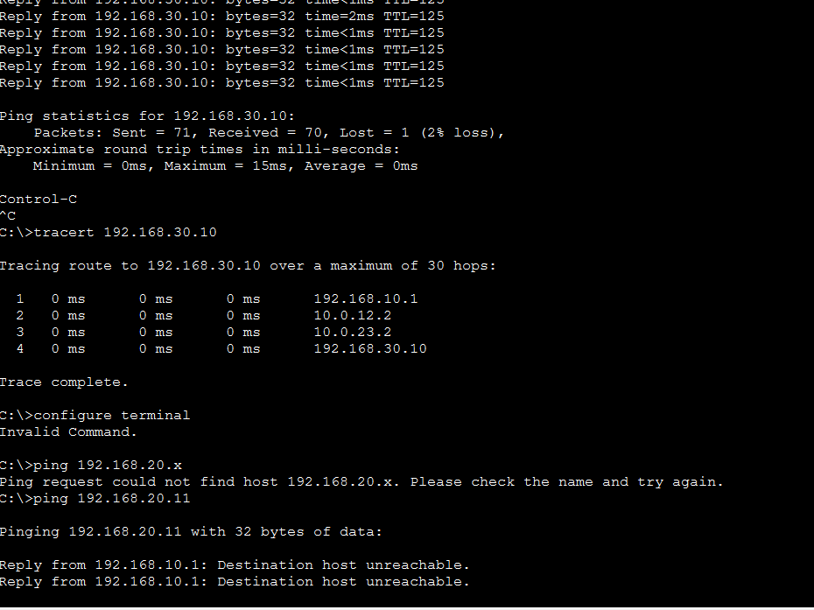
Figure 27: PC0 pinging the staff PC (192.168.20.11): blocked by the access list on R1
Test 6 is the convergence measurement. When an interface is shut down, the router detects the loss at once and OSPF recomputes its routes within seconds; a failure that the interface does not detect would instead wait for the 40-second OSPF dead interval. Here one echo reply was lost out of 71. The relevance to the transport layer is that the failover path is one hop longer, so the round-trip time of a running RUDP flow increases and the flow must re-learn its window. Smart-RUDP observes exactly this signal through its RTT-ratio state.
Packet Tracer is a simulator: its devices cannot be captured by Wireshark, and the transport tests of Sections 5 to 8 do not run inside it. The Packet Tracer part of the project therefore validates the network design, and the Wireshark part (Section 10) validates the protocol traffic.

10. WIRESHARK PACKET ANALYSIS
Two kinds of capture are used. The first is a real capture of the loopback interface with tshark inside WSL (Section 6.3). The second is a trace exported by Smart-RUDP itself (the --pcap option), which records every data segment and acknowledgment that reaches its destination across the emulated path, as seen at the receiver, in the standard pcap format. The exported file uses the topology addresses (192.168.10.10 to 192.168.30.10, UDP port 8888) so that it reads as a capture on the server LAN of Figure 23. The headers in this file are written by the program and not by a network interface, and the connection handshake bypasses the emulator and is not included.
A Wireshark dissector written in Lua (rudp.lua) decodes the 13-byte RUDP header into sequence number, acknowledgment number, flags (SYN, ACK, FIN, DATA), checksum and payload length. Useful display filters are smartrudp.flags.data == 1 for data, smartrudp.flags.ack == 1 for acknowledgments, and smartrudp.seq == N, which lists every copy of one packet and so exposes retransmissions.
Figure 28 is a real capture of the client and server on the loopback interface (rudp_capture_loss.pcapng, 164 packets) taken with tshark while packet loss was applied, and opened in Wireshark with the dissector. The first three packets are the three-way handshake (SYN, SYN-ACK, ACK), and the expanded header of the SYN shows the sequence number, acknowledgment number, flags (0x01), checksum and payload length decoded field by field. In Figure 29, the filter smartrudp.seq == 1327198699 shows the same data segment twice: once at 0.0004 s and again at 0.501 s. The segment before it was lost, so the receiver kept acknowledging the same number, the sender timed out after 500 ms and resent the whole window (Go-Back-N), which is the retransmission behaviour described in Section 3.4.
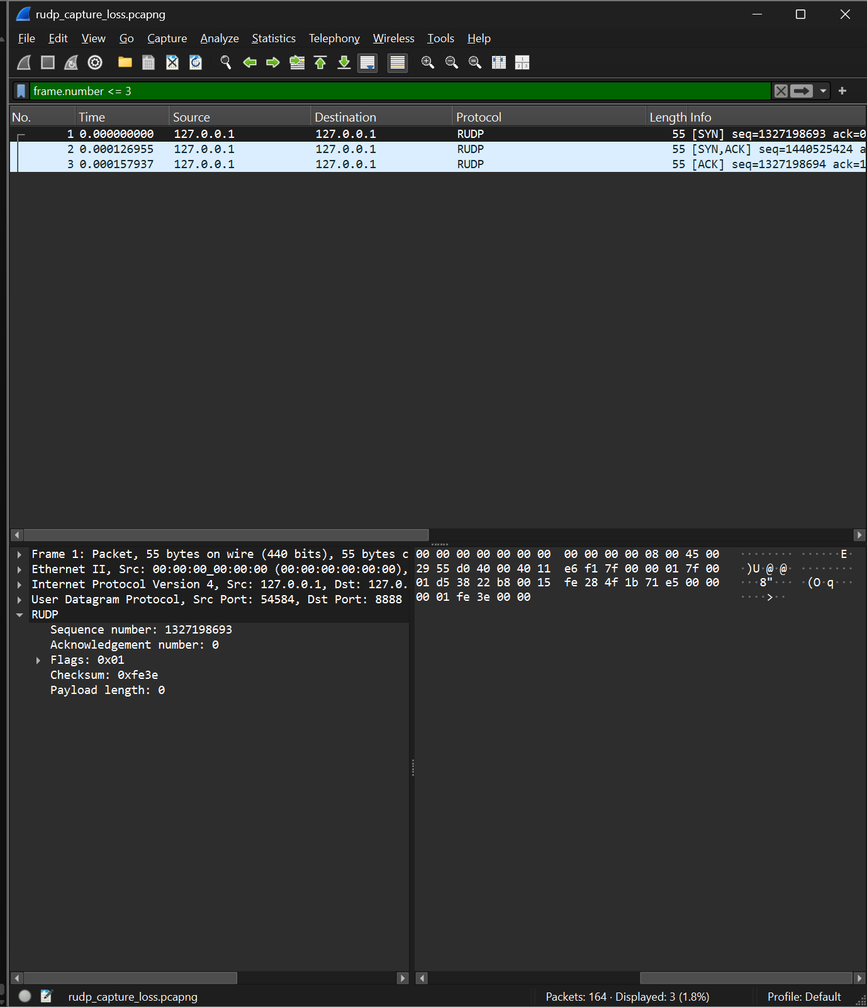
Figure 28: Real loopback capture opened with the RUDP dissector: SYN, SYN-ACK and ACK, with the header of the SYN decoded
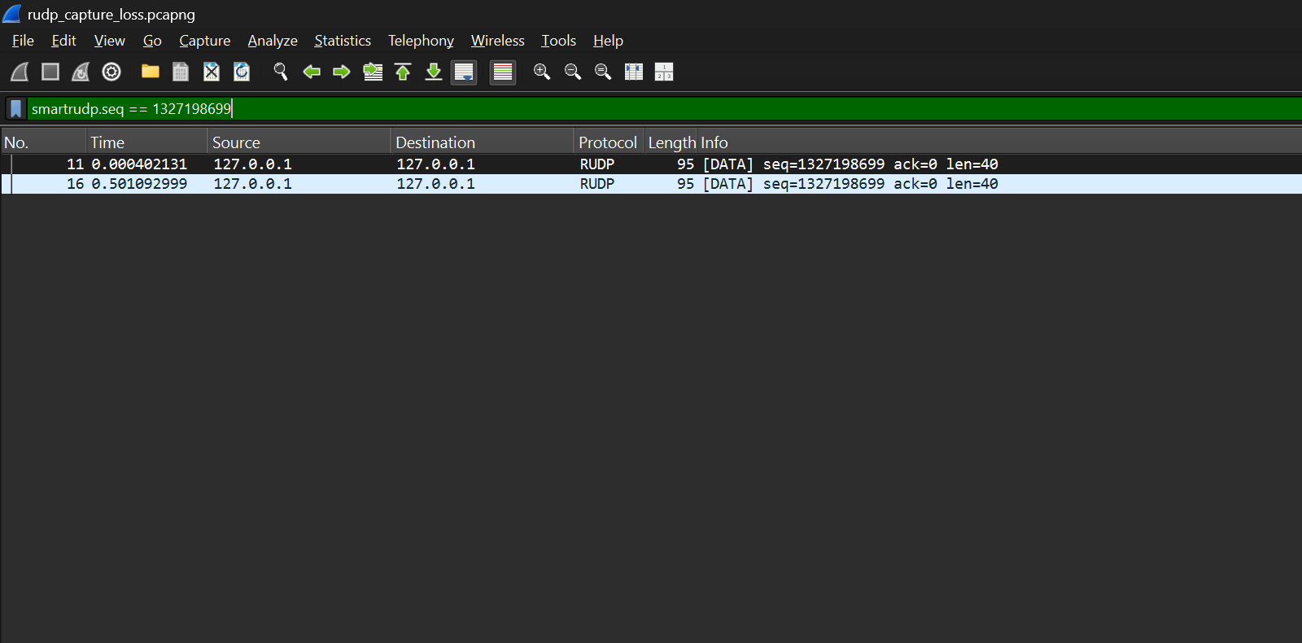
Figure 29: Display filter smartrudp.seq == 1327198699: the same data segment sent at 0.0004 s and resent at 0.501 s after a timeout
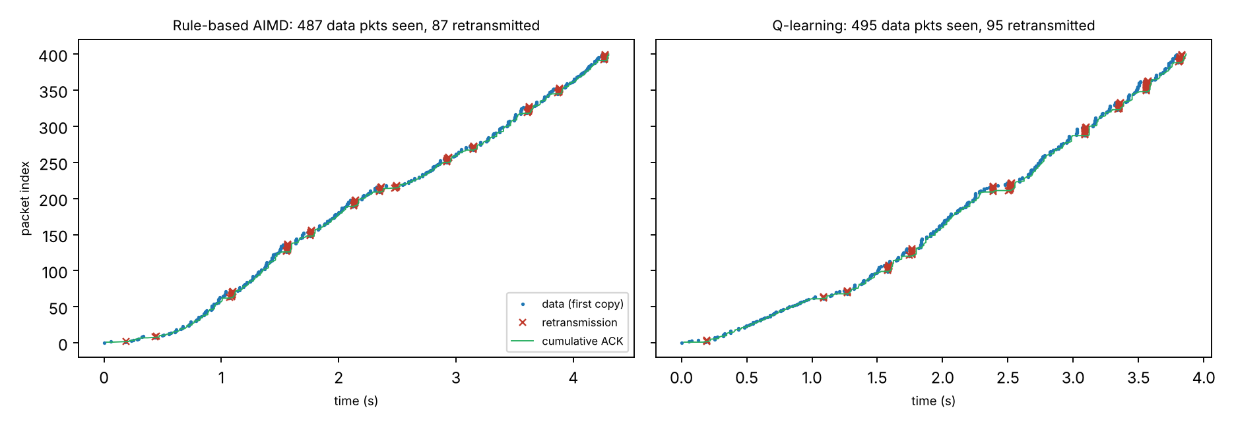
Figure 30: Sequence-against-time view built from the exported traces of a 400-packet transfer over the lossy-wireless path: first copies of data, retransmissions and the cumulative ACK for AIMD (left) and Smart-RUDP (right)
Figure 30 plots the two traces in the style of a Wireshark time-sequence graph. In this run the receiver saw 487 data segments and 487 acknowledgments for the AIMD flow, of which 87 data segments carried a sequence number already seen, and 495 data segments and 495 acknowledgments for the Smart-RUDP flow, of which 95 were repeats. The staircase of repeated points shows Go-Back-N resending a window after each loss. The two flows delivered the same 400 packets; the counts are from a single run, are counted at the receiver (segments lost on the path are not visible), and are not a statistical comparison.

11. APPLICATION DEMONSTRATION: RUDP CHAT
To show what the protocol does for a user, a messenger was built on the same packet format in three forms. The terminal program (src/chat.c) is a symmetric peer: each message is one data segment with a sequence number, the receiver delivers messages strictly in order and answers with cumulative ACKs, and the sender keeps a Go-Back-N window of eight messages with a 300 ms timeout and fast retransmit on three duplicate ACKs. Packet loss is simulated on the sending side, so a user can watch a lost message being recovered while the conversation still arrives complete and in order.
The program was then extended to run between two machines. The peer is given as ip:port, the socket binds to all interfaces, and each side sends small acknowledgment packets to the other until the first packet arrives, which opens the return path through home routers (NAT); the peer address is then learned from the first valid packet. The two ends were connected over a Tailscale private network, one on the laptop and one on an Android phone.
Finally, a browser front end was added (web/rudp_web.py and web/index.html). A browser cannot send raw UDP, so a small gateway written in Python with only the standard library implements the same RUDP rules and serves the chat page over local HTTP. It interoperates with the C program: in a test with 30% simulated loss in both directions, messages from the browser and from the terminal peer all arrived once and in order. The page, shown in Figure 31, marks each sent message as delivered once it is acknowledged and shows a live loss slider, counts of packets sent, lost and resent, the number of messages in flight, and a log of timeouts and fast retransmits.
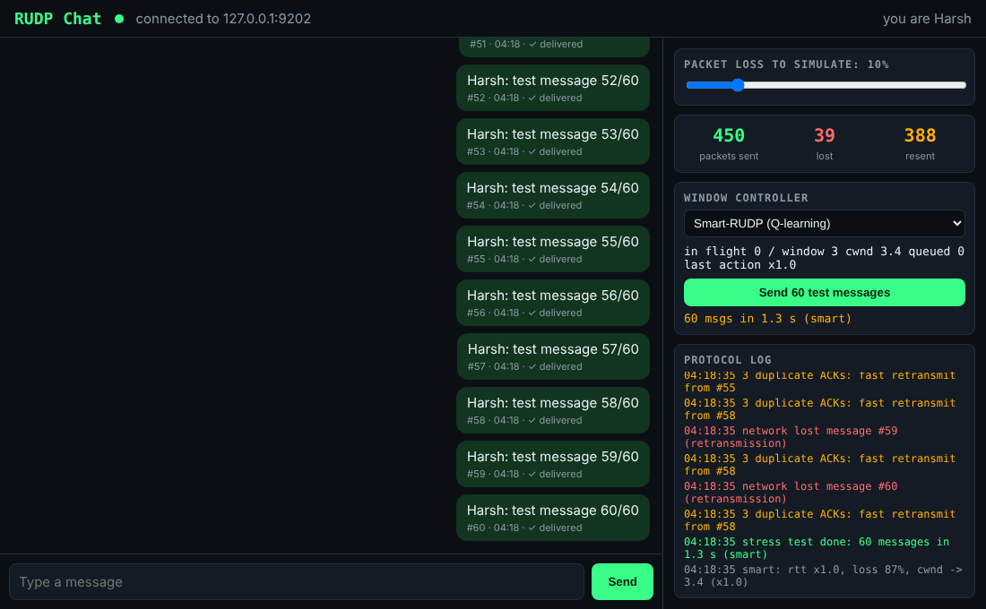
Figure 31: RUDP Web Chat with the Smart-RUDP controller selected, after a 60-message test at 10% simulated loss and 40 ms emulated delay: delivered ticks, packet counters, window controller and protocol log.
The web page also lets the user choose the window controller: a fixed window of eight, the AIMD rule, or the Smart-RUDP Q-learning agent. A button sends 60 test messages and reports how long delivery took. The chat is a different setting from the experiments of Section 8: traffic comes in short bursts and the loss on the path is random rather than caused by a full queue. The Smart-RUDP agent for the chat was therefore retrained (web/train.py) on a discrete-event simulator of the chat transport (web/sim.py), over 6,000 randomly drawn paths with 0 to 15% loss, 20 to 150 ms one-way delay and an optional bottleneck link. Two choices are worth stating. First, AIMD and Smart-RUDP start from the same initial window of 10 (RFC 6928), so neither gets a head start. Second, the agent may not shrink the window while there is neither loss nor delay growth; with this rule removed the trained agent was slower than AIMD on every path, so it is part of the design and not a detail. The agents were evaluated frozen and greedy on six held-out paths and 60 random seeds each; Table 11 gives the mean time to deliver 60 messages.
Table 11: Mean time to deliver 60 chat messages on simulated held-out paths (60 seeds each; lower is better)
Path (one-way delay) | Fixed 8 | AIMD | Smart-RUDP | Smart vs AIMD
10% loss, 40 ms | 1.09 s | 2.17 s | 0.90 s | faster
2% loss, 100 ms | 1.77 s | 1.66 s | 1.43 s | faster
6% loss, 60 ms | 1.34 s | 1.81 s | 1.08 s | faster
4% loss, 50 ms, bottleneck | 1.30 s | 1.55 s | 1.37 s | faster (marginal)
No loss, 30 ms, bottleneck | 0.61 s | 0.56 s | 0.56 s | equal
14% loss, 90 ms | 2.21 s | 4.89 s | 1.85 s | faster

Stress test. To check that Table 11 was not a lucky choice of paths, web/stress.py draws 48 random paths the agent never trained on (loss 0 to 30%, delay 10 to 300 ms, jitter up to 80 ms, optional bottleneck of 60 to 400 packets per second with a queue of 5 to 40, 10 to 120 messages) and runs each with 3 seeds. Mean delivery time was 3.73 s for Smart-RUDP, 3.88 s for the fixed window and 7.16 s for AIMD. Smart-RUDP was faster than AIMD on 27 paths, slower on 5 and within 5% on 16. Against the fixed window it was faster on 26, slower on 13 and within 5% on 9. Its weak spots are tight bottleneck queues and very high loss, where the fixed window of eight is hard to beat. A second agent trained on a broader range of paths did worse (mean 5.84 s) and was discarded. These results are from simulation, and Section 8.7 shows that this simulator flattered the learned agents at high loss. In a live test, 200 messages sent at 30% loss in both directions arrived complete and in order in 4.3 s, and the gateway kept responding when the peer disappeared.
Deep reinforcement learning. The abstract proposed a deep agent, so a neural version was added (web/dqn.py, web/train_deep.py). It is a Deep Q-Network written in numpy: a network with two hidden layers of 32 units reads five continuous inputs (RTT growth, loss fraction, window size, throughput share and the last action) and outputs a value for each of the same five window actions. It learns from a replay buffer with a separate target network, using the same reward, the same no-shrink rule and the same 6,000 simulated training paths as the table agent. Training is not stable: of four random seeds, three produced a good agent and one (seed 12) was slower than AIMD. The agent used here was therefore chosen by its score on 16 separate validation paths, which are not the held-out paths and not the stress paths. On the six held-out paths of Table 11 it was faster than the table on five and equal on one (40 seeds each). On the 48 unseen stress paths its mean delivery time was 3.20 s, against 3.73 s for the table, 3.88 s for the fixed window and 7.16 s for AIMD; it was faster than the table on 19 paths and slower on 6, and faster than AIMD on 27 and slower on 5. The gain over the table is modest, which fits a small state space, and the deep agent is weak on the same tight bottleneck queues as the table agent. It runs in the Python chat gateway and the simulator, and was later added to the C transport (Section 8.5). The simulated figures in this paragraph come from a simulator that allowed a retransmission storm; Section 8.7 repeats them with the realistic rule, where the agent is about level with AIMD, and tests the agent in C with equal caps, where it still wins.
Baselines: plain UDP and TCP. The abstract also proposed TCP and plain-UDP baselines. Plain UDP and a model of TCP were run on the same 48 stress paths (web/baselines.py). The TCP model has slow start, congestion avoidance, fast recovery with selective acknowledgments and a retransmission timer after RFC 6298, with the same initial window of 10 and cap of 32 as the chat. It is a model of TCP, not the kernel stack. Plain UDP delivered on average 68% of the messages and delivered every message on only 4 of the 48 paths, which is the reason reliability is needed. Table 12 gives the times.
Table 12: 48 unseen random paths, 3 seeds each, simulated, 60 messages unless the path says otherwise
Transport / controller | Mean time (s) | Median time (s) | Note
Plain UDP | n/a | n/a | 68% delivered
TCP model (selective ACK) | 4.56 | 1.48 | Go-Back-N not used
RUDP, fixed window 8 | 3.88 | 2.00
RUDP, AIMD | 7.16 | 2.72
RUDP, Smart-RUDP table | 3.73 | 1.99
RUDP, Smart-RUDP deep | 3.20 | 1.79

The TCP model was faster than RUDP with AIMD on 33 of the 48 paths, and its median is the lowest of all. Its mean is higher than the learned controllers because its timer backs off at very high loss, where RUDP's fixed 300 ms timer does not. The deep agent was faster than the TCP model on 22 paths and slower on 23. The main reason for the gap to AIMD is Go-Back-N, which resends the whole window after a loss. A basic selective-acknowledgment variant of the same simulated transport (web/sack_test.py) cut the mean time with the fixed window from 3.88 s to 2.53 s and with AIMD from 7.16 s to 4.90 s (median 2.72 s to 1.44 s), and was faster on 39 and 34 of the 48 paths respectively. Selective acknowledgment is therefore the most valuable next change to the protocol. One regime goes the other way: at 10 to 20% random loss the whole-window resend of Go-Back-N acts as redundancy and the fixed window was slightly faster without SACK.
Reordering. The C emulator keeps packets in order, so reordering was tested in the simulator by adding jitter larger than the packet spacing (2% loss, 50 ms delay, 60 messages, 40 seeds; web/reorder_test.py). A Go-Back-N receiver drops out-of-order packets and sends duplicate ACKs, so reordering looks like loss. AIMD with Go-Back-N went from 0.82 s with no jitter to 6.79 s at 20 ms jitter. The learned agents were more tolerant, and selective acknowledgment removed most of the damage (Table 13). The learned agents were trained only on in-order paths with Go-Back-N.
Table 13: Mean time to deliver 60 messages (s) under reordering; GBN is Go-Back-N, SACK is selective acknowledgment; simulated
Jitter | AIMD, GBN | AIMD, SACK | Table, GBN | Deep, GBN | Deep, SACK
0 ms | 0.82 | 0.77 | 0.77 | 0.49 | 0.48
20 ms | 6.79 | 1.61 | 1.25 | 0.93 | 0.64
50 ms | 7.06 | 1.82 | 1.67 | 1.13 | 0.80
100 ms | 8.16 | 2.61 | 2.77 | 1.63 | 1.11
200 ms | 10.06 | 6.34 | 4.23 | 2.54 | 1.55

Smart-RUDP was faster than AIMD on five of the six paths and equal on the sixth, and faster than the fixed window on five paths. The reason is specific: AIMD resets its window to one packet after every timeout, which is expensive when loss is random and not caused by congestion, while the agent learned to hold its window in that case. The advantage is therefore largest on high-loss paths and absent on a clean bottleneck, where there is nothing to learn. These are simulated paths. A real-time check of the gateway with two copies on one machine (four runs per controller) gave a mean of 1.2 s for Smart-RUDP against 2.6 s for AIMD at 10% loss and 40 ms, and 2.3 s against 3.0 s at 2% loss and 100 ms, with the fixed window at 0.8 s and 1.8 s; the run-to-run spread there is large, so those numbers support the direction and not the size of the effect. Section 8 stands as reported: on the 5G-like, lossy and satellite-like paths of that experiment the learned controller did not beat AIMD.
This demonstration is an application of the protocol, not a new measurement. Over the internet the result also depends on the network between the peers: direct connections between two home networks usually work, but shared or carrier-grade NAT, as on many hostel networks, can block them, which is why the private-network route was used.

12. LIMITATIONS
- Go-Back-N. One lost packet forces retransmission of the whole in-flight window on timeout, which wastes bandwidth compared with Selective Repeat. It was the original strategy; the default is now Selective Repeat.
- Selective Repeat. The receiver buffers out-of-order packets and the sender resends only the packets that are missing, each with its own timer. Here the receiver reports what it holds in a 64-bit bitmap inside every cumulative ACK.
- Fixed timeout in the original client. The 500 ms retransmission timeout of the benchmarked client is not estimated from measured round-trip time and does not back off; the Smart-RUDP client of Section 8 adds an adaptive timeout with backoff.
- Simplified fast recovery. The window is halved on three duplicate ACKs, but window inflation from RFC 5681 is not implemented.
- Limited test conditions. All tests ran on one machine over the loopback interface. The simulator drops only client data packets, and delay, jitter and reordering were not tested.
- Single runs. Each benchmark level was run once with a clock-seeded random generator, so small differences between levels are not statistically meaningful.
- No encryption or multiplexing. RUDP does not provide the security or stream features of QUIC.

13. CONCLUSION AND FUTURE ENHANCEMENTS
RUDP shows that TCP's core guarantees, ordered and complete delivery over a lossy datagram service together with a self-limiting sending rate, can be built and verified from first principles. The final system delivered all 62 packets of a 2,442-byte message at every simulated loss level from 0% to 40%. The congestion window responded as AIMD predicts, shrinking from 18.71 to 2.00 packets as loss rose, and the 500 ms retransmission interval was visible both in the cwnd graph and in the packet capture.
Smart-RUDP then tested whether a learned window policy could improve on the rule. A tabular Q-learning agent matched AIMD on the lossy path and was slower on the 5G-like and satellite-like paths, with somewhat fewer retransmissions; the honest finding is that this simple agent does not beat a well-tuned rule. A neural agent trained in simulation did beat AIMD on all three paths in the C transport (by 15%, 27% and 24%), and selective acknowledgments cut retransmissions about tenfold without changing completion time significantly (Section 8.5). The network design adds a four-router OSPF network with VLANs, DHCP, an access list and a tested link failover in Cisco Packet Tracer, and the Wireshark work adds a dissector and traces that make the protocol behaviour visible packet by packet.
The project also taught that reliable transport is largely timers and edge cases, that congestion control is a feedback loop in which the sender listens to the network, that independent evidence such as a packet capture matters, and that debugging the environment is as important as debugging the code.
Future enhancements are:
- Testing Selective Repeat on a real path where throughput, not the bottleneck rate, limits the transfer, and re-running the simulator studies with it as the default (RUDP_SR=1).
- Training the agent against the hand-over (so it learns when not to act), and a lower-loss-aware reward; the hybrid of Section 8.8 is a rule, not a learned policy.
- Multi-flow fairness in the C transport and a less aggressive agent for long paths (Section 8.6 shows 74% share against AIMD on the 120 ms path).
- An adaptive retransmission timer in the C transport (it exists in the web chat gateway, Section 8.6).
- A CUBIC window-growth variant to compare with the AIMD results reported here.
- Running the provided netem_baselines.sh on a Linux machine to measure kernel TCP, plain UDP and RUDP on the same impaired path, and repeating the Smart-RUDP scenarios on a real multi-machine path.
- Repeated runs per loss level for the base protocol, with averages and confidence intervals; this was done for the Smart-RUDP scenarios (Table 8b).
- Training the neural agent directly in the C transport and on real netem paths, since it has so far been trained only in a simulator, and testing selective acknowledgment on a path where throughput, not the bottleneck rate, limits the transfer.

REFERENCES
[1] V. Jacobson and M. J. Karels, "Congestion Avoidance and Control," in Proc. ACM SIGCOMM '88, 1988, pp. 314-329.
[2] D.-M. Chiu and R. Jain, "Analysis of the Increase and Decrease Algorithms for Congestion Avoidance in Computer Networks," Computer Networks and ISDN Systems, vol. 17, no. 1, pp. 1-14, 1989.
[3] M. Allman, V. Paxson and E. Blanton, "TCP Congestion Control," RFC 5681, IETF, Sept. 2009.
[4] S. Ha, I. Rhee and L. Xu, "CUBIC: A New TCP-Friendly High-Speed TCP Variant," ACM SIGOPS Operating Systems Review, vol. 42, no. 5, pp. 64-74, July 2008.
[5] A. Langley et al., "The QUIC Transport Protocol: Design and Internet-Scale Deployment," in Proc. ACM SIGCOMM '17, Los Angeles, CA, Aug. 2017.
[6] J. Iyengar and M. Thomson, Eds., "QUIC: A UDP-Based Multiplexed and Secure Transport," RFC 9000, IETF, May 2021.
[7] S. Hemminger, "Network Emulation with NetEm," Open Source Development Lab, Apr. 2005, as cited in the tc-netem manual page.
[8] J. Postel, "User Datagram Protocol," RFC 768, IETF, Aug. 1980.
[9] K. S. Midhula and P. Arun Raj Kumar, "An Adaptive Congestion Control Protocol for Wireless Networks Using Deep Reinforcement Learning," IEEE Trans. Network and Service Management, vol. 21, no. 2, pp. 2027-2043, 2024.
[10] Y. Cao, J. Nie, Y. Fan, X. Shao and G. Lei, "DRLFcc: Deep Reinforcement Learning-empowered Congestion Control Mechanism for TCP Fast Recovery in High Loss Wireless Networks," in Proc. IEEE GLOBECOM 2023, pp. 4345-4350, 2023.
[11] C. J. C. H. Watkins and P. Dayan, "Q-learning," Machine Learning, vol. 8, no. 3-4, pp. 279-292, 1992.
[12] M. Dong, Q. Li, D. Zarchy, P. B. Godfrey and M. Schapira, "PCC: Re-architecting Congestion Control for Consistent High Performance," in Proc. USENIX NSDI 2015, pp. 395-408.
[13] J. Moy, "OSPF Version 2," RFC 2328, IETF, Apr. 1998.

