Dr. AMBEDKAR INSTITUTE OF TECHNOLOGY

**Near Jnana Bharathi Campus, Bengaluru-560 056.**

**(An Autonomous Institution, Aided by Government of Karnataka)**

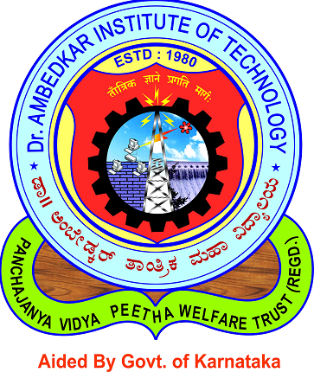

**CERTIFICATE**

This is to certify that the mini project entitled “**MILK DAIRY MANAGEMENTSYSTEM**” submitted in the partial fulfillment of the requirement of the 5th semester mini project curriculum during the year 2018-19 is a result of bonafide work carried out by

**VARSHA K M VARUN HEGDE**

**1DA16CS155 1DA16CS156**

**Signature of guide:**

_______________________ ______________________

**Mrs. Rashmi N Mr. Vinod Kumar K P**

**Asst. Prof., Dept. of CSE Asst. Prof., Dept. of CSE**

**Dr. AIT Dr.AIT**

**Name of examiners:**

1. Internal Examiner _____________ ______________________________

2. External Examiner _____________ ______________________________