Daniel Araujo

Johnson Le

**PART 1:**

**PART 2:**

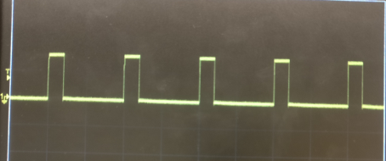

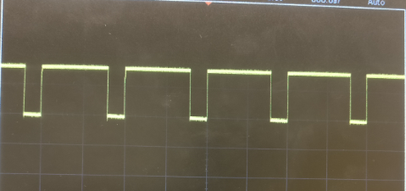

**PART 3:**

**PART 4:**

**PART 5:**

Number of steps for 360 degrees is 200.

Set rate is at 500. We start losing accuracy at about a set rate of 840.

For Wave step drive at a set rate of 500 we require 100 steps to get a full 360-degree rotation. At a set rate of about 562 we start losing our accuracy.

For half-step drive at a set rate of 100 we require 50 steps to get a full 360-degree rotation. At a set rate of about 1510.

**PART 6:**

Full step drive: Set Rate of 800 with a number of steps at 200, which gives us a full 360-degree rotation with accuracy.

At a set Rate of 850 with the same number of steps, we start to lose the 360-degree rotation accuracy.

Half step drive: Set Rate of 1800 with a number of steps at 200, gives us a full 360-degree rotation with accuracy.

At a set rate of 1900 with the same number of steps, we start losing our full 360-degree accuracy.

Eighth step drive: Set Rate of 6700 with a number of steps at 200, which gives us a full 360-degree rotation with accuracy.

At a set rate of 6850 with the same number of steps, we start losing our full 360-degree accuracy.