[Jones] Site Plan

[Joshua Seth Jones]

WDD 130

Overview

Purpose
The purpose of this page is to get to know me, Joshua Seth Jones. For anyone interested in getting to know me, this will be a good way to get to know me on a basic level.

Audience
Anyone really interested in getting to know me. Specifically, nerds who are too introverted to talk to me themselves and want some material so that they CAN talk to me themselves.

Branding

Website Logo
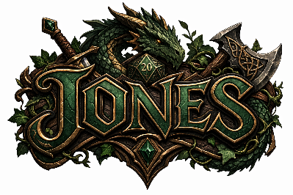

Style Guide

Color Palette
Primary | Secondary | Accent 1 | Accent 2
#4b6039 | #eaa219 | #e2bd7b | #946637

Typography

Heading Font: ../fonts/bookman_Bolditalic-font.otf

Paragraph Font: bookman_Regular-font.otf

Navigation
Home About Me Story

Content

[All content for the pages here, including written text and images]

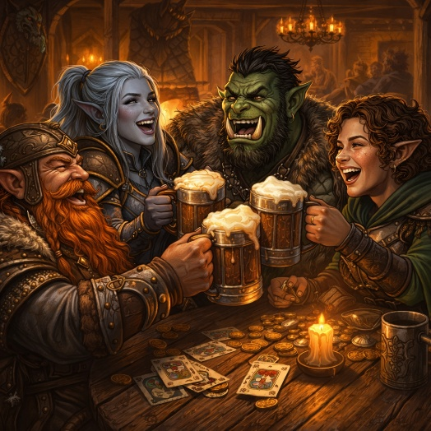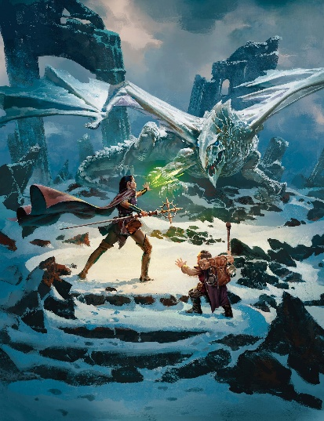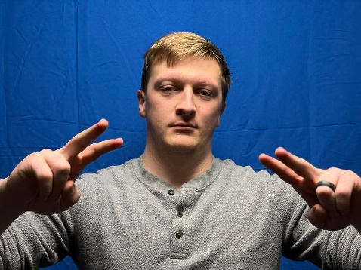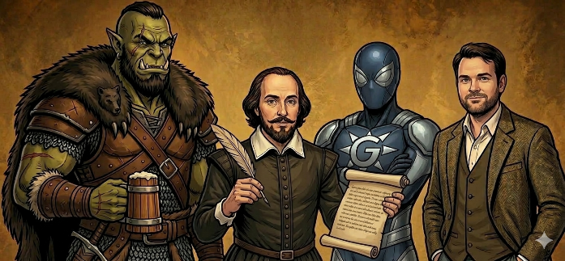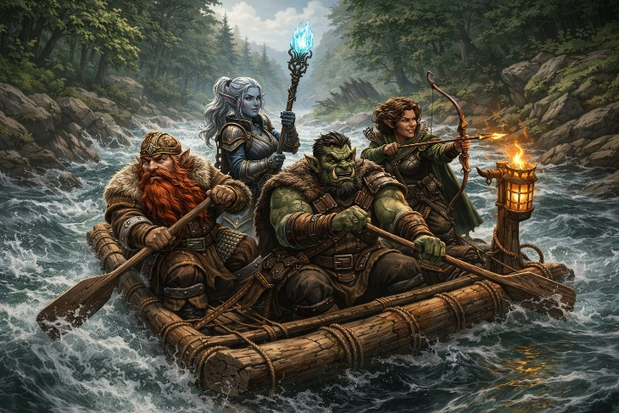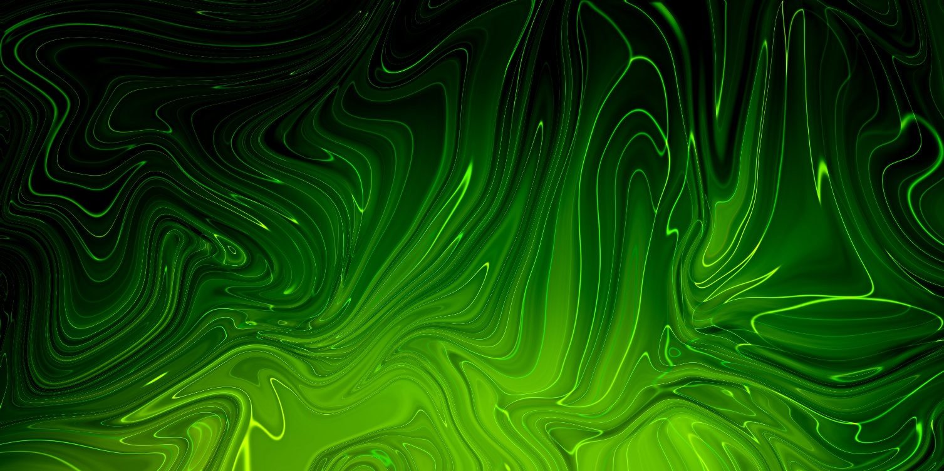
About Me Text
Hello, Reader!
I’m originally from West Valley City and currently a student at Brigham Young University–Idaho, where I’m studying both web development and acting. I’m still early in my path in programming, but it’s something I’m committed to developing over time. I chose to pursue this direction after receiving personal revelation that I needed to move into the world of computer programming, and that decision continues to shape my education and long-term goals.
Alongside that, acting is a major focus of my life. It’s not just something I enjoy—it’s something I’m actively training in and working to refine. My study has included learning from practitioners like Sanford Meisner and Uta Hagen, and I’m especially drawn to Meisner’s approach for its emphasis on truthful, instinctive performance. What draws me to acting is the opportunity to portray real human experiences in a way that people can connect with. Whether the story is dramatic or comedic, I’m interested in work that feels honest and meaningful.
That love of storytelling carries into other areas of my life as well. I recently spent several years leading a long-form Dungeons & Dragons campaign set 500 years after the events of Middle-earth, where a new evil sought to restore Sauron to power. Over time, it became far more than just a game. It was a chance to build a world from the ground up, develop characters with depth, and create experiences that people could genuinely invest in. Moments like that reinforced my interest in storytelling—not just as entertainment, but as something that brings people together and creates lasting memories.
I also take pride in the kind of person I am in my relationships. I’m someone people can rely on. I value loyalty, honesty, and clear communication, and I try to be intentional about how I show up for others. I’m also a straightforward person—I don’t shy away from addressing problems or saying what needs to be said, even when it’s uncomfortable. I believe that growth, both individually and in relationships, comes from being willing to confront things directly rather than avoiding them.
My long-term focus is to build a stable and meaningful life for my family. I want to support my wife and son, provide opportunities for my children, and create a life where we’re not constantly limited by financial stress. I want the freedom to travel, to pursue creative work, and to actually enjoy the life I’m building instead of just getting through it. To me, success means being able to provide, create, and live with purpose. Acting is something I hope to be part of that future, but more than anything, I’m committed to building a life that allows my family to thrive.
Because of that, I take growth seriously. Whether it’s improving as a developer, refining my skills as an actor, or becoming a better husband, father, and friend, I’m focused on steady progress. I don’t expect everything to come together immediately, but I do believe in consistent effort over time. I’d rather build something solid and lasting than chase quick success that doesn’t hold up.
My faith is central to everything I do. As a member of The Church of Jesus Christ of Latter-day Saints, I believe that God plays an active role in guiding my life. That belief influences how I make decisions, how I treat others, and the direction I’m working toward. It gives purpose to what I’m building and perspective when things don’t go as planned.
When I’m not studying or working, I spend my time with close friends, watching or creating stories, and continuing to grow as an actor. I’m especially drawn to environments where people can collaborate, create, and share experiences together.
At the end of the day, I’m focused on building something that matters—whether that’s a career, a story, or a life. I’m still figuring out exactly what that looks like, but I’m committed to moving forward with purpose, continuing to improve, and making the most of the opportunities I’ve been given.

Story Text
Please enjoy this story I wrote inspired by Dungeons and Dragons!

Caverns
Tárulthan held his torch as high as was possible to illuminate the dark, rocky caverns he was traversing. He crouched low to not hit his head, simultaneously being cautious of its proximity to the warm flames licking the cave ceiling. The trapped, stagnant air smelled intensely of moss and wet stone.
He knew that he shouldn’t have left the others. He’d left them early that morning, before the sun rose over the horizon, while they were all asleep because he could swear he saw gold from the hollow entrance. The others had insisted that they all wait until sunrise, but Tárulthan wanted a head start on collecting the gold. Being a treasure hunter meant they had to evenly distribute the findings amongst themselves, but Tárulthan didn’t like the idea of sharing an equal portion with a dragonborn and a goblin.
He shivered in disgust just thinking about them as he ducked beneath a particularly low portion of stone from overhead. He went onward, practically waddling uncomfortably through the short enclosed cavern. The echoes of his movement seemed unnaturally loud in the silence, reflecting the noise of his thoughts.
It came with the job, working with various races and species. That didn’t mean he had to like them, or that they had to get equal pay. If he had known he’d be signing a contract to complete this six person job with those two, he’d have probably spat at the feet of the employer and torn the agreement into pieces. Instead the amount of gold he was to receive from fetching the item distracted him from reading through the details as thoroughly. He’d been cursing himself ever since he’d met the group.
At least the other three were human. Though they were significantly inferior to his elvish heritage, at least they looked similar enough to him than a humanoid of scales and a creature of halfling disfigurement. The female was obviously less intelligent than the men, but stupidity was better than the combination of ineptitude and unprepossessing features. At least she did what human women were meant to do and cooked all the meals during the past five day journey.
The cave ceiling had expanded and he was able to stand up straight, though he still had to keep the torch from scraping against the jagged ceiling. The occasional water droplets would land on his intricately patterned leather armor, which was beginning to annoy him. He should have left his nice armor back at camp, but he couldn’t risk the others stealing it though that was how he’d acquired it himself.
Tárulthan approached a section of rock that narrowed into a sort of vertically, elongated backward S-shape where he had to squeeze through with difficulty. The lumps of the porous rock pressed painfully into his buttocks and scraped against the palms of his hands, but he successfully pulled himself through. His breaths were heavy afterwards from the effort, so he stopped for a short rest when he noticed a large gash in his beautiful leather armor. Tárulthan grumbled in frustration and annoyance, and sat on the flattest rock within his vicinity.
Movement from around a turn and farther down the tunnel made him freeze mid-squat. Tárulthan immediately quelled his heavy breathing. The silence that followed after hovered palpably in the muggy air.
He quietly unsheathed his sword and mentally prepared for any encounter. His silvery blade reflected the orange and red of the torch in his other hand. He inched stealthily forward, intently listening to any more shuffles or sounds. Tárulthan cautiously leaned around the bend to investigate the origin of the commotion, raising his steel in a defensive position, readying himself for an attack.
Nothing.
The cavern led straight forward for a long while, from what he could see from his darkvision, and yet he didn’t perceive any sort of danger. He didn’t see anything but a large stone the size of a tun barrel that created a simple obstacle in the path. He released his breath, feeling at ease, lowered his sword and turned back to the semi-leveled seat he had been intending to use before the scare. He decided that he must have been hearing things.
Tárulthan plopped down on the naturally-made chair and resheathed his sword. He heaved a sigh and arched his back, stretching the muscles in his back. Crouching while walking for so long had affected his lower back. He hated that. He was only 78 years old and his body was betraying him like he was a human senior. Although, he had put his body through a lot during his adventures over the years.
After around 5 minutes, as far as he could guess, Tárulthan eventually evened out his breathing. He’d better hurry or the others would wake and catch up soon. Tárulthan stood up and arched his back, stretching it out again. He readjusted his grip on the splintered shaft of the portable brazier in his hand and started forward again.
The treasure was sure to be close at this point. He’d been traveling for a while now; it couldn't be much farther. It had been maybe, what, an hour now? And there had been no sign of shiny gems, gold, or precious items and his time in the claustrophobic cave had begun to be slightly overbearing. He’d better pick up his or pace or he’d—
There it was again.
Tárulthan stopped short before the bend in the path. That distinct soft, scuttling sound echoed farther down the elongated, craggy corridor as far as his ears perceived.
Tárulthan’s heart rate increased, thumping against the inside of his leather armor. His mouth became as though he’d swabbed it with a ball of cotton, his palms became clammy with sweat and the hairs on the back of his neck stood on end.
So, there is something down here. Tárulthan thought, and drew his sword once more.
He put his back against the rounded wall of the cave and slowly peered around the bend. Again, there was nothing. Just a clear tunnel, with little to no obstacles, leading further down into the deep caverns.
He kept his sword drawn as he slowly stepped on the uneven rock floor, avoiding the crevices filled with accumulated water. Sweat trickled from his brow to the corner of his mouth, saltily quenching a small portion of his dry lips.
Tárulthan stopped, his sword held in a defensive position in front of him, and hesitated. Maybe he should wait for the rest of the party. This was risky. They were all warned there was a danger in these caves but it was unknown what it could be. It could be anything.
He started to turn around to go back when the firelight revealed a slight goldish-glint in the distant darkness. He squeezed his eyes to investigate from afar without moving, but was unsuccessful. Tárulthan took a very cautious step forward, raising his flame slightly higher; there were more small gold-colored reflections that sparkled like stars in the sky on a clear night.
Tárulthan’s eyes widened greedily as he took a quick intake of breath. He took three unintended steps forward in eagerness, the light revealing the outline of the entryway to a much bigger space. More importantly, there sat an ornate, dark brown, ebony wood chest with slightly rusted brass outlining the seams and edges, the size of a resting cow, on the far side of the room. Its lid, slightly ajar revealing the star-like shinies to be beautiful round gold coins and colorful gems.
I found it. Finally!
He quickly approached the entrance to the new cavern area. He glanced to the left of the large expanse, barely acknowledging the sheer size of what was the aftermath of a rockslide stemming from the top left with rocks and boulders of all sizes lying as still as fresh fallen corpses at Tárulthan’s feet. The quiet rush of water revealed a small stream weaving in and out of the loose granite of the rockslide like snakes searching for their prey.
To the right of the room leaned a massive angled stone wall that sloped up from the ground to form a high vaulted ceiling that connected to the pinnacle of the rockslide on the opposite side. The mountain wall curved to form the back of the room opposite Tárulthan where the treasure chest rested, awaiting its pillaging. The stream from atop the rock slide amassed to form a wider stream at the bottom, traveling across the floor and escaping through a horizontally wide crack at the foot of the wall.
Tárulthan enthusiastically hopped over the wide waterway towards the chest, childishly giggling under his breath, anxious to gather his discovered goodies. Reverently, he stepped up to the wooden chest, a broad grin growing on his moist face. He jammed the torch into a crevice in the angled wall to illuminate the area and rested his sword against a tun barrel sized rock sitting next to the equally large treasure-holding strongbox.
Tárulthan knelt before the enormous chest full of valuables and listened to the creak of its hinges as he slowly opened the lid, relishing the tension of the moment. The light of the flame illuminated the gradually revealed coin, jewels and gems, filled to the brim of the chest, and reflected onto the ecstatic countenance of Tárulthan. The lid thudded gently against the curved wall behind it.
Oh, this was much, much more than he had expected. Both of his hands grasped the sides of the chest, and he leaned in, his nose inches from the treasure pile, and inhaled the glorious metallic scent. He was barely holding himself together as he allowed himself to become hypnotized by the vast amount of wealth before him. He was in heaven-like euphoria.
The sudden sound of metal against stone clanged loudly, pulling Tárulthan out of his trance and his head jerking toward the noise. His sword had been a mere 2ft away; it was now almost his body length away from him. But even more strangely, the sword fell from its position against the rock, but the blade had fallen up the rockslide.
How does that happen? His heart was pumping wildly from the sudden sound.
Tárulthan heard a sickening wet, peeling sound. He went rigid, acknowledging the noise was coming directly from the chest, then his head turned towards the noise, a slow, dread-filled swivel. The chest’s lid had almost completely closed by itself from its fully open position, and appeared to be slightly suspended over his hands still resting on two ends of the chest lip.
The subtle, moist squelch happened again. This time Tárulthan located the origin to the brass strap strapped atop the lid. His gaze slowly traveled from the now limited view of the precious contents to the top of the wooden box. There, dead center on the summit of the strongbox cover, appeared to be two pomegranate-sized, black orbs glazed with what appeared to be a slimy substance, vaguely reflecting the light of flame and Tárulthan’s image. The orbs looked as though they had lifted the brass strap edge but had only bent them in a manner that the brass was almost encasing them. How did the brass not break from age?
Tárulthan leaned in closer to the orbs, observing the slimy balls fixed atop the lid. He had no clue what they could be.
Were they part of a puzzle to solve? No, the chest was open when he arrived.
Had he passively missed the strange spheres in his excitement? The gelatinous globes were significant enough that he determined that would have been impossible to miss.
What on Faerûn were they?
He stared into the black spheres, captivated by the void-like darkness seemingly inviting him in. Deeper and deeper, Tárulthan’s gaze swam through the shadow, the reflections of the torch floating like a wispy, orange and red aurora borealis in the night sky.
Then, the orbs blinked.
Tárulthan’s eyes widened. His heart rate shot from an excited trot into a panicked gallop.
Before he could react, hundreds of yellowish dagger-like teeth protruded from all around the lip border, all at once, and then the lid slammed shut.
Teeth sank straight through Tárulthan’s hands.
Tárulthan screamed, the sound reverberating off the stone. Blinded by the pain of the two inch wide teeth embedded into his wrists, his mental logic vanished and he desperately attempted to pull away from the immovable, wooden jaw.
The Chest smiled, wickedly.
Tárulthan yanked frantically, but the strength of the Chest was too great. His hands and wrists were trapped in the maw of this creature, but the adrenaline made him keep pulling and pulling. He was starting to feel the stretch and tear of muscle and ligaments, as he pleaded with himself to stop, but emotion overcame intellect. Tárulthan collapsed to his knees onto the wet rock, hands still stuck in the monster’s fangs but still tugging wildly.
Then there was red. So much red.
Tárulthan witnessed in terror as a thick, long tentacle-like tongue coated in saliva emerged from between a gap in the Chest’s teeth, lapping up the blood spilling from Tárulthan’s flesh. The Chest vibrated and seemed to grow excited. More black, orb-like eyes popped open on the cover of the chest. Then, like a dog climbing a rope during tug of war, the Chest lurched forward, with a blur of motion, opening its mouth and shutting it down on Tárulthan’s upper forearms.
Tárulthan shrieked, tears streaming down his face. He could smell death on its breath from the others that it had previously consumed. In fact, even through his sudden gagging and coughing, he could hear their screams as they had died trying to escape the beast, or was that just him?
Tárulthan yelled for help and screamed even more as he felt the pressure of the jaw crunch down on his arms tighter. He screamed for help again, hoping against hope the echoes would reach his group. He twinged and cried out as the sticky, sandpaper-like pointed tongue dug into the openings of his flesh that Tárulthan himself had torn. Tárulthan hung his head towards the rocky floor.
There was nothing he could do. He was going to die in this moist, dank cave all because he wanted a bit more gold. Why had he been so thoughtless in determining going alone was the best way to do it? He needed someone to save him. Anyone! Even the Dragonborn or Goblin, he’d be forever in their debt if they saved him now. At this point, he didn’t care how anyone looked, where they came from, or their intelligence. He’d treat them with respect and assist them with anything they would need if they were able to get him out of this alive. But no, these were his final moments.
I’m sorry for my utter foolishness…
Then he remembered his sword.
Tárulthan’s head jerked up and his eyes connected with the blade. Due to the lunge the creature had made to get more taste of blood, it had unintelligently moved them in closer proximity to his weapon. If he could reach with his feet, he could maybe angle it in the right position and at least get himself free. There was not much of a chance, but what other choice did he have.
He angled his body awkwardly and painfully from his arms still clutched in the Chest’s jaw, and reached his leather boot toward the sword. He was inches away despite the slope of the rockslide. He could do this! He just had to get a little closer.
Tárulthan grunted as the Chest gnawed on his arms, squeezing more crimson from his wounds. He was starting to feel woozy. The cave around him was starting to look blurry and sound fuzzy. No! He needed to stay focused.
Determined, Tárulthan looked back at the sword then to the boulder that reminded him of the tun barrel. Tárulthan then whipped his left leg towards the large rock and hooked his foot into one of its crevices. He looked back at his poor arms. They were beginning to become sickeningly pale. He probably would lose both his limbs after this, but he had to do this if he wanted to survive.
Taking a breath to prepare for the pain, Tárulthan pulled.
Muscle and flesh tore and his elbows popped out of place. He gnashed his teeth and shouted in agony as he managed to pull the enormous Chest a mere two inches.
It was just enough.
Tárulthan managed a single laugh. As he steadied himself using the boulder, he found he could, indeed, manipulate the blades positioning.
Yes, I knew it! I don’t need anyone! Haha! Curse those inferior species, I can do this myself.
The rock’s mouth opened and razor sharp teeth plunged into Tárulthan’s leg.
Tárulthan’s mouth was agape but no sound trickled out. It was so quick and sudden; Tárulthan didn’t even see it coming. The Rock started chomping down in speedy succession, making Tárulthan spasm in agony from the torture. Still no sound slipped from Tárulthan’s vocal chords, they were too roughly damaged and inflamed from the exertion of all the screaming.
The Chest moved and rotated to line up parallel with the newly discovered Rock Creature. Tárulthan was limp but still breathing, still awake. He was done. He couldn’t get out of this anymore. He would just wait until they consumed him completely. He anticipated the Chest would soon tire from the lack of blood seeping from his arms and bite towards his head, instantly killing him. A quick death, and a preferred one.
Unfortunately, the creatures had other plans. The Chest that held in its jaws both of Tárulthan’s arms, now likely a mush of broken bones and dissolving tissue, and the Rock that still chewed his leg into a mangled mess, clenched their jagged mouths tight.
And after a slight, torturous repositioning of the monsters, they both started to pull away from the other in opposite directions.
___________________________________________________________________________

Orthanx, Moithi, and the rest of the party hurriedly pushed through the dark, rocky caverns.
They had woken up at dawn discovering Tárulthan was missing and with Orthanx’s survival skills and his sensitive nose, he told the rest of the group that Tárulthan had left them for the contracted treasure about 30 minutes prior to their rising. They all rolled their eyes and finished preparing themselves to enter the caves, wiping off the morning dew off their equipment.
After a 40-45 minute, nonchalant trek through the tunnels, Moithi, who was leading the way, stopped and her goblin ears twitched. The tension suddenly rose with the stagnant moss and wet stone air. Moithi turned to Orthanx, eyes wide and face contorted with fear.
Then Orthanx heard the soft echoes of screams.
And now here they were, bolting down the tunnels. Orthanx’s large scaly body struggled pushing through a tight crevice so he allowed the others who were smaller than him to rush through first. With some effort, he managed to slip through. After turning a bend in the tunnel, he found the others at the mouth of a bigger cavern opening, weapons drawn and eyes darting this way and that.
Orthanx drew his own sword and mentally prepared his Eldritch Blast cantrip. There was no sign of Tárulthan, no sign of danger. Just a large rockslide to his left, a wide stream crossing through the room to a crack in the wall, and an huge, ornate, dark brown, ebony wood chest on the far side of the room, its lid slightly ajar.

Wireframes

Home
