**SVKM’s NMIMS**

**Mukesh Patel School of Technology Management & Engineering**

**Electronics and Telecommunication Engineering Department**

**Program: MBA Tech EXTC**

**Course: MBA Tech. (EXTC)**

**Faculty: Dr Avinash Tandle**

|  |  |
| --- | --- |
| Roll No. J047 | Name: Roshan Srivastava |
| Program: MBA Tech. EXTC | Division: |
| Batch: | Date of Experiment: 20/1/2022 |
| Date of Submission: 27/1/2022 | Grade: |

**Theory:**

1. Calibration

Display the FFT for FP2-A2 channel in Neuromax and determine the highest value for Power Spectral Density (in this case it is 526).

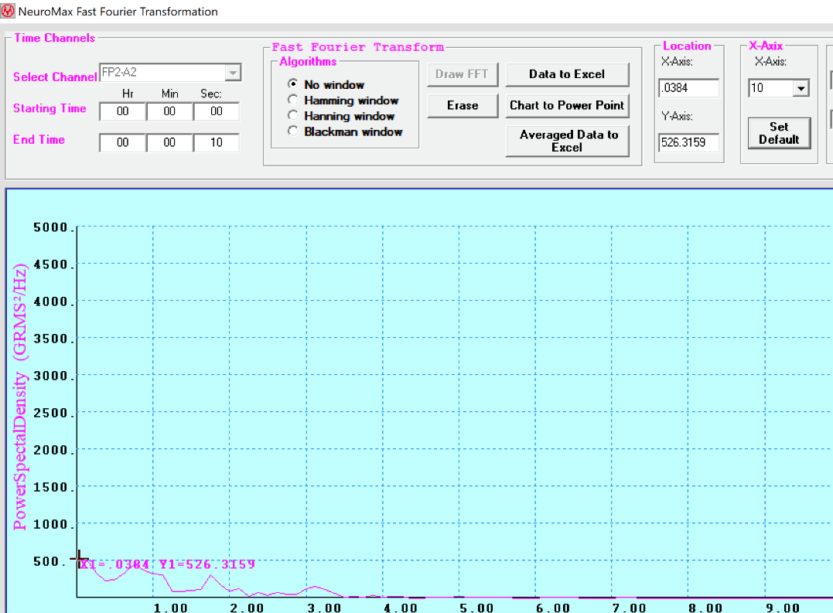

Divide the highest spectral amplitude values from own FFT graphs by 190, to get highest value as 526 (100000//526 = 190)

Divide all the spectral amplitude values across channels by 190 to calibrate the data.

1. Windowing is used in FIR filter design to convert discontinuities in frequency into transition bands between values on either side of the discontinuity. This is done through a process called tapering i.e. choosing an interval such that a finite non-zero value is returned inside it and a zero value is returned outside it.

Windows used in this experiment are:

1. Hanning window (cosine taper)
2. Hamming window (modified cosine taper)
3. Blackman window (modified cosine taper using 2 cosines)

The first side lobe of the Hamming window is lower than the first side lobe of the Hanning window (thus Hamming window is better), but the “distant” side lobes of the Hanning windows are lower than those of Hamming window (thus Hanning is better in that regard).  The Blackman window has a wider main lobe width (undesirable) as compared to the other 2 windows, but it also has more side lobe attenuation (desirable).

**Observations:**

**Unfiltered Data:**

Frequency plot without windowing

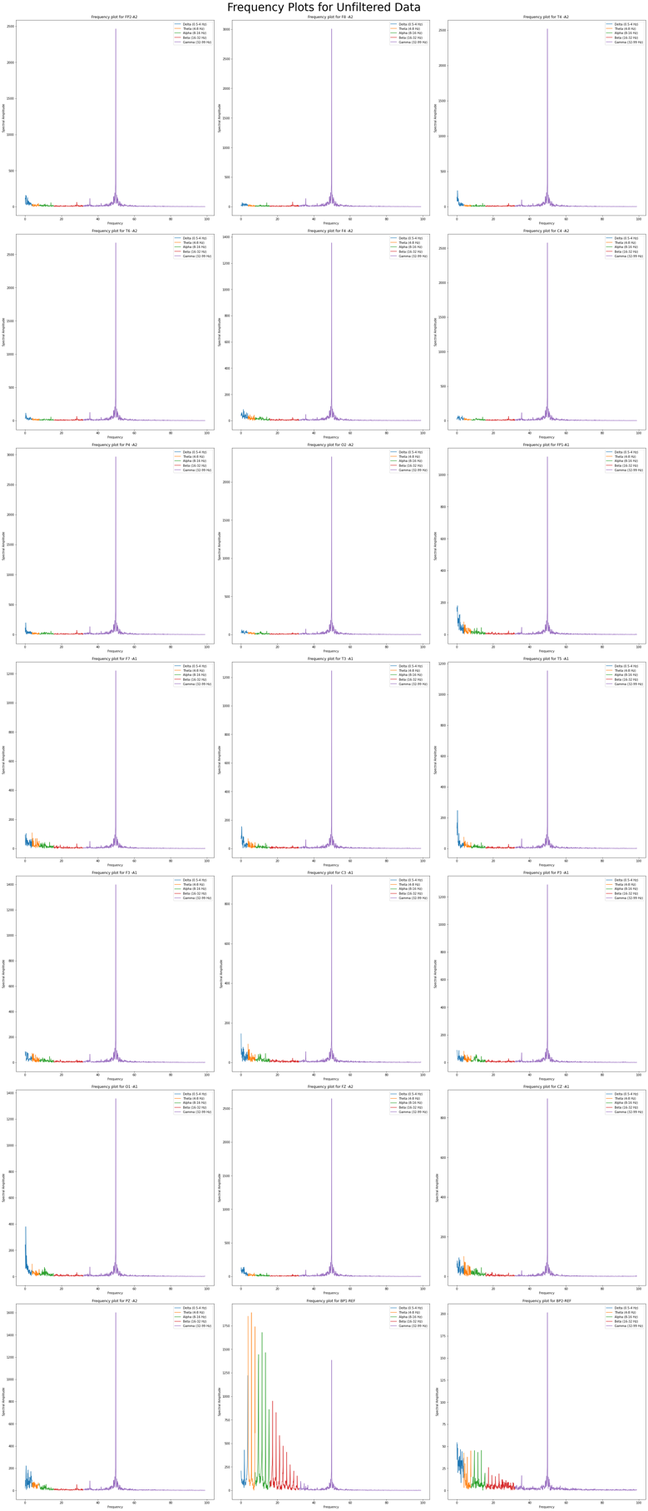

Frequency plot after applying Hamming window

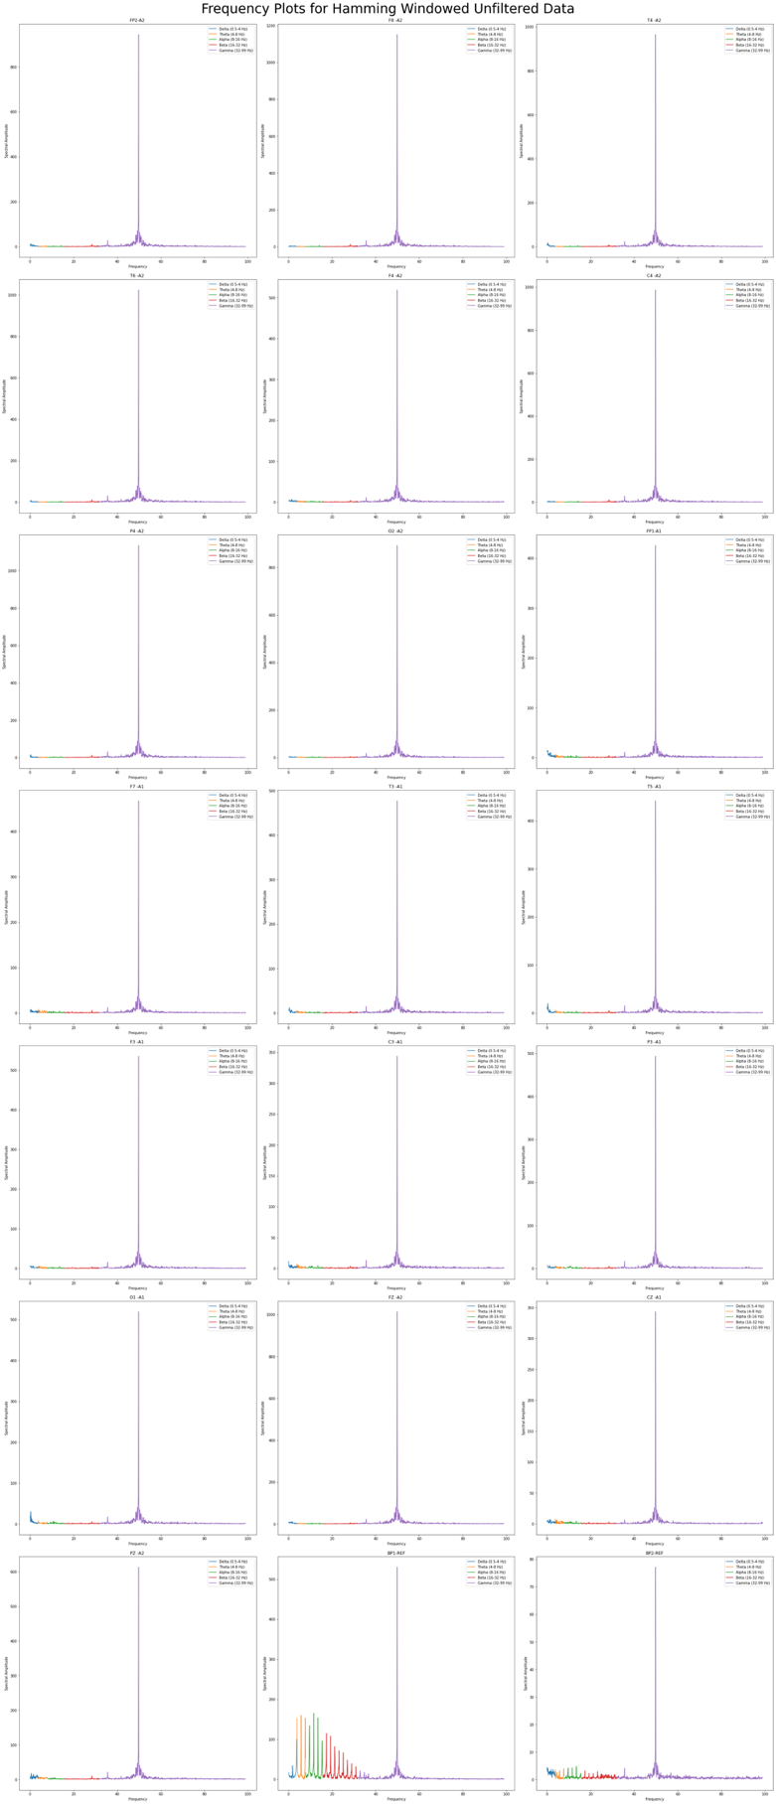

Frequency plot applying Hanning window

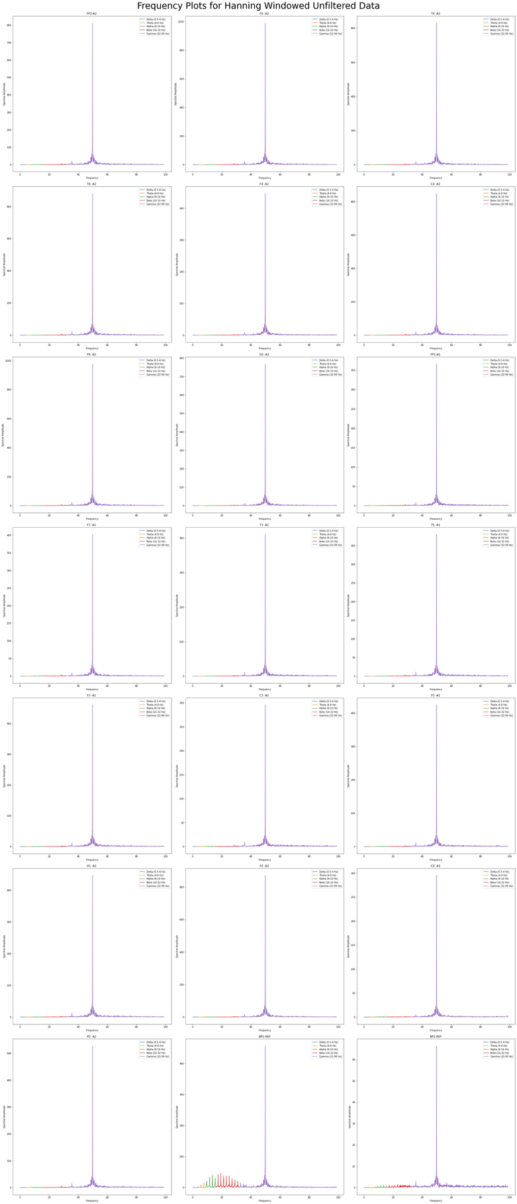

Frequency plot after applying Blackman window

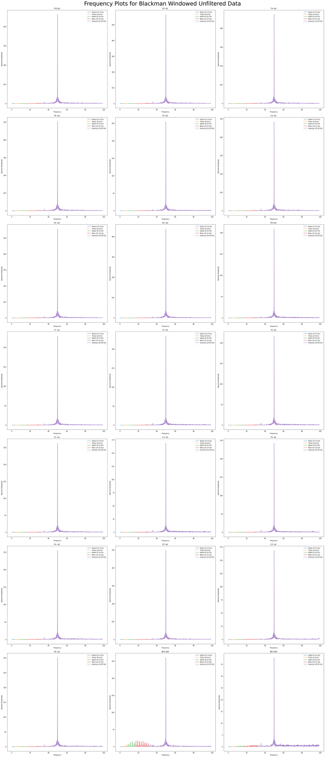

**Filtered Data**

Frequency plot without windowing

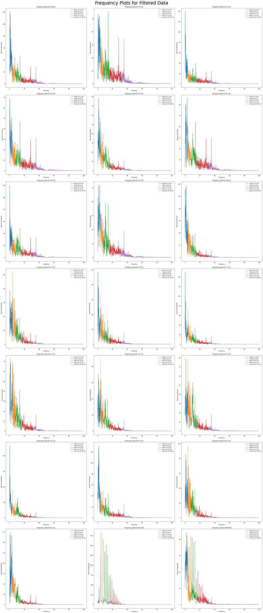

Frequency plot after applying Hamming window

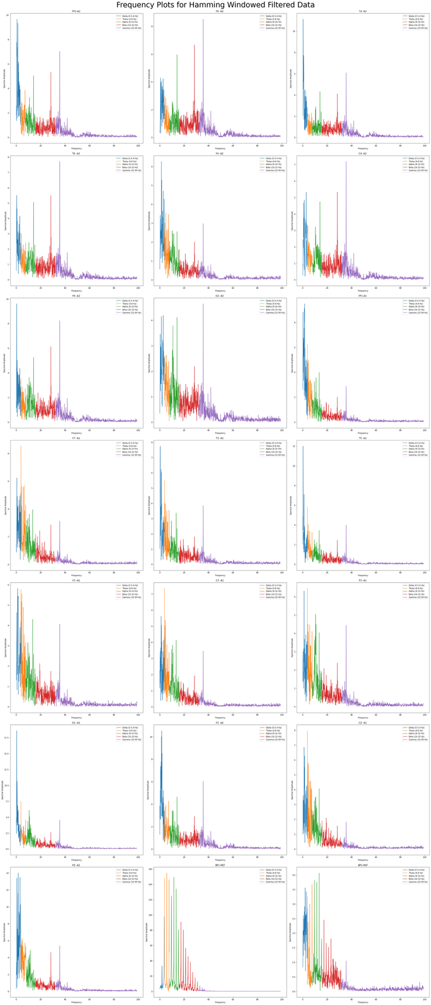

Frequency plot applying Hanning window

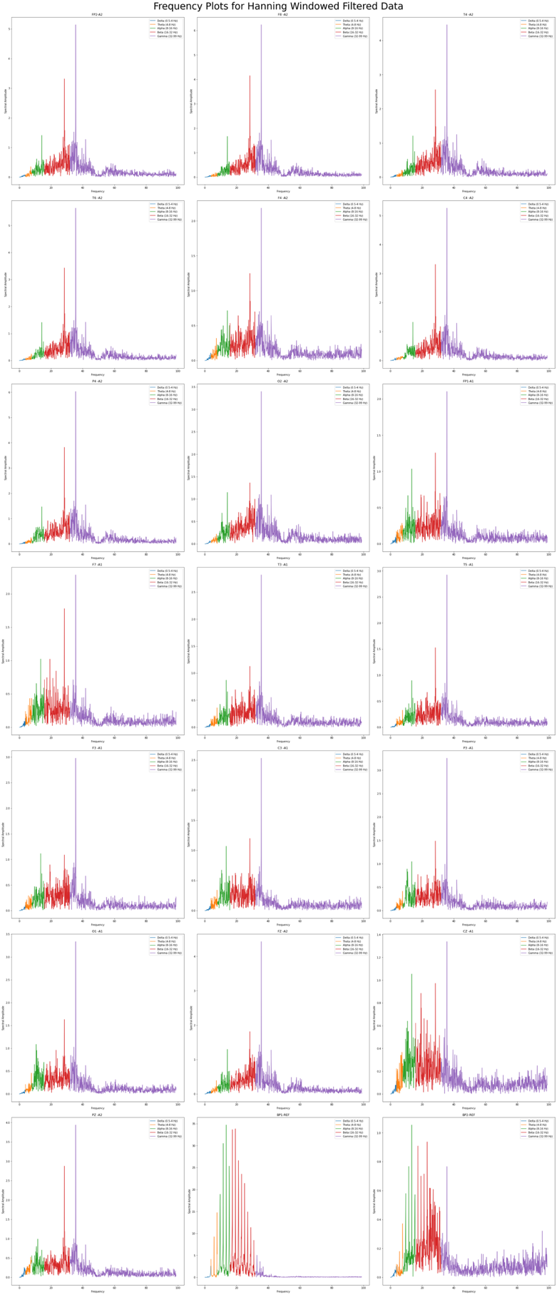

Frequency plot after applying Blackman window

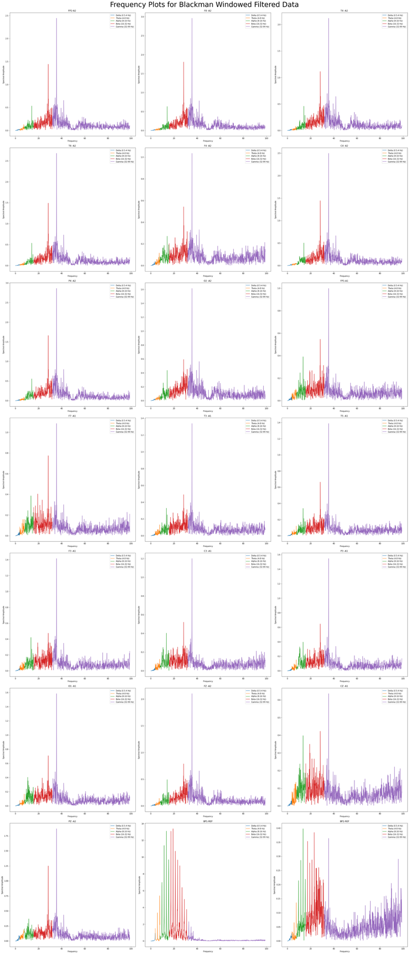

**Conclusion:**

In this experiment, we first calibrated the raw data, then applied fast Fourier transform to view the data in frequency domain. After viewing spectral leakage, we applied hamming, hanning and blackman windows to the data to avoid the leakage.