**SVKM’s NMIMS**

**Mukesh Patel School of Technology Management & Engineering**

**Computer Engineering Department**

**Program: MBA Tech EXTC**

**Course: MBA. Tech (EXTC)**

**Faculty: Dr Avinash Tandle**

|  |  |
| --- | --- |
| *Roll No.*  J047 | *Name:* Roshan Srivastava |
| *Program :* MBA Tech. EXTC | *Division:* |
| *Batch:* | *Date of Experiment:* 27/01/2022 |
| *Date of Submission:* 27/01/2022 | *Grade :* |

AIM: -EOG artefact removal from artefacted EEG Signals using EOG subtraction

Instructions and Objective:

1. Download the excel files EOG and contaminated from file section of team.
2. Convert in them into csv and import in google coalb
3. Remove NaN values if any from the data
4. Plot the same and observe the EOG artefacts
5. Remove the EOG artefact by subtracting the EOG artefacts as shown in fig.
6. Measure the amplitude and frequency of EOG artefact

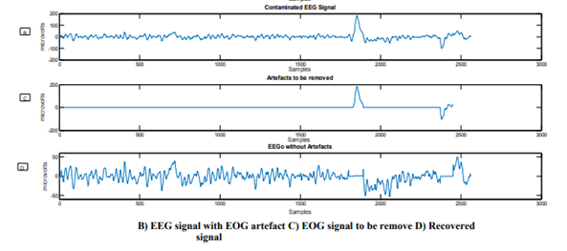

**Observations:**

Original Data:

Representation using Sample: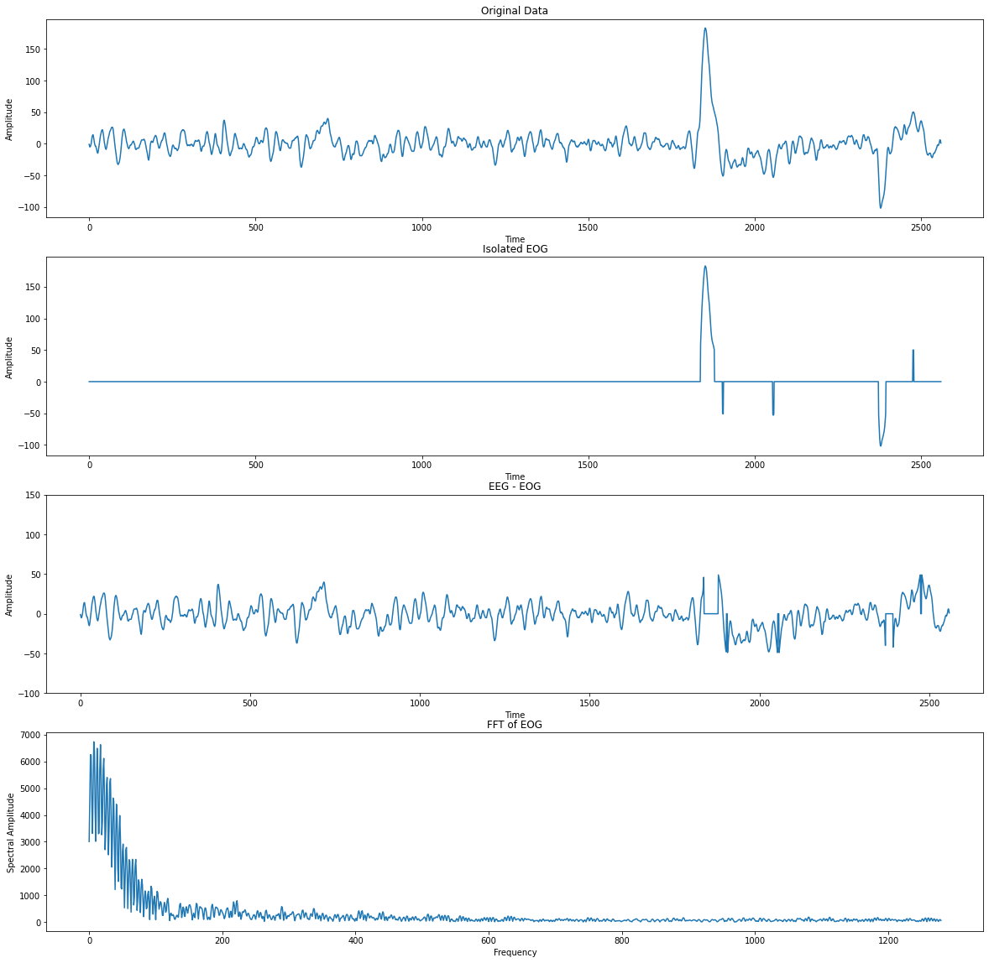

Total Data Representation with DBSCAN outlier detection:

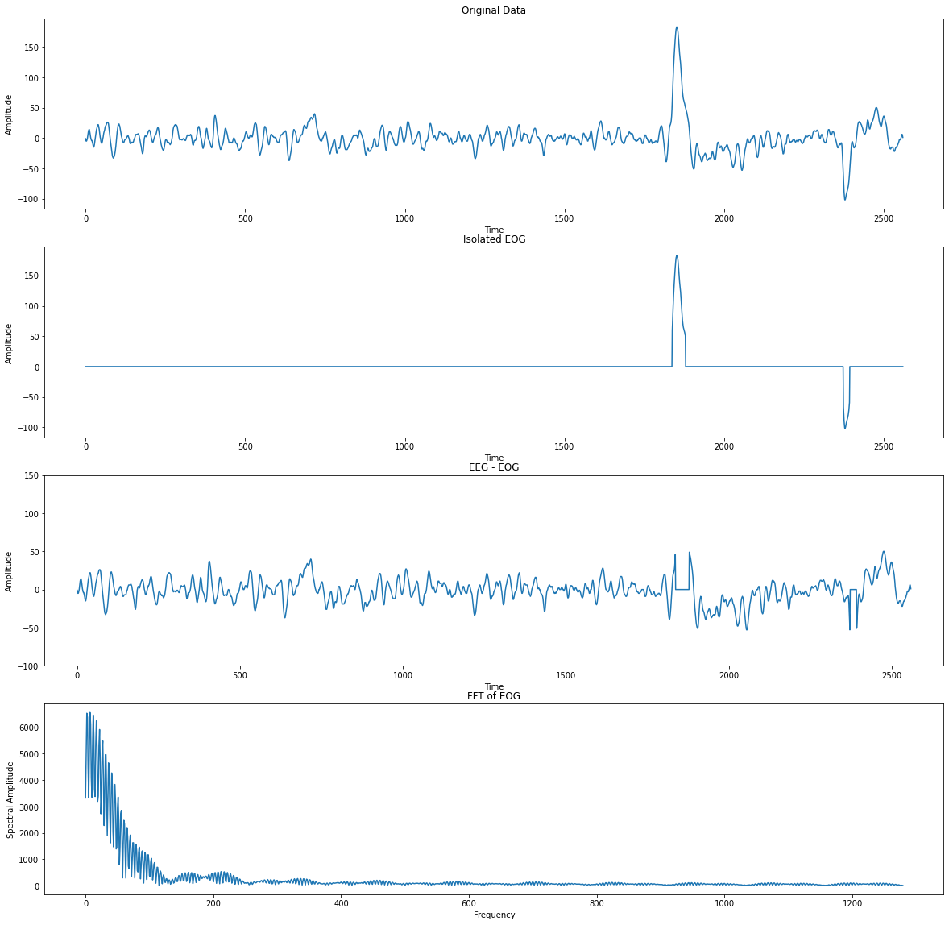

Spectral Amplitude Range

Frequency Range: 0Hz – 25Hz

**Conclusion:** In this experiment, we obtained contaminated EEG data, used samples to separate EOG from those signals, and plot the EEG without EOG anomalies. We also used DBSCAN for outlier detection to get better anomaly detection than the previous method. As can be seen in the second figure, only the peaks due to eye movement and eye blinking are detected.