**SVKM’s NMIMS**

**Mukesh Patel School of Technology Management & Engineering**

**Computer Engineering Department**

**Program: MBA Tech EXTC**

**Course: MBA. Tech (EXTC)**

**Faculty: Dr Avinash Tandle**

|  |  |
| --- | --- |
| *Roll No.* J047 | *Name:* Roshan Srivastava |
| *Program:* MBA Tech. EXTC | *Division:* C |
| *Batch:* | *Date of Experiment:* |
| *Date of Submission:* | *Grade:* |

AIM: -To implement descriptive models of stimulus cognition using statistical tests and supervise machine learning algorithms

Instructions and Objective:

1. Download FTheta and OTheta from file section team
2. Curate the data if required
3. Perform various statistical analysis to create region descriptive and asymmetry descriptive model (for both dataset)
4. Perform t-test and one-way ANOVA (analysis of variance)

**Definition of Hypothesis**

1. **Hypotheses for paired t-test**

|  |  |  |
| --- | --- | --- |
| H00: μbefore = μduring | H01:μbefore = μafter | H02: μduring = μafter |
| H10: μbefore =/= μduring | H11:μbefore =/= μafter | H12: μduring =/= μafter |

Assume the threshold value for **p to be 0.05**:

If the obtained p value obtained > threshold value, then we cannot reject the null hypothesis in favour of the alternative hypothesis; and if the obtained p value obtained < threshold value, then we can reject the null hypothesis in favour of the alternative hypothesis.

1. **Hypotheses for ANOVA**

H0: μbefore = μduring = μafter

H1: Means are not all equal

**Observations (Highlighted to show acceptance of alternate hypothesis)**

# T – Test Values

|  |  |  |  |
| --- | --- | --- | --- |
| **Data \ States** | **Before – During** | **During – After** | **Before – After** |
| **Left Brain; OTheta; Appreciator** | Statistic: -3.3415  p-value: 0.002 | Statistic: 3.423  p-value: 0.002 | Statistic: -0.489  p-value: 0.628 |
| **Right Brain; OTheta; Appreciator** | Statistic: 0.612  p-value: 0.546 | Statistic: -.0231  p-value: 0.819 | Statistic: -1.084  p-value: 0.304 |
| **Left Brain; OTheta; Non - Appreciator** | Statistic: -1.817  p-value: 0.0099 | Statistic: 1.907  p-value: 0.086 | Statistic: -1.084  p-value: 0.304 |
| **Right Brain; OTheta; Non - Appreciator** | Statistic: 1.907  p-value: 0.086 | Statistic: -1.614  p-value: 0.138 | Statistic: -1.006  p-value: 0.338 |
| **Left Brain; FTheta; Appreciator** | Statistic: -1.788  p-value: 0.085 | Statistic: 1.258  p-value: 0.219 | Statistic: -0.558  p-value: 0.581 |
| **Right Brain; FTheta; Appreciator** | Statistic: 2.264  p-value: 0.032 | Statistic: -1.387  p-value: 0.176 | Statistic: 0.644  p-value: 0.525 |
| **Left Brain; FTheta; Non-Appreciator** | Statistic: -0.918  p-value: 0.378 | Statistic: -1.071  p-value: 0.307 | Statistic: -0.988  p-value: 0.344 |
| **Right Brain; FTheta; Non-Appreciator** | Statistic: -0.414  p-value: 0.687 | Statistic: -0.246  p-value: 0.810 | Statistic: -0.866  p-value: 0.405 |

# ANOVA

|  |  |
| --- | --- |
| **Data** | **ANOVA** |
| Left Brain; OTheta; Appreciator | Statistic: 2.1  p-value: 0.129 |
| Right Brain; OTheta; Appreciator | Statistic: 0.247  p-value: 0.782 |
| Left Brain; OTheta; Non - Appreciator | Statistic: 1.960  p-value: 0.159 |
| Right Brain; OTheta; Non - Appreciator | Statistic: 0.521  p-value: 0.599 |
| Left Brain; FTheta; Appreciator | Statistic: 1.222  p-value: 0.3 |
| Right Brain; FTheta; Appreciator | Statistic: 0.944  p-value: 0.393 |
| Left Brain; FTheta; Non-Appreciator | Statistic: 0.260  p-value: 0.772 |
| Right Brain; FTheta; Non-Appreciator | Statistic: 0.162  p-value: 0.851 |

# Kruskal

# Mann Whitney

# Wilcoxon

# MEANS

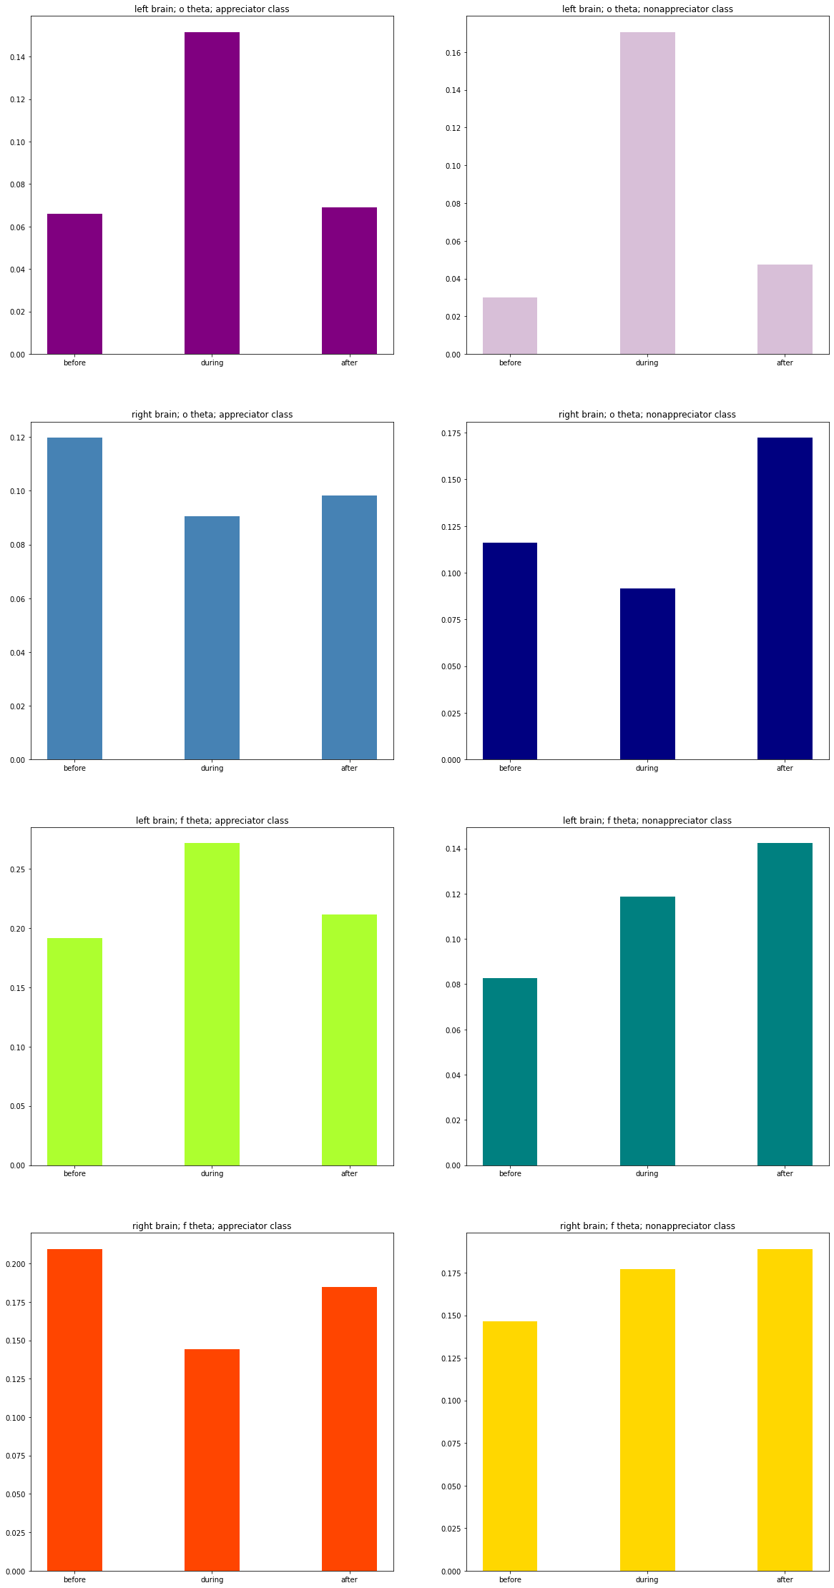

**Conclusion:** In this experiment, we learned how to extract Frontal Theta and Occipital Theta values. We obtained these values for instances before, during and after a subject has listened to music. Once this data is extracted and necessary calculations are done, we apply paired T test on different states (before, during, after) whose results are tabulated above, then performed ANOVA test for both Theta values, both sides of the brains given that the subject was an appreciator or not. Finally, we calculated means for each case and plotted them as above.

Threshold Value: p = 0.05

**Symmetric T-tests**

**Frontal lobe** – Because the input was music, most hypotheses were accepted with respect to this lobe.

1. Right hemisphere (A)
2. for before-during pair, null hypothesis can be accepted
3. for before-after and after-during pair, null hypothesis can be rejected
4. Right hemisphere (NA)
5. for before-during, before-after and after-during pair, null hypothesis can be rejected
6. Left hemisphere (A)
7. for before-during pair, null hypothesis can be accepted
8. for before-after and after-during pair, null hypothesis can be rejected
9. Left hemisphere (NA)
10. for before-during, before-after and after-during pair, null hypothesis can be rejected

**Occipital lobe** – because this lobe is related to visual stimulus, most hypotheses are rejected because the input in this experiment was music

1. Right hemisphere (A)
2. for before-during, before-after and after-during pair, null hypothesis can be rejected
3. Right hemisphere (NA)
4. for before-during, before-after and after-during pair, null hypothesis can be rejected
5. Left hemisphere (A)
6. for before-during pair, null hypothesis can be accepted
7. for before-after pair and after-during, null hypothesis can be rejected
8. Left hemisphere (NA)
9. for before-during, before-after and after-during pair, null hypothesis can be rejected

**Asymmetric T-tests**

**Frontal Lobe**

For appreciators, null hypothesis is rejected for During-During pair as it has significant p-value. All other null hypotheses are accepted.

**Occipital Lobe**

For non-appreciators, null hypothesis is rejected for Before-Before and After-After pairs as they have significant p-values. For appreciators, null hypothesis is accepted for all 3 pairs.

**ANOVA tests: p = 0.05**

All null hypotheses are rejected as the obtained p values are all greater than threshold p value.