**SVKM’s NMIMS**

**Mukesh Patel School of Technology Management & Engineering**

**Computer Engineering Department**

**Program: B. Tech/MBA Tech EXTC**

**Course: B. Tech/MBA. Tech (EXTC)**

**Faculty: Dr Avinash Tandle**

|  |  |
| --- | --- |
| *Roll No.* J047 | *Name:* Roshan Srivastava |
| *Program:* MBA Tech. EXTC | *Division:* |
| *Batch:* | *Date of Experiment:* 17/2/2022 |
| *Date of Submission:* 17/2/2022 | *Grade:* |

AIM: -To implement descriptive models of stimulus cognition using supervised knn algorithm

Instructions and Objective:

1. Download FTheta and OTheta from file section team
2. Curate the data if required
3. Draw the scatter (x axis right brain and y axis left brain only for the during stimulus features) plot using different colours for labels showing asymmetry pattern
4. Apply Knn classifier algorithm (80% training and 20% testing)
5. Use evaluation attributes precision recall f1-score

You can can :

from sklearn.neighbors import KNeighborsClassifier

from sklearn.model_selection import train_test_split

import matplotlib.pyplot as plt

import pandas as pd

Observations:

Red: Appreciator

Green: Non-Appreciator

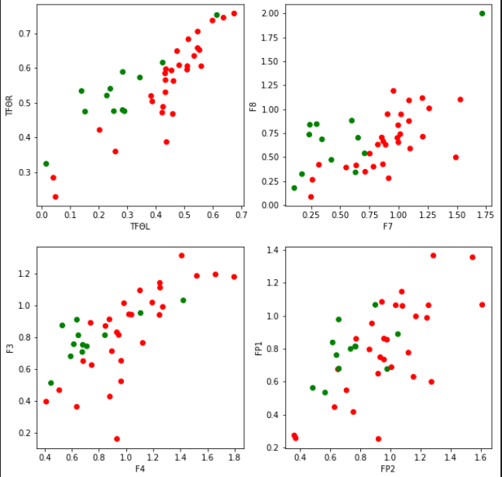

|  |  |  |  |
| --- | --- | --- | --- |
| **Model Features** | **Precision** | **Recall** | **Accuracy** |
| TFΘR, TFΘL | 0.833 | 1.0 | 84.615% |
| F3-A1, F4-A2 | 1.0 | 1.0 | 100% |
| F7-A1, F8-A2 | 1.0 | 1.0 | 100% |
| FP1-A1, FP2-A2 | 0.846 | 1.0 | 84.615% |
| O1-A1, O2-A2 | 0.8334 | 1.0 | 83.33% |

**Conclusion:**

In this experiment, we used kNN to predict, given some features whether the subject is appreciator or non-appreciator. While the prediction worked well for Frontal Theta values, as they are the ones that are affected on music stimuli, Occipital Theta accuracy values are low because there are not many changes in these values while listening to music.