**SVKM’s NMIMS**

**Mukesh Patel School of Technology Management & Engineering**

**Computer Engineering Department**

**Program: MBA Tech EXTC**

**Course: MBA. Tech (EXTC)**

**Faculty: Dr Avinash Tandle**

|  |  |
| --- | --- |
| Roll No.J047 | Name: Roshan Srivastava |
| Program: MBATech EXTC | Division: |
| Batch: | Date of Experiment: 4/3/2022 |
| Date of Submission: 10/3/2022 | Grade: |

**Aim:** To implement descriptive models of stimulus cognition using supervised KNN algorithm

**Instructions and Objective:**

1. Download FTheta and OTheta from file section team
2. Curate the data if required
3. Draw the scatter (x-axis right brain and y-axis left brain only for the during stimulus features) plot using different colours for labels showing asymmetry pattern
4. Apply SVM classifier algorithm with radial and linear kernels (80:20 train-test split)
5. Use evaluation attributes (precision, recall and f1-score)

**Theory:**

In this experiment we use a Support Vector Machine (SVM) to predict which data points in the EEG dataset (collected in the ‘during’ phase, from left and right, frontal and occipital lobes) belong to appreciators or non-appreciators of the stimulus (in this case, musical stimulus).

The SVM algorithm creates a line or a hyperplane which separates the data into classes; this is done by finding the points closest to the line from both the classes i.e. support vectors. Next, the distance between the line and the support vectors i.e. the margin is calculated. The line for which the margin is maximum is the optimal hyperplane. Thus SVM tries to make a decision boundary in such a way that the separation between the two classes is as wide as possible.

Features used for training of the SVM include asymmetric data from left and right lobes for:

* Combined right and left FTheta
* FP1-A1 and FP2-A2
* F7-A1 and F8-A2
* F3-A1 and F4-A2
* Combined right and left OTheta

Target variable remains common for all models as the appreciator/non-appreciator rating.

**Observations:**

SCATTERPLOTS FOR ENTIRE DATASET

FTheta

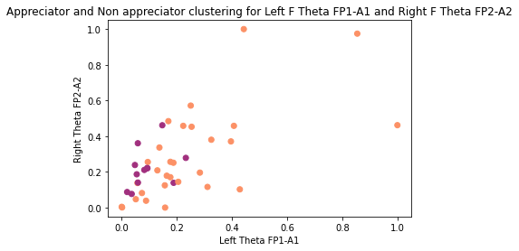

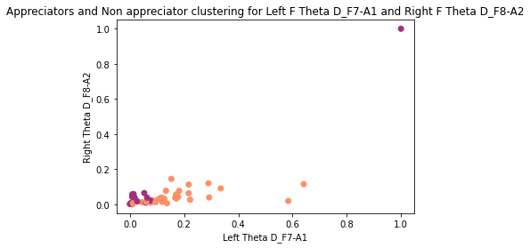

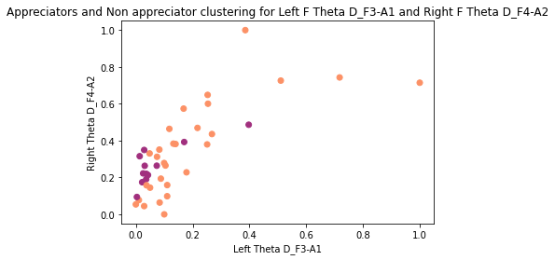

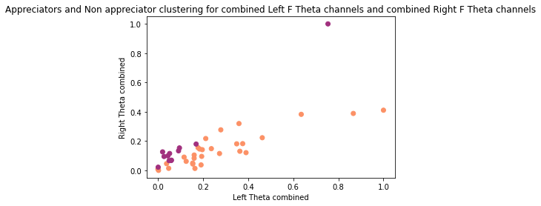

OTheta

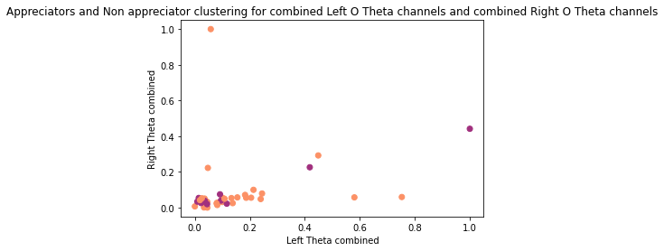

SVM RESULTS

Choosing linear kernel

FTheta

|  |  |  |
| --- | --- | --- |
| **Channels** | **Classification Report** | **Confusion Matrix** |
| Combined |  | /var/folders/7d/s04s9ccn4r1c5p6xb5cnzyjc0000gn/T/com.microsoft.Word/Content.MSO/395A5658.tmp |
| FP1-A1 and FP2-A2 |  | /var/folders/7d/s04s9ccn4r1c5p6xb5cnzyjc0000gn/T/com.microsoft.Word/Content.MSO/C75D73EF.tmp |
| F7-A1 and F8-A2 |  | /var/folders/7d/s04s9ccn4r1c5p6xb5cnzyjc0000gn/T/com.microsoft.Word/Content.MSO/376492D2.tmp |
| F3-A1 and F4-A2 |  | /var/folders/7d/s04s9ccn4r1c5p6xb5cnzyjc0000gn/T/com.microsoft.Word/Content.MSO/AE796AF1.tmp |

OTheta

|  |  |  |
| --- | --- | --- |
| **Channels** | **Classification Report** | **Confusion Matrix** |
| Combined - OTheta |  | /var/folders/7d/s04s9ccn4r1c5p6xb5cnzyjc0000gn/T/com.microsoft.Word/Content.MSO/9FE36AFC.tmp |

Choosing radial kernel

FTheta

|  |  |  |
| --- | --- | --- |
| **Channels** | **Classification Report** | **Confusion Matrix** |
| Combined |  | /var/folders/7d/s04s9ccn4r1c5p6xb5cnzyjc0000gn/T/com.microsoft.Word/Content.MSO/CEB8DF63.tmp |
| FP1-A1 and FP2-A2 |  | /var/folders/7d/s04s9ccn4r1c5p6xb5cnzyjc0000gn/T/com.microsoft.Word/Content.MSO/1E0A556.tmp |
| F7-A1 and F8-A2 |  | /var/folders/7d/s04s9ccn4r1c5p6xb5cnzyjc0000gn/T/com.microsoft.Word/Content.MSO/E50D59C5.tmp |
| F3-A1 and F4-A2 |  | /var/folders/7d/s04s9ccn4r1c5p6xb5cnzyjc0000gn/T/com.microsoft.Word/Content.MSO/31C5B460.tmp |

OTheta

|  |  |  |
| --- | --- | --- |
| **Channels** | **Classification Report** | **Confusion Matrix** |
| Combined - OTheta |  | /var/folders/7d/s04s9ccn4r1c5p6xb5cnzyjc0000gn/T/com.microsoft.Word/Content.MSO/D7CF7E97.tmp |

**Conclusion:**

We reached the following conclusions based:

SCATTERPLOTS

All the scatterplots show a greater number of appreciators (majority class) as compared to non-appreciators (minority class).

FTheta

Scatterplot for FP1-A1 & FP2-A2 shows non-appreciator outlier

Scatterplot for F7-A1 and F8-A2 / F3-A1 and F4-A2 show appreciator outliers

Scatterplot for combined channels shows one appreciator and non-appreciator outl ier

OTheta

Scatterplot shows one appreciator and non-appreciator outlier each

SVM RESULTS

FTheta

Linear kernel:

* + Highest accuracy was obtained for the combined left and right FTheta channels
  + F1 scores for classification the appreciator class were higher than that for the non-appreciator class; this is the result of class imbalance which led to better recall of the majority class (appreciators)

Radial kernel:

* + Highest accuracy was obtained for the combined left and right FTheta channels
  + F1 scores for minority classes in individual left-right channel pairs were very low (0 or 0.25)

OTheta

Linear kernel:

* + The minority class (non-appreciators) had recall value = 0; the moderately high accuracy was a largely result of accurate appreciator classification rather than a balance between appreciator/non-appreciator classification

Radial kernel:

* + The minority class (non-appreciators) had recall value = 0