Commodity: Petroleum and Crude oil

ANALYSIS: INCREASE AND DECREASES IN THE EXPORT QUANTITY

|  |  |  |
| --- | --- | --- |
| Country exporting to India | Quantity 2011-12 | Quantity 2012-13 |
| SAUDI ARAB | 33571839 | 36436183 |
| IRAQ | 23778037 | 25374113 |
| KUWAIT | 19599691 | 20306796 |
| QATAR | 18080814 | 20705230 |
| U ARAB EMTS | 17168628 | 18060219 |
| NIGERIA | 16743270 | 16123252 |
| IRAN | 14796228 | 13334090 |
| VENEZUELA | 9466282 | 20768994 |
| ANGOLA | 7976415 | 10091752 |
| BRAZIL | 3801674 | 3748884 |
| EGYPT A RP | 3561201 | 2995975 |
| MALAYSIA | 2593848 | 2847311 |
| OMAN | 2589749 | 618308 |
| SINGAPORE | 2386472 | 844939 |
| ALGERIA | 2373567 | 809627 |
| MEXICO | 2364568 | 4628256 |
| U S A | 1462048 | 2866229 |
| CHINA P RP | 1407016 | 1103558 |
| YEMEN REPUBLC | 1232233 | 1086881 |
| AZERBAIJAN | 1008478 | 2159348 |

ANALYSIS: TOP 10 LEADING PETROLEUM EXPORTER FOR INDIA IN 2011-12

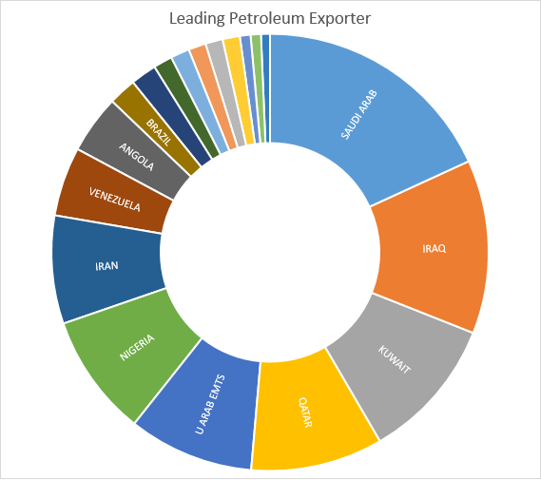

|  |  |
| --- | --- |
| Country exporting to India | Quantity 2011-12 |
| SAUDI ARAB | 33571839 |
| IRAQ | 23778037 |
| KUWAIT | 19599691 |
| QATAR | 18080814 |
| U ARAB EMTS | 17168628 |
| NIGERIA | 16743270 |
| IRAN | 14796228 |
| VENEZUELA | 9466282 |
| ANGOLA | 7976415 |

**ANALYSIS: Price Comparison Between 2011 and 2012**

|  |  |  |
| --- | --- | --- |
| Country exporting to India | Price 2011-12/TON | Price 2012-13/TON |
| ALBANIA | ₹ 0.000024 | ₹ 0.000030 |
| ALGERIA | ₹ 0.000023 | ₹ 0.000022 |
| ANGOLA | ₹ 0.000025 | ₹ 0.000023 |
| AUSTRALIA | ₹ 0.000026 | ₹ 0.000023 |
| AZERBAIJAN | ₹ 0.000025 | ₹ 0.000024 |
| BAHARAIN IS | ₹ 0.000022 | ₹ 0.000021 |
| BANGLADESH PR | ₹ 0.000023 | ₹ 0.000018 |
| BRAZIL | ₹ 0.000028 | ₹ 0.000026 |
| BRUNEI | ₹ 0.000025 | ₹ 0.000021 |
| CAMEROON | ₹ 0.000025 | ₹ 0.000024 |
| TAIWAN | ₹ 0.000023 | ₹ 0.000020 |
| CHINA P RP | ₹ 0.000035 | ₹ 0.000030 |
| COLOMBIA | ₹ 0.000032 | ₹ 0.000027 |
| CONGO P REP | ₹ 0.000030 | ₹ 0.000025 |
| EGYPT A RP | ₹ 0.000029 | ₹ 0.000026 |
| EQUTL GUINEA | ₹ 0.000022 | ₹ 0.000023 |
| FRANCE | ₹ 0.000014 | ₹ 0.000021 |
| GABON | ₹ 0.000022 | ₹ 0.000025 |
| GERMANY | ₹ 0.000015 | ₹ 0.000010 |
| GUINEA | ₹ 0.000021 | ₹ 0.000025 |
| INDONESIA | ₹ 0.000051 | ₹ 0.000036 |
| IRAN | ₹ 0.000027 | ₹ 0.000025 |
| IRAQ | ₹ 0.000026 | ₹ 0.000023 |
| JAPAN | ₹ 0.000024 | ₹ 0.000012 |
| KOREA RP | ₹ 0.000018 | ₹ 0.000016 |
| KUWAIT | ₹ 0.000026 | ₹ 0.000024 |
| LIBYA | ₹ 0.000023 | ₹ 0.000022 |
| MALAYSIA | ₹ 0.000024 | ₹ 0.000021 |
| MEXICO | ₹ 0.000029 | ₹ 0.000026 |
| NETHERLAND | ₹ 0.000026 | ₹ 0.000023 |
| NIGERIA | ₹ 0.000024 | ₹ 0.000022 |
| OMAN | ₹ 0.000027 | ₹ 0.000023 |
| PAKISTAN IR | ₹ 0.000023 | ₹ 0.000019 |
| PANAMA REPUBLIC | ₹ 0.000037 | ₹ 0.000025 |
| QATAR | ₹ 0.000032 | ₹ 0.000026 |
| SAUDI ARAB | ₹ 0.000025 | ₹ 0.000023 |
| SINGAPORE | ₹ 0.000023 | ₹ 0.000018 |
| SOUTH AFRICA | ₹ 0.000019 | ₹ 0.000015 |
| SPAIN | ₹ 0.000086 | ₹ 0.000028 |
| SUDAN | ₹ 0.000030 | ₹ 0.000022 |
| SYRIA | ₹ 0.000023 | ₹ 0.000024 |
| THAILAND | ₹ 0.000027 | ₹ 0.000021 |
| U ARAB EMTS | ₹ 0.000025 | ₹ 0.000022 |
| U K | ₹ 0.000026 | ₹ 0.000032 |
| U S A | ₹ 0.000037 | ₹ 0.000054 |
| VENEZUELA | ₹ 0.000030 | ₹ 0.000027 |
| YEMEN REPUBLC | ₹ 0.000026 | ₹ 0.000023 |

Average Price

* **Year 2011-2012**  **₹ 0.000027/ton**
* **Year 2012-2013 ₹ 0.000024/ton**

Analysis: Percentage Increase and Decrease in the export country wise

|  |  |
| --- | --- |
| Country exporting to India | %increase or Decrease in Export |
| SAUDI ARAB | 4% |
| IRAQ | 3% |
| KUWAIT | 2% |
| QATAR | 7% |
| U ARAB EMTS | 3% |
| NIGERIA | -2% |
| IRAN | -5% |
| VENEZUELA | 37% |
| ANGOLA | 12% |
| BRAZIL | -1% |
| EGYPT A RP | -9% |
| MALAYSIA | 5% |
| OMAN | -61% |
| SINGAPORE | -48% |
| ALGERIA | -49% |
| MEXICO | 32% |
| U S A | 32% |
| CHINA P RP | -12% |
| YEMEN REPUBLC | -6% |
| AZERBAIJAN | 36% |
| BRUNEI | 14% |
| KOREA RP | -11% |
| COLOMBIA | 61% |
| AUSTRALIA | -37% |
| BAHARAIN IS | -19% |
| CAMEROON | -5% |
| SUDAN | -72% |
| TAIWAN | -8% |
| CONGO P REP | 27% |
| INDONESIA | -7% |
| JAPAN | -78% |
| NETHERLAND | 57% |
| EQUTL GUINEA | 47% |
| PANAMA REPUBLIC | -55% |
| SYRIA | -34% |
| UNSPECIFIED | -72% |
| GUINEA | 64% |
| U K | -14% |
| SPAIN | 11% |
| ALBANIA | -47% |
| GABON | 83% |
| THAILAND | -16% |
| LIBYA | 96% |
| PAKISTAN IR | 10% |
| GERMANY | -20% |
| SOUTH AFRICA | -13% |
| FRANCE | 59% |
| BANGLADESH PR | 35% |

Note: + : increase in export and - :decrease in sale