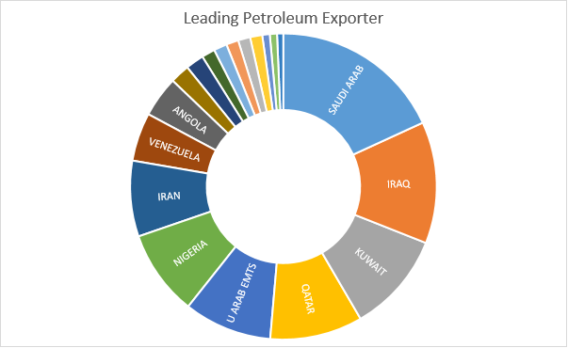

|  |  |
| --- | --- |
| Country_exporting_to_India | Quantity_2011_12 |
| SAUDI ARAB | 33571839 |
| IRAQ | 23778037 |
| KUWAIT | 19599691 |
| QATAR | 18080814 |
| U ARAB EMTS | 17168628 |
| NIGERIA | 16743270 |
| IRAN | 14796228 |
| VENEZUELA | 9466282 |
| ANGOLA | 7976415 |