Домашнее задание

1) create table employees(id int primary key, name text, department text, salary decimal);
После заполнения:

2) Представления:
create view department_salary as (select department, avg(salary) avg_department_salary from employees group by department);
create view top_earners as(select id, name from employees where salary >= 80000.00);
3) Использование представлений:
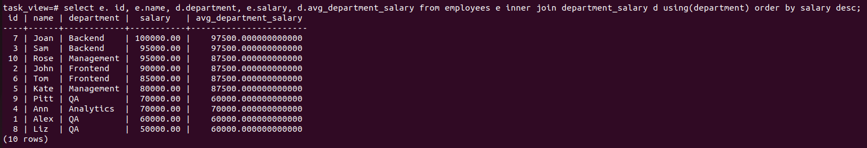
select e. id, e.name, d.department, e.salary, d.avg_department_salary from employees e inner join department_salary d using(department) order by salary desc;

with cte as(select id, name, salary, department, avg_department_salary from employees e join department_salary d using(department)) select t.id, t.name, cte.department, cte.salary, cte.avg_department_salary from cte join top_earners t using(id) where department = 'Backend' and salary = (select max(salary) from employees where department = 'Backend');
select t.id, t.name, e.department from top_earners t join employees e using(id) where department in ('Frontend', 'Backend');

4) Модификация и удаление представлений:
create or replace view top_earners as (select id, name, department from employees where salary >= 80000.00);
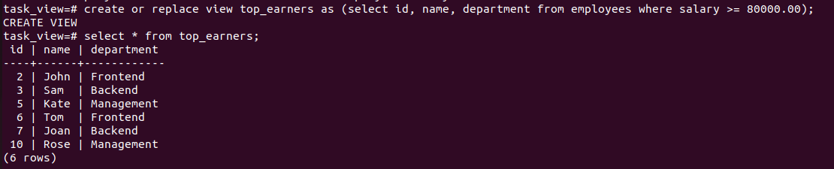
drop view department_salary;
Преимущество использования view в возможности глобального применения в рамках базы данных как отдельной таблицы в отличии от табличного выражения (cte).

