LENOVO | [Course Title] | [Date]

Bank Management System(130)
  - JAVA

Code:
- import java.util.*;

- class BankData {
- Scanner sc = new Scanner(System.in);
- Random rand = new Random();
- private double balance;
- private long accno;

- BankData() {
- System.out.println("enter a bank balance");
- if (sc.nextDouble() < 10000) {
- System.out.println("incuficuent balance for open account");
- System.out.println("enter new balance");
- balance = sc.nextDouble();
- while (balance < 10000) {
- System.out.println("incuficuent balance for open account");
- System.out.println("enter new balance");
- balance = sc.nextDouble();
- }
- } else {
- System.out.println("confirm please type amount again");
- balance = sc.nextDouble();
- }
- accno = rand.nextLong(999999999);
- System.out.println("Account number is ----" + accno);
- System.out.println("User balance is ----" + balance);
- System.out.println("--------------------------------------------------------------------------------");
- }

- void cradit() {
- System.out.println("how much rupee you want to cradit?");
- double cradit = sc.nextDouble();
- balance += cradit;
- System.err.println(
- "Your Account XXX" + accno + " ,blaence is sucessfully cradited " + cradit + " ,Avl Bal =" + balance);
- }

- void debit() {
- System.out.println("how much rupee you want to debit?");
- double debit = sc.nextDouble();
- if (balance - debit <= 10000) {
- System.err.println(
- "You must be mantain 10000 ruppy your account not zero balance if you need zero balance account content me 9979684555");
- } else {
- balance -= debit;
- System.err.println(
- "Your Account XXX" + accno + " ,blaence is sucessfully debited " + debit + " ,Avl Bal =" + balance);
- }
- System.err.println(
- "Your Account XXX" + accno + " ,blaence is sucessfully debited " + "00.00" + " ,Avl Bal =" + balance);
- }

- void avlbal() {
- System.err.println("Your Account XXX" + accno + " ,Avl Bal =" + balance);
- }
- }

- public class Bank {
- static String bank_name = "State Bank of india";
- static String branch_name = "Rayaroad branch";
- static double IFSC = 323656656;

- static {
- System.out.println(bank_name);
- System.out.println(branch_name);
- System.out.println(IFSC);
- }

- static void welcome() {
- Scanner sc = new Scanner(System.in);
- String username = new String("PriyankSolanki555");
- String password = new String("Priyank@123");
- System.out.println("Enter Your user name");
- String enteredusername = sc.next();
- System.out.println("Enter Your user password");
- String enteredpassword = sc.next();
- if (username.equals(enteredusername)&&password.equals(enteredpassword)) {
- System.out.println("Welcome in SBI");
- }else{
- System.out.println("May be Your username or password is incorrect not match try again.");
- }
- System.out.println("--------------------------------------------------------------------------------");
- }

- public static void main(String[] args) {
- welcome();
- BankData cus1 = new BankData();
- Scanner sc = new Scanner(System.in);
- int choice = 20;
- while (choice != 0) {
- System.out.println("Enter a choice");
- System.out.println("1 ---- Cradit");
- System.out.println("2 ---- Debit");
- System.out.println("3 ---- Check balance");
- System.out.println("0 ---- Exit");
- choice = sc.nextInt();
- switch (choice) {
- case 1:
- cus1.cradit();
- break;
- case 2:
- cus1.debit();
- ;
- Break;
- case 3:
- cus1.avlbal();
- ;
- break;
- case 0:
- break;
- }
- }
- }
- }

Output:
1.Required user name and password

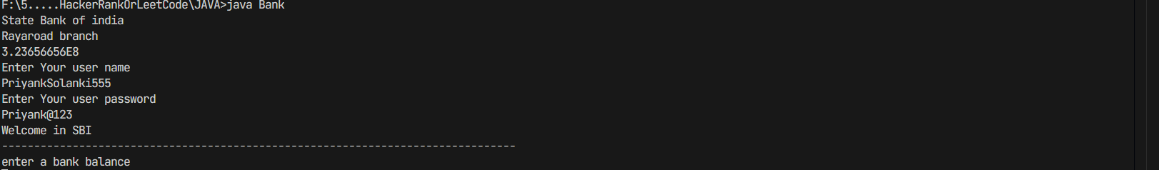

2.Enter initial balance
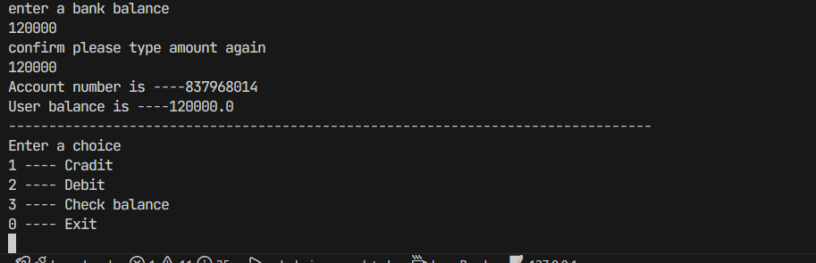

3.perform credit operation
