**Online Classified Advertising Platform(EmoVend*)***.

2020

Prasheesh Negi

Krishnakant Pande

Shubhangam Tripathi

.

**INDEX**

|  |  |  |
| --- | --- | --- |
| **Sr. No** | **TITLE** | **Page No** |
| 1. | Introduction of Project | 3 |
| 2. | Abstract | 4-6 |
| 3. | Manifesto | 7 |
| 4. | DFD | 8-12 |
| 5. | ER | 13 |
| 6. | Methodologies | 14 |

**Introduction of Project**

**Online classifieds**  are used to provide the user with a bulk of information . This is used to advertise the products with images. One can easily login to get any kind of information. Here the user is also facilitated to directly interact with the consumer.

He can get the desired product with different rates and quality. The main goal is to provide the customer with various goods just by sitting in front of a computer .He can get the goods easily without moving from place to place. Consumers can also have a chance of introducing their products not only in a single place but throughout the world using online classifieds.

It is used to provide the customers with huge amount of information. This is a site to login to get the latest updates of the automobiles, matrimony and real-estate. An easy way to buy a product just sitting in front of your computers by registering into our site.

This is to facilitate all people who are busy with their works and have no time to get their desired goods. We are here to provide you all the best and suitable places for sale. If once you register into our site, then you are benefitted with our latest updates of the sales!

This is used to advertise the products with images. One can easily login to get any kind of information. Here the user is also facilitated to directly interact with the consumer. He can get the desired product with different rates and quality.

**Abstract**

**Objective and scope**

To provide a platform which is helpful for the students to sell, buy & share their used stuff as well as on rental basis too within a campus.

**Existing System**

* We cannot directly interact with the consumer through newspaper as it is possible with online classifieds.
* We don’t even have a clear image of the product

**Proposed System along with intended objectives**

* Create a website dynamic in nature.
* Create a User friendly interface.
* Emphasis on homepage to make it interactive.
* Easy accessible by every person

**Project Objective**

* To Increase number of subscriptions.
* Every time accessibility online.
* Enhancement in the existing business structure

**Vision**  
This software is aimed at making data entry, management, updating, storage and retrieval easier and faster. The following objectives have been kept in mind:

• Practicality: The system is quite stable and can be operated by the people with average intelligence.

• Efficiency: I tried to involve accuracy, timeliness and comprehensiveness of the system output.

• Cost: It is desirable to aim for the system with a minimum cost subject to the condition that it must satisfy the entire requirements.

• Flexibility: I have tried that the system should be modifiable depending on the changing needs of the user. Such modifications should entail extensive reconstructing or recreation of software. It should also be portable to different computer systems.

• Security: This is a very important aspect and I have tried to cover the areas of hardware reliability, fallback procedures, and physical security of data.

**Manifesto**

We are uncovering better ways of developing software by doing it and helping others do it. Through this work, we have come to value −

* Individuals and interactions over Processes and tools
* Working software over Comprehensive documentation
* Customer collaboration over Contract negotiation
* Responding to change over Following a plan

That is, while there is value in the items on the right, we value the items on the left more.

**DATAFLOW DIAGRAM**

**Data Flow Diagram**

Data flow diagram is graphical tool used to describe and analyze the movement of data through system – manual or automated- including the process, stores of data and delays in the system. Data flow diagrams are the central tool and the basis from which other components are developed. The transformation of data from input to output through process may be described logically and independently of the physical components associated with the system. They are termed **logical data**

## **Theory**

[https://upload.wikimedia.org/wikipedia/commons/thumb/c/c8/DataFlowDiagram_Example.png/360px-DataFlowDiagram_Example.png](https://en.wikipedia.org/wiki/File:DataFlowDiagram_Example.png)

Data flow diagram example

[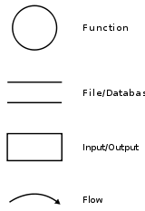](https://en.wikipedia.org/wiki/File:Data-flow-diagram-notation.svg)

Data flow diagram -[Yourdon](https://en.wikipedia.org/wiki/Edward_Yourdon)/[DeMarco](https://en.wikipedia.org/wiki/Tom_DeMarco" \o "Tom DeMarco) notation

This context-level DFD is next "exploded", to produce a Level 1 DFD that shows some of the detail of the system being modeled. The Level 1 DFD shows how the system is divided into sub-systems (processes), each of which deals with one or more of the data flows to or from an external agent, and which together provide all of the functionality of the system as a whole. It also identifies internal data stores that must be present in order for the system to do its job, and shows the flow of data between the various parts of the system.

Data flow diagrams are one of the three essential perspectives of the structured-systems analysis and design method [SSADM](https://en.wikipedia.org/wiki/SSADM). The sponsor of a project and the end users will need to be briefed and consulted throughout all stages of a system's evolution. With a data flow diagram, users are able to visualize how the system will operate, what the system will accomplish, and how the system will be implemented. The old system's dataflow diagrams can be drawn up and compared with the new system's data flow diagrams to draw comparisons to implement a more efficient system. Data flow diagrams can be used to provide the end user with a physical idea of where the data they input ultimately has an effect upon the structure of the whole system from order to dispatch to report. How any system is developed can be determined through a data flow diagram model.

In the course of developing a set of *leveled* data flow diagrams the analyst/designer is forced to address how the system may be decomposed into component sub-systems, and to identify the [transaction data](https://en.wikipedia.org/wiki/Transaction_data) in the[data model](https://en.wikipedia.org/wiki/Data_model).

Data flow diagrams can be used in both Analysis and Design phase of the [SDLC](https://en.wikipedia.org/wiki/Systems_development_life-cycle).

There are different notations to draw data flow diagrams (Yourdon & Coad and [Gane](https://en.wikipedia.org/wiki/Chris_Gane_(computer_scientist)" \o "Chris Gane (computer scientist)) & [Sarson](https://en.wikipedia.org/wiki/Trish_Sarson" \o "Trish Sarson)[[5]](https://en.wikipedia.org/wiki/Data_flow_diagram#cite_note-5)), defining different visual representations for processes, data stores, data flow, and external entities.[[6]](https://en.wikipedia.org/wiki/Data_flow_diagram#cite_note-6)

**Flow Diagrams of Project**

***Authentication***

***User name and password Type***

Home

NO

yes

Search according requirement

**USER DFD**

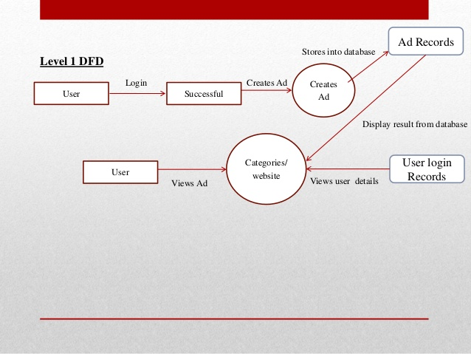

**ADMIN LOGIN DFD**

**ER- DIAGRAM**

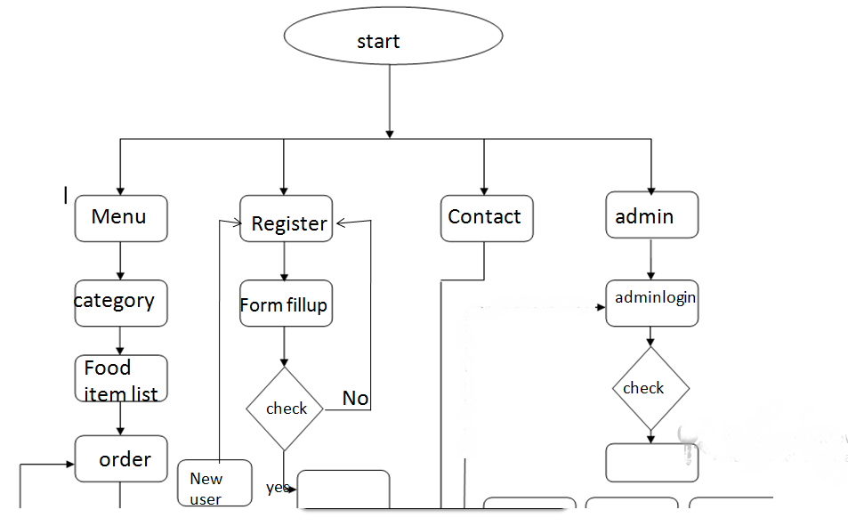

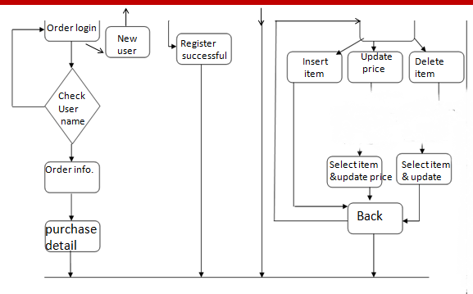

# 

**Methodologies**

Out of all the methodologies Feature Driven Development methodology is the best foot toward our project. This is a model-driven, short-iteration process that was built around software engineering and is the best practices such as domain object modeling, developing by feature, and code ownership. The blending of these practices that resulted in a cohesive whole is the best characteristic of FDD.

Some key features of FDD are:-

* Development of an overall model
* Building a feature list
* Planning by feature
* Designing by feature
* Building by feature

FDD begins by establishing an overall model shape, which will result in a feature list. It then continues with a series of two-week “plan by feature, design by feature, build by feature” iterations. The features are small, “useful in the eyes of the client” results. If they will take more than two weeks to build, then they will have to be broken down into smaller features.

Goal of FDD:-

FDD’s main purpose is to deliver tangible, working software in a timely manner, repeatedly.

Advantages

1. It can be deployed to large group of teams due to the concept of “just enough design initially” (JEDI).
2. It is a great solution to maintain control for incremental and inherently complex agile project management.

Disadvantages

Iterations are not well defined by the process as other agile methodologies