#### NAV in 802.11

## 9.2.5 Duration/ID field (QoS STA)

|  |  |  |
| --- | --- | --- |
| **QD9** | **Duration/ID rules for QoS STA** | **9.2.5** |

时间单位为微秒，0-32767(16bits)

计算时向上取整，如果小于0，则NAV为0

NDP_1M Ack frame

NDP_2M Ack frame

### 9.2.5.2 Setting for single and multiple protection under enhanced distributed channel access (EDCA)

STA发起TXOP传输可选两种NAV模式：

Single protection:正常设置

Multiple protection:

802.11ax引入的新NAV机制： 双重NAV机制，包含Inter/intra NAV

The 802.11 Task Group working on High-Efficiency Wireless will possibly include not just one NAV field, but two different NAVs to the 802.11ax standard. Having an intra-BSS NAV and an inter-BSS NAV could help STAs to predict traffic within their own BSS and feel free to transmit when they know the state of overlapping traffic.

[Wi-Fi 6(802.11ax)解析9：双重NAV技术（Dueling NAVs） - 知乎 (zhihu.com)](https://zhuanlan.zhihu.com/p/77365487)

[Wi-Fi 6(802.11ax)解析26：Wi-Fi 6的一些理念（基本思想+接入机制） - 知乎 (zhihu.com)](https://zhuanlan.zhihu.com/p/461494392)

## 9.7 Aggregate MPDU (A-MPDU)

|  |  |
| --- | --- |
| **HTM7** | **Duration/ID rules for A-MPDU and TXOP** |

在test_mac_tx_ampdu_frame的scoreboard中新增AMPDU中MPDU Duration字段检测。协议规范要求AMPDU中所有的MPDU中的Duration一致。

## 10.3.2.1 CS mechanism 载波帧听机制

|  |  |
| --- | --- |
| **PC3.1** | **Network allocation vector (NAV) function** |

**The NAV maintains a prediction of future traffic on the medium based on duration information that is announced in RTS/CTS frames by non-DMG STAs and RTS/DMG CTS frames by DMG STAs prior to the actual exchange of data.**

**10.3.2.4 Setting and resetting the NAV (DMG/non-DMG STA)**

单NAV更新流程，可以是 non-DMG STAs and DMG STAs，即802.11ac。

## 10.3.2.6 RTS/CTS with fragmentation

## 10.3.2.15 NAV distribution

## 10.39.10 Updating multiple NAVs (DMG STA)

多NAV更新流程，只能是DMG STA，802.11ax。

## 10.27 Protection mechanisms

|  |  |  |  |
| --- | --- | --- | --- |
| **PC30** | **Update NAV is long enough to cover frame and any response** | **10.27** | |
| **PC33** | **Update NAV** | |

## 11.38.5 NAV assertion in a VHT BSS

|  |  |  |  |
| --- | --- | --- | --- |
| **VHTM8.3** | **CCA on primary 20 MHz, secondary 20 MHz, and secondary 40 MHz channels** | **11.38.5** | |
| **VHTM8.4** | **CCA on secondary 80 MHz channels for 160 MHz and 80+80 MHz** | | **11.38.5** | |

A VHT STA shall update its NAV as described in 10.3.2.4 using the Duration/ID field value in any frame that

does not have an RA matching the STA’s MAC address and that was received in a 20 MHz PPDU in the

primary 20 MHz channel or received in a 40 MHz PPDU in the primary 40 MHz channel or received in

an 80 MHz PPDU in the primary 80 MHz channel or received in a 160 MHz or 80+80 MHz PPDU.

NOTE—The PHY might filter out a PPDU as described in 21.3.20 or not receive a PPDU due to VHT TXOP power

saving described in 11.2.3.17. If so, frames in the PPDU are not received by the MAC and have no effect on the NAV.

## 10.26.5 L-SIG TXOP protection(From 802.11n-2016)

实现通过L-SIG进行TXOP保护（可选）

实现STA对L-SIG中的NAV进行检测以及更新（必选）

## [beacon帧字段结构最全总结（二）——HT字段总结 - fengf233 - 博客园 (cnblogs.com)](https://www.cnblogs.com/fengf233/p/10919436.html)

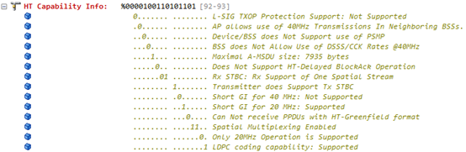

1. L-SIG TXOP保护： Legacy Signal Transmission Opportunity（传统信号域传输机会）。在L-SIG TXOP保护方式下，HT帧的L-SIG域包含一个时间值（此时间值应等于MAC帧头中的MAC持续时间值），要求传统设备直到这个时间结束后再进行正常收发。传统设备因无法接收在L-SIG持续时间范围内开始的PPDU，故在L-SIG TXOP内，传统接收机不会收到任何帧。若11n下支持L-SIG TXOP保护，HT Capability Info中的L-SIG TXOP Protection位应该置1，0代表不支持。

[802.11n Protection Mechanisms: Part 2 (cwnp.com)](https://www.cwnp.com/802-11n-protection-mechanisms-part-2/)

An HT STA must indicate whether it supports L-SIG TXOP Protection in its **L-SIG TXOP Protection Support capability field** in **Association Requests and Probe Responses**.

The AP determines whether all HT stations associated with its BSS support L-SIG TXOP Protection and indicates this in the **L-SIG TXOP Protection Full Support field** of its HT Information Element. This field is set to 1 only if the L-SIG TXOP Protection field is set to 1 by **all HT station** in the BSS.

Under L-SIG TXOP Protection operation, the L-SIG field with an HT mixed format PHY preamble represents a duration value equivalent to the sum of:

a) the value of Duration/ID field contained in the MAC header, and

b) the duration remaining in the current packet (from the end of the symbol containing the L-SIG field to the end of the last symbol of the packet).

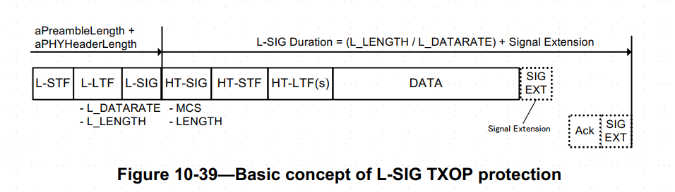

## 26.2.4 Updating two NAVs(From 802.11ax 2021)

|  |  |  |  |
| --- | --- | --- | --- |
| **HEM8** | **NAV update** | **26.2.4** |  |
| **HEM8.1** | **Update basic NAV** | **26.2.4** | **CFHE:M** |
| **HEM8.2** | **Update IntraBSS NAV** | **26.2.4** | **CFAP AND CFHE: O  CFIndepSTA AND CFHE:M** |

A non-AP HE STA shall maintain two NAVs, and an HE AP may maintain two NAVs: an intra-BSS NAV

and a basic NAV. The intra-BSS NAV is updated by an intra-BSS PPDU. The basic NAV is updated by an

inter-BSS PPDU or a PPDU that cannot be classified as intra-BSS or inter-BSS.

intra-BSS NAV由BSS内PPDU负责更新，基础NAV由其他非intra-BSS PPDU更新。