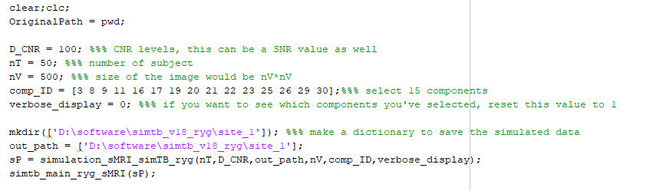

Step 1: add the toolbox into the Matlab search path, and run the demo.m file, then you can generate simulated data with 50 subjects (you can change “nT” any number you want).

* If you want to visualize which components you’ve selected, please set “verbose_display” to 1.
* The distributions of the 30 components you can generate with the toolbox are shown below.

