What is K-fold Cross Validation?
Cross validation is an evaluation method used in machine learning to find out how well your machine learning model can predict the outcome of unseen data. It is a method that is easy to comprehend, works well for a limited data sample and also offers an evaluation that is less biased, making it a popular choice.
The data sample is split into ‘k’ number of smaller samples, hence the name: K-fold Cross Validation. You may also hear terms like four fold cross validation, or ten fold cross validation, which essentially means that the sample data is being split into four or ten smaller samples respectively.

How is k-fold cross validation performed?
The general stratergy is quite straight forward and the following steps can be used:
- First, shuffle the dataset and split into k number of subsamples. (It is important to try to make the subsamples equal in size and ensure k is less than or equal to the number of elements in the dataset).
- In the first iteration, the first subset is used as the test data while all the other subsets are considered as the training data.
- Train the model with the training data and evaluate it using the test subset. Keep the evaluation score or error rate, and get rid of the model.
- Now, in the next iteration, select a different subset as the test data set, and make everything else (including the test set we used in the previous iteration) part of the training data.
- Re-train the model with the training data and test it using the new test data set, keep the evaluation score and discard the model.
- Continue iterating the above k times. Each data subsamples will be used in each iteration until all data is considered. You will end up with a k number of evaluation scores.
- The total error rate is the average of all these individual evaluation scores.
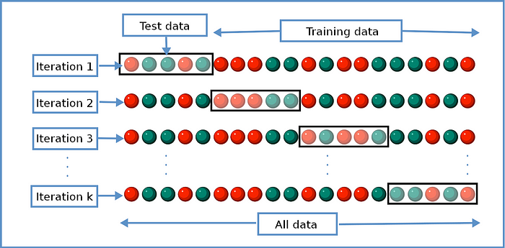

How to determine the best value for ‘k’ in K-Fold Cross Validation?
Choosing a good value for k is important. A poor value for k can result in a poor evaluation of the model’s abilities. In other words, it can cause the measured ability of the model to be overestimated (high bias) or change widely depending on the training data used (high variance).
Generally, there are three ways to select k:
- Let k = 5, or k =10. Through experimentation, it has been found that selecting k to be 5 or 10 results in sufficiently good results.
- Let k = n, where n is the size of the dataset. This ensures each sample is used in the test data set.
- Another way is to chose k so that every split data sample is sufficiently large, ensuring they are statistically represented in the larger dataset.

Why Should I Use K-fold Cross-Validation?

Make use of your data

We have a lot of readily available data that can explain a lot of things and help us identify hidden patterns. However, if we only have a small dataset, splitting it into a training and test dataset at a 80:20 ratio respectively doesn’t seem to do much for us.
However, when using K-fold cross validation, all parts of the data will be able to be used as part of the testing data. This way, all of our data from our small dataset can be used for both training and testing, allowing us to better evaluate the performance of our model.

More available metrics to help evaluate

Let’s refer back to the example of splitting your dataset into training and testing as a 80:20 ratio or a train-test split - this provides us with only one result to refer to in our evaluation of the model. We are not sure about the accuracy of this result, if it’s due to chance, the level of bias, or if it actually performed well.
However, when using k-fold cross validation, we have more models that will be producing more results. For example, if we chose our k value at 10, we would have 10 results to use in our evaluation of the model's performance.
If we were using accuracy as our measurement; having 10 different accuracy results where all of the data was used in the test phase is always going to be better and more reliable than using one accuracy result that was produced by a train-test split - where all the data wasn’t used in the test phase.
You would have more trust and confidence in your model's performance if the accuracy outputs were 94.0, 92.8, 93.0, 97.0, and 94.5 in a 5-fold cross validation than a 93.0 accuracy in a train-test split. This proves to us that our algorithm is generalizing and actively learning and is providing consistent reliable outputs.

Better performance using dependent data

In a random train-test split, we assume that the data inputs are independent. Let’s further expand on this. Let’s say we are using a random train-test split on a speech recognition dataset for British English speakers who reside from London. There are 5 speakers, with 250 recording each. Once the model performs a random train-test split, both the training and testing dataset will learn from the same speaker, which will be saying the same dialogue.
Yes this does improve the accuracy and boost the performance of the algorithms, however, what about when a new speaker is introduced to the model? How does the model perform then?
Using K-fold cross validation will allow you to train 5 different models, where in each model you are using one of the speakers for the testing dataset and the remaining for the training dataset. This way, not only can we evaluate the performance of our model, but our model will be able to perform better on new speakers and can be deployed in production to produce similar performance for other tasks.

