# TITLE:

## Results and Discussion

### Field Data Collection

#### Suspended Sediment Concentration

From October 1, 2014, to January 9, 2015, 418 samples were collected in Faga'alu and analyzed for SSC. Three sites were the focus of this analysis: 1) FOREST(n=17), 2) QUARRY (n=16 grab samples, n=192 from the Autosampler), and 3) VILLAGE (n=33). Mean SSC of grab samples collected during baseflow and stormflow were 47 mg/L at the FOREST site, 219 mg/L at the QUARRY, and 24 mg/L the downstream VILLAGE site. Maximum SSC values were 236 mg/L, 1,837 mg/L, and 194 mg/L at the upstream (FOREST), quarry (QUARRY), and downstream (VILLAGE) sites, respectively. The maximum SSC value at QUARRY (1,837 mg/L ) was sampled on 11/03/2014 at 96 L/sec. The maximum SSC value at VILLAGE (194 mg/L) was sampled on 11/03/2014, when discharge was 2,288 L/sec. The maximum SSC value for the upstream site (236 mg/L) was sampled on 01/09/2015 at discharge 888 L/sec.

At FOREST, 13 grab samples (0%) were taken during stormflow conditions (Q_DAM>165 L/sec), with mean SSC of 61 mg/L. At QUARRY, 10 grab samples (0%) were taken during stormflow conditions (Q_DAM>165 L/sec), with mean SSC of 67 mg/L. At VILLAGE, 19 samples (0%) were taken during stormflow conditions (Q_VILLAGE>364 L/sec), with mean SSC of 32 mg/L (Figure 5). This pattern of SSC values suggests that little sediment is contributed from the forest upstream of FOREST, then there is a large input of sediment between FOREST and QUARRY, and then SSC is diluted by addition of stormflow with lower SSC between QUARRY and VILLAGE.

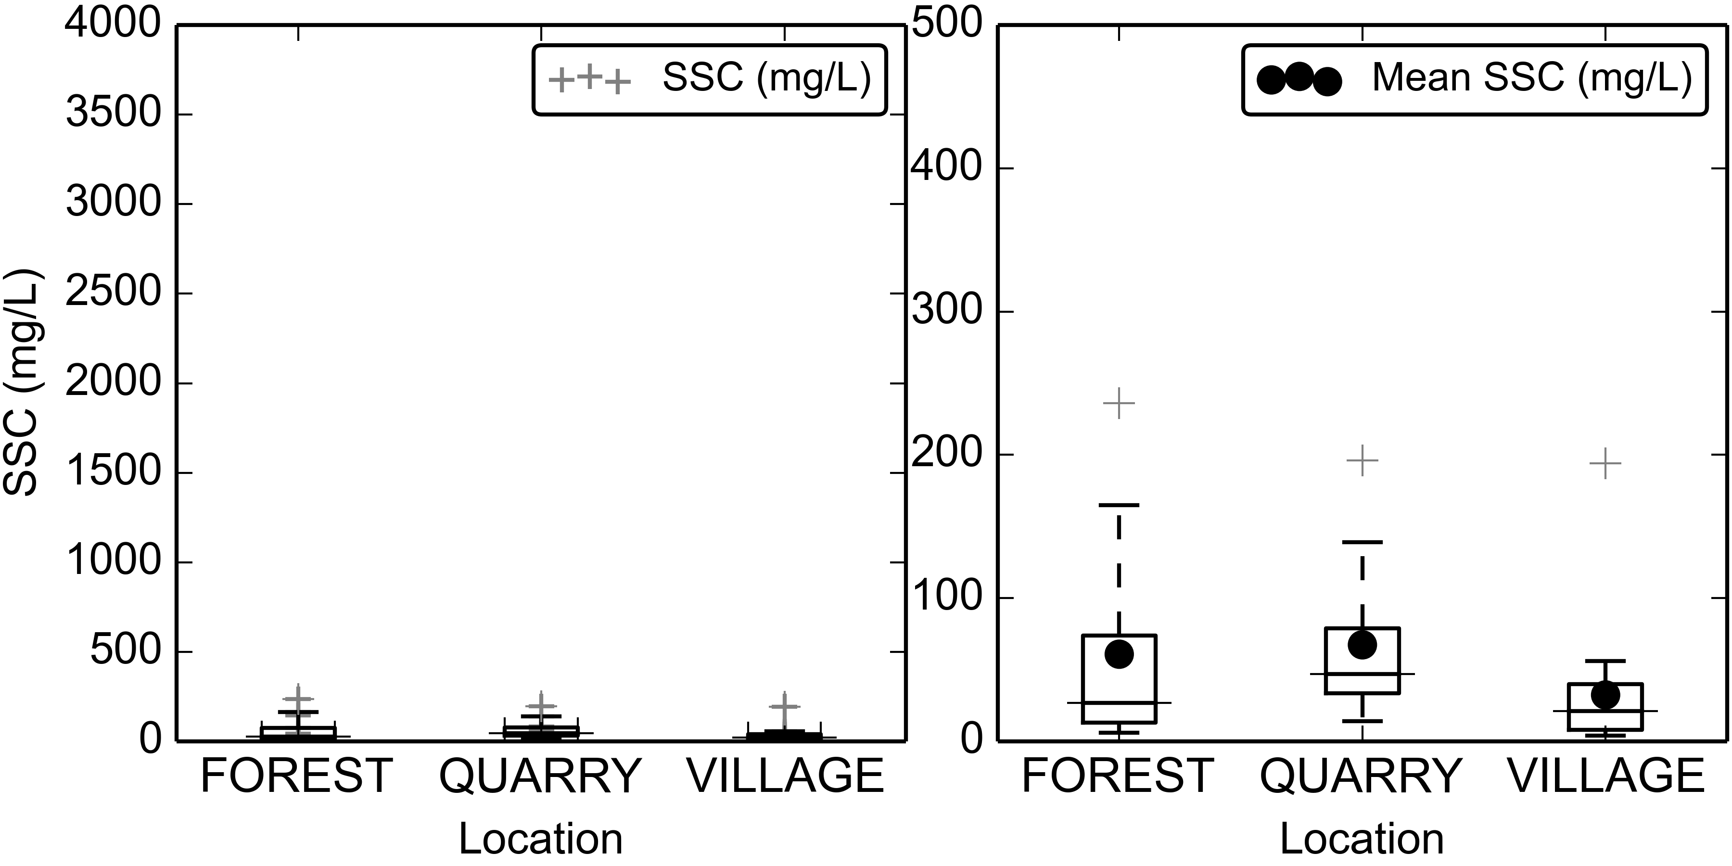

Figure 5. Boxplots of Suspended Sediment Concentration (SSC) from grab samples only (no Autosampler) at FOREST, QUARRY, and VILLAGE during storm periods.

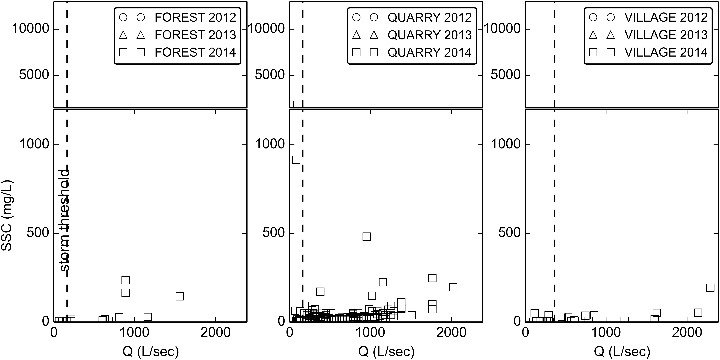

Figure 6. Water Discharge vs Suspended Sediment Concentration at FOREST, QUARRY, and VILLAGE during baseflow and stormflow periods. Samples from Autosampler are included with grab samples at QUARRY.

Storm Events

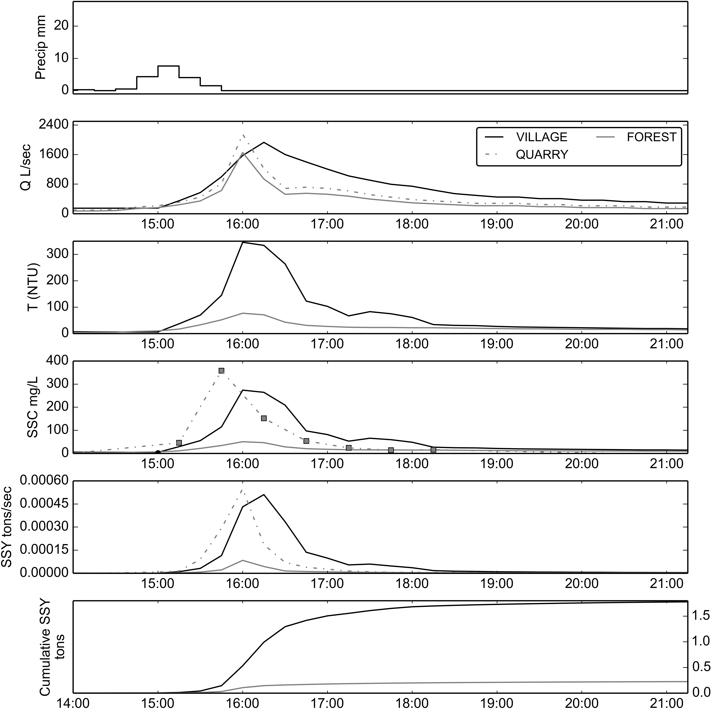

Figure 11. Example of storm event (02/14/2014) before sediment mitigation structures installed at quarry. SSY at FOREST and VILLAGE calculated from SSC modeled from T, and SSY at QUARRY from SSC samples collected by the Autosampler.

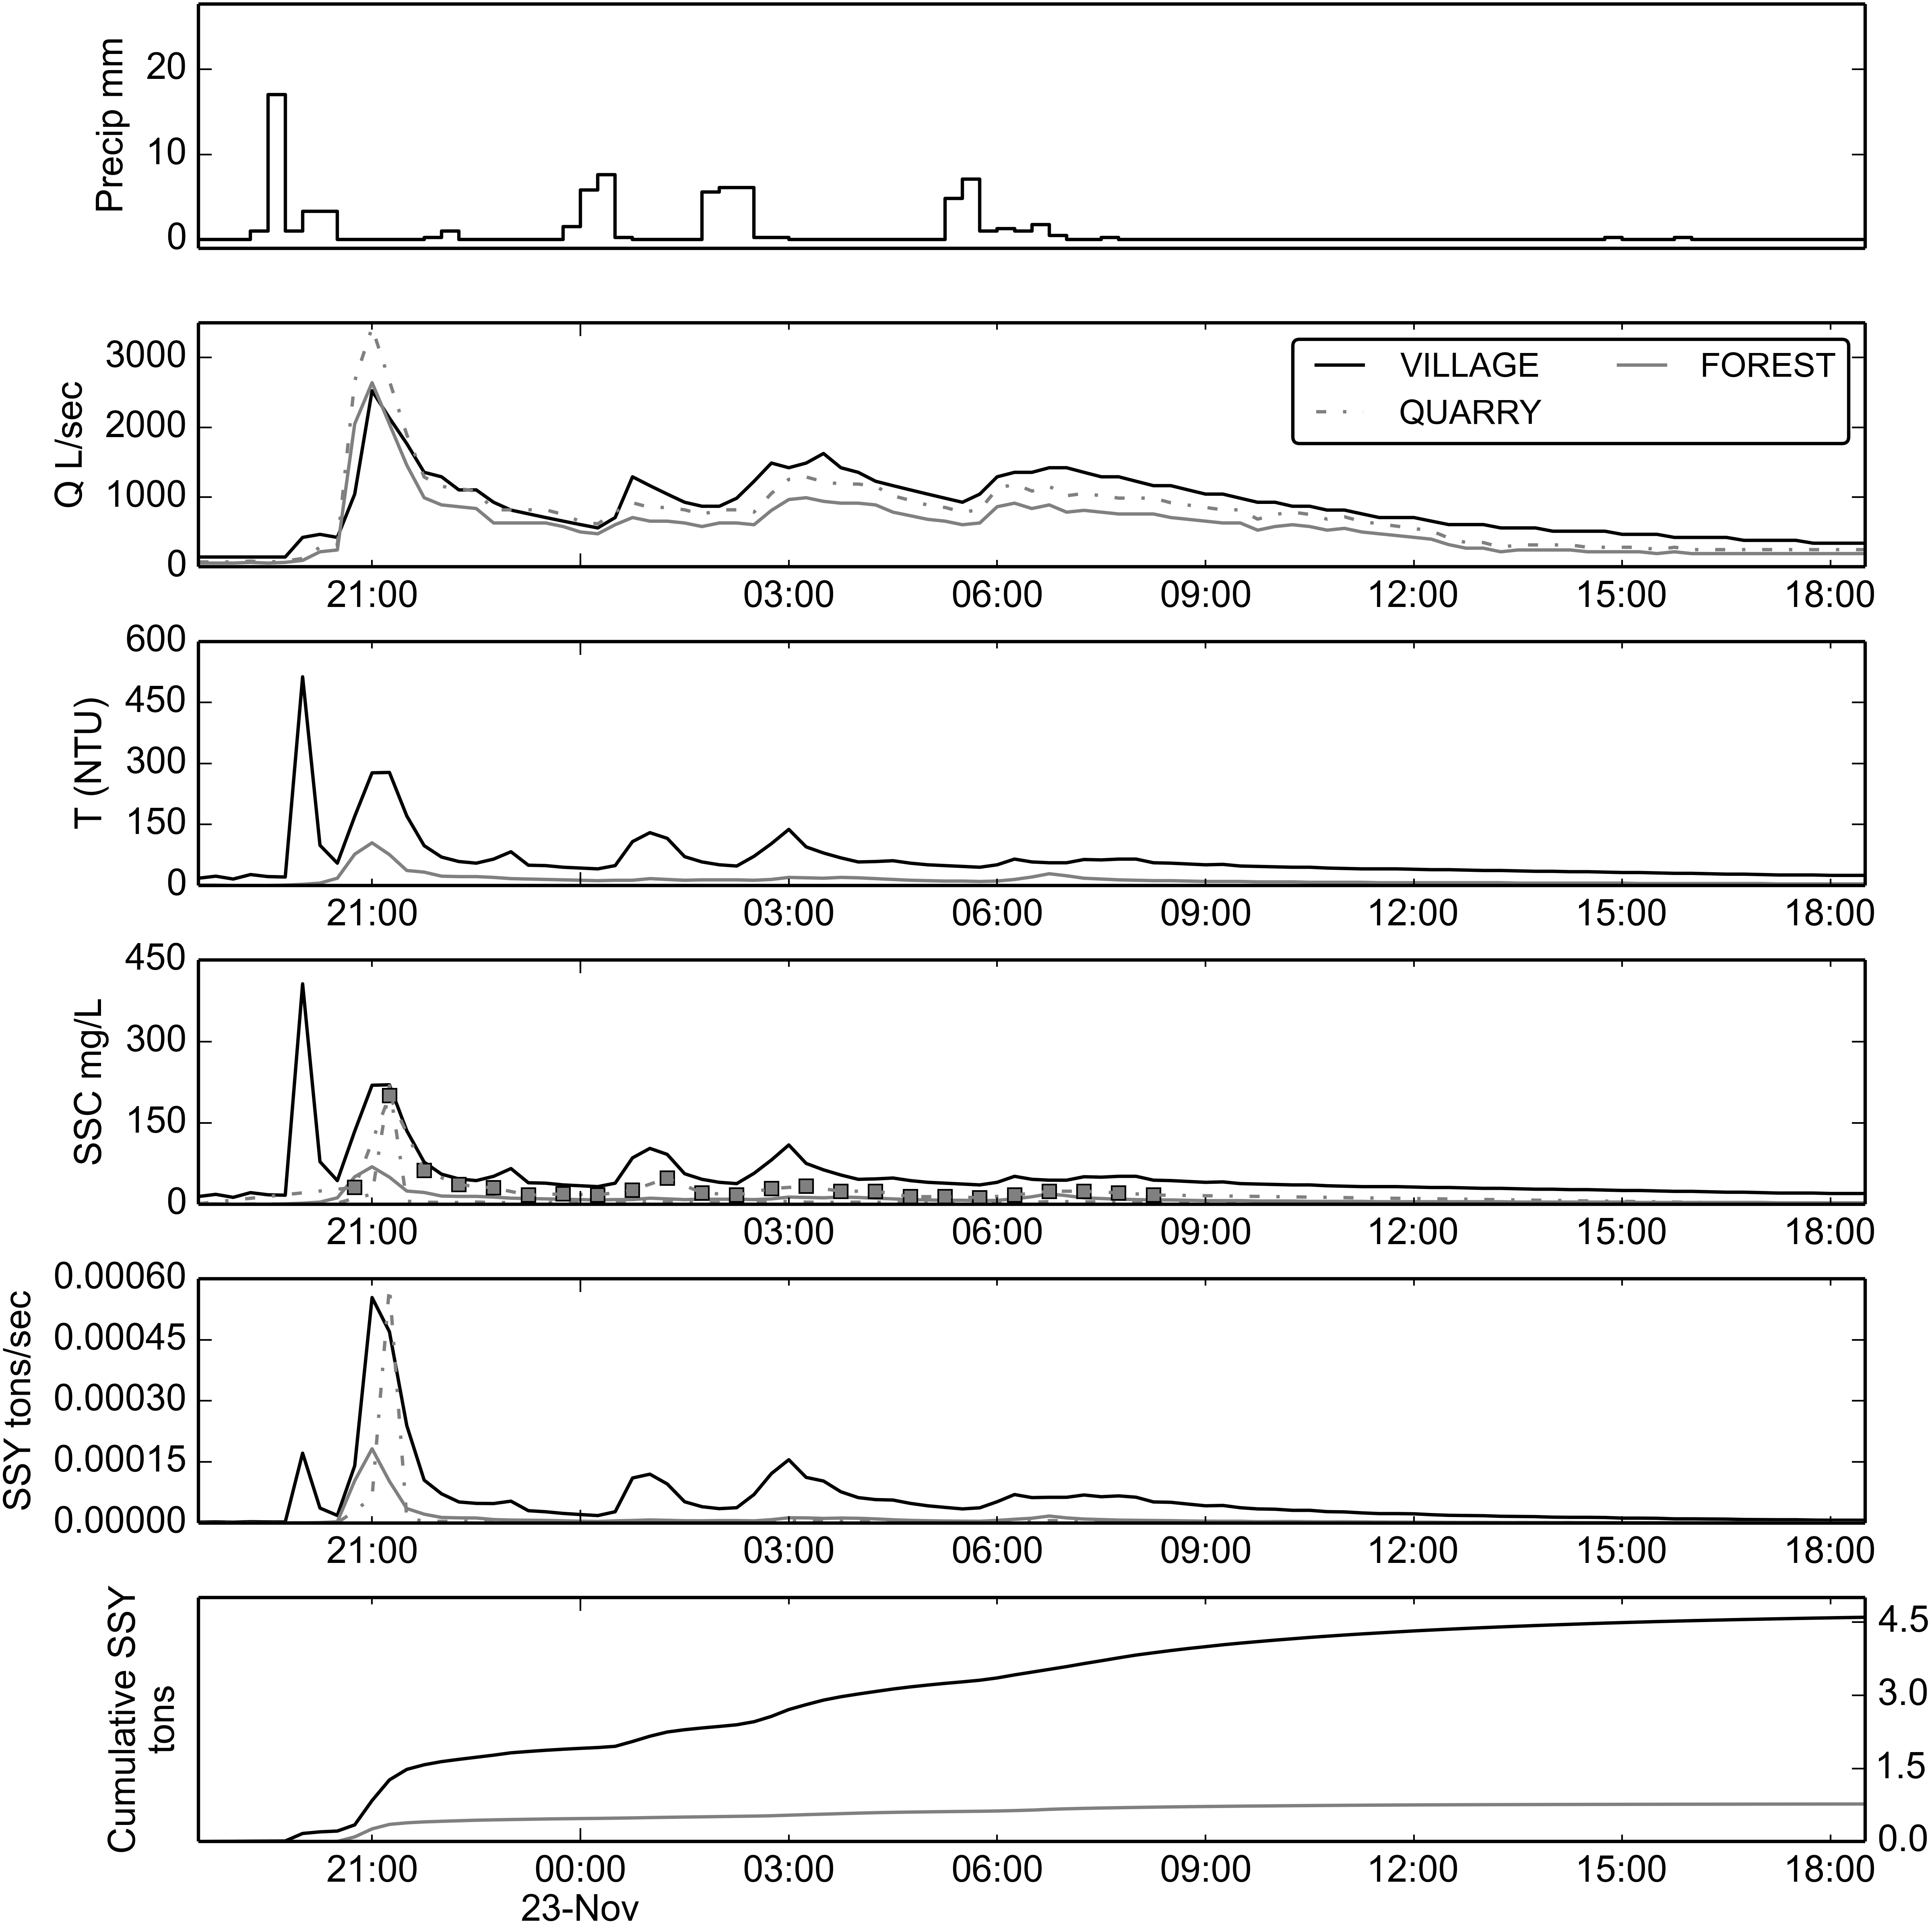

Figure 12. Example of storm event (11/22/2014) after sediment mitigation structures installed at quarry. SSY at FOREST and VILLAGE calculated from SSC modeled from T, and SSY at QUARRY from SSC samples collected by the Autosampler.

Using the stage threshold method and manual separation of complex storm events, 20 storm events were identified from Q data at VILLAGE from October, 2014, to January 2015. Valid Q data was recorded during 20 events at FOREST, and 15 events at VILLAGE . Valid SSC data from T and Interpolated Grab samples was recorded during 20 events at FOREST, and 14 events at VILLAGE. Of those storms, 12 events had valid P and SSY data for both the FOREST and VILLAGE to calculate and compare SSY from the UPPER and LOWER watersheds (Table 2). Valid SSY data from Interpolated grab samples was collected at QUARRY for 12 storms to compare with SSY from FOREST and VILLAGE directly (Table 3). Storm event durations ranged from 2 hours to 2 days, with mean duration of 13 hours.

### Comparing SSY from disturbed and undisturbed subwatersheds

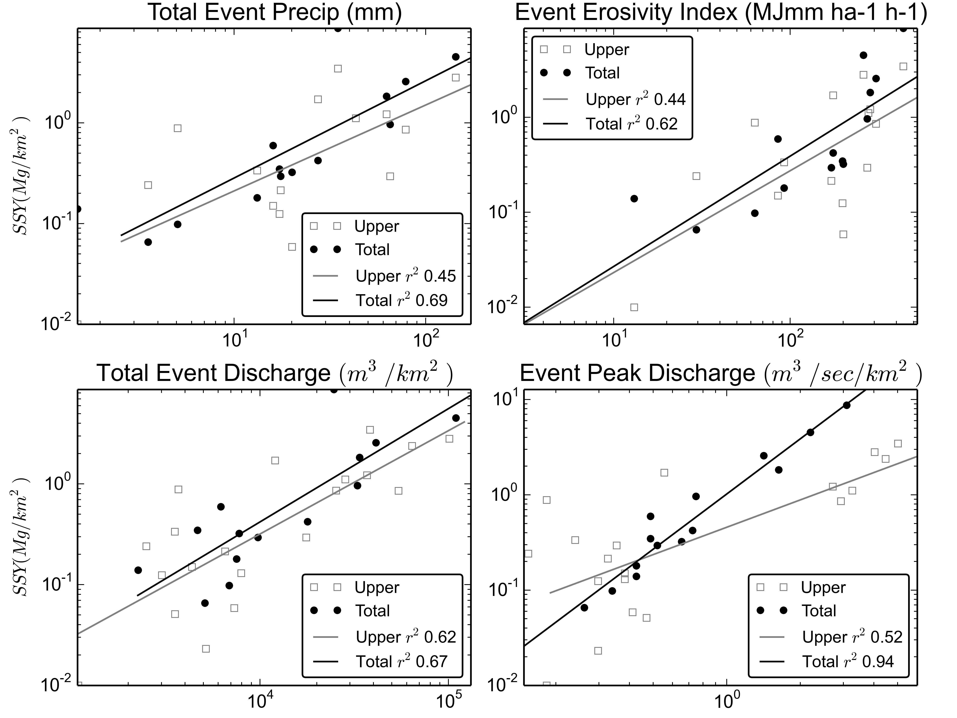

Figure 13. SSY rating curves for predictors

|  |  |  |  |  |  |  |
| --- | --- | --- | --- | --- | --- | --- |
| Table 5. Model statistics | | | | | | |
| Model | Pearson | Spearman | r2 | RMSE(tons) | alpha | Beta |
| Psum_upper | - | - | 0.45 | 3.35 | 0.027 | 0.85 |
| Psum_total | 0.83 | 0.88 | 0.69 | 2.33 | 0.054 | 0.97 |
| EI_upper | - | - | 0.44 | 3.38 | 0.002 | 1.07 |
| EI_total | 0.78 | 0.88 | 0.62 | 2.57 | 0.003 | 1.16 |
| Qsum_upper | 0.79 | 0.74 | 0.62 | 2.81 | 0.000 | 1.03 |
| Qsum_total | 0.82 | - | 0.67 | 2.39 | 0.000 | 1.12 |
| Qmax_upper | 0.72 | - | 0.52 | 3.21 | 0.454 | 0.95 |
| Qmax_total | 0.97 | 0.94 | 0.94 | 1.45 | 0.598 | 1.92 |

## Conclusion

## APPENDIX