Stream stage was measured with non-vented pressure transducers (PT) (Solinst Levelogger or Onset HOBO Water Level Logger) installed in stilling wells at FG1 and FG3. Q was measured in the field by the area-velocity method (AV) using a Marsh-McBirney flowmeter to measure flow velocity and channel surveys measure cross-sectional area (Harrelson et al., 1994; Turnipseed and Sauer, 2010).

Barometric pressure data collected at Wx were used to calculate stage from the pressure data recorded by the PT. Data gaps in barometric pressure from Wx were filled by data from stations at Pago Pago Harbor (NSTP6) and NOAA Climate Observatory at Tula (TULA) (Figure 1). Priority was given to the station closest to the watershed with valid barometric pressure data. Barometric data were highly correlated and the data source made little (<1cm) difference in the resulting water level.

AV-Q measurements could not be made at high stages at FG1 and FG3 for safety reasons, so stage-Q relationships were constructed to estimate a continuous record of Q. At FG3, the channel is rectangular with stabilized rip-rap on the banks and bed (Appendix Figure A1.1). Recorded stage varied from 4 to 147 cm. AV-Q measurements (n= 14) were made from 30 to 1,558.0 L/sec, covering a range of stages from 6 to 39 cm.

so the rating could not be extrapolated by a power law. Stream conditions at FG3 fit the assumption for Manning's equation

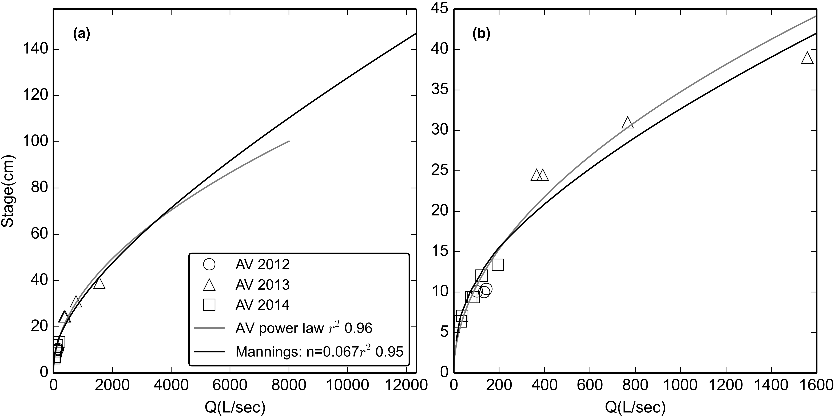

Figure 3. Stage-Discharge relationships for stream gaging site at FG3 for (a) the full range of observed stage and (b) the range of stages with AV measurements of Q. RMSE was 93 L/sec, or 32% of observed Q.

The structure is a rectangular channel 43 cm deep that transitions abruptly to gently sloping banks, causing an abrupt change in the stage-Q relationship (Appendix Figure A1.2). At FG1, recorded stage height ranged from 4 to 120 cm, while area-velocity Q measurements (n= 22) covered stages from 6 to 17 cm. there was a distinct change in channel geometry above 43 cm the rating could not be extrapolated by a power law.

The surveyed geometry of the upstream channel and flow structure at FG1 were input to HEC-RAS, and the HEC-RAS model was calibrated to the Q measurements (Figure 4). While a power function fit Q measurements better than HEC-RAS for low flow, HEC-RAS fit better for Q above the storm threshold used in analyses of SSY (Figure 4).

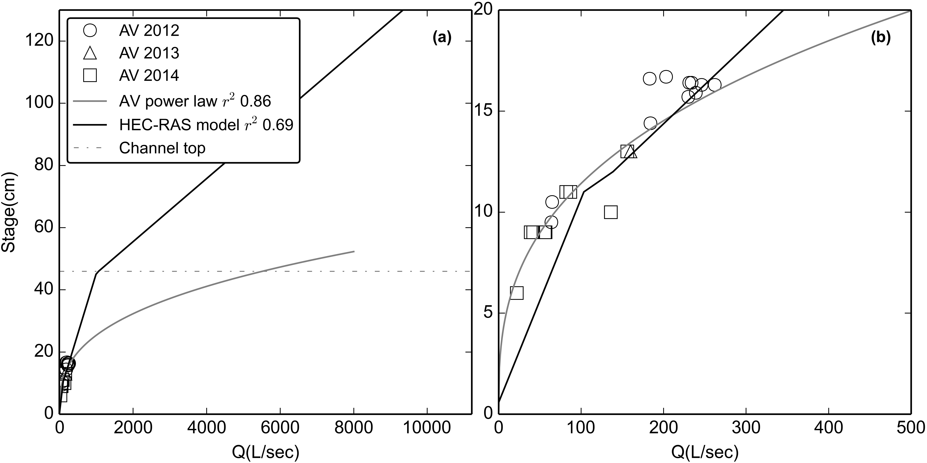

Figure 4. Stage-Discharge relationships for stream gaging site at FG1 for (a) the full range of observed stage and (b) the range of stages with AV measurements of Q. RMSE was 31 L/sec, or 22% of observed Q. "Channel Top" refers to the point where the rectangular channel transitions to a sloped bank and cross-sectional area increases much more rapidly with stage. A power-law relationship is also displayed to illustrate the potential error that could result if inappropriate methods are used.

Storm events with incomplete or invalid T data were not used in the analysis. A three-point calibration was performed on the YSI turbidimeter with YSI turbidity standards (0, 126, and 1000 NTU) at the beginning of each field season and approximately every 3-6 months during data collection. Turbidity measured with 0, 126, and 1000 NTU standards differed by less than 10% (4-8%) during each recalibration. The OBS requires calibration every two years, so recalibration was not needed during the study period. All turbidimeters were cleaned following storms to ensure proper operation.

At FG3, a YSI turbidimeter recorded T (NTU) at 5 min intervals from January 30, 2012, to February 20, 2012, and at 15 min intervals from February 27, 2012 to May 23, 2012, when it was damaged during a large storm. The YSI turbidimeter was replaced with an OBS, which recorded Backscatter (BS) and Sidescatter (SS) at 5 min intervals from March 7, 2013, to July 15, 2014 (OBSa), and was resampled to 15 min intervals. No data was recorded from August 2013-January 2014 when the wiper clogged with sediment. A new OBS was installed at FG3 from January, 2014, to August, 2014 (OBSb). To correct for some periods of high noise observed in the BS and SS data recorded by the OBSa in 2013, the OBSb installed in 2014 was programmed to make a burst of 100 BS and SS measurements at 15 min intervals, and record Median, Mean, STD, Min, and Max. All BS and SS parameters were analyzed to determine which showed the best relationship with SSC. Mean SS showed the highest r2 and is a physically comparable measurement to NTU measured by the YSI and TS (Anderson, 2005).

At FG1, the TS turbidimeter recorded T (NTU) at 5 min intervals from January 2012 until it was vandalized and destroyed in July 2012. The YSI turbidimeter, previously deployed at FG3 in 2012, was repaired and redeployed at FG1 and recorded T (NTU) at 5 min intervals from June 2013 to October 2013, and January 2014 to August 2014. T data was resampled to 15 min intervals to compare with SSC samples for the T-SSC relationship, and to correspond to Q for calculating SSY.

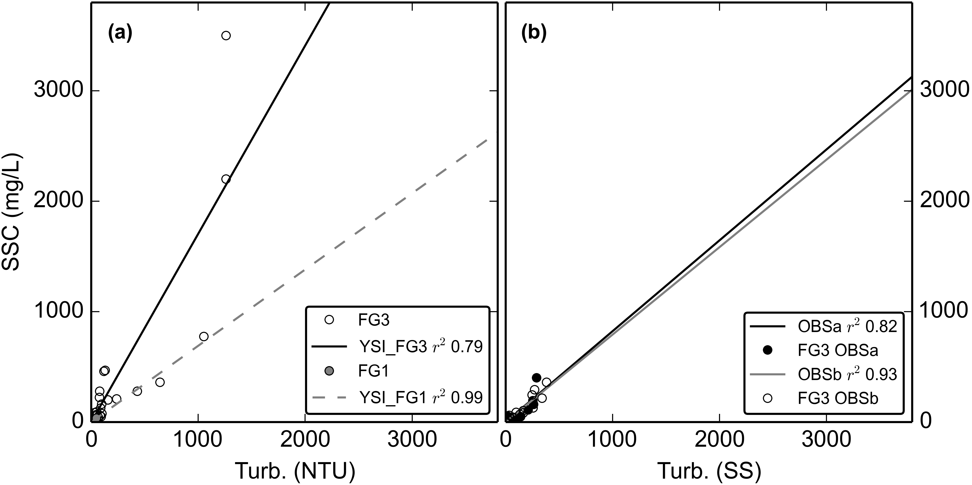

Figure 5. Turbidity-Suspended Sediment Concentration relationships for a) the YSI turbidimeter deployed at FG3 (02/27/2012-05/23/2012) and the same YSI turbidimeter deployed at FG1 (06/13/2013-12/31/2014). b) OBS500 turbidimeter deployed at FG3 (03/11/2013-07/11/2013) and c) OBS500 turbidimeter deployed at FG3 (01/31/2014-03/04/2014).

A "synthetic" T-SSC relationship was also developed by placing the turbidimeter in a black tub with water, and sampling T and SSC as sediment was added (Appendix 4, Figure 1), but results were not comparable to T-SSC relationships developed under actual storm conditions and were not used in further analyses.

The T-SSC relationships varied among sampling sites and sensors but all showed acceptable. Lower scatter was achieved by using grab samples collected during stormflows only.

For the TS (not shown) and YSI deployed at FG1, the r2 values were high (0.58, 0.99) but the ranges of T and SSC values used to develop the relationships were considered too small (0-16 NTU) compared to the maximum observed during the deployment period (1,077 NTU) to develop a robust relationship for higher T values. Instead, the T-SSC relationship developed for the YSI turbidimeter installed at FG3 (Figure 5a) was used to calculate SSC from T data collected by the TS and the YSI at FG1. For the YSI turbidimeter, more scatter was observed in the T-SSC relationship at FG3 than at FG1 (Figure 5a), which could be attributed to the higher number and wider range of values sampled, and to temporal variability in sediment characteristics. The OBSa and OBSb turbidimeters had high r2 values (0.82, 0.93) and compared well between the two periods of deployment (Figure 5b).

More appropriate for results: