<5pp, including figures, graphs, etc.

**Significance**

Sediment loading is a key stressor on coral reefs. (more here, 1 paragraph max).

**Methods**

1. STREAMFLOW AND SEDIMENT LOADING

*List of materials*

Pressure transducer

Turbidimeter

Bottles for collecting water from streams

Filters

…

*Rationale for storm sampling*

Most of the sediment load occurs during storm events. Sediment concentration in water during baseflow is often very low, and increases rapidly with streamflow. Thus, it is very important that sampling for sediment include estimates of sediment concentrations during storm events.

*Key metric: Sediment loading during storm and inter-storm events*

Sediment load at any given time is calculated as (Equation 1):

Q is determined from…

SSC is determined from…

(include filtration equipment used, laboratory methods).

*Analysis for impact assessment: Relationship between peak stormflow and sediment loading*

It can be difficult to interpret sediment concentrations in terms of impact of management activities, because sediment concentration varies widely with streamflow. Is sediment concentration high because of some management activity upstream, or because a sample was taken during a storm event when concentrations may be naturally high? Similarly, the load is highly dependent on streamflow.

The impact of streamflow on sediment concentration and loads can be controlled for by plotting different metrics of streamflow (e.g. peak discharge, streamflow at a given time, total stormflow volume, etc) against total sediment load to the stream (Figure xx—conceptual sketch). We found that there is no simple relationship between streamflow and sediment concentration, because that relationship changes depending on whether you sample the rising or falling limb of the stormflow hydrograph. Therefore, we used total storm loading of sediment (tons per event) versus peak stormflow (Qpeak) (Figure xx). A management impact would be demonstrated by a change in the Qpeak-sediment load relationship.

*Continued monitoring recommendations*

We anticipate that at least 10 storms will need to be measured in order to establish any change in the Qpeak-sediment load relationship. Storm sampling includes taking at least xx samples per storm, at xx minute intervals.

1. SEDIMENTATION IN THE BAY

*List of materials*

PVC tubes (2”)

SedPods (N=?)

*Rationale for monitoring sedimentation*

Sediment loaded from the watershed may or may not affect the reef depending on ocean conditions. If loading happens during a time of intense ocean circulation, deposition may be much lower than if loading happens during times of quiescent ocean conditions. Therefore, monitoring of sedimentation rates on the reef itself is important to determine the ultimate impact of management activities on a reef.

*Key metric: Sedimentation rates in tubes and on SedPods*

Two aspects of sedimentation are important for corals:

1. Gross accumulated sediment deposition. This is measured by PVC tubes, which capture all sediment that enters them and prevents the sediment from getting washed away.
2. Net sediment deposition, accounting for sediment getting resuspended and washed away. This is measured using concrete SedPods, which are exposed to waves and currents, allowing sediment to get washed away. Texture of the concrete is designed to replicate the texture of coral reef.

The tubes are constructed from … (picture).

SedPods are constructed from … (picture).

Sediment is collected monthly by…

*Key metric: Sediment characteristics: Fine/coarse fractions and terrestrial fraction*

The impact of sediment on coral may depend on the sediment size, and the fraction of the sediment that is terrestrial vs marine in origin. We anticipate that the fine fraction and terrestrial fractions will decrease with reduced loading from the watershed.

The fine-coarse faction can be determined with simple laboratory equipment, but the methods must be followed very carefully to be consistent with other results.

**Baseline values**

*Figure xx. Qpk-Sedload plot*

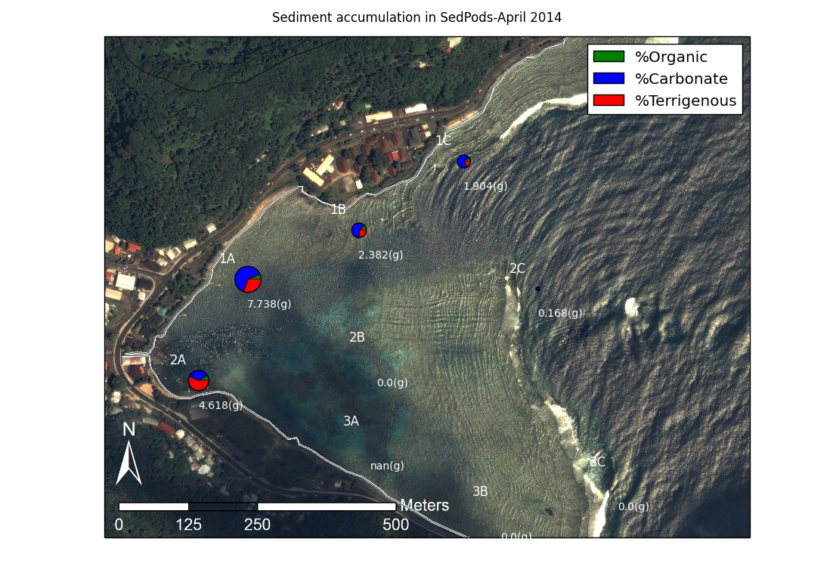

*Figure xx. Map showing locations of sedpods + tubes, sample plots with amounts, coralline vs terrestrial fraction.*

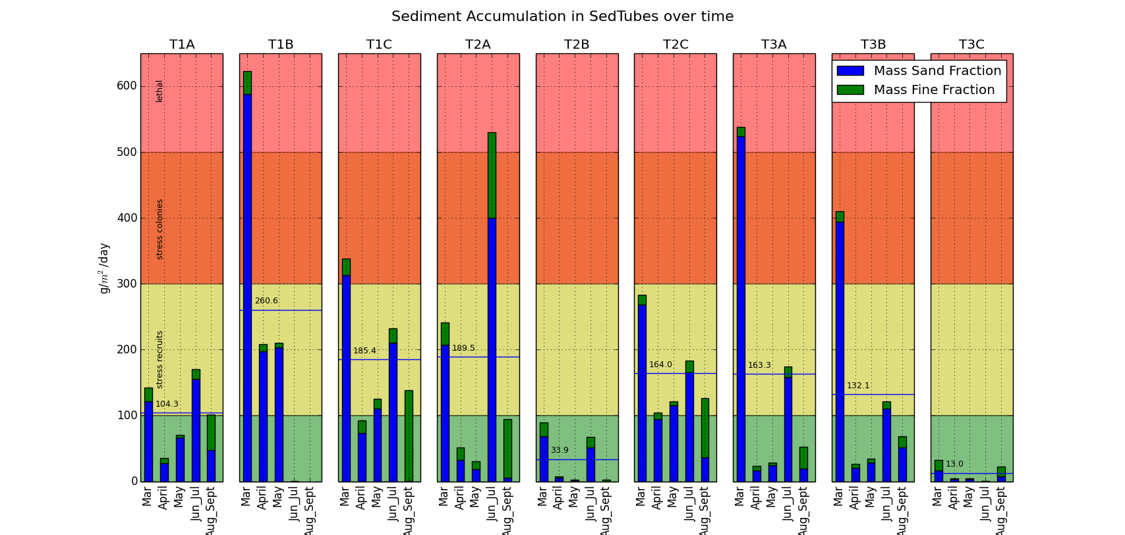

*Figure xx. Time series of sediment accumulation in the tubes, March 2014-August 2014.*