Title: Modular Segmented Wheel Cover for a Wheelchair Drive Wheel and Methods of Making and Installing
Applicant/Inventor: Adam Fabiano

TITLE OF THE INVENTION

[0001] Modular Segmented Wheel Cover for a Wheelchair Drive Wheel and Methods of Making and Installing the Same.

FIELD

[0002] The present disclosure relates to wheelchair wheel covers (spoke guards) for manual wheelchair drive wheels, and more particularly to modular wheel covers assembled from multiple segments and installed using flexible fasteners, including cable ties.

BACKGROUND

[0003] Manual wheelchair drive wheels typically include spokes and, in many configurations, a hand rim used for propulsion. Wheel covers may reduce entanglement or contact with spokes, protect hands and clothing, and provide aesthetic customization. Known-spoke guards are commonly one‑piece discs sized to a particular wheel diameter; one‑piece structures can be more difficult to fabricate on consumer 3D printers with limited build volume and may be less repairable than modular systems.

SUMMARY

[0004] In one aspect, a modular wheel cover assembly comprises a plurality of rigid segments arranged circumferentially about a wheel axis to form a generally circular wheel‑cover disc sized to cover at least a portion of a wheelchair drive wheel (e.g., the spoke region).

[0005] Each segment includes an arcuate outer edge portion, an inner edge portion defining or contributing to a central aperture sized to clear a hub/axle region, and first and second radial edge portions. Adjacent segments are retained together along seams using flexible fasteners routed through apertures and/or slots defined by the segments.

[0006] The assembled disc is attached to the wheelchair drive wheel using flexible fasteners routed through selected apertures/slots and around wheel structures such as spokes, rim members, and/or hand‑rim posts. In some embodiments, at least one fastener provides “double‑duty” retention by both (i) joining a seam between adjacent segments and (ii) coupling the disc to a wheel structure.

[0007] Segments are preferably fabricated by fused-filament fabrication / fused deposition modelling (FDM) 3D printing. The segmented architecture enables fabrication on printers that cannot print a full‑diameter disc in one piece and enables repair by replacing an individual segment.

BRIEF DESCRIPTION OF THE DRAWINGS

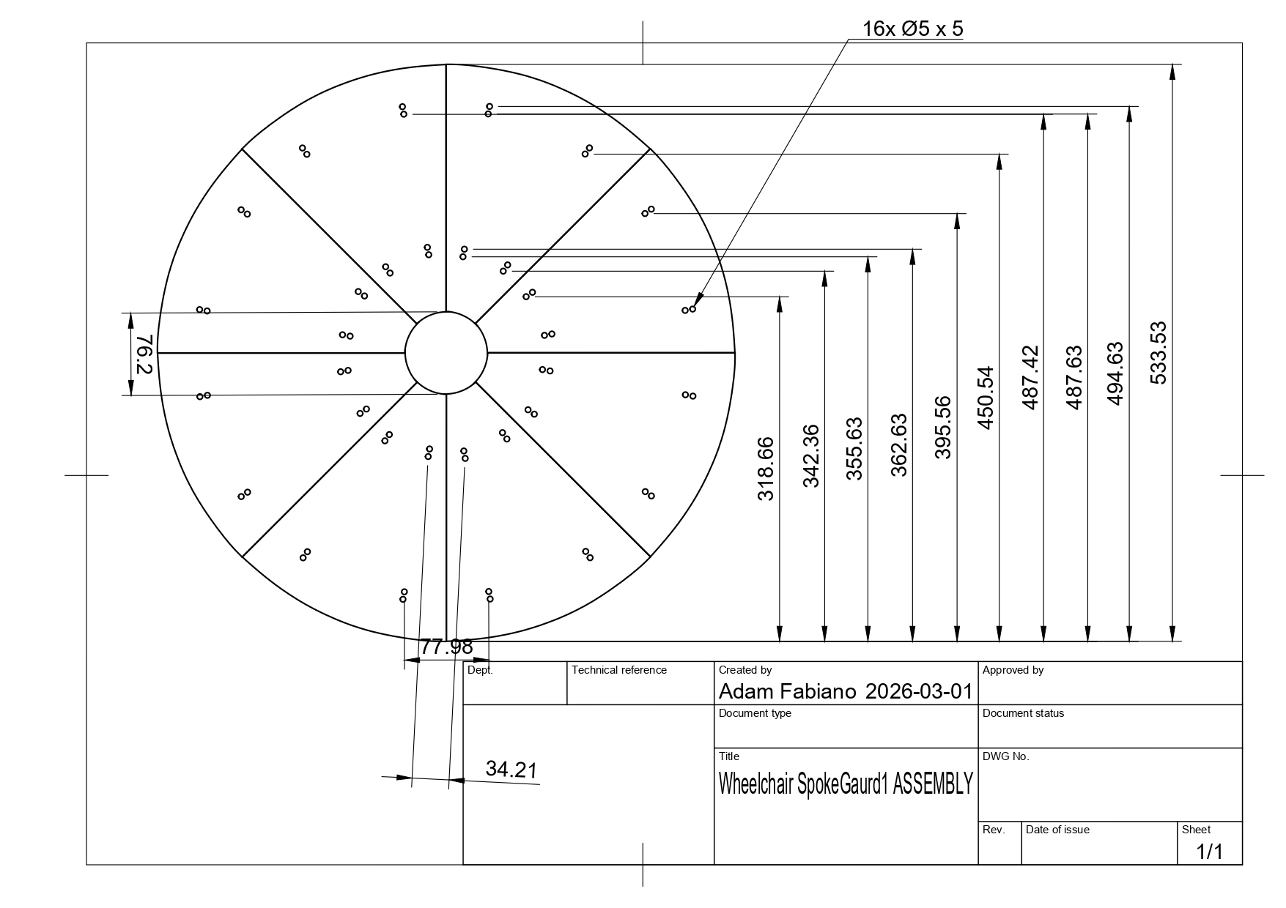

[0008] FIG. 1: Exploded view showing N segments arranged circumferentially to form the disc (example: N=8).
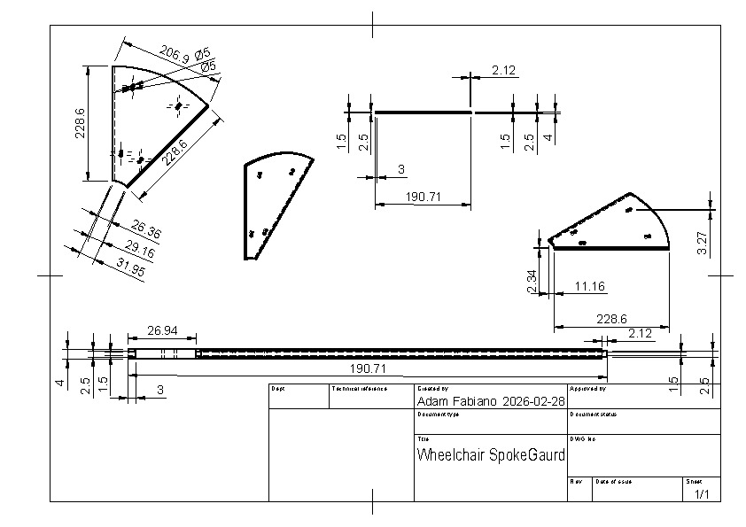
[0009] FIG. 2: Plan view of a single segment showing arcuate outer edge, inner edge portion, tongue edge, groove edge, and apertures/slots used for seam retention and wheel attachment.
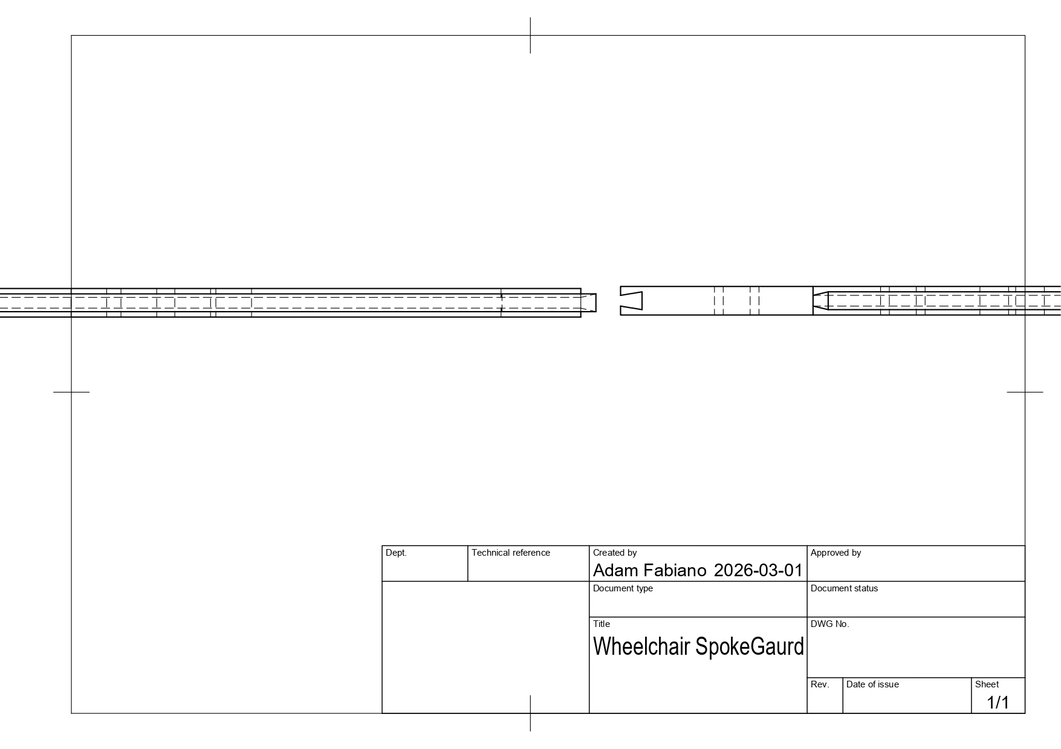
[0010] FIG. 3 Seam detail showing tongue‑and‑groove engagement between adjacent segments and a fastener routed through aligned apertures/slots bridging the seam.
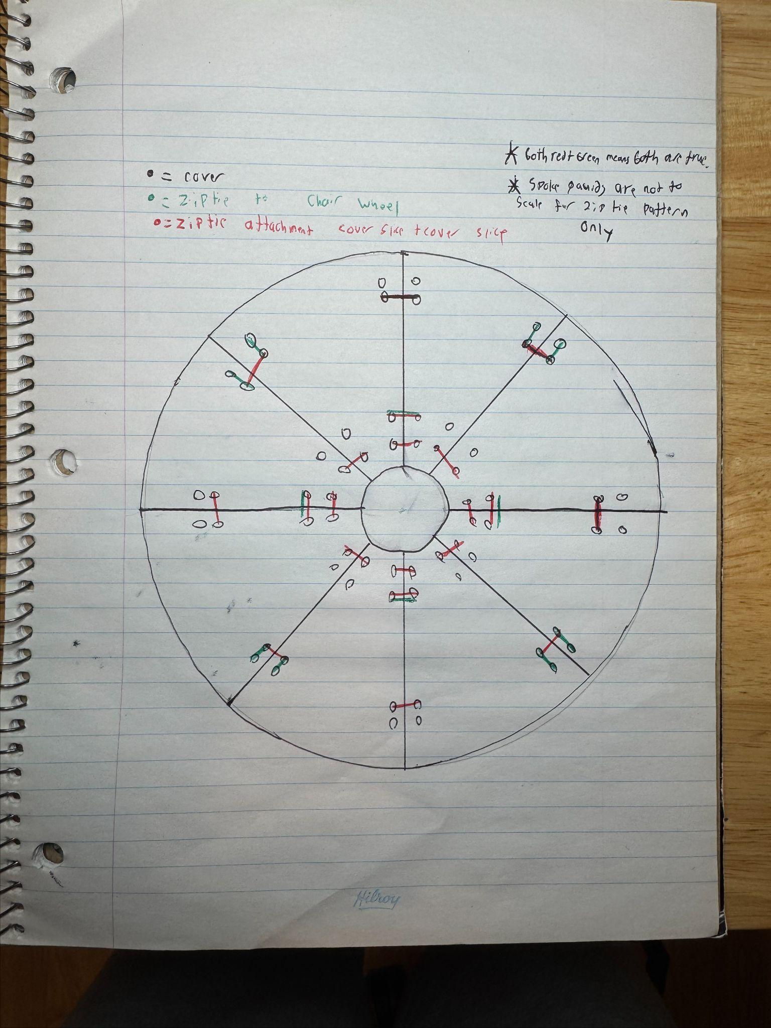
[0011] FIG. 4: Wheel‑attachment detail showing a fastener routed through an attachment aperture/slot and around a spoke and/or a hand‑rim post; the fastener head is oriented inboard.

Drawing placement instruction: Place FIGS. 1–4 immediately after paragraph [0013] (or collect all figures at the end of the specification).

DETAILED DESCRIPTION

[0012] Definitions. “Segment” means a panel portion of a wheel‑cover disc occupying a circumferential fraction of a circle. “Flexible fastener” includes cable ties (zip ties), metal ties, wire ties, reusable straps, hook‑and‑loop straps, silicone straps, and other elongated fasteners capable of being routed through an aperture/slot and tightened. “Wheel‑cover disc” means the assembled structure formed from multiple segments.

[0013] Segment count and intended wheel sizes. In a preferred embodiment, eight segments (N=8) form one wheel‑cover disc (approximately 45 degrees per segment), and sixteen segments form two discs for two wheelchair wheels. In non‑limiting alternatives, N may be 4, 5, 6, 8, 10, 12, or more segments, selected based on printer bed size, desired stiffness, aesthetics, and mounting pattern. The design is intended to fit common wheelchair wheel diameters up to about 26 inches, and may be scaled/parameterized for other sizes.

[0014] Segment geometry. Each segment includes: (i) an arcuate outer edge portion; (ii) an inner edge portion contributing to a central aperture; (iii) first and second radial edges forming seams with adjacent segments; and (iv) multiple apertures and/or slots positioned near one or more of the outer edge, inner edge, and radial edges. Apertures may include round holes and elongated slots.

[0015] Keyed seam (preferred). In a preferred embodiment, each segment is identical in overall planform and is “keyed” by having a tongue profile along one radial edge and a complementary groove profile along the other radial edge. When assembled, the tongue engages the groove to align the seam and resist relative shear. The tongue may be slightly undersized relative to the groove to accommodate printer tolerances and thermal expansion/contraction while maintaining sufficient engagement for use.

[0016] Apertures/slots and adaptable fastening. The apertures/slots provide routing paths for (i) seam retention fasteners and (ii) wheel‑attachment fasteners. In some embodiments, one or more elongated slots are provided to permit adjustable fastener placement to accommodate different spoke patterns and wheels with or without camber. A distributed slot/holes pattern allows the installer to select fastening points that avoid interference with wheel components and promote concentricity.

[0017] Fasteners and fastening pattern (representative). In a preferred embodiment, cable ties are used as flexible fasteners. A representative tie size is about 3 mm × 100 mm; other widths (e.g., about 1.8–4.8 mm) and lengths may be used, provided they fit the apertures/slots and can be tightened to maintain tension. A robust fastening map may employ multiple ties distributed around the disc; in a tested example, the total tie count may be on the order of about 28–32 ties per wheel, including multiple ties used for seam retention (e.g., two or more ties per seam as a non‑limiting example) and additional ties used for wheel attachment. Tie heads are oriented to the inboard side (toward the spoke cavity), and tie tails are flush‑cut.

[0018] Wheel attachment, placement, and clearance. After assembly, the disc is positioned on the outboard side of the wheel (in front of the spokes). The disc is secured by routing attachment fasteners through selected apertures/slots and around spokes, rim members, and/or hand‑rim posts (if present). The cover is intended to be compatible with wheels that include a hand rim and with wheels that omit a hand rim. Thickness is selected to balance stiffness with clearance and ergonomics; a preferred maximum thickness is about 6 mm, and a minimum thickness of 4mm

[0019] Non‑limiting dimensioned example from inventor's drawing. The inventor diagram titled “Wheelchair SpokeGaurd” (dated 2026‑02‑28) illustrates non‑limiting example dimensions including: 228.6 mm shown on the segment in more than one location; an arc/edge dimension of about 206.9 mm; hole callouts of Ø5 (5 mm diameter) at outer‑region holes; seam/engagement/run dimension 190.71 mm; a local seam feature length 26.94 mm; local dimension callouts including 26.36 mm, 29.16 mm, 31.95 mm; and seam/profile-related callouts including 2.12 mm, 3 mm, 1.5 mm, 2.5 mm, 4 mm, 11.16 mm, 2.34 mm, and 3.27 mm. These dimensions are examples and may be scaled/parameterized for different wheel diameters, hub apertures, and fastening maps.

[0020] Best mode (inventor‑preferred) 3D printing parameters. Each segment is printed by FDM/FFF using a 0.4 mm nozzle (preferably hardened steel) on a coreXY‑type printer, sliced using Bambu Studio or an equivalent slicer. Preferred settings include: 0.2 mm layer height; six perimeter walls (0.4 mm line width per loop); 5% infill (gyroid preferred); tree supports with ~30° overhang threshold where needed; random Z‑seam enabled; ironing enabled; printed flat on a PEI or grip build plate without brim or raft. Nozzle/bed temperatures follow filament manufacturer recommendations. Post‑processing is not required, but optional deburring may be performed.

[0021] Materials, environmental limits, and alternatives. Preferred materials include PETG for indoor/outdoor use below about 60 °C and ABS for higher‑temperature environments below about 95 °C. Other thermoplastics may be used (e.g., ASA, nylon (PA), polycarbonate (PC), filled polymers, PPS, and similar materials) if compatible with the printer and intended environment. PLA may be used, but it is less preferred for heavy outdoor or daily use. Fasteners may include disposable or releasable ties, metal ties, wire, hook‑and‑loop straps, silicone straps, and other fasteners (preferably ≤ about 5 mm width) capable of maintaining tight tension. The modular design permits the replacement of a single segment if damaged.

[0022] Manufacturing and installation method (example). (1) Manufacture N segments for one wheel. (2) Arrange segments circumferentially and engage keyed seams. (3) Route and tighten seam fasteners through seam apertures/slots to form a rigid disc. (4) Position the disc on the outboard side of the wheel. (5) Route and tighten wheel‑attachment fasteners through selected apertures/slots around wheel structures (spokes/rim/hand‑rim posts). (6) Ensure tie heads are inboard; flush‑cut tails; verify clearance, concentricity, and hand‑rim access if present.

[0023] Additional alternative embodiments (non‑limiting). Seams may use lap joints, dovetails, puzzle seams, overlapping seams, or other interlocks. Slots may be circumferential, radial, or keyed. Segments may include embossed/engraved/customized surface features. A kit may include a set of segments and a set of fasteners sufficient for assembly and wheel attachment.

Claims
- A modular wheel cover for a wheelchair drive wheel, comprising: a plurality of rigid segments arrangeable circumferentially to form a wheel‑cover disc, each rigid segment having: (i) an arcuate outer edge portion; (ii) an inner edge portion defining at least a portion of a central aperture; (iii) first and second radial edge portions; and (iv) a plurality of apertures or slots positioned to receive elongated flexible fasteners; and a plurality of flexible fasteners routed through at least some of the apertures or slots to secure adjacent rigid segments together along seams between the radial edge portions, thereby forming the wheel‑cover disc, wherein the wheel‑cover disc is configured to be attached to the wheelchair drive wheel using one or more additional flexible fasteners routed through at least some of the apertures or slots and around structural elements of the wheelchair drive wheel.

- The modular wheel cover of claim 1, wherein the plurality of rigid segments consists of eight segments, each segment spanning approximately 45 degrees of the wheel‑cover disc.

- The modular wheel cover of claim 1, wherein each seam between adjacent segments is secured by at least two flexible fasteners located at different radial distances from the central aperture.

- The modular wheel cover of claim 1, wherein at least one flexible fastener both (i) secures two adjacent segments together and (ii) secures the wheel‑cover disc to the wheelchair drive wheel. Accomplished by threading throught the 2 holes and wrapping around the spokes as illustrated by figure 4.

- The modular wheel cover of claim 1, wherein the flexible fasteners comprise cable ties.

- The modular wheel cover of claim 5, wherein the cable ties are about 3 mm wide and about 100 mm long.

- The modular wheel cover of claim 1, wherein at least some of the apertures or slots are elongated slots oriented substantially circumferentially, such that a fastener position is adjustable to accommodate different spoke patterns.

- The modular wheel cover of claim 1, wherein the rigid segments are additively manufactured polymer segments.

- The modular wheel cover of claim 8, wherein the polymer segments comprise PETG or ABS.

- The modular wheel cover of claim 1, wherein the wheel‑cover disc is configured to be positioned on an outboard side of the wheelchair drive wheel while maintaining access to a hand rim of the wheelchair drive wheel.

- A kit comprising: the modular wheel cover of claim 1 in an unassembled state; and a set of cable ties sufficient to secure the plurality of rigid segments together and secure the wheel‑cover disc to the wheelchair drive wheel.

- A method of installing a modular wheel cover on a wheelchair drive wheel, the method comprising: arranging a plurality of rigid segments circumferentially to form a disc; routing first cable ties through seam slots of adjacent segments and tightening the first cable ties to form an assembled wheel‑cover disc; positioning the assembled wheel‑cover disc on an outboard side of the wheelchair drive wheel; and routing second cable ties through attachment slots of the assembled wheel‑cover disc and around structural elements of the wheelchair drive wheel to secure the assembled wheel‑cover disc to the wheelchair drive wheel.

Key variable parameters (non‑limiting) — summary table

Parameter | Preferred/example | Alternatives/range
Segments per wheel (N) | 8 | 2,3,4, 5, 6, 8, 10, 12, or more
Target wheel diameter | up to ~26 in | scalable/parameterized
Min thickness | ~4mm | ~2mm
Max thickness | ~5mm | ~8mm
Hub aperture | 4 in diameter | parameterized per hub
Fasteners | zip ties, wire/metal ties, hook‑and‑loop, silicone straps | other ≤~5 mm width
Preferred tie size | ~3 mm × 100 mm | ~1.8–4.8 mm width; ~80–160 mm length
Total ties per wheel | ~28–32 | varies by wheel + slot map
Print process | FDM | Other suitable fabrication is possible
Nozzle | 0.4mm | 0.2mm-0.8mm
Layer Height | 0.2mm | ~0.12mm-0.3mm
Walls | 4 | 2-10
Infill | 5%: gyroid | ~0–25%: any pattern
Supports | tree supports; ~30° threshold as needed | any supports; ~30° threshold as needed
Materials | PETG, ABS, ASA, Nylon, PC | Filled polymers, PPS, PLA (less preferred for heavy outdoor use)

Prior-art differentiation and open items
Prior-art differentiation paragraph (short)
Wheelchair spoke guards and wheel covers are commercially known, and published instructions show that cable ties are used to mount spoke guards with tie heads oriented on the inside of the wheel cavity. Wheel cover patents also exist, supporting that a “wheel cover” concept may be treated as known baseline subject matter. This disclosure differentiates by emphasizing a modular segmented architecture optimized for small-format 3D printing, keyed tongue‑and‑groove seam alignment, a distributed hole/slot pattern enabling adaptable tie routing across spoke patterns and cambered wheels, and modular repair/customization by replacing individual segments.

