Part 3: Query the Database
Manager (ManagerID, Name, PhoneNumber, Email, Address, City)
Department (DeptID, DeptName, ManagerID)
Staff (StaffID, Name, PhoneNumber, Email, Address, City, DeptID)
Student (StudentID, Name, PhoneNumber, Email)
Course (CourseID, CourseName, CourseType)
Assignment (AssignID, AssignType, MaxScore, CourseID)
Grade (GradeID, AssignID, Score)
StudentStaff (StudentID, StaffID)
StudentCourse (StudentID, CourseID)

15 complex SQL queries
Query 1: List each department, its manager, and the number of staff in that department.
SELECT d.DeptName, m.Name AS Manager_name, COUNT(s.StaffID) AS Number_of_staff FROM Department d
JOIN Manager m ON d.ManagerID = m.ManagerID
JOIN Staff s ON d.DeptID = s.DeptID
GROUP BY d.DeptID, d.DeptName, m.ManagerID, m.Name
ORDER BY d.DeptID;
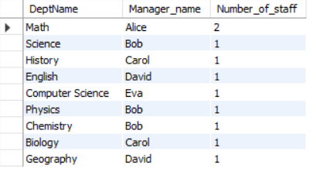

Query 2: Find all students who are taking more than 1 course.
SELECT s.StudentID, s.Name, COUNT(sc.CourseID) AS TotalCourse FROM Student s
JOIN StudentCourse sc ON s.StudentID = sc.StudentID
JOIN Course c ON sc.CourseID = c.CourseID
GROUP BY s.StudentID, s.Name
HAVING COUNT(DISTINCT sc.CourseID) > 1;


Query 3: Show each staff member with the department name and the manager responsible for that department.
SELECT s.StaffID, s.Name AS Staff_Name, d.DeptName, m.Name AS Reponsible_Manager FROM Staff s
JOIN Department d ON s.DeptID = d.DeptID
JOIN Manager m ON d.ManagerID = m.ManagerID
ORDER BY s.StaffID;
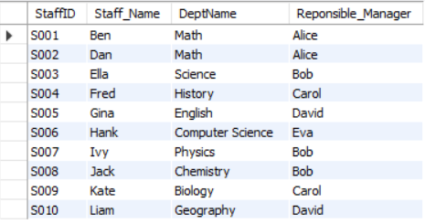

Query 4: List all students supervised by staff in the Math department.
SELECT DISTINCT s.StudentID, s.Name AS Student_Name FROM Student s
JOIN StudentStaff ss ON s.StudentID = ss.StudentID
JOIN Staff sf ON ss.StaffID = sf.StaffID
JOIN Department d ON sf.DeptID = d.DeptID
WHERE d.DeptName = 'Math';
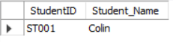

Query 5: Find the highest score achieved in each assignment type.
SELECT a.AssignType, MAX(g.Score) AS HighestScore FROM Assignment a
JOIN Grade g ON a.AssignID = g.AssignID
GROUP BY a.AssignType;
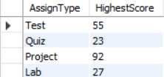

Query 6: List all courses with the number of students enrolled in each course.
SELECT c.CourseName, COUNT(sc.StudentID) AS TotalStudents FROM Course c
JOIN StudentCourse sc ON c.CourseID = sc.CourseID
GROUP BY c.CourseName;
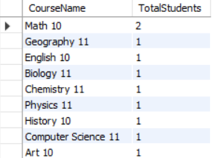

Query 7: Display each student with their total score across all assignments.
SELECT s.StudentID, s.Name, SUM(g.Score) AS TotalScore FROM Student s
JOIN StudentCourse sc ON s.StudentID = sc.StudentID
JOIN Assignment a ON sc.CourseID = a.CourseID
JOIN Grade g ON a.AssignID = g.AssignID
GROUP BY s.StudentID, s.Name;
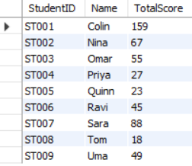

Query 8: Find all staff who supervise more than one student.
SELECT ss.StaffID, s.Name, COUNT(ss.StudentID) AS TotalStudents FROM StudentStaff ss
JOIN Staff s ON ss.StaffID = s.StaffID
GROUP BY ss.StaffID, s.Name
HAVING COUNT(ss.StudentID) > 1;


Query 9: List all assignments where the average score is higher than 95%.
SELECT a.AssignID, a.AssignType, AVG(g.Score), a.MaxScore FROM Assignment a
JOIN Grade g ON a.AssignID = g.AssignID
GROUP BY a.AssignID, a.AssignType, a.MaxScore
HAVING AVG(g.Score) > (a.MaxScore * 0.95);
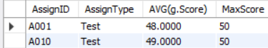

Query 10: List all students along with how many assignments they have grades for.
SELECT s.StudentID, s.Name, COUNT(g.GradeID) AS TotalGradedAssignments FROM Student s
JOIN StudentCourse sc ON s.StudentID = sc.StudentID
JOIN Assignment a ON sc.CourseID = a.CourseID
JOIN Grade g ON a.AssignID = g.AssignID
GROUP BY s.StudentID, s.Name;
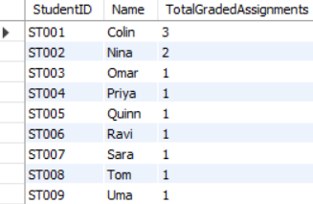

Query 11: List all courses with their total assignment weight, sorted from highest to lowest.
SELECT c.CourseName, SUM(a.MaxScore) AS TotalAssignmentWeight FROM Course c
JOIN Assignment a ON c.CourseID = a.CourseID
GROUP BY c.CourseName
ORDER BY TotalAssignmentWeight DESC;


Query 12: List students who have at least one grade above 90.
SELECT DISTINCT s.StudentID, s.Name FROM Student s
JOIN StudentCourse sc ON s.StudentID = sc.StudentID
JOIN Assignment a ON sc.CourseID = a.CourseID
JOIN Grade g ON a.AssignID = g.AssignID
WHERE g.Score > 90;
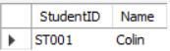

Query 13: Count how many courses each course type has.
SELECT CourseType, COUNT(CourseID) AS TotalCourses FROM Course
GROUP BY CourseType;


Query 14: List all students who are enrolled in at least one course that is an Online course.
SELECT s.StudentID, s.Name FROM Student s
WHERE EXISTS(
SELECT * FROM StudentCourse sc
JOIN Course c ON sc.CourseID = c.CourseID
WHERE sc.StudentID = s.StudentID
AND c.CourseType = 'Online');
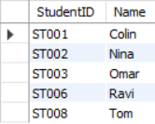

Query 15: List departments that have no staff assigned.
SELECT d.DeptID, d.DeptName FROM Department d
WHERE NOT EXISTS (
SELECT * FROM Staff s
WHERE d.DeptID = s.DeptID);
