**IS6025 Design Thinking For Business Analytics**

**Introduction**

This course helps me to understand the user centric problem-solving skills and with sustainable innovation. Working with different approaches taught me the value of interaction among team and building a business idea out of it. Our project ECO-VOYAGE focused on resolving the issues by urban traveler, showcasing with the how I learnt the structured methodologies and formed a solution out of it, This essay explores my experience of applying design thinking principle to create the solutions for the ECO VOYAGE business.

**THE JOURNEY**

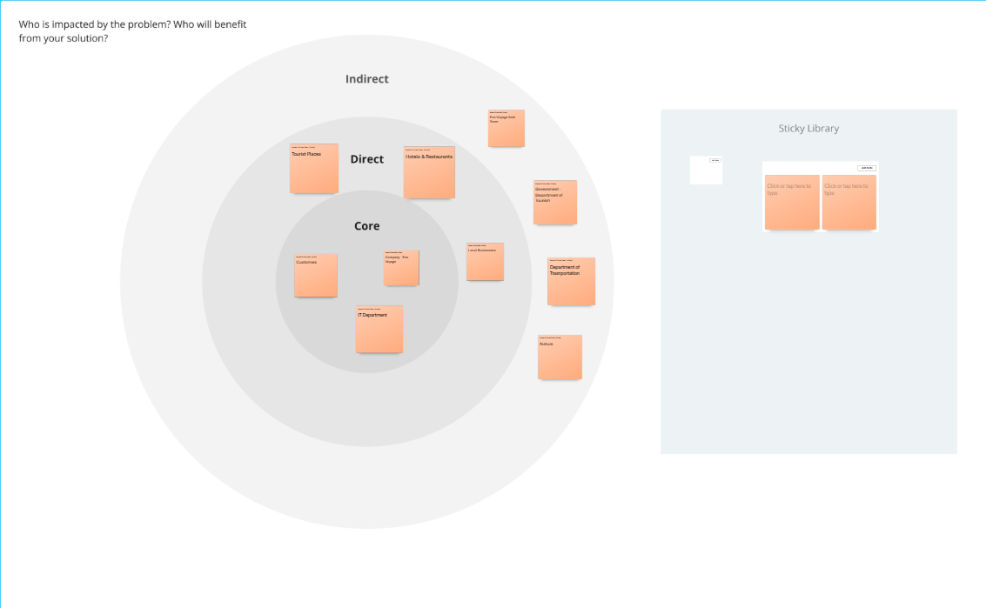

**(Fig. 1: Individual Stakeholder Map)**

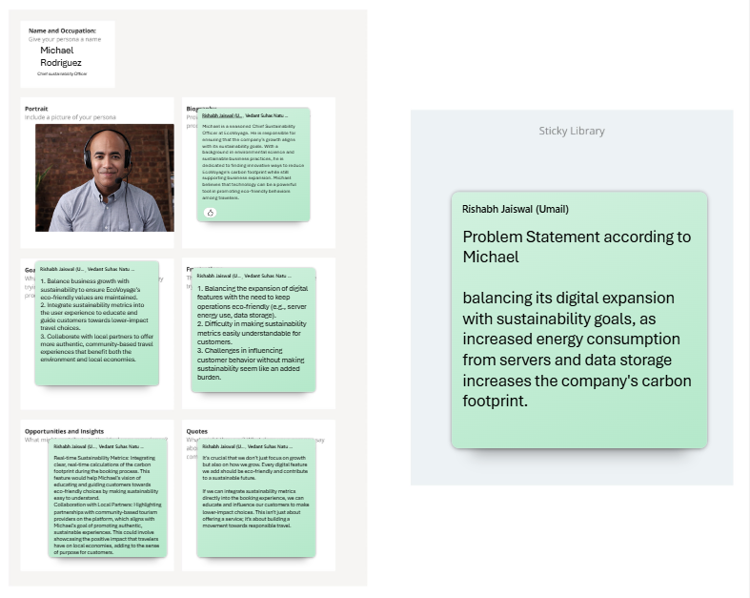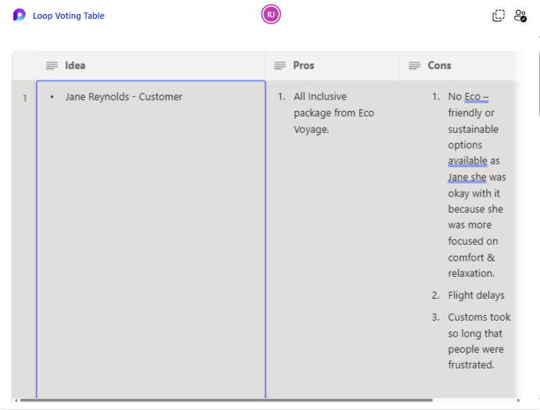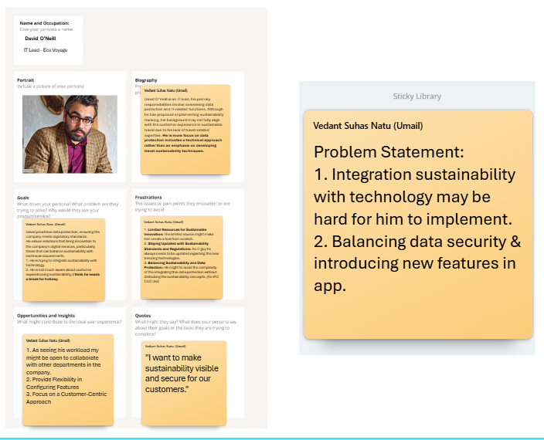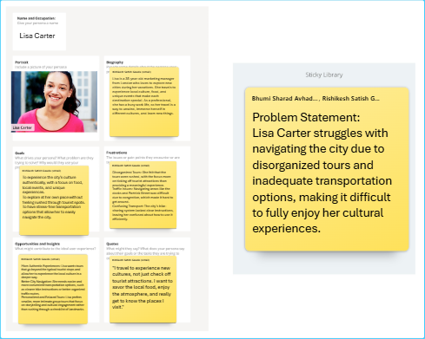(**Figure. 2.1 Persona) (Figure. 2.2 Persona)**

**(Figure 2.3 Persona) (Figure. 3.1 Loop Voting Table)**

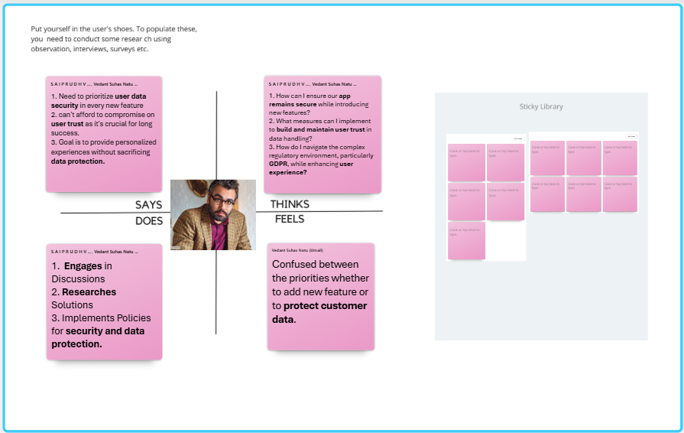In the *research* *phase* we began by creating the individual Stakeholder map **(*Fig. 1)*,** which were then merged into one stakeholder map considering all inputs of other comrades as well. This exercise helped us to identity key stakeholder affected by other indirect and direct stakeholders. Instead of moving to empathy phase, we moved to Persona’s phase listening and shortlisting major 3 Persona’s ***(Fig. 2.1), (Fig. 2.2), (Fig 2.3)*** from 8 interviews using *Loop Voting Table* ***(Fig. 3.1).***

**(Figure 4.1 Empathy Map)**

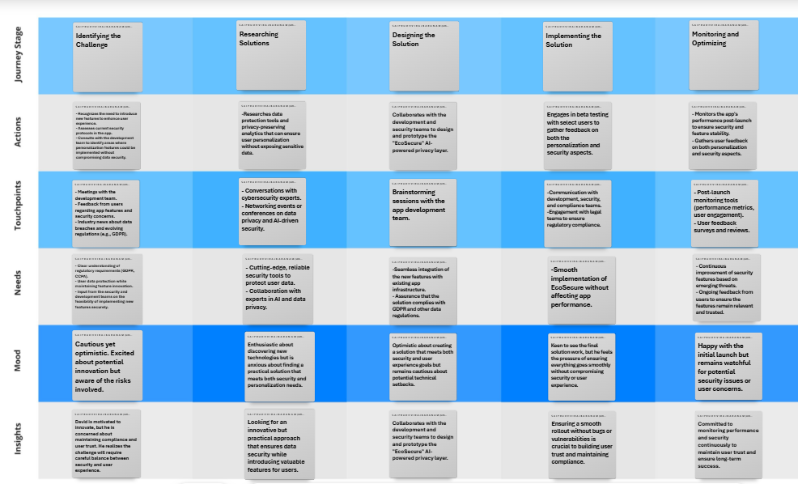**(Figure 5.1: Journey Map)**

After shortlisting persona’s then we moved to *Empathy Map* ***(Fig. 4.1)*** personal contributing in this stage was to make empathy map of ECO-VOYAGE tech leads empathy map. Later we moved on to *Journey Map* ***(Fig. 5.1).*** Stating the Journey stage, Actions, touchpoints, Needs, Moods, Insights etc. We also derived the information source and service my persona- putting myself in tech lead shoes.

**Defining the Problem Statement**

Using all the flow of *Stakeholder Map* **(*Fig. 1),*** *Persona’s* ***(Fig. 2.1), (Fig. 2.2),******(Fig 2.3)****, Empathy Map* ***(Fig. 4.1),*** *Customer Journey Map* ***(Fig. 5.1).***We shortlisted major problem, which was our problem statement was *“Lisa Carter struggles with navigating the city due to disorganized tours and inadequate transportation options, making it difficult to fully enjoy her cultural experiences”*

**Ideate**

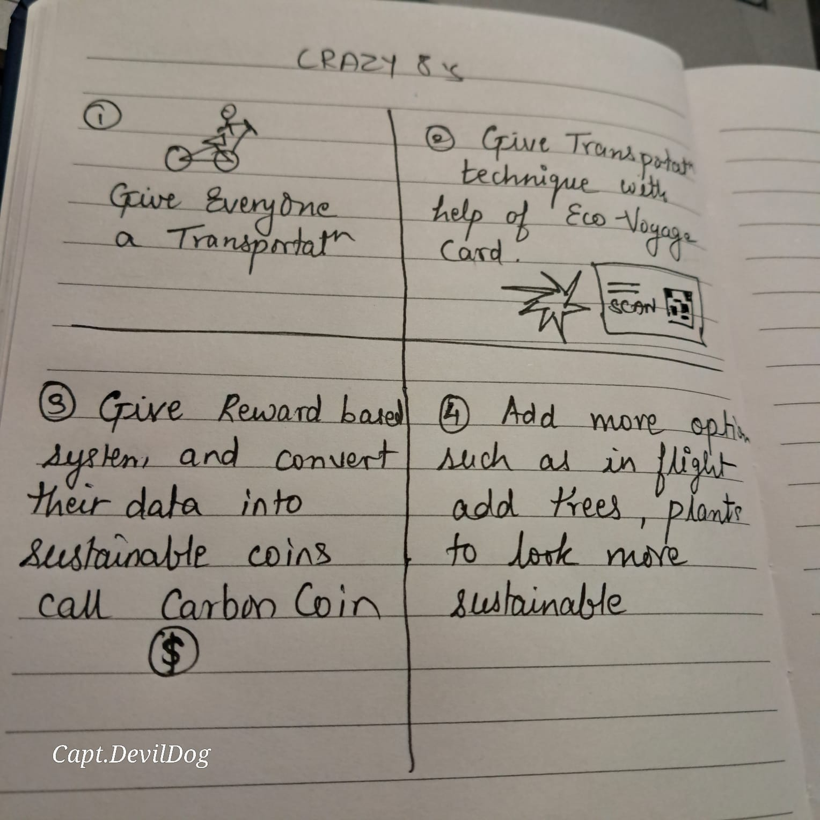

**(Figure. 6.1: Crazy 8s)**

After describing our problem we started to find the solution. We brainstormed several solutions including AR VR virtual tours, personalized idea for smaller groups, We used technic of crazy 8’s which help us to get ideas out of the box. My crazy 8s***(Fig. 6.1)****.* We later shortlisted the one solution Number 3 that *“instead on keeping data stored we will use it as Carbon Cash Rewards which also help to our sustainable goals”.*

Collaborating with teammates enriched the ideation process, everyone bought their unique idea which led to well rounded solution. This stage personally taught me the value of open minded decision and power of combining the idea to create impactfull outcomes. Once the Ideate stage was complete, I moved to prototyping stage.

**Prototyping**

Later after completing the Ideate stage I started creating wireframes learning how prototyping, how to design wireframes (freeCodeCamp.org, 2020), Later I started making rough sketches, implementing another thoughts about UI designing and all.

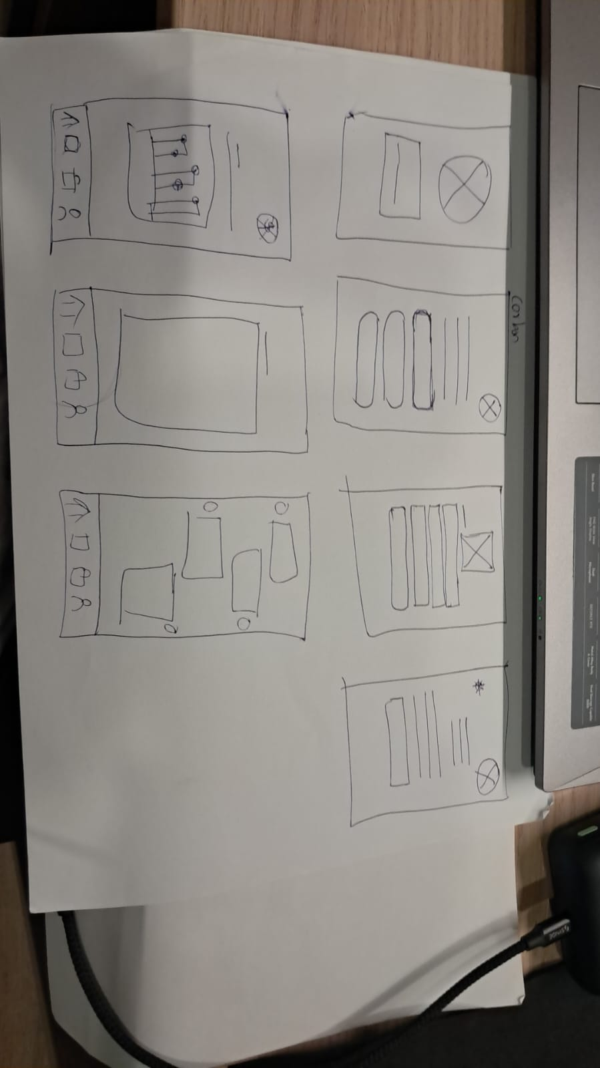

**(Figure. 7.1: Rough Inputs from Teammates)**

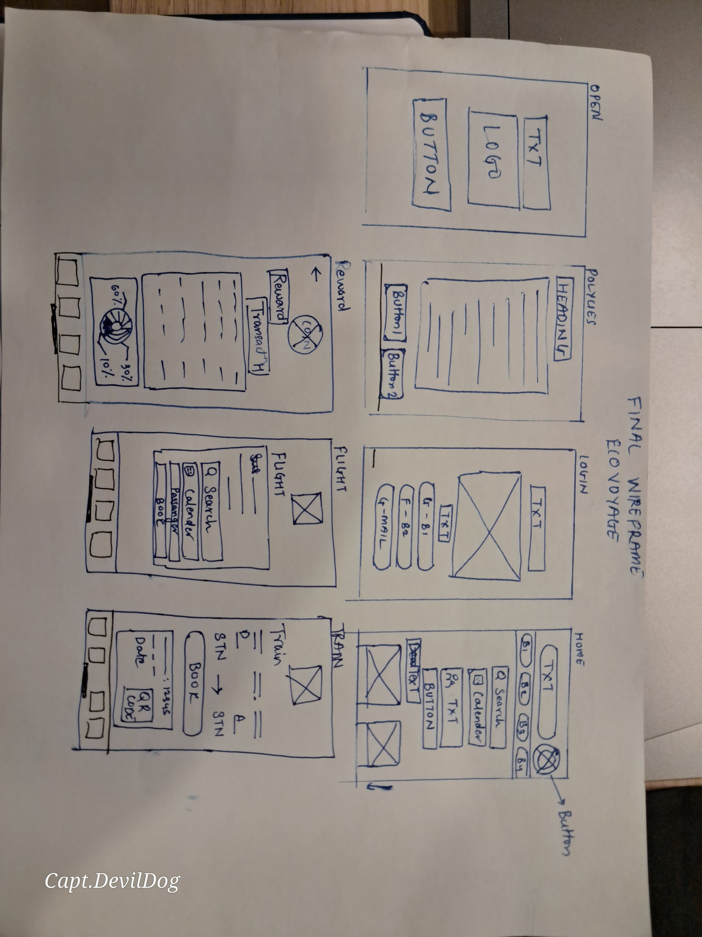

**(Figure. 7.2 : Final Wireframe Design I made)**

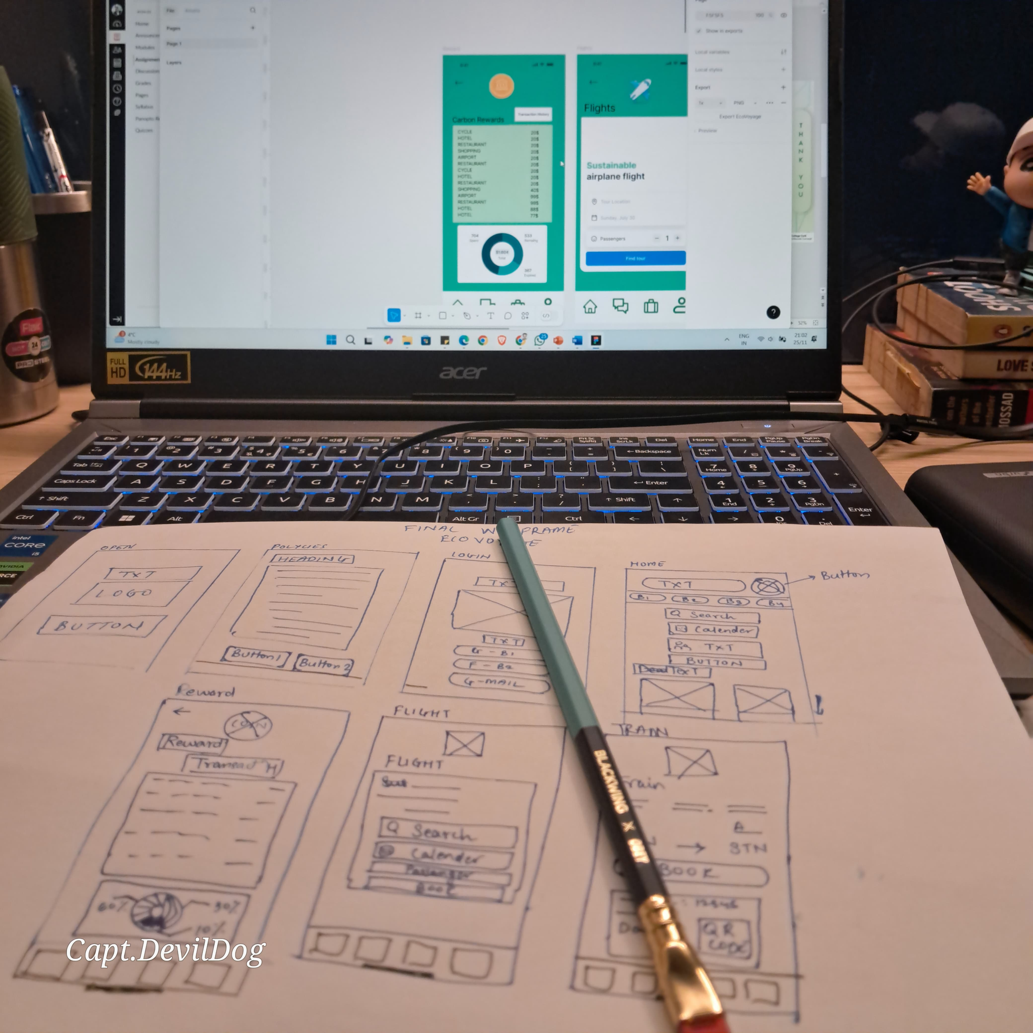

**(Figure. 7.3: Prototyping Progress in Figma)**

*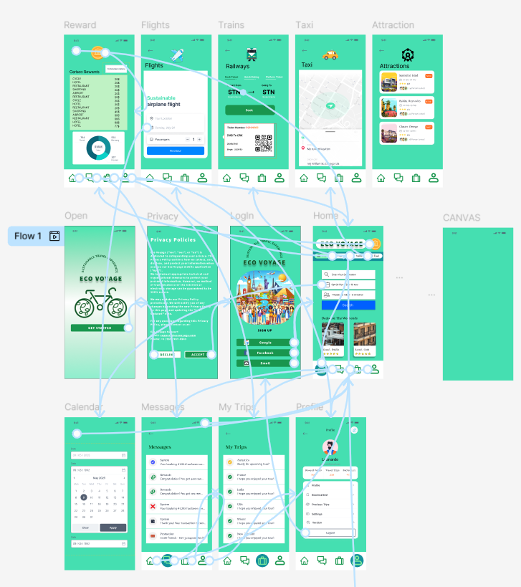****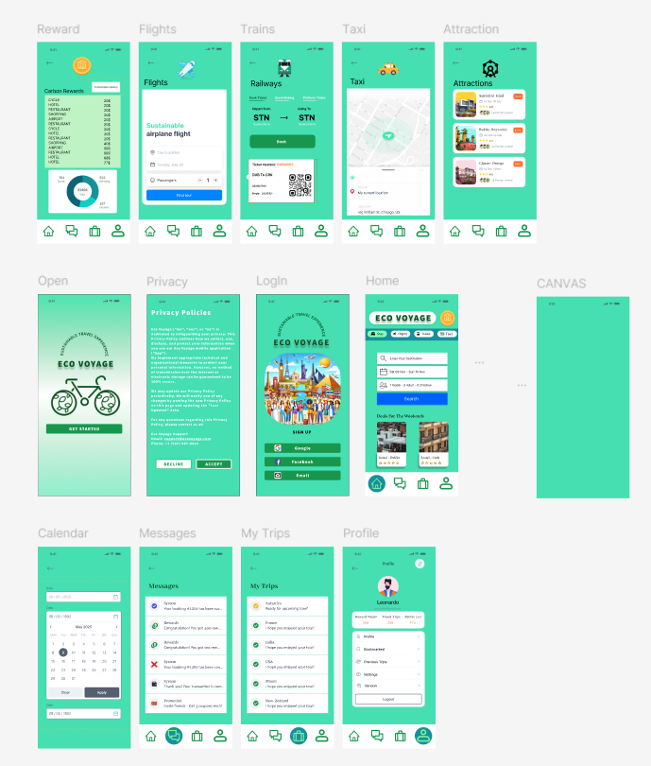***My main roll was here. I started focusing on mockups sketches, wireframing, creating a story board, and prototyping. I also started collecting inputs from the teammates. We made the the final design and proceed to prototyping. I didn’t had an idea how is so process of creating UI so I started using Figma Tool (*Figma for Education | Free Tools for the Classroom*, n.d.) as Prof. Andrew suggested during the lecture. Other than that I learnt Figma from outer source such as YouTube videos (*Figma UI Design Tutorial: Get Started in Just 24 Minutes! - YouTube*, n.d.), Reading blogs (Pruciak, 2022)**.** After personal learning phase I started actual designing Rough Work ***(Fig.7.1)*** then proceed with Final Design As shown in ***(Fig. 7.2).*** Once after design was ready I started creating try and error prototypes. ***(Fig. 7.3).*** I also used AI tool call design.com to create the logo of the ECO-VOYAGE company **[Link:** (VEDANT, 2024)**].**

**(Figure. 8.1: Eco Voyage Framework) (Figure: 8.2: Prototyping)**

Although we didn’t have time for extensive testing, we planned to gather feedback from team member as well as Prof. Andrew Pope regarding the framework and prototype in Figma **[Link:**(VEDANT, 2024)**].** Their insights helped & guide us in refining the prototypes further. I tried to create the app UI for Eco Voyage framework ***(Fig. 8.1****)* And Prototyping Nodes connection ***(Fig. 8.2).*** I also used the Iconify Figma plugins to use icons such as home, message, coins, Train, Taxi, Google, attractions etc. (Vjacheslav, 2024)

**Figma Prototype Link:** [**https://www.figma.com/proto/iv8kwrUIOOnCGYrAJynln3/EcoVoyage?node-id=27-98&t=ve5uvL1L5wzFNK45-1&starting-point-node-id=27%3A98**](https://www.figma.com/proto/iv8kwrUIOOnCGYrAJynln3/EcoVoyage?node-id=27-98&t=ve5uvL1L5wzFNK45-1&starting-point-node-id=27%3A98)

**Conclusion**

This project provided valuable insights into the practical application of design thinking. By Empathizing with the user and Defining a clear problem, I gained the deeper perspective from user approach. The Ideation process taught me how to constantly interact with the people for new and creative idea which might be out of the box. The Prototyping phase highlighted the importance of the feedback from user point. Design thinking has not only shaped my approach to analytics but also inspired me to prioritize innovation and sustainability in all aspects of my work.

**References**

*Figma for Education | Free Tools for the Classroom*. (n.d.). Figma. Retrieved 26 November 2024, from https://www.figma.com/education/

*Figma UI Design Tutorial: Get Started in Just 24 Minutes! - YouTube*. (n.d.). Retrieved 26 November 2024, from https://www.youtube.com/watch?v=FTFaQWZBqQ8

freeCodeCamp.org (Director). (2020, September 3). *How to Design a Website – A UX Wireframe Tutorial* [Video recording]. https://www.youtube.com/watch?v=pN92rnO_n5U

Pruciak, M. (2022, February 24). *21 Dazzling Examples of Mobile App UI Design to Inspire You in 2023*. https://www.ideamotive.co/blog/dazzling-examples-of-mobile-app-ui-design

VEDANT, N. (2024). *Eco-Voyage, LOGO* [Graphic]. https://www.design.com/maker/logo/eco-green-bicycle-145124?text=ECO+VOYAGE&isVariation=True

VEDANT, N. (2024, November 6). *EcoVoyage Prototyping Link*. https://www.figma.com/proto/iv8kwrUIOOnCGYrAJynln3/EcoVoyage?node-id=0-1&t=ve5uvL1L5wzFNK45-1.

Vjacheslav. (2024, October 29). *Iconify*. Figma. https://www.figma.com/community/plugin/735098390272716381/iconify