# MIS 344 Lab 1

You will need to complete each section of this document then upload it to Blackboard. Save your document with the following naming convention:

* CourseNumber_Assignment Number_First Initial Last Name (Example: MIS344_Lab1_LStewart.docx)

Instructions

Overview

For this assignment you ae going to be asked to create Crystal Reports with specific criteria and specifications. To obtain the correct dataset it is helpful to get familiar with the database (*use the data dictionary)* and also write out SQL queries in Microsoft SQL Server to help you get the correct output.

This lab provides hands-on experience connecting to a data source, mining the data, and displaying the data meaningfully.

It is common to find challenges when working with datasets. Especially when working with large enterprise level databases. In order to navigate through a database it is helpful to have a data dictionary to help identify where the requested data lives within the database.

You must demonstrate as much of the solution as possible. Here is a link to download Crystal Reports for Visual Studio: <https://www.crystalreports.com/crystal-reports-visual-studio/>

To download, install and start a project view video resource in Blackboard.

Carefully read and complete Parts A, B, C and D.

**Part A**

Use Visual Studio to create a Crystal Report. The database you will want to connect to will be CPS95E that you should have restore into Microsoft SQL Server.

Use the *standard report* wizard create a report that displays all patient’s names in the system grouped by their Gender.  
  
Name the Crystal Report, Lab 1 Part A Your Name.rpt Example: Lab1PartA_LStewart.rpt

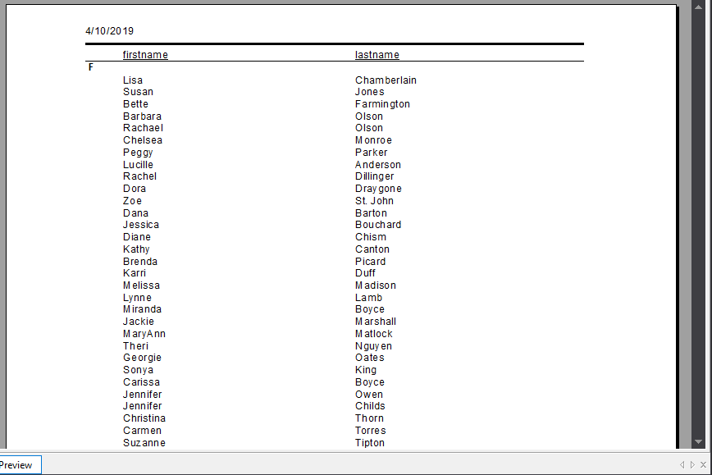

**Part B**

Use Visual Studio to create a Crystal Report. The database you will want to connect to will be CPS95E that you should have restore into Microsoft SQL Server.

Create a report that uses a formula to display all patients by age. Hint: *Patients DOB is stored in the CPS95E system but age is not stored. You must create a formula to calculate this. Be sure to take into account leap year which is 365.25.*

Once your formula is written you need to group your patients into the following groupings:

Ages   
0-1  
1-2  
2-5  
5-10  
10-15  
15-20  
20-25  
25-30  
30-40  
40-50  
50-60  
60+

This report must include patient demographics, gender, name, race, city, state. Make sure you only include patients. Hint: *There are more than one way of getting this data. One way could be to use the person table but that table also includes physicians. Look at the various attributes and see how you can extract just patient data.*

The output of the report should look like:

Age: 30-40

|  |  |  |  |  |
| --- | --- | --- | --- | --- |
| Name | Gender | Race | City | State |
| John, Smith | M | White | Klamath Falls | OR |
| Doe, Jane | F | White | Portland | OR  # of patients: 2 Total Patients: 248 |

Name the Crystal Report, Lab 1 Part B Your Name.rpt Example: Lab1PartB_LStewart.rpt  
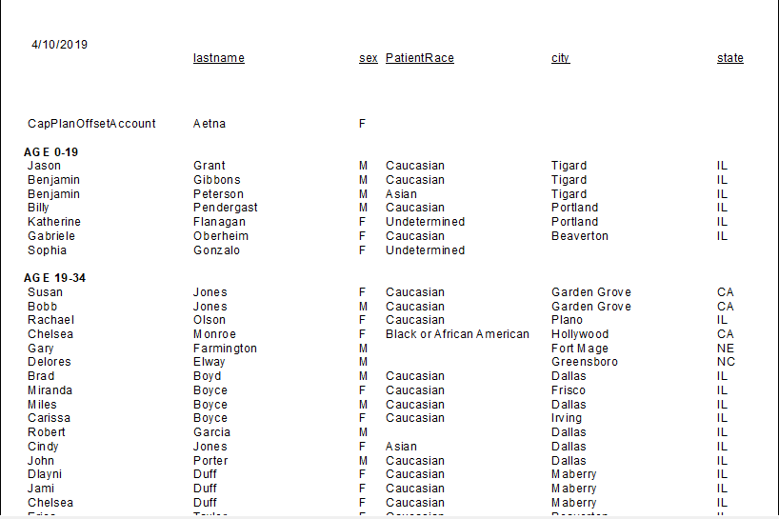

**Part C**

Use the Adventure Works database for this part of the lab. This database does not come with a data dictionary. Use Microsoft SQL Server to create an ERD and to get familiar with the dataset.   
  
Create a Crystal Report that gives a snapshot of all of the sales representatives by territory. Display their current quota, sales figures and email. Be sure to provide summary information for the group and territory

The output of the report should look like:

**North America**

Northwest

|  |  |  |  |  |  |
| --- | --- | --- | --- | --- | --- |
| Name | Email | State | YTD Sales | Quota | Met Quota |
| Ansman-Wolfe, Pamela | pamela0@adventure-works.com | Oregon | $1,352,577 | $250,000 | Y |
| Campbell, David | david8@adventure-works.com | Washington | $1,573,013 | $250,000 | Y |
| Mensa-Annan, Tete | tete0@adventure-works.com | Massachusetts | $1,576,562 | $300,000 | Y |

Name the Crystal Report, Lab 1 Part C Your Name.rpt Example: Lab1PartC_LStewart.rpt

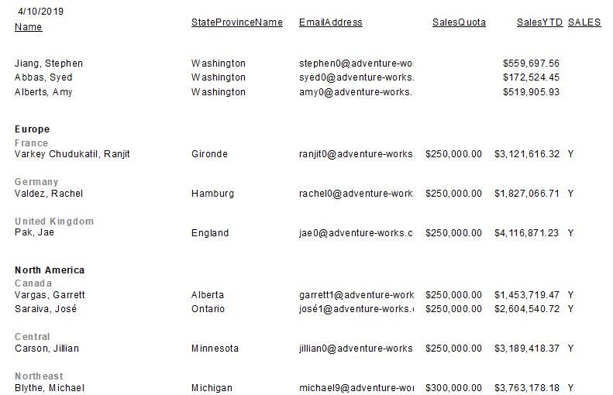

**Part D**   
  
Use the Adventure Works database for this part of the lab. This database does not come with a data dictionary. Use Microsoft SQL Server to create an ERD and to get familiar with the dataset.  
  
Create a Crystal Report that displays a grouping of employees by department.   
  
The output of the report should look like:

**Dept. Name: Information Services  
Group Name: Executive and Administration**

|  |  |  |  |  |  |
| --- | --- | --- | --- | --- | --- |
| National ID | Name | Age | Title | Rate /hr | Pay Frequency |
| 643805155 | Ajenstat, Francois | 43 | Database Administrator | $38.46 | Monthly |
| 929666391 | Wilson, Dan | 42 | Database Administrator | $38.46 | Monthly |
| 441044382 | Trenary, Jean | 42 | Info. Services Manager | $50.48 | Monthly |

Information Services: 10 Employees  
Companywide: 334 Employees

Name the Crystal Report, Lab 1 Part D Your Name.rpt Example: Lab1PartD_LStewart.rpt

