# MIS 344 Lab 2

You will need to complete each section of this document then upload it to Blackboard. Save your document with the following naming convention:

* CourseNumber_Assignment Number_First Initial Last Name (Example: MIS344_Lab5_LStewart.docx)

Instructions

Overview

For this assignment you ae going to be asked to create Crystal Reports with specific criteria and specifications. To obtain the correct dataset it is helpful to get familiar with the database (*use the data dictionary)* and also write out SQL queries in Microsoft SQL Server to help you get the correct output.

You must demonstrate as much of the solution as possible. Video resources on how to connect to Microsoft SQL Server and create Crystal Reports in Visual Studio can be found in BB.

Carefully read and complete Parts A, B, C and D.

**You will add the following to all reports in this and future Crystal Report labs.**

* Programmed Title and create a description for each report
* Page number and author must be in the footer as well as the file path
* In the header add the date the instance of the report was ran.
* Use colors to distinguish different grouping hierarchies.
* Use different fonts for level of importance, and utilize bolding.

**Part A**

Use Visual Studio to create a Crystal Report. The database you will want to connect to will be CPS95E that resides in Microsoft SQL Server.   
  
Create a report that displays all prescriptions by a patient’s medical record number (this is different than the PID). Display the medication name or description; the clinical date the meds were filled as well as the qty. and the number of refills available, if the result is nothing create a formula to display “N/A” in the place of the blank field.

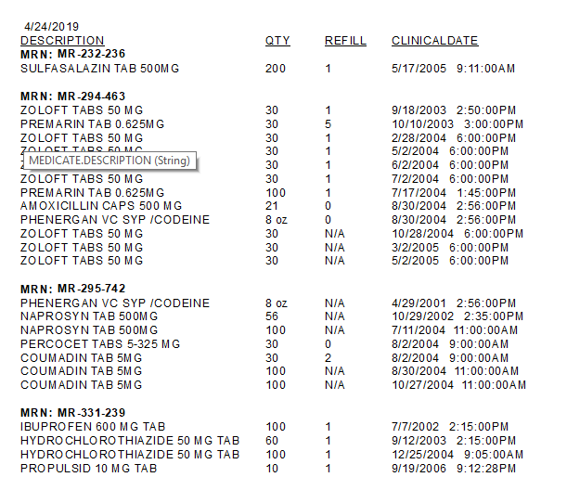  
  
Name the Crystal Report, Lab 2 Part A Your Name.rpt Example: Lab2PartA_LStewart.rpt

**Part B**

Use Visual Studio to create a Crystal Report. The database you will want to connect to will be CPS95E that resides in Microsoft SQL Server.  
  
Create a report that only shows persons that are not a provider or a patient. These patients have data integrity issues and you need to report the inaccuracies to your clinical manager to fix the issues. You will also need to group persons by race.

In addition, include the following report fields: person’s id, name, null fields requested, address and phone number.

😊

Name the Crystal Report, Lab 2 Part B Your Name.rpt Example: Lab2PartB_LStewart.rpt

**Part C**

Use Visual Studio to create a Crystal Report. The database you will want to connect to will be CPS95E that resides in Microsoft SQL Server.

Create a report that allows a user to view all patients by the allergy entered by the user. Pre-populate the parameter with the different options. Allow the user to select multiple allergies. The report must group patients by the allergy description and provide a distinct count of the # of patients by allergy description.

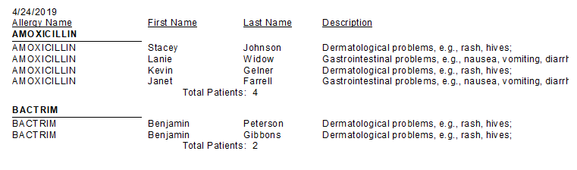  
Name the Crystal Report, Lab 2 Part C Your Name.rpt Example: Lab2PartC_LStewart.rpt

**Part D**

Use Visual Studio to create a Crystal Report. The database you will want to connect to will be CPS95E that resides in Microsoft SQL Server.

Create a report that provides information on all Hispanic patients by the age range selected by the user. The report needs to also display what immunizations each patient has had.

Provide a count of immunizations for each patient as well as a distinct count of immunizations by patient.

90700

Hispanic with immunizations:

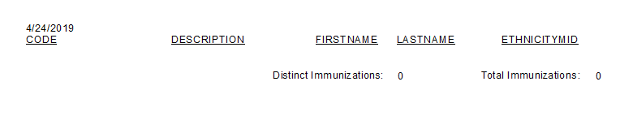

Non-Hispanics who have received immunizations, and the count of shots:

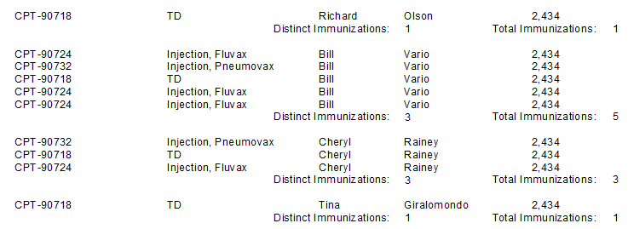

People with a BirthDate of “11/8/1973 12:00:00 AM” with immunizations:

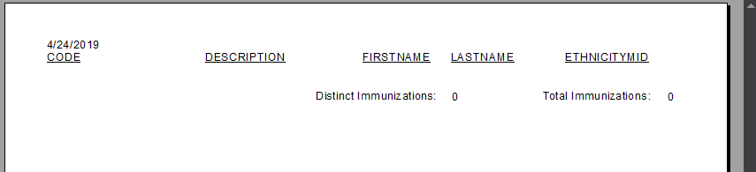

Name the Crystal Report, Lab 2 Part D Your Name.rpt Example: Lab2PartD_LStewart.rpt