# MIS 344 Lab 3

You will need to complete each section of this document then upload it to Blackboard. Save your document with the following naming convention:

* CourseNumber_Assignment Number_First Initial Last Name (Example: MIS344_Lab5_LStewart.docx)

Instructions

Overview

For this assignment you are going to be asked to create a Power BI dashboard. To begin you will need to get Power BI Desktop, overview the applications functions and features, get familiar with accessing, modeling and visualizing data and creating the dashboard itself. Complete all of the parts of the lab, imbed screenshots to show you completed each section and then submit this document to Blackboard.

In order to save textbook cost, we will be using Microsoft Guided learning literature and activities.

**Part A Get Power BI**

The lesson you will be completing for this part of the lab are through Microsoft Power BI Guided Learning. You can access the Power BI download either through Microsoft Office 360 or through a free download found in the following link: <https://powerbi.microsoft.com/en-us/get-started/?&OCID=AID719832_SEM_bHb24t0B&lnkd=Google_PowerBI_Brand&gclid=EAIaIQobChMIkuXY-4Wo4QIVFKvsCh2W4QEuEAAYASAAEgJ1avD_BwE>

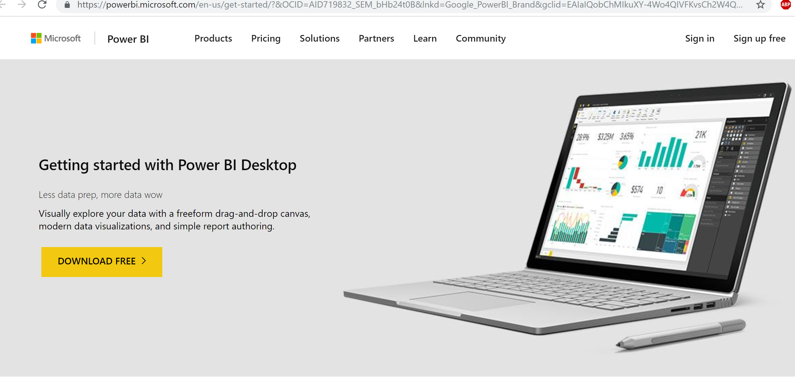

Before installing Power BI complete the “Getting Started” Section of the guided learning activity. Here is the link to Microsoft Guided Learning site: <https://docs.microsoft.com/en-us/power-bi/guided-learning/>

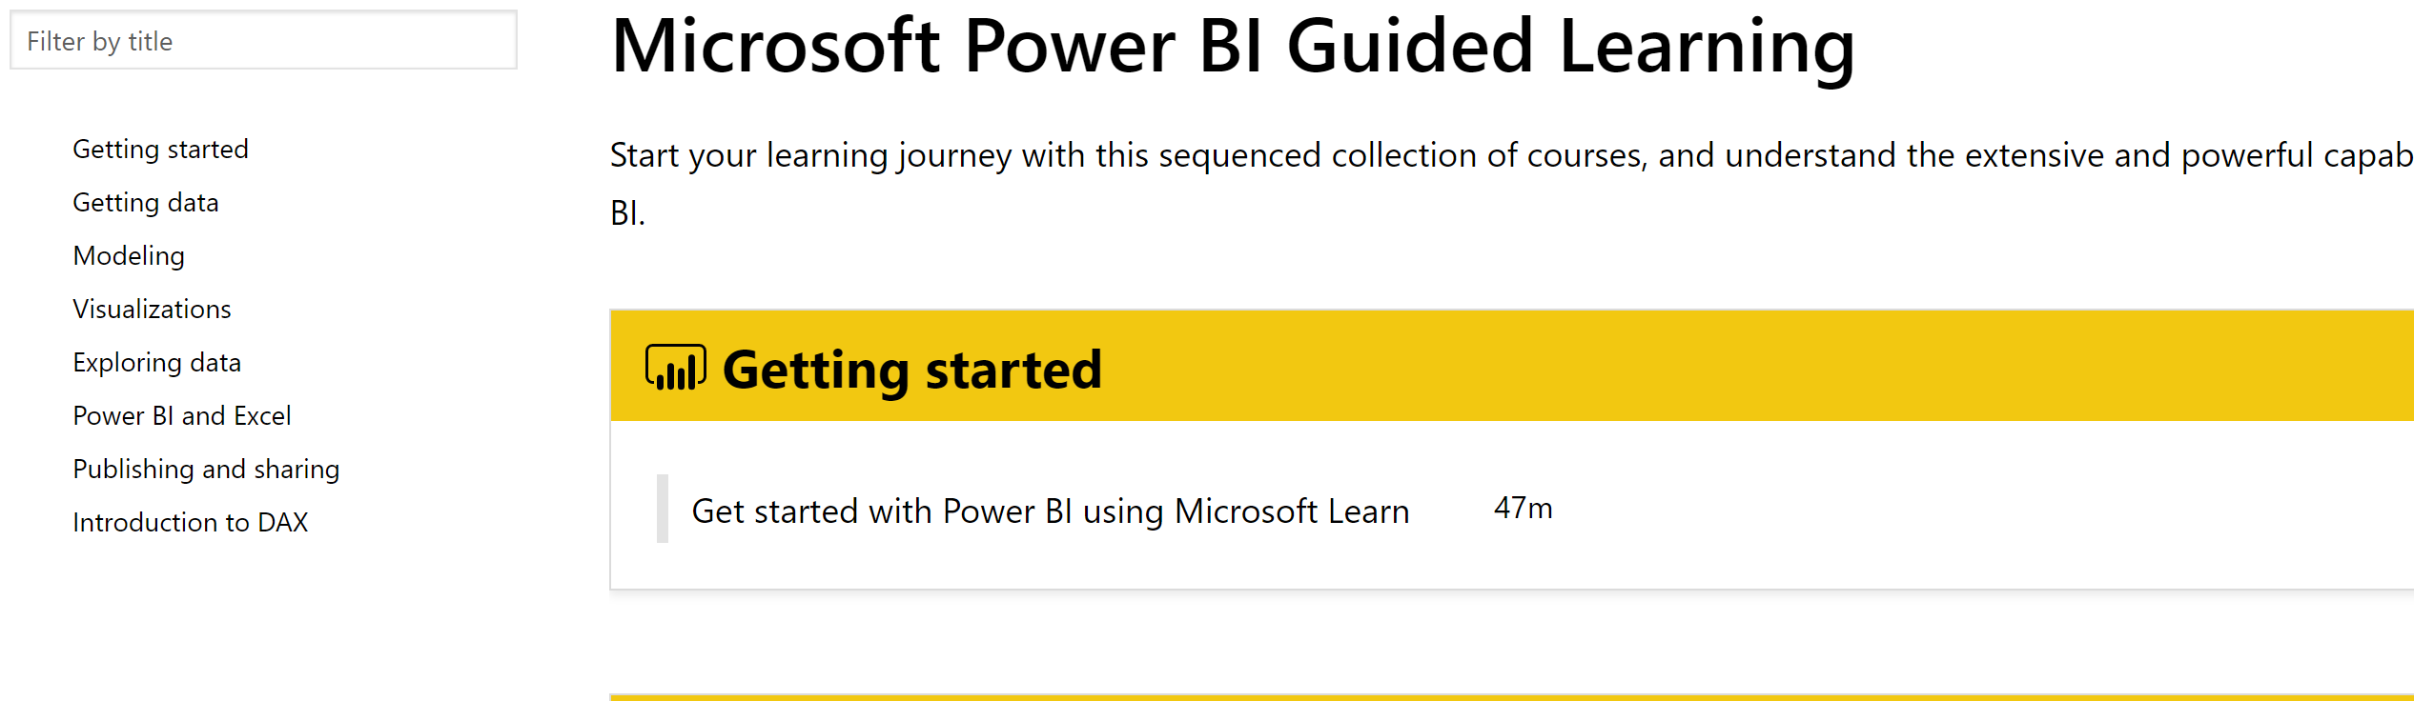

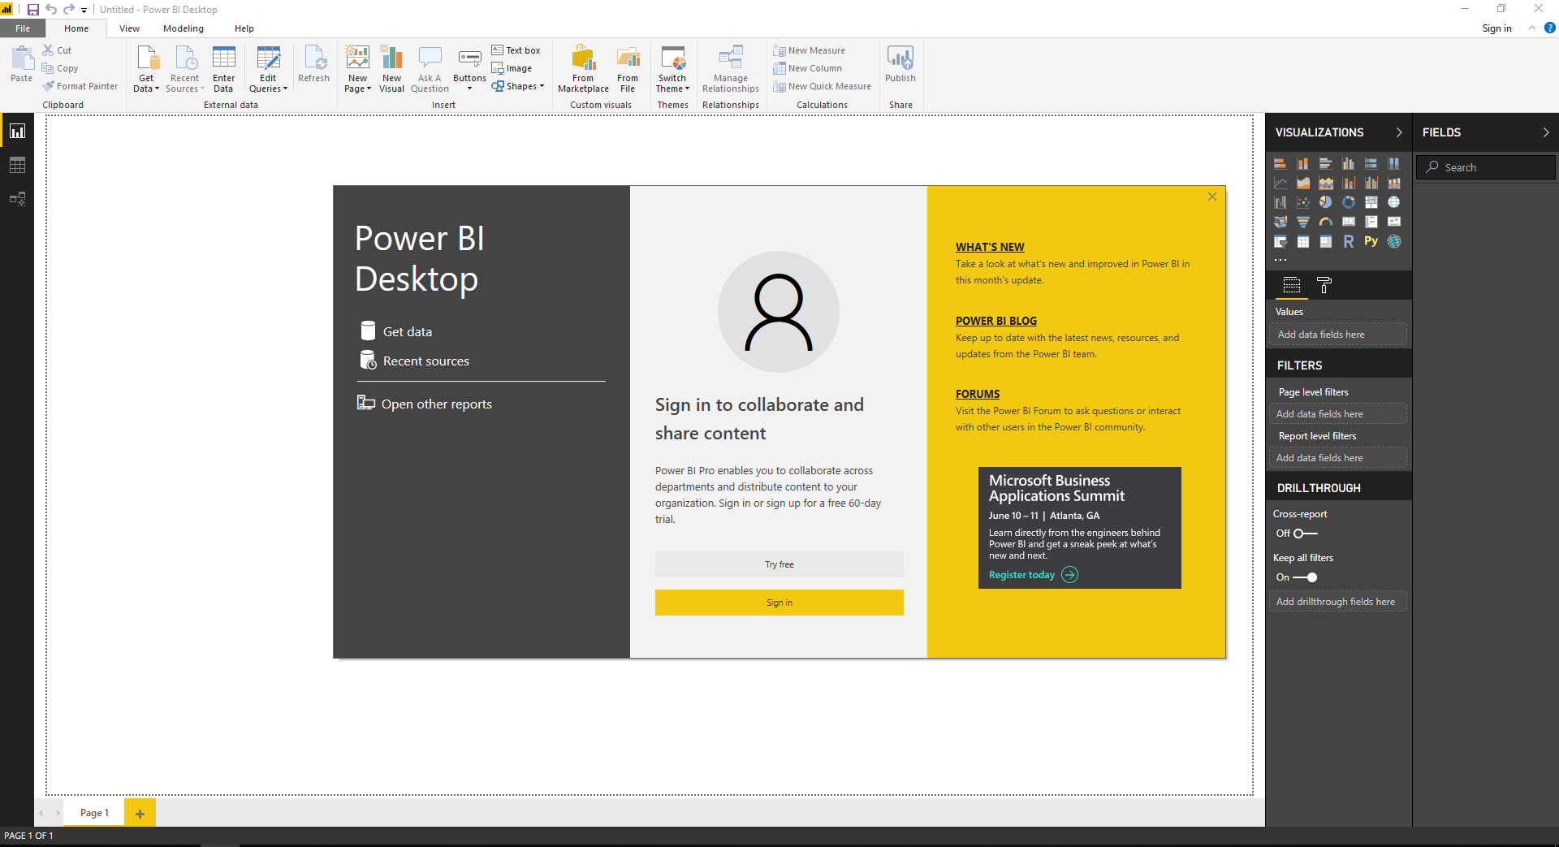

**Part B Getting Data**

Continue with the Microsoft Guided Learning activities. Complete each of the sections of the “Getting Data” Section of the guided learning activities. The “Overview of Power BI Desktop” is more of a review of what you completed in Part A. If you feel comfortable with your take away from that section you can skip the overview.

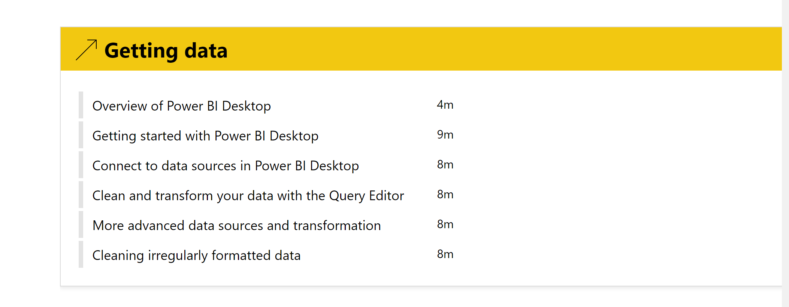

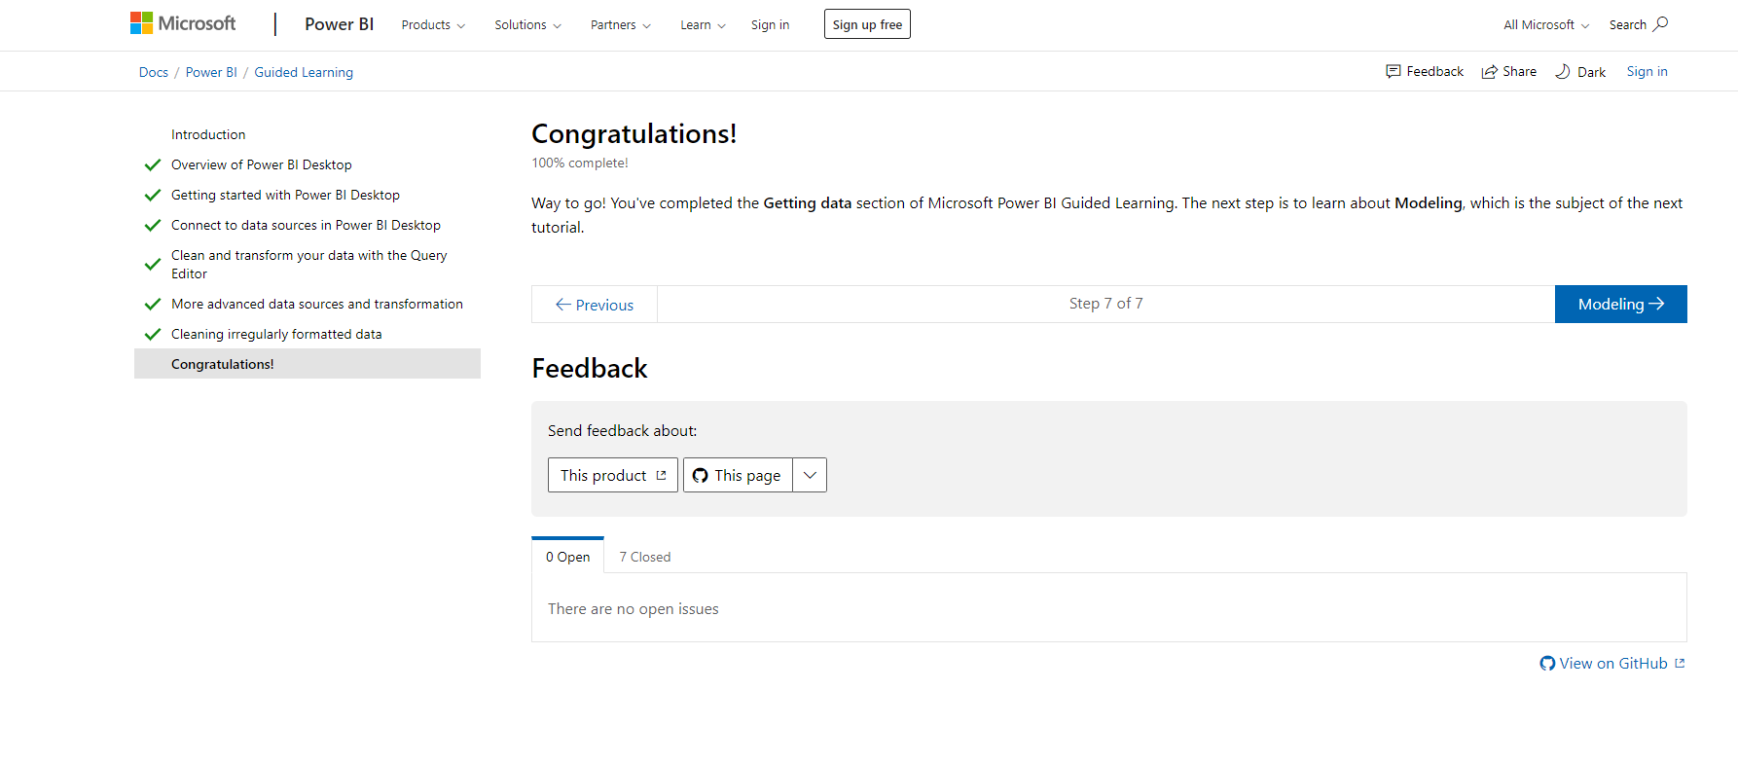

**Part C**

Continue with the Microsoft Guided Learning activities. Complete each of the sections of the “Modeling” and “Visualizations” Sections of the guided learning activities.

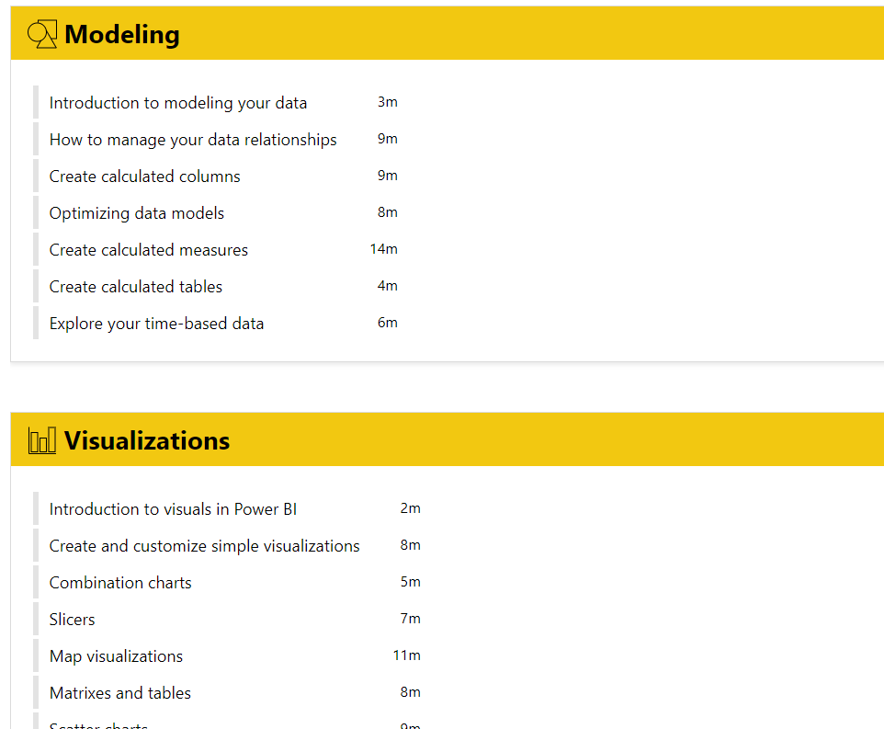

Screen Print Two Visualizations (of your choosing) that you have created and explored in Power BI.

**Part D**

Continue with the Microsoft Guided Learning activities. Complete each of the sections of the “Modeling” and “Visualizations” Sections of the guided learning activities.

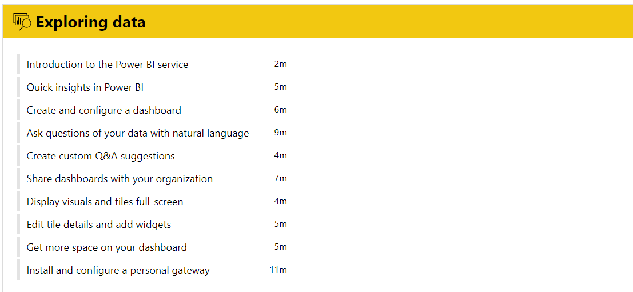

Build a Power BI Dashboard and Screen Print Report