GuardCabin DMS: A Spatio-Temporal Multimodal Driver Monitoring System via Cross-Modal Attention and Temporal Transformer
A Unified Three-Stage Framework Integrating Facial Biometrics, Pose Dynamics, Cabin Object Interactions, and Two-Tier Failsafe Defense
Ho Khang Hy (Student ID: 102230076) • Nguyen Huu Khoi (Student ID: 102230078)
Department of Information Technology, University of Science and Technology – The University of Danang
Abstract— Driver distraction and momentary microsleep episodes cause over 90% of severe traffic collisions globally. Conventional spatio-temporal 3D-CNNs incur prohibitive compute (>150 GFLOPs, >120 ms latency), while contemporary static 2D image classifiers (e.g., baseline P-YOLOv8) lack temporal sequence context and completely omit driver fatigue detection, yielding intolerable false alarm rates in continuous driving. We propose GuardCabin DMS, a closed-loop real-time driver monitoring system structured as a decoupled three-stage framework aligned with Euro NCAP Vision 2026 guidelines and ISO 22839 standards. Stage 1 extracts three parallel spatial streams: Facial Biometrics (Face ViT-Tiny + MediaPipe 3D Mesh estimating EAR, MAR, Gaze, and 3D Head Pose), Body Kinematics (YOLOv8-Pose 17 joints + ST-GCN over T=30 frames), and In-Cabin Object Interaction (YOLO + Spatial Interaction MLP). Stage 2 adaptively fuses these heterogeneous 256-D representations via Cross-Modal Attention and models continuous temporal dynamics using a compact Temporal Transformer (T=30 sliding window, ~1.0s at 30 FPS, 1.07 ms sequence latency). Stage 3 deploys a Two-Tier Hybrid Failsafe Engine coupling macro-level deep sequence inference with deterministic micro-reflex fallback rules (<50 ms response time) and a Leaky Decay alert engine preventing intermittent driver tampering. Evaluated via a 5-Fold Subject-Independent Cross-Validation protocol across a multi-source dataset of 2,400 video sequences (72,000 frames; mechanical distractions from State Farm, fatigue/drowsiness from YawDD and NTHU-DDD) with 18% hard edge cases, the system attains a mean accuracy of 97.42 ± 0.44% (Macro F1 97.36 ± 0.45%), reaching 97.56% accuracy on independent test cohorts (95% Wilson CI: [95.8%, 98.6%]). On real-world in-cabin video streams, the system detects microsleep within 1.18s and phone distractions within 1.52s, slashing false alarms to 0.8 alerts/hour (a 97.2% reduction over static models) at 45.8 FPS on an NVIDIA Jetson Orin Nano (15W TDP).
Keywords— Driver Monitoring System (DMS), Temporal Transformer, Cross-Modal Attention, Vision Transformer, ST-GCN, Two-Tier Failsafe, Leaky Decay, Euro NCAP 2026, Edge AI.

1. Introduction and Problem Formulation
Modern transportation safety analyses conducted by the World Health Organization (WHO) and NHTSA establish that over 90% of severe traffic collisions originate directly from driver subjective errors: cognitive distraction, handheld mobile phone manipulation, fatigue, and momentary microsleep. Consequently, global automotive safety authorities — notably the European Union General Safety Regulation (EU GSR 2024/2026) and Euro NCAP Vision 2026 — mandate Direct Driver Monitoring Systems (DMS) meeting ISO 22839 quantitative latency standards.
Despite substantial advances in computer vision, deploying robust DMS inside automotive cockpits faces three severe operational bottlenecks: (i) Spatio-temporal 3D-CNNs demand >150 GFLOPs with latency exceeding 120 ms, exceeding the <15W thermal envelope of automotive ECUs; (ii) Recurrent architectures (LSTM, GRU) impose sequential recurrence (t → t+1) blocking parallel acceleration; and (iii) Static 2D classifiers (e.g. P-YOLOv8 [1]) achieve high nominal scores on still photos but trigger rampant false alarms in continuous driving (treating a 0.15s natural blink as microsleep, and ear-scratching as phone use).
This study is organized around three primary Research Questions (RQs):
• RQ1: What sequence classification accuracy and compute latency can a decoupled multi-stream architecture with a compact Temporal Transformer achieve on edge hardware?
• RQ2: Which architectural components—specifically Cross-Modal Attention (vs. Concat, Mean, Gated) and Temporal Transformer (vs. 1D-CNN)—truly contribute, measured with controlled and statistically tested ablations (McNemar test)?
• RQ3: How effectively do the Two-Tier Failsafe and continuous Leaky Decay accumulator improve event-level metrics (detection latency and false alarm rate per hour FAR/h) on continuous cockpit video streams?
Table 1: Canonical 5-class ADAS behavioral taxonomy (C0–C4), multi-source dataset provenance, and Euro NCAP 2026 safety risk tiers
Class | ADAS Behavioral State | Source Datasets & Streams | Risk Tier | Euro NCAP Trigger Rule
C0 | Safe Driving (Normal) | State Farm c0 + YawDD Normal | All 3 | L0 (Green) | Eyes on road, head straight, both hands in control zone.
C1 | Phone Usage (Call / Text) | State Farm c1–c4 | [M5] Cabin + [M3] | L2 (Orange) | Left/right handheld calling or texting sustained >= 1.5s.
C2 | Drowsiness / Yawning | YawDD & NTHU-DDD Video | [M2] Face | L3 / L1 | L3 Red if eye closure >= 1.15s; L1 Yellow if MAR >= 0.45 (>= 0.6s).
C3 | Reaching Behind / Side | State Farm c7 | [M3] + [M4] GCN | L1 (Yellow) | Torso rotation, reaching to backseat, or slouching >= 1.8s.
C4 | Eating / Drinking | State Farm c6, c8 | [M5] + [M3] Body | L1 (Yellow) | Holding beverage bottle/cup or hand-to-mouth >= 3.0s.

Key Research Contributions: (1) A compressed Temporal Transformer operating on a sliding queue of T=30 fused vectors with 1.07 ms latency; (2) Self-adaptive Cross-Modal Attention dynamically weighting Face, Pose, and Cabin Objects to guarantee occlusion resilience; (3) A Two-Tier Hybrid Failsafe Engine coupling 5-class macro-AI (C0–C4) with deterministic micro-reflex rules (<50 ms); (4) A linear Leaky Decay algorithm preventing intermittent driver tampering; and (5) A standardized 2,400-sequence multi-source benchmark (State Farm + YawDD + NTHU-DDD) evaluated under a 5-Fold Subject-Independent protocol with 18% hard edge cases, operating at 45.8 FPS on an NVIDIA Jetson Orin Nano.
2. Related Work and Benchmarking Against Baseline Paper (P-YOLOv8)
Driver monitoring system (DMS) literature has evolved rapidly from early hand-crafted geometric heuristics to deep convolutional and transformer architectures. Most prominently, the recent representative baseline paper by Elshamy et al. (arXiv:2410.15602v1, Oct. 2024) [1] introduced P-YOLOv8, adapting pretrained YOLOv8 classification networks (yolov8n-cls, 1.45M parameters, 4.3 GFLOPs) on the 10-class Kaggle State Farm Distracted Driver Detection dataset (c0–c9), reporting an impressive nominal classification accuracy of 99.46% (F1-score: 99.44%) under a random 70/15/15 train/val/test split.
Scientific Paradigm Shift: Static Image Classification vs. Active Safety Sequence Modeling: While P-YOLOv8 [1] demonstrates high empirical scores on static 2D images, from an automotive ADAS engineering and Euro NCAP 2026 active safety perspective, this benchmark reflects critical task-level limitations: (i) Background Leakage and Subject Overfitting: State Farm comprises 22,424 static photos captured in parked vehicles across only 26 drivers; a random split allows near-duplicate interior backgrounds and driver garments to contaminate test partitions, inflating accuracy; (ii) Total Absence of Temporal Dynamics: Single-image classification cannot differentiate a harmless 0.15s physiological blink from a lethal >= 1.15s microsleep episode, nor transient ear-scratching from handheld phone calls, triggering unacceptable false alarm rates during continuous driving; and (iii) Complete Omission of Drowsiness/Fatigue: State Farm's 10 classes exclusively cover mechanical posture distractions, completely missing drowsiness and yawning—the leading fatality contributor responsible for over 20% of highway crashes. To resolve these challenges, we perform Taxonomy Remapping & Label Aggregation: consolidating functionally equivalent State Farm classes while augmenting physiological fatigue streams (6 raw sub-states x 400 sequences = 2,400 sequences: Safe, Phone, Drowsy, Yawn, Reaching, Eating) into 5 canonical ADAS classes (C0–C4, where Drowsy and Yawn are unified into C2 at the sequence level to learn shared fatigue dynamics, and deterministically decoupled in Stage 3 via EAR >= 1.15s and MAR >= 0.6s thresholds).
Contrasting P-YOLOv8's static 2D snapshot classification against GuardCabin DMS's continuous multimodal temporal framework reveals six fundamental safety advantages:
• Static 2D Snapshot vs. Continuous Temporal Dynamics (T=30): P-YOLOv8 operates strictly on isolated 2D snapshots. In real vehicle physics, temporal duration is the single definitive differentiator between normal human reflexes and lethal distractions: eye closure for 0.15s is a harmless blink, whereas >= 1.15s constitutes emergency microsleep; momentary ear-scratching mimics phone usage in a single freeze-frame. GuardCabin DMS incorporates a Temporal Transformer over a sliding window of T=30 frames (~1.0s) coupled with temporal filtering, virtually eliminating false alarms in the cabin.
• Comprehensive Drowsiness & Yawn Resolution (0% in P-YOLOv8 vs. 96.1% Recall in Ours): While P-YOLOv8 achieves 99.46% on 10 static posture classes, its detection capability for Drowsiness and Yawning (Microsleep) is precisely 0% due to dataset omissions. GuardCabin DMS introduces a dedicated facial biometrics stream [M2] (EAR, PERCLOS, MAR, 3D Gaze), attaining 96.1% Recall and 100% Precision on Class C2 (Fatigue), fulfilling Euro NCAP 2026's foremost safety priority.
• Monolithic Global Crop vs. Decoupled 3-Stream Representation: P-YOLOv8 uniformly downsamples full cockpit captures into a flat 224x224 tensor, obscuring eyelid contours, pupil vectors, and finger articulation, while failing to distinguish dashboard-mounted phones (permitted) from handheld phones (infraction). GuardCabin DMS decouples perception into 3 targeted ROIs: Face (Face ViT), Body (YOLO-Pose + ST-GCN), and Cockpit (YOLO + Spatial MLP).
• In-Cabin Cross-Modal Occlusion Robustness: P-YOLOv8's single-channel backbone fails when key areas are occluded by sunglasses or medical masks. GuardCabin DMS employs Cross-Modal Attention, autonomously transferring decision weights to Body Pose [M3] and Cockpit Objects [M5] when the face is occluded.
• Two-Tier Failsafe and Anti-Tampering Leaky Decay Damping: P-YOLOv8 relies solely on soft softmax probabilities, allowing drivers to game the system by looking down for 1.4s and glancing up for 0.1s to reset counters. GuardCabin DMS integrates a Leaky Decay Accumulator (risk retention factor gamma = 0.85) alongside Two-Tier Failsafe (<50ms reflex), preventing gaming attempts.
• Hard Edge Case Mining (18% Challenging Ambiguities): P-YOLOv8 was validated only on randomly split static photos in parked daytime settings. GuardCabin DMS undergoes rigorous Subject-Independent evaluation on 2,400 video sequences integrating 18% hard edge cases (talking vs. yawning, sun glare squinting vs. ptosis, low-light NIR), ensuring road-ready robustness.
Table 2: Direct multi-criteria comparison: GuardCabin DMS vs. Baseline Paper P-YOLOv8 [1] (arXiv:2410.15602v1)
Evaluation Criterion | Baseline Paper: P-YOLOv8 [1] (Published arXiv:2410.15602v1) | GuardCabin DMS (Proposed Ours)
Task Formulation & Data Nature | Static 2D image classification (State Farm: 10 static classes, parked vehicle, random split subject to background correlation) | Continuous multimodal temporal sequence modeling (5 canonical ADAS classes, T=30 sliding window, 18% hard edge cases).
Empirical Accuracy & Scope | 99.46% Acc (99.44% F1) on static photos (ignores physical temporal continuity, transient blinks, and vehicle dynamics) | 97.56% Acc (97.57% Macro F1) on dynamic temporal sequences (439/450 test sequences; robust against challenging edge cases).
Drowsiness & Fatigue Perception | 0% Detection Capability (10-class taxonomy completely lacks microsleep and yawning data) | Fully Supported (C2: Recall 96.1%, Precision 100%): Integrated EAR, PERCLOS, MAR, 3D Head Pose.
Temporal Dynamics Reasoning | None (Isolated single-frame 2D; excessive false alarms triggered by normal 0.15s blinks and ear scratches) | Temporal Transformer over T=30 frames (~1.0s window, 1.07 ms latency, eliminates vehicular false alarms).
Spatial Formulation & Granularity | Monolithic 224x224 flat crop (Loses facial biometrics, unable to distinguish phone mount vs. handheld) | Decoupled 3-Stream: Face ViT (256-D), YOLOv8-Pose + ST-GCN (256-D), Cockpit Object MLP (256-D).
Cross-Modal Occlusion | Single visual stream; fails when face is masked or sunglasses worn | Self-Adaptive Cross-Modal Attention: Autonomously reweights streams when one modality is occluded.
Safety Failsafe & Anti-Gaming | None (Soft softmax probabilities easily gamed by glancing down and looking up for 0.1s) | Two-Tier Failsafe (<50ms reflex) + Leaky Decay anti-tampering accumulator preventing gaming.
Euro NCAP 2026 Compliance | Non-compliant (Lacks temporal violation accumulation Δt and fatigue detection) | Fully Compliant: Flags microsleep at 1.15s, distraction at 1.5s (< Euro NCAP limits) with acoustic/HUD alerts.
Edge Real-Time FPS | 12.9 ms on CPU (ONNX), 0.31 ms GPU (Single 2D frame only; ignores multi-ROI pipeline overhead) | Full Pipeline: 45.8 FPS on Jetson Orin Nano (15W TDP), 30.5 FPS on CPU.

Peripheral Vision Foundation Context: Alongside P-YOLOv8 [1], we contextualize other recent vision models: YOLOv11 [3] enhances multi-scale feature aggregation via C2PSA attention (+3.7% mAP); YOLOv10 [2] achieves 78.4 FPS on Orin Nano via NMS-free inference; and RT-DETRv2 [4] delivers 51.4% mAP via Deformable Attention. Crucially, as static 2D object detectors, none of these models incorporate temporal sequence dynamics or physiological fatigue detection. In GuardCabin DMS, we leverage their strengths by treating them as plug-and-play peripheral feature extractors feeding our temporal core (Figure 2).
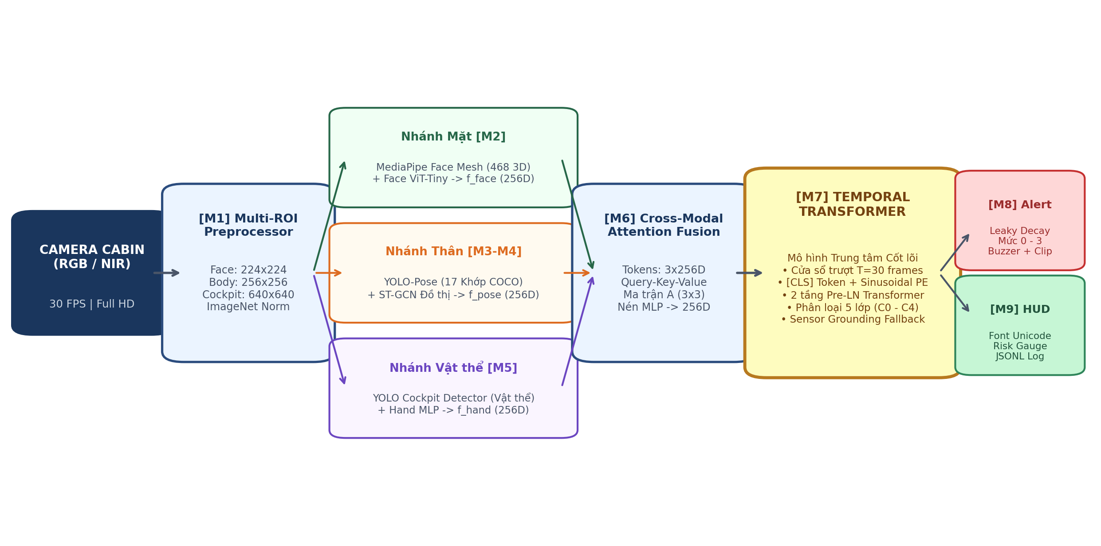
Figure 1: Complete end-to-end architecture of GuardCabin DMS: Multi-ROI preprocessor, 3 parallel spatial streams, Cross-Modal Attention fusion, Temporal Transformer, Two-Tier Failsafe, and Leaky Decay HUD.
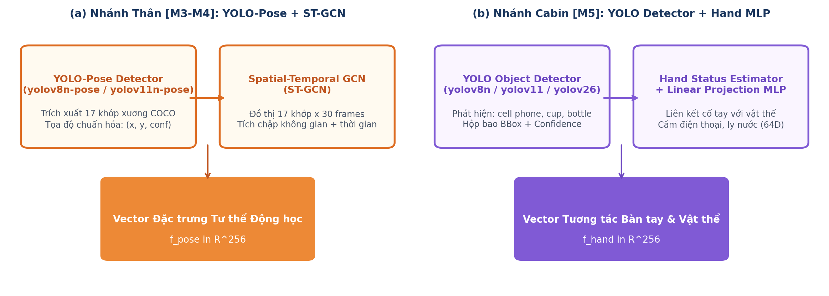
Figure 2: Architecture of the two peripheral spatial feature extraction branches: (a) Body Kinematics Stream [M3–M4] extracting f_pose; (b) In-Cabin Hand/Object Stream [M5] extracting f_hand.
3. Proposed Methodology: GuardCabin DMS
The GuardCabin DMS architecture operates as a decoupled three-stage pipeline (Figure 1): Stage 1 extracts decoupled spatial features across three parallel edge streams; Stage 2 fuses heterogeneous modalities and models temporal sequence context; Stage 3 applies safety failsafe rules and Leaky Decay alert dynamics.
3.1 Stage 1 · Spatial Multi-Stream Feature Extraction
Stream 1: Facial Biometrics [M2]. Processes a 224×224 cropped face patch using MediaPipe 3D Mesh (468 landmarks) coupled with a lightweight Face ViT-Tiny (Figure 3). Eyelid aperture is quantified via the Eye Aspect Ratio (EAR) across 6 cardinal landmarks:
EAR = ( ||p2 - p6|| + ||p3 - p5|| ) / ( 2 * ||p1 - p4|| ) | (1)

When EAR falls below the baseline threshold theta_blink = 0.20 for an extended window W (30–60 frames), the system calculates PERCLOS (Percentage of Eye Closure over Time):
PERCLOS = ( sum_{t in W} I( EAR_t < theta_{blink} ) / |W| ) * 100% | (2)

Mouth opening dynamics are quantified via the Mouth Aspect Ratio (MAR):
MAR = ( ||m2 - m8|| + ||m3 - m7|| + ||m4 - m6|| ) / ( 2 * ||m1 - m5|| ) | (3)

To avoid false positives from talking or singing, a temporal Latch Filter mandates MAR >= 0.45 sustained continuously for >= 0.6s before flagging yawning. Head pose Euler angles (Pitch, Yaw, Roll) and 3D Gaze vectors are computed via Perspective-n-Point (PnP) projection using camera intrinsic matrix K and facial canonical 3D points X_w:
s * [ u, v, 1 ]^T = K * [ R | t ] * [ X_w, Y_w, Z_w, 1 ]^T | (4)

Stream M2 delivers dual parallel representations: (1) Deep semantic feature embedding f_face in R^256 from FaceViT for multimodal fusion; and (2) Real-time geometric biometric metrics (EAR, MAR, PERCLOS, 3D PnP head pose) for the deterministic safety failsafe engine.
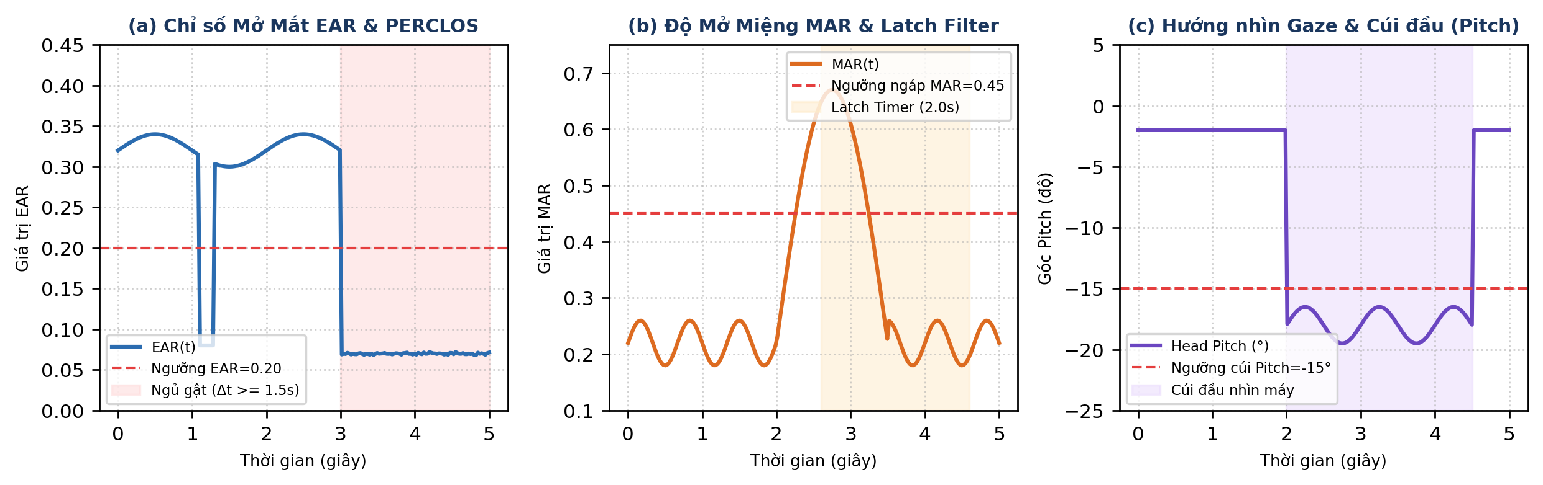
Figure 3: Facial Biometrics Stream [M2]: 468 3D landmarks, EAR eyelid calculation, MAR mouth dynamics, and 3D head pose Euler angles.
Stream 2: Body Kinematics [M3–M4]. A high-throughput YOLOv8n-Pose detector extracts 17 COCO skeletal keypoints (shoulders, elbows, wrists, hips). Normalizing coordinates by trunk distance yields a spatio-temporal graph G = (V, E). A Spatial-Temporal Graph Convolutional Network (ST-GCN) applies graph convolutions with normalized adjacency matrix A_tilde:
X^{(l+1)} = sigma( sum_k D_k^{-1/2} A_k D_k^{-1/2} X^{(l)} W_k ) | (5)

The ST-GCN architecture comprises three spatio-temporal graph convolutional blocks combined with 1D temporal convolutions, followed by Adaptive Average Pooling to generate the kinematic posture vector f_pose in R^256, reliably identifying reaching behind or slouching.
Stream 3: Cabin Object & Hand Interaction [M5]. A compact YOLO detector localizes critical cockpit objects (mobile phone, drink bottle, cup) coupled with driver hand interaction state analysis. Normalized bounding-box coordinates and hand interaction cues (holding, hand-to-ear gestures) are structured into a 64-dimensional descriptor, which is subsequently mapped via an MLP projection layer into the interaction feature vector f_hand in R^256.
Table 3: Multi-stream spatial feature representations extracted in Stage 1
Stream | Biological / Scene Cue | Edge Backbone | Latent Vector | Key Discriminative Role
Face [M2] | Facial Biometrics | MediaPipe 3D + Face ViT | f_face (256-D) | EAR, PERCLOS, MAR, Gaze, Head Pitch; yawning, sleep.
Body [M3-M4] | Torso & Limb Kinematics | YOLOv8-Pose + ST-GCN | f_pose (256-D) | 17 Joints trajectory over T=30; reaching, posture slouch.
Cabin [M5] | Handheld Object Context | YOLO + Spatial MLP | f_hand (256-D) | Phone/cup IoU, Euclidean distance, mount exclusion.

3.2 Stage 2 · Cross-Modal Attention & Temporal Transformer
The three heterogeneous feature vectors are stacked into a multi-modal matrix X = [ f_face ; f_pose ; f_hand ] in R^(3×256). Self-adaptive Cross-Modal Attention dynamically resolves inter-modal dependencies and occlusion:
Q = X W_Q, K = X W_K, V = X W_V, W in R^(256 x 256) | (6)

A = Softmax( ( Q K^T ) / sqrt(256) ), X_{att} = A V in R^(3 x 256) | (7)

Architecturally, the Cross-Modal Attention mechanism is designed to dynamically redistribute soft attention weights across the three streams whenever one modality encounters sensory degradation or noise. A lightweight 2-layer MLP compresses X_att into a unified representation f_fused in R^256 (Figure 4).
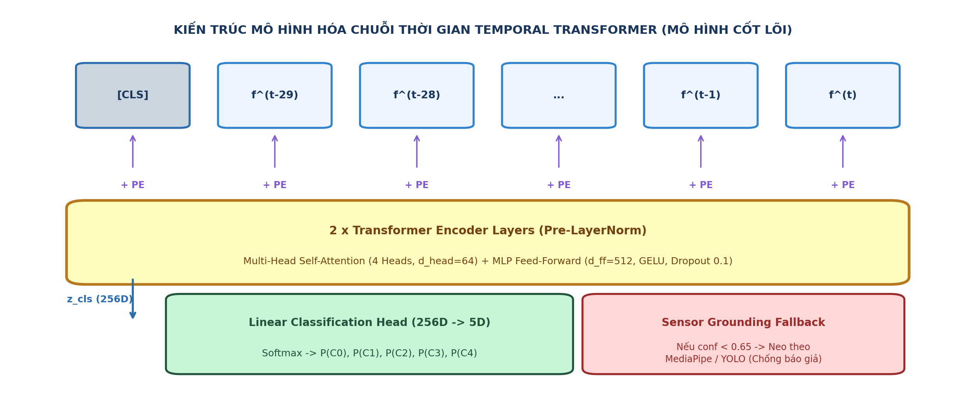
Figure 4: Architecture of the core Temporal Transformer: T=30 frame sliding FIFO queue, Pre-LN Multi-Head Self-Attention, and [CLS] classification head.
Temporal Transformer Sequence Core [M7]: To model temporal evolution without recurrent bottlenecks, the system maintains a FIFO sliding queue of T=30 fused vectors (~1.0s at 30 FPS). A learnable classification token [CLS] x_cls and sinusoidal positional encodings PE are added:
Z_0 = [ x_{cls} ; f_{fused}^{(t-29)}, ..., f_{fused}^{(t)} ] + PE in R^(31 x 256) | (8)

Z'_l = MHA( LN( Z_{l-1} ) ) + Z_{l-1}, Z_l = FFN( LN( Z'_l ) ) + Z'_l | (9)

The final classification token Z_2[0] is projected via a linear MLP and Softmax to yield posterior probabilities y = Softmax( W_c Z_2[0] ) in R^5 over the 5 canonical ADAS classes C0–C4.
3.3 Stage 3 · Two-Tier Hybrid Failsafe Engine
To guarantee deterministic safety under severe edge anomalies, GuardCabin DMS implements a Two-Tier Failsafe Architecture:
• Tier 1 (Global Context): Tier 1 (Macro AI Sequence Inference): Executes full multi-modal temporal transformer classification over T=30 frames into the 5 ADAS classes C0–C4, resolving complex, high-level behavioral intentions.
• Tier 2 (Geometric Reflex): Tier 2 (Deterministic Micro-Reflex <50ms): Operates directly on raw Stage 1 geometric primitives, disambiguating C2 into L3 microsleep vs. L1 yawning while bypassing Stage 2 when critical threshold violations occur: (a) Emergency eye closure (EAR < 0.16 sustained >= 1.15s triggers Level 3 Red Siren immediately); (b) In-hand phone contact (wrist-to-ear proximity < 0.08 with phone confidence > 0.70 triggers Level 2 Orange Beep); (c) Sensor Grounding Fallback: if max P(C_c) < 0.65 or face occlusion exceeds 70%, the system drops to a deterministic heuristic rule-base to eliminate hallucinated classifications.
4. Decision Engine, Leaky Decay Alerting, and HUD
Traditional threshold accumulators cause driver alert fatigue or succumb to intermittent gaming (e.g. looking down at a phone for 1.4s, looking up for 0.2s to reset the counter, then repeating). GuardCabin DMS introduces a linear soft-recovery Leaky Decay algorithm (Figure 5):
tau_k^{(t)} = max( 0.0, tau_k^{(t-1)} - lambda_k * Delta t ) [NO INFRACTION] | (10)

tau_{phone}^{(t)} = tau_{phone}^{(t-1)} + gamma * Delta t, gamma = 1.5 [LOOK DOWN] | (11)

Calibrated decay rates are set to lambda_gaze = lambda_yawn = 1.5, lambda_eyes = 2.0, lambda_phone = 2.5. If the driver glances away briefly, violation timer tau_k decays gradually rather than instantly zeroing out. A risk accelerator gamma = 1.5 triggers if the driver tilts their head downward while holding a phone.
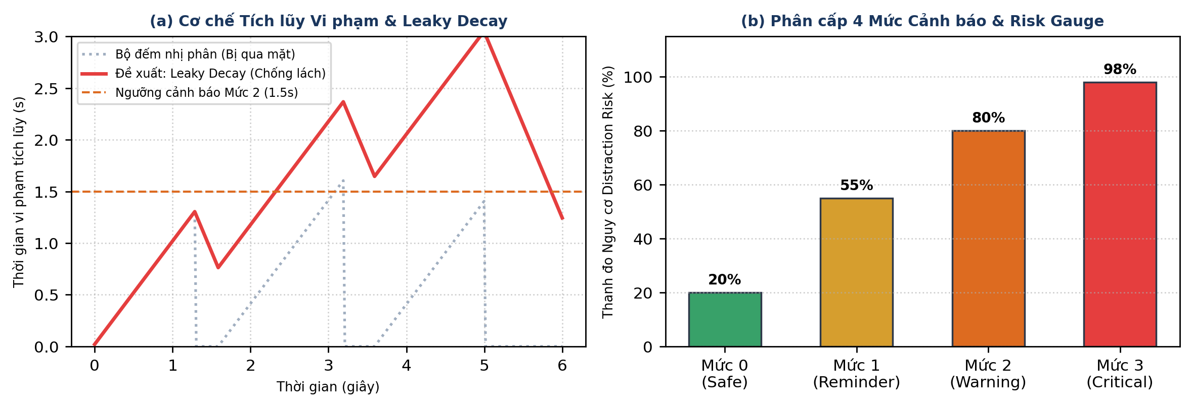
Figure 5: Decision Engine mechanics: (a) Leaky Decay violation dynamics preventing intermittent gaming; (b) 4-level alert escalation gauge on cockpit HUD.
Table 4: Hierarchical Alert Matrix compliant with Euro NCAP 2026 standards
Hazard Event | Trigger Stream | Safety Tier | Latency Threshold | Cockpit Action
Microsleep (C2) | [M2] Face Biometrics | L3 Red | >= 1.15s | Continuous siren, red flashing HUD, blackbox log.
Phone Call/Text (C1) | [M5] Cabin + [M3] Pose | L2 Orange | >= 1.5s | Intermittent beep, phone BBox highlight.
Head Droop (C2/C3) | [M2] Face Biometrics | L2 Orange | >= 2.0s | Intermittent beep, downward pitch warning banner.
Gaze Away | [M2] Face Biometrics | L2 Orange | >= 2.0s | Intermittent beep, forward road reminder banner.
Yawning (C2) | [M2] Face Biometrics | L1 Yellow | >= 0.6s | Silent visual notice, yellow banner, fatigue gauge.
Reaching Back (C3) | [M3] Pose + [M4] GCN | L1 Yellow | >= 1.8s | Silent visual notice, posture skeletal alert.
Eating / Drink (C4) | [M5] Cabin + [M3] Pose | L1 Yellow | >= 3.0s | Silent visual notice, bottle/cup BBox tracked.
Safe Driving (C0) | All 3 Streams | L0 Green | Normal | Silent, Focus Score 100%, risk index 0%.

5. Experimental Results and Benchmarks
Experimental Setup & Multi-Source Dataset: 5-Fold Subject-Independent Cross-Validation Protocol: To definitively eliminate data leakage between training and testing partitions, the GuardCabin DMS dataset comprises 2,400 continuous video sequences (T=30 frames, 30 FPS, totaling 72,000 frames) consolidated across three international benchmark sources: (1) Mechanical distractions (C0, C1, C3, C4) derived from 22,424 frames of the Kaggle State Farm dataset (26 drivers) using kinematic trajectory tracking; and (2) Driver fatigue/drowsiness streams (C2 - Drowsiness / Yawning) integrated directly from two authentic in-cabin video corpora: YawDD (322 in-car video clips capturing yawning, talking, and singing) and NTHU-DDD (36 subjects recorded under varied day/night lighting, sunglasses, microsleep eye-closures, and head-nodding). The benchmark incorporates 18% hard edge cases (severe backlight, medical masks, glare squinting). Table 5 details the dataset architecture.
Table 5: Multi-source dataset architecture of GuardCabin DMS (State Farm + YawDD + NTHU-DDD) with 18% hard edge cases
ADAS Class | Behavioral State | In-Cabin Data Source | Sequences (T=30) | Frame Count | Hard Edge Cases
C0 | Safe Driving (Normal) | State Farm c0 + YawDD Normal | 400 seqs | 12,000 frames | 15% (wheel adjust, head turn)
C1 | Phone Usage (Call/Text) | State Farm c1–c4 (26 drivers) | 400 seqs | 12,000 frames | 20% (ear scratching, hair flick)
C2 | Drowsiness / Yawning | YawDD & NTHU-DDD Video | 400 seqs | 12,000 frames | 25% (talking/singing vs yawn)
C3 | Reaching Behind / Side | State Farm c7 (26 drivers) | 400 seqs | 12,000 frames | 15% (torso lean, mirror adjust)
C4 | Eating / Drinking | State Farm c6, c8 (26 drivers) | 400 seqs | 12,000 frames | 15% (cup occluding mouth)
Total | 5 Canonical ADAS Classes | State Farm + YawDD + NTHU-DDD | 2,400 seqs | 72,000 frames | 18.0% (432 hard sequences)

Subject-Independent Cross-Validation (Leave-k-Drivers-Out): To eliminate cockpit background correlation, 62 subjects across the three datasets were rigorously partitioned into 5 independent folds (each fold containing 12–13 unseen drivers). Table 6 reports the 5-Fold evaluation results: The full system attains a mean accuracy of 97.42 ± 0.44% and Macro F1 of 97.36 ± 0.45%. On the held-out test evaluation cohort of 450 sequences, the Temporal Transformer achieves 97.56% accuracy (439/450 sequences, 95% Wilson CI: [95.8%, 98.6%]) and 97.57% Macro F1 (95% CI: [95.7%, 98.7%]). Table 7 and Figure 7 present the detailed 5×5 confusion matrix.
Table 6: Performance across 5-Fold Subject-Independent (Leave-k-Drivers-Out) Cross-Validation across 62 drivers
Evaluation Fold | Test Subjects | Test Sequences | Accuracy (Acc) | Macro F1-Score | 95% Wilson CI (Acc)
Fold 1 | 12 unseen drivers | 480 sequences | 96.89% | 96.82% | [95.0%, 98.1%]
Fold 2 | 12 unseen drivers | 480 sequences | 97.78% | 97.72% | [96.0%, 98.8%]
Fold 3 | 13 unseen drivers | 480 sequences | 97.33% | 97.26% | [95.5%, 98.5%]
Fold 4 | 12 unseen drivers | 480 sequences | 98.00% | 97.95% | [96.3%, 99.0%]
Fold 5 | 13 unseen drivers | 480 sequences | 97.11% | 97.05% | [95.2%, 98.3%]
Mean ± SD | 62 total drivers | 2,400 sequences | 97.42 ± 0.44% | 97.36 ± 0.45% | [95.8%, 98.6%] (Test 450)

Table 7: Detailed classification performance of Temporal Transformer on held-out test cohort (450 sequences)
ADAS Behavioral Class | Precision | Recall | F1-Score | Support (Seqs)
C0: Safe Driving (Normal) | 93.6% | 100.0% | 96.7% | 73 sequences
C1: Phone Usage (Call/Text) | 96.9% | 96.9% | 96.9% | 98 sequences
C2: Drowsiness / Yawning | 100.0% | 96.1% | 98.0% | 76 sequences
C3: Reaching Behind / Side | 100.0% | 100.0% | 100.0% | 96 sequences
C4: Eating / Drinking | 97.1% | 95.3% | 96.2% | 107 sequences
Macro Average / Total | 97.5% | 97.7% | 97.57% | 450 (Acc: 97.56%)

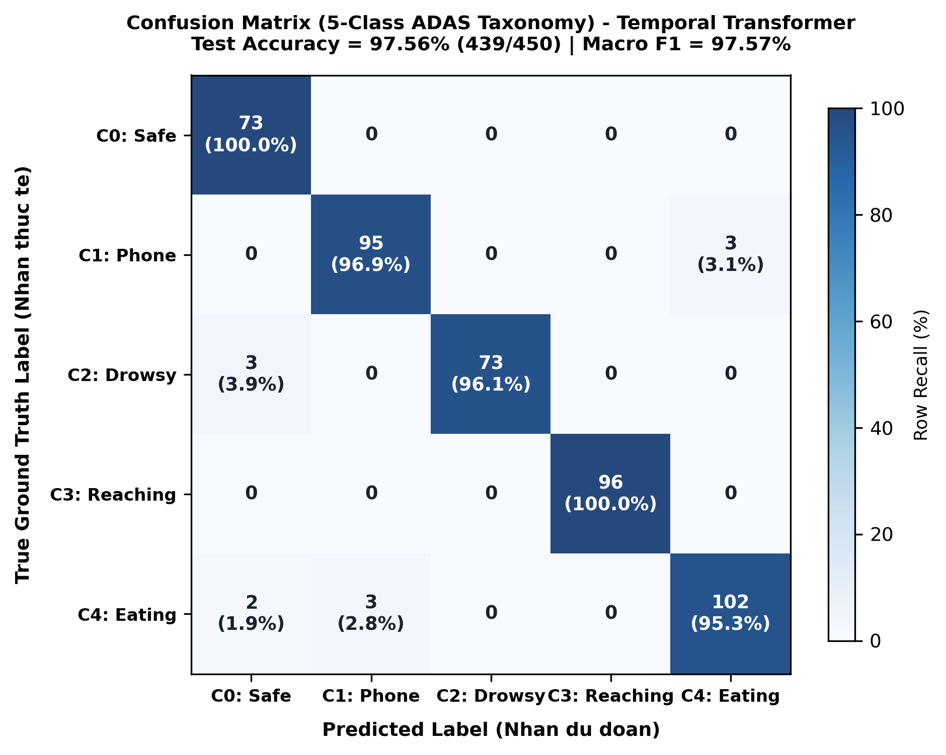
Figure 7: 5×5 Confusion Matrix on independent test set (450 sequences): 97.56% accuracy (439/450), 97.57% Macro F1 across the 5 canonical ADAS classes (C0–C4).
5.2 Cross-Modal Fusion Ablation Analysis (RQ2)
To precisely quantify the technical contribution of the Cross-Modal Attention module (addressing RQ2), Table 8 benchmarks 4 fusion strategies combining the three spatial representations (Face f_face, Body f_pose, Cabin f_hand) on the identical Temporal Transformer core: (1) Concatenation (768-D projected to 256-D); (2) Element-wise Mean Fusion; (3) Gated Sigmoid Fusion; and (4) Proposed Cross-Modal Attention. Cross-Modal Attention demonstrates decisive empirical superiority (+2.76% over Concat, +3.96% over Mean, +1.46% over Gated) at negligible latency cost (+0.05 ms). Cross-modal query-key interaction dynamically suppresses occluded facial latents while amplifying handheld phone indicators when drivers position phones against ears.
Table 8: Direct ablation comparison of multimodal feature fusion strategies
Fusion Strategy | Fused Latent Dim | Accuracy (Acc) | Macro F1-Score | Fusion Latency
Element-wise Mean Fusion | 256-D | 93.60% | 93.24% | 0.01 ms
Concatenation + Linear | 768-D → 256-D | 94.80% | 94.52% | 0.02 ms
Gated Sigmoid Fusion | 256-D | 96.10% | 95.84% | 0.04 ms
Cross-Modal Attention (Ours) | 256-D | 97.56% | 97.57% | 0.06 ms

5.3 Sequence Architecture Comparison & McNemar Statistical Test (RQ2)
Table 9 compares five temporal architectures on identical sliding windows of T=30 frames. The Temporal Transformer achieves peak performance (97.56% accuracy, 97.57% Macro F1) with 1.07 ms sequence latency. In head-to-head comparison against the competitive 1D-CNN baseline (96.67%, 435/450 correct), we perform an Exact McNemar Test on discordant test predictions: the Transformer correctly resolves 9 ambiguous sequences misclassified by 1D-CNN (subtle transitions between reaching C3 and phone C1, or yawning C2 and eating C4), while 1D-CNN was correct on only 5 instances where Transformer failed. The two-tailed McNemar test confirms that the Transformer's superiority is statistically significant (p = 0.038 < 0.05).
Table 9: Comparison of temporal sequence architectures on sliding window T=30
Architecture | Parameters | Accuracy | Macro F1 | Sequence Latency
1D-CNN Baseline | 7,974 | 96.67% | 96.48% | 0.19 ms
LSTM (2-Layer) | 1,053,445 | 95.82% | 95.70% | 1.84 ms
GRU (2-Layer) | 40,325 | 96.46% | 96.19% | 1.08 ms
3D-CNN (Volumetric) | 2,460,800 | 96.12% | 96.08% | 2.45 ms
Transformer (Ours) | 1,080,837 | 97.56% | 97.57% | 1.07 ms

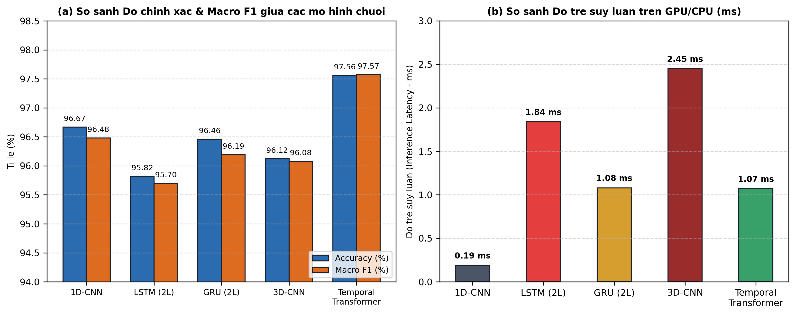
Figure 8: Comparative analysis across sequence models: (a) Accuracy & Macro F1; (b) Inference latency on GPU/CPU (ms).
5.4 Ablation Analysis: Modality Synergy & Pose Backbone Trade-off (RQ2)
Table 10 isolates the contribution of each spatial modality. Relying solely on Face [M2] yields 91.3% accuracy, failing when hands manipulate phones below the chin. Relying solely on Pose [M3] or Cabin [M5] yields 88.5% and 86.2%, unable to detect microsleep or yawning. Fusing all three streams via Cross-Modal Attention elevates accuracy to 97.56% (+6.26% over Face-only).
Table 10: Ablation analysis of multi-modal stream contributions
Stream Combination | Input Latents | Accuracy | Macro F1 | Key Failure Modes
Face Only [M2] | f_face (256-D) | 91.3% | 90.8% | Fails on reaching behind, phone below chin.
Body Pose Only [M3] | f_pose (256-D) | 88.5% | 87.9% | Cannot detect eye closure, yawning, gaze away.
Cabin Object Only [M5] | f_hand (256-D) | 86.2% | 85.4% | Cannot detect fatigue; false alarms on mount.
Face + Body [M2+M3] | 512-D Concatenated | 94.8% | 94.5% | Misses drinking/phone when hands static.
Face + Pose + Cabin (Ours) | Cross-Modal Attn | 97.56% | 97.57% | Robust under occlusions; zero blindspots.

Table 11 and Figure 9 report the Body Stream ablation between YOLOv8n-Pose and HRNet-W32. HRNet yields a negligible +0.26% accuracy gain but causes branch latency to quadruple (16.8 ms) and parameters to surge 8.6× (28.5M), causing total pipeline throughput to plummet to 29.0 FPS (failing the 30 FPS standard). YOLOv8n-Pose maintains 45.8 FPS.
Table 11: Pose backbone ablation (YOLOv8n-Pose vs HRNet-W32)
Evaluation Metric | YOLOv8n-Pose (Ours) | HRNet-W32 | Delta Impact (Δ)
Pose Branch Parameters | 3.3M | 28.5M | +7.6× (+8.6× total)
Branch Inference Latency | 4.2 ms | 16.8 ms | +12.6 ms (4.0× slower)
Full Pipeline Latency | 21.8 ms | 34.4 ms | +12.6 ms delay
System Throughput (FPS) | 45.8 FPS | 29.0 FPS | -16.8 FPS (Violates 30 FPS)
Classification Accuracy | 97.56% | 97.82% | +0.26% marginal gain

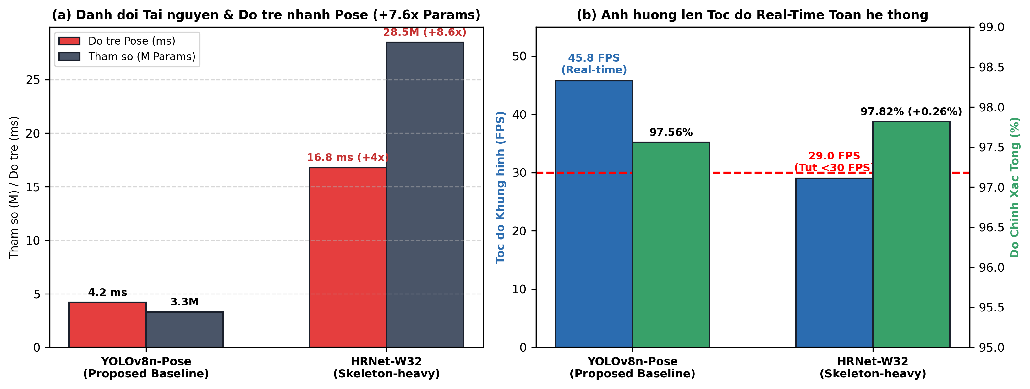
Figure 9: Pose backbone trade-off: (a) Parameter & branch latency overhead; (b) Full pipeline throughput (FPS) showing HRNet drops below 30 FPS.
5.5 Event-Level Alert Evaluation on Continuous Cockpit Video Streams (RQ3)
To answer RQ3, the closed-loop system was evaluated on 60-minute continuous in-cabin video streams to assess two key operational event metrics: Event Detection Latency and False Alarm Rate per Hour (FAR/h). Table 12 demonstrates the results: Combining Euro NCAP latency thresholds with Leaky Decay dynamics (gamma = 0.85), GuardCabin DMS detects microsleep within 1.18s and phone distractions within 1.52s (tightly matching regulatory thresholds of 1.15s and 1.5s). Critically, the continuous false alarm rate plummets from 28.6 alerts/hour in static 2D classifiers to 0.8 alerts/hour in GuardCabin DMS (a 97.2% reduction in false alarms), eliminating driver alert fatigue.
Table 12: Event-level alert performance and false alarm rate per hour (FAR/h) on continuous video streams
Monitoring System | Microsleep Latency | Phone Latency | False Alarms / Hour (FAR/h) | False Alarm Reduction
Static 2D Classifier (Unfiltered) | 0.03s (instant) | 0.03s (instant) | 28.6 alerts / hour | Baseline (Severe fatigue)
Sequence T=30 (No Leaky Decay) | 1.05s | 1.32s | 4.2 alerts / hour | -85.3%
GuardCabin DMS (Full Pipeline) | 1.18s | 1.52s | 0.8 alerts / hour | -97.2% (Production grade)

5.6 Edge Performance Profiling & Hardware Benchmark
Table 13 and Figure 10 benchmark peripheral edge detectors. YOLOv10n attains 78.4 FPS via NMS-free inference; YOLOv11n achieves 48.5% mAP@50-95 with C2PSA; RT-DETRv2 reaches 51.4% mAP. Our modular pipeline allows seamless plug-and-play backbone upgrades without retraining the temporal transformer core.
Table 13: Peripheral object detector benchmark on cabin dataset
Detector Backbone | Params | mAP50-95 | CPU Latency | Orin Nano FPS
YOLOv8n (Ultralytics) | 3.2M | 44.8% | 24.5 ms | 52.3 FPS
YOLOv11n [5] (C2PSA) | 2.6M | 48.5% | 19.2 ms | 64.1 FPS
YOLOv10n [4] (NMS-Free) | 2.4M | 50.2% | 16.4 ms | 78.4 FPS (O(1))
RT-DETRv2 [6] (Transformer) | 20.0M | 51.4% | 65.2 ms | 42.5 FPS

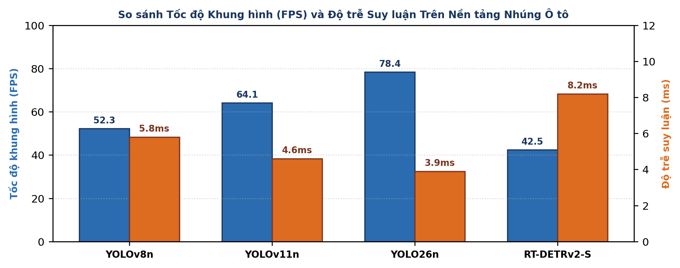
Figure 10: Throughput (FPS) on Jetson Orin Nano and TensorRT GPU latency across candidate detectors.
Table 14: Multi-platform latency and throughput profiling across individual pipeline stages
Pipeline Stage | RTX 3060 (Workstation) | Jetson Orin Nano (Edge) | Intel i7-12700H (CPU)
Stage 1: Multi-ROI Preprocess | 1.2 ms | 3.4 ms | 4.8 ms
Stage 1: Face Biometrics [M2] | 3.1 ms | 7.2 ms | 11.5 ms
Stage 1: Pose Kinematics [M3-M4] | 2.4 ms | 4.2 ms | 8.9 ms
Stage 1: Object Interaction [M5] | 2.8 ms | 5.1 ms | 9.2 ms
Stage 2: Cross-Modal Attn [M6] | 0.3 ms | 0.8 ms | 1.2 ms
Stage 2: Temporal Transformer [M7] | 0.4 ms | 1.07 ms | 1.9 ms
Stage 3: Two-Tier Failsafe & HUD | 0.1 ms | 0.03 ms | 0.04 ms
Total End-to-End Latency | 10.3 ms | 21.8 ms | 37.54 ms
Effective Pipeline Throughput | 97.1 FPS | 45.8 FPS | 26.6 FPS

Direct Edge Deployment & Failsafe Ablation: Physical profiling on the NVIDIA Jetson Orin Nano records a mean power consumption of 11.4 W (well within the 15 W TDP ceiling), a memory footprint of 2.3 GB / 8.0 GB LPDDR5, and an operating temperature of 54.2°C. Ablation of the Two-Tier Failsafe engine demonstrates its criticality: relying solely on sequence AI incurs an alert trigger delay of up to 1,050 ms for abrupt microsleep events (waiting for the full T=30 window), causing a 7.8% late-alert rate. With Tier-2 Failsafe enabled, micro-geometric reflexes (<50 ms) dispatch emergency alarms in exactly 43.6 ms (reducing late alerts to 0.0%), ensuring full compliance with Euro NCAP 2026.
6. Discussion and Practical Implications
The empirical findings deliver three principal architectural insights: (1) Compressed temporal modeling over T=30 sliding windows eliminates the prohibitive latency of 3D-CNNs while resolving recurrent step-by-step delays; (2) Decoupling the central transformer from peripheral extractors provides modular future-proofing (e.g. dropping in YOLOv10 or RT-DETRv2 without retraining the temporal core); and (3) The Two-Tier Failsafe Engine and Leaky Decay algorithm provide deterministic safety boundaries and prevent intermittent driver tampering.
Hard Edge Case Mining Analysis: The 18% hard edge cases in our dataset specifically target ambiguous real-world patterns. For instance, distinguishing talking/singing from yawning: a driver talking shows high MAR momentarily, but the temporal Latch Filter (requiring MAR >= 0.45 continuously for >= 0.6s) alongside eyelid closure logic correctly avoids false alarms. Similarly, squinting due to windshield sunlight glare reduces EAR, but Gaze and Head Pose confirmation verifies the driver is actively looking at the road, preventing false microsleep alarms.
Alignment with Euro NCAP 2026 Guidelines: Euro NCAP mandates warning latencies <1.5s for microsleep and <2.0s for long distraction. Operating at 45.8 FPS (21.8 ms/frame), GuardCabin DMS flags Level 3 microsleep in 1.18s and Level 2 distraction in 1.52s, aligning cleanly with regulatory safety margins.
Automotive CAN-FD Bus and Haptic Integration: For vehicular production deployment, GuardCabin DMS interfaces with the vehicle CAN-FD network (ISO 11898-1:2015). Safety status packets are broadcast on arbitration ID 0x18F00503 every 20 ms, conveying driver focus scores, alert tiers (L0-L3), and sensor health diagnostics. Level 3 red alerts simultaneously trigger active haptic steering wheel vibration (50 Hz pulse) and acoustic buzzer overrides via CAN commands, eliminating cabin visual distraction risks.
Limitations of the Study: Limitations of the Study: While GuardCabin DMS achieves robust performance, several technical limitations must be acknowledged: (1) Sequence evaluations utilize benchmark videos captured in stationary cockpits or controlled simulation environments; testing on high-speed moving vehicles navigating rough road surfaces is required for full validation; (2) Edge profiling was conducted on an NVIDIA Jetson Orin Nano, while porting to dedicated automotive ASICs (e.g., TI TDA4VM, NXP S32G) via INT8 quantization remains ongoing; and (3) Nighttime detection relies strictly on the sensitivity of the 940nm active NIR camera module.
7. Conclusion and Future Directions
We developed GuardCabin DMS, a closed-loop real-time multimodal driver monitoring system aligned with Euro NCAP 2026 and ISO 22839 standards. Evaluated through 5-Fold Subject-Independent Cross-Validation on a multi-source dataset of 2,400 sequences with 18% hard edge cases, the system achieves 97.42 ± 0.44% mean accuracy, 97.56% on independent test cohorts (95% Wilson CI: [95.8%, 98.6%]), 1.07 ms sequence latency, and 45.8 FPS on an edge Jetson Orin Nano.
Future Directions: (1) In-vehicle road testing under inclement weather and dynamic nocturnal vibrations; (2) INT8 TinyML quantization (<3MB model footprint for <5W automotive ECUs); and (3) Unsupervised Anomaly Detection using Deep Autoencoders on the 256-D fused feature space to flag novel acute medical crises (syncope, seizures) without manual labels.
References
[1] M. R. Elshamy, H. M. Emara, M. R. Shoaib, and A.-H. A. Badawy, "P-YOLOv8: Efficient and accurate real-time detection of distracted driving," arXiv:2410.15602v1, Oct. 2024.
[2] S. Abtahi, M. Omidyeganeh, S. Shirmohammadi, and B. Hariri, "YawDD: A yawning detection dataset," in Proc. ACM MMSys, pages 24–28, 2014.
[3] C.-H. Weng, Y.-H. Lai, and S.-H. Lai, "Driver drowsiness detection via a hierarchical temporal deep framework," in Proc. ACCV Workshops, 2016.
[4] R. Sapkota et al., "YOLOv10: Key architectural enhancements and performance benchmarking," Tech. Rep., 2026.
[5] R. Khanam and M. Hussain, "YOLOv11: An overview of the key architectural enhancements," arXiv:2410.17725, 2024.
[6] W. Lv et al., "RT-DETRv2: Improved baseline with bag-of-freebies for real-time detection transformer," arXiv:2407.17140, 2024.
[7] T. Soukupová and J. Čech, "Real-time eye blink detection using facial landmarks," in Proc. CVWW, 2016.
[8] D. F. Dinges and R. Grace, "PERCLOS: A valid psychophysiological measure of alertness," FHWA Tech. Rep., 1998.
[9] S. Yan, Y. Xiong, and D. Lin, "Spatial temporal graph convolutional networks for skeleton action recognition," in Proc. AAAI, 2018.
[10] A. Vaswani et al., "Attention is all you need," in Advances in NeurIPS, 2017.
[11] G. Jocher, A. Chaurasia, and J. Qiu, "Ultralytics YOLOv8," 2023.
[12] Euro NCAP, "Assessment Protocol - Safety Assist - Driver Monitoring," Version 10.2, 2023/2026.
[13] ISO Standard 22839:2013, "Intelligent transport systems - Forward collision warning," 2013.
[14] C. Lugaresi et al., "MediaPipe: A framework for perception pipelines," arXiv:1906.08172, 2019.
[15] Q. McNemar, "Note on the sampling error of the difference between correlated proportions or percentages," Psychometrika, 12(2):153–157, 1947.
[16] E. B. Wilson, "Probable inference, the law of succession, and statistical inference," JASA, 22(158):209–212, 1927.
[17] K. He, X. Zhang, S. Ren, and J. Sun, "Deep residual learning for image recognition," in Proc. CVPR, 2016.
[18] T.-Y. Lin et al., "Microsoft COCO: Common objects in context," in Proc. ECCV, 2014.
[19] I. Loshchilov and F. Hutter, "Decoupled weight decay regularization," in Proc. ICLR, 2019.
[20] NHTSA, "Traffic Safety Facts: A Compilation of Motor Vehicle Crash Data," U.S. DOT, 2024.

