# Reboot Camp 2023 Arduino Workshop

# How to Connect your Arduino to the Computer and Upload a Program

1. Connect the USB cable to the PC and the Arduino

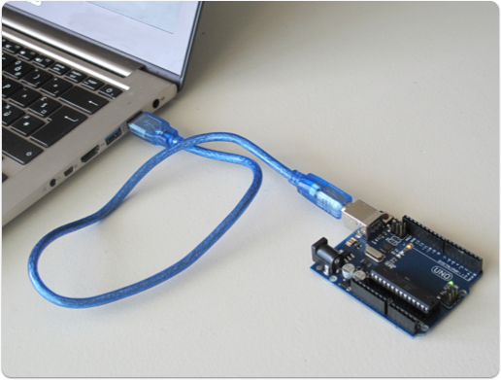

1. Open the Arduino IDE



1. Click on to “Tools” >> “Port:”,
2. Select one of the options available labelled with “COM#” – For example “COM1”, “COM4”, or similar ones.  
   If this does not work, try another option.  
   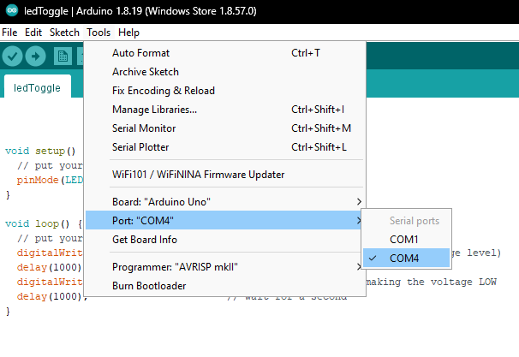
3. To check to see if the code will upload to the Arduino, first click on the “Verify” button.



1. If an error occurs, you will need to fix your Arduino code.   
   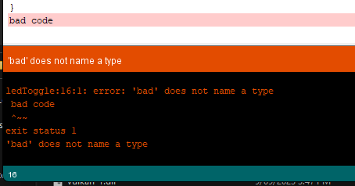
2. If the “Verify” works with no error, you then upload your code to the Arduino.  
   To upload the code to the Arduino, click on the “Upload” button.  
   A screenshot of a computer

   Description automatically generated



1. The Arduino will then start working with your code!