# Methods

## Subjects

All experiments were approved by ethical committees. Healthy volunteers received a financial compensation for their participation. 20 subjects have been scanned with MEG (22±3 years old; 11 males, 18 right-handed). Each experiment lasted for approximately 1 hour-long.

## Experimental protocol

One sentence summary: e.g. The aim of the present protocol was to investigate, at the single trial level, the neural bases of stimuli presented at perceptual threshold (Figure 1). Each trial started with a blank presentation (t=XXX±100ms), succeeded by a variably oriented and variably contrasted Gabor patch hereafter referred to as ‘Target’ stimulus. T 50 msthen by maximallypresented for .600 ms later, second variably oriented Gabor patch, hereafter referred to as ‘Probe’ stimulus was presented for 50 ms. Subjects were then asked to provide a behavioural response fulfilling two tasks simultaneously. First subjects had to indicate whether the Probe was rotated clockwise (right hand) or anti-clockwise (left hand) relative to the Target. Second, subjects had to report the visibility of the target itself in a range from 1: no experience of the Target to 4: clear experience of the Target, according to the Perceptual Awareness Scale40. Visibility ratings were reported using four of each hand’s fingers, where the index fingers indicated no visibility and the little fingers indicated maximum visibility.

## Stimuli

Target and Probe stimuli were Gabor patches Gaussian std, size etc). Spatial frequency of probe and target? Target and Probes were identicalandTarget contrast was varied across three different levels: 50%, 75% and 100%. Additionally, XXX % of the trials replaced the target stimulus with a blank screen (‘absent’ trials). Target orientation was varied among six possible equally-spaced orientations: 15°; 45°; 75°; 105°; 135°; 165°, where 0° refers to the vertical axis. Cardinal axes were avoided because of the higher discrimination performance these orientations elicit39. The probe remained fully contrasted across all trials and was tilted 30° clockwise or anti-clockwise relative to the Target. Tilt, spatial frequency, orientations and proportion of absent/present trials were pseudo-randomized per each one of five blocks. Target, Probe and Mask stimuli occupied a disk of 16.2° of visual angle. A fixation point was maintained during the whole trial to limit eye movements.

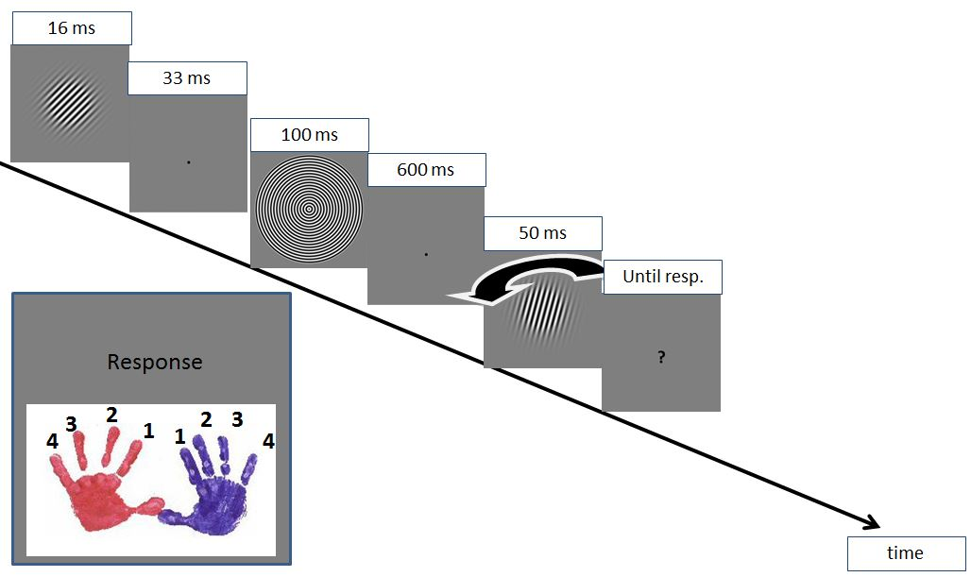

**Figure 1**

Experimental design. Notice that in this case the probe was tilted anti-clockwise to the target. The subject responded at the same time about the tilt of the probe relatively to the target (hand) and about the visibility of the target itself (finger).

## Recording setting

Magnetic brain activity was recorded through magneto-encephalography (Elekta Neuromag® MEG system, Helsinki, Finland, comprising 204 planar gradiometers and 102 magnetometers in a helmet-shaped array). Data were sampled at 1 KHz with on-line analog low-pass filtering at 330 Hz, and on-line analog high-pass filtering at 0.1 Hz. The head position with respect to the sensor array was determined by four head position indicator coils attached to the scalp. The locations of the coils were digitized with respect to three anatomical landmarks (nasion and pre-auricular points) with a 3D digitizer (Polhemus Isotrak system®). Then, head position with respect to the device origin was acquired before each 10-15 minutes block of MEG recording. Subjects were asked to keep their eyes opened and to avoid eye movements by focusing on a fixation point displayed at the centre of the screen. Monocular eye movements were recorded during the whole experiment and recalibrated on every main block with an SR-Research EyeLink1000©.

## Pre-processing

Signal space separation (SSS41) was applied to suppress unwanted magnetic interferences (e.g. outside disturbances, limb movements), to interpolate noisy MEG sensors and to realign MEG data into a subject-specific head position. Noisy MEG sensors were removed with MaxFilterTM in the SSS pre-processing step. Event related signals were digitally low-pass filtered at 30 Hz and down-sampled to 256 Hz. Trials were then segmented from -800 ms to 2200 ms relative to Target onset, and were corrected for baseline from -300 ms to -50 ms.

Probe ERF.

Response lock ERF.

Segmentation and filtering was done with Fieldtrip42.

## Unvariate analyses

1. Type of analyses (visibility, orientation etc)
2. Statistics
3. Correction for multiple comparison

## Multivariate pattern analyses

Introductory sentence: e.g. For each subject, we implemented a series of multivariate pattern analyses (MVPA) that aimed at combining multiple sensors into a single statistical tests, and thus i) maximize the extraction of information contained in subjects’ MEG responses while ii) minimizing the number of statistical tests. Specifically, each MVPA was based on a cross-validated fit of a linear model (Support Vector Machine or Linear Regression). Cross-validation was eight-folded within each subject (i.e. repeatedly trained on 7/8th of the trials, and tested on the remaining independent test trials), and stratified, meaning each fold contained homogenous proportion of trials. A support vector classifier (SVC) with a linear kernel44 was supplemented with a continuous output method providing, for each trial, an estimate of the probability of belonging to a given class45. After fitting the SVC on the training set, classification scores were estimated on the independent test set. Decoding was performed using the Scikit-learn open-source online library for Python46.

2. contrasts

SVC: absent/present, visibility

Statistics: ranksum/man whitney

SVC or PLR??: orientation

Statistics: non uniformity

3. Generalization across condition

4. Generalization across time (and across condition?)

6. correction for multiple comparison

# Results

## Behavioural

1. Show that protocol is adapted:

* Stimuli were presented at threshold: Mean proportion of visibility responses
* Subjects did not answer randomly: Detection d’ + discrimination d’ as a function of visibility
* HOWEVER: contrast had little effect: visibility as a function of contrast + discrimination d’ as a function of contrast

1. Provide potentially important details for subsequent interpretations:

* Reaction time
* Response biases: finger, hand, contrast, visibility

#### Visibility reports index performance

Accuracy (M: .84, SD: .22) was moderately influenced by contrast (1-way ANOVA on within-subject z-score F(1,19) = 13.66, p < .001) and by visibility (F(1,19) = 55.06, p = < .001) but a great inter-subject variability existed, as indicated by the fact that significance was reached only if within subject data were first normalized (Figure 3).

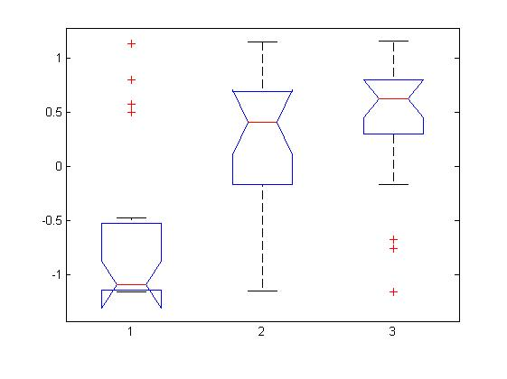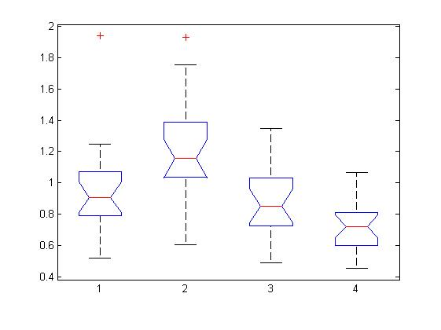

**Figure 3.** Top-left: accuracy as a function of contrast. Top-right: accuracy as a function of visibility. Bottom-left: RT as a function of visibility. The first two graphs represent z-scores calculated within subjects. This was done in order to account for the different threshold levels that participants might have had. ANOVA performed on raw scores did not yield significant results although it did if performed on z-scores.

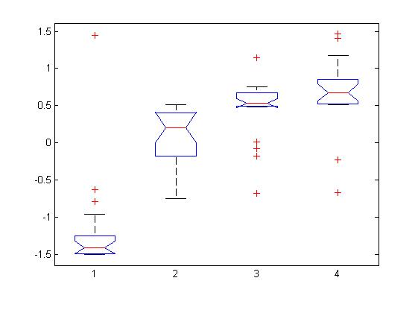

ANOVA on RT shows that visibility has a strong effect (F(1,19)=12, p<.001) (fig 3). Visibility 2 gave rise to slowest RT, thus probably indicating the maximum level of uncertainty. A 2-way ANOVA showed a strong effect of contrast (F(1,19)=97.83, p < .001) and orientation (F(1,19)=3.63, p < .01) on visibility and a marginally significant interaction between the two (F(2,19)=1.52, p=.09). Overall these results suggest that visibility reports were reliable predictors of objective performance, but were also influenced by orientation.

## Event Related Fields

Event-related fields (ERFs) were computed within subject for different conditions of interest and different time windows. Results were then averaged across subjects and analysed. Main comparisons were done on simple contrasts: target orientation (fig 4), present/absent, visibility (4 levels), seen/unseen, visibility on present trials only (4 levels), seen/unseen on present trials only, correct/incorrect response, response button, tilt, target contrast (4 levels), target spatial frequency. In case of binary comparisons a ranksum test was done on each time point of the hypothesis that the two distributions come from distributions with equal medians. ~~However the problem of multiple comparisons has not been addressed yet.~~ Other comparisons were done to show interaction effects among main conditions of interest. , ANOVAs were performed to test for interactions between X and X.

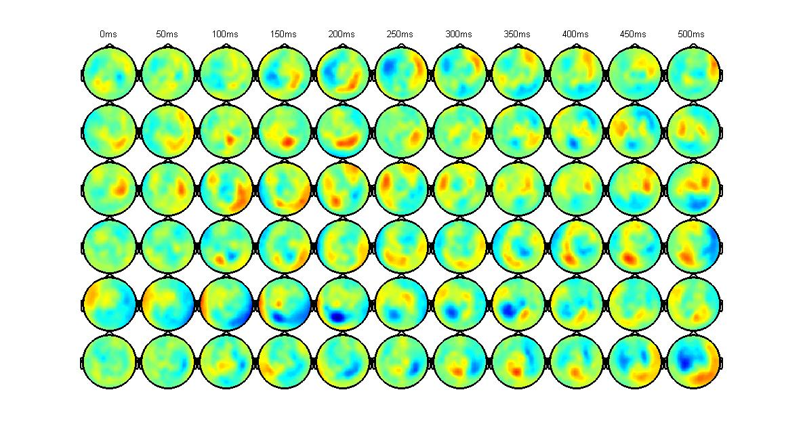

**Figure 4**. Average topographies for magnetometers for different orientations across subjects. Rows represent the six orientations of the target, columns represent the first 500ms from target presentation. It can be seen that different orientations led to different topographies at different time points, suggesting possible sources that our classifier might have drawn upon.

## MEG results: Decoding

A first classifier (*Orientation Classifier*) was trained on the discrimination of target orientations. Overall we were able to decode the orientation of a masked target as shown in Fig 5 below:

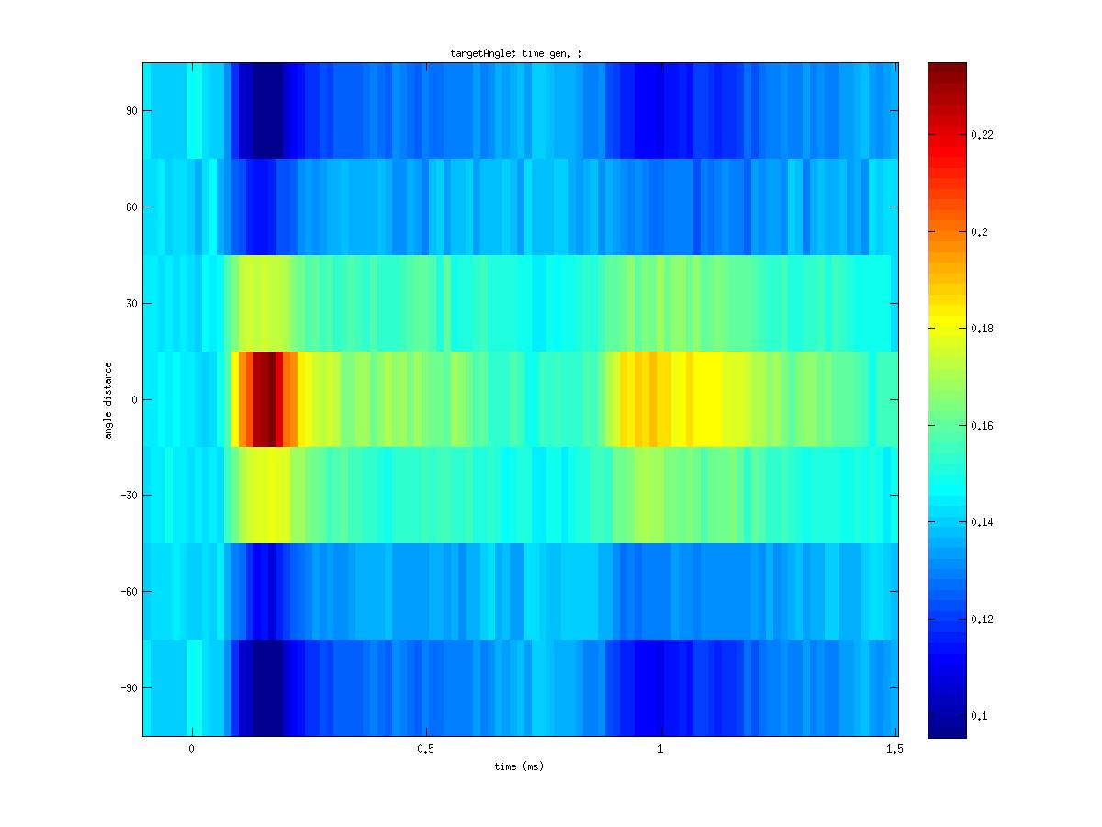

**Figure 5.** Target orientation decoding in the time-window from -300ms to 1500ms. Orientations were realigned. A first activation can be seen after 130ms. The probability assigned by the classifier decreases with distance from target confirming Prediction 3. A second transient activity can be seen after 270ms accompanied with symmetrical activity on both sides, suggesting probe anticipation.

Orientations have been realigned in order to be visually meaningful. The most relevant finding observed in the figure above shows that decoding of target orientation is possible. A first activation seems to take place after 140ms from target presentation t0. The probability assigned by the classifier decreases with distance from target.

We then trained the same classifier on several time points and see whether it was able to generalize to other time points (fig 6 top). Good classification can be observed along the diagonal (where train and testing time points are the same). On the top of this, some generalization can be observed off the diagonal and in particular when classifier is trained at 900ms and tested around 200ms. The weakest generalization is observed when training on the target (weak stimulus) and testing on the probe (strong stimulus). We performed a circular r-test of non-uniformity (Circular Statistics Toolbox for Matlab) on the null hypothesis that the population is uniformly distributed around the circle. Figure 6 (bottom) represents log p-values with greater values corresponding to higher significance. It can be seen that strong significance is observed along the diagonal, particularly around target and probe presentation. On the top of this main effect some generalization is observed when training on the probe and testing on the target. The effect is small compared to major effects on the diagonal, but significant. Indeed a significance value of .05 corresponds to a –log10 value of 1.3 on the colour scale. To a less extent the same generalization can be observed when training on the target and testing on the probe (bottom right part of the graph).

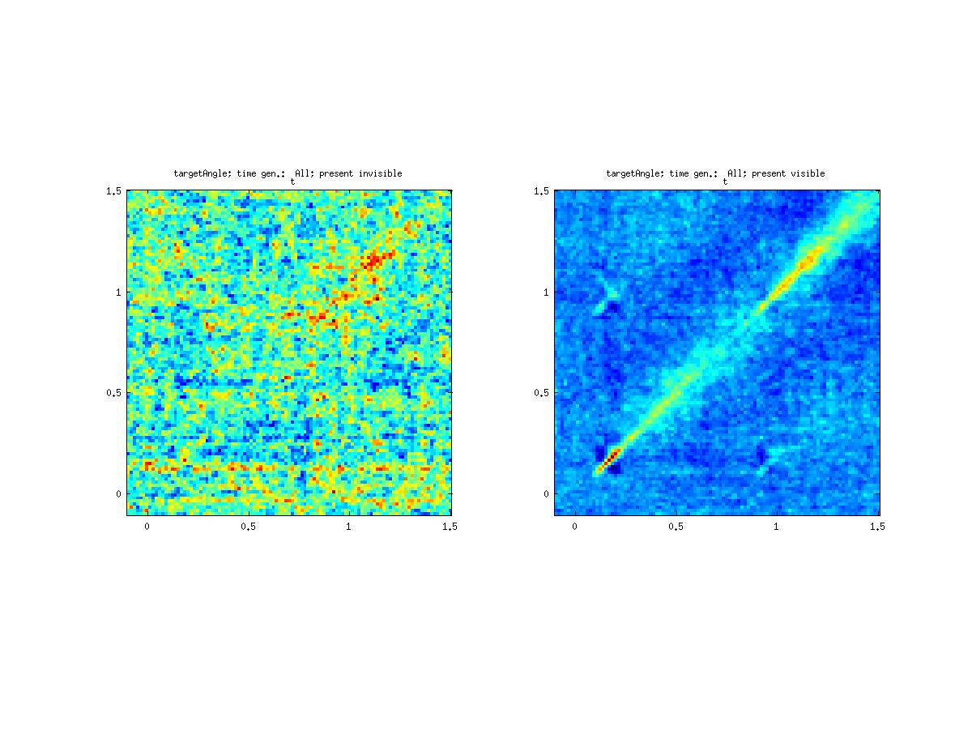

**Figure 6.** **Top:** Target classifier trained at each single time points (y-axis) and tested to all time points (x-axis). Left: Classifier trained on invisible trials only. Right: Classifier trained on visible trials only. **Bottom-Left:** log p-values of Rayleigh’s test of non-uniformity. Notice that a p-value of .05 corresponds to a value of 1.3 on the colour scale. Thus a small but significant effect is found when training on the probe and testing on the target. **Bottom-Right:** v-test for different reported visibilities (top) and median p-values (log-transformed) for different visibility ratings.

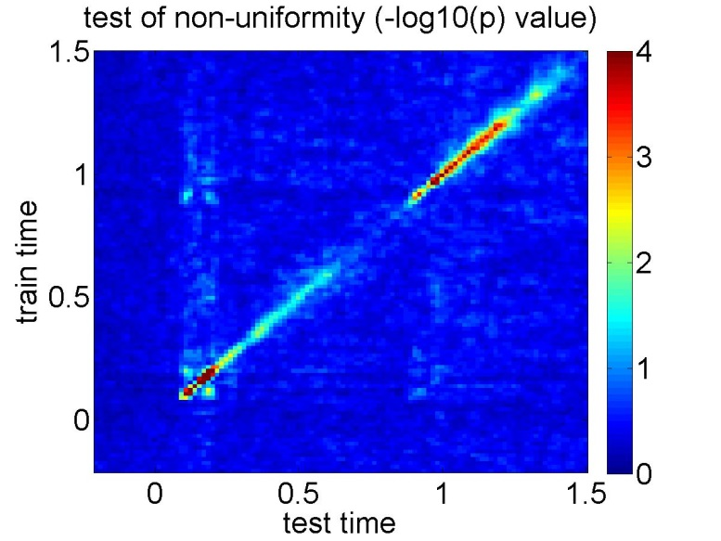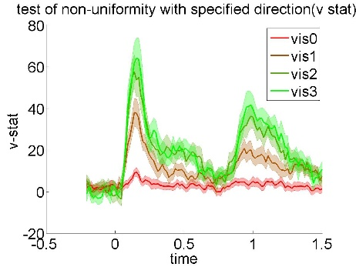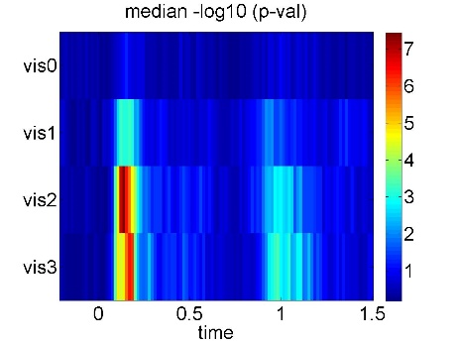

Then we sorted trials according to the reported visibility. In particular we compared present seen trials with present unseen trials to match the physical stimulation (fig 6, top). The figure shows the extremely noisiness of the signal to be decoded when stimuli are reported as unseen. Physical stimulation cannot explain the results given that it was identical to the two conditions. Target angle decoding performance scaled with reported visibility as measured by the circular test of non-uniformity (fig 6 bottom right). It can be seen that significant difference from uniformity null hypothesis is observed in early (20ms) and late stages (900ms). Trials reported as unseen are not easily decodable as it can be observed by the extremely low –log p-values represented in figure 6 (bottom-right). This shows that visibility indeed measures the information availability or strength of the signal available for further processing. Two possible methods can be used in order to address the multiple comparisons problem. First we could define a-priori, based on the literature, few time windows of interest where to test our hypothesis. Alternatively (and perhaps more preferably) we could perform a cluster-based test. This family of tests produces positive results only if significant effects are found to cluster together in nearby time regions. The same effect scaling according to visibility was not observed when considering a probe angle classifier.

A second classifier (*Presence Classifier*) was trained on the discrimination between present/absent trials. Figure 7 shows the classifier output probability of belonging to the “absent” class (y-axis). Discrimination among the two classes (present vs absent trials) peaks around 200 ms. Prob(absent) (blue line) decreases progressively reaching the baseline again toward the end, suggesting maintenance of the representation across time. Baseline probability is low because of the different proportion of present and absent trials presented to the subjects. The same classifier output but sorted according to visibility ratings is shown in the bottom graph. Again the effects scale according to reported visibility. Contrary to our expectations however a present target reported as unseen is still assigned a higher probability of being present than absent. In other words the classifier recognizes it as a present even if considering late processing stages. Although the output probability of being absent is higher for present unseen stimuli compared to present seen stimuli, the relative time series is qualitatively closer to the present stream (dotted lines) than to the absent stream (continuous lines).

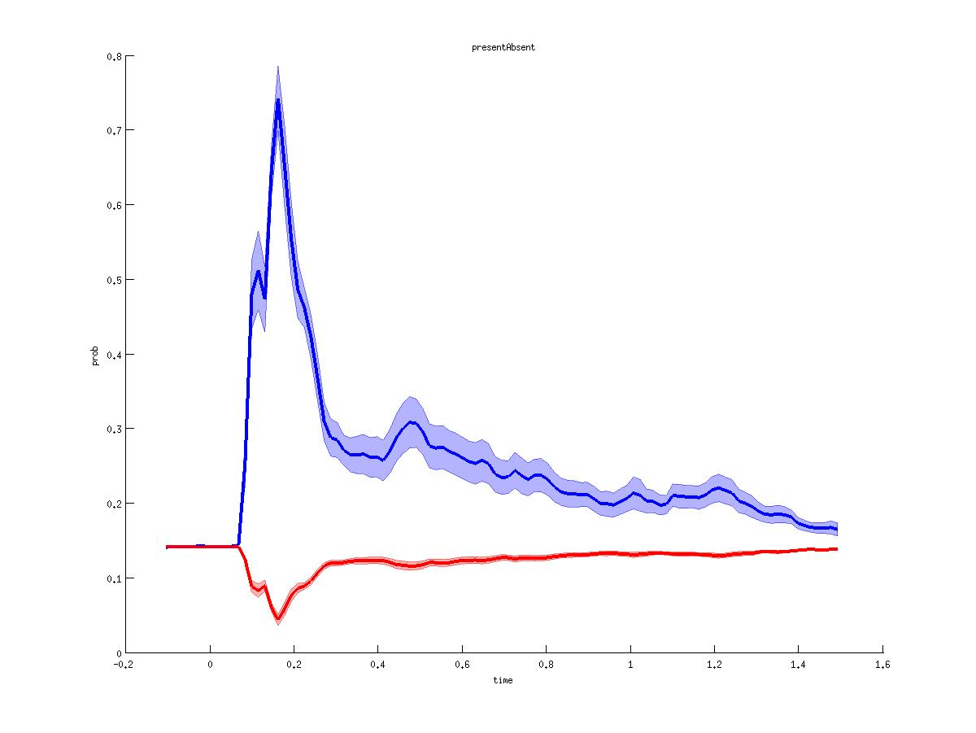

**Figure 7.** *Presence Classifier.* Y-axis represents the output probability of absent trial. The baseline is very low because present trials were more frequent than absent ones. Top: all trials considered. Blue line represent absent trials only, red line represents present trials only. Bottom: Same classifier sorted by visibility. It can be noted that after a sharp peak common to all visibility ratings, differentiation comes after few hundreds millisecond.

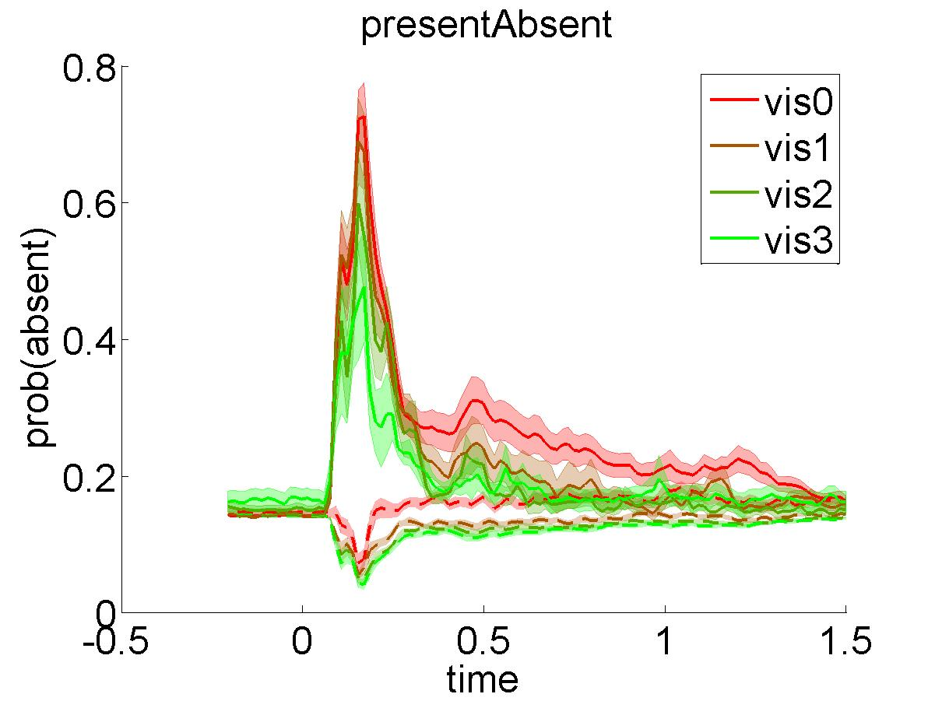

A third classifier (*Visibility Classifier*) was trained on the discrimination between seen/unseen trials (fig 8). Great decoding performance can be observed only if considering all trials, probably reflecting the presence/absence of the stimulus rather than visibility per se. Selecting only those trials where a stimulus was indeed presented did not result hitherto to significant results.

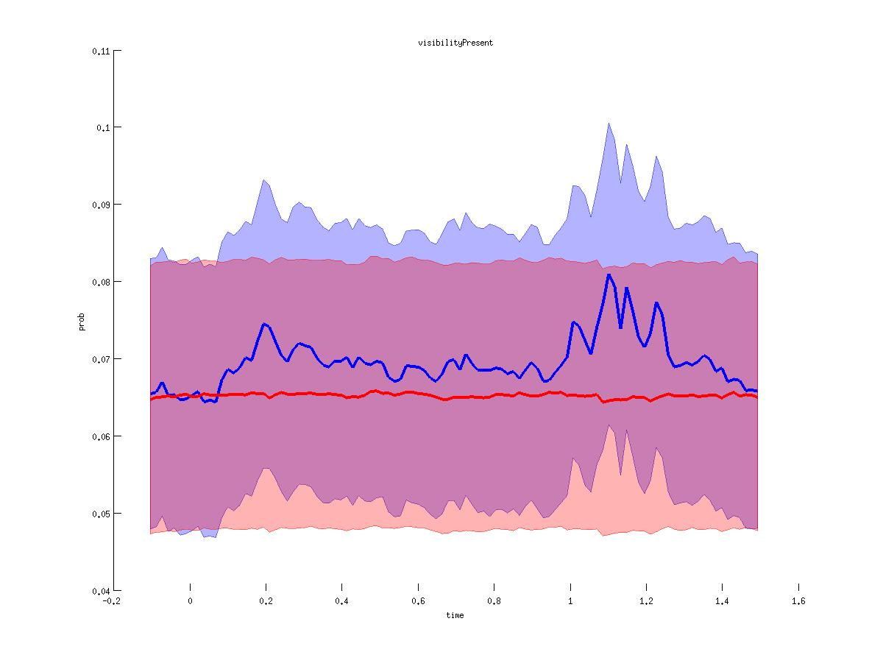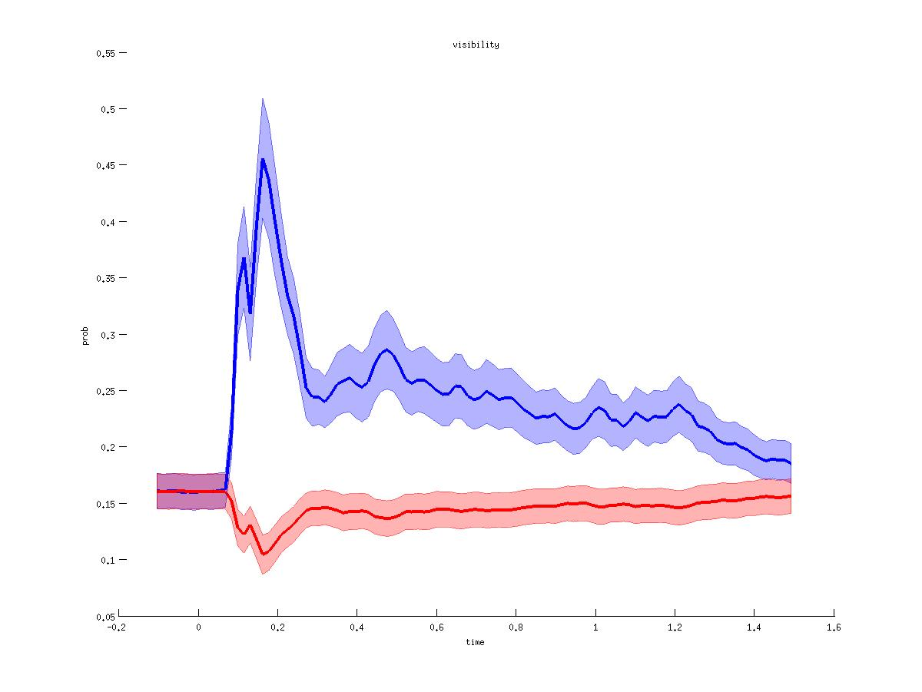

**Figure 8**. Visibility classifier. Top: all trials considered. Bottom: only present trials considered (consider possible bug in the script).

Furthermore, classifiers were trained on the lamda of the gabors presented and on the tilt of the task (fig 9).

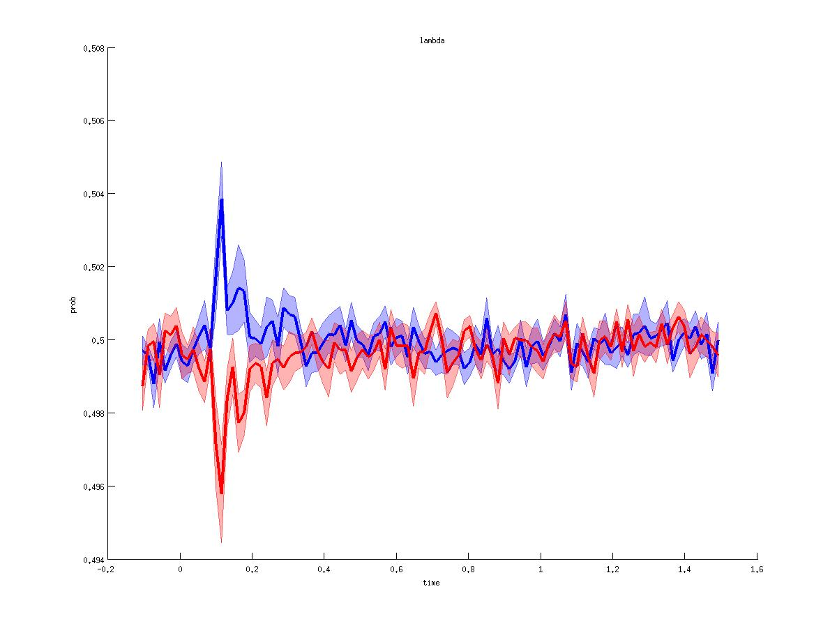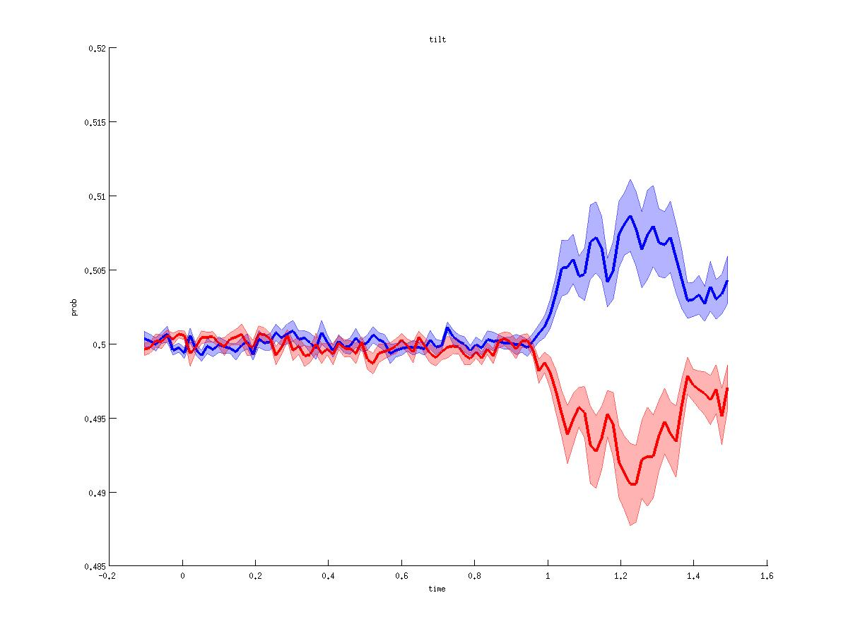

**Figure 9**. Top: tilt classifer. Bottom: lambda classifer.