Black States are States in which Electric Cars increase GHG emissions relative to Gasoline Cars

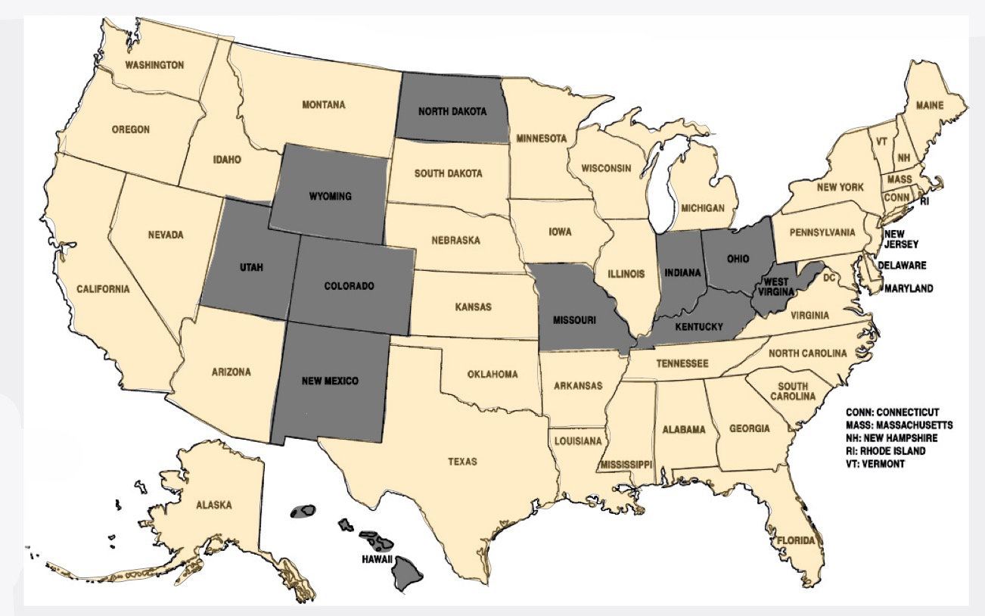

Electric Car Taxes Relative to Gasoline, Taxes are Shown in Cents per Gallon of Gasoline Equivalent

