Table of Contents

Brief problem statement 1

System requirements 2

Users profile 2

Feature requirements (described using use cases) 2

Use case diagrams 4

Use case description 5

UC - 02 5

US - 05 6

UC - 13 7

UC - 10 8

Overview of important usecases as diagram 9

**Software Requirements Specification (SRS) Document.**

|  |  |
| --- | --- |
|  | Content Optimizer  Akdov SSAD-Team 6  Rohan Karnawat  Aayush Naik  Vinayak Athavale  Mohammed Sharfuddin  Vinay Reddy |

# Brief problem statement

1. The objective is to develop a system that, when integrated into the websites of small/medium businesses, generates content relevant to the user, on the basis of their location, recent activities, industry the belong to (on the basis of content consumed).

# System requirements

The servers that host the website must support PHP as a server side scripting language.

The website must be able to send data packets.

Website should support Javascript (analytics)

Working Server

* 1. The system must be allowed access to the website's databases.

# Users profile

1. Registered users or consumers.
2. Organizations requiring digital marketing (who will implement the service):

* Managers of e-commerce website engine
* Small to medium industrial service providers

# Feature requirements (described using use cases)

|  |  |  |  |
| --- | --- | --- | --- |
| **No.** | **User Case Name** | **Description** | **Release** |
|  | Get IP address | Using Php, get IP address of visitors. | R1 |
|  | Process IP address | Use the IP address to obtain location: area, city, country, and user ISP | R1 |
|  | Log ip address | Store IP address and details in Clicky | R1 |
|  | Generate Visitor ID | Generate a unique ID of visitor to the site | R1 |
|  | Generate Cookie | Contains information regarding visitor | R1 |
|  | Retrieving visited user's information | The previously logged data of a user visiting again is retrieved from the Clicky database | R1 |
|  | Log processed data to Clicky | All the activity and searches is recorded and logged into Clicky | R1 |
|  | Data Analysis | Scan through logged data before retrieving data that is optimized. | R1 |
|  | Retrieve Personalized User information | Retrieve the user specific details for a logged in user | R2 |
|  | Set preferences (tags) | Registered user can choose tags which it prefers to view, when it visits the site. | R2 |
|  | Retrieve preferential data | Retrieve the data the user has set its preference to. | R2 |
|  | Generate location-based optimized content | Based on the location deduced from the IP Addr popular content is renderd and displayed. | R2 |
|  | Generate history-based optimized content | Content having same tags as past searches / activities is displayed. | R2 |
|  | Generate preference-based optimized content | End Users can personalize the type of content they wish to see by selecting tags, this would be displayed | R2 |
|  | Traffic Analysis | Keep a track of all the frequently visited artifacts and location from where traffic is high. | R1 |
|  | Sending information from analytics to Data-pub tool | Data as json objects are sent from analytics to the Data-pub application. | R1 |
|  | Rendering graphs | Based on the data gathered (traffic), statistical grpahs are generated | R1 |

## Use case diagrams

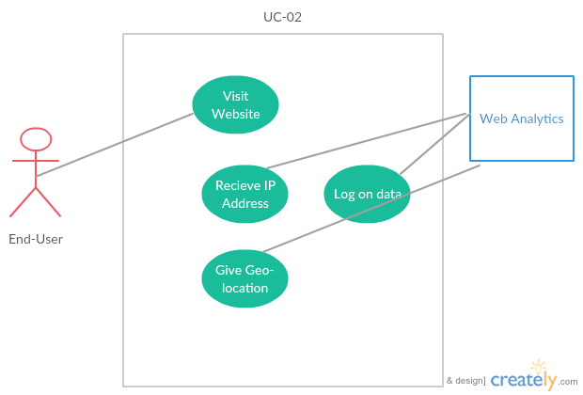

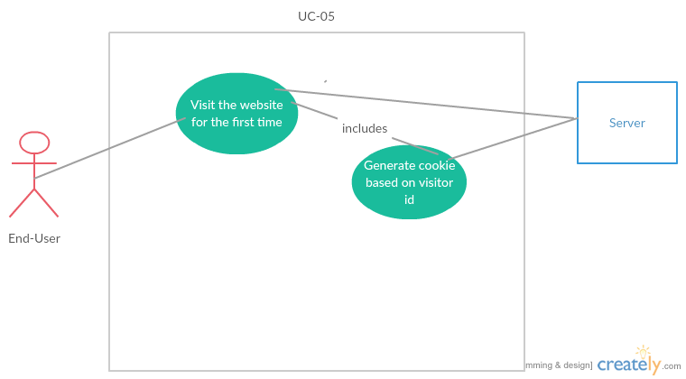

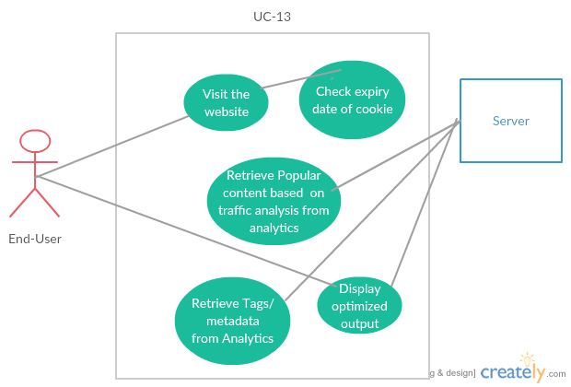

# Use case description

## UC - 02

|  |  |
| --- | --- |
| **Use Case Number:** | UC-02 |
| **Use Case Name:** | Process IP Address |
| **Overview:** | Use the IP address to obtain location: area, city, country, and user ISP |
| **Actors:** | Web Analytics, End - User |
| **Pre condition:** | 1. User has to access/visit the website |
| **Flow:** | 1. User visits the website. 2. Analytics tool receives IP address of the user 3. Geo Location API gives location (as json objects). 4. This data is logged into the Clicky analytics |
| **Alternate flow:** | - |
| **Post Condition:** | The analytics tool generates reports of the location, ISP obtained from the GEOLocation API |

## US - 05

|  |  |
| --- | --- |
| **Use Case Number:** | UC-05 |
| **Use Case Name:** | Generate Cookie |
| **Overview:** | Generates/update a cookie for a visitor |
| **Actors:** | Server(PHP),end-user |
| **Pre condition:** | * User visits the web site. |
| **Flow:** | 1. User visits the website for the first time. 2. User's unique visitor ID is created using epoch-time. (Note: ID is created only on the first visit) 3. A cookie is created with the unique ID as its identifier, containing visitor location, statistics and other logged data. This cookie is valid for 30 days. |
| **Alternate flow:** | 1. The visitor visits the website, but not for the first time. 2. A new visitor ID is not created. 3. Existing cookie is used and renewed for 30 more days. |
| **Post Condition:** | * This cookie is used for logging data and generating optimized content. |

## UC - 13

|  |  |
| --- | --- |
| **Use Case Number:** | UC-13 |
| **Use Case Name:** | Generate history-based optimized content |
| **Overview:** | Content having same tags as past searches / activities is displayed. |
| **Actors:** | Server(PHP),End-User |
| **Pre condition:** | * User visits the web site again(not the first time). * User must visit website within 30 days, since last visit. |
| **Flow:** | 1. The visitor visits the website and his cookie is retrieved. 2. Logged information from analytics is read and logged activity is retreived. 3. Recent tags/metadata viewed by the visitor are retreived. 4. Popular content based on traffic analysis on those tags is retreived and rendered. 5. The optimised output is displayed on the page. |
| **Alternate flow:** | 1. Cookie is not received due to server error    1. 404 Page not Found    2. User will have to reload the page 2. - 3. - 4. If no traffic was generated, content viewed will be displayed. 5. If user visits after 30 days since last visit or for the first time, popular content based on traffic analysis of tags is displayed. |
| **Post Condition:** | * This cookie is used for logging data and generating optimized content. |

## UC - 10

|  |  |
| --- | --- |
| **Use Case Number:** | UC-10 |
| **Use Case Name:** | Set preferences |
| **Overview:** | Registered user can choose tags which it prefers to view, when it visits the site. |
| **Actors:** | Server(PHP),end-user |
| **Pre condition:** | * User is logged in. * User has set preferences. |
| **Flow:** | 1. User logs in.  2. User views preferential data retrieved from the analytics log.  3. User chooses his preferences about what content he wishes to see.  4. Preferences for user logged in analytics.  5. On refresh optimized content according to preferences served. |
| **Alternate flow:** | 1. User is not registered => output based on demographic displayed.  3. User does not choose to fill preferences.  5.Content served according to user characteristics like location etc. |
| **Post Condition:** | * Data according to the (logged in) users preferences and user demographic is served. |

## Overview of important usecases as diagram

