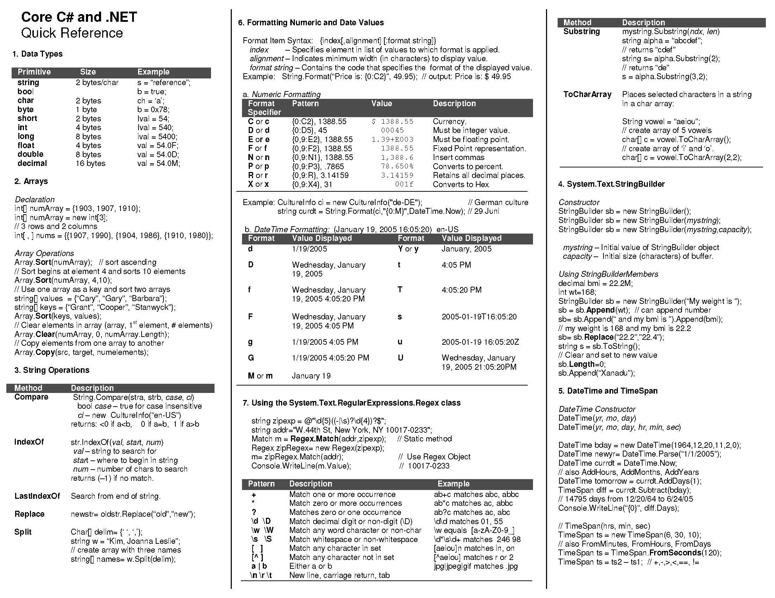
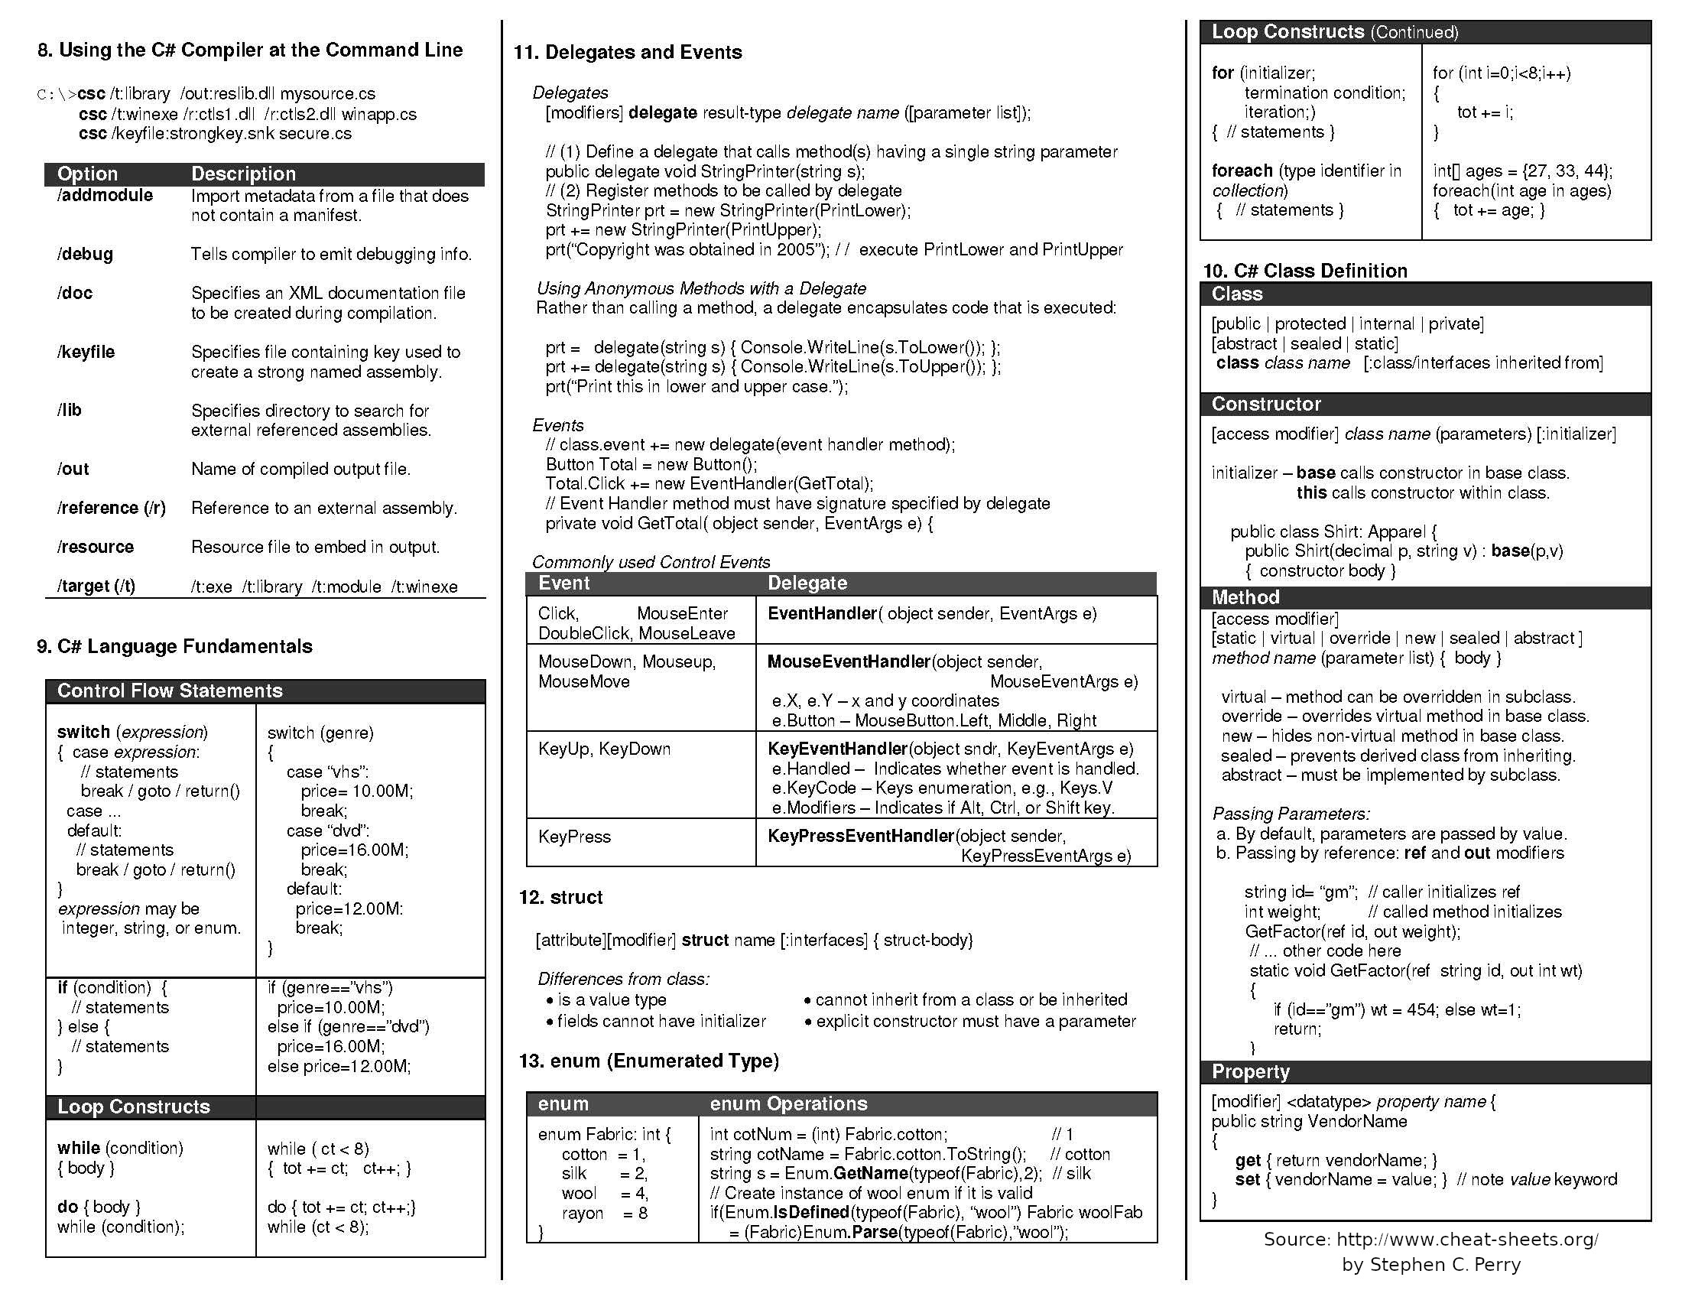
Tru REPL

public abstract class TruExpr : TruStatement {
/// Executes a TruStatement. Overridden in subclasses of TruExpr
public abstract TruVal Interpret(Environment env);
}

/// Represents a value or literal in the Tru language.
public abstract class TruVal : TruExpr {
public override TruVal Interpret(Environment env) { return this; }
}

public class TruBool : TruVal {
public bool val;
public TruBool(bool val) { this.val = val; }
}

/// Represents a callable, ie built-in or functions.
public abstract class TruCallable : TruVal {
public abstract TruVal call(Environment env, TruExpr[] args);
}

public class TruBuiltIn : TruCallable { /// Represents a built-in function, and, or, not
/// TruOperation takes a TruExpr[] so it can preform short-circuit evaluation.
public delegate TruVal TruOperation(Environment env, TruExpr[] parameters);
public TruOperation op;

public override TruVal call(Environment env, TruExpr[] args) {
return this.op(env, args);
}
}

/// Represents a user defined function.
public class TruFunc : TruCallable {
public string[] parameters;
public TruExpr body;
public Environment env; // closures.

public override TruVal call(Environment env, TruExpr[] args) {
if (this.parameters.Length == args.Length) {
Environment locEnv = this.env;
for (int i = 0; i < args.Length; i++) { // add the args to the environment.
locEnv = locEnv.ExtendLocal(this.parameters[i], args[i].Interpret(env));
}
return this.body.Interpret(locEnv);
} else {
throw new TruRuntimeException(“Function call with incorrect argument count");
}
}
}

public class TruId : TruExpr {
public string name;
}

/// Represents a call to a function or a built-in
public class TruCall : TruExpr {
public TruExpr func;
public TruExpr[] args;

public override TruVal Interpret(Environment env) {
TruVal funcVal = this.func.Interpret(env);

if (funcVal is TruCallable callable) {
return callable.call(env, this.args);
} else {
throw new TruRuntimeException($"'{funcVal}' is not callable.");
}
}
}

/// Represents a lambda expression (which should evaluate to a TruFunc)
public class TruLambda : TruExpr {
public string[] parameters;
public TruExpr body;

public override TruVal Interpret(Environment env) {
return new TruFunc(this.parameters, this.body, env);
}
}

C# Basic Chat

public class ClientModel
{
private TcpClient _socket;
public string message;
public string messageBoard;
public bool active;
private string _userName;

public ClientModel (string username)
{
// initializing variables
_socket = new TcpClient("127.0.0.1", 8888);
_userName = username;
active = true;

// welcome message and creating the thread to handle input
Console.WriteLine("Welcome to the conversation. Type in a message when ready.");

// assign a thread to constantly be running GetMessage
var thread = new Thread(GetMessage);
thread.Start();

// initial connection
_socket.WriteString(username);
}
}

