Software

Engineering

Project

Team ‘Télétravail, Famine, Pâtes-Riz’ :

ALMEIDA Mickael

BERNARD Hippolyte

DRAY Gabriel

Table des matières

Organization of the team 3

Students and their responsibilities: 3

Development 3

Specifications 4

System Behavior Document : 4

Use cases 5

Design 7

Modules 7

Design choices 9

SOLID Princilples 9

GitHub repository 9

Tests 9

Test plan 9

Test report 10

# Organization of the team

## **Students and their responsibilities:**

• ALMEIDA Mickael (*Captn138* on GitHub): Lead Tech

Threads : 1 receiver and 1 listener in order to keep receiving messages while sending others

Networking : connection between client and server

Security : The passwords are hashed with SHA512 before being inserted into the database. Thus, no clear password is stored in the database;

UMLs : Drawing the architecture UML

• BERNARD Hippolyte (*Rxdsilver* on GitHub): Lead Graphist

Graphical User Interface : what the user sees, in a window with buttons, text fields etc

Basic classes : the classes to make the chat work.

Uses Cases : the use cases of the chat.

• DRAY Gabriel (*Laartem* on GitHub): Lead Organization

Database : How to store messages and users/passwords (hashed) in a database.

Organization and Managing of the group : Giving the tasks and the deadlines for each work.

Unit Tests : Building the unit tests.

## Development

We have chosen to work with a V-model, as we are only three and we need to overlap the development of several component. Thus, we chose this model as it provides us a convenient way of working.

# Specifications

## System Behavior Document :

Here are listed the requirements of our project. They are classified as functional (F) and non-functionnal (NF).

|  |  |  |  |
| --- | --- | --- | --- |
| Requirement ID | Name | Type | Description |
| REQ01 | Responsivity | F | Server must be maximum 1 second responsive |
| REQ02 | Multi-platforming | F | Application must run on Windows/Linux/Mac |
| REQ03 | Stockage | NF | Messages must be stored in a database |
| REQ04 | Reliability | NF | Messages must not be lost |
| REQ05 | Security | NF | Passwords must never be sent nor stored in clear |
| REQ06 | Non-duplication | NF | Usernames must be unique |
| REQ07 | Account | F | Accounts are locked by the couple username/password |
| REQ08 | Connectivity | F | User can connect on multiple instances |
| REQ09 | Continuity | NF | Sending messages doesn’t interrupt the reception of new messages |
| REQ10 | Simplicity | F | Users can send messages easily |

To produce the list of the requirements, we ask ourselves what was necessary and what wasn’t. We started by starting out what were the simplest and needed functionalities, and then we tried to imagine how we could make the application and finally what would be in it. Also, we looked at all the chatting apps we already know to see what could be done.

## Use cases

|  |  |  |
| --- | --- | --- |
| **USE CASE 1** | **Register** | |
| Goal in context | User issues a request to the server and expects registration to be done in second | |
| Preconditions | Application is running | |
| Success end condition | User sent a username which is not taken yet | |
| Failed end condition | User sent a username which is already taken | |
| Actors | User, local network, server | |
| Trigger | Registration request comes in | |
| Description | Step | Description |
|  | 1 | User sends a registration request with a username and a password |
|  | 2 | Server captures username and password and checks if the username is not taken |
|  | 3a | Server sends confirmation of the registration |
|  | 4a | User is registered and can connect |
|  | 3b | Server sends failed registration information |
|  | 4b | User must retype username and password |
| Performance | 1 second or less | |
| Superordinate | None | |
| Subordinate | Send a message (use case 3), Log in (use case 2) | |
|  |  |  |
| **USE CASE 2** | **Log in** | |
| Goal in context | User issues a request to the server and expects connection to be done in second | |
| Preconditions | Application is running, user has a registered account | |
| Success end condition | User is registered, user send the right username and password | |
| Failed end condition | User is not registered or has sent the wrong username or password | |
| Actors | User, local network, server | |
| Trigger | Connection request comes in | |
| Description | Step | Description |
|  | 1 | User sends a connexion request with a username and a password |
|  | 2 | Server captures username and password and checks if the couple corresponds to a registered user |
|  | 3a | Server sends confirmation of the connexion |
|  | 4a | User is connected |
|  | 3b | Server sends failed connection information |
|  | 4b | User must retype username and password |
| Performance | 1 second or less | |
| Superordinate | register (use case 1) | |
| Subordinate | Send a message (use case 3) | |
|  |  |  |
| **USE CASE 3** | **Send a message** | |
| Goal in context | User issues a request to the server and expects message to be sent in second | |
| Preconditions | Application is running, user is connected | |
| Success end condition | User is connected to the network | |
| Failed end condition | User is not connected to the network | |
| Actors | User, local network, server | |
| Trigger | Message comes in | |
| Description | Step | Description |
|  | 1 | User sends a message with its username and a content |
|  | 2 | Server captures messages |
|  | 3a | (If the message is a text message) Server saves the message in the database |
|  | 4a | Server sends the message to everyone |
|  | 3b | (If the message is a connexion request) see use case 2 |
|  | 3c | (If the message is a registration request) see use case 3 |
| Performance | 1 second or less | |
| Superordinate | Register (use case 1), Log in (use case 2) | |
| Subordinate | None | |

Here we have summarized the use cases in a diagram:

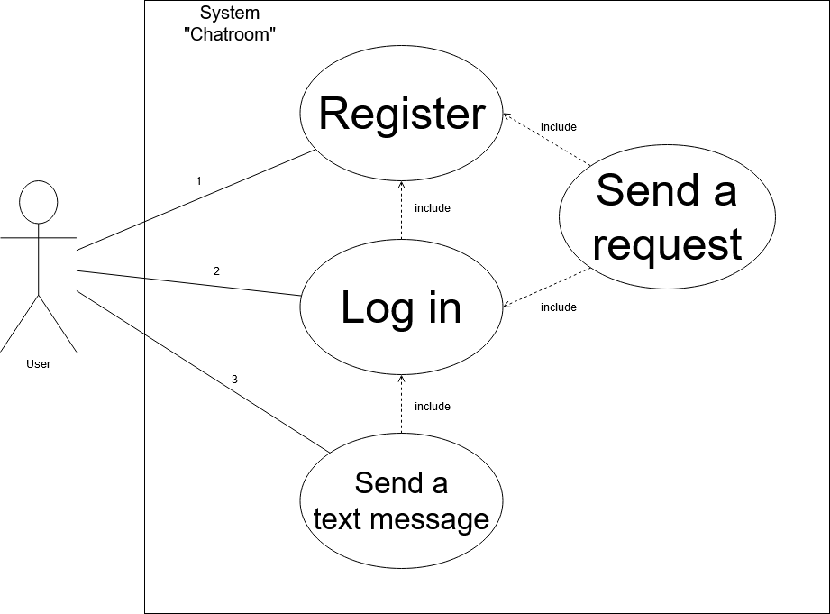

# Design

## Modules

Our project will be separated in 3 modules.

First one is ‘chatroom’. It contains all the base classes, such as Message, Sender and Reciever. These are the class that are used by everything else.

Second one is ‘client’. It contains a GUI class and a Client class. This one will handle interactions between the GUI and the rest of the classes.

Last one is ‘server’. It only contains a class Server because it is the only one that is needed on server-side.

This means, on client-side, we have a package composed of the module client and the module chatroom, while on server-side, we will have a package composed of the module server and chatroom.

We modeled the different modules of our project in 3 UML diagrams.

Package chatroom:

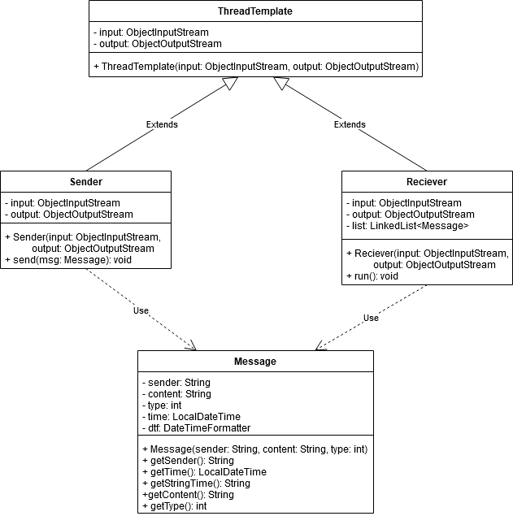

Package client:

Package server:

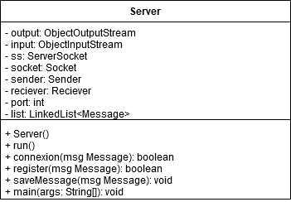

## Design choices

We tried to get an application as clean and minimalist as possible. We didn’t want too much information displayed that could lead to misunderstanding of the functioning of the interface, so we tried to automate some things and got rid of some others.

We have chosen the Facade pattern design, because not only it provides a unique control point, but it will also be easier to interact with, as there will only be interactions with one class.

## SOLID Princilples

• Single responsibility: We have separated the code in several classes, each one corresponds to a precise task. For example, Reader only reads incoming messages while Sender only sends messages.

• Open/Closed: We use an abstract class to generate our threads. This means we could extend this class to create new types of threads without changing the code.

• Liskov’s Substitution: This principle was actually not applied to the Threads.

• Interface Segregation: We did not create interfaces to implement in the classes.

• Dependency inversion: We did not use interfaces when calling methods.

# GitHub repository

Our project can be found online on the following GitHub repository:

<https://github.com/Captn138/Chatroom>

We can find all the Javadoc in the ‘Javadoc’ folder, a copy of the report in the ‘Report’ folder, the modules in the ‘Modules’ folder, the Eclipse code in the ‘SoftwareEngineeringProject2020’ folder, the Unit Tests in the ‘Tests’ folder and some things that didn’t work in the ‘Unused’ folder.

# Tests

## Test plan

* Check if the app runs on Windows, MacOS and Linux.
* Try to create an account.
* Try to connect on multiple instances.
* Try to send a message and check that it is received in less than 1s.
* Try to send a message on two instances and check that REQ09 is applied.

## Test report

Test 1 :

Server launch : success

Application freezing when clicking on “Register” or “Login”

Forcekill the application.

End of Test 1.

After several tests, the result is basically the same : we can’t access to the chatroom.

We spent a lot of time looking at the code, but we couldn’t manage to find out where the error comes from.